Mineral Resources in Smartphones
This is a self-guided research exercise about the sourcing and use of some of the most important chemical elements in smartphones and many other consumer electronics.
Choose one of the following ten elements to focus on:

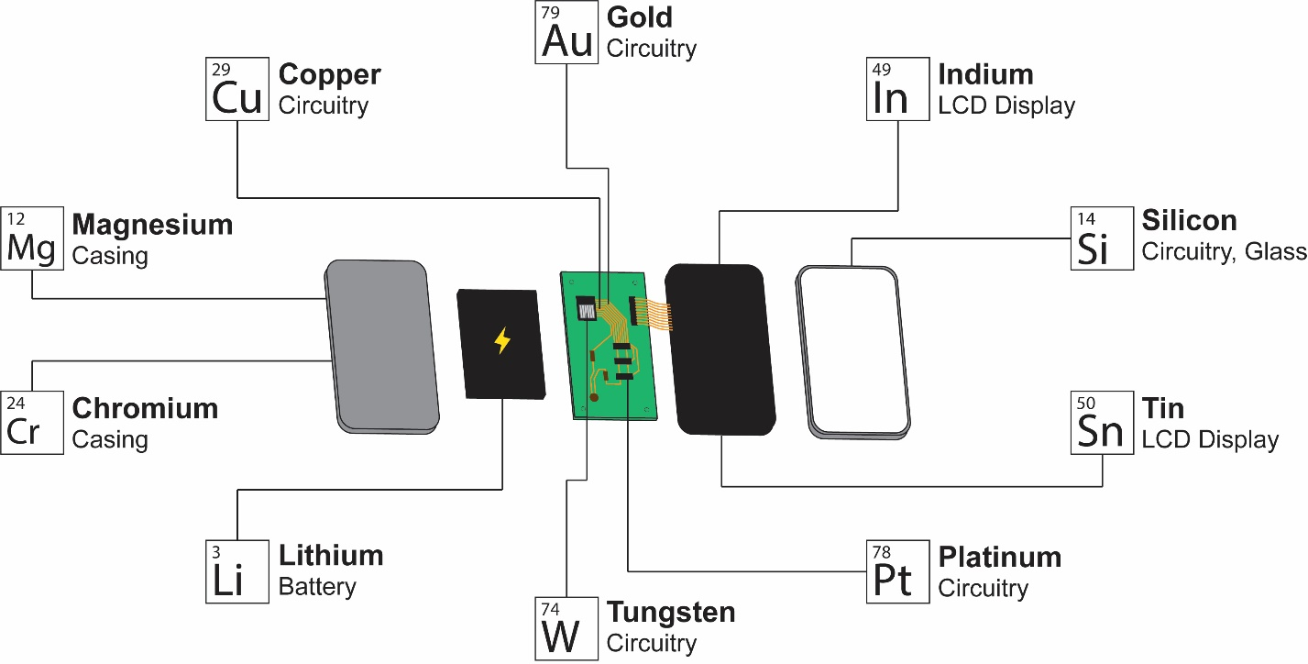

Using any resources available to you, write a short summary report on that element that addresses all of the following points (in any order):
- The name of your chosen element.
- How is this element is used in smartphones?
- Why is this element ideal for this role?
- Where do we get your chosen element? How is it extracted from the Earth?
  - What rock / mineral types are the most common industrial targets for this element?
  - Very generally, how do these deposits form?
- What countries or geographic regions are the top producers of this element?
- What are some political, environmental, or economic implications of this element’s industrial extraction, in a national or global context?
- What is one production statistic related to your mineral? (e.g. tons per year produced, productivity of industry in dollars, etc.)

Example

Aluminum is a metallic element that is widely used in the casing and other structural components of smartphones. Many smartphone manufacturers use aluminum in the bodies of their phones because it is light, sturdy, and, importantly, a good conductor of heat, which is produced in greater and greater amounts as smartphones house more powerful computers.
The principle ore of aluminum is a rock called bauxite, which contains many aluminum bearing minerals like gibbsite (Al(OH)₃). Bauxite is a sedimentary rock that is formed due to the chemical weathering of other rocks near the surface of the Earth. Because of this, it is commonly strip mined, a technique whereby a large area of earth is excavated to a shallow depth.
China is the world’s biggest producers of aluminum from the strip mining of bauxite. The United States, on the other hand, imports almost all of its aluminum. This difference is a due to the fact that bauxite is much more common in China and their regulations over the considerably destructive act of strip mining are more relaxed. Worldwide, many tens of millions of tons of aluminum are produced every year.

