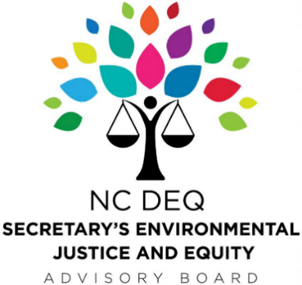

DRAFT Meeting Minutes

Monday April 26, 2021
Virtual Meeting

The meeting was called to order by Chairman Johnson at 12:00 pm. All Board members were reminded of the ethics statement. Ms. Renee Kramer, DEQ Staff Liaison, called roll.

Board Members Present:
Dr. James Johnson, Jr.
Dr. Danelle Lobdell
Marilynn Marsh-Robinson
Sherri White-Williamson
Carlos Velazquez
Dr. Marian Johnson-Thompson
Naeema Muhammad (Joined at 12:04, left at 12:36)
Veronica Carter
Jamie Cole (Joined at 12:07)
Randee Haven-O’Donnell
Dr. Susan Jakes
Rev. Rodney Sadler Jr.
Carolina Fonseca Jimenez

Board Members Absent:
Jeff Anstead
William Barber III
Elke Weil
Dr. Deepak Kumar
Old Business
MHD ZEV Projects in North Carolina, Discussion:
The following questions were posed to the Board at the February 22, 2021 quarterly meeting and form the basis for this special meeting’s discussion:
- What are the most important transportation needs, improvements, and priorities for EJ communities in NC?
- Do you see specific benefits or concerns regarding this project?
- Is there additional information you would like to have about health, safety or other impacts related to this project while considering these questions?
- What are the best ways in which to share this information and engage with communities?
- Please let us know if you would be interested and available to be a Point of Contact for NC. Or if you have anyone else you would recommend, we bring into this effort, please let us know.
Veronica Carter: Is this just a box to be checked?
Secretary Delli-Gatti responds that no, this is more than that and added that this discussion will help advise the Agency on how best to move forward on this initiative as well as others where the Board’s advice is solicited. Secretary Delli-Gatti encouraged Ms. Carter and the rest of the Board to look at both the emissions profile of these vehicles and the opportunities for investments.
Sherri White-Williamson: Consideration of usefulness of ZEV infrastructure in rural EJ communities where there isn’t much electric infrastructure.
Chairman Johnson: Can we look at opportunity zones? There is a lot of opportunity for investment here given the settlement.
Reverend Rodney Sadler Jr.: Opportunities for targeted investment in minority communities. The shift to renewable energy is a great economic opportunity to lift black and brown communities out of poverty.
Naeema Muhammad: In Rocky Mount, we need to make sure the local government is including everyone in these conversations.
Susan Jakes: Cumulative effects are unequal; policies are developed for status quo so how can we put forth new policies to shift this status quo to create opportunities for different people to get this business.
Ms. Carter: Much of this goes to County so if the County Commissioners aren’t aware, the funds do not make it to EJ communities
Chairman Johnson: What is the supply chain to build this infrastructure?
Several members, including Chairman Johnson, Jeff Anstead and Ms. Haven-O'Donnell referred to monies for EJ communities and Dr. Jakes inquired that: since it is a settlement, what is the time frames? Maybe we have more time?
Robin Barrows, in the Division of Air Quality responded that there is no money attached to the MHDZEVMOU that it is simply an aspirational program. She clarified that the monies listed on one of the slides in the deck was from Phase I of the VW Settlement and that Phase II, $60M is forthcoming.
Ms. Carter: We should use community colleges to train the communities now so when RFPs go out there is knowledge in the community and capacity for work.
Marilyn Marsh Robinson remarked that perhaps there is federal money available, we need to know which communities are most impacted, which to prioritize using mapping and cumulative impacts. Reverend Sadler continued that the programs should expand infrastructure as much as possible, aligned with EO80.
Chairman Johnson: Are there existing ongoing efforts we could connect with this effort to solve multiple problems at once?
Ms. Carter: thinks list sent out prior is a great start to try and implement some of those items.
Dr. Johnson-Thompson mentioned that there should be educational programs to engage youth and that materials should be prepared in “plain language,” easily sharable content. Ms. Carter added that this may be a good place to work with nonprofits and we could develop educational material in plain language.
Regarding Surveys? Ms. Carter suggested -going to the churches in EJ communities, Ms. White-Williamson added we need to have an educational component to tell people what this is.
Secretary Delli-Gatti capped the meeting with an overview of the themes that were discussed: what is EJ and what needs are must be defined; communications; linkages; and necessary oversight, responsibility, and accountability.
The Special Meeting adjourned at 1:02pm upon the motion by Dr. Marian Johnson-Thompson, seconded by Reverend Rodney Sadler Jr.

