Septic Systems in High Rock Watershed

DWR NPS Staff Recommendation
NPS staff recommends no watershed-specific, additional regulation of septic systems be considered in a High Rock regulatory package. Otherwise, given watershed model findings, we consider the question of whether to redistribute septic loading to be insignificant for purposes of establishing overall reduction goals. We would support redistributing the baseline nutrient load associated with septic systems to other sources for the purposes of identifying overall reduction goals. These recommendations are based on the following considerations:
- The overall proportion of baseline nutrient loading from septic systems is 1%, and the impact to other sources of redistributing is negligible.
- Septic system malfunction repair is already required by state statute and County-level health departments.
- Illicit discharge detection and elimination is already a component of municipal MS4 Stormwater permits.
- The landowners most likely to need repairs are the least likely to perform them without outside assistance.
- Under an existing development rule framework, local jurisdictions traditionally have trouble identifying and funding load-reducing retrofit and repair projects, and retention of septic repair as a nutrient load reduction credit will be a valuable tool for compliance.

Modeling and Technical Background

Watershed Model
The High Rock Lake watershed model developed by Tetra Tech made estimates of the nutrient loading associated with poorly functioning septic systems in the watershed. This included developing quantitative estimates of failure rates, population using on-site wastewater systems, and malfunction discharge concentrations. The breakdown of this analysis is shown in graphical format below:
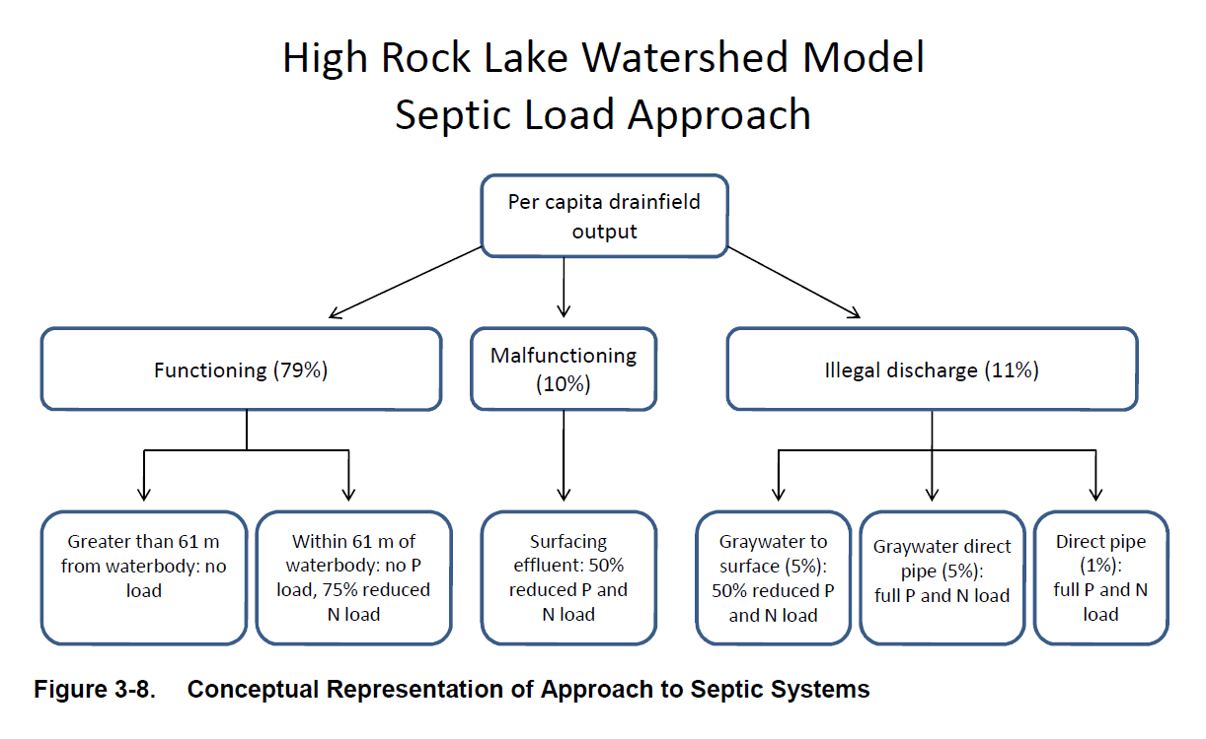
Tetra Tech summarized their approach to septic system nutrient loads as described below:
A septic system failure rate was assumed based upon literature and available data provided by NCDPH. For example, one literature source indicated a failure rate of 11.4 percent in North Carolina (NCDEH,2000). The county specific information gathered by DWQ and recommendations provided by NCDPH were also considered, resulting in a final estimated failure rate of 10 percent. The conceptual model shown in Figure 3-8 presents four situations in which septic loads will be represented in the model. Table 3-15 was used as a starting point for assigning water quality characteristics for septic loads. The model inputs are summarized in Table 3-16 along with comments to indicate assumptions. Moreover, key assumptions are summarized below.
- The percentages for determining loading conditions presented in Figure 3-8 were first applied to any census tract in the study area.
- Assumed failure rate of 10 percent.
- Assumed one percent of systems represent straight piping of wastewater effluent.
- Gray water, water that has been used in the home such as dish washing, shower, sink, and laundry. This excludes sanitary wastewater.
- Non-failing systems within 61 meters (200 feet) of a waterbody were assumed to have no delivered phosphorus load and nitrogen concentrations that were equivalent to 25 percent of soil water quality concentrations at 1.2 meters drainfield depth. The nitrogen was assumed to be all in the form of NO3.
- Surface failing septic systems within 61 meters (200 feet) of a waterbody were assumed to have concentrations that were equivalent to 50 percent of soil water quality concentrations at 0.6 meters drainfield depth (EPA, 2002).
- Direct straight pipe load was assumed to be equal to septic tank effluent concentrations as presented in Table 3-15.

Hydrologic Soil Groups
It is also important for septic systems to be installed in soils with a sufficient infiltration rate to ensure treatment of outflow. This requires a minimum infiltration rate based on soil porosity, and most soils in the High Rock Lake Watershed have moderate infiltration rates.
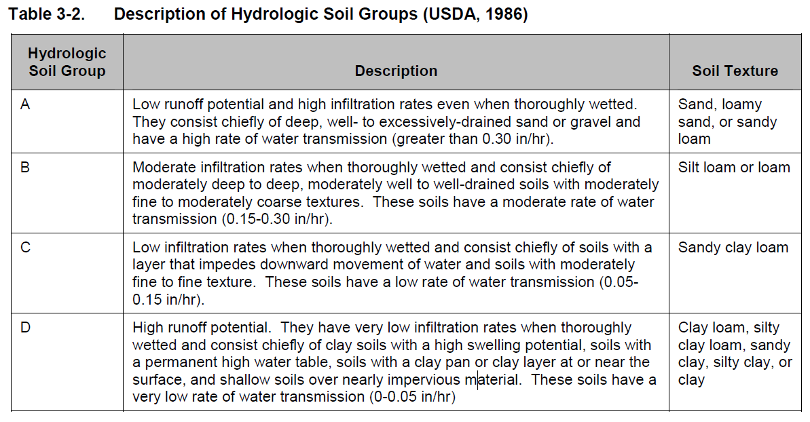

Most soils in the High Rock Lake Watershed are well draining B soils, and the low infiltration C soils are predominantly concentrated in the area around Winston-Salem, Lexington, High Point, and Salisbury, all of which are MS4-permitted communities. Additional C soils are located in the I-40 corridor between Mocksville and Bermuda Run, neither of which are MS4-permitted communities, and around High Rock Lake itself.

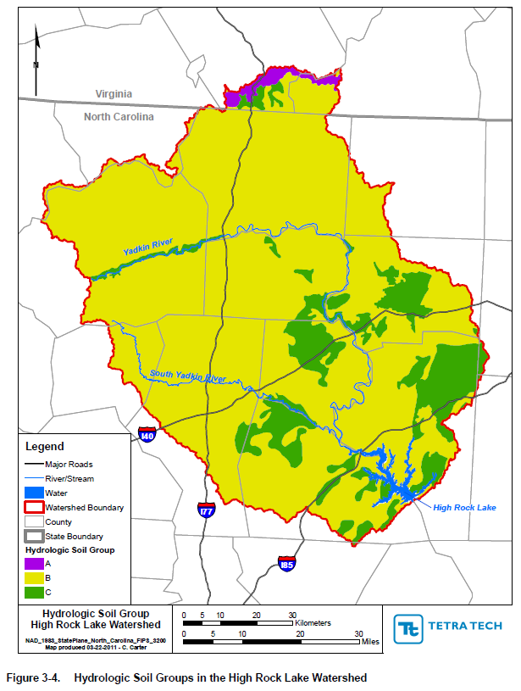

Statewide Regulatory Changes Since Baseline
In 2006, legislation passed that developed the North Carolina Onsite Wastewater Contractors and Inspectors Certification Board, an independent Occupational Licensure Board that administers the certification of septic tank system installers and Time-of-Sale Inspectors. There were no protocol or procedures in place prior to this legislation that qualified the persons installing septic tank systems or conducting time-of-sale inspections of existing septic tank systems at time of real estate transfer.
In 2015, legislation passed that established the Engineer Option Permit as an option for developers and homeowners in obtaining a permit for the installation or repair of onsite wastewater systems. Prior to this legislation, only the local environmental health departments within the counties, acting as authorized agents of the State were able to evaluate sites, design systems, or act as an agent of the owner.
In 2018, legislation passed that established a “hybrid” protocol for obtaining a permit from the Local Health Department. Under this hybrid, the owner hires a licensed soil scientist to do soil and site evaluations and then transfer the signed and sealed document to the LHD for continuation of the permitting process.
In 2019, the Authorized Onsite Wastewater Evaluator was created by Session Law. This requires a Licensed Soil Scientist to obtain another level of training and gives the Evaluator the ability to permit sites where non-engineered systems are mandated.
In 2021, 15A NCAC 18E wastewater rules were adopted which added private sector abilities to not only better expedite the turnaround of permits, but to also make sure there were better qualified professionals to conduct site evaluation.

Existing Development Rule Credit
Under the Falls Lake Nutrient Management Strategy, local governments are required to implement a load reduction program that provides estimates of, and plans for offsetting, nutrient loading increases from lands developed subsequent to the baseline period and not subject to the requirements of the New Development Stormwater rule. Certain jurisdictions are required to begin and continuously implement a program to reduce loading from discharging sand filters and malfunctioning septic systems discharging into waters of the State within those jurisdictions and subwatersheds. Credit is assigned for compliance according to the procedure specified in the “Catalog of Nutrient Reduction Practices For North Carolina”, which makes this project eligible for Existing Development rule credit statewide. Additionally, the EPA 319 program consistently funds septic system repair programs in various parts of the state.
Septic system maintenance and repair is currently governed by 15A NCAC 18A .1938, which makes clear that individual property owners must ensure their system is working correctly. Properly maintained septic systems generally have very high nitrogen removal efficiencies and remove 100% of generated phosphorus, and so there does not appear to be a need to change the process by which systems are sited or installed within a nutrient sensitive watershed. By contrast, a malfunctioning system acts as a point source of nitrogen, phosphorus, and pathogens, regardless of whether or not it has been installed in a nutrient sensitive watershed.
Factors that preclude property owners from ensuring proper septic system maintenance include financial capability and knowledge/awareness. Additional basin-scale regulatory mandates are unlikely to improve financial capability of property owners who already cannot afford to comply with regulatory obligations, and redundant requirements to maintain and/or repair are unlikely to significantly improve the rate at which owners do so. The EPA Phase NPDES MS4 Stormwater Program requires that local jurisdictions identify and eliminate elicit discharges, including from malfunctioning on-site wastewater systems. This program can be used to improve information sharing between individuals when property changes hands, as well as between tenants and landlords when tenants notice a problem with their system. There are currently 14 Phase I/II MS4 communities in the High Rock Lake Watershed, and these ongoing educational efforts are a valuable component of nutrient load reduction in the watershed.

