North Carolina Department of Environmental Quality
Division of Water Infrastructure
Fall 2022 Application for Funding
(Last updated: July 2022)

Grants and low-interest loans are available for drinking water and wastewater infrastructure construction, pre-construction planning, and study projects. Low-interest CWSRF loans are available for green projects such as stormwater quality infrastructure and stream restoration projects. The new Local Assistance for Stormwater Infrastructure Investments (LASII) grants are available for stormwater quality and stormwater quantity infrastructure construction projects, stormwater planning grant, and for developing and implementing a new stormwater utility. Complete this Application for Funding form and submit it along with required additional forms and documents to the Division of Water Infrastructure for consideration.

Fall 2022 application due date is September 30, 2022.

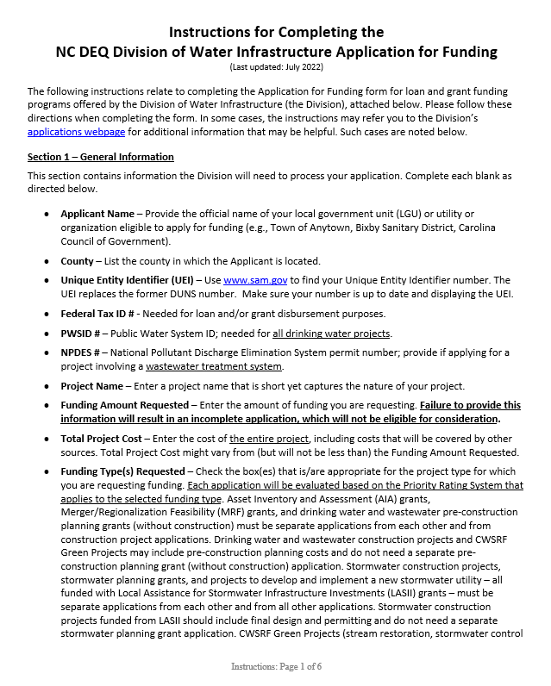 |  | 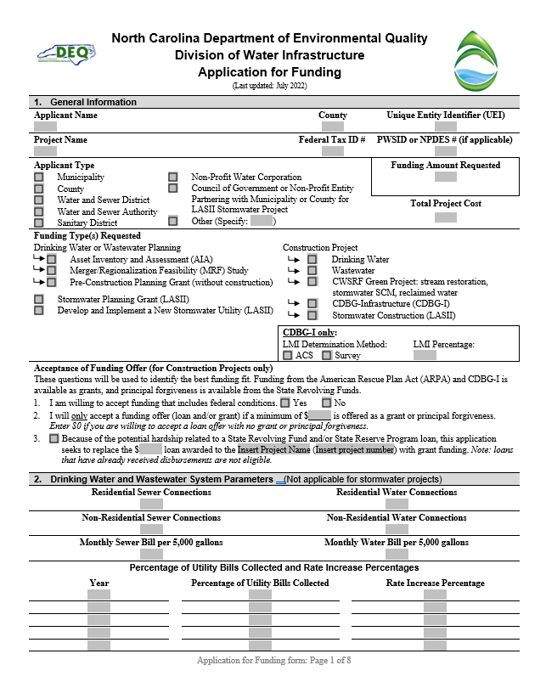
Instructions are enclosed. |  | Application form is attached after the Instructions.  Additional forms required for completing an application are available on the Division of Water Infrastructure’s application page.

(This page intentionally left blank)

Instructions for Completing the
NC DEQ Division of Water Infrastructure Application for Funding
(Last updated: July 2022)
The following instructions relate to completing the Application for Funding form for loan and grant funding programs offered by the Division of Water Infrastructure (the Division), attached below. Please follow these directions when completing the form. In some cases, the instructions may refer you to the Division’s applications webpage for additional information that may be helpful. Such cases are noted below.
Section 1 – General Information
This section contains information the Division will need to process your application. Complete each blank as directed below.
- Applicant Name – Provide the official name of your local government unit (LGU) or utility or organization eligible to apply for funding (e.g., Town of Anytown, Bixby Sanitary District, Carolina Council of Government).
- County – List the county in which the Applicant is located.
- Unique Entity Identifier (UEI) – Use www.sam.gov to find your Unique Entity Identifier number. The UEI replaces the former DUNS number. Make sure your number is up to date and displaying the UEI.
- Federal Tax ID # - Needed for loan and/or grant disbursement purposes.
- PWSID # – Public Water System ID; needed for all drinking water projects.
- NPDES # – National Pollutant Discharge Elimination System permit number; provide if applying for a project involving a wastewater treatment system.
- Project Name – Enter a project name that is short yet captures the nature of your project.
- Funding Amount Requested – Enter the amount of funding you are requesting. Failure to provide this information will result in an incomplete application, which will not be eligible for consideration.
- Total Project Cost – Enter the cost of the entire project, including costs that will be covered by other sources. Total Project Cost might vary from (but will not be less than) the Funding Amount Requested.
- Funding Type(s) Requested – Check the box(es) that is/are appropriate for the project type for which you are requesting funding. Each application will be evaluated based on the Priority Rating System that applies to the selected funding type. Asset Inventory and Assessment (AIA) grants, Merger/Regionalization Feasibility (MRF) grants, and drinking water and wastewater pre-construction planning grants (without construction) must be separate applications from each other and from construction project applications. Drinking water and wastewater construction projects and CWSRF Green Projects may include pre-construction planning costs and do not need a separate pre-construction planning grant (without construction) application. Stormwater construction projects, stormwater planning grants, and projects to develop and implement a new stormwater utility – all funded with Local Assistance for Stormwater Infrastructure Investments (LASII) grants – must be separate applications from each other and from all other applications. Stormwater construction projects funded from LASII should include final design and permitting and do not need a separate stormwater planning grant application. CWSRF Green Projects (stream restoration, stormwater control measures, reclaimed water) construction project applications will be reviewed according to the Priority Rating System for Wastewater Projects, not the Priority Rating System for Stormwater Construction.
- Acceptance of Funding Offer (for Construction Projects only) – Answer the questions as described below if applying for construction projects. Responses to these questions will determine for which funding program(s) the project is eligible.
- Answer this question as “Yes” if you are willing to take on funding that contains federal requirements and conditions.
- The Division may offer a combination of grants (or principal forgiveness) and/or low-interest loans to applicants. Enter the minimum amount you require in grant or principal forgiveness funding to accept any funding offer from the Division for this application. Enter $0 if you are willing to accept a loan-only offer. If the desired amount of grant funding is available, the Division will offer grant funding up to the full amount for which the applicant is eligible, including above the stated minimum request if applicable. Selecting a lower acceptable amount than what you may be eligible for does not reduce your potential grant offer if funds are available. Selecting too high of an acceptable amount risks the possibility of not being offered any funding if there are insufficient grant funds available to meet your desired minimum. If grant funding cannot be offered to meet your requested minimum, no funding offer (loan or grant) will be made.
For drinking water, wastewater, and CWSRF Green Project construction projects, and drinking water/wastewater pre-construction planning grants, provide a copy of the Affordability Calculator (available on the Division’s application page) or handwritten affordability calculations as part of the application package.
- While American Rescue Plan Act (ARPA) State Fiscal Recovery Fund grants are available for Distressed and At-Risk drinking water and wastewater utilities, Distressed and At-Risk applicants that have already been awarded a State Revolving Fund loan and/or State Reserve Program loan for a construction project may apply for a grant to replace the loan portion of the existing project. Projects that have already received loan disbursements are not eligible. If the application project is an existing project with an awarded loan but has not yet received disbursements, check this box, provide the amount of the awarded loan, the project name, and the project number, and complete the rest of the application for the construction project. The application will be reviewed among all other applications. The score sheet of the project’s previous application that received a loan award is available upon request to assist with completing this application.
Section 2 – Drinking Water and Wastewater System Parameters (not applicable for stormwater projects)
This section contains information related to drinking water and wastewater system parameters, which is used across all programs except for the stormwater funding program (LASII). Please complete all blanks unless otherwise noted.
- Residential and Non-Residential Sewer and Water Connections – Follow the guidance found in Line Item 4.A of the Priority Rating System Guidance and Form for Division of Water Infrastructure Construction Funding Programs (Priority Rating System guidance, available on the Division’s application page). For wastewater applications, count only sewer connections. For drinking water applications, count only drinking water connections. Include only existing connections; do not include number of new connections resulting from the project.
- Monthly Sewer and Water Bills per 5,000 gallons – If your system offers it, provide the monthly bills for 5,000 gallons per month of use for both sewer and water. These rates are (1) used to calculate Line Item 3.B operating ratio eligibility via rates to median household income; (2) used to determine points in Line Item 4.B; and (3) used to determine grant or principal forgiveness eligibility for some funding programs. See Line Item 4.B in the Priority Rating System for Drinking Water/Wastewater guidance for more information about what is needed for this parameter.
Sections 3, 4, and 5 – Applicant, Application Preparer, and Engineer Contact Information
Complete this section with all pertinent information. The following bullet points contain specific information.
- Authorized Representative Name – This name must match the name listed on the Resolution by Governing Body of Applicant as the Authorized Representative.
- Mailing Addresses – Provide the mailing address where the Applicant, Preparer, and Engineer receive mail. For example, if you have a PO Box, provide this information rather than your physical address.
Note: Zip codes between PO Boxes and physical addresses may vary. If using a PO Box to receive mail, use the zip code that matches the PO Box.

- Engineer Contact Information – If your Application Preparer is the same as the Engineer Contact, check the No box. Section 5 may then be left blank. If the answer is Yes, provide the appropriate information.
Section 6 – Project Description
In this section, provide a brief description of the proposed project in a broad level of detail. Include the project purpose and what the project entails. For example: rehabilitation of 2,000 l.f. of sewer, construction of a new well, stream restoration, construction of a new stormwater control measure, conducting an asset inventory and assessment of the water system in the southwestern district, connecting 104 residences in a disadvantaged area to the water system along Orchard St., repair culverts along Main Street to reduce flooding that affect Community Heart Hospital, evaluating the potential for a merger with a neighboring system, developing and implementing a new stormwater utility with a stormwater enterprise fund using LASII grants, etc. Include information such as types of equipment to be included, capacity of equipment, estimates of line length, street names for sewer or waterline or stormwater piping work, and/or neighborhoods or areas where work will occur or benefits will accrue. Descriptions of the work related to the major line items in the Project Budget (Sections 8a, 8b, and 8c) must be included in the project description. For example, if 2,000 l.f. of 4-inch, 3,000 l.f. of 6-inch, 4,000 l.f. of 8-inch pipe, and a stormwater control measure are listed in the project budget, they must be listed in the project description.
For drinking water and wastewater projects, expenses such as pre-construction expenses, rate studies, and training may be included in construction projects. Rate studies and training may also be included with AIA and MRF grant applications. If any of these items are part of the project, please include in the project description and specify how they are directly related to the construction or study project. For training, reimbursement will occur only for registration and mileage costs.
For stormwater projects, if the Applicant is a Council of Government or a nonprofit entity partnering with a Municipality or County, the Applicant must identify the Municipalities and/or Counties that are partners on the project. Describe the project, location of the project work, the beneficiaries of the project, and the nature of the partnership between the Applicant and the Municipalities/Counties, including the roles and responsibilities of all partners and whether there is an agreement between the Municipalities/Counties and the Applicant to conduct this project.
If the project is a regional project that involves two or more partners, such as two or more units of local government, identify all of the partners, describe the project and its location, the beneficiaries of the project, how the project is being co-funded (if applicable), and the nature of the partnership between all partners, including the roles and responsibilities of all partners. Identify whether the partners have interlocal agreement(s) or begun discussions on an agreement for the project.
If your drinking water or wastewater or CDBG-I construction project will add new connections to the water and/or wastewater system (or to a decentralized system owned, operated, and maintained by the public utility), please estimate the number of new connections in this section.
For drinking water, wastewater, CDBG-I, CWSRF Green Projects, and pre-construction planning grants only: check the appropriate box(es) if the project is a result of a study grant (Asset Inventory and Assessment grant and/or Merger/Regionalization Feasibility grant) previously awarded by the Division. If neither is the case, check None of the Above.
Section 7 – Additional Information for Consideration
In some situations, a construction project’s purpose might not be listed as eligible for points under Category 1 – Project Purpose of the relevant construction projects’ Priority Rating System. In these situations, you may use the Supplemental Guidance for the Ranking of Applications and Providing Additional Information for Consideration found on the Division’s application page. Please note the following related to this section:
- This section does not apply to the Drinking Water State Revolving Fund program.
- Information for this section must fit into the space provided.
Section 8 – Project Budget
Complete the project budget for your project as discussed in Section 8a, Section 8b, and Section 8c.
Complete Section 8a for all construction projects (including stormwater construction) and for drinking water and wastewater pre-construction planning grants. If the project includes related training and/or rate study costs, include those in Section 8b.
Complete Section 8b for Asset Inventory and Assessment grants, Merger/Regionalization Feasibility grants, and training and/or rate study components to drinking water or wastewater projects.
Complete Section 8c for stormwater planning grants from LASII, and for projects to develop and implement a new stormwater utility.
Section 8a – Project Budget for All Construction Projects (including Stormwater) and Pre-Construction Planning Grants Only
Complete the project budget by addressing the categories provided in the table (insert rows as needed). Total the cost amount for each line and provide the total cost amount. Please note the following related to this section:
- Project budget is required for construction projects and pre-construction planning grants.
- If applying only for a pre-construction planning grant (without construction), complete the Engineering Costs and Administration Costs sections of the budget.
- If applying for a construction project, include the pre-construction planning costs in the budget. Final design and permitting costs are eligible as pre-construction costs for stormwater construction projects. You do not need to apply for a separate pre-construction planning grant or stormwater planning grant.
- Note the instructions at the top of Section 8a about separating costs and labeling them to show portions of the project costs that are attributable to certain factors, such as cost components for disadvantaged areas vs. non-disadvantaged areas, stormwater quantity vs. stormwater quality, and replacement/rehabilitation of lead service lines and older water/sewer lines vs. newer lines. This can be done by adding additional lines to the project budget (e.g.: 1) construction of 720 linear feet of waterline extensions in disadvantaged areas, and 2) 300 linear feet of waterline extensions in non-disadvantaged areas). You may also add additional columns for the sole purpose of separating and labeling costs as required at the top of Section 8a.
- If your project will connect residences in disadvantaged areas that voluntarily choose to connect to the water or wastewater systems (including for CDBG-I projects), complete the Compensation for Connection Fees and System Development Fees line.
- The project budget must be signed and sealed by a properly licensed Professional Engineer (PE). If you do not provide a PE signature and seal on the budget, the application will be incomplete and not considered for funding.
Section 8b – Project Budget for AIA and MRF Grants, and Training and/or Rate Study Components to Drinking Water or Wastewater Projects (Not applicable for Drinking Water/Wastewater Pre-Construction Planning Grants or any type of LASII stormwater projects)
Provide basic aspects of the AIA or MRF study costs. For example, if applying for an AIA grant, some budget items might include the following: (1) mapping of collection system, (2) condition assessment, and (3) grant administration. Note: AIA and MRF applications must be separate applications from each other and from construction projects.
Training and/or rate studies may be components of a drinking water/wastewater construction project, pre-construction planning grant, AIA, and/or MRF project. If so, specify the training and/or rate study costs in this section (and exclude from Section 8a, if applicable). Training and rate studies must be related to the project. Training is limited to $2,000 per applicant and covers registration and mileage costs for governing board officials and utility staff. Training and/or rate studies for stormwater projects should not be included in this section unless applying for a CWSRF Green Project.
Section 8c – Project Budget for Stormwater Planning Grants (LASII) and Projects to Develop and Implement a New Stormwater Utility (LASII)
List each activity that will be undertaken in the stormwater planning study and/or in the development and implementation of a new stormwater utility (keeping them separate), and provide their associated costs.
Certification by Authorized Representative
The Authorized Representative must read and initial in the space beside each question, or use “N/A”.
Completeness Checklist
When putting together the application package, initial to show that the information is in the package, if applicable. Failure to include or properly document an item marked with * will result in the application being incomplete and ineligible for consideration of funding. Forms are available separately on the Division’s application page.
Submittal Information
- Applications must be submitted electronically no later than 5:00 pm on Friday, September 30.
- Submit the application electronically at: https://edocs.deq.nc.gov/Forms/OPA-ARPA.
- Follow the directions as shown on the form on the website.
- Complete the required fields, almost all of which can be found directly from this Application for Funding form.
- Upload each required document (e.g. completed Application for Funding form, Resolution by Governing Body, Narrative to Claim Points, etc.) individually; do not upload a single file with the entire application package. Combine all documentation to support the narrative in claiming points into one file before uploading. Individual file sizes must be limited to 250 MB.
- Uploading files may take several minutes and may be slow during high volume periods. It is strongly encouraged to submit applications several days before the application due date to avoid technical difficulties.
- Once you have submitted your application online, you should receive a confirmation email.
- Online submittal of the application package is sufficient for all applications except for CDBG-Infrastructure applications. For CDBG-I applications only, please submit a hard copy of the application to the Division in addition to the application submitted online.
Application Signature
The Authorized Representation, who is named in the Resolution by Governing Body of Applicant, must sign the application. An application without this signature is incomplete and will not be eligible for consideration.

 | North Carolina Department of Environmental Quality
 | Division of Water Infrastructure
 | Application for Funding
 | (Last updated: July 2022)
- General Information
Applicant Name |  |  |  |  |  |  | County |  |  | Unique Entity Identifier (UEI)
Project Name |  |  |  |  |  |  | Federal Tax ID # |  |  | PWSID or NPDES # (if applicable)
Applicant Type |  |  |  |  |  |  |  |  |  | Funding Amount Requested
Municipality  County  Water and Sewer District  Water and Sewer Authority  Sanitary District |  | Non-Profit Water Corporation  Council of Government or Non-Profit Entity Partnering with Municipality or County for LASII Stormwater Project  Other (Specify: )
 |  |  |  |  |  |  |  |  |  | Total Project Cost
Funding Type(s) Requested
Drinking Water or Wastewater Planning  Asset Inventory and Assessment (AIA)  Merger/Regionalization Feasibility (MRF) Study  Pre-Construction Planning Grant (without construction)  Stormwater Planning Grant (LASII)  Develop and Implement a New Stormwater Utility (LASII) |  |  |  |  |  | Construction Project  Drinking Water  Wastewater  CWSRF Green Project: stream restoration, stormwater SCM, reclaimed water  CDBG-Infrastructure (CDBG-I)  Stormwater Construction (LASII)
 |  |  |  |  |  | CDBG-I only:  LMI Determination Method:  ACS Survey |  |  |  |  | LMI Percentage:
Acceptance of Funding Offer (for Construction Projects only)
These questions will be used to identify the best funding fit. Funding from the American Rescue Plan Act (ARPA) and CDBG-I is available as grants, and principal forgiveness is available from the State Revolving Funds.
- I am willing to accept funding that includes federal conditions. Yes No
- I will only accept a funding offer (loan and/or grant) if a minimum of $ is offered as a grant or principal forgiveness. Enter $0 if you are willing to accept a loan offer with no grant or principal forgiveness.
- Because of the potential hardship related to a State Revolving Fund and/or State Reserve Program loan, this application seeks to replace the $ loan awarded to the Insert Project Name (Insert project number) with grant funding. Note: loans that have already received disbursements are not eligible.

- Drinking Water and Wastewater System Parameters (Not applicable for stormwater projects)
Residential Sewer Connections |  |  |  |  | Residential Water Connections
Non-Residential Sewer Connections |  |  |  |  | Non-Residential Water Connections
Monthly Sewer Bill per 5,000 gallons |  |  |  |  | Monthly Water Bill per 5,000 gallons
Percentage of Utility Bills Collected and Rate Increase Percentages

Year |  |  |  | Percentage of Utility Bills Collected |  |  |  |  | Rate Increase Percentage

- Applicant Contact Information
Authorized Representative Name:
Authorized Representative Title:
Mailing Address Line 1:
Mailing Address Line 2:
City:
State:
Zip Code:
Physical Address Line 1:
Physical Address Line 2:
Physical Address City:
Physical Address State:
Physical Address Zip Code:
Phone Number:
Email Address:
- Application Preparer Contact Information
Firm Name:
Contact Name:
Mailing Address Line 1:
Mailing Address Line 2:
City:
State:
Zip Code:
Physical Address Line 1:
Physical Address Line 2:
Physical Address City:
Physical Address State:
Physical Address Zip Code:
Phone Number:
Email Address:
- Engineer Contact Information
Is the engineering firm different from the application preparer? | Yes No
Engineering Firm Name:
Contact Name:
Mailing Address 1:
Mailing Address 2:
City:
State:
Zip Code:
Physical Address Line 1:
Physical Address Line 2:
Physical Address City:
Physical Address State:
Physical Address Zip Code:
Phone Number:
Email Address:

- Project Description (see Instructions)
Estimated number of new connections served by Drinking Water or Wastewater construction project:
For Drinking Water and Wastewater Construction, CDBG-I, CWSRF Green Projects, Pre-Construction Planning Grants:
The proposed project is a result of an Asset Inventory and Assessment grant previously awarded by the Division.
The proposed project is a result of a Merger / Regionalization Feasibility Study grant previously awarded by the Division.
None of the above.

- Additional Information for Consideration
8a. Project Budget for All Construction Projects and Drinking Water/Wastewater Pre-Construction Planning Grants only. Do not use for AIA, MRF, Stormwater Planning Grant (LASII), or Develop and Implement a New Stormwater Utility (LASII) projects.
- Drinking Water/Wastewater: Costs for portions of the project that will fulfill the requirements related to rehabilitating or replacing waterlines, old infrastructure, lead service lines (DW/WW Priority Rating System Line Items 1.C, 1.C.1 or 1.D.1) must be labeled and shown separately to successfully claim points.
- Stormwater: Costs for stormwater quality project components and costs for stormwater quantity project components (Stormwater Priority Rating System Line Items 1.A or 1.C), must be labeled and shown separately to successfully claim points.
- All: Costs for portions of the project that will benefit disadvantaged areas (DW/WW Priority Rating System Line Items 1.E or 4.D, Stormwater Priority Rating System Line Item 4.C) must be labeled and shown separately to successfully claim points.
- Add additional lines as needed.
Indicate construction costs by line item (e.g., linear feet of different-sized lines, each type of stormwater control measure, each stream restoration/enhancement/stabilization reach). Include a more detailed construction cost budget if needed. | Division Funding Requested | Other Secured Funding Source(s) | Total Cost Amount
Construction Costs
Contingency (10% of construction costs):
Construction Subtotal:
Engineering Costs
Engineering Design
Permitting
Land Surveying Costs
Other:
Engineering Subtotal:
Administration Costs
Planning (pre-construction costs)
Easement Preparation
Engineering Report Preparation
Environmental Documentation Preparation (if applicable)
Legal Costs
Compensation for Water/Wastewater Connection Fees and System Development Fees that will not be charged after connecting residences in disadvantaged areas (if applicable)
Project Funding Administration (if applicable)
Other:
Administration Subtotal:
TOTAL PROJECT COST:
A Professional Engineer signature and seal for the estimate must be provided in the space to the right for the application to be considered complete.

8b. Project Budget for AIA and MRF Grants, and Training and/or Rate Study Components to Drinking Water or Wastewater Projects. Do not use for Pre-Construction Planning Grants, or any type of LASII Stormwater project.
Add additional lines as needed.
Division Funding Requested
TOTAL DIVISION FUNDING REQUESTED:

8c. Project Budget for Stormwater Planning Grant (LASII) and Grant to Develop and Implement a New Stormwater Utility (LASII). Do not use for any other project type, including stormwater construction (LASII).
- If the application includes a request for funds to both Develop and Implement a New Stormwater Utility and other Stormwater Planning work, the budget shown below must be labeled and shown separately.
- Add additional lines as needed.
Division Funding Requested
TOTAL DIVISION FUNDING REQUESTED FOR STORMWATER PLANNING GRANT (LASII):
TOTAL DIVISION FUNDING REQUESTED TO DEVELOP AND IMPLEMENT A NEW STORMWATER UTILITY (LASII):

Certification by Authorized Representative
The attached statements and exhibits are hereby made part of this application, and the undersigned representative of the Applicant certifies that the information in this application and the attached statements and exhibits are true, correct, and complete to the best of his/her knowledge and belief. By initialing each item and signature at the end of this application, he/she further certifies that:

_______ | - as Authorized Representative, he/she has been authorized to file this application by formal action of the governing body;
_______ | - the governing body agrees to provide for proper short-term and long-term maintenance and operation of the approved project after its completion;
_______ | - the Applicant has substantially complied with or will comply with all federal, state, and local laws, rules, and regulations and ordinances as applicable to this project;
_______ | - the Applicant will adopt and place into effect on or before the completion of the project a schedule of fees and charges which will provide for the adequate and proper operation, maintenance, and administration and repayment of all principal and interest on loans (if applicable) of the project [if not applicable, initial “N/A”];
_______ | - the Applicant has followed proper accounting and fiscal reporting procedures, as evidenced by the Applicant’s most recent audit report, and that the Applicant is in substantial compliance with provision of the general fiscal control laws of the State;
_______ | - the Project Budget for all construction projects and pre-construction planning grants provided in this application form (Section 8a, if applicable) includes all funding requested from all sources of funding proposed for this project;
_______ | - the (Town or County), North Carolina is organized and chartered under the laws of North Carolina, or the special purpose unit of local government is incorporated under the laws of North Carolina. All officials and employees are aware of, and in full compliance with NCGS 14-234, “Public officers or employees benefiting from public contracts; exceptions.” (For units of local government only. All others should initial “N/A”);
______ | - the Applicant acknowledges that all loans and Viable Utility Reserve grants are subject to approval by the Local Government Commission (not applicable for CDBG-I or stormwater projects);
______ | - the Applicant acknowledges that if the application is for a drinking water or wastewater project and any one of the local government units involved in the project is designated as distressed by the State Water Infrastructure Authority and the Local Government Commission, the local government unit(s) must complete the viable utility requirements in NCGS 159G-45(b) by conducting an asset assessment and rate study, participate in a training program, and develop a short-term and long-term action plan considering infrastructure repair, maintenance, and management, continuing education, and long-term financial management plan. Additional conditions may be imposed on the local government(s) designated as distressed by the State Water Infrastructure Authority and/or the Local Government Commission. (Initial “N/A” if does not apply to project type or all local governments involved in the project).
_______ | - the Applicant acknowledges that, in accordance with G.S. 120-157.2, for local government debt to be issued greater than $1,000,000, the local government must report to Committee Chairs, Committee Assistant, and the Fiscal Research Division of the General Assembly at least 45 days prior to presentation before the Local Government Commission (For units of local government only. All others, and CDBG-I and stormwater (LASII) applicants should initial “N/A”); and
_______ | - if the Applicant receives a grant with American Rescue Plan Act (ARPA) State Fiscal Recovery Funds, the Applicant acknowledges and accepts the following conditions:  - all ARPA project funds must be reimbursed by December 31, 2026;  - project funds will not be used to pay existing debt or as a match for other federal funds;  - if the project is also funded with other federal funds, the federal requirements of the other funds will apply to the ARPA funds; and  - for projects receiving ten million dollars or more in ARPA funding: recipients must certify or provide plans and reports meeting federal requirements on reporting on prevailing wage rates, project labor agreements, and related information as specified in the U.S. Treasury’s Compliance and Reporting Guidance for the State and Local Fiscal Recovery Funds.

Completeness Checklist
In addition to this application, the following items must be included in the application package to be eligible or to successfully claim priority points. Failure to include or properly document an item marked with * will result in an incomplete and ineligible application which will not be considered for funding. Please initial that each item is included in this submittal. If not applicable for the project, please initial “N/A”.

______ | Resolution by Governing Body of Applicant with Certification by Recording Officer * †
______ | Resolution by Governing Body of Applicant to Develop and Implement a Stormwater Utility with a Stormwater Enterprise Fund * † [for ‘Develop and Implement a New Stormwater Utility’ project only; replaces “Resolution by Governing Body of Applicant with Certification by Recording Officer” above]
______ | Comprehensive Narrative to Claim Points in the Priority Rating System *
______ | Documentation to Support the Comprehensive Narratives, including maps or images as needed
______ | Applicable Priority Rating System Form to Claim Points † [for Construction Projects and Pre-Construction Planning Grants only]
______ | Affordability Calculator † or handwritten affordability calculations [not applicable to CDBG-I, AIA, MRF, or stormwater projects (LASII)]
______ | Fund Transfer Certification with appropriate box checked * † [not applicable to CDBG-I or stormwater projects (LASII)]
______ | Water & Sewer Financial Information Form † [not applicable to stormwater projects (LASII)]
______ | Commitment of Other Funds Form, Low to Moderate Income Documentation, and Federal Compliance Documents* † [for CDBG-I applications only]
______ | Stormwater Entity Eligibility Certification Form * † [for stormwater projects (LASII) only]
______ | Current rate sheets and NC Water & Sewer Rate Form† in effect on application deadline (for both water and sewer if the utility provides both water and sewer, or for water or sewer depending on the utility service) [not applicable to stormwater projects (LASII)]
______ | Current stormwater fees in effect on application deadline [for stormwater projects (LASII) only if fees apply]
______ | PE Seal on Project Budget * [for Construction Projects and Pre-Construction Planning Grants only]
* Required in the application package. Failure to include or properly document will result in an incomplete and ineligible application which will not be considered for funding.
† Forms and templates are available separately on the Division’s application webpage.

Submittal Information
All application packages must be submitted electronically at https://edocs.deq.nc.gov/Forms/OPA-ARPA

See Instructions on completing the form online.

Online submittal of the application package is sufficient for all applications, except for CDBG-Infrastructure applications.

For CDBG-Infrastructure applications only: in addition to submitting the application package electronically at the link above, you must send one (1) original hard copy* of the application package to:

Mailing Address† (US Postal Service only) |  |  | Physical Address (FedEx, UPS)‡
Division of Water Infrastructure  1633 Mail Service Center  Raleigh, NC 27699-1633 |  |  | Division of Water Infrastructure – 8th Floor, Archdale Building  512 North Salisbury Street  Raleigh, NC 27604  919.707.9160
* Provide a hard copy that is bound (e.g., report cover with fasteners, plastic report combs, spiral or 3-ring binders). No paper clips, staples or binder clasps.
† Please allow two weeks for delivery if mailing via the US Postal Service.
‡ For all courier services, please use the physical address, as having a courier deliver to the mailing address will delay package delivery.

Application Signature
Original signature is required for the application.
Application with no signature is incomplete and ineligible for consideration.
SIGNATURE OF AUTHORIZED REPRESENTATIVE
 | , |  |  | ,
TYPED NAME |  | TYPED TITLE |  |  | DATE

