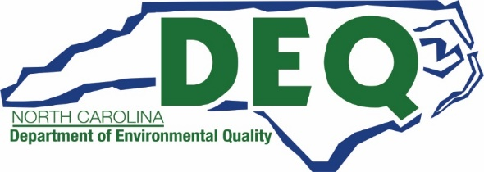

Project Quarterly Report

INSTRUCTIONS:
Awardees are required to submit quarterly reports on March 31, June 30, September 30, and December 31 for the 3-month period immediately preceding each of these dates until a contract is closed out. Indicate below the reporting period for which this report is being submitted and complete all sections of this this form for the selected reporting period.

Part I: General Information
Project Title:
Organization Name:
Agreement/Contract Number:

Quarterly Reporting Period | ☐ January 1 - March 31, 2021  ☐ April 1 – June 30, 2021  ☐ July 1 - September 30, 2021  ☐ October 1 - December 31, 2021

Part II: Quarterly Report
What specific tasks have been completed during the reporting period?

Did any public relations events regarding your awarded project take place during the reporting period? If so, please describe the events.
If milestones and timelines were not met, why not? Did you encounter any challenges during the reporting period which may interfere with meeting the project objectives?
How do you propose to remedy any challenges? Can NCDEQ be of any help to remedy any challenges you may be having?
Any additional question or comments?

Part III: Certification
I hereby affirm, under penalty of law, that the information provided here is true and correct to the best of my knowledge.
Signature
Print Name |  | Date

Part IV: Submission
Please email this completed form and any supporting documentation to your project manager listed here:

School Bus Program Sheila.Blanchard@ncdenr.gov

Onroad/Offroad/DERA Programs Jill.Vitas@ncdenr.gov

Transit Program Melanie.Henderson@ncdenr.gov

DC Fast Program Dave.Willis@ncdenr.gov

Level 2 Program Steven.Rice@ncdenr.gov

