The Rachel Carson Reserve Habitat Resilience Plan
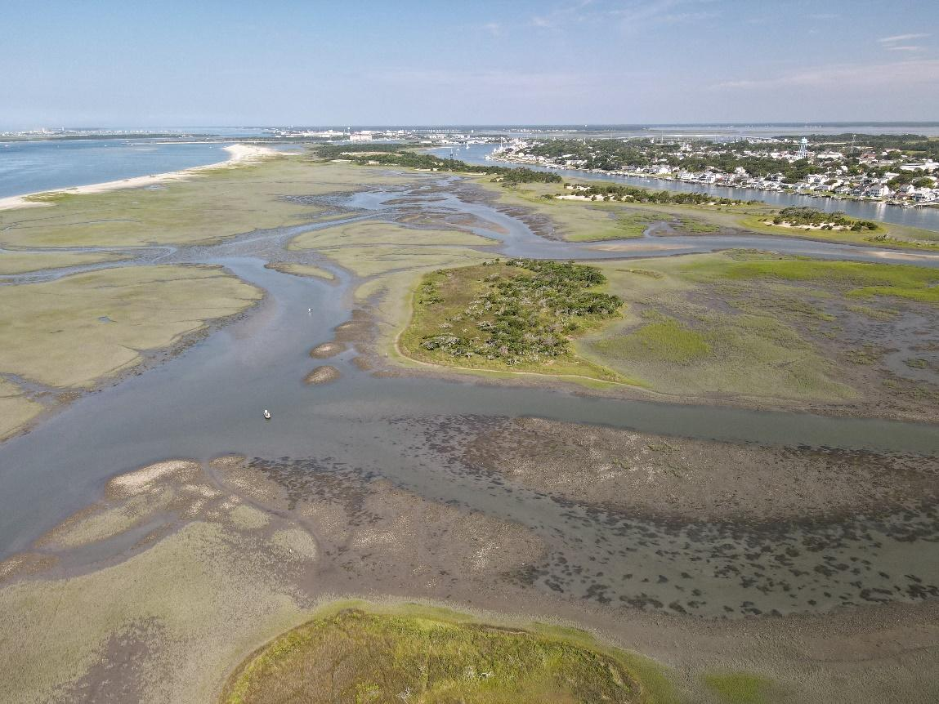
North Carolina Coastal Reserve and National Estuarine Research Reserve

NC Division of Coastal Management
December 2024
Table of Contents

Executive Summary
Introduction 1
Background 2
Geographic Setting 3
Ecosystem and Community Vulnerability 4
A Vulnerable Historic Town 10
Other NC Resilience Initiatives 11
Methodology for Plan Development 13
Plan Component I: Knowledge Base 13
Plan Component II: Habitat Resilience Strategic Plan 14
Plan Component III: Risk and Vulnerability Assessment 19
Plan Component IV: Partner Engagement 25
Plan Component V: Prioritization of Threat Interventions Using
“Resist-Accept-Direct” Framework 26
Next Steps 27
Acknowledgements 27
References 29
APPENDIX 1: Habitats and protected species of the Rachel Carson Reserve 31
APPENDIX 2: Research Needs at the Rachel Carson Reserve 32
APPENDIX 3: Partner Meeting Intervention Summary by Geography and Threat 33

List of Figures and Tables

Figure 1: Relative sea level rise trend at the Beaufort tidal station from 1953 to 2020 2
Figure 2: Rachel Carson Reserve Boundary Map 3
Figures 3a, 3b, 3c, & 3d: Habitat change at the RCR, 1986-2020 6-8
Figure 4: Shoreline change at Bird Shoal, 1958-2020 9
Figure 5: Changes in the width of the Beaufort Inlet from 1942 to 2020 10
Figure 6: Overview of the planning process 13
Figure 7: The Rachel Carson Reserve (boundary = green outline) broken down into discrete areas (blue outline) with ecological and social/economic uses or reasons of importance noted by icons. 21
Figure 8. Consolidated geographic areas with ecological and social/economic uses. 23
Figure 9. Vulnerability matrix 24
Figure 10. Summary of geographic areas and threats for partner input. 25
Figure 11. Summary of prioritized intervention actions 27

List of Terms
- APNEP – Albemarle-Pamlico National Estuary Program
- CAMA – Coastal Area Management Act
- CCVATCH – Climate Change Vulnerability Assessment Tool for Coastal Habitats
- CHPP – Coastal Habitat Protection Plan
- DCM – Division of Coastal Management
- DEQ – Department of Environmental Quality
- EO80 – Executive Order 80
- IPCC – Intergovernmental Panel on Climate Change
- NCNERR – North Carolina National Estuarine Research Reserve
- NERRA – National Estuarine Research Reserve Association
- NERRS – National Estuarine Research Reserve System
- NFWF – National Fish and Wildlife Foundation
- NOAA – National Oceanic and Atmospheric Administration
- NWL – Natural and Working Lands
- OCM – Office for Coastal Management
- RAD – Resist, Accept, Direct
- RCCP – Resilient Coastal Communities Program
- RCR – Rachel Carson Reserve
- SAV – submerged aquatic vegetation
- SLR – sea level rise
- USACE – United States Army Corps of Engineers

EXECUTIVE SUMMARY

The Rachel Carson Reserve (RCR) is one of four components of the North Carolina National Estuarine Research Reserve, which protects approximately 10,500 acres of estuarine habitats in coastal North Carolina for the purposes of research and education. The RCR component is a 2,315-acre complex of islands located near Beaufort, North Carolina. Stewardship of the site includes protecting and restoring the natural integrity of the site to ensure suitable environments for research and education.
A recreational and economic mainstay for the Town of Beaufort, the RCR lies between the town’s historic waterfront and the path to the Atlantic Ocean through the Beaufort Inlet. Its primary purpose is to provide a suitable environment for research and education and to support coastal and estuarine species and habitats of environmental, economic, and traditional use value. Inherently, stewardship of the site in its natural state helps to protect Beaufort and its waterfront businesses and population from damaging wave energy associated with the inlet and storms. However, environmental conditions associated with climate stressors and the widening of Beaufort Inlet have led to rapid and noticeable habitat changes, signaling the need for a plan to address habitat resilience and community protection. With support from the National Fish and Wildlife Foundation and the North Carolina General Assembly, Reserve staff and local partners engaged in a collaborative process to develop this Habitat Resilience Plan (“the Plan”). The Plan will be executed with consideration of the balance between the vulnerability of the Town of Beaufort and its need for protection, the vulnerability of the habitats of the Reserve, and letting nature take its course. The Plan details actions that correspond to each of the Reserve’s four program areas: research, education, coastal training, and stewardship. The Plan also identifies priority resilience-enhancing projects that may be implemented through the capacity of the Reserve and its partners.

Project Leadership Team (NCNERR)
- Grace Roskar, Natural Resources Resilience Specialist*
- Paula Gillikin, Central Sites Manager
- Rebecca Ellin, Program Manager
- Brandon Puckett, Research Coordinator*
- Whitney Jenkins, Coastal Training Program Coordinator
- Hope Sutton, Stewardship Coordinator*

* = By the time of Plan publication, Grace Roskar, Brandon Puckett and Hope Sutton moved to positions with NOAA Fisheries, National Centers for Coastal and Ocean Science and N.C. Wildlife Resources Commission, respectively.

Resilience Planning Partners
- Carteret County Shoreline Protection Office
- Duke University
- East Carolina University
- Kris Bass Engineering
- Moffatt & Nichol
- National Park Service Cape Lookout National Seashore
- NC Audubon Society
- NC Coastal Federation
- NC Division of Marine Fisheries
- NC Division of Coastal Management
- NC Natural Heritage Program
- NC Sea Grant
- NC State University
- NC Wildlife Resources Commission
- NOAA's Center for Coastal Ocean Studies
- Town of Beaufort
- University of North Carolina Institute of Marine Sciences
- US Army Corps of Engineers

INTRODUCTION
The North Carolina Climate Risk Assessment and Resilience Plan defines resilience as “the capacity of individuals, a community, business, or natural environment to prevent, withstand, respond to, and recover from a disruption.” Resilience planning has been propelled to the forefront of state and local priorities due to the increasing vulnerability of coastal communities and ecosystems to climate change. Sea level rise is already occurring in many coastal areas, with increases of around 11-19 inches in the next 30 years expected along the southeastern U.S., which will amplify the threats of erosion and flooding, and extreme storms like Hurricane Florence (2018) have already delivered record-breaking rainfall and flooding, causing widespread damage and destruction.
The state of North Carolina faces a wide range of climate threats due to its breadth of habitats across its three physiographic regions (Mountains, Piedmont, and Coastal Plain). At the coast, North Carolina faces numerous threats on both land and sea, with sea level rise (SLR), extreme storms, changing air and water temperatures, and habitat loss chiefly among them. Amplification of these threats in the last few decades has resulted in several studies and reports documenting such changes and predicting future changes at both national and statewide levels. For example, North Carolina published a Sea Level Rise Assessment report in 2010 with an update in 2015 and 2024⁴ published SLR rates from tidal stations and greenhouse gas emission scenario projections by the Intergovernmental Panel on Climate Change (IPCC) were used to predict relative SLR scenarios over the next 30 years to 2045, which ranged from an average of 2.4 inches to 8.1 inches, depending on the scenario and station location.
The North Carolina Climate Science Report, published in 2020, also used IPCC scenarios to make predictions about temperature, precipitation, and sea level rise across the state and provided qualitative confidence estimates about such projections. The report revealed that it is very likely that temperatures in the state will significantly increase in all seasons and likely that annual total precipitation will increase for the state. For the Coastal Plain region, it was predicted with medium to high confidence that the intensity of strong hurricanes will increase in the future. Moreover, there was also medium to high confidence that there will be an increase in the likelihood of damaging storm surge and severe winds accompanying hurricanes in the future. Under relative SLR projections, it was predicted that flooding associated with high tides under fair weather (also known as “high tide flooding”) could occur as often as one out of every two days from 2050 to 2060, and every day towards the end of the century (~2080). For Beaufort, these high tide flooding events would lead to water levels 1.8 ft above the present Mean Higher High Water levels.

According to 2022 projections of sea level rise by NOAA, an average of 10-14 inches of sea level rise is predicted in the next 30 years for the east coast of the U.S. At the Beaufort tidal station, which is located at the Duke University Marine Laboratory, the relative sea level rise trend was 3.29 mm/yr from 1953 to 2020 (Figure 1), which is equivalent to a change of 1.08 ft in 100 years.
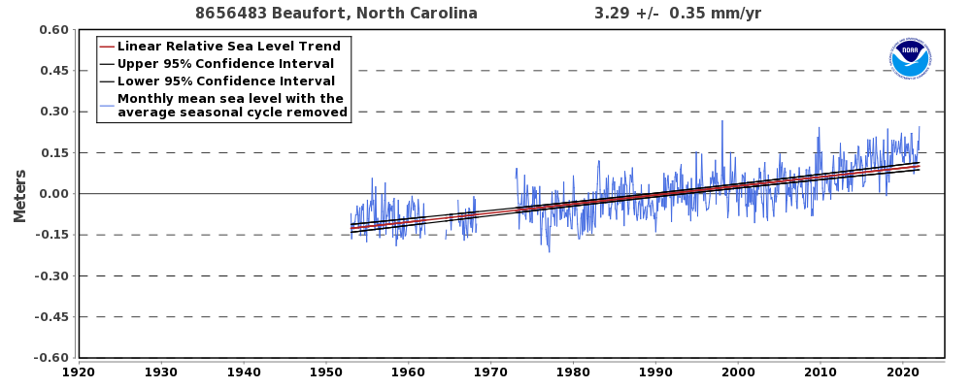
It is predicted that Beaufort will likely see between 1.15 and 1.67 ft of sea level rise by 2050, and the nearby Rachel Carson Reserve (RCR) can expect to see similar rates. According to NOAA’s Sea Level Rise viewer and its projections updated in 2022, Middle Marsh will be almost completely inundated under just 1 ft of sea level rise, with only very minimal areas of marsh and the relatively elevated waterbird nesting rookery (“Egret Island”) remaining above water at high tide. At 2 ft of sea level rise, most of the sandy beach at Bird Shoal will be flooded, and water levels will start to reach the shrub-scrub habitats beyond the marshes around the dredge spoil islands of the site.
Figure 1: Relative sea level rise trend at the Beaufort tidal station from 1953 to 2020

BACKGROUND

Geographic Setting
The Rachel Carson Reserve (RCR) is located in southern Carteret County, North Carolina (Figure 2). The Reserve lies between the mouths of the Newport and North Rivers and directly across Taylor’s Creek from the Town of Beaufort. The site comprises 2,315 acres and is a complex of small islands: Town Marsh, Carrot Island, Bird Shoal, Horse Island, and Middle Marsh, which is located across the North River Channel from the other four islands. Shackleford Banks, part of Cape Lookout National Seashore, and the Beaufort Inlet lie south of the Reserve. The Reserve is within the White Oak River Basin as well as the Albemarle-Pamlico National Estuary Program (APNEP) area and is therefore part of a congressionally designated “estuary of national significance.” The Reserve is also a Resilience Hub as designated in the National Fish and Wildlife Foundation’s (NFWF) Regional Coastal Resilience Assessment. The western portion (Town Marsh, Bird Shoal, Carrot Island, and Horse Island) of the Reserve is located within the Town of Beaufort’s city limits, and parts of Town Marsh and Bird Shoal are within the boundaries of Beaufort’s Historic District, which was added to the National Register of Historic Places in 1974. This designation was formalized, in part, to protect Beaufort’s waterfront vista and the potential for the islands to yield archeological resources. The significance of the Rachel Carson Reserve is also recognized statewide—the North Carolina Natural Heritage program has ranked the RCR as having maximum conservation value, “exceptional” biodiversity significance, and as an area of “exceptional” coastal wetlands.
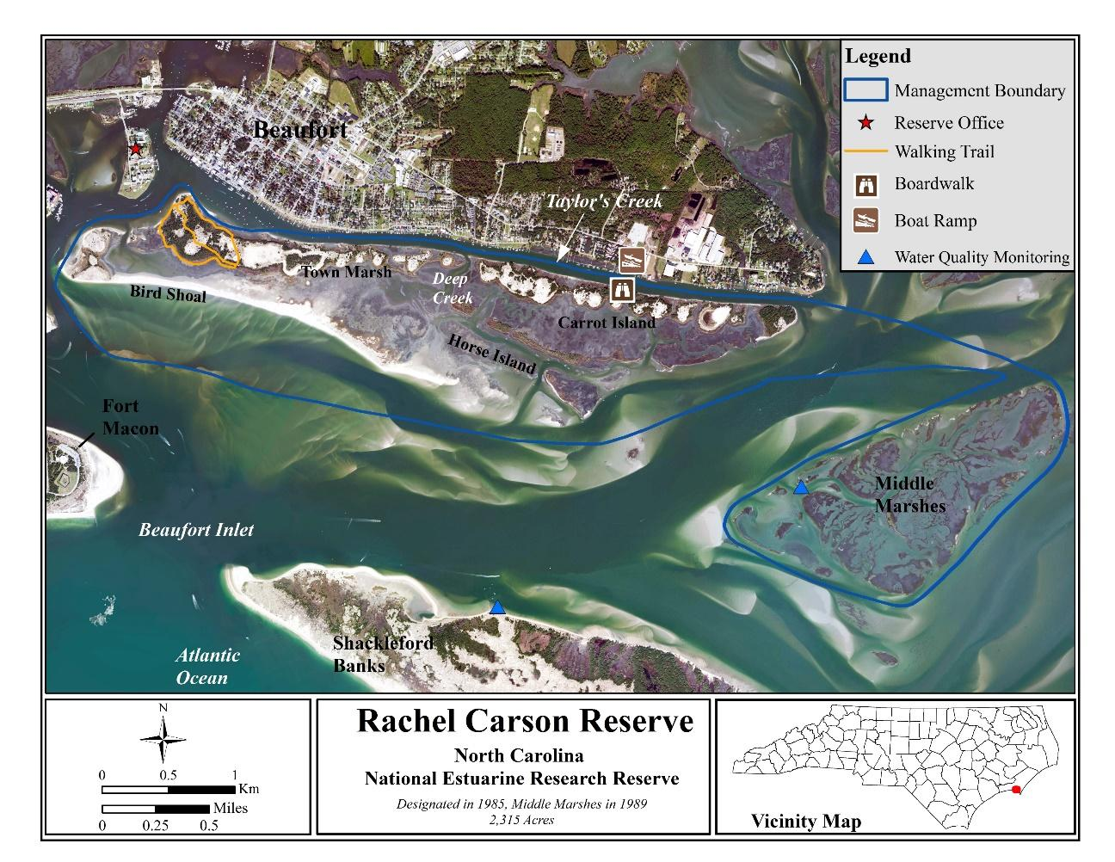

Figure 2. Rachel Carson Reserve Boundary Map
The RCR is comprised of a diverse array of habitats that are home to various estuarine species, many of which are protected (Appendix 1). Primary habitats at the RCR are salt marsh, maritime shrub-scrub and forest, subtidal flats, and dredge material deposition areas that comprise sand dunes, grassy areas, and sandy beaches. Other present habitat types may be less dominant but are still ecologically valuable, including oyster reefs and intertidal sand and mud flats. The U.S. Army Corps of Engineers (USACE) holds an easement along the north side of Town Marsh and Carrot Island for dredge material deposition within designated cells.
Ecosystem Services
Coastal communities are inherently vulnerable to weather and climate impacts due to their location at the land-water interface, but protected and natural areas such as the RCR can mitigate flooding, protect against erosion, and serve as storm buffers. Salt marshes, oyster reefs, and sand dunes can all attenuate waves and stabilize shorelines. Seagrass beds prevent erosion, recycle nutrients, filter sediment, and sequester carbon. These ecosystem services can be translated to economic terms as well—it is estimated that coastal wetlands in the U.S. provide an equivalent to over $23 billion in storm protection services annually. Salt marshes in front of land contribute to 20% fewer property damages compared to areas where no salt marsh protects the land. Loss of seagrass can be associated with millions of dollars in losses associated with fishing, property values, and carbon sequestration. For example, if just 5% of submerged aquatic vegetation (SAV) is lost within the Albemarle-Pamlico Estuarine System in the span of a decade, it could cost the state over $8.6 million.

Ecosystem and Community Vulnerability
Beaufort’s vulnerability to storm and ocean wave energy has been apparent since it was developed as a town in the early 1700s. By the late 1800s, government officials, business leaders, and residents in Beaufort were voicing concerns to the federal government about the vulnerability of the town and its harbor to wave energy entering Beaufort Inlet. The harbor was also experiencing shoaling, which was a concern for maritime commerce. In 1915, the U.S. Army Corps of Engineers installed a rock breakwater running from east to west in a zig-zag pattern across Town Marsh. The breakwater was constructed to protect Beaufort and its harbor from ocean wave energy that had been causing damage and shoaling. Dredging of the Beaufort Harbor also led to changes in the area that now makes up the Reserve. Dredge material was deposited along the north side of the marsh islands and transformed the low-lying complex of marsh islands and small creeks into a more contiguous and diverse complex of habitats that included several hundred acres of higher elevation supratidal habitats. Decades of natural vegetation succession resulted in persistent habitats of high marsh, shrub-scrub, maritime forest, and dunes consisting of deposited dredge material. The rock breakwater was also eventually mostly covered by deposited dredge material. This process created elevation for the islands and transformed the ecosystem to look and function as it does today. However, increased frequency of stronger storms, SLR, and widening of the Beaufort Inlet, thereby increased ocean energy entering the estuary, have caused erosion and loss of elevation in some areas of the RCR.
Assessing the vulnerability of natural resources at the Reserve to help inform decision-making is a current priority of NCNERR management. The Climate Change Vulnerability Assessment Tool for Coastal Habitats (CCVATCH) was used by Reserve staff in 2017 to further examine the vulnerability of intertidal salt marsh to climate change, and the process revealed that the direct effect of SLR, along with the interaction of sea level rise and erosion, contributes the most to the vulnerability of marshes at the main island complex (Town Marsh and Carrot Island) and Middle Marsh. Middle Marsh was ranked as very highly vulnerable due to low adaptive capacity, because of low chances of marsh being able to keep up with SLR, and high exposure-sensitivity due to the erosion and SLR occurring. The main island complex was ranked as highly vulnerable, facing the same exposures such as erosion and SLR, but the area has a relatively better ability to adapt to changing conditions due to the adjacent dredge material deposit cells that can supply sediment to assist in vertical migration of the marshes.
The National Estuarine Research Reserve System (NERRS) has also taken efforts to assess marsh resilience on a landscape scale in a separate assessment. In this effort, while the southeast region was found to have the most resilient marshes on a regional scale, the marshes at RCR were found to have low resilience as a result of several factors (e.g., high fragmentation of marshes, high vulnerability due to erosion potential and tidal range, low migration space).
While formal vulnerability assessments have not been undertaken for the other habitats at the Reserve, habitat and shoreline changes at the Reserve have been analyzed. Habitat mapping of RCR started in 1986 and continues today, with the most recent habitat maps completed in 2020. Using these maps, in 2021 RCR staff completed an analysis of habitat change at RCR. In the main island complex of the Reserve (Town Marsh, Carrot Island, Horse Island, and Bird Shoal), every habitat experienced a change in area over the four-decade period (Figure 3a, 3c, and 3d). The extent of these changes at the Reserve is clear evidence of the dynamic nature of these habitats, which are impacted by manmade actions as well as environmental stressors.
Habitat data was only available from 2010 and 2020 for Middle Marsh. Analyses revealed that in a span of ten years, 38% of oyster reefs, 11% of salt marshes, and 38% of forest-shrub habitats were lost. The loss of salt marsh and oyster reefs and consequential conversion of these areas to sand flats and water signifies erosion occurring at the edges of many of the marsh patches. The forest-shrub habitat is mainly found at an elevated patch that hosts an important waterbird nesting rookery, one of the last sizable rookeries in the county (Figure 3b).
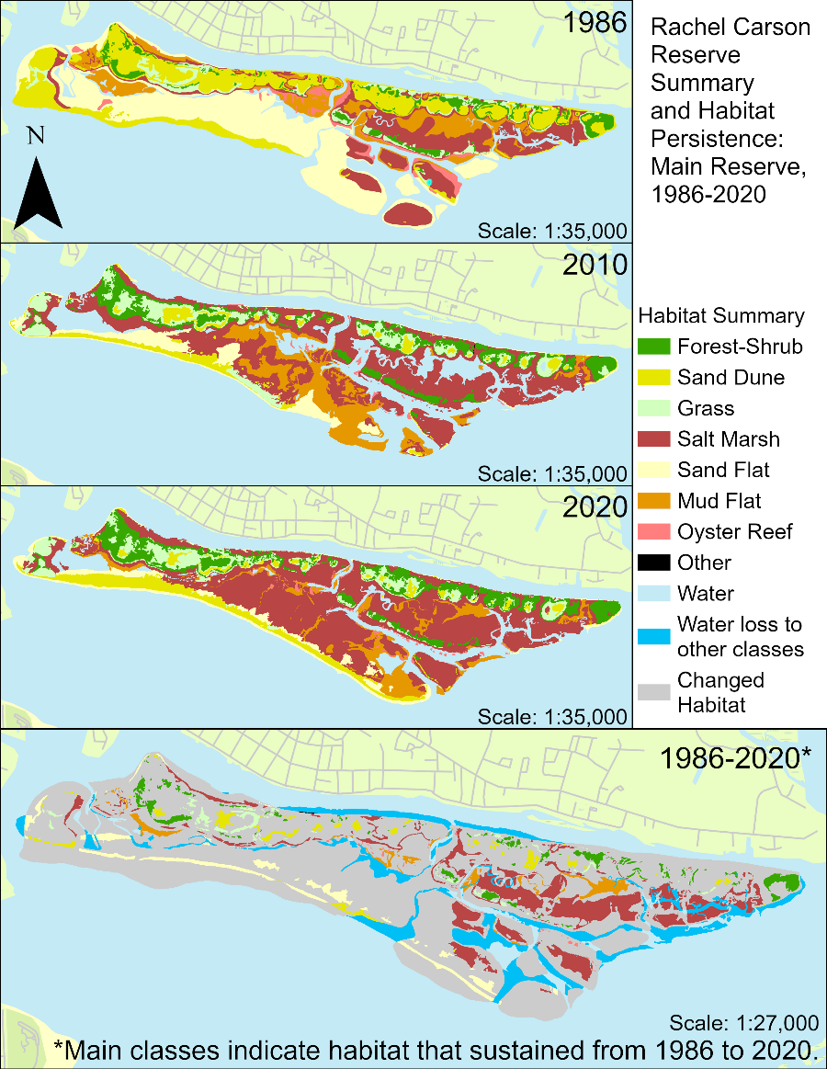

Figure 3a. Habitat maps of the main islands of the Rachel Carson Reserve (Town Marsh, Carrot Island, Bird Shoal, and Horse Island) from 1986 to 2020. Click maps to enlarge.

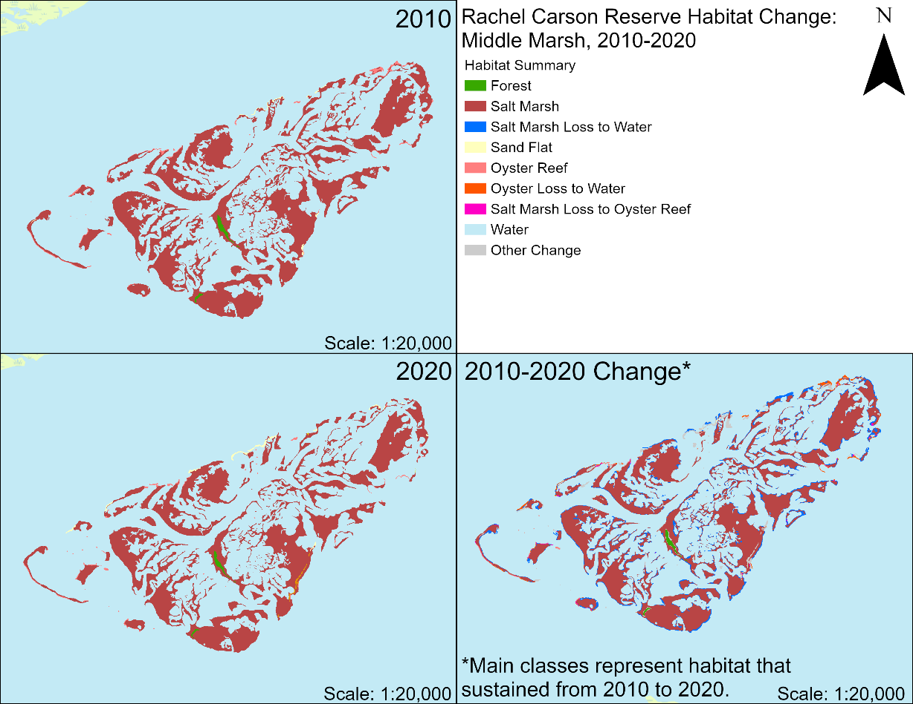

Figure 3b. Habitat change at Middle Marsh from 2010-2020.

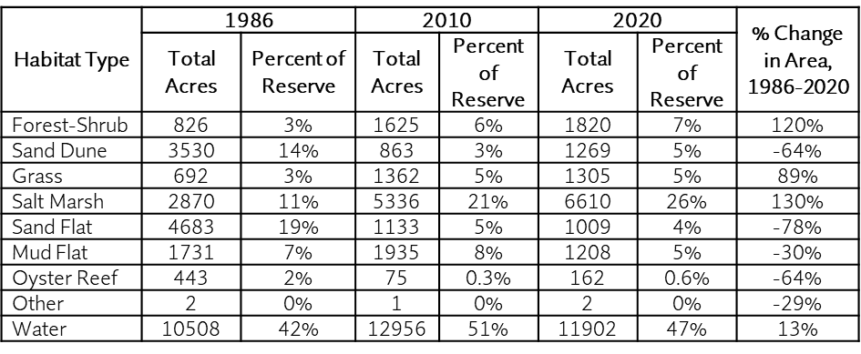
Figure 3c. Habitat change across all islands of the Rachel Carson Reserve from 1986 to 2020.
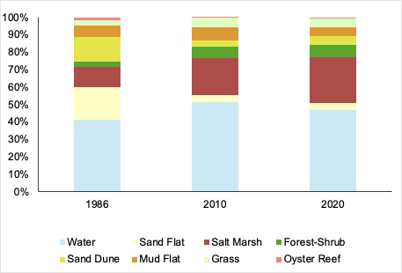

Figure 3d. Habitat change across all islands of the Rachel Carson Reserve from 1986 through 2020.
Shoreline change at the RCR also reveals the dynamic nature of the area. From 1942 to 2020, the shoreline of the southern edge of Bird Shoal moved towards the north, but in the 1990s also started rapidly extending eastward (Figure 4) as Beaufort Inlet rapidly widened (Figure 5). The shoreline of Bird Shoal is influenced by the changes that occur at the Beaufort Inlet, lying south of Bird Shoal. The eastern end of the inlet comprises the western end of Shackleford Banks, which has also experienced geomorphological changes to its shoreline over the last several decades. The Beaufort Inlet started to narrow in the mid-1900s, meaning the western tip of Shackleford Banks extended much more westward. After 2010, Shackleford Banks started receding, thereby widening the Inlet and presumably allowing more ocean wave energy and sediment movement to pass through the Inlet and into Back Sound, eventually reaching Bird Shoal. The widening of the Beaufort Inlet and associated changes occurring at Bird Shoal have captured the attention of both the public and the media; in 2016, after overwash events occurred in the sand dunes of Bird Shoal at high tide, several news stories captured the concern of Beaufort citizens and local leaders. High water levels bringing water across Bird Shoal highlighted how important the RCR is as a protective buffer for Beaufort, and Town staff recognized this in news interviews at the time.

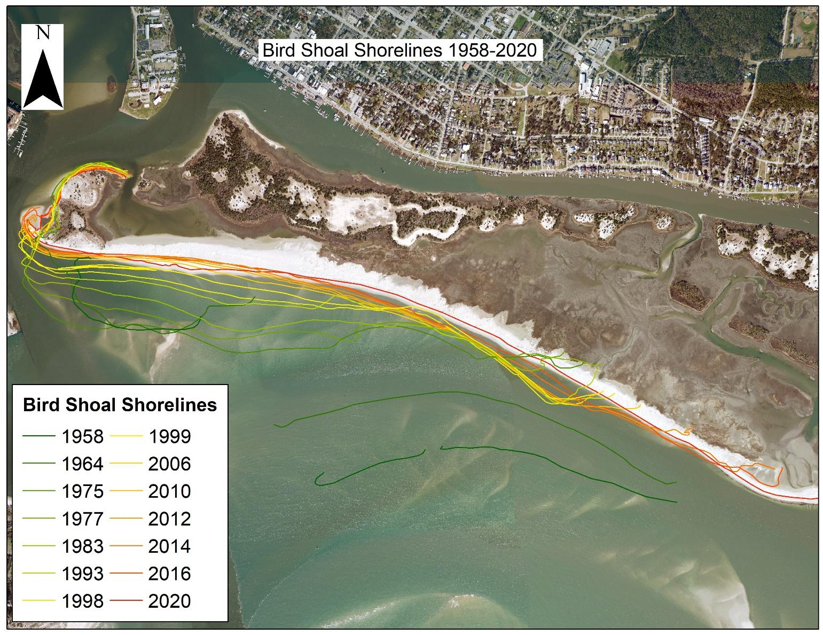
At the southeastern side of Carrot Island (facing the inlet), marsh edge erosion has been documented as ~0.65-0.75 m/yr since 1958. At the eastern terminus of RCR at Carrot Island, recent analysis reveals an erosion rate of over 5 ft/yr from 1993-2014. The primary erosive forces along the more protected Taylor’s Creek (between the north side of the Reserve and Beaufort) are fewer due to the buffering presence of the RCR and are primarily contributed to boat wakes and storm surge. The north side of the RCR has experienced approximately 1.3 ft/yr erosion from 1993-2014, but it’s important to note that mapping error can influence smaller calculated erosion rates more than larger calculated erosion rates such as at the highly erosive area at east end of Carrot Island.
Figure 4. Change in Bird Shoal shorelines from 1958-2020.

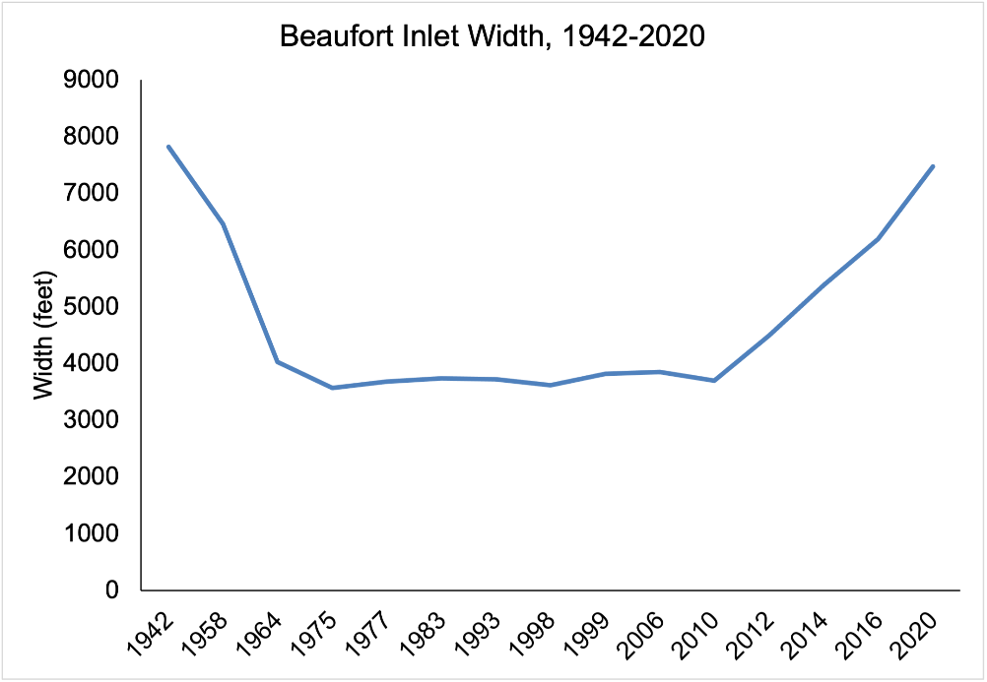
Figure 5. The width of Beaufort Inlet in feet from 1942 to 2020

A Vulnerable Historic Town
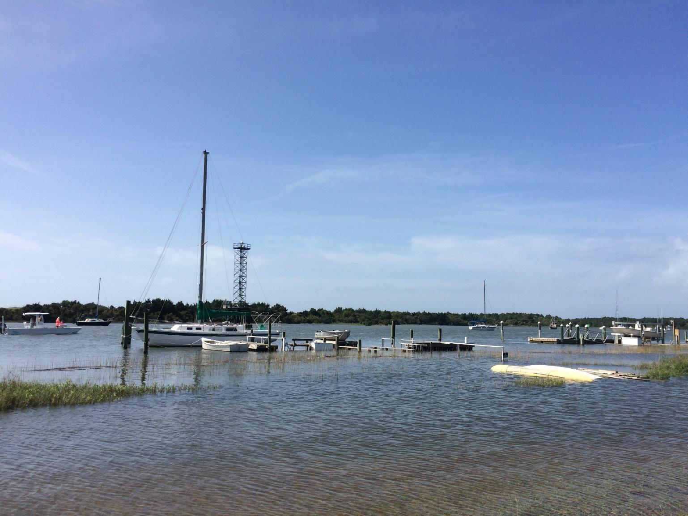
As a frontline community to climate change and coastal hazards, the Town of Beaufort recognizes its vulnerability and has incorporated resilience and hazard planning into its management activities. Beaufort received a grant to participate in the N.C. Division of Coastal Management’s North Carolina Resilient Coastal Communities Program (RCCP), which allows the Town to conduct a risk and vulnerability assessment and harness a community action team to plan and prioritize coastal resilience projects to increase community resilience.
Additionally, from 2020 to 2022, the Town of Beaufort embarked on an update to their Comprehensive and Coastal Area Management Act (CAMA) Land Use Plan (hereafter: Comp. Plan). The Rachel Carson Reserve Manager, Paula Gillikin, served on the Steering Committee for the plan development. Two of the Comp. Plan’s main goals include to “protect, preserve, and restore our shorelines, sensitive habitats, and waterways”, and to “increase resilience to natural hazards and climate change impacts for natural and built areas.” One of the objectives of the Comp. Plan is also to preserve, maintain, and enhance the RCR. Actions under this objective include having Town staff participate in advisory and planning activities with the Reserve and educating the public about the ecological and storm protection benefits of the Reserve. Other plan objectives or actions that may impact the RCR include, but are not limited to, continually monitoring water quality in Taylor’s Creek, identifying areas for wetland and habitat restoration, and tracking shoreline and habitat change to inform possible interventions (e.g., habitat protection, restoration).
Inclusion of the RCR in the Comp. Plan update is supported by the Town’s residents. In a survey of Beaufort residents conducted as part of the public engagement effort for the Comp. Plan, 68% of residents responded that “protection of the Rachel Carson Reserve” was a high priority, and 54% responded that “impacts from SLR and climate change” were a high priority. In an open-ended question about what residents value most about Beaufort, the RCR was included in several respondents’ answers, along with several answers mentioning the natural environment and waterways. For another open-ended question asking what the most important issue the Town will face in 5, 10, and 20 years, around 1/3 of responses included mention of climate change and the resulting impacts, vulnerability, the natural environment, SLR, flooding, or storms/hurricanes.

Other NC Resilience Initiatives
Hazard and resilience planning has been incorporated into natural resource management, policy, and planning documents throughout various levels of State government. The actions included in the RCR habitat resilience plan align with one or more strategies of the following statewide and local plans. Inspiration from and references to these plans are found below.
North Carolina National Estuarine Research Reserve Management Plan
The management plan acknowledges the NCNERR sites as vulnerable to coastal hazards and presents the following objectives:
- Objective T3.1: Assess vulnerability of Reserve natural resources to coastal hazards and use results to inform management decisions.
- Objective T3.2: Increase understanding and communicate knowledge of the importance of natural infrastructure (e.g., oyster reefs, marsh, living shorelines) to coastal resilience.
- Objective T3.3: Increase understanding of SLR implications and resilience opportunities for Reserve sites and coastal and estuarine ecosystems by participating in local, regional, and state initiatives.
Executive Order 80
In October 2018, Governor Roy Cooper issued Executive Order 80 (EO80)—North Carolina’s Commitment to Address Climate Change and Transition to a Clean Energy Economy. The Executive Order directed state agencies to “integrate climate adaptation and resiliency planning into their policies, programs, and operations (i) to support communities and sectors of the economy that are vulnerable to the effects of climate change and (ii) to enhance the agencies’ ability to protect human life and health, property, natural and built infrastructure, cultural resources and other public and private assets of value to North Carolinians”.
At the direction of EO80, the Department of Environmental Quality developed the North Carolina Climate Risk Assessment and Resilience Plan. As a part of the state’s coastal resources and infrastructure, the Reserve program was included in the state’s resilience plan and features the Reserve’s priorities to identify and implement strategies to improve resilience and adaptive capacity.
Additionally, the RCR is state-owned land that contains some of the ecosystems that the state has defined as most vulnerable, including estuarine communities and submerged aquatic vegetation.
Natural and Working Lands Action Plan
The Natural and Working Lands Action Plan was developed out of the NC Climate Risk Assessment and Resilience Plan to recommend specific actions to build ecosystem and community resilience on natural and working lands (NWL), among other goals.
Included in the priority recommendations for coastal habitats are the protection and restoration of such habitats; strategies to achieve this include prioritizing climate change and sea level rise in coastal habitat restoration planning, protecting habitat migration corridors, and providing incentives to stakeholders to protect coastal habitats.
The RCR habitat resilience plan aligns with the recommendation to prioritize climate change and SLR in planning efforts and serves as an example of the co-benefit of community and ecosystem resilience.
NC Coastal Habitat Protection Plan
The NC Department of Environmental Quality (DEQ) updates the agency’s Coastal Habitat Protection Plan (CHPP) every five years to address habitat and water quality issues to enhance coastal fisheries.
While the focus of the CHPP has always been to conserve, protect, and restore coastal habitats, the 2021 Amendment recognizes the urgent need to enhance resiliency of coastal habitats as climate change continues to impact habitats and the species and ecosystem services they support.
The updated amendment includes recommendations for protecting and restoring submerged aquatic vegetation and employing nature-based solutions for wetland protection and restoration. The amendment also highlights the need to prevent salt marsh loss from SLR and erosion, and offers various nature-based solutions to consider, including living shorelines and wetland preservation.
Natural and Working Lands Action Plan

Natural and Working Lands Action Plan
PLAN COMPONENTS

The RCR habitat resilience planning process consisted of Reserve staff centralizing all available information and research related to RCR and nearby history, habitat characterization and change, species inventories, environmental stressors, and more. Simultaneously, staff began generating a habitat resilience strategic plan and assessed habitat vulnerability and risks. Partners were then engaged through a half-day workshop to discuss possible intervention actions and their feasibility. Finally, staff used the “Resist, Accept, Direct” (RAD) framework to evaluate proposed interventions and prioritize possible projects. Based on this work, the Plan is organized into five components listed and shown in the figure, below:

- Plan Component I: Knowledge Base
- Plan Component II: Habitat Resilience Strategic Plan
- Plan Component III: Risk Identification and Vulnerability Analysis
- Plan Component IV: Partner Engagement to Identify and Evaluate Intervention Options
- Plan Component V: Prioritization of Threat Interventions Using “Resist-Accept-Direct” Framework

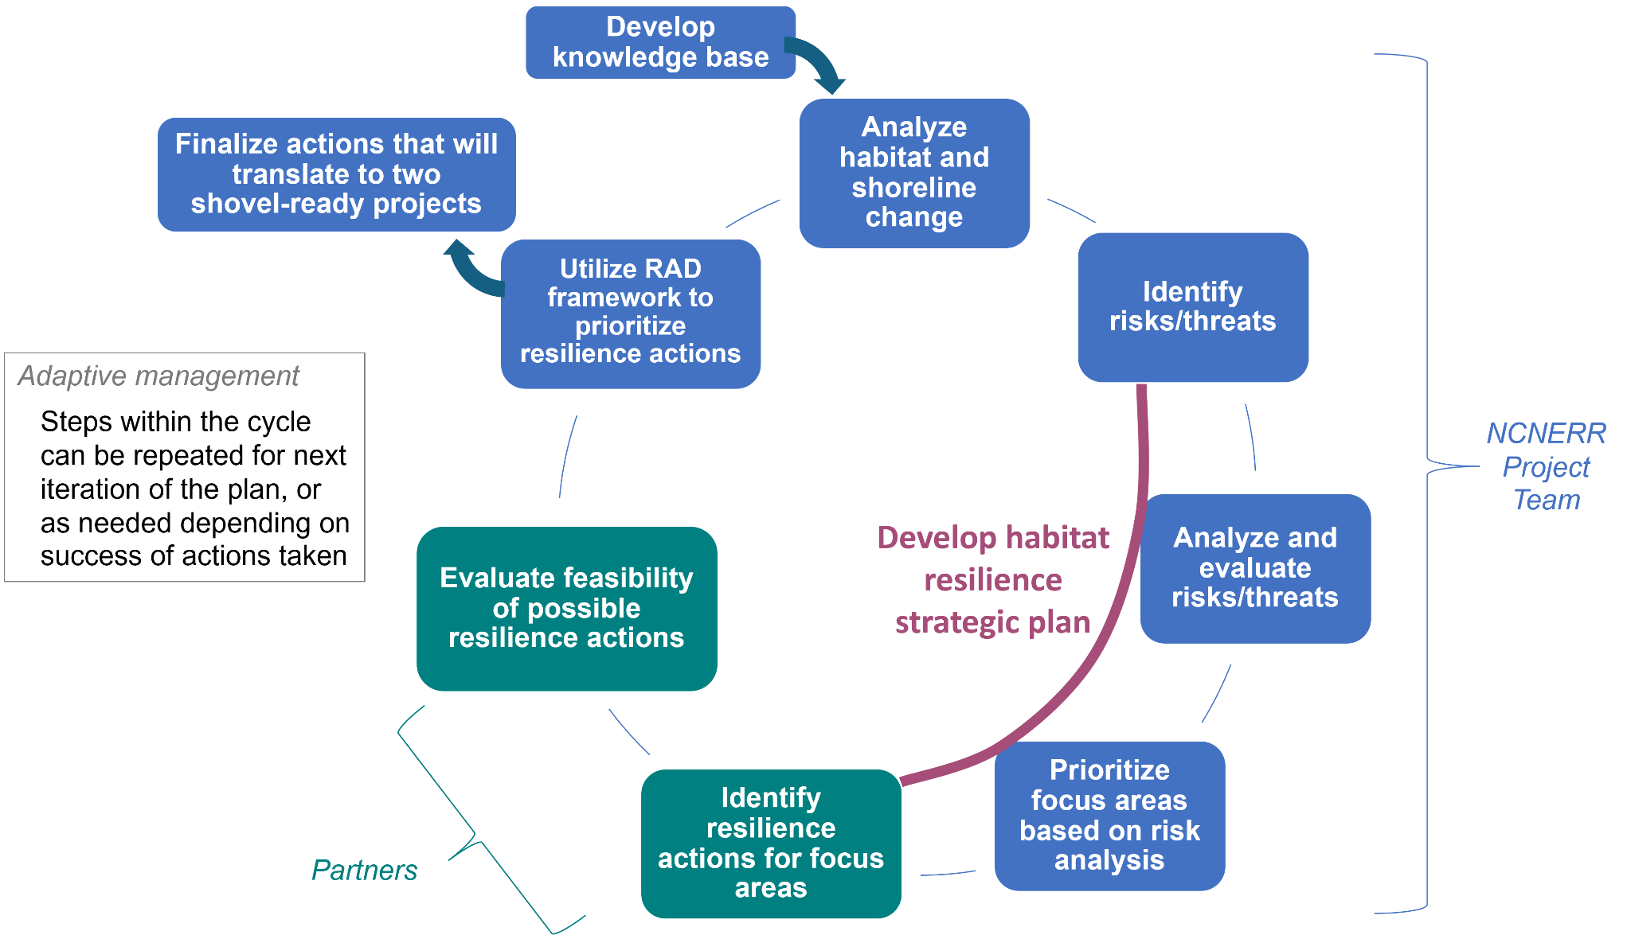

Figure 6. Overview of the resilience planning process


Plan Component I: Knowledge Base
The planning process started with the curation of a “knowledge base,” a comprehensive synthesis of research, reports, and historic documents and imagery, including charts of the Reserve and surrounding areas. Compiling all available information and knowledge about the RCR was important to inform the planning process and improve the ability to identify and prioritize actions and on-the-ground projects to enhance resiliency of the Reserve’s habitats and its protective services, and maintain a place where staff, students, researchers, partners, and the general public can access information in a central location related to the RCR’s resilience. The effort to compile a knowledge base took shape in the form of creating a “Resilience Hub” website for the RCR, hosted via the ArcGIS Online Hub application, that presents the story of change at the RCR interwoven with a summary of relevant climate impact and restoration information that has been generated from research at RCR. The website also hosts a spreadsheet of resources comprising the “knowledge base library,” which is publicly available for downloading.
Figure SEQ Figure \* ARABIC 7: Homepage of the RCR Resilience Hub site
Click or scan this QR code to access the Resilience Hub

Plan Component II: Habitat Resilience Strategic Plan
At the start of the planning process, the project team developed habitat resilience goals related to each mission area of the Reserve program (e.g., research, education, coastal training, and stewardship) as well as goals pertaining to policy and planning issues relevant to the management of the Rachel Carson Reserve. Each broad goal is accompanied by several objectives, and each objective has one or more discrete implementation actions. The funding for development of this plan included support to conduct a feasibility study for an on-the-ground resilience project. This project is captured in the actions and objectives under the stewardship goal.
Timeframe
The Plan considers impacts and actions on an approximately 30-year timeframe, to the year 2050. This timeframe aligns with those of other vulnerability assessments (e.g., CCVATCH). This Plan is a living document and can be updated at any time. However, the Plan will be formally reviewed and updated every 5 years.
Vision
The habitats of the Rachel Carson Reserve are resilient to natural and manmade climate impacts and continue to provide a healthy estuarine ecosystem to support research, education, stewardship, compatible traditional uses, and protect the Town of Beaufort.
Purpose
The purpose of the Plan is to provide the Reserve with a strategic approach that will guide planning and management actions related to habitat resilience at the Rachel Carson Reserve and community resilience of Beaufort. The Plan is intended to be a living document that is periodically updated to incorporate the latest best available science and adaptive management outcomes.

Goals, Objectives, and Actions
NOTE: Corresponding goals/objectives/actions of the 2020-2025 NCNERR Management Plan are listed in italics after related Resilience Plan goals/objectives/actions.

Policy and Planning Objectives and Actions
- Goal 1: Adaptive management and resilience strategies for the Rachel Carson Reserve are incorporated into planning and policy decisions at the local (i.e., Town of Beaufort) and state level (i.e., DCM/NCNERR).

  - Objective 1.1: Reserve staff and the Town of Beaufort engage in collaborative planning on environmental topics.
    - Action 1: Reserve staff participate in relevant environmental planning processes with the Town of Beaufort, such as updating the Town’s Comprehensive Plan and CAMA Land Use Plan.

    - Action 2: Reserve staff continue to coordinate with partner organizations and the Town of Beaufort on abandoned and derelict vessel management in Taylor’s Creek to reduce adverse impacts to reserve habitats.

    - Action 3: Reserve staff collaborate with Town of Beaufort staff to develop and propose projects at the Rachel Carson Reserve as part of Beaufort’s participation in the N.C. Resilient Coastal Communities Program.

    - Action 4: Reserve staff participate in North Carolina’s Coastal Resilience Community of Practice through quarterly meetings to contribute to knowledge-transfer discussions and share lessons learned with diverse coastal stakeholders working on ecosystem and coastal resilience issues.

  - Objective 1.2: The RCR Resilience Plan serves as an example and resource for other entities’ resilience efforts.

- Action 1: The Plan is presented to other Reserves in the NERRS to share knowledge and lessons learned, via the NERRS/NERRA Annual Meeting or in other targeted discussions or presentations. If appropriate, the Reserve will work with the NERRS strategic concept plan workgroup to share experiences that may be useful for strategic concept development.

- Action 2: The Plan (or concepts, strategies, projects contained within) is presented to relevant external audiences through outreach and participation in professional meetings, including the Restore America’s Estuaries Coastal and Estuarine Summit, the Carolinas Climate Resilience Conference, North Carolina Coastal Conference and the leadership team for the North Carolina Coastal Habitat Protection Plan.

- Action 3: The Plan is used as a template for development of similar plans for other Reserve sites in North Carolina.

Research Objectives and Actions

- Goal 2: Research and best available data on climate change impacts to estuarine ecosystems, habitats, and species, conducted within or outside of the Rachel Carson Reserve, is used to inform adaptive management to improve resiliency of the Rachel Carson Reserve.

  - Objective 2.1: Research and monitoring conducted within and near the Rachel Carson Reserve advances understanding of climate change impacts, including sea level rise, erosion, extreme storm events, increasing air and water temperatures, and precipitation changes on the Reserve’s ecosystems, habitats, and species, and informs potential responses and/or management actions.

    - Action 1: Produce and maintain an up-to-date list of resilience research studies conducted at or near the RCR and showcase on the Resilience Hub website.

    - Action 2: Conduct habitat mapping efforts (following NERRS protocols) at ten-year intervals and/or before and after extreme storm events [NCNERR Mgmt. Plan Research Program Action 2.1.3: Continue implementation of the NERRS SWMP to assess change in abiotic and biotic indicators and habitat distribution.]

  - Objective 2.2: The Rachel Carson Reserve is promoted as a place-based research platform for climate change resilience research. [NCNERR Mgmt. Plan Research Program Objective 2.3: Reserve sites are promoted as place-based research platforms and Reserve’s long-term datasets are promoted as a research tool.]

- Action 1: When appropriate, the Rachel Carson Reserve serves as a test site for adaptation and restoration strategies, including new technology testing such as thin layer sediment placement or oyster groins.

- Action 2: Where possible, facilitate and promote the scaling-up of existing research studies to better understand how these projects can protect habitats.

- Objective 2.3: Assess monitoring infrastructure needs that will improve future resiliency planning and implementation efforts.

    - Action 1: Collaborate with NOAA OCM and NERRS colleagues to assess infrastructure needs and monitoring sites, and identify opportunities for technical support, resources, etc.

- Action 2: Incorporate the research needs identified herein into the Reserve’s Wetlands and Water Levels plan.

- Action 3: Continue sentinel monitoring activities at Middle Marsh and consider expanding these or similar activities to the main part of the Reserve. [NCNERR Mgmt. Plan Research Program Action 2.1.5: Continue implementing the Sentinel Site Application Modules as resources are available to detect and understand the effects of sea level change on estuaries.]

Objective 2.4: Articulate resilience research needs to partners, stakeholders, and
academic researchers and students.

- Action 1: Produce, maintain, and distribute a list of research needs pertaining to habitat resilience at the RCR.

- Action 2: Update the Reserve-wide management needs list to include the latest habitat resilience research needs (identified in Action 2.4.1) and take advantage of funding opportunities such as funding from the NERRS Science Collaborative. [NCNERR Mgmt. Plan Research Program Action 2.4.2: Develop at least 2 collaborative research proposals annually seeking external funds to support Reserve research priorities.]

- Action 3: Include relevant research needs in competitive Requests for Proposals for research conducted at the RCR, such as the Coastal Research Fellowship and the Margaret A. Davidson Fellowship, for research related to needs mentioned in Action 2.4.2. [NCNERR Mgmt. Plan Research Program Action 2.3.3: Support and promote the Coastal Research Fellowship in collaboration with N.C. Sea Grant to provide opportunities for graduate students to conduct research within Reserve boundaries.]

Objective 2.5: Research and stewardship staff will monitor performance of on-the-
ground resilience projects to assess effectiveness.

- Action 1: Develop and implement monitoring plans for any on-the-ground resilience projects, including performance metrics and timelines.

Education & Coastal Training Objectives and Actions
- Goal 3: Visitors to the Rachel Carson Reserve and residents of the Town of Beaufort understand why the Rachel Carson Reserve is important in protecting the Town against storm events and why its resilience is of social, economic, and ecological importance.

  - Objective 3.1: Climate change and resilience topics are incorporated into workshops and curricula for educators that receive information on North Carolina’s coastal and estuarine ecosystems through the NCNERR Education Program.

- Action 1: [NCNERR Mgmt. Plan Education Program Action 1.1.3: Incorporate Reserve research and stewardship activities and monitoring data into workshops and curricula.]

- Objective 3.2: Climate change and resilience topics are incorporated into educational field trips for K-college students and into curricula for classroom visits. Programming for public outreach programs at RCR.

- Action 1: Stewardship staff will work with education staff to incorporate resilience topics into classroom and field trip curricula, such as including stops on the field trip to see and discuss progress of current resilience projects. [NCNERR Mgmt. Plan Education Program Action 1.2.1: Conduct educational field trips for K-college students, focusing each field trip on the grade’s standards.] [NCNERR Mgmt. Plan Education Program Action 1.2.3: Present coastal and estuarine concepts and curricular activities to students through classroom visits.]

  - Objective 3.3: Climate change and resilience topics are incorporated into of programming for public outreach programs at RCR.

- Action 1: Stewardship staff will work with education staff to incorporate resilience topics into summer public field trip curricula, such as including stops on the field trip to see progress of current resilience projects and discuss how the projects will benefit the Town and the field trip audiences [NCNERR Mgmt. Plan Education Program Action 1.3.1: Conduct public outreach programs at Reserve sites.]

Objective 3.4: Resilience and preparedness for coastal hazards are incorporated into
technical assistance, existing training programs or are promoted through new
training events through the Coastal Training Program.

- Action 1: Coastal Training Program Coordinator and Stewardship Staff will work with program partners to coordinate new training events relating to coastal resilience. [NCNERR Mgmt. Plan Coastal Training Program Action 1.4.2: Coordinate new training events in response to the 2014 needs assessment and emerging policy issues in collaboration with program partners.]

Objective 3.5: Reserve staff use innovative ways to engage with the public about
resilience and restoration topics.

- Action 1: Project staff take NOAA’s “Fostering Behavior Change in Coastal Communities” training and consider designing and employing a social marketing campaign to elicit interest from audiences in resilience topics.

- Action 2: Innovative displays, such as QR codes, are installed on signage related to resilience projects at the site, informational displays throughout the Reserve, and on Reserve signage on the Beaufort waterfront.

- Action 3: Promote citizen science to document environmental change by maintaining a photo monitoring chronolog at RCR.

Stewardship Objectives and Actions

- Goal 4: Management of coastal and estuarine habitats at the Rachel Carson Reserve enhances site resilience while maintaining natural integrity.

  - Objective 4.1: Vulnerable habitats are managed, enhanced, and restored by implementing activities that 1) are informed by best-available science, best management practices, and lessons learned from prior restoration efforts in the area, and 2) are prioritized through collaboration with partners and stakeholders [NCNERR Mgmt. Plan Stewardship Program Action 3.1.4: Manage, enhance, and restore habitats by implementing activities to support the natural integrity of sites, working with partners and contributing to state and regional initiatives.]

    - Action 1: Utilize previous vulnerability assessments, risk analyses, partner input and feedback, and the Resist, Accept, Direct decision-making framework to prioritize on-the-ground resilience actions.

    - Action 2: Collaborate with engineering partners to conduct feasibility studies for areas of the RCR that were identified as highly vulnerable to climate threats the Reserve is facing, with a high likelihood that the threat is already occurring or will occur within ten years.

  - Objective 4.2: Acquisition opportunities based on ecological value and habitat resilience needs are explored [NCNERR Mgmt. Plan Stewardship Program Objective 3.4: Boundary expansion and acquisition opportunities are explored to protect Reserve sites.]

    - Action 1: Capitalize on collaborations and initiatives associated with the North Carolina Salt Marsh Action Plan to identify needs and strategies for marsh migration planning.

  - Objective 4.3: To support mutually beneficial outcomes and create synergies, the U.S. Army Corps of Engineers and Reserve are aware of each other’s management challenges and needs.

    - Action 1: The Reserve invites the Army Corps of Engineers to participate in resilience planning and/or serve as an end-user for relevant research and restoration projects and the Reserve participates in Corps regional and local beneficial use initiatives.

    - Action 2: The Reserve is included in discussions about local dredging projects that may have the potential to contribute to site resilience needs.

Plan Component III: Risk and Vulnerability Assessment
Using staff knowledge and expertise, resources and tools from the knowledge base, the 2020 analyses of habitat and shoreline change, and previous vulnerability assessments such as CCVATCH, the project team identified risks and threats posed by climate stressors at different areas of the Reserve (Bird Shoal, the northern shorelines of Town Marsh and Carrot Island, and Middle Marsh). It became evident that most of the threats facing the RCR stemmed from SLR and extreme storms (i.e., hurricanes), so those stressors were the focus of this first iteration of a vulnerability assessment, risk analysis, and evaluation process (Figure 8), which was adapted from several planning guides produced by federal agencies. The vulnerability of each area of the RCR was characterized through a risk analysis and evaluation process, and partners were consulted through a ½ day meeting to identify resilience actions that could be implemented to mitigate the risks (Plan Component IV), and the feasibility of possible resilience actions was also evaluated. The project team then utilized the “Resist, Accept, Direct” (RAD) framework to identify and consider all management response options to the risks/threats (Plan Component V).
Risk identification and vulnerability scoring

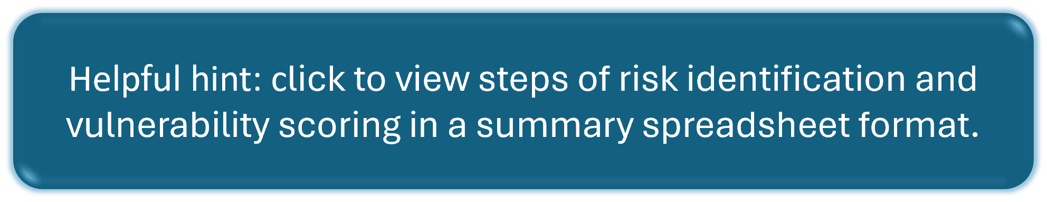
Step One. Divide RCR into discrete geographies and identify significant natural history characteristics, and commercial and recreational use.
The geography of the RCR was broken down into eleven discrete areas on a scale that was large enough so that any risks considered were numerous and diverse, and small enough so that the project team could delineate the area based on its unique characteristics such as supporting beachgoing, a bird nesting area, presence of protected species, and others. Identifying all the different ways an area of the RCR supports the ecosystem and the human uses of the site is important in order to think comprehensively about the various risks and threats each area may face. Icons representing the various uses or significant natural history characteristics were placed on a satellite map of the Reserve during this activity conducted by the project team (Figure 7).

<scroll to next page>

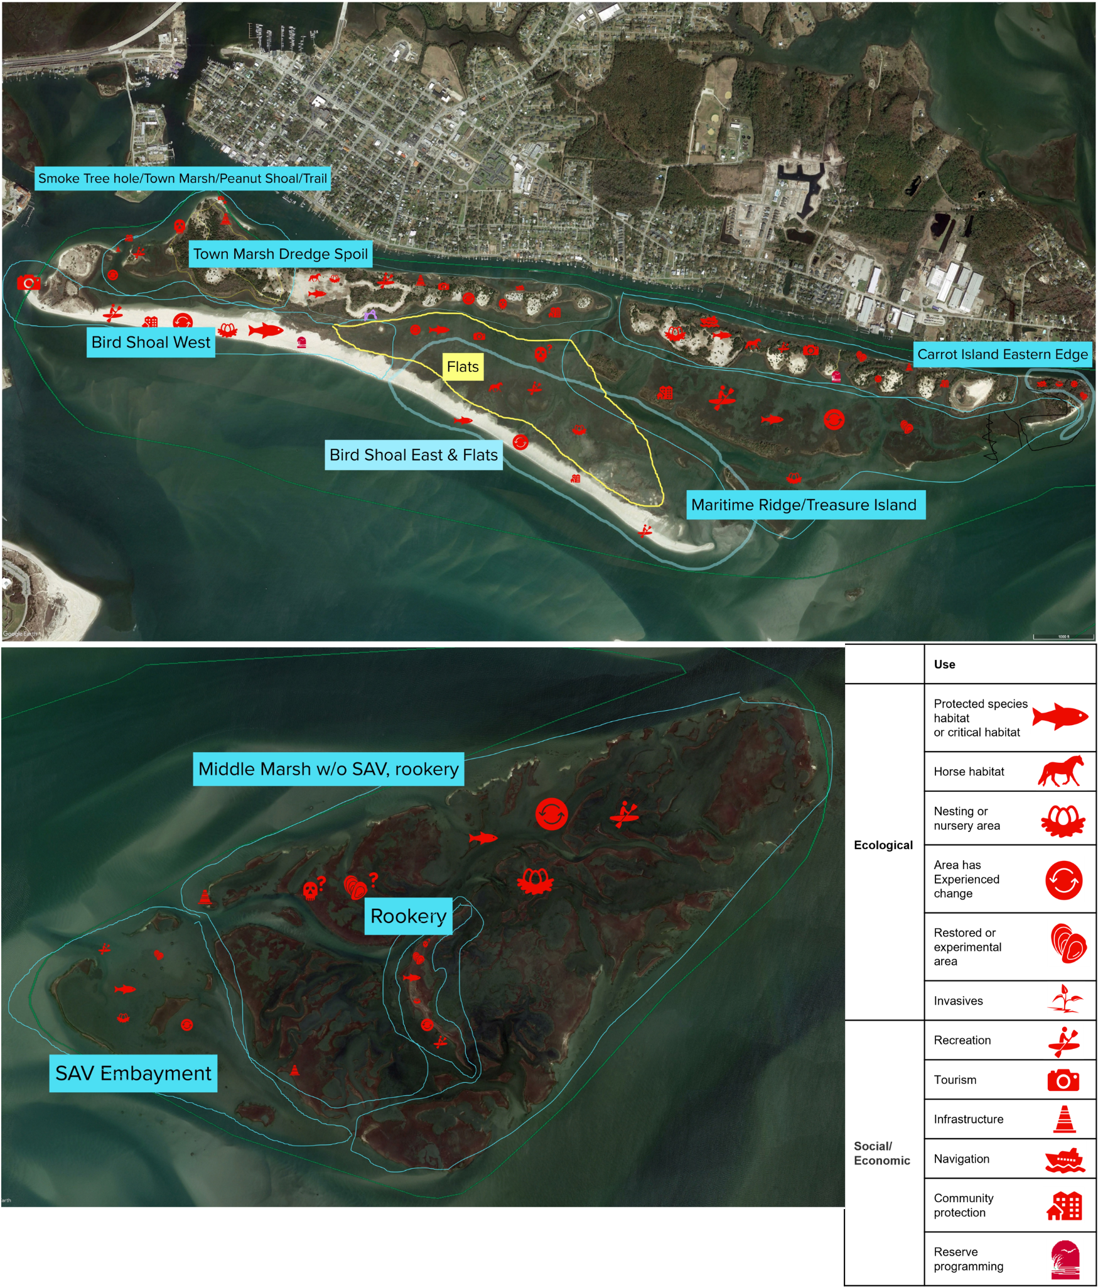
Figure 7. Discrete geographies with significant natural history characteristics, and commercial and recreational use

Step Two: Develop a list of risks/threats associated with sea level rise and extreme storms at each geographic area.
The project team developed a list of risks/threats at each area caused by direct climate stressors (e.g., sea level rise, extreme storms, temperature changes, precipitation changes, increased carbon dioxide) using their knowledge and expertise, as well as information gleaned from the knowledge base, the habitat and shoreline change analyses, previous vulnerability assessments such as CCVATCH, and other research efforts at the Reserve. During this exercise, it became clear that the majority of the risks/threats the Reserve faces are caused by SLR and storms (e.g., hurricanes) and the secondary effects (e.g., sedimentation, erosion, etc.) of those stressors. Therefore, for the first iteration of this resilience plan, the project team decided to focus on threats related to SLR and extreme storms. During this step, the project team also identified significant overlap across geographic areas related to risk, ecological significance, and recreational and commercial uses. To address this and simplify partner input, the 11 geographic areas were reduced to five final areas of focus which are shown in Figure 8 and are as follows: Middle Marsh, maritime ridge and Treasure Island, northern shoreline, Bird Shoal and flats, Smoke Tree Hole/Town Marsh/Peanut Shoal. The eastern end of Carrot Island was not included, as Carteret County and Moffatt and Nichol were entering into a partnership with the Reserve to apply for funding to design and implement a large living shoreline project.

<scroll to next page>
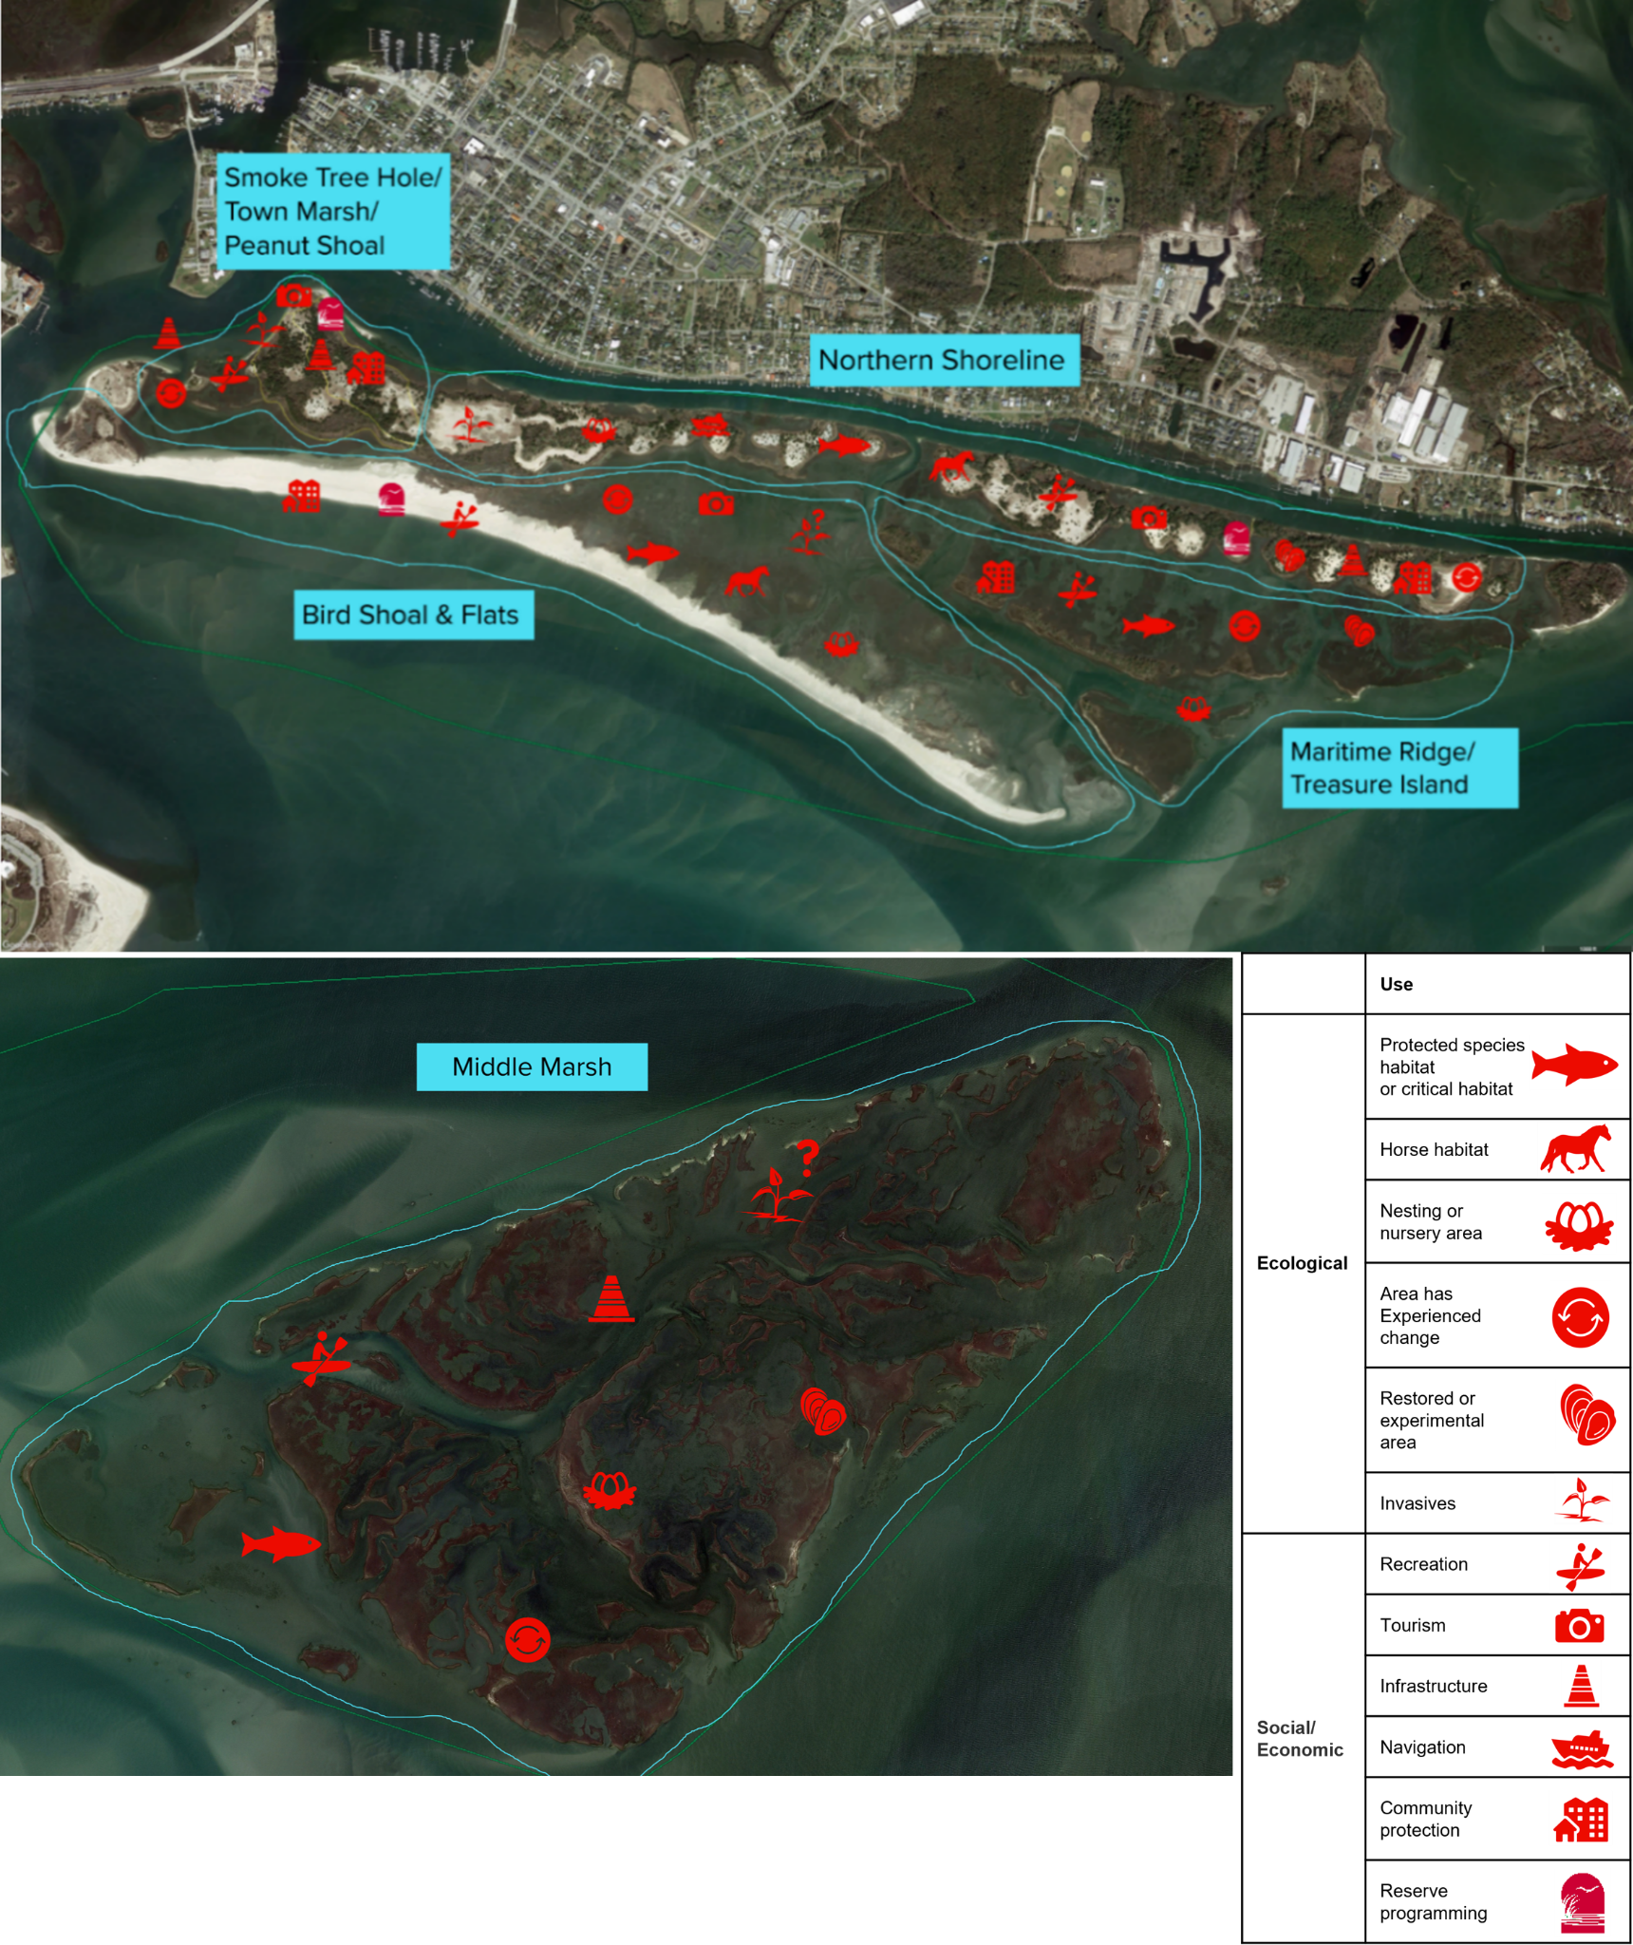
Figure 8. Consolidated map of geographic areas with areas of ecological and social significance in red.

Step Three: Conduct risk analysis for each focal area.
After identifying the risks/threats facing the RCR, the project leads conducted a risk analysis, adapted from the EPA’s Being Prepared for Climate Change workbook for developing risk-based adaptation plans. For each risk/threat, a list of consequences was developed and then the impact of those consequences was ranked on a qualitative scale of low, medium, or high. The criterion for the scale is as follows:

Impact of Consequences: effect the risk/threat would have on the function of the habitat, ecosystem, or entire site were it to occur.
- Low: habitat and/or ecosystem will still function as normal; Reserve will still function as normal; not as important as other things; could adjust
- Medium: habitat and/or ecosystem will still function as normal for the majority of the time but will be minorly disrupted; Reserve will still function as normal for the majority of the time but will be minorly disrupted
- High: major disruption to habitat and/or ecosystem; major disruption to function of Reserve; mitigation/resilience goal is out of reach or not even attainable
Each risk/threat was then evaluated based on the likelihood of it occurring in 30 years, which is the timeframe that the resilience plan is focusing on. The criteria for the likelihood scale is as follows:

- Low: will likely occur in >30 years
- Medium: will likely occur in 10-30 years
- High: already occurring or will occur in <10 years
Step Four: Determine vulnerability.
Next, the habitat type(s) (Table 1) that the risk/threat would affect were listed, as well as sources or references that support the determination of these criteria made by the project team, and a qualitative estimate of confidence in this analysis based on the resources and knowledge available. The project team also noted if the risk/threat would impact a mission area of the Reserve, which includes research, education, stewardship, or compatible traditional uses.
Once the risk analysis step was completed, the risks were evaluated by feeding the qualitative scores from the impact of consequences (low, medium, high) and likelihood of occurrence in 30 years (low, medium, high) into a matrix to determine an overall “vulnerability score”, in which the vulnerability of the area to the risk can be summarized (Figure 9). The vulnerability score assisted the project team with prioritization of threats and areas to focus on during partner engagement and in the first iteration of the resilience plan.
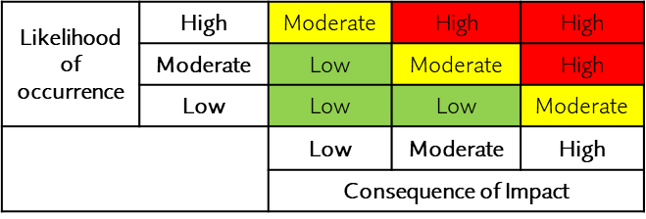
Figure 9: Vulnerability matrix

Plan Component IV: Partner Engagement to Identify and Evaluate Intervention Options
Once the risk analysis and evaluation processes were completed for all the risks/threats identified within focus areas of the Reserve, the project staff and partners convened for a ½ day virtual meeting (held in September 2021) to identify possible intervention strategies that could be implemented to protect the reserve against the risk/threat and lessen the impact of any consequences of the risk/threat. Due to time constraints of the meeting and the goal of fostering comprehensive discussions and effective brainstorming of possible intervention actions, the areas of focus for this activity were narrowed down to Bird Shoal, the Northern Shoreline, and Middle Marsh, and two threats for each area with a high or moderate vulnerability score were selected for partners to focus on. A summary of the select geographic areas and threats to be evaluated by partners is found, below, in Figure 10 and a detailed version is found, here.

Geographic area | Climate stressor | Risk/Threat | Habitats affected | Vulnerability score | Intervention action
Northern shoreline (Town Marsh & Carrot Island dredge spoils + shoreline) | SLR | Rising water levels will inundate shoreline, intertidal and supratidal vegetation | Sand flats, marsh, oyster reefs | High | Determine after partner input
 | SLR; extreme events | Rising water levels erode shoreline along Taylor's Creek | Sand flats, marsh | High | Determine after partner input
Bird Shoal & Flats | SLR; extreme events | Increased wave energy through a wider inlet accelerates northward movement of Bird Shoal and extends horizontal length to the east | Sand flats, sand dune, marsh | High | Determine after partner input
 | SLR; extreme events | Marsh becomes inundated by rising water levels or storm surges | Marsh | High | Determine after partner input
Middle Marsh | SLR; extreme events | Rising water levels and/or storms increase erosion of marsh patches | Marsh, SAV | High | Determine after partner input
 | SLR | Rising water levels inundate habitats | Marsh, shellfish beds | Moderate | Determine after partner input

Figure 10. Summary of select geographic areas and threats for partner input.

Prior to the partner meeting, partners were asked to prepare by reviewing and familiarizing themselves with select sections of the Resilience Hub website and knowledge base library. During the partner meeting, the online program Mural was utilized to facilitate brainstorming and prioritization of intervention ideas to address threats. Mural is a collaborative tool that acts as an online whiteboard, allowing all participants to write, draw, post, and comment on the whiteboard itself.
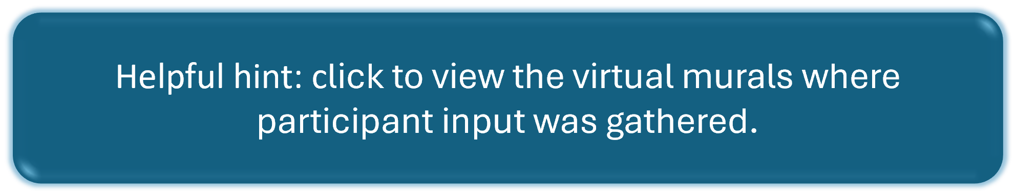
Partners were divided into three breakout groups, with the groups rotating through each of three geographic area murals during timed sessions. Partners were guided through numbered sections (1-7) of each mural by a facilitator. Partners engaged directly with the murals by providing input in sections 3, 4, 6, and 7. The mural sections are presented visually in the link above and outlined, below:
- Maps and reference for geographic area of interest (Northern Shoreline, Bird Shoal and Flats, or Middle Marsh), aerial imagery and habitat and/or shoreline change maps were provided.
- Threat one: vulnerability summary that includes a description of the threat, climate stressors, habitats affected, consequences, vulnerability score and vulnerability confidence.
- Threat one: Should we intervene within 30 years? If so, what are the top five strategies or interventions to address the threat?
- Threat one: Strategy or intervention priority ranking with consideration to vulnerability and feasibility.
- Threat two: vulnerability summary that includes a description of the threat, climate stressors, habitats affected, consequences, vulnerability score and vulnerability confidence. Threat two: Should we intervene within 30 years? If so, what are strategies or interventions to address the threat?
- Threat one: Should we intervene within 30 years? If so, what are the top five strategies or interventions to address the threat?
- Threat two: Strategy or intervention priority ranking with consideration to vulnerability and feasibility considerations.
For sections 4 and 7 of the murals, partners evaluated potential strategies for their feasibility, taking into account technical considerations (e.g., engineering feasibility, effectiveness), social considerations (e.g., is there community support for the action?), environmental considerations (e.g., secondary impacts, affecting protected species or other assets or resources), and considerations of rules, regulations, permitting, and administrative capacity (e.g., funding, staffing, maintenance). These considerations were adapted from the STAPLEE method, developed by the Federal Emergency Management Agency (FEMA) for their state and local mitigation planning guide. Detailed partner input by geography and threat is included in Appendix 3.
Plan Component V: Prioritization of Threat Interventions Using “Resist-Accept-Direct” Framework
The RAD framework is a decision-making tool that has come into use in the last decade by natural resource managers from different agencies such as the National Park Service, the U.S. Fish and Wildlife Service, the U.S. Geological Survey, and more. The framework provides three management directions in which to respond to ecological changes:
- Resist the trajectory of change, by working to maintain or restore ecosystem processes, function, structure, or composition based upon historical or acceptable conditions
- Accept the trajectory of change, by allowing ecosystem processes, function, structure, or composition to change, without intervening to alter their trajectory or
- Direct the trajectory of change, by actively shaping ecosystem processes, function, structure,
or composition towards desired new outcomes.”

A subset of threats and geographies (water level rise at Middle Marsh and increased wave energy at Bird Shoal) assessed during the partner meeting were evaluated using the resist-accept-direct (RAD) framework²⁸. The intention of Reserve staff was to crosscheck partner meeting outcomes with project leadership team perspectives for the purpose of ensuring that appropriate on-the-ground projects were selected for short-term implementation. The team’s RAD analysis is summarized in this worksheet and intervention action priorities are summarized in the table, below (Figure 11). It is important to remember that the RAD activity was performed on a select set of recommended interventions. The entire list of recommended interventions provided during the partner meeting is found in Appendix 3.

Geographic focus area | Resist, Direct, Accept | Intervention action | Comments
Bird Shoal - western end | Direct | Manage sediment to maintain beach and dune, protect tidal embayment, and provide protection for the Town of Beaufort.
Middle Marsh - southwest ribbon of marsh | Resist | Protect seagrass bed by enhancing southwest ribbon of marsh with tested methods such as installation of fringing oyster reefs to resist further erosive changes.
Middle Marsh - wading bird rookery | Direct | Manage elevation with sediment placement and plantings in select areas.
Middle Marsh - generally, across the area | Accept | Allow natural processes to continue while monitoring rates of change and begin research on possible future mitigation strategies such as thin layer deposition and creating in-water sediment feeders nearby. | Accept in the short term and re-evaluate based on research and monitoring.

Figure 11 Summary of prioritized intervention actions that emerged after the RAD framework was applied.
Next Steps
The Reserve’s intent is to seek funding for priority research, restoration and/or enhancement activities identified through this planning process. After this plan was drafted, NFWF funding was used to hire Kris Bass Engineering to conduct a feasibility study and concept plan for restoration and enhancement work at western Bird Shoal. Applications for Bird Shoal construction funding have not been successful and the Reserve will apply for upcoming opportunities. For the Middle Marsh wading bird breeding rookery, funds have been secured for a restoration feasibility study, which is currently underway. Reserve staff will periodically re-evaluate threats and management actions identified during the partner workshop that did not emerge as high priorities at that time and possibly add new priority intervention actions to this plan.
Figure SEQ Figure \* ARABIC 8: Overview of the planning process
ACKNOWLEDGEMENTS

The NCNERR would like to thank the National Fish and Wildlife Foundation and the North Carolina General Assembly for funding this resilience project. Outside of the project leadership team, additional Reserve staff were instrumental in assisting with this process. In particular, thank you to Duncan Anderson, the Reserve’s GIS Specialist, for conducting the habitat and shoreline change analyses.

This collaborative process would not have been possible or nearly as productive and comprehensive without the knowledge and expertise that our partners contributed. Thank you to all of the participants that attended the partner meeting in September 2021, including Gregory Rudolph (Carteret County Shore Protection Office), Dr. Justin Ridge (Duke University), Dr. Rachel Gittman (East Carolina University), Kat Cerny-Chipman and Sam Whitin (EA Engineering), Dawn York (Moffatt & Nichol), Mary Schoell (National Estuarine Research Reserve Association), Jeff West (National Park Service Cape Lookout National Seashore), Cat Bowler (NC Audubon Society), Lexia Weaver (NC Coastal Federation), Tancred Miller and Mackenzie Todd (NC Division of Coastal Management), Misty Buchanan and Brenda Wichmann (NC Natural Heritage Program), Sarah Spiegler (NC Sea Grant), Drs. Michael Burchell and Celso Castro-Bolinaga (NC State University), Dr. Tony Rodriguez (University of North Carolina-Institute of Marine Sciences), Matthew Godfrey (NC Wildlife Resources Commission), Drs. Carolyn Currin and Jenny Davis (NOAA National Centers for Coastal Ocean Sciences), Miriam Sutton (Reserve volunteer), John Day and Samantha Burdick (Town of Beaufort), Dr. Susan Cohen and Peggy Mullin (University of North Carolina), and Jason Glazener and Emily Hughes (U.S. Army Corps of Engineers).

REFERENCES
Barbier, E. B., Hacker, S. D., Kennedy, C., Koch, E. W., Stier, A. C., & Silliman, B. R. (2011). The
value of estuarine and coastal ecosystem services. In Ecological Monographs (Vol. 81, Issue 2).

Dobson, G., Johnson, I., Rhodes, K., Hutchins, M., & Chestnutt, M. (2019). Regional Coastal Resilience Assessment. National Fish and Wildlife Foundation (NFWF). Washington, D.C.

Environmental Protection Agency (EPA) Office of Water. (2014). Being Prepared for Climate Change: Workbook for Developing Risk Based Adaptation Plans.

Federal Emergency Management Agency (FEMA) 2003. State and Local Mitigation Planning How-To Guide:
Developing the Mitigation Plan – Identifying Mitigation Actions and Implementation Strategies. http://mitigation.eeri.org/wp-content/uploads/FEMA_386_3.pdf

Field, D., Kenworthy, J., & Carpenter, D. (2021). Extent of Submerged Aquatic Vegetation: High
Salinity Estuarine Waters Metric Report.

Grabowski, J. H., Brumbaugh, R. D., Conrad, R. F., Keeler, A. G., Opaluch, J. J., Peterson, C. H.,
Piehler, M. F., Powers, S. P., & Smyth, A. R. (2012). Economic valuation of ecosystem services provided by oyster reefs. BioScience, 62(10), 900–909. https://doi.org/10.1525/bio.2012.62.10.10

Kunkel, K. E. , D.R. Easterling, A. Ballinger, S. Bililign, S.M. Champion, D.R. Corbett, K.D. Dello, J.
Dissen, G.M. Lackmann, R.A. Luettich, Jr. , L.B. Perry, W.A. Robinson, L.E. Stevens, B.C.
Stewart, & A.J. Terando. (2020). North Carolina Climate Science Report. https://ncics.org/nccsr

Kutcher, T.E. (2008). Habitat and Land Cover Classification Scheme for the National Estuarine Research Reserve
System. National Estuarine Research Reserve System (NERRS). https://coast.noaa.gov/data/docs/nerrs/NERRS_Classificaiton_Scheme_Documentation.pdf

National Oceanic and Atmospheric Administration (NOAA). (2010). Adapting to Climate Change: A Planning Guide for State Coastal Managers. http://coastalmanagement.noaa.gov/climate/adaptation.html

National Oceanic and Atmospheric Administration (NOAA) Office for Coastal Management. (2016). Guide for
Considering Climate Change in Coastal Conservation. https://coast.noaa.gov/data/digitalcoast/pdf/considering-climate-change.pdf

National Oceanic and Atmospheric Administration (NOAA) Office for Coastal Management. (2022). Sea Level Rise
Viewer. https://coast.noaa.gov/digitalcoast/tools/slr.html

North Carolina Coastal Resources Commission Science Panel. (2015). North Carolina Sea Level Rise Assessment Report.

North Carolina Coastal Reserve and National Estuarine Research Reserve (NCNERR). (2022). Rachel Carson
Reserve Resilience Hub. https://data-ncdenr.opendata.arcgis.com/pages/dcm-rachel-carson-reserve

North Carolina National Estuarine Research Reserve. (2020). North Carolina National Estuarine Research Reserve
Management Plan 2020-2025.

North Carolina Natural Heritage Program (NCNHP). (2022). Natural Heritage Data Explorer. https://ncnhde.natureserve.org/content/map. North Carolina Department of Natural Resources, Raleigh,
NC.

North Carolina Department of Environmental Quality (NCDEQ). (2020). North Carolina Climate Risk Assessment and Resilience Plan. (2020).

North Carolina Department of Environmental Quality (NCDEQ). (2021). North Carolina Coastal Habitat Protection Plan 2021 Amendment. 266 p.

Plunket, Jennifer. (2018). Saltmarshes in the Southeast Climate Change Vulnerability Assessment. https://ccvatch.wordpress.com

Rouleau, T., Colgan, C. S., Adkins, J., Castelletto, A., Dirlam, P., Lyons, S., & Stevens, H. (2021). The Economic Value of America’s Estuaries: 2021 Update. http://www.estuaries.org/

Shepard, C. C., Crain, C. M., & Beck, M. W. (2011). The protective role of coastal marshes: A systematic review
and meta-analysis. PLoS ONE 6(11). https://doi.org/10.1371/journal.pone.0027374

Shutak, M. (2016, May 11). Overwash at shoal worries town staff. Carteret County News-Times. https://www.carolinacoastonline.com/news_times/article_dc2c6c14-1786-11e6-86c4 37990682557e.html

Stevens, R. & Shull, S. (2021). Landscape Scale Marsh Resilience.
https://www.nerra.org/landscape-scale-marshresilience/

Sutherland, S. A., von Haefen, R. H., Ellis, T., Crowell, B., Kenworthy, J., Cathey, D., Dietz, D., Jennings, H., Puckett, B., Harrison, J., Rozowski, C., Liu, Y., Ermagassen, Z., Deangelis, B., & Li, Y. (2021). Economic
Valuation of Submerged Aquatic Vegetation in the Albemarle-Pamlico Estuary Final Report.

Sutton-Grier, A. E., Wowk, K., & Bamford, H. (2015). Future of our coasts: The potential for natural and hybrid
infrastructure to enhance the resilience of our coastal communities, economies and ecosystems.
Environmental Science and Policy, 51, 137–148). https://doi.org/10.1016/j.envsci.2015.04.006

Theuerkauf, E. J., Stephens, J. D., Ridge, J. T., Fodrie, F. J., & Rodriguez, A. B. (2015). Carbon export from fringing
saltmarsh shoreline erosion overwhelms carbon storage across a critical width threshold. Estuarine,
Coastal and Shelf Science, 164, 367–378. https://doi.org/10.1016/j.ecss.2015.08.001

Town of Beaufort, North Carolina (2022). Comprehensive and CAMA Land Use Plan. Draft. Accessed May 2022. https://www.beaufortnc.org/sites/default/files/fileattachments/planning_and_inspections/page/ 031/compplanbeaufort_draft.pdf

APPENDIX 1:

Protected species of the Rachel Carson Reserve
Table SEQ Table \* ARABIC 1: Habitats of the Rachel Carson Reserve
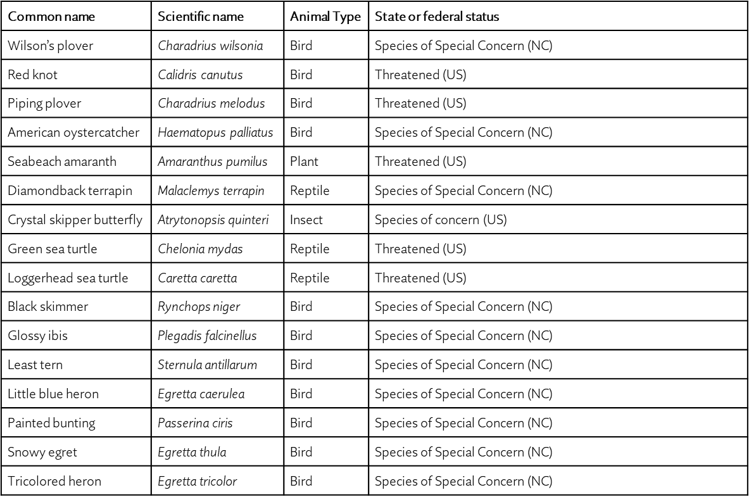
APPENDIX 2:
Research Needs at the Rachel Carson Reserve

This is a list of research needs related to resilience for the Rachel Carson Reserve generated by the project team and partners during planning meetings from 2020-2021.
- Understand and quantify the contribution of boat wakes, water level rise, and storm events to erosion and shoreline changes in Taylor’s Creek
  - Quantify the amount of wave energy that comes from boat wakes
  - Quantify erosion rates along Taylor’s Creek shoreline
    - Quantify changes in width of Taylor’s Creek over time
    - Understand the relationship between shoreline erosion and boat traffic

- Understand how Beaufort Inlet affects habitat change at RCR

- Understand the impacts of sediment deposition on invertebrate species that use marsh as habitats

- Understand sediment dynamics in the greater area (from Cape Lookout Shoals to Beaufort Inlet)
  - Storm-derived sediment movement
  - Source of sediment that ends up on Bird Shoal

- Identify mechanisms of habitat changes in Middle Marsh

- Quantify elevation changes (gains or losses) in sand flats and dunes around Town Marsh/Carrot Island/Bird Shoal

- Better understand interaction between SAV, oyster reefs, and salt marsh in Middle Marsh as it relates to sediment dynamics
  - Better understanding of seagrass-oyster interactions to help with placement of oyster restoration projects
  - Better understanding of sand dynamics around Middle Marshes to inform possible use of strategic in-water placement of sediment to create subtidal sand flats as feeders for marsh areas

- If/how oyster distribution in the intertidal zone will change with increasing temperatures

- Understand the impact that feral horses have on marsh propagation (Spartina alterniflora) through seed dispersal
  - Understand seed viability after it passes through the digestive tract of feral horses. If viable, does it successfully propagate into new plants in the field?

APPENDIX 3:
Partner Meeting Intervention Summary by Geography and Threat

Three breakout groups rotated between geographic area Murals™ and each provided input which was documented by a notetaker or transcribed directly from the participant’s virtual sticky notes. The virtual murals can be viewed, here.

Northern Shoreline

THREAT 1: Rising water levels will inundate shoreline and habitats along the shore
- Research/monitoring needs:
  - Sediment deposition (rates, locations, sources, elevation, etc.)
  - Coastal currents
  - Where wave energy comes from (i.e., how much is from boat wakes)
  - If sand flats have gained or lost elevation
  - If TLP is needed
  - Place SET somewhere on northern shoreline to understand what marshes are doing in response to SLR
  - Experimental use of different planting strategies, grading options, and living shoreline approaches. Monitoring of performance of restoration and other interventions
  - Impacts of deposition on the invertebrates and other species that are currently using the marshes
  - Monitoring other stressors along Taylor's Creek (water quality, shoreline development, boat traffic)
- Possible strategies:
  - Beneficial use of dredged material and thin layer placement to elevate marshes
    - Feasibility considerations: unknowns about placement locations, logistics, pollutant levels, sediment dynamics, currents, permitting challenges
  - Planting or addition of animals to enhance marsh & upland habitats
    - Feasibility considerations: more feasible than TLP as far as permitting, uncertainty regarding ROI for reducing vulnerability
  - Work with regulatory and resource agencies to reform/streamline permitting process to allow for use of confined disposal facilities on the RCR to restore marsh habitat
  - Ex-closure fencing to prevent horse overgrazing on east Carrot Island/Treasure Island
  - Oyster restoration/living shorelines farther into the marsh cheeks
  - Planting native species
  - Invasive species removal
  - Monitoring species (especially vulnerable species)

THREAT 2: Shoreline erosion along Taylor's Creek
- Research/monitoring needs:
  - Quantify shoreline erosion rates along Taylor’s Creek
    - how the width of Taylor’s Creek has changed over time
    - Is there an increase in shoreline erosion related to the recent increase in boat traffic?
- Possible strategies:
  - Coordination w/ Waterways/Harbor Committee (Town of Beaufort)
    - Reserve present final resilience plan to Harbor committee
  - Engage with clean marina/clean boater program to education re: no wake zones
  - Enforcement of ferries observing no wake zone
  - Enforcement of 10-day anchorage limit
  - Potential hardened structure to reduce erosion

Overall Questions/Comments:
- Is the RCR open to habitat type change over the 30-year timeframe? If so, focus on subtidal habitat?
- Possible to grade some of those deposits that are already there?
- Southern shoreline may be less stable/more vulnerable than northern shoreline
- Bird Shoal and Middle Marsh may be more important to focus on than northern shoreline

Bird Shoal

THREAT 1: Increased wave energy through a wider inlet accelerates northward movement of Bird Shoal and extends horizontal length to the east
- Research/monitoring needs:
  - Sediment dynamics (modelling) from CALO shoals to Beaufort Inlet
    - Monitoring storm-derived sediment movement
  - Source of sediment
  - Habitat change and species habitat utilization → in tandem w/ sediment dynamics study
- Possible strategies:
  - Sand deposition in historic placement areas or around west end of shoal.
    - Dredged material could be placed on eastern spit of Shackleford Banks and would provide protection to Bird Shoal
  - Dune planting and/or sediment addition to dunes at west end of Bird Shoal
    - Sugarloaf Island has similar issues → act as an example
    - Dunes built could be thought of as sacrificial. Could build dunes but be ok with material being washed into marsh

Overall Questions/Comments:
- Bird Shoal is currently migrating (like a barrier island) northward toward Town Marsh and Horse Island-- and may be in the future.
- Port needs to be involved with this discussion - what is the future of the port as they look to expand?
- Partner with the NPS to evaluate future management efforts and what opportunities there may be to protect RCR.
- What are the interactions with surrounding islands, including Radio Island? Extensive erosion has been observed on Radio Island as well.
- Opportunities are there but will involve habitat tradeoffs and will need to be careful about type of sediment added to intertidal habitats

Middle Marsh

THREAT 1: Rising water levels and/or storms increase erosion of marsh patches
- Research/monitoring needs:
  - Identify mechanisms of change (e.g SLR vs. boat wakes)
  - Evaluate data on sea level impacts to middle marsh, e.g., is it keeping up with sea level rise?
  - Better understanding of interaction between SAV and salt marsh as it relates to sediment dynamics
- Possible strategies:
  - Sediment placement in interior
  - Terrestrial plantings for stabilization
  - Oyster reef outside of the SW corner and along the western side/inside of SW marsh ribbon
    - Perpendicular reefs functioning as groins could help keep sediment in particular locations
    - May be permitting issues with SAV nearby
  - No-Go zones for boaters
    - Low feasibility: difficult to enforce

THREAT 2: Habitats are inundated by rising water levels
- Research/monitoring needs:
  - Better understanding of sediment dynamics especially with respect to changing inlet morphology
  - Experimental interventions via research and monitoring
  - Better understanding of interaction between SAV, oyster and salt marsh as it relates to sediment dynamics
    - Better understanding of seagrass-oyster interactions to help with placement of oyster restoration projects
- Possible strategies:
  - Oyster restoration along marshes with scarped or eroding edges
    - Design of oyster restoration will depend on energy setting
  - Thin layer placement to elevate marsh
    - Work with partners (i.e. Carteret County) for use of sediment from navigation channels
    - Permitting concerns
    - Start w/ small research plots
    - Do in colder months when less vulnerable species present
    - Leverage experts from Louisiana
  - Seagrass restoration
    - Climate change/warming waters may dictate the success/failure of seagrass restoration. Species will matter
  - Strategic in-water placement of dredge spoil to create su tidal flats as “feeders” for sustaining Middle Marsh
    - Need to first do as a research/demonstration scale
    - Sediment transport/dynamics modeling would be important for this strategy and can be done with existing data

Overall Questions/Comments:
- Will oyster distribution in the intertidal change with increasing temperatures?

Whole Group Discussion
- Northern Shoreline is not the most vulnerable place compared to Bird Shoal and Middle Marsh
- Research and monitoring should be incorporated within each project
- Middle Marsh has very vulnerable habitats, and any intervention needs to be interconnected to impact all the habitats (e.g., SAV restoration, oyster restoration, adding high ground to preserve rookery)
- Combining restoration with research makes it more attractive to permitting agencies
- Sediment dynamics/energy transport is a big knowledge gap
- Bird Shoal/Northern shoreline are acting like barrier islands (the dunes roll back, sand overwashes into marsh, and entire complex is moving northward) but the issue arises when there is a barrier behind a barrier island (i.e., the shoreline of Beaufort)

NCDEQ 2020
NOAA 2022
N.C. Coastal Resources Commission Science Panel 2015.
Ibid.
Kunkel et al. 2020
NOAA 2022
Ibid.
Ibid.
Dobson et al. 2019
NCNHP 2022
Barbier et al. 2011, Grabowski et al. 2012, Shepard et al. 2011
Sutherland et al. 2021, Field et al. 2021
Sutton-Grier et al. 2015
Rouleau et al. 2021
Sutherland et al. 2021
Plunket 2018
Stevens & Shull 2021
Shutak 2016
Theuerkauf et al. 2015
Town of Beaufort 2022
NCDEQ 2022
EPA 2014, NOAA 2010
Schuurman et al. 2020
EPA 2014
https://www.mural.co/
FEMA 2003
Schuurman et al. 2020

