Town of Duck

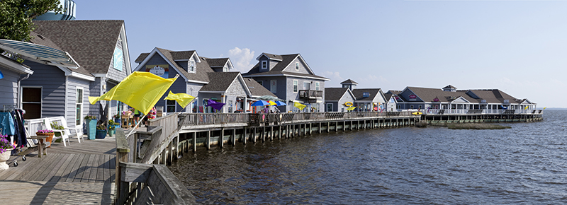
Duck boardwalk and shops. Photo credit: OBX Guides

Resilience Evaluation and Needs Assessment
Final Report
April 2018

Table of Contents
Project Overview..……………………………………………………………………………………………………….....2
Purpose and Scope………………………………………………………………………………………………………....3
Section 1: Introduction…………………………………………………………………………………………………….5
Section 2: RENA Framework in Practice……………………………………………………………………………6
Resilience evaluation (RE) process
2.1.RE: Map assets…………………………….…………………………………………………………………7
2.2.RE: Identify current issues………………………………………………………………………………8
2.3.RE: Conduct public input meetings…………………………………………………………………9
2.4.RE: Overlay current and future models…………………………………………………………..9
Needs Assessment (NA) process
2.5.NA: Identify hotspots…………………………………………………………………………………….10
2.6.NA: Prioritize assets………………………………………………………………………………………10
2.7.NA: Document existing projects…………………………………………………………………….10
2.8.NA: Explore future projects……………………………………………………………………….....12
Data Resources……………………………………………………………………………………………………………….13
Funding Resources………………………………………………………………………………………………………….15
Appendix…………………………………………………………………………………………………………………………19

Project Overview
In 2016, The Division of Coastal Management (DCM) commenced a five-year project to create a resilience framework guide for coastal communities in North Carolina. DCM hired a two-year Fellow, Monica Gregory, as part of the Coastal Management Fellowship (CMF) through the National Oceanic and Atmospheric Administration (NOAA). The Fellow was hired to lay the groundwork for the guide by working with five communities to implement a vulnerability assessment and a needs assessment within their towns. The five communities will serve as case studies in the guide to illustrate the planning process, highlight best practices, and discuss resilience projects identified through the vulnerability assessment. Edenton, Pine Knoll Shores, Oriental, Duck, and Hatteras Village participated in the project. The outcome of the five-year project will be a comprehensive guide to resilience-building in coastal communities in North Carolina.
The final guide aims to serve local governments by:
1) illustrating a successful planning framework they can use to engage their communities in resilience and adaptation projects;
2) identifying common needs from local governments and compiling state and federal resources that can address those needs;
3) providing case studies across the North Carolina coast that can help guide other local governments in resilience planning;
and
4) discussing adaptation and mitigation strategies that can be applied in a variety of situations experienced by coastal communities in our state.

Purpose and Scope for Duck
The purpose of this two-year project is to identify and map important social and physical assets in Duck that may be vulnerable to current and future impacts from coastal hazards, including sea-level rise and storm surge. The planning process will help Duck identify hotspots where the town can prioritize resilience-building projects. Through the process, participants will also identify local government and community-specific needs in building resilience.
Duck is part of Dare County’s robust multi-jurisdictional hazard mitigation plan. Through mapping and community planning, this project adds research to assist Duck in meeting several of their Hazard Mitigation Action Plan (HMP) goals:
Preventive Goals
    - Goal 3a: Identify areas vulnerable to stormwater problems (p. 243)
    - Goal3c: Provide funding for stormwater improvements (p. 243)
    - Goal 4a: Adopt and apply development policies that balance protection of natural resources and fragile areas with residential and economic development (p. 244)
    - Goal 4b: Develop policies that minimize threats to life, property, and natural resources resulting from development located in or adjacent to hazard areas, such as those subject to erosion, high winds storm surge, flooding, or sea level rise (p. 244)

Property Protection Goals
- Goal 7c: Enroll in the FEMA Community Rating System and take advantage of the various mitigation strategies promoted by the program (p. 246)

Natural Resource Protection Goals
- Goal 9a: Identify vulnerable areas and conditions (p. 247)
- Goal 10a: Identify available property for open space (p. 247)

Structural Project Goals
- Goal 14b: Identify capital projects to address drainage issues on NC 12 (p. 251)

In addition, the RENA project can assist Duck in realizing their 2027 vision by providing additional data to help the town plan for adapting Duck Village to future flood impacts; protecting vibrant, thriving businesses in town; and creating responsive town staff and leaders that are prepared for future climate scenarios.
This guide draws from the HMP for general information on Duck such as hazards, demographics, capabilities, and risk. This guide adds to the information Duck and Dare County already possess by mapping repetitive flooding in the town based on staff knowledge as well as gathering more in-depth input about community priorities. It also identifies specific areas, such as streets, intersections, and buildings, that the town can target for resilience work.
The final map and guide for Duck can be used for resilience planning purposes as well as for future grant applications related to resilience-building to highlight identified areas in need of adaptation and mitigation projects. DCM strongly recommends the Town of Duck holds a public workshop or input session to allow residents to voice their concerns, priorities, and needs. In addition, the public workshops were very well-received and helped build community support for resiliency planning.

Section 1: Introduction
Regional survey
In February 2017, DCM released a survey to local-level staff and elected officials in coastal towns and counties to better understand their experiences with hazards and their needs for addressing them. DCM had an 11% response rate, which is about average for an online survey. Through questions about impacts from coastal hazards and existing planning efforts, DCM identified a critical need for a formal resilience planning framework to be used by regional, county, and town staff in adapting to and mitigating impacts from major and minor storms, sea level rise, hurricanes, and Nor’easters, among other hazards.
DCM staff formed an advisory committee to guide the research and selection process. Advisors included staff from The Nature Conservancy, North Carolina Sea Grant, the Coastal Federation, and DCM planners and field staff. DCM conducted a review of published resilience guides and community resilience planning methodologies.
DCM drew from various resources to create the methodology used in pilot communities. The Community Resilience Building guide, the U.S. Climate Resilience Toolkit, the California Adaptation Planning Guide, and the Community Based Vulnerability Assessment Guide from MDC, Inc. and UNC Chapel Hill strongly influenced this project.

Selection process
To select pilot communities for case studies, DCM staff consulted state planners, state field staff, and nonprofit organizations for recommendations on towns with staff capacity and community buy-in to work through this process from beginning to end. After receiving recommendations to reach out to Duck, DCM staff held an initial scoping meeting with the town manager and planner in December 2016. After discussing their history with coastal hazards, staff capacity, and community dynamics, the Town of Duck accepted our invitation to participate in the pilot program as one of five case study communities in the DCM resilience framework guide.

Section 2: RENA Framework in Practice
DCM used the following eight-step process in each pilot community, divided into the resilience evaluation phase and the needs assessment phase:
Resilience evaluation (RE):
- Map assets
- Identify current issues
- Conduct public input meetings
- Overlay current and future models
Needs assessment (NA):
- Identify hotspots
- Prioritize assets
- Document existing projects
- Explore future projects

Resilience Evaluation (RE)
2.1.RE. Map assets
In March 2017, DCM staff met with the planner to map community assets and discuss potential physical and social vulnerabilities in Duck. DCM downloaded a base map of the town from ArcGIS and printed the map at a large enough scale to identify roads and specific parcels. DCM brought the map to the meeting.
At the mapping meeting, the planner worked with DCM to physically color in parcels that are considered important assets to Duck. DCM staff provided sharpies, highlighters, post-it notes, and colored tabs at the meeting. For each asset category, one color was used. For example, critical facilities like town hall and the fire station were identified then colored with red sharpie. DCM staff recorded their color and location to later create a GIS attribute table and a key for the map.
Under the GIS polygon layer, town staff identified community assistance, critical facilities, flooding, historical sites, HOA water access, private recreation, public recreation, research sites, stormwater ponds, and utilities as physical vulnerabilities. In addition, DCM and town staff identified repetitive loss properties for internal use only per the Privacy Act of 1974.
Duck identified high traffic areas, such as shopping centers, as social vulnerability components to include on the map. Residents and tourists frequent high traffic areas in large numbers, particularly during the summer months. These areas are particularly vulnerable during the tourist season and can be targeted for pre- and post-disaster protocols and education programs. Though not included in this project, additional social vulnerability indicator data exists, such as census data on reported income and data on property tax value. Such indicators can be used to identify areas where financial resources for recovery post-disaster may be limited. Social vulnerability indicators that may be used in other communities – such as concentrated areas of 65+ residents, concentrated areas of non-English speakers, and concentrated areas where people have low trust in government – do not exist in Duck.
After working with the planner, DCM staff returned to their home office and used the transferred information on the physical map to a digital map in ArcGIS. DCM created a narrative explaining the map as well as a key to use with the map. After multiple revisions, Duck’s Board of Commissioners approved the vulnerability map and narrative.
2.2.RE. Identify current issues
Through online surveys, DCM collected the experiences and viewpoints of staff and elected officials in Duck. The survey focused on staff knowledge and experience with coastal hazards and their impacts in the community.
Town Staff Survey Results
Nineteen staff members, elected officials, and appointed board members participated in the survey on coastal hazards and their impacts in Duck, with ten respondents having worked for the town for six or more years.
Hazards
Out of a list 15 potential hazards, the most selected issues were beach erosion/estuarine shoreline erosion (18); drainage issues (18); hurricanes (18); damaging winds (18); flooding due to heavy precipitation/stormwater management issues (18); and Nor’easters (18). When asked to list the three most pressing environmental issues facing Duck, respondents overwhelmingly cited beach erosion (14), followed by stormwater management issues (4) and high winds (4). Respondents cited damage to the economy (11), property damage (6), and limited access to the town and property (5) as the most commonly experienced impacts from flooding and other hazards.

Flooding
Most respondents believe Duck could withstand and recover from a minor storm with limited flooding: on a scale of one to ten, 17 of 18 respondents rated Duck’s ability to recover as an eight or above. Respondents say Duck staff is “prepared for minor flooding and storm damage.”
Respondents differed in their thoughts on whether Duck could withstand and recover from a major storm with extensive flooding, with eight respondents ranking Duck’s ability as a five or less. One respondent explained that “[the town] lacks the personnel or resources to quickly recover from a major storm, especially if much of the east coast is impacted by the same event, which will mean many municipalities will be competing for the same resources.”
Specific impacts from flooding
Sixteen respondents listed specific areas around Duck that are impacted by environmental issues. Georgetown Sands (8), Sound Sea Village (7), the sound side of Sanderling streets (6) and Four Seasons (5) were most commonly cited.

Social impacts
Four of 18 respondents believe environmental issues disproportionately affect certain segments of the population in Duck. Respondents cited the elderly (3), low-income (2), and renters (1).
Town Needs
Respondents cited a wide variety of needs to address environmental challenges in Duck. Out of 18 respondents, the most common needs were assistance with finding relevant funding (7); digital resources from state or federal entities (7); and resources to increase community buy-in (7).

2.3.RE. Conduct public input meetings
The Town of Duck was unable to conduct a public input meeting to groundtruth and add to their asset map. DCM strongly recommends town staff hold a workshop with their residents or gather input through a survey process to engage their community in the conversation, include new and diverse voices, and create a more comprehensive, inclusive plan for sea level rise, flooding, and other coastal hazards.
To replicate the RENA workshop process, the Town of Duck can refer to the final project guide located on DCM’s website.
2.4.RE. Overlay current and future models
In 2018, the CMF reached out to The Nature Conservancy (TNC) to request a collaboration between DCM’s asset mapping and TNC’s coastal resilience mapping tool. TNC agreed to host town asset maps so local government staff could easily apply sea level rise and coastal flooding models to their maps. TNC uses NOAA data for a variety of future scenarios; all data are readily available for download through the NOAA Digital Coast’s Coastal Flood Mapper. Potential datasets include:
- Shallow Coastal Flooding - Areas subject to shallow coastal flooding.
- FEMA Flood Zones - Areas at risk from flooding.
- Storm Surge - Areas at risk from storm surge.
- Sea Level Rise - Areas likely to be inundated by sea level rise.
All datasets are available for Dare County. Future scenarios through TNC’s coastal resilience mapper include risk in three separate years: 2045, 2060, and 2100. Town staff and leaders can choose to plan for low, medium, or high risk in any given year to see which assets will be most at risk from one or a combination of hazardous events.

Needs Assessment (NA) Process

2.5.NA. Identify hotspots
Through TNC’s mapping portal, town staff and residents can view their asset maps and overlay sea level rise scenarios, storm surge scenarios, and coastal flooding data. Staff can pinpoint areas to focus resilience-building efforts that are consistent with their ongoing resilience work or with their current town vision. The town staff can decide what planning scenario they wish to use: for example, a town can use the medium sea level rise scenario for the year 2045 to identify assets and areas they wish to adapt or mitigate from increased flooding.
In the future, town staff can hold additional workshops to better understand community priorities in the face of sea level rise, increased frequency and severity of storm surge, and increased flooding.

2.6.NA. Prioritize assets
The Town of Duck can prioritize assets and areas of vulnerability to focus their resilience-building efforts. Assets could be prioritized be residents in the community; by cost-benefit or return-on-investment analyses; or by other means selected by town staff. Staff could hold additional workshops to receive input from residents regarding asset prioritization.
2.7.NA. Document existing projects
The Town of Duck has been integrating resilience into several of their planning and project processes for several years. Several efforts are included in the following list:
- For many years, the Town of Duck has enforced a variety of development standards intended to manage the density and intensity of new development in the community. These standards include limitations on the maximum impervious coverage of lots, maximum size/occupancy of residences, amount of fill and grading of properties, and removal of trees and other vegetation.
- In January 2018, the Town of Duck adopted an ordinance allowing construction of features often associated with a living shoreline/marsh restoration project, including rip-rap, fill, sills, and groins. The intent was to make it equally easy for a property owner to obtain approval for a more natural shoreline stabilization project as constructing a bulkhead.
- In November 2016, the Town adopted an ordinance permitting the establishment of an accessory dwelling unit on any residential property in Duck. This allowance provides the opportunity for any property owner to construct or convert a modest-sized second dwelling in an attempt to provide affordable housing options on a neighborhood scale.
- With anticipated changes to flood zones in the preliminary flood maps for Dare County, the Town of Duck is working with other municipalities on the Outer Banks to establish higher regulatory construction standards in order to minimize future flood damage by elevating structures and requiring the use of flood resistant materials for new construction and additions to existing structures.
- Over the past decade, the Town of Duck has designed, funded, and constructed at least half a dozen engineering projects addressing stormwater drainage issues along Duck Road (N.C. Highway 12).
- The Town of Duck is presently preparing a stormwater management plan that addresses pumping of stormwater following significant flooding events in cooperation with the N.C. Division of Water Resources.
- In partnership with Dare County, the Town of Duck partially funded and completed a $14 million beach/dune nourishment project along 1.7 miles of the Town’s oceanfront in 2017. The project was intended to stabilize the beach and dune system to prevent property damage and losses in the project area.
- For many years, the Town of Duck has funded the planting of Beach Grass and Sea Oats along its oceanfront dune throughout the Town. The Town has also funded the installation of sand fencing on the dune for the same purpose.
- The Town of Duck has engaged in a significant effort to educate property owners and rental companies about the importance and ways to stabilize the oceanfront dune system.
- The Town of Duck is presently seeking approval to construct a living shoreline/marsh restoration project along a stretch of the Town Park property in Currituck Sound. This project is intended to provide an example of a living shoreline and encourage property owners to consider softer, more natural solutions to shoreline stabilization.
- In coordination with the N.C. Department of Transportation and following input from hundreds of citizens, the Town of Duck adopted a Comprehensive Pedestrian Plan in 2014. The plan outlines many recommendations for constructing new facilities and improving the safety of bicyclists and pedestrians.
- Constructed in three phases over the past decade, the Town of Duck has installed a sound front boardwalk that provides a valuable transportation alternative for pedestrians and lessens the need to construct additional traffic lanes through Duck Village. The boardwalk also offers an opportunity for residents and visitors to appreciate the beauty and nature along the sound.
- The Town of Duck has designed, funded, and is currently under construction of the first phase of bicycle lane and sidewalk improvements throughout Duck Village. Additional phases are anticipated to occur in 2018-19 and 2019-20.
- The Town of Duck participates on the Currituck Sound Science Panel that evaluates the health of the ecosystem and water quality in Currituck Sound.
- The Town of Duck coordinates with the N.C. Aquarium on an educational process and guided tours highlighting wildlife and the ecosystem along Currituck Sound.
- The Town of Duck offers presentations and information about local wildlife on its website.

2.8.NA. Explore future projects
The following policies and projects are not prioritized. Town staff can prioritize the list based on cost, asset vulnerability, or community preference, if desired. The list serves to inspire residents, officials, and staff to work collaboratively to make the Town of Duck the most resilient town it can be. Additionally, towns that conducted public workshops received various suggestions from residents; Duck could benefit from a workshop process to better understand what the community envisions in terms of resiliency to coastal hazards.
Suggestions from DCM:
- Adopt the final vulnerability map into land-use planning decisions to decrease unsustainable development in areas vulnerable to sea level rise or flooding.
- Align community plans through the lens of resilience, including economic plans, housing plans, and natural resource management plans.
- Work with the Community Rating System to increase Duck’s rating and reduce the cost of flood insurance. Work with The Nature Conservancy and other entities like the Coastal Federation to achieve a higher score.
- Increase freeboard requirements within the town boundaries.
- Prepare for future sea level rise and flooding impacts by using long-term planning scenarios such as “medium” or “high” scenarios in year 2100.
- Work to plan collaboratively for climate impacts at the watershed level. Bringing entities such as town officials, county officials, and neighboring town staff and officials will be critical. The Albemarle Pamlico National Estuary Partnership (APNEP) can help facilitate meetings or workshops related to climate planning.
- Create emergency plans for all public institutions. Plans for state buildings, churches, and other historic buildings (private and public) could be created. Duck staff and business leaders could use the Red Cross Ready Rating Program to create emergency plans.
- Communicate the benefits of living shorelines to property owners in Duck if environmental conditions are suitable for soft stabilization.

Data Resources
The following resources are tools and useful guides to plan for resilience. Researchers, planners, and town managers may find them helpful in the context of hazard mitigation, resilience-building, and community engagement.
- Coastal Inundation Toolkit (NOAA Digital Coast):
A toolkit that communities can use to understand coastal inundation and to identify their risks and vulnerabilities. Users can visualize information to better explain risk concepts: https://coast.noaa.gov/digitalcoast/training/coastal-inundation-toolkit.html
- Coastal Resilience Index (Mississippi-Alabama Sea Grant Consortium):
A guide that can communities can use to examine different elements to increase their resilience: http://masgc.org/news/article/assessing-resilience-cri
- Community Based Vulnerability Assessment, 2009 (University of North Carolina and MDC, Inc.):
A guidebook for communities to walk through the process of assessing their physical and social vulnerabilities, with an emphasis on social justice and inclusion:
http://www.mdcinc.org/sites/default/files/resources/Community%20Based%20Vulnerability%20Assessment.pdf
- Community Toolbox (University of Kansas):
A toolbox with extensive resources to better understand and engage with community members. The toolbox includes resources for developing assessment plans, understanding and describing communities, and conducting focus groups, among others: http://ctb.ku.edu/en/table-of-contents
- Naturally Resilient Communities, 2017 (APA, TNC, ASCE, and partners):
An online tool that helps decision-makers explore solutions to natural hazards based on the type of hazard, the type of community, the project scale, and the project cost. Additionally, the tool provides case studies from several regions in the U.S.:
http://nrcsolutions.org/strategies/?fwp_hazards=coastal
- The U.S. Climate Resilience Toolkit, 2016 (NOAA):
The Toolkit is designed to help people find and use tools, information, and subject matter expertise to build climate resilience. The Toolkit offers information from across the U.S. federal government in one easy-to-use location. https://toolkit.climate.gov/
- Vulnerability, Consequences, and Adaptation Planning Scenarios (VCAPS) tutorial, 2013 (University of South Carolina, South Carolina Sea Grant Consortium, Carolinas Integrated Sciences and Assessments, and Social and Environmental Research Institute): A tutorial that walks through the process of using VCAPS, a tool for community decision-makers to better understand the challenges their communities face under climate change stressors: http://www.vcapsforplanning.org/docs/VCAPS%20UserGuide%2025March13.pdf
- Rising to the Challenge, Together, 2017 (The Kresge Foundation): An overview of the climate adaptation field with guidance on how to move forward cohesively: https://kresge.org/content/rising-challenge-together?utm_source=ASAP&utm_campaign=5851507e8a-EMAIL_CAMPAIGN_2017_12_29&utm_medium=email&utm_term=0_390b9a48ee-5851507e8a-420011193&mc_cid=5851507e8a&mc_eid=0e67b19bed
- ClimateAssessment.org, 2018 (National collaboration): ClimateAssessment.org facilitates rigorous and transparent evaluation of climate science and climate adaptation/mitigation practice, and aims to further develop and support a network of scientists and practitioners in producing, managing, and using credible and relevant climate-related information: https://www.climateassessment.org/
- Coastal Resilience, 2017 (The Nature Conservancy): A portal by The Nature Conservancy focused on case studies, mapping tools, and resources for communities to build their resilience to coastal hazards and their impacts: http://coastalresilience.org/

Funding Resources
The following list compiles information on local and national grant programs, information on nonprofits and agencies focused on funding resiliency-related projects, and existing lists of funding sources from other organizations. This list is not comprehensive.
Grants
- State Grant Program - North Carolina’s Department of Environmental Quality, Division of Coastal Management (DEQ-DCM) Planning and Management Grants
  - Funding frequency: Periodic; As funding allows
  - Description: DEQ-DCM’s Planning and Management grants help local governments in the 20 coastal counties fund local planning and management projects. Funding is prioritized by issue. During the 2017-2018 cycle, Natural Hazards and Storm Recovery projects were encouraged.
  - For more information: https://deq.nc.gov/about/divisions/coastal-management/coastal-management-land-use-planning/grants
- State Grant Program: Clean Water Management Trust Fund (CWMTF)
  - Funding frequency: Annually
  - Description: The CWMTF grants are available to non-profit and governmental organizations to protect land for natural, historical and cultural benefit, limit encroachment on military installations, restore degraded streams, and develop and improve stormwater treatment technology.
  - For more information: https://cwmtf.nc.gov/

- State Grant Program: Water Resources Development Grant Program
  - Funding frequency: Bi-annually
  - Description: The purpose of this program is to provide cost-share grants and technical assistance to local governments throughout the state. Applications for grants are accepted for seven purposes: General Navigation, Recreational Navigation, Water Management, Stream Restoration, Land Acquisition and Facility Development for Water-Based Recreation, NRCS Environmental Quality Incentives Program (EQIP) stream restoration projects and Feasibility/Engineering Studies.
  - For more information: http://deq.nc.gov/about/divisions/water-resources/water-resources-grants/financial-assistance
- Federal Grants: U.S. Climate Resilience Toolkit List
  - Funding frequency: Dependent on grant
  - Description: The U.S. Climate Resilience Toolkit is a website designed to help people find and use tools, information, and subject matter expertise to build climate resilience. The Toolkit offers information from all across the U.S. federal government in one easy-to-use location. In the United States, a range of government entities and private foundations offer financial and technical resources to advance local adaptation and mitigation efforts. For convenience, the Toolkit has compiled a list of some of those funding resources.
  - For more information: https://toolkit.climate.gov/content/funding-opportunities
- Federal Grants: Resilience AmeriCorps VISTAs Funding List
  - Funding frequency: Dependent on grant
  - Description: Resilience AmeriCorps VISTA builds capacity in vulnerable, low-income communities to develop plans and implement projects that increase the community’s resilience to shocks and stressors. The document was created for Resilience AmeriCorps VISTA members and lists a variety of grants for resilience-building.
  - For more information: http://www.regions.noaa.gov/secar/wp-content/uploads/2013/06/Federal-Funding-for-Resilience-Projects.pdf [PDF Download]
- Federal Grants: National Oceanic and Atmospheric Administration (NOAA), Office of Coastal Management (OCM)
  - Funding frequency: Dependent on grant
  - Description: NOAA is an agency that enriches life through science. Our reach goes from the surface of the sun to the depths of the ocean floor as we work to keep citizens informed of the changing environment around them. NOAA’s OCM manages a competitive grant program that funds projects that are helping coastal communities and ecosystems prepare for and recover from extreme weather events, climate hazards, and changing ocean conditions. All project proposals undergo a rigorous merit review and selection process by a panel of subject matter experts from across the United States that include representatives of government, academia, and private industry.
  - For more Information: https://coast.noaa.gov/resilience-grant/
- National Non-Profit Grants: The Kresge Foundation
  - Funding frequency: Dependent on grant
  - Description: The Kresge Foundation is a $3.6 billion private, national foundation that works to expand opportunities in America’s cities through grant-making and social investing in arts and culture, education, environment, health, human services and community development.
  - For more information: https://kresge.org/opportunities
- National Non-Profit Grants: Model Forest Policy Program (MFPP)
  - Funding frequency: Dependent on grant
  - Description: The Model Forest Policy Program is a national nonprofit that builds the capacity of communities to be climate resilient by sustaining water resources, productive forests, citizens’ wellbeing, and thriving economies. Our team compiled a Climate Resilience Funding Guide to help communities identify financial support for climate adaptation projects. MFPP’s will help communities learn about established funding programs that have evolved to provide funding for climate adaptation activities, and to match those funding sources with local adaptation goals.
  - For more information: http://www.mfpp.org/climate-resilience-funding-guide/ [Guide available to download for free]
Organizations
- Local Non-Profit Organization: Coastal Federation
  - Description: The North Carolina Coastal Federation is a member-supported 501(c)3 that focuses on protecting and restoring the North Carolina coast. Since 1982, the federation has been in the field restoring miles of coastline; training and educating students, adults and communities to take actions that result in cleaner coastal waters and advocating for an accessible, healthy, productive coast. The Coastal Federation has worked in communities across North Carolina to assist with grant-writing and to implement on-the-ground projects.
  - For more information: https://www.nccoast.org/about-us/
- Local Non-Profit Organization: North Carolina Land of Water (NC LOW)
  - Description: NC LOW is a 501(c)3 non-profit formed around 2016 that may be able to assist with identifying funding sources for local projects in North Carolina. CAMA counties covered in NC LOW’s region include: Bertie, Beaufort, Camden, Carteret, Chowan, Craven, Currituck, Dare, Gates, Hertford, Hyde, Pamlico, Pasquotank, Perquimans, Tyrrell, and Washington.
  - For more information: http://www.nclandofwater.org/
- National Non-Profit Organization (local chapter): The Nature Conservancy, North Carolina
  - Description: The mission of The Nature Conservancy is to conserve the lands and waters on which all life depends. For 41 years, TNC has been working in North Carolina. Staff in Kill Devil Hills, North Carolina, worked extensively with the CMF to host asset maps created by DCM and local governments. TNC has tools, resources, and staff expertise to assist communities to build resilience.
  - For more information: https://www.nature.org/ourinitiatives/regions/northamerica/unitedstates/northcarolina/index.htm

Appendix
Appendix 1: Asset Map
-1A. Asset Map…………………………………………………………………………………………………………….20
-1B. Asset Map Narrative……………………………………………………………………………………………..21
-1C. GIS Data Sources…………………………………………………………………………………………………..25
Appendix 2: Surveys
-2A. Town Staff Survey……………………………………………………………….……………………………….26
-2B. Full Survey Report……………………………………………………………………………………………….38
Appendix 3: Modeling Examples…………………………………………………………………………………………….63
Appendix 4: TNC Mapping Portal – Workflow Example…………………………………………………………..65
Appendix 5: Timeline & Schedule of Activities………………………………………………………………………..67

APPENDIX 1: Asset Map
1A. Asset Map

1B. Asset Map Narrative
Mapping Duck: Introduction
The Director of Community Development identified community assistance assets, critical facilities, flooding, HOA water access, the registered historical sites, private and public recreation, research areas, stormwater ponds, and utilities as important physical assets in Duck. The pedestrian trail running was also identified as an important asset to the town.
High traffic areas were identified as potentially vulnerable social assets. DCM has access to additional social vulnerability indicators, such as census data on reported income and property tax value, which can be used to identify areas where financial resources for recovery post-disaster may be limited. This map does not include those social vulnerability indicators. Additional social vulnerability indicators used in other communities – such as concentrated areas of 65+ residents, concentrated areas of non-English speakers, and concentrated areas where people have low trust in government – were not identified in Duck.
Physical Vulnerabilities
Community Assistance | Critical Facilities | Flooding | Historical Site  (Registered) | HOA Water Access | Private Recreation | Public  Recreation | Research | Repetitive Loss Property  (INTERNAL USE ONLY) | Stormwater Ponds | Utilities
Community Center (HOA) | Town Hall |  | Caffey’s Inlet Light Saving Station |  | Kitty Hawk Kites | Park | ACOE |  | Sanderling Subdivision | Water Tower
Nonprofit Center | Fire Station |  |  |  | Nor’Banks Sailing and Watersports | Dock | ACOE Pier |  | Sound and Sea Subdivision | Multifamily Septic/Historic Pumping Area
Storm Parking | Public Safety Building |  |  |  |  |  |  |  |  | Communications Center
 | Emergency Vehicle Access
The following table is a full list of mapped physical vulnerabilities, with the green header as the overarching category for each column:

Community Assistance
Community assistance assets are local assets that could aid residents after a natural disaster. HOA-owned community centers in Duck are well-known places in each residential area. They are included in this category because they can serve as meeting points, communications centers, and distribution centers after natural disasters.
The church and training center in Duck is designated as the nonprofit complex. It was included for its value as a potential food pantry and distribution center. It also serves as a training center for disaster response volunteers, making it a valuable source of knowledge in the community.
Staff identified storm parking as an important addition to the map as it provides a visualization of high ground areas that could be reserved for residential parking during storm events. In Duck, residents park at the Sanderling Resort if there is a risk of flooding in their community.
Critical Facilities
Critical facilities are buildings that are important in the aftermath of a disaster, whether because they provide public assistance (such as police stations or fire stations) or because the populations residing within the facility may need immediate assistance post-disaster (such as populations in nursing homes or hospitals). In Duck, the town hall, the public safety building, and the emergency vehicle access points are critical facilities. Staff at the town hall and public safety building can serve as first-line responders following a natural disaster, as well as aid residents with mobility issues when needed. The emergency vehicle accesses allow responders to assist residents and visitors on beaches and in the ocean.

Flooding
Historical flooding is included on the vulnerability map. Areas where locals regularly experience flooding can be targeted by the town for mitigation to better prepare the community for future floods.
Historical Site
Historical sites are structures or areas that have a special meaning to a community, such as monuments, museums, and sacred spaces. Historical resources can be damaged by a disaster and affect the culture, quality of life, and tourism revenue in a community. In Duck, there is a nationally registered historical site connected to the Sanderling Resort at the northern end of town. The historical resource is the Caffey’s Inlet Lifesaving Station, which is now part of a restaurant.

HOA Water Access
Duck has many HOA-owned water access points on both the sound side and the ocean side of town. HOA water access points are viewed as a major asset to homeowners and are highly valued by residents and visitors. Some HOA water access points may be more exposed to hazards, particularly flooding, than others.
Private Recreation
Private recreational resources are important for the economy in Duck. Mapping private recreation may help local business owners pinpoint areas to mitigate to keep attracting tourists and maintain a healthy, sustainable economy. Private recreation includes Kitty Hawk Kits and Nor ’Banks Sailing and Watersports.
Public Recreation
Public recreational resources are important for quality of life and for the economy in Duck. Town staff can pinpoint public-owned areas to focus adaptation and mitigation projects to protect open recreation. The two public recreation points in Duck are the park by town hall where the town holds popular festivals and the boardwalk that connects several businesses on the sound side of town.
Research
There are two research areas in Duck owned by the Army Corps of Engineers (ACOE). ACOE owns a large plot of land in the center of town where researchers conduct fieldwork coastal processes and hydraulics. A complex of buildings and a pier are two major ACOE assets located on the ocean-side of Duck.
Repetitive Loss Property – FOR INTERNAL USE ONLY
One property has been identified as repetitive loss. Note: Under the Privacy Act of 1974, repetitive loss properties cannot be individually mapped to present to the public. Repetitive loss “areas” may be mapped as determined by the town staff.

Stormwater Ponds
There are four stormwater ponds in town; all are located on the eastern end of town. Two ponds are in the Sanderling Subdivision and two are located in the Sound and Sea subdivision.

Utilities
Utilities are important infrastructure that should be identified pre- and post-disaster to keep a community safe and healthy. By mapping utilities, town staff can quickly locate areas to repair and mitigate future damages. Duck’s utilities are the water towers (one of which is owned by Dare County), multifamily septic/historic pumping area, and communications buildings.
Geography
DCM staff included waterbodies on the map to better visualize locations prone to flooding based on natural geography, as well as to identify areas with the potential to mitigate flooding risk, such as wetlands that could be expanded.

Social Vulnerabilities
The following table is a list of mapped social vulnerabilities, with the green header as the overarching category for each column:
High Traffic Areas
Retail Area
Duck Commons
Wee Winks Shopping Center
Sunset Grill
Post Office

High Traffic Areas
Duck’s permanent population is about 400. During the summer months, Duck hosts about 40,000 visitors each day. Visitors are more vulnerable to weather events because they are less aware of the location of community assistance assets, emergency communications networks, and points of contact for recovery assistance in the event of a major disaster. Pinpointing areas where visitors frequent may help staff better prepare an outreach strategy. Staff identified high traffic areas where visitors unfamiliar with Duck’s emergency response protocols would likely frequent. Other retail areas, including the Waterfront Shops, are included. In addition, beach areas may have higher social vulnerability during the summer months due to the influx of visitors. Property managers have communications systems to inform renters about weather events and emergency protocols.
1C. GIS Data Sources
The following table lists data sources used to compile asset maps in Duck and other communities.
Layer Type | Source | Website
Building Footprint  Schools  Flood Hazard Areas  City Limits | NC Flood Mapping Program | https://sdd.nc.gov/sdd/DataDownload.aspx
Roads, Bridges, Rail | NC DOT | https://connect.ncdot.gov/resources/gis/pages/gis-data-layers.aspx
Waterbodies | USGS – National Hydrological Dataset | https://viewer.nationalmap.gov/basic/
Critical Infrastructure (Police, Fire…) | USGS – National Structures Dataset | https://viewer.nationalmap.gov/basic/
Historic Districts/Buildings | NC Historic Preservation Office | http://gis.ncdcr.gov/hpoweb/default.htm?config=AdvancedUser.xml
Duck & Hatteras Parcels | NC OneMap | http://data.nconemap.gov/geoportal/catalog/main/home.page
Edenton Parcels | Chowan County | http://maps.agdmaps.com/nc/chowan/
Pine Knoll Shores Parcels | Carteret County | http://gisdata-cc-gis.opendata.arcgis.com/
Oriental Parcels | Pamlico County | http://maps.agdmaps.com/nc/pamlico/

Appendix 2: Surveys
2A. Town Staff Survey
*This survey was created using Qualtrics survey engine.

Town of Duck: Coastal Hazards Survey

Survey Flow
Block: Instructions (1 Question)
Standard: I. General Information (4 Questions)
Standard: Part II: Environmental Issues in Your Community (11 Questions)
Standard: Part III. Local Government Needs (4 Questions)
Standard: End of Survey (1 Question)
Page Break

Start of Block: Instructions

Town of Duck: Coastal Hazards Survey
Introduction and instructions:
Thank you for taking the time to complete this survey. Your input is very important to us!
We are working with partners from the National Oceanic and Atmospheric Administration and the N.C. Division of Coastal Management to assess our vulnerabilities to coastal hazards such as storms and flooding. We are also working on identifying ways in which we can become a more resilient community.
We would like to hear from you about the most common and pressing hazards and environmental issues you experience in Duck, along with your needs for addressing them.
This survey contains three sections and should take less than 15 minutes to complete:
1. General Information 2. Environmental Issues in Our Community 3. Local Government Needs
All responses will remain confidential; no individual respondent will be identified in the survey report.
If you would like to participate, please complete this survey by 5 p.m. on Friday, February 9, 2018. If you have questions or need assistance with the survey, please contact Monica Gregory at monica.gregory@ncdenr.gov or (252) 808-2808, ext. 230.
*Please note: this survey is intended for local government officials, staff, and related entities. Separate methods will be used to gather information from residents.
Thank you for taking the time to complete our survey!

Page Break

End of Block: Instructions

Start of Block: I. General Information

1. Do you currently work for the Town of Duck or serve as an elected town council member or appointed board member for the town?
- Yes (1)
- No (2)

Skip To: End of Survey If Do you currently work for the Town of Duck or serve as an elected town council member or appointe... = No

Page Break

2. Which position from the following list most closely matches your own?
- Elected Official (4)
- Appointed Board Member (5)
- Town Employee (Please list your position): (6) ________________________________________________

3. Approximately how long have you served or worked with Duck?
- Less than 1 year (1)
- 1-5 years (2)
- 6-10 years (3)
- Over 10 years (4)

Q21 Approximately how long have you lived in Duck?
- Less than 1 year (1)
- 1-5 years (2)
- 6-10 years (3)
- Over 10 years (4)

End of Block: I. General Information

Start of Block: Part II: Environmental Issues in Your Community

4. Please check all the issues Duck has faced in the last 10 years:
- Algal blooms (1)
- Beach erosion/estuarine shoreline erosion (2)
- Damaging winds (3)
- Drainage issues (16)
- Drought (4)
- Dune instability (5)
- Infrastructure failure/damage (roads, utilities, etc.) (6)
- Extreme temperatures (7)
- Flooding due to heavy precipitation/stormwater management issues (8)
- Hurricane (9)
- Nor'easter (10)
- Saltwater intrusion (12)
- Sea level rise (11)
- Storm surge (13)
- Tidal flooding (14)
- Other (please list): (15) ________________________________________________

5. In your experience, what are the three most pressing environmental issues facing Duck at this time?
________________________________________________________________

6. In what ways do those three environmental issues affect our community (e.g.: damage to human health, damage to local economy, displacement of citizens, etc.)?
________________________________________________________________

Page Break

7. On a scale of what 1 to 10, where 1 is "completely unable" and 10 is "fully able," how would you rate Duck's ability to withstand and recover from a minor storm with limited flooding?
- 1 (1)
- 2 (2)
- 3 (3)
- 4 (4)
- 5 (5)
- 6 (6)
- 7 (7)
- 8 (8)
- 9 (9)
- 10 (10)

8. Why did you select this rating?
________________________________________________________________

Page Break

9. On a scale of what 1 to 10, where 1 is "completely unable" and 10 is "fully able," how would you rate Duck's ability to withstand and recover from a major storm with extensive flooding?
- 1 (1)
- 2 (2)
- 3 (3)
- 4 (4)
- 5 (5)
- 6 (6)
- 7 (7)
- 8 (8)
- 9 (9)
- 10 (10)

10. Why did you select this rating?
________________________________________________________________

Page Break

11. In your experience, do environmental issues disproportionately affect different sectors of Duck (e.g.: the elderly, the disabled, low-income, etc.)?
- Yes (1)
- No (2)

Skip To: 12. If In your experience, do environmental issues disproportionately affect different sectors of Duck (... = No

11a. Which groups in Duck are disproportionately affected? Please be as specific as possible.
________________________________________________________________

Page Break

12. In your experience, do environmental issues affect specific areas in Duck more than others (certain streets, neighborhoods, buildings, etc.)?
- Yes (1)
- No (2)

Skip To: End of Block If In your experience, do environmental issues affect specific areas in Duck more than others (certa... = No

12a. Which areas are more affected by environmental issues? Please be as specific as possible, including neighborhood names, streets names, or addresses, if you know them.
________________________________________________________________

End of Block: Part II: Environmental Issues in Your Community

Start of Block: Part III. Local Government Needs

13. In your opinion, what is the most difficult part of dealing with environmental issues in Duck (e.g. community buy-in, lack of financial resources, size of staff, etc.)?
________________________________________________________________

Page Break

14. In your experience, what does the Town of Duck need in terms of tools and resources to better address our environmental issues?
- Additional staff (1)
- Assistance with finding relevant funding (2)
- Assistance with grant writing (3)
- Digital resources from state or federal entities, such as visualization tools or case studies on similar issues your community faces (4)
- Resources to increase community buy-in (5)
- Training (7)
- Outreach materials (8)
- Other (please list): (6) ________________________________________________

Page Break

15. Do you have additional comments pertaining to your experiences with environmental issues in Duck?
________________________________________________________________

Page Break

16. If you have anything else that you would like to share with us, please let us know!
________________________________________________________________

Page Break

End of Block: Part III. Local Government Needs

Start of Block: End of Survey

- Thank you again for sharing your experiences and needs with us. If you have any questions or concerns, please contact Monica Gregory at monica.gregory@ncdenr.gov.
Have a good day!

End of Block: End of Survey

2B. Full Survey Report
Default Report
Town of Duck: Coastal Hazards Survey
February 12th 2018, 7:39 am MST
1. - Do you currently work for the Town of Duck or serve as an elected town council member or appointed board member for the town?
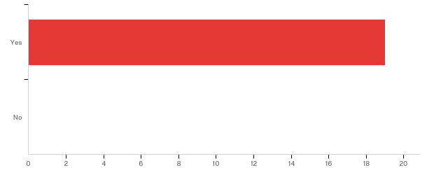

# | Answer | % | Count
1 | Yes | 100.00% | 19
2 | No | 0.00% | 0
 | Total | 100% | 19

2. - Which position from the following list most closely matches your own?
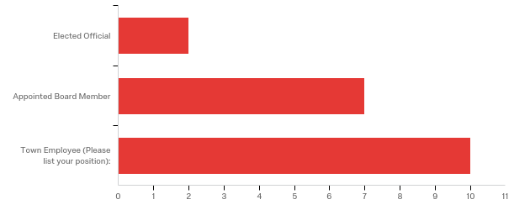

# | Answer | % | Count
4 | Elected Official | 10.53% | 2
5 | Appointed Board Member | 36.84% | 7
6 | Town Employee (Please list your position): | 52.63% | 10
 | Total | 100% | 19

Town employee position*: | %: | Count:
Fire | 15.79% | 3
Police | 15.79% | 3
Managers | 15.79% | 3
Unspecified | 5.26% | 1

*Specific titles removed to avoid identifying information

3. - Approximately how long have you served or worked with Duck?
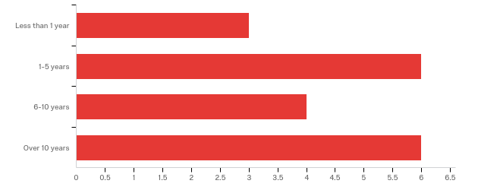

# | Answer | % | Count
1 | Less than 1 year | 15.79% | 3
2 | 1-5 years | 31.58% | 6
3 | 6-10 years | 21.05% | 4
4 | Over 10 years | 31.58% | 6
 | Total | 100% | 19

Q21 - Approximately how long have you lived in Duck?
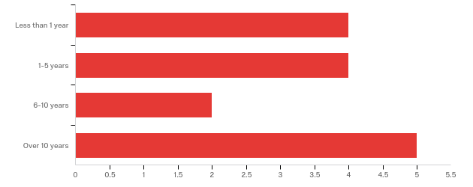

# | Answer | % | Count
1 | Less than 1 year | 26.67% | 4
2 | 1-5 years | 26.67% | 4
3 | 6-10 years | 13.33% | 2
4 | Over 10 years | 33.33% | 5
 | Total | 100% | 15

4. - Please check all the issues Duck has faced in the last 10 years:
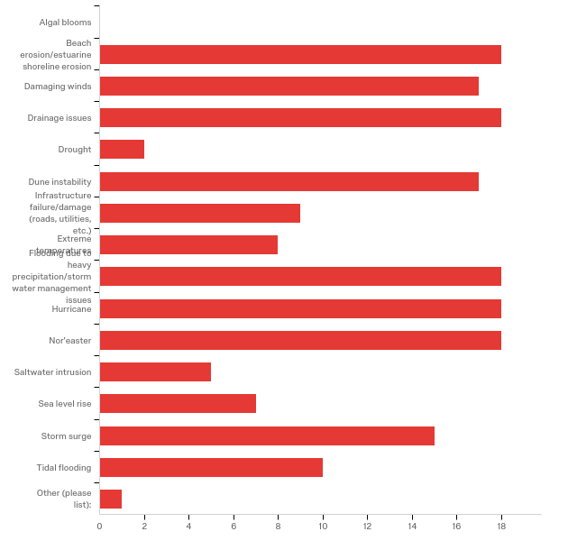

# | Answer | % | Count
1 | Algal blooms | 0.00% | 0
2 | Beach erosion/estuarine shoreline erosion | 9.94% | 18
3 | Damaging winds | 9.39% | 17
16 | Drainage issues | 9.94% | 18
4 | Drought | 1.10% | 2
5 | Dune instability | 9.39% | 17
6 | Infrastructure failure/damage (roads, utilities, etc.) | 4.97% | 9
7 | Extreme temperatures | 4.42% | 8
8 | Flooding due to heavy precipitation/stormwater management issues | 9.94% | 18
9 | Hurricane | 9.94% | 18
10 | Nor'easter | 9.94% | 18
12 | Saltwater intrusion | 2.76% | 5
11 | Sea level rise | 3.87% | 7
13 | Storm surge | 8.29% | 15
14 | Tidal flooding | 5.52% | 10
15 | Other (please list): | 0.55% | 1
 | Total | 100% | 181

Other (please list):
Other (please list): - Text
Soundside flooding

5. - In your experience, what are the three most pressing environmental issues facing Duck at this time?

In your experience, what are the three most pressing environmental issues facing Duck at this time?
Erosion, water table fluctuations, sea level rise
sound side flooding, ocean over wash, diminishing shoreline
Beach erosion, Flooding from severe storms like Matthew, high winds
Sound side Erosion, Stormwater Run Off, Oceanside Erosion
beach erosion and flooding
Beach erosion, salt damage and high wind
Flooding, beach erosion, drainage issues
beach erosion
Beach erosion, drainage of storm water, ocean rise
Erosion, flooding, sea level rise
Water drainage, Hurricanes, Nor Easters
Pollution from septic systems, Stormwater management and beach erosion.
Major rain event flooding. Sound side flooding. Electrical resiliency in high wind situations.
beach erosion, dune preservation and stormwater maintenance when flooding occurs
coyotes, stormwater runoff, abundance of nonnative rats
1. High winds 2. Wetland erosion in the Currituck Sound 3. Beach/dune erosion along the Atlantic Ocean
beach erosion, flooding from heavy rains, and coyotes

6. - In what ways do those three environmental issues affect our community (e.g.: damage to human health, damage to local economy, displacement of citizens, etc.)?

In what ways do those three environmental issues affect our community (e.g.: damage to human health, damage to local economy, displacement of citizens, etc.)?
Uncertainty of property stability can affect property values. Water table issues could lead to septic failures.
limiting access, property damage, commercial down-time
Property destruction, accessibility to property, lost revenue to town businesses, property damage
Economy and Human Health
loss of tourism and difficulty traveling
Houses have been lost to beach/dune erosion. House have been moved away from the ocean to protect them and millions of dollars have been spent on beach nourishment.
closed roadways, property damage, personal must deal with issues
damage to local economy
Displacement of homes, dangerous driving conditions
damage to local economy, environmental health concerns, infrastructure damage
damage to property, local economy,
Long term economic damage following a major event.
Loss of tourism income, property loss
beach erosion and dune preservation have direct impacts on the tourist based economy. There are also economic losses to property owners when repairs are needed. The preservation of the dunes are important to the overall health of the beach and the quality of life for both visitors and residents. The Stormwater issues that we have experienced have impacted the community by creating safety hazards to residents and emergency personnel, unhealthy conditions, economic losses, mental stress to residents in affected areas and in some cases displacement.
Disease spread, human interaction, vehicular and real property damage, missing small pets, missing small game
1. High can result in significant structural damage to buildings and a loss of economic activity until repairs can be made. 2. Loss of sound front wetlands can result in lesser water quality, declining habitat, and shoreline erosion. In particular, the erosion can result in damage to structures. 3. Beach/dune erosion can result in damage to structures and significant damage to the town's reputation and tourist-driven economy.
damage to residences and infrastructure, spread of diseases

7. - On a scale of what 1 to 10, where 1 is "completely unable" and 10 is "fully able," how would you rate Duck's ability to withstand and recover from a minor storm with limited flooding?
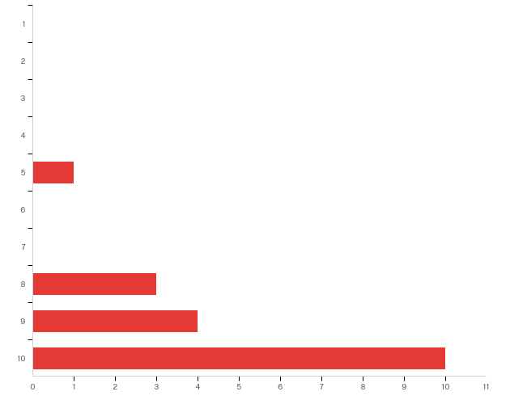

# | Answer | % | Count
1 | 1 | 0.00% | 0
2 | 2 | 0.00% | 0
3 | 3 | 0.00% | 0
4 | 4 | 0.00% | 0
5 | 5 | 5.56% | 1
6 | 6 | 0.00% | 0
7 | 7 | 0.00% | 0
8 | 8 | 16.67% | 3
9 | 9 | 22.22% | 4
10 | 10 | 55.56% | 10
 | Total | 100% | 18

8. - Why did you select this rating?

Why did you select this rating?
The sandy soil drains well. Duck has the capacity to communicate well with residents and visitors regarding emergency situations.
Only a few geographic problem areas are susceptible to severe damage
This recovery has been experienced last year with 2 category hurricanes within weeks of each other.
Because, we see minor storms often and I have seen us handle them
Past experience has shown efficient recovery from minor storms
We’ve done it before.
We recover fairly quickly with the help of all town staff, however it is a frequent hassle
the quick work of the community to displace water
Experience
The Town is prepared for minor flooding and storm damage
Quick response to the immediate needs
The Town has shown it can recover quickly from minor storms.
Strong economic position, and strong economic incentive to recover quickly.
wording - minor storm with limited flooding
Current stormwater management, and fire department operations allow for swift response
The community has the resources to assist with minor flood recovery efforts.
They have been able to recover completely from all the minor storms I have been around for

9. - On a scale of what 1 to 10, where 1 is "completely unable" and 10 is "fully able," how would you rate Duck's ability to withstand and recover from a major storm with extensive flooding?
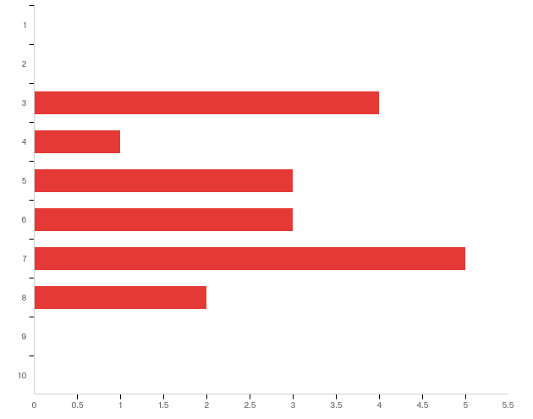

# | Answer | % | Count
1 | 1 | 0.00% | 0
2 | 2 | 0.00% | 0
3 | 3 | 22.22% | 4
4 | 4 | 5.56% | 1
5 | 5 | 16.67% | 3
6 | 6 | 16.67% | 3
7 | 7 | 27.78% | 5
8 | 8 | 11.11% | 2
9 | 9 | 0.00% | 0
10 | 10 | 0.00% | 0
 | Total | 100% | 18

10. - Why did you select this rating?

Why did you select this rating?
Although it could take time Duck is capable of recovery unless there is a long term breach on Duck Road.
Only certain spots already identified would be susceptible to flooding and would only cause concern with those locations, not necessarily town wide.
Lack of resources, and dependability on other entities like water and electricity. Lack of equipment to service roads, displace water. Limited ability to secure essential resources such as bottled water, food, etc.
Loaded question as into where the Storm caused the flooding. Duck is very susceptible to Soundside flooding as we can lose our only road
I think Duck can and will recover from a major storm, but it will take time and resources not readily available.
The worst hurricane we’ve had was Isabelle in 2003 and major erosion (up to 45 feet of dune loss) and this was never addressed until beach nourishment in the spring of 2017.
We are a very small island and there isn’t so many places for the water to go so sometimes we have to wait it out
Have not been here for such event
I believe the town is very resilient, but some property would be damaged beyond repair
The Town would be limited in its ability to recover from major storms and flooding on its own and would require outside assistance
Limited staff and resources
The Town lacks the personnel or resources to quickly recover from a major storm, especially if much of the east coast is impacted by the same event, which will mean many municipalities will be completing for the same resources.
The higher cost associated with severe events combined with the workforce (construction workers/landscapers etc.) being more affected by severe widespread events extends response time.
as the intensity of any storm increases, our ability to recover will decrease
Not enough pumps
The Town has the resources to contract for larger clean-up efforts, but these efforts will take time. Individual property owners may have challenges addressing damage to their properties.
There are many areas that would not be able to withstand a major storm or extensive flooding

11. - In your experience, do environmental issues disproportionately affect different sectors of Duck (e.g.: the elderly, the disabled, low-income, etc.)?
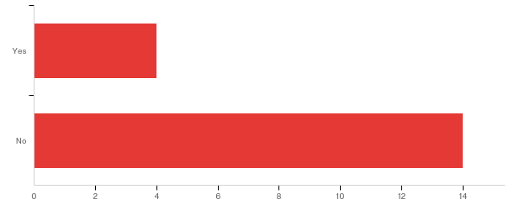

# | Answer | % | Count
1 | Yes | 22.22% | 4
2 | No | 77.78% | 14
 | Total | 100% | 18

11a. - Which groups in Duck are disproportionately affected? Please be as specific as possible.

Which groups in Duck are disproportionately affected? Please be as specific as possible.
Elder
The elderly and low income. I’m very fortunate that I have enough resources to repair and protect my property; however, beach erosion has personally cost me in excess of $222,000. These resources could have been better used for other things.
low-income, renters
The elderly

12. - In your experience, do environmental issues affect specific areas in Duck more than others (certain streets, neighborhoods, buildings, etc.)?
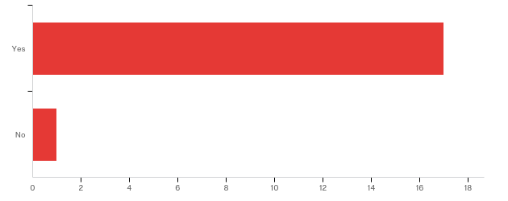

# | Answer | % | Count
1 | Yes | 94.44% | 17
2 | No | 5.56% | 1
 | Total | 100% | 18

12a. - Which areas are more affected by environmental issues? Please be as specific as possible, including neighborhood names, streets names, or addresses, if you know them.

Which areas are more affected by environmental issues? Please be as specific as possible, including neighborhood names, streets names, or addresses, if you know them.
Low lying areas that are prone to flooding - East Sea Hawk, Ocean Crest and other communities in southern Duck. Some pockets of Duck Road and other neighborhoods can flood in the Sanderling area.
Poteskeet, Sound Sea VIllage, Four Seasons, Sand Dollar Shores, Georgetown Sands, Soundside Sanderling Streets, Waterfront Shops
Low lying areas-road through Sanderling, property at Duck road and Nor'banks/osprey, Duck road at Sunset Grill, Road into/out of Duck in Southern Shores
Georgetown Sands area, Sound Sea Village, any low lying areas that can be affected by rising levels of the ground water due to heavy rain. All sound and ocean front properties from waves, surge, erosion etc.
lower lying areas and lots flood considerable more than other lots
Lower areas on the sound front and the ocean front north of the Core of Engineers pier.
depends on the issue you want to discuss. beach erosion typically occurs more in the northern area of town on the ocean front. soundside flooding is more of an issue around Sound Sea Ave area and Sea Colony Drive. Roadway typical flooding occurs at The Sanderling Inn very frequently especially during heavy storms, area of 1232 Duck Rd, area of 1216 Duck Rd, and very badly again at Charles Jenkins Ln.
Sanderling, Carolina dunes oceanfront, Georgetown sands
some areas of Sound Sea, Schooner Ridge, Four Seasons, Plover Drive, Georgetown Sands, Sea Breeze Drive, Sea Hawk, Bias Shores, Ocean Crest
1240 Duck Road, Georgetown Sands, Sea breeze, South end of town, Caffeys Inlet area and Sanderling area
Duck has a number of historic "low spots", which tend to flood.
Sound Sea Village, The Ocean Side depression that runs from Southern shores to the Army Corps property, Sound side Sanderling. Area where Duck road and Norbanks drive storm water is directed to 1269 Duck Road
oceanfront and soundfront properties/owners, and low lying areas in Ocean Crest, Bias Shores, Tides, Tuckahoe, Sea Hawk, Sand Dollar Shores, Georgetown Sands, Sea Acres, Four Season, in the area of the Waterfront Shops alog Duck Road, Buffell Head Road, Caffeys Inlet, Sound Sea Village, Gulls Flight, Ocean Pines, and most of Sanderling east side, Sanderling Resort along Duck Road, and just north of Palmers Island along Duck Road
Stormwater - E Charles Jenkins, E Bias, E Tuckahoe, Seabreeze, Georgetown Sands, E Sea Hawk, Tides, Plover, Four Seasons, and Duck Landing. Coyotes - North of Barrier Island to Northern Town Line, Expanding Southward rapdily
In the aftermath of Hurricane Matthew, isolated flooding remained in the following areas: Sound-Sea Village, Barrier Island Station, Schooner Ridge Drive, Duck Hunt Club Lane (Four Seasons), Georgetown Sands, Sea Breeze Drive, E. Sea Hawk Drive, E. Bias Lane, and E. Charles Jenkins Road.
Carolina dunes oceanfront, oceanfront in the village

13. - In your opinion, what is the most difficult part of dealing with environmental issues in Duck (e.g. community buy-in, lack of financial resources, size of staff, etc.)?

In your opinion, what is the most difficult part of dealing with environmental issues in Duck (e.g. community buy-in, lack of financial resources, size of staff, etc.)?
Financial resources and authority (roads are controlled by the state or are privately owned). We are also a bottleneck for traffic to Corolla so we affect many more than simply those residing or visiting Duck.
With high rainwater accumulation, there is not much we can do. Being helpless is not very PR worthy
Size, experience of staff; lack of equipment; dependability in other entities for utilities.
Governmental Hurdles on the State and Federal level. We have the community, funds and staff to deal with these issues.
the element of surprise, like in unusual and unexpected snowfall or ice storms
I believe that community buy in is the biggest issue. I live in the recent beach nourishment area and I pay 7 to 8 times as much for beach renourishment as my neighbor directly across the street. I sincerely believe that the cost of beach nourishment should be shared equally by every property in Duck based on the tax accessed value of the property. Everyone in town benefits from the town having a great ocean front not just a few home owners in the nourished area.
Lack of personnel, the fire and police departments tend to be the ones addressing these issues and cannot focus on other matters more in line with their job description. pumps and signs have to be brought out, traffic has to be directed, and pumps have to be operated.
You can’t keep a staff large enough for a major disaster. We will have to have outside help
large scale projects are required (in terms of scope and cost)
Size of staff and equipment
Size of staff and financial resources needed to fully prepare and/or deal with these issues.
Long-term planning is needed. The seasonal water table will be the long term issue that develops as sound side sea level rise eventually raises the water table. Areas that currently experience slow drainage will become chronic problem areas, as drainage slows over time. Currently working septic fields will fail if a permanent long term water table management system is not put in place. Duck is a small relatively wealthy community. A combination of temporary and long term sound side flood mitigation strategy is also necessary. While radical, the most effective long term solution would be to open one of the historic inlets. Development has caused the barrier island to become a static land mass. Inlets replenish beach sand, and allow water levels in the sound built up by run-off and wind pressure to equalize more efficiently.
most roads are privately owned. Most issues are the result of poor planning before the town incorporated, trying to retrofit a plan is difficult and very costly.
Federal Government, expense of solutions
Issues encompass hundreds of privately owned, individual properties, making it difficult to coordinate large-scale solutions
lack of resources both equipment and staff

14. - In your experience, what does the Town of Duck need in terms of tools and resources to better address our environmental issues?
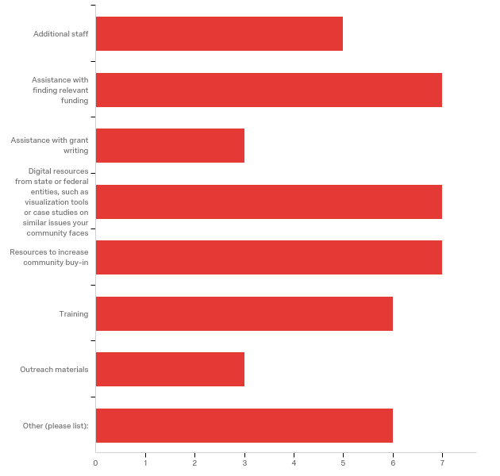

# | Answer | % | Count
1 | Additional staff | 11.36% | 5
2 | Assistance with finding relevant funding | 15.91% | 7
3 | Assistance with grant writing | 6.82% | 3
4 | Digital resources from state or federal entities, such as visualization tools or case studies on similar issues your community faces | 15.91% | 7
5 | Resources to increase community buy-in | 15.91% | 7
7 | Training | 13.64% | 6
8 | Outreach materials | 6.82% | 3
6 | Other (please list): | 13.64% | 6
 | Total | 100% | 44

Other (please list):
Other (please list): - Text
Nothing
Common sense approach to projects that require outside permitting/permission
I'm not sure how to answer this. Current staff is very capable and able to multi-task. They regularly receive grants when needed. Perhaps look toward the ramifications of global warming in terms of heating AND cooling.
Roadways need to be elevated, leveled, or permanent pumps installed in problems areas to prevent or reduce the occurrences
I’m really not sure
Additional equipment to deal with erosion and flooding

15. - Do you have additional comments pertaining to your experiences with environmental issues in Duck?

Do you have additional comments pertaining to your experiences with environmental issues in Duck?
We have encountered a variety of issues in Duck and in each case we seem to address things well. It is always helpful to have additional resources and support. I’m proud of how responsive this town has been - a function of a dedicated, knowledgeable staff and engaged community.
None
No
No. I have been very lucky where I am located.
No
You cannot raise the all the homes on the ocean or soundfront properties however I feel as though something could be done about the roadways. I have watched many vehicles flood in high waters on NC 12 during heavy rain and winds. I have not seen anything done to improve the issue except for permanent drainage installed at "Lake" Tuckahoe Drive. We have had no flooding issues since and this use to be our most problematic area.
No
No
The worst effects of sea level rise are hopefully decades away. A solid plan to mitigate effects will put the town in a position to maintain property values, so that ongoing mitigation efforts can be funded.
no
No
Environmental issues in Duck take two forms: (1) incident-related issues resulting from storms and (2) broader impacts from long-term trends (sea level rise)
no

16. - If you have anything else that you would like to share with us, please let us know!

If you have anything else that you would like to share with us, please let us know!
I think there is a need for additional education as to what to do in case of severe environmental issues, training and practice. Are effective mutual aid agreements in place to gain equipment and services to deal with the environment issue aftermath. Recent example is lack of equipment to clear roads after recent snows.
Not at this time
In the question regarding Duck residency, very few employees live in Duck
No

Appendix 3: Modeling Examples
The Nature Conservancy (TNC) hosted our asset maps on their coastal resilience mapping tool starting in 2018. The tool allows town staff, planners, and the public to see which assets will be affected under a variety of conditions in current and future scenarios. Below are some samples of models that can be overlaid onto Duck’s asset map through the tool.
You can view the asset maps on TNC’s tool here.

Sea level rise at the medium scenario, year 2100 – High traffic areas, community assistance assets, critical facilities, utilities, and public recreation are affected in this area:
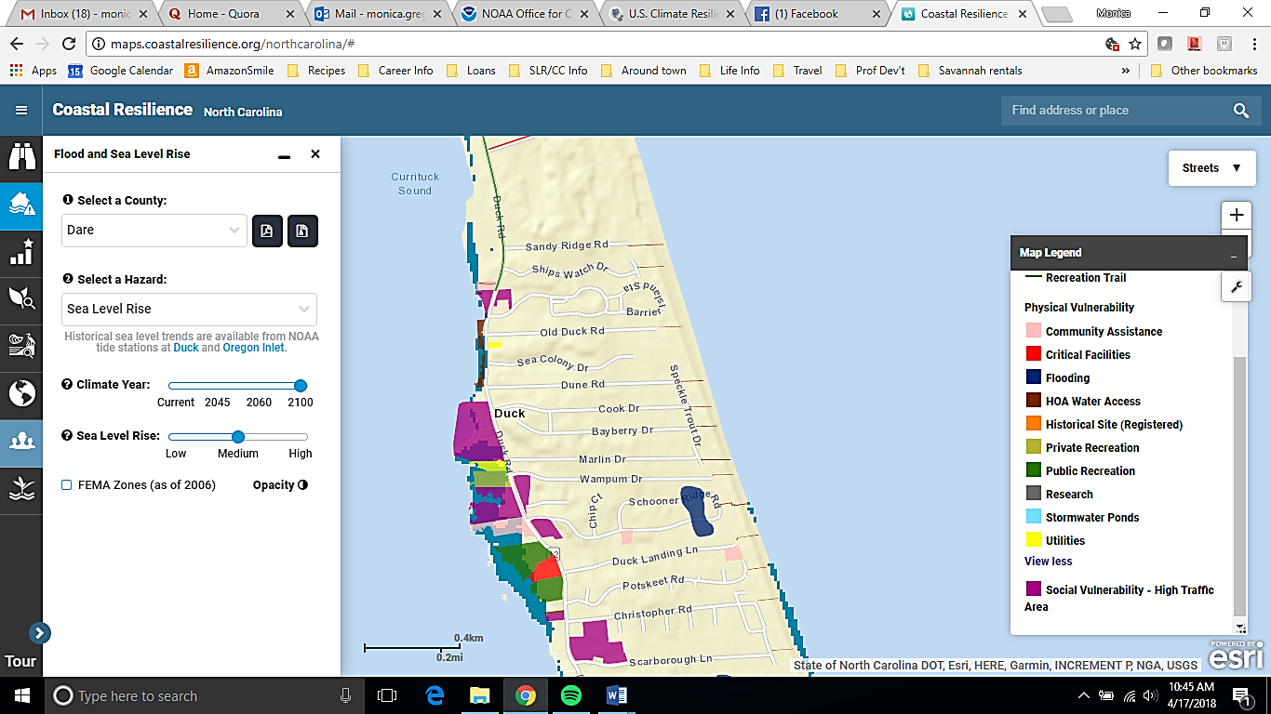

Category 3 Hurricane Storm Surge in current year – Nearly all mapped assets on both the oceanside and soundside are impacted to varying degrees, with the northern side of the barrier island almost uniformly impacted by 3 feet of water. If combined with sea level rise models, some assets could be severely impacted in year 2100:
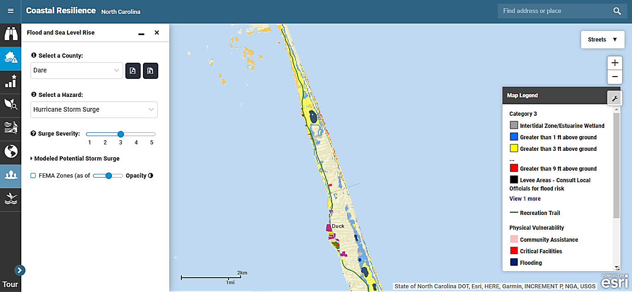

Closer view of northern end of Duck under a Category 3 Hurricane Storm Surge model:
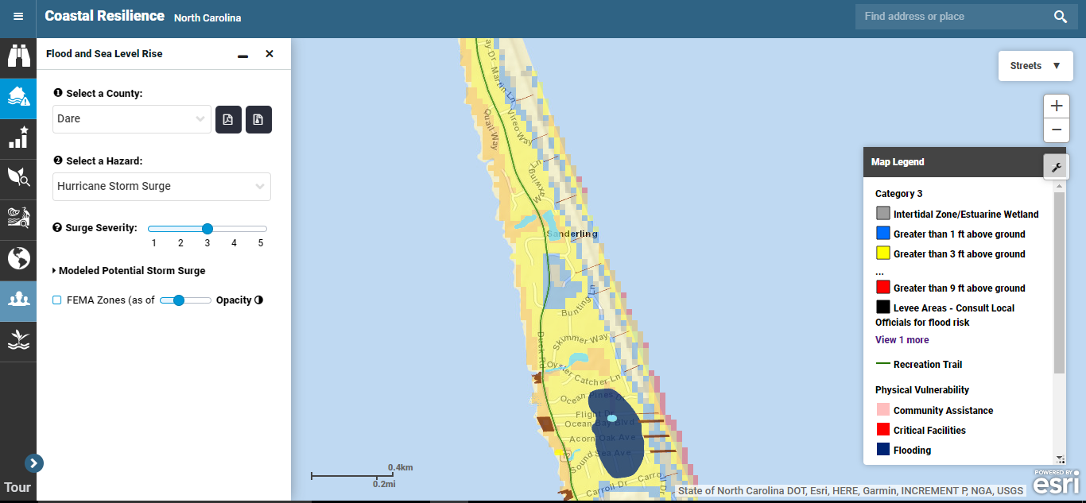

Appendix 4: TNC Mapping Portal – Workflow Example
The following workflow was created by Lora Eddy from The Nature Conservancy to assist communities in visualizing risk. In Section II. Adding Community Specific Information to Your Map, towns can find a version of their asset map to help visualize their vulnerabilities to coastal hazards like flooding and sea level rise.

Flood and Sea Level Rise app - Example Workflow
Dare County
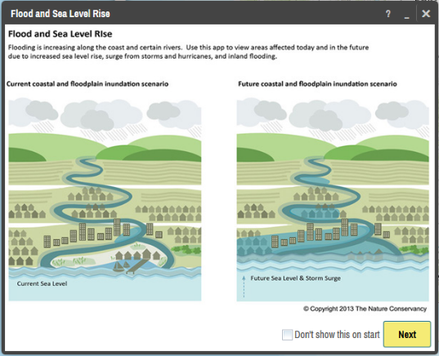
I. Visualizing Risk

- In your internet browser enter: maps.coastalresilience.org/northcarolina/
- Activate the Flood app by clicking on the icon on the left.

- Choose a Region
- Click on “Select a Region” box and select Dare County from the drop-down menu.
- The map zooms to Dare

- Zoom into Manteo
- Zoom by using the center scroll of your mouse or double-clicking over the area OR

- In the top right corner of the map in the search bar, type in Manteo, NC
- As you type in the search box the drop-down list will auto-populate
- Select the address and the map will zoom to the address

- Choose a Hazard
- Click the “Select a Hazard” box and select Coastal Flooding (NC Emergency Mgmt)
- Slide the “Sea Level Rise” slider to 40 cm to see flooding impacts due to sea level rise alone
- Slide the “Flood Extent” slider to 100-yr to see areas in the future at risk to coastal flooding with sea level rise.
- Click on the icon next to “Flood Extent” for more information about the data you have selected

- Click on Opacity
- Click on the slider to adjust the opacity of the storm surge

- Minimize the Flood app window and leave the map on your zoomed in location.

II. Adding Community Specific Information to your Map
- Activate the Community Planning app by clicking on icon on the left.

- Select Dare County>Flood Map>Effective DFIRM and turn on this data layer by clicking on the button next to Effective DFIRM
- Notice the change on the map and legend
- Minimize the legend
- Click on the icon for more information about the data layer you have selected
- Click the … to expand a pop-up menu that allows you to adjust the data layer’s transparency, adjust the transparency to half

- Select Dare County>Infrastructure>Building Footprints and turn on this data layer by clicking on the button next to Building Footprints

- Move around the map dragging and dropping to view roads, buildings and land that are at a higher risk to flooding.

- To view Parcel boundaries Select Dare County>Land Use>Parcels

**Coastal Resilience Map Hints & Tips:
- Click on Tour for a brief introduction to the mapping site or visit coastalresilience.org/tools/training/ for an online Try Me Tutorials.
- This web-based tool can be used in most Internet browsers, including Chrome, Firefox, and Safari. NOT Internet Explorer.
- Refresh your browser window (push the F5 key) if the tool seems laggy (e.g. layers are stuck).
- Also try using a browser window which does not retain cookies or other browsing data. For example:
  - Chrome: incognito window
Firefox and Safari: private browsing window
Appendix 5: Timeline and Schedule of Activities
Below is the approximate timeline from the initial meeting with Duck’s town staff to the completion of the project. The Town of Duck did not conduct public input workshops or surveys, so the timeline is condensed.
Month/Year | Purpose | Activities
January 2017 | Scoping meeting with Town Manager and planner | - Discuss project and time commitment  - Identify potential stakeholders to include  - Establish initial timeline
March 2017 | Map vulnerabilities with Town Manager, Planner, and other staff stakeholders | - Identify physical and social vulnerabilities from the town staff perspective
June 2017 | Survey town staff | - Identify coastal hazards and their impacts on the community  - Identify town needs to address impacts from hazards  - Identify specific areas that flood in town
April 2017 – December 2017 | Revise asset map, write narrative to justify included assets, and begin final report for town | - Update asset map according to town comments and suggested revisions. There may be several versions of the map until you add everything in the correct place.  - Write a narrative to complement the map so both the town staff and the public can easily understand what assets were included and why (see Appendix 1C)  - Begin final town report with information from background research, meetings with town staff, the town staff survey, and other relevant information
January 2018 – May 2018 | Update asset maps and upload them to the coastal resilience mapping tool to pinpoint hotspots and prioritize projects. | - Added resident input to asset maps  - Worked with TNC to upload asset maps to the coastal resilience mapping tool  - Worked with town staff to identify hotspots where assets are currently, and will be, drastically affected by sea level rise or coastal flooding  - Worked with town staff and external partners such as The Nature Conservancy and Coastal Federation to identify specific projects that could mitigate or adapt hotspot areas to sea level rise or flooding  - Complete final report for the town

“‘Resilience’ means the ability to anticipate, prepare for, and adapt to changing conditions and withstand, respond to, and recover rapidly from disruptions.” (Former President Barack Obama, Executive Order 13653)
According to FEMA, “assets are defined broadly to include anything that is important to the character and function of a community and can be described very generally in the following four categories: People, Economy, Built environment, Natural environment.”
Dare County Hazard Mitigation Plan. 2010. Pg. 243-253. https://www.darenc.com/home/showdocument?id=800
In the context of this project, a physical vulnerability is indicated by a geographic area exposed to a hazard, such as waterfront properties repeatedly flooded after hurricanes. A social vulnerability is indicated by a population that is exposed to a hazard, such as residents in a neighborhood in a low-lying area that repeatedly floods. Both physical and social vulnerabilities can be low or high risk, depending on their level of exposure, preparedness, and ability to recover after a disaster, among other indicators.
See Appendix 1B for the map narrative and key.

