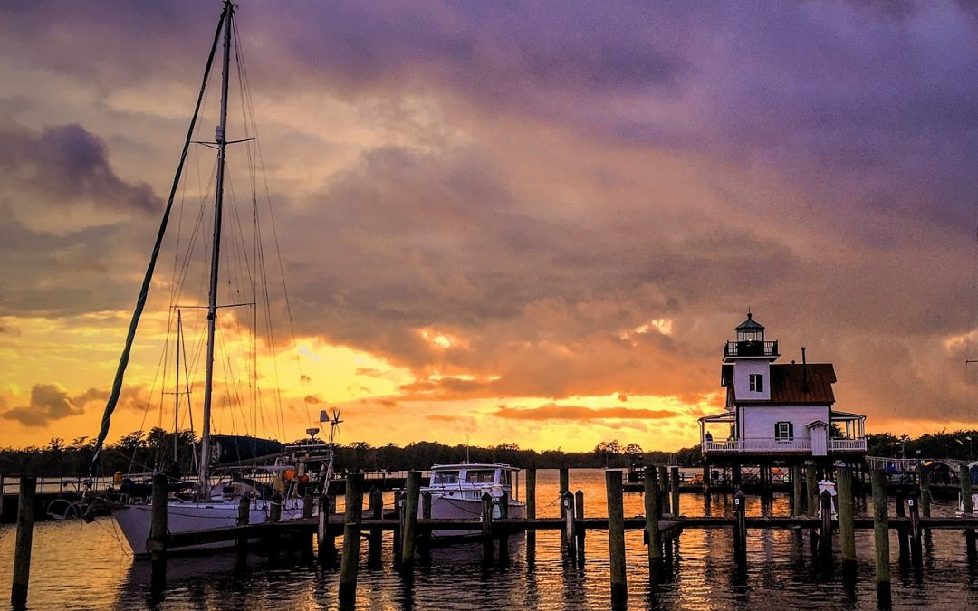
Town of Edenton
Edenton waterfront. Photo credit: James LaCorte
Resilience Evaluation and Needs Assessment
Final Report
May 2018
Table of Contents
Project Overview..……………………………………………………………………………………………………….....2
Purpose and Scope………………………………………………………………………………………………………....3
Section 1: Introduction…………………………………………………………………………………………………….4
Section 2: RENA Framework in Practice……………………………………………………………………………5
Resilience evaluation (RE) process
2.1.RE: Map assets……….………………………………………………………………………………………6
2.2.RE: Identify current issues………………………………………………………………………………7
2.3.RE: Conduct public input meetings…………………………………………………………………8
2.4.RE: Overlay current and future models………………………………………………………….11
Needs assessment (NA) process
2.5.NA: Identify hotspots…………………………………………………………………………………….11
2.6.NA: Prioritize assets…..…………………………………………………………………………………12
2.7.NA: Document existing projects……………………………………………………………………12
2.8.NA: Explore future projects………………………………………………………………………….13
Data Resources………………………………………………………………………………………………………………15
Funding Resources…………………………………………………………………………………………………………17
Appendix……………………………………………………………………………………………………………………….21

Project Overview
In 2016, the Division of Coastal Management (DCM) commenced a five-year project to create a resiliency planning framework guide for coastal communities in North Carolina. DCM hired a two-year Fellow, Monica Gregory, as part of the Coastal Management Fellowship (CMF) through the National Oceanic and Atmospheric Administration (NOAA). The Fellow was hired to lay the groundwork for the guide by working with five communities to implement a vulnerability assessment and a needs assessment within their towns. The five communities will serve as case studies in the guide to illustrate the planning process, highlight best practices, and discuss resilience-building projects identified through the vulnerability assessment. Edenton, Pine Knoll Shores, Oriental, Duck, and Hatteras Village participated in the project.
The outcome of the five-year project will be a comprehensive guide to resilience-building in coastal communities in North Carolina. Edenton will serve as one of five case studies from which other communities can learn about resilience planning.
The final guide aims to serve local governments by:
1) illustrating a successful planning framework they can use to engage their communities in resilience and adaptation projects;
2) identifying common needs from local governments and compiling state and federal resources that can address those needs;
3) providing case studies across the North Carolina coast that can help guide other local governments in resilience planning;
and
4) discussing adaptation and mitigation strategies that can be applied in a variety of situations experienced by coastal communities in our state.

Purpose and Scope for Edenton
The purpose of this two-year project is to identify and map important social and physical assets in Edenton that may be vulnerable to current and future impacts from coastal hazards, including sea-level rise and storm surge. The planning process will help Edenton identify hotspots where the town can prioritize resilience-building projects. Through the process, participants will also identify local government and community-specific needs in building resilience.
Chowan County has a robust regional hazard mitigation plan (HMP) which includes the Town of Edenton. This project meets several high priority needs highlighted in the HMP, including EDN2, EDN4, EDN11, EDN12, EDN14, EDN16, EDN17, EDN27, and EDN29. Edenton’s RENA results reinforce ideas in the HMP and highlight additional concerns and priorities voiced by the community.
This guide draws from the HMP for general information on Edenton such as hazards, demographics, capabilities, and risk. This guide adds to the information Edenton already possesses by mapping repetitive flooding in the town based on staff and resident knowledge as well as gathering more in-depth input about community priorities. It also identifies specific areas, such as streets, intersections, and buildings, that the town can target for resilience work. The final map and guide for Edenton can be used for resilience planning purposes as well as for future grant applications related to resilience-building to highlight identified areas in need of adaptation and mitigation projects.

Section 1: Introduction
Regional survey
In February 2017, DCM released a survey to county-level and local-level staff to better understand their experiences with coastal hazards and their needs for addressing them. DCM had an 11% response rate, which is about average for an online survey. Through questions about impacts from coastal hazards and existing resilience-planning efforts, DCM identified a critical need for a formal planning framework to be used by regional, county, and town staff in adapting to and mitigating impacts from major and minor storms, sea level rise, hurricanes, and Nor’easters, among other hazards.
DCM staff formed an advisory committee to guide the research and selection process. Advisors included staff from The Nature Conservancy, North Carolina Sea Grant, the Coastal Federation, and DCM planners and field staff. DCM conducted a review of published resilience guides and community resilience planning methodologies.
DCM drew from various resources to create the methodology used in pilot communities. The Community Resilience Building guide, the U.S. Climate Resilience Toolkit, the California Adaptation Planning Guide, and the Community Based Vulnerability Assessment Guide from MDC, Inc. and UNC Chapel Hill strongly influenced this project.
Selection process
To select pilot communities for case studies, DCM staff consulted state planners, state field staff, and nonprofit organizations for recommendations on towns with staff capacity and community buy-in to work this process from beginning to end. After receiving multiple recommendations to reach out to Edenton, DCM staff held an initial scoping meeting with the Town Manager and planner in January 2017. After discussing their history with coastal hazards, staff capacity, and community dynamics, the Town of Edenton accepted our invitation to participate in the pilot program as one of five case study communities in the DCM resilience framework guide.

Section 2: RENA Framework in Practice
DCM used the following eight-step process in each pilot community, divided into the resilience evaluation phase and the needs assessment phase:
Resilience evaluation (RE):
- Map assets
- Identify current issues
- Conduct public input meetings
- Overlay current and future models
Needs assessment (NA):
- Identify hotspots
- Prioritize assets
- Document existing projects
- Explore future projects

Resilience Evaluation (RE) Process
2.1.RE. Map assets
In April 2017, DCM staff met with the Town Manager to map physical and social assets in Edenton. DCM downloaded two base maps from ArcGIS: one of Edenton’s historic district and surrounding areas, and one of the airport which is town-owned property. DCM printed both maps at a large enough scale to identify roads and specific parcels. DCM brought both maps to the meeting.
At the mapping meeting, the Town Manager worked with DCM to physically color in parcels that are considered important assets to Edenton. DCM staff provided sharpies, highlighters, sticky notes, and colored tabs at the meeting. For each asset category, one color was used. For example, critical facilities like hospitals and the fire station were identified by town staff then colored with red sharpie. DCM staff recorded their color and location to later create a GIS attribute table and a key for the map.
The Town Manager identified high density employment areas, community assistance assets, critical facilities, cultural resources, environmental assets, fishing/boating facilities, flooding, government assets, recreational resources, and utilities as important physical assets in Edenton. Redevelopment zones and a retirement community were identified as areas of high social vulnerability, particularly in the context of disaster recovery. The Town Manager did not identify assets in need of resilience research on the airport-focused base map.
Though not included in this project, additional social vulnerability indicator data exists, such as census data on reported income and data on property tax value. Such indicators can be used to identify areas where financial resources for recovery post-disaster may be limited. Other social vulnerability indicators that may be used in other communities – such as concentrated areas of 65+ residents, concentrated areas of non-English speakers, and concentrated areas where people have low trust in government – were not identified in Edenton.
After working with the Town Manager, DCM staff returned to their home office and used the physical map to transfer collected data to ArcGIS. DCM created a narrative to be used with the map. DCM sent questions, the draft map, and the draft narrative to the Town Manager for comments and additions. After multiple revisions, the Town Manager approved the asset map and narrative for Edenton. The map was then circulated to key town and county staff, board members, and critical organizations in Edenton for commentary.
2.2.RE. Identify current issues
Through a survey process, DCM collected the experiences and viewpoints of staff and elected officials in Edenton. The survey focused on staff knowledge and experience with coastal hazards and their impacts in the community.
Town Staff and Elected Officials: Survey Results
Eight staff members or elected officials participated in the survey on coastal hazards and their impacts in Edenton, with six respondents having worked for the town for over ten years.
Hazards
Out of a list of 14 potential hazards, eight respondents chose flooding due to heavy precipitation and drainage issues as hazards Edenton has faced in the last ten years. Seven respondents chose algal blooms, damaging winds, hurricanes, and storm surge as common hazards. Six respondents chose infrastructure failure or damage and Nor’easters. When asked to list the three most pressing environmental issues facing Edenton, respondents listed flooding and drainage issues (4), algal blooms (4), and infrastructure-related issues (3) most often. Respondents cited human health (5) and the local economy (5) as most affected by these issues, followed by damage to public and/or private property (4).
Flooding
All respondents believe Edenton could withstand and recover from a minor storm with limited flooding: on a scale of one to ten, all ratings were between five and ten. Edenton regularly experiences minor storms with limited flooding and “the town keeps plugging away!” However, respondents differed in their thoughts on whether Edenton could withstand and recover from a major storm with extensive flooding, with three respondents ranking the town as a “1” or “2,” and five respondents ranking it as a “6,” “7,” or “8.” One respondent cited Edenton’s successful recovery from Hurricane Matthew in 2016 as an example of how the town can withstand and recover from a major storm event. Another respondent thought “[it was] a matter of time before… structures built in old creek beds are flooded.” Two respondents cited infrastructure-related issues as barriers for Edenton to successfully mitigate flooding.
Specific impacts from flooding
Of the four respondents who have seen specific impacts around Edenton, the following areas were mentioned: Water Street (3), Pembroke Circle (2), Pembroke Creek Apartments/Area (2), King Street (1), Blount Street (1), Queen Anne Drive (1), North Edenton (1), Parke Avenue (1) Johnson Street (1) Cabarrus Street (1) Virginia Road (1), North Granville (1), South Oakum (1).
Social impacts
Over half of respondents do not believe environmental issues disproportionately affect certain segments of the population in Edenton. The three respondents who do believe there are disproportionate impacts listed low-income areas as being more affected than others.
Town Needs
Out of seven respondents, six cited financial resources as the largest barrier to dealing with environmental issues in town followed by size of staff (2). To overcome their barriers, staff listed assistance with finding relevant funding (5), additional staff (4), training (3), and resources to increase community buy-in (3) as their most pressing needs. Other cited needs include assistance with grant writing, digital resources from state or federal entities, outreach materials, and technical assistance to improve resiliency.

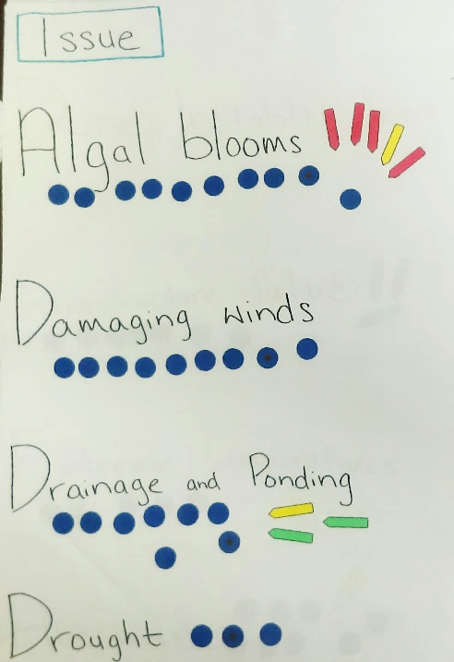
2.3.RE. Conduct public input workshops
Page 1 of the issue list Edenton residents worked on with their stickers and flags, 2018.
In March 2018, Edenton and DCM conducted a public input workshop focused on two activities: 1) coastal hazard issues and prioritization and 2) asset mapping. The CMF partnered with the Chowan-Edenton Environmental Group (CEEG) to facilitate the workshop process.
Activity 1: Issues and Prioritization
In the first activity, eleven residents worked to identify all issues they had experienced over the past 10 years in Edenton. The issues were taken from the town staff survey (Appendix 2B, question 4) so the Town Manager could compare staff perceptions to resident perceptions of coastal hazards and their impacts.
Residents placed blue dot stickers next to each issue they had experienced. To prioritize issues, residents were given a red, yellow, and green flag sticker. They marked their top concern with the red sticker; their second concern with the yellow sticker; and their third concern with the green sticker.
Out of a list of 20 issues, with five additional issues added by residents, over half of participants experienced the following hazards and impacts in Edenton over the past decade:
- Algal blooms (11)
- Damaging Winds (9)
- Stormwater management (9)
- Drainage and ponding issues (8)
- Hurricanes (8)
- Nor’easters (8)
- Infrastructure failure (7)
- Sewage issues (7)
- Storm surge (7)
Residents cited the following concerns as top priorities for the town to prepare for, mitigate, or adapt to:
- Algal blooms – Four residents listed algal blooms as their top concern and one listed it as their second-priority concern.
- Drainage and ponding – One resident listed drainage and ponding as their second-priority concern, and two listed it as their third-priority concern.
- Storm surge – Two residents listed storm surge as their top-priority concern, and one listed it as their third priority concern.
Other top concerns were infrastructure failure (2); stormwater management (2); hurricanes (1); and infiltration (1).
Activity 2: Asset mapping
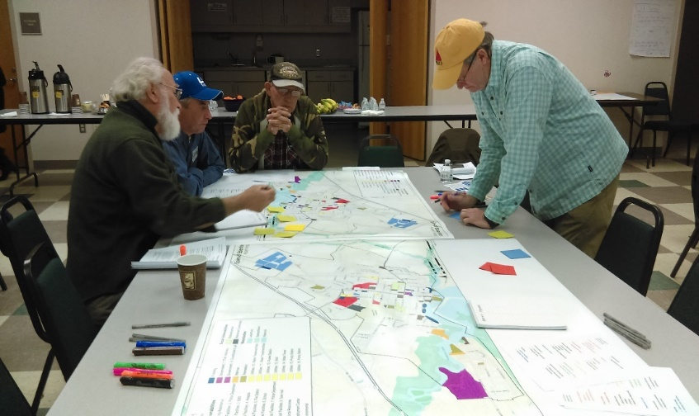
During the second activity, residents split into small groups to focus on asset mapping. Each group was led by a volunteer resident who used an instruction packet developed by the CMF (see Appendix 3C) to manage the activity.
Edenton residents work on mapping assets important to their community, 2018.
Over the course of the activity, small groups discussed the assets to insure they were accurately portrayed on the map. Each group made additions, including adding the local theater to cultural resources; the Women’s Club to recreation; the bank, vet’s office, and food/fuel locations to commercial assets; and additional localized flooding and storm parking locations. Residents also noted the importance of access to Edenton from both the highway and the airport. Bridges, roads, and access points are critical for both pre-disaster evacuation and post-disaster recovery.
The maps below show the difference between the assets mapped by the town and the assets added by residents:
Map 1 – Assets Mapped with Town Staff

Map 2 – Assets Mapped with Resident Additions

2.4.RE. Overlay current and future models
In 2018, the CMF reached out to The Nature Conservancy (TNC) to request a collaboration between DCM’s asset mapping and TNC’s coastal resilience mapping tool. TNC agreed to host town asset maps so local government staff could easily apply sea level rise and coastal flooding models to their maps. TNC uses NOAA data for a variety of future scenarios; all data are readily available for download through the NOAA Digital Coast’s Coastal Flood Mapper. Potential datasets include:
- Coastal Flood Hazard Composite - Provides a quick visual assessment of areas most prone to flood hazard events.
- Shallow Coastal Flooding - Areas subject to shallow coastal flooding.
- FEMA Flood Zones - Areas at risk from flooding.
- Storm Surge - Areas at risk from storm surge.
- Sea Level Rise - Areas likely to be inundated by sea level rise.
In Edenton, current model overlays are sea level rise data from NOAA and coastal flooding data for current mean high water, a 10-year flood event, a 100-year flood event, and past flooding from Hurricane Fran (1996) from North Carolina’s Division of Emergency Management.
Future scenarios through TNC’s coastal resilience mapper include risk in three separate years: 2045, 2060, and 2100. Town staff and leaders can choose to plan for low, medium, or high risk in any given year to see which assets will be most at risk from one or a combination of hazardous events.

Needs Assessment (NA) Process

2.5.NA. Identify hotspots
Through TNC’s mapping portal, town staff and residents can view their asset maps and overlay sea level rise scenarios, storm surge scenarios, and coastal flooding data. Staff can pinpoint areas to focus resilience-building efforts that are consistent with their ongoing resilience work or with their current town vision. The town staff can decide what planning scenario they wish to use: for example, a town can use the medium sea level rise scenario for the year 2045 to identify assets and areas they wish to adapt or mitigate from increased flooding.
In the future, town staff can hold additional workshops to better understand community priorities in the face of sea level rise, increased frequency and severity of storm surge, and increased flooding.
2.6.NA. Prioritize assets
Edenton can prioritize assets and areas of vulnerability to focus their resilience-building efforts. Assets could be prioritized by residents in the community; by cost-benefit or return-on-investment analyses; or by other means selected by town staff. Staff could hold additional workshops to receive input from residents regarding asset prioritization.
2.7.NA. Document existing projects
The Town of Edenton has been integrating resilience into several of their planning and project processes for several years. Current efforts include:
1. Old Hertford Road and North Broad Street Culverts & Drainage Analysis - Through the RENA process, the Town Manager and planner identified a specific area in need of mitigation services in Edenton located by the main commercial asset in town. The project was an analysis of drainage and ditch culverts that drains 256 acres of farm and industrial land in Edenton. During Hurricane Matthew in 2016, the culverts proposed in the study were over capacity and the roads were washed out. After the hurricane, the local railroad replaced an existing culvert with a larger culvert west of the study area. The town was concerned that the larger culvert would require upgrading the existing culverts in the area to avoid flooding. A small grant from DCM allowed Edenton to begin an engineering analysis for future flood mitigation. The design was completed in January 2018, and Edenton plans to petition a formal request to North Carolina’s Department of Transportation to improve the culverts studied during the engineering analysis. In addition, the town’s Public Works Department is developing a formal maintenance plan for inspecting the culverts and drainage ditches within the area. They are also initiating communications with the railroad to gain access to culverts under the tracks.
2. Red Cross Ready Rating Program – Edenton is working through the Ready Rating system developed by the Red Cross to assess their level of preparedness for emergency situations as well as their progress with resilience planning and hazard mitigation. Edenton leaders attended a disaster preparedness planning workshop for businesses and communities. The workshop was a one-day overview of the program with instructions on how to use the process in the participants’ communities. The Edenton Employee Safety Committee will walk through the assessment and planning process. Edenton staff will also send the planning framework to local businesses to develop their own specialized plans.
3. Edenton won a grant from the Gold Lead Foundation after Hurricane Matthew negatively impacted ionic inflow and infiltration within the sanitary sewer system. The grant-funded project is intended to identify areas in need of emergency repairs or longer-term solutions.
4. Edenton hired an engineering firm to conduct an East Water Street Stormwater Evaluation. The engineering firm assessed the pump and pipe capacity and made recommendations to improve drainage efficiency. Edenton funded the evaluation and is currently seeking funds to implement recommendations.
5. Edenton applied for a Hazard Mitigation Grant through the Department of Housing and Public Safety to buy out repetitive loss properties in town. One of two properties met all criteria and will be elevated through the grant.
6. Edenton hired a new Public Works Director whose goal was to do a comprehensive assessment at the existing drainage system in Edenton. The director has created a plan to clean stormwater pipes, ditches and catch basins throughout town. Edenton received a grant post-Hurricane Matthew to clean most of their ditches and catch basins. Silt and sand had infilled the ditches and basins, taking up a high level of capacity for drainage. Those areas have now been cleared.
7. Updated research on the algal bloom phenomenon showed that the tested waters had increased levels of nitrogen. Researchers hypothesize that the nitrogen could be from failing septic tanks upriver as well as from livestock. Additional research will be conducted in the future to pinpoint the source and create solutions to decreasing the nitrogen content in the water.
8. Edenton had a failing bulkhead along the public waterfront, a high value space for tourists and residents alike. Edenton received a grant from the Division of Coastal Management to repair and replace the bulkhead to protect the park, open space for drainage, and public water access. Edenton received a $100,000 grant and paid a $200,000 match with town funds.
9. The Town of Edenton recently joined the Atlantic Intracoastal Waterway Association (AIWA), an organization with a mission to encourage the continuation and further development of waterborne commerce and recreation in the Intracoastal Waterways of Virginia, North Carolina, South Carolina, Georgia and Florida through the promotion of adequate dredging, safe navigation and maintenance; to work to ensure the US Army Corps of Engineers maintains the waterway at a 12-foot depth at low tide, as authorized by Congress; and to educate the nation and the region about the historical and economic value of the waterway to its citizens.
2.8.NA. Explore future projects
In addition to recommendations from the community, the Town can explore potential policy changes and future projects based on sea level rise and flood scenarios. The following policies and projects are not prioritized. Town staff can prioritize the list based on cost, asset vulnerability, or community preference, if desired. The list serves to inspire residents, officials, and staff to work collaboratively to make the Town of Edenton the most resilient town it can be.

Resident suggestions from public workshops:
- Increase the size of the culvert at McMullen Avenue between Phillips Street and Highway 32.
- Identify all 30 lift stations in town and add them to the asset map.
- Identify all the culverts throughout Edenton to add to the asset map and assess their condition.
- Assess all roads within Edenton, particularly those used for emergency vehicles, evacuations, and post-disaster recovery, such as the road to and from the airport.
- Identify all pharmacies and gas stations and add them to the asset map for pre-/post-disaster planning.
- Create emergency plans for all public institutions, drawing from two of the local associations in charge of the Cupola House and the Barker House. Plans for state buildings, churches, and other historic buildings (private and public) could be created. Edenton could use the Red Cross Ready Rating Program for all public institutions.
- Revise policies related to yard waste and commercial/residential trash. Debris ends up in storm drains and impacts their function during flood events.
- Adopt longer planning horizons for zoning and overall town planning.
- Review all gas stations for emergency power.
- Consider the airport as a FEMA coordination location.
- Plan consistently for creek maintenance.
- Continue reviewing drainage systems.
- Identify the shoreline and low-lying areas in town that could be mitigated or protected from development.
- Work to add additional historic resources to national registries to increase funding options for mitigation work.
- Scale the asset mapping and vulnerability assessment process up to the county-level.
Additional suggestions from DCM:
- Adopt the final vulnerability map into land-use planning decisions to decrease unsustainable development in areas vulnerable to sea level rise or flooding.
- Align community plans through the lens of resilience, including economic plans, housing plans, and natural resource management plans.
- Continue working with the Community Rating System to increase Edenton’s rating and reduce the cost of flood insurance. Work with The Nature Conservancy and other entities like the Coastal Federation to achieve a higher score.
- Increase freeboard requirements within the town boundaries.
- Prepare for future impacts by using long-term planning scenarios such as “medium” or “high” scenarios in year 2100.
- Work to plan collaboratively for climate impacts at the watershed level. Bringing entities such as town officials, county officials, and neighboring town staff and officials will be critical. The Albemarle Pamlico National Estuary Partnership (APNEP) can help facilitate meetings or workshops related to climate planning.
Data Resources
The following resources are tools and useful guides to plan for resilience. Researchers, planners, and town managers may find them helpful in the context of hazard mitigation, resilience-building, and community engagement.
- Coastal Inundation Toolkit (NOAA Digital Coast):
A toolkit that communities can use to understand coastal inundation and to identify their risks and vulnerabilities. Users can visualize information to better explain risk concepts: https://coast.noaa.gov/digitalcoast/training/coastal-inundation-toolkit.html
- Coastal Resilience Index (Mississippi-Alabama Sea Grant Consortium):
A guide that can communities can use to examine different elements to increase their resilience: http://masgc.org/news/article/assessing-resilience-cri
- Community Based Vulnerability Assessment, 2009 (University of North Carolina and MDC, Inc):
A guidebook for communities to walk through the process of assessing their physical and social vulnerabilities, with an emphasis on social justice and inclusion:
http://www.mdcinc.org/sites/default/files/resources/Community%20Based%20Vulnerability%20Assessment.pdf
- Community Toolbox (University of Kansas):
A toolbox with extensive resources to better understand and engage with community members. The toolbox includes resources for developing assessment plans, understanding and describing communities, and conducting focus groups, among others: http://ctb.ku.edu/en/table-of-contents
- Naturally Resilient Communities, 2017 (APA, TNC, ASCE, and partners):
An online tool that helps decision-makers explore solutions to natural hazards based on the type of hazard, the type of community, the project scale, and the project cost. Additionally, the tool provides case studies from several regions in the U.S.:
http://nrcsolutions.org/strategies/?fwp_hazards=coastal
- The U.S. Climate Resilience Toolkit, 2016 (NOAA):
The Toolkit is designed to help people find and use tools, information, and subject matter expertise to build climate resilience. The Toolkit offers information from across the U.S. federal government in one easy-to-use location. https://toolkit.climate.gov/
- Vulnerability, Consequences, and Adaptation Planning Scenarios (VCAPS) tutorial, 2013 (University of South Carolina, South Carolina Sea Grant Consortium, Carolinas Integrated Sciences and Assessments, and Social and Environmental Research Institute): A tutorial that walks through the process of using VCAPS, a tool for community decision-makers to better understand the challenges their communities face under climate change stressors: http://www.vcapsforplanning.org/docs/VCAPS%20UserGuide%2025March13.pdf
- Rising to the Challenge, Together, 2017 (The Kresge Foundation): An overview of the climate adaptation field with guidance on how to move forward cohesively: https://kresge.org/content/rising-challenge-together?utm_source=ASAP&utm_campaign=5851507e8a-EMAIL_CAMPAIGN_2017_12_29&utm_medium=email&utm_term=0_390b9a48ee-5851507e8a-420011193&mc_cid=5851507e8a&mc_eid=0e67b19bed
- ClimateAssessment.org, 2018 (National collaboration): ClimateAssessment.org facilitates rigorous and transparent evaluation of climate science and climate adaptation/mitigation practice, and aims to further develop and support a network of scientists and practitioners in producing, managing, and using credible and relevant climate-related information: https://www.climateassessment.org/
- Coastal Resilience, 2017 (The Nature Conservancy): A portal by The Nature Conservancy focused on case studies, mapping tools, and resources for communities to build their resilience to coastal hazards and their impacts: http://coastalresilience.org/

Funding Resources
The following list compiles information on local and national grant programs, information on nonprofits and agencies focused on funding resiliency-related projects, and existing lists of funding sources from other organizations. This list is not comprehensive.
Grants
- State Grant Program - North Carolina’s Department of Environmental Quality, Division of Coastal Management (DEQ-DCM) Planning and Management Grants
  - Funding frequency: Periodic; As funding allows
  - Description: DEQ-DCM’s Planning and Management grants help local governments in the 20 coastal counties fund local planning and management projects. Funding is prioritized by issue. During the 2017-2018 cycle, Natural Hazards and Storm Recovery projects were encouraged.
  - For more information: https://deq.nc.gov/about/divisions/coastal-management/coastal-management-land-use-planning/grants
- State Grant Program: Clean Water Management Trust Fund (CWMTF)
  - Funding frequency: Annually
  - Description: The CWMTF grants are available to non-profit and governmental organizations to protect land for natural, historical and cultural benefit, limit encroachment on military installations, restore degraded streams, and develop and improve stormwater treatment technology.
  - For more information: https://cwmtf.nc.gov/

- State Grant Program: Water Resources Development Grant Program
  - Funding frequency: Bi-annually
  - Description: The purpose of this program is to provide cost-share grants and technical assistance to local governments throughout the state. Applications for grants are accepted for seven purposes: General Navigation, Recreational Navigation, Water Management, Stream Restoration, Land Acquisition and Facility Development for Water-Based Recreation, NRCS Environmental Quality Incentives Program (EQIP) stream restoration projects and Feasibility/Engineering Studies.
  - For more information: http://deq.nc.gov/about/divisions/water-resources/water-resources-grants/financial-assistance
- Federal Grants: U.S. Climate Resilience Toolkit List
  - Funding frequency: Dependent on grant
  - Description: The U.S. Climate Resilience Toolkit is a website designed to help people find and use tools, information, and subject matter expertise to build climate resilience. The Toolkit offers information from all across the U.S. federal government in one easy-to-use location. In the United States, a range of government entities and private foundations offer financial and technical resources to advance local adaptation and mitigation efforts. For convenience, the Toolkit has compiled a list of some of those funding resources.
  - For more information: https://toolkit.climate.gov/content/funding-opportunities
- Federal Grants: Resilience AmeriCorps VISTAs Funding List
  - Funding frequency: Dependent on grant
  - Description: Resilience AmeriCorps VISTA builds capacity in vulnerable, low-income communities to develop plans and implement projects that increase the community’s resilience to shocks and stressors. The document was created for Resilience AmeriCorps VISTA members and lists a variety of grants for resilience-building.
  - For more information: http://www.regions.noaa.gov/secar/wp-content/uploads/2013/06/Federal-Funding-for-Resilience-Projects.pdf [PDF Download]
- Federal Grants: National Oceanic and Atmospheric Administration (NOAA), Office of Coastal Management (OCM)
  - Funding frequency: Dependent on grant
  - Description: NOAA is an agency that enriches life through science. Our reach goes from the surface of the sun to the depths of the ocean floor as we work to keep citizens informed of the changing environment around them. NOAA’s OCM manages a competitive grant program that funds projects that are helping coastal communities and ecosystems prepare for and recover from extreme weather events, climate hazards, and changing ocean conditions. All project proposals undergo a rigorous merit review and selection process by a panel of subject matter experts from across the United States that include representatives of government, academia, and private industry.
  - For more Information: https://coast.noaa.gov/resilience-grant/
- National Non-Profit Grants: The Kresge Foundation
  - Funding frequency: Dependent on grant
  - Description: The Kresge Foundation is a $3.6 billion private, national foundation that works to expand opportunities in America’s cities through grant-making and social investing in arts and culture, education, environment, health, human services and community development.
  - For more information: https://kresge.org/opportunities
- National Non-Profit Grants: Model Forest Policy Program (MFPP)
  - Funding frequency: Dependent on grant
  - Description: The Model Forest Policy Program is a national nonprofit that builds the capacity of communities to be climate resilient by sustaining water resources, productive forests, citizens’ wellbeing, and thriving economies. Our team compiled a Climate Resilience Funding Guide to help communities identify financial support for climate adaptation projects. MFPP’s will help communities learn about established funding programs that have evolved to provide funding for climate adaptation activities, and to match those funding sources with local adaptation goals.
  - For more information: http://www.mfpp.org/climate-resilience-funding-guide/ [Guide available to download for free]
Organizations
- Local Non-Profit Organization: Coastal Federation
  - Description: The North Carolina Coastal Federation is a member-supported 501(c)3 that focuses on protecting and restoring the North Carolina coast. Since 1982, the federation has been in the field restoring miles of coastline; training and educating students, adults and communities to take actions that result in cleaner coastal waters and advocating for an accessible, healthy, productive coast. The Coastal Federation has worked in communities across North Carolina to assist with grant-writing and to implement on-the-ground projects.
  - For more information: https://www.nccoast.org/about-us/
- Local Non-Profit Organization: North Carolina Land of Water (NC LOW)
  - Description: NC LOW is a 501(c)3 non-profit formed around 2016 that may be able to assist with identifying funding sources for local projects in North Carolina. CAMA counties covered in NC LOW’s region include: Bertie, Beaufort, Camden, Carteret, Chowan, Craven, Currituck, Dare, Gates, Hertford, Hyde, Pamlico, Pasquotank, Perquimans, Tyrrell, and Washington.
  - For more information: http://www.nclandofwater.org/
- National Non-Profit Organization (local chapter): The Nature Conservancy, North Carolina
  - Description: The mission of The Nature Conservancy is to conserve the lands and waters on which all life depends. For 41 years, TNC has been working in North Carolina. Staff in Kill Devil Hills, North Carolina, worked extensively with the CMF to host asset maps created by DCM and local governments. TNC has tools, resources, and staff expertise to assist communities to build resilience.
  - For more information: https://www.nature.org/ourinitiatives/regions/northamerica/unitedstates/northcarolina/index.htm

Appendix
Appendix 1: Asset Maps
-1A. Asset Map from Town Staff Input………………………………………………………………………….22
-1B. Final Asset Map with Resident Input……………………………………………………………………..23
-1C. Final Asset Map Narrative……………………………………………………………………………………..24
-1D. GIS Data Sources…………………………………………………………………………………………………..30
Appendix 2: Surveys
-2A. Town Staff Survey…………………………………………………………………………………………………31
-2B. Full Survey Report…………………………………………………………………………………………………46
Appendix 3: Public Input Workshop Activities
-3A: Workshop Agenda & Preparation Needs………………………………………………………………68
-3B: Workshop Advertisement Example……………………………………………………………………...71
-3C: Workshop Instructions for Volunteers………………………………………………………………….72
-3D: Asset List for Workshop Participants…………………………………………………………….……..82
Appendix 4: Modeling Examples……………………………………………………………………………………………..83
Appendix 5: TNC Mapping Portal – Workflow Example……………………………………………………………85
Appendix 6: Timeline & Schedule of Activities…………………………………………………………………………87

Appendix 1: Asset Maps
1A. Asset Map from Town Staff Input
1B. Final Asset Map with Resident Input

1C. Final Asset Map Narrative
Introduction and Purpose
The Division of Coastal Management (DCM) and the Town of Edenton worked together to create a map of the community’s physical and social vulnerabilities to natural hazards. DCM worked with town staff and residents in a multi-step process to understand their community’s hazards and capabilities, as well as to identify community assets to include in this project. After town staff worked with DCM to create initial maps, residents had an opportunity to add their knowledge to the maps through a public input session.
The mapping project is a three-part process: asset mapping, public meetings, and analysis. After the initial asset map was completed and reviewed by the Town Manager, DCM and town staff conducted public meetings to add residents’ experiences with flooding and other impacts from coastal hazards. DCM combined knowledge from staff and residents into one map and worked with The Nature Conservancy (TNC) to upload final asset maps to the Coastal Resilience Mapping Tool. The tool allows local government staff and other interested parties to pinpoint ‘hotspots’ where town assets are threatened by current and future flooding due to sea level rise and other events. Towns can prioritize these hotspots to focus project-planning efforts and funding to increase resilience.
DCM undertook this process as a pilot program to gather information for local governments, to better understand community perceptions and needs in relation to flooding, and to identify areas where town staff could focus resources to mitigate future flooding or adapt to changing conditions. The maps also serve as additional documentation when applying for grant funding for resilience projects.
At the end of the project period, DCM intended to begin work on a framework guide for coastal communities to prepare for sea level rise and flooding, with Edenton as one of four case studies in that guide.

Mapping Edenton: Introduction
The Town Manager identified community assistance facilities, critical facilities, cultural resources, employment centers, environmental resources, marinas, government facilities, recreational resources, and utilities as important assets in Edenton. Redevelopment zones and a retirement community were identified as areas of high social vulnerability. Areas that experience frequent flooding due to heavy precipitation and other events were also mapped.
Residents added utilities, cultural resources, and another retirement community to the asset map. In addition, residents expanded the areas subject to frequent flooding and requested that the historic
district boundaries be drawn on the map. They also identified bridges as critical assets for emergency services pre- and post-disaster, as well as for access to and from Edenton by residents and other entities like the Federal Emergency Management Agency (FEMA). One resident also cited the importance of the airport (not shown on the map) as a critical facility post-disaster to receive assistance.
DCM has access to additional social vulnerability indicators, such as census data on reported income and property tax value, which can be used to identify areas where financial resources for recovery post-disaster may be limited. This map does not include those social vulnerability indicators. Additional social vulnerability indicators used in other communities – such as concentrated areas of 65+ residents, concentrated areas of non-English speakers, and concentrated areas where people have low trust in government – were not identified in Edenton.
Physical Vulnerabilities
The following table is a full list of mapped physical vulnerabilities, with the green header as the overarching category for each column:
Employment Center | Community Assistance | Critical Facilities | Cultural Resources | Environmental | Flooding | Government | Marinas | Recreation | Utilities
Employment Center | Habitat for Humanity/Food Pantry/Clothing Closet | School | Historic Sites  (Nationally Registered) (Names in GIS Database – includes national landmarks) | Constructed Wetlands | Historical Flooding | Fish Hatchery |  | Parks | Water Treatment/Well
 | FEMA buy-outs (not mapped per the Privacy Act of 1974. Can be found in internal GIS database). | Town Hall | Lane House (Oldest House in NC) | Champion Tree | Flooding from Matthew | Town of Edenton Electric & Water Department |  | Kayak Launch | Well
 |  | Fire Station | African American Cemetery |  | Nuisance Flooding from Nor’easters | Courthouse & Jail |  | Baseball Field | Water Tower (2)
 |  | Police Department | African American Church |  | No Drainage | Public Works Department |  | Tennis Court/Boy Scout Hut | Pump Station
 |  | EMS | Historic Armory |  | Nuisance flooding from wind/rain |  |  |  | Power Station
 |  | Hospital | Historic Swain School |  | Historic & New Ponding |  |  |  | Sewage Life Station
 |  | County Offices, Sheriff’s Department, & E-911 Center | Historic Edenton Cotton Mill
 |  | Bridges
 |  | Airport (Not Shown)

Employment Center
The Town Manager mapped major employment centers with a workforce of 50+ people. The local economy and community livelihood would be negatively affected in the event of nearby, sustained road flooding or infrastructure damage to employment centers.

Community Assistance
Community assistance facilities can aid residents after a natural disaster. FEMA buy-outs are included in this category as an example of a strategy to move residents out of some of the most dangerous areas in town in terms of repetitive flooding. The nonprofit complex at the north end of town was included for its value as a potential food pantry, distribution center, and clothing closet.
Critical Facilities
Critical facilities are buildings that are important in the aftermath of a disaster, whether because they provide public assistance (such as police stations or fire stations) or because the population residing within the facility needs immediate assistance post-disaster (such as nursing homes or hospitals). The county offices that host the sheriff’s department and the 911 Center; the EMS facility; the hospital; the fire station; the school; the police department; and the town hall are critical facilities. The school is both a vulnerable point in the community due to the young population as well as a potential meeting place or distribution center in the case of a major disaster. The police station, county offices, town hall, fire station, and EMS can serve as first-line responders following a natural disaster, as well as aid residents with mobility issues. The hospital is the major medical facility in Edenton. Additionally, bridges in Edenton are critical for pre-disaster evacuation, post-disaster access to the town, and daily mobility by residents and government staff. The airport is also a critical facility: in the event of a disaster, external aid organizations can use the airport as a delivery point.
Cultural Resources
Cultural resources are structures or areas that have a special meaning to a community, such as monuments, museums, and sacred spaces. Cultural resources can be damaged by a disaster and affect the culture, quality of life, and tourism revenue in a community. It is important to map cultural resources so both town staff and residents know their location for mitigation or recovery projects. Registered historic sites, national landmarks, community-documented historic sites, the African American cemetery, and the historic African American church are important cultural resources in Edenton.
Environmental
Environmental assets can protect communities; increase quality of life; or serve as healthy habitats for wildlife. Constructed wetlands and champion trees were identified as important environmental assets to Edenton staff and residents. Wetlands could be expanded to help improve water quality, retain excess water from rain events, or increase habitat for wildlife. Town staff expressed interest in wetland reconstruction projects as a potential strategy to increase resilience. Champion trees were included in this category because they hold environmental, cultural, and economic value. They are a point of interest for tourists and a part of Edenton’s history.
Marinas
The Town Manager identified marinas as important resources to protect from coastal hazards for their commercial and recreational value.
Flooding
Historic, regular flooding, nuisance flooding, drainage issues, ponding, and flooding experienced during Hurricane Matthew (2016) are included on the asset map. Areas where locals regularly experience flooding or drainage issues can be targeted by the town to improve quality of life under current conditions and to better prepare the community for future conditions. Hurricane Matthew and more recent rain events caused flooding in areas that had never been flooded, indicating that more frequent, heavy rains may increase flood risk in certain areas.

Government
Government facilities in Edenton include the courthouse and jail, the town-owned electric and water department, the public works department, and the fish hatchery. These structures are important government assets that should be mapped so emergency management staff can quickly identify their location. They could also serve as meeting points or distribution centers in the event of a natural disaster.
Recreation
Recreational resources are important for quality of life and the economy. Mapping recreational resources helps town staff pinpoint areas to mitigate to keep attracting tourists and maintain characteristics that make Edenton a unique, enjoyable place to live. The Town Manager identified parks and kayak launch points as important recreational resources, and residents added more parks throughout their communities.

Utilities
Utilities are important infrastructure that should be identified pre- and post-disaster to keep a community safe and healthy. By mapping utilities, town staff can quickly locate areas post-disaster to repair damages. Utilities could be important for pre-disaster planning and mitigation projects to increase overall community resilience. Sewage lift stations, power stations, water treatment plants, water towers, and wells were identified as important assets to protect. Residents cited additional sewage lift stations throughout Edenton but were unable to pinpoint their locations. The Town of Edenton could invest in mapping their utilities to create a complete map and prioritize mitigation projects.
Geography
DCM staff included waterbodies on the map to better visualize locations prone to flooding based on natural geography, as well as to identify areas with the potential to mitigate flooding risk, such as wetlands that could be expanded.

Social Vulnerabilities
The following table is a full list of assets that could be considered socially vulnerable, with the green header as the overarching category for each column:

Redevelopment Area | Retirement Community
North Oakum St. Area | Edenton Retirement Community
Moseley St. Area | Chowan River Nursing Center

Redevelopment Area
The Town Manager identified two areas that are undergoing redevelopment to decrease blight in Edenton: North Oakum Street Area and Moseley Street Area. Redevelopment areas are categorized as blighted because over half of the structures in each area are classified as deteriorating. Blighted areas
are at a higher risk of damage from flooding and other environmental influences, such as high winds. Many deteriorating structures in the two redevelopment areas are occupied, making residents in these areas more socially vulnerable to weather events and, potentially, less able to recover without assistance from the town.

Retirement Community
Retirement communities are commonly categorized as containing socially vulnerable populations because residents within that community may need additional assistance vacating before a storm event and recovering post-disaster due to limited mobility or resources. Edenton has two retirement communities.

1D. GIS Data Sources
The following table lists data sources used to compile asset maps in Edenton and other communities.

Layer Type | Source | Website
Building Footprint  Schools  Flood Hazard Areas  City Limits | NC Flood Mapping Program | https://sdd.nc.gov/sdd/DataDownload.aspx
Roads, Bridges, Rail | NC DOT | https://connect.ncdot.gov/resources/gis/pages/gis-data-layers.aspx
Waterbodies | USGS – National Hydrological Dataset | https://viewer.nationalmap.gov/basic/
Critical Infrastructure (Police, Fire…) | USGS – National Structures Dataset | https://viewer.nationalmap.gov/basic/
Historic Districts/Buildings | NC Historic Preservation Office | http://gis.ncdcr.gov/hpoweb/default.htm?config=AdvancedUser.xml
Duck & Hatteras Parcels | NC OneMap | http://data.nconemap.gov/geoportal/catalog/main/home.page
Edenton Parcels | Chowan County | http://maps.agdmaps.com/nc/chowan/
Pine Knoll Shores Parcels | Carteret County | http://gisdata-cc-gis.opendata.arcgis.com/
Oriental Parcels | Pamlico County | http://maps.agdmaps.com/nc/pamlico/

Appendix 2
2A. Town Staff Survey
*This survey was created using Qualtrics survey engine.
Town of Edenton: Coastal Hazards Survey
Survey Flow
Block: Instructions (1 Question)
Standard: I. General Information (3 Questions)
Standard: Part II: Environmental Issues in Your Community (11 Questions)
Standard: Part III. Local Government Needs (4 Questions)
Standard: End of Survey (1 Question)

Instructions

Thank you for taking the time to complete this survey -- your input is very important to us! We are working with partners from the National Oceanic and Atmospheric Administration and the N.C. Division of Coastal Management to assess our vulnerabilities to coastal hazards such as storms and flooding. We would like to hear from you about the most common and pressing hazards and environmental issues you experience in Edenton, along with your needs for addressing them.
This survey contains three sections and should take less than 15 minutes to complete:
1. General Information
2. Environmental Issues in Our Community
3. Local Government Needs
All responses will remain confidential; no individual respondent will be identified in the survey report. If you would like to participate, please complete this survey by 5 p.m. on August 25, 2017. If you have questions or need assistance with the survey, please contact Monica Gregory at monica.gregory@ncdenr.gov or (252) 808-2808, ext. 230.
*Please note: this survey is intended for local government officials and staff only. Separate methods will be used to gather information from residents.
Thank you for taking the time to complete our survey!

Page Break

End of Block
I. General Information

1. Do you currently work for the Town of Edenton or Chowan County?
- Yes (1)
- No (2)

Skip To: End of Survey If 1. = No (2)
Skip To: 2. If 1. = Yes (1)

2. Which position from the following list most closely matches your own?
- Accounting or Finance Officer (1)
- Administrative Assistant (2)
- Code Enforcement Officer (12)
- Elected Official (4)
- GIS Analyst (5)
- Human Resources Officer (6)
- Intern (7)
- Planner (8)
- Permitting Agent/Inspector (9)
- Policy Analyst (3)
- Public Safety Official (22)
- Public Works Official (23)
- Town Manager or Town Manager Assistant (10)
- Other: (11) ________________________________________________

3. Approximately how long have you worked for the Town of Edenton?
- Less than 1 year (1)
- 1-5 years (2)
- 6-10 years (3)
- Over 10 years (4)

End of Block
Part II: Environmental Issues in Your Community

4. Please check all the issues you are aware Edenton has faced in the last 10 years:
- Algal blooms (1)
- Beach erosion/estuarine shoreline erosion (2)
- Damaging winds (3)
- Drainage issues (16)
- Drought (4)
- Dune instability (5)
- Infrastructure failure/damage (6)
- Extreme temperatures (7)
- Flooding due to heavy precipitation/stormwater management issues (8)
- Hurricane (9)
- Nor'easter (10)
- Riverine flooding (11)
- Saltwater intrusion (12)
- Storm surge (13)
- Tidal flooding (14)
- Other (please list): (15) ________________________________________________

5. In your experience, what are the three most pressing environmental issues facing Edenton at this time?

6. In what ways do those three environmental issues affect our community (e.g.: damage to human health, damage to local economy, displacement of citizens, etc.)?

Page Break

7. On a scale of what 1 to 10, where 1 is "completely unable" and 10 is "fully able," how would you rate Edenton's ability to withstand and recover from a minor storm with limited flooding?
- 1 (1)
- 2 (2)
- 3 (3)
- 4 (4)
- 5 (5)
- 6 (6)
- 7 (7)
- 8 (8)
- 9 (9)
- 10 (10)

8. Why did you select this rating?

Page Break

9. On a scale of what 1 to 10, where 1 is "completely unable" and 10 is "fully able," how would you rate Edenton's ability to withstand and recover from a major storm with extensive flooding?
- 1 (1)
- 2 (2)
- 3 (3)
- 4 (4)
- 5 (5)
- 6 (6)
- 7 (7)
- 8 (8)
- 9 (9)
- 10 (10)

10. Why did you select this rating?

Page Break

11. In your experience, do environmental issues disproportionately affect different sectors of our community (e.g.: the elderly, the disabled, low-income, etc.)?
- Yes (1)
- No (2)

Skip To: 12. If 11. = No (2)

11a. Which groups in Edenton are disproportionately affected? Please be as specific as possible.

Page Break

12. In your experience, do environmental issues affect specific areas in Edenton more than others (certain streets, neighborhoods, buildings, etc.)?
- Yes (1)
- No (2)

Skip To: End of Block If 12. = No (2)

12a. Which areas are more affected by environmental issues? Please be as specific as possible, including street names, neighborhood names, or building names, if you know them.

End of Block
Part III. Local Government Needs

13. In your opinion, what is the most difficult part of dealing with environmental issues in Edenton (e.g.: community buy-in, lack of financial resources, size of staff, etc.)?

Page Break

14. In your experience, what does the Town of Edenton need in terms of tools and resources to better address our environmental issues?
- Additional staff (1)
- Assistance with finding relevant funding (2)
- Assistance with grant writing (3)
- Digital resources from state or federal entities, such as visualization tools or case studies on similar issues your community faces (4)
- Resources to increase community buy-in (5)
- Training (7)
- Outreach materials (8)
- Other (please list): (6) ________________________________________________

Page Break

15. Do you have additional comments pertaining to your experiences with environmental issues in Edenton?

Page Break

16. If you have anything else that you would like to share with us, please let us know!

Page Break

End of Block
End of Survey

- Thank you again for sharing your experiences and needs with us. If you have any questions or concerns, please contact Monica Gregory at monica.gregory@ncdenr.gov. Have a good day!

End of Block

2B. Full Survey Report
*This report was created using Qualtrics survey engine.
Town of Edenton: Coastal Hazards Survey
1. - Do you currently work for the Town of Edenton or Chowan County?

2. - Which position from the following list most closely matches your own?
*Chart reconfigured in Excel to avoid personally identifiable information*

3. - Approximately how long have you worked for the Town of Edenton?
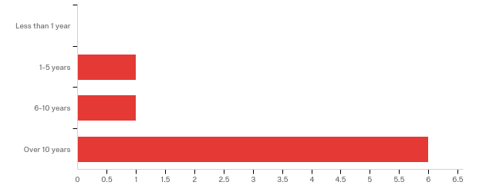

# | Answer | % | Count
1 | Less than 1 year | 0.00% | 0
2 | 1-5 years | 12.50% | 1
3 | 6-10 years | 12.50% | 1
4 | Over 10 years | 75.00% | 6
 | Total | 100% | 8

4. - Please check all the issues you are aware Edenton has faced in the last 10 years:
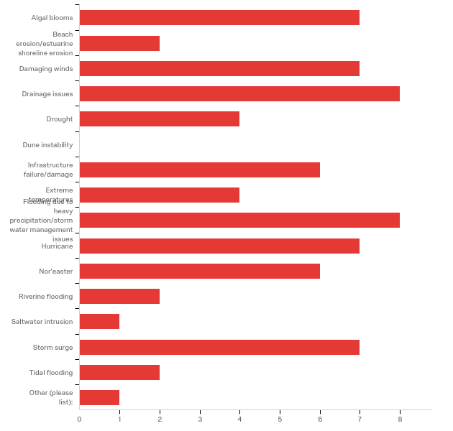

# | Answer | % | Count
1 | Algal blooms | 9.72% | 7
2 | Beach erosion/estuarine shoreline erosion | 2.78% | 2
3 | Damaging winds | 9.72% | 7
16 | Drainage issues | 11.11% | 8
4 | Drought | 5.56% | 4
5 | Dune instability | 0.00% | 0
6 | Infrastructure failure/damage | 8.33% | 6
7 | Extreme temperatures | 5.56% | 4
8 | Flooding due to heavy precipitation/stormwater management issues | 11.11% | 8
9 | Hurricane | 9.72% | 7
10 | Nor'easter | 8.33% | 6
11 | Riverine flooding | 2.78% | 2
12 | Saltwater intrusion | 1.39% | 1
13 | Storm surge | 9.72% | 7
14 | Tidal flooding | 2.78% | 2
15 | Other (please list): | 1.39% | 1
 | Total | 100% | 72

Other (please list):
Other (please list):
Road Conditions

5. - In your experience, what are the three most pressing environmental issues facing Edenton at this time?

In your experience, what are the top three environmental issues most affect...
Rising sea level,
Algae bloom, drainage issues from storm waters/heavy rain,
Infrastructure Failure/Damage, Stormwater Management, Algal Blooms
Road Conditions, Lack of Grocery Stores, and Lack of Entertainment, Lack of Jobs
Hurricanes, Algal,
Flooding, water run-off, water quality
Sewer issues, water drainage
Algal Bloom & Water Quality, storm surge & flooding due to heavy precipitation

6. - In what ways do those three environmental issues affect our community (e.g.: damage to human health, damage to local economy, displacement of citizens, etc.)?

In what ways do the top three environmental issues affect your community (e...
All that are mentioned.
damages to property, displacement of businesses and citizens
Damage to health, economy, and public and private property
Local economy,
damage to human heath
damage to human health, damage to citizens’ personal property, higher insurance rates
damage to environment, damage public health & safety and damage to local economy

7. - On a scale of what 1 to 10, where 1 is "completely unable" and 10 is "fully able," how would you rate Edenton's ability to withstand and recover from a minor storm with limited flooding?
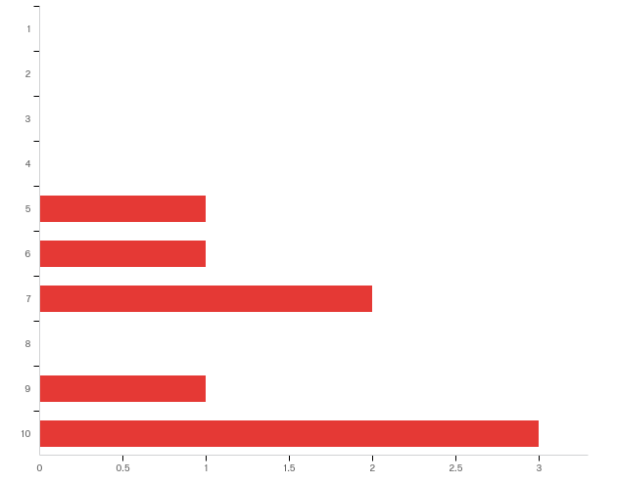

# | Answer | % | Count
1 | 1 | 0.00% | 0
2 | 2 | 0.00% | 0
3 | 3 | 0.00% | 0
4 | 4 | 0.00% | 0
5 | 5 | 12.50% | 1
6 | 6 | 12.50% | 1
7 | 7 | 25.00% | 2
8 | 8 | 0.00% | 0
9 | 9 | 12.50% | 1
10 | 10 | 37.50% | 3
 | Total | 100% | 8

8. - Why did you select this rating?

Why did you select this rating?
Happens regularly
We have a pretty good support system from our citizens and are a strong community
it happens all the time and the Town keeps plugging away!
Awesome Public Works Crew that can get the job done and cleaned up
Prepared but can be better able to respond
we have infrastructure in place that helps us withstand impacts from minor flooding

9. - On a scale of what 1 to 10, where 1 is "completely unable" and 10 is "fully able," how would you rate Edenton's ability to withstand and recover from a major storm with extensive flooding?
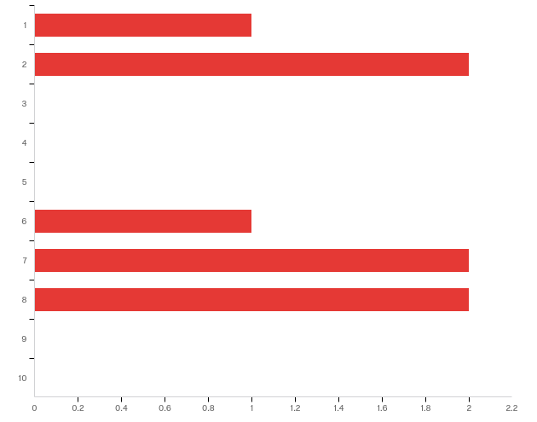

# | Answer | % | Count
1 | 1 | 12.50% | 1
2 | 2 | 25.00% | 2
3 | 3 | 0.00% | 0
4 | 4 | 0.00% | 0
5 | 5 | 0.00% | 0
6 | 6 | 12.50% | 1
7 | 7 | 25.00% | 2
8 | 8 | 25.00% | 2
9 | 9 | 0.00% | 0
10 | 10 | 0.00% | 0
 | Total | 100% | 8

10. - Why did you select this rating?

Why did you select this rating?
It’s a matter of time before this is experienced and the structures built in old creek beds are flooded
Same
Because of our infrastructure and stormwater issues, and the size of our community
Town does well on preparing and maintaining services
Strom Drains need to be cleaned to help from flooding but overall we managed threw hurricane Isabel so we can do it again
We recovered from Matthew, a storm with major flooding relatively well

11. - In your experience, do environmental issues disproportionately affect different sectors of our community (e.g.: the elderly, the disabled, low-income, etc.)?
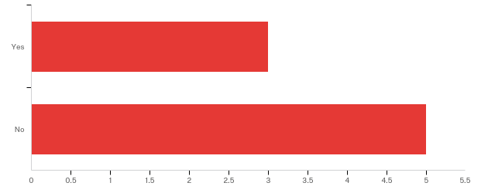

# | Answer | % | Count
1 | Yes | 37.50% | 3
2 | No | 62.50% | 5
 | Total | 100% | 8

11a. - Which groups in Edenton are disproportionately affected? Please be as specific as possible.

Please elaborate on your response so we can better understand how environme...
Low income people
Low income, poor
Lower income areas

12. - In your experience, do environmental issues affect specific areas in Edenton more than others (certain streets, neighborhoods, buildings, etc.)?
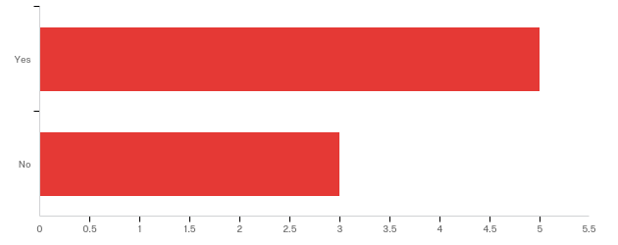

# | Answer | % | Count
1 | Yes | 62.50% | 5
2 | No | 37.50% | 3
 | Total | 100% | 8

12a. - Which areas are more affected by environmental issues? Please be as specific as possible, including street names, neighborhood names, or building names, if you know them.

Which areas are more affected by environmental issues? Please be as specifi...
The ones that are built on old creek beds.
Water St, Pembroke Circle, Pembroke Creek Apts,
Water Street, King Street, Blount Street, Pembroke Circle, Queen Anne Drive, Pembroke Creek area
North Edenton. Park Ave., Johnston St, Cabarrus St., Virginia Road, N Granville, E Water Street, South Oakum.

13. - In your opinion, what is the most difficult part of dealing with environmental issues in Edenton (e.g.: community buy-in, lack of financial resources, size of staff, etc.)?

Thinking about your community, what is the most difficult part of dealing w...
Town Government
lack of financial resources. Not sure about size of staff
Lack of financial resources
financial
lack of financial resources
Financial Resources, Size of staff
lack of financial resources

14. - In your experience, what does the Town of Edenton need in terms of tools and resources to better address our environmental issues?
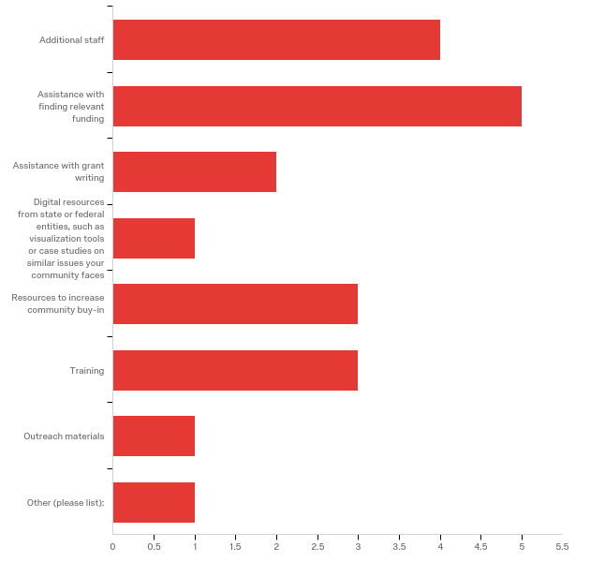

# | Answer | % | Count
1 | Additional staff | 20.00% | 4
2 | Assistance with finding relevant funding | 25.00% | 5
3 | Assistance with grant writing | 10.00% | 2
4 | Digital resources from state or federal entities, such as visualization tools or case studies on similar issues your community faces | 5.00% | 1
5 | Resources to increase community buy-in | 15.00% | 3
7 | Training | 15.00% | 3
8 | Outreach materials | 5.00% | 1
6 | Other (please list): | 5.00% | 1
 | Total | 100% | 20

Other (please list):
Other (please list):
technical advice/solutions/strategies to improve resiliency

15. - Do you have additional comments pertaining to your experiences with environmental issues in Edenton?

Do you have additional comments pertaining to your experiences with environ...
Not sure about what needs the town has since I'm not directly involved.
NO
When Edenton sets a goal, it usually achieves. We need to set goals.

16. - If you have anything else that you would like to share with us, please let us know!

If you have anything additional pertaining to this survey or to your commun...
Yes
Thank you

Appendix 3: Public Input Workshop Activities
3A. Workshop Agenda & Preparation Needs
The following agenda was used during the public workshop. The workshop took about 1.5 hours to complete.
Activity | Time
The Town Manager or Leader welcomes attendees and introduces the presenters. | 2 minutes
A Town Planner or Resident Expert talks about the town’s current issues and why this project is important for the town. | 10 minutes
The RENA Project Manager or Leader talks about the purpose of this project and the process attendees are undertaking.  During the presentation, volunteers pass out large blue dot stickers. | 15 minutes
Attendees take their blue dot stickers and mark all issues they experience within their community.  Attendees take their arrow stickers and mark their top three priorities: #1 red, #2 yellow, and #3 is green. | 40 minutes
The larger group reconvenes. The Project Manager splits the group into 3-5 people. | 10 minutes to count off and split into smaller groups
One volunteer will lead each group. The group will discuss the assets presented on the map and make additions as needed. The volunteer will take notes and insure that all information is captured. | 25 minutes
The small groups reconvene for questions. | 10 minutes

Total time: ~1.5-2 hours

Below is a list of supplies that must be gathered by the Project Manager or Leader before the workshop:
Supplies Needed | Purpose
Large hard-copy asset maps with a parcel base map – number depends on expected number of attendees | Asset maps will be ground-truthed by attendees. There should be 1 map for every 3-5 people. The maps should be large enough for attendees to identify each parcel in case attendees want to make additions to the map.
Large blue dot stickers | For attendees to mark all issues they have experienced in their communities
Arrow stickers – red, yellow, and green | For attendees to prioritize their #1, #2, and #3 issues
Sharpies – Black and Multicolored | Project Manager or Leader can use a black sharpie to take notes; Attendees can use various colored sharpies to take notes or mark on the asset maps
Large paper and tape/thumb tacks | A large sheet of paper should be taped or tacked to a wall or board. The issues should be listed on a large sheet of paper for attendees to mark with blue dots and with multicolored arrows.
Notebooks | Notebooks should be provided to volunteers to take notes as they lead small groups. Notebooks must be collected at the end of the workshop so the Project Manager or Leader can synthesize the ideas in the final report for the community.
Post-it Notes | Post-it notes should be on the tables with maps so attendees can take short notes and place them on the maps as needed.

Below is a list of pre-workshop activities that must be completed before the workshop:
Activity | Purpose
Reserve a space for the workshop | A space should be reserved at least a month before the workshop date to insure a date is set before advertising
Organize volunteers and provide training | Work with the local government or external organizations to obtain volunteers for the workshop. 1 volunteer for every 3-5 people will be best, if possible. Provide training at least two days before the workshop so the volunteers know about the project and the process that will be used during the workshop.
Advertise | Begin advertising 2-3 weeks before the workshop date. Advertise in multiple mediums such as through emails, flyers, and town newsletters.
Organize refreshments | If funds allow, order catering or provide refreshments such as coffee, tea, water, and light snacks for attendees on the date of the workshop
Write all 15 issues from the town staff survey (see Appendix 2B, question 4) on 1-2 pieces of large paper | Attendees will mark all issues they have experienced in their communities as well as prioritize those issues with stickers. This information should be matched with town staff responses to see which issues are most critical to both populations, and which issues town staff may need to better understand from the community perspective.
Pack supplies | The Project Manager or Leader should make sure they have the following supplies:  _____ - Sharpies  _____ - Blue dot stickers  _____ - Arrow stickers (red, green, yellow)  _____ - Post-it notes  _____ - Large sheets of paper  _____ - Tape or thumb tacks  _____ - Notebooks for volunteers  _____ - Pens or pencils  _____ - Printed maps for the session  _____ - Issues written on large sheets of paper

3B. Workshop Advertisement Example
Below is a sample flyer from the Town of Edenton. Edenton can replicate the flyer if they desire to do another input workshop or scale up the project to the county by using the free online tool, Canva.

3C. Workshop Instructions for Volunteers
Edenton’s Chowan Edenton Environmental Group (CEEG) assisted the Town and the CMF to organize the workshop. CEEG provided volunteers to assist with pre-workshop set-up and small group leadership. Below is the volunteer instruction packet given to each volunteer before the workshop activities.
Activity | Time
Anne Marie or Colleen welcomes attendees and introduces the project lead, Monica Gregory. | 2 minutes
The project lead talks about the purpose of this project and the process attendees are undertaking.  During the presentation, volunteers pass out large blue dot stickers. | 10 minutes
Attendees take their blue dot stickers and mark all issues they experience within their community.  Attendees take their arrow stickers and mark their top three priorities: #1 red, #2 yellow, and #3 is green. | 30-40 minutes
The larger group reconvenes. The project lead splits the group into 3-5 people. | 10 minutes to count off and split into smaller groups
One volunteer will lead each group. The group will discuss the assets presented on the map and make additions as needed. The volunteer will take notes and insure that all information is captured. | 40-50 minutes
The small groups will reconvene for questions.  **Exit survey** | 10 minutes

Thank you again for volunteering to assist with our workshop!
Please arrive at the Cooperative Extension building between
9 a.m. and 9.30 a.m. on Saturday, March 10.

Instructions:
Part I – Selecting and prioritizing issues
Activity overview:
- Participants will take blue dot stickers and place a sticker next to each of the issues they have experienced or seen in the past 10 years.
- Participants will take arrow stickers and prioritize their top three issues.
  - #1 concern should be in red;
  - #2 concern should be in yellow;
  - #3 concern should be in green.
- Participants can add issues on the last paper where I have created spaces for additional concerns.
- Participants can add comments directly below each issue -OR- participants can use the general comment notepad at the front of the room.
- Once finished, participants should sit back down so we know they are done with their selections.

Total time: About 30-40 minutes

Instructions:
Part 2 – Mapping assets:
Activity overview:
- Participants will work in small groups (ideally about 5 people per group) with one Edenton map per group.
- You will act as the small group facilitator.
  - Encourage open dialogue.
  - Insure that the small groups understand that they can mark directly on the map and use post-it notes for comments.
  - Insure that newly mapped assets are categorized clearly so I can add them to the map.
  - Take notes on any overarching ideas or consistent thoughts/concerns from your small group. A notebook will be provided to you.
  - When we have 5-10 minutes left, I will ask you to add newly mapped assets to the colorful asset list on the next page so I can clearly see new additions.
*I will be walking from group to group, but please feel free to grab me if you have any questions!

Total time: About 40-50 minutes

Color-Coded Asset List:
*At the end of your small group session, I will ask you to add newly mapped assets to this list under the appropriate category. If necessary, you can create new categories on the next page.
Community Assistance
- Habitat for Humanity/Food pantry/Clothing pantry
- New Asset:
- New Asset:
Comments:

Critical Facilities
- Numbered on map
- New Asset:
- New Asset:
Comments:
Cultural Resources
- African American cemetery
- Churches
- Historic Sites (Registered)
- New Asset:
- New Asset:
Comments:

Employment Center
- New Asset:
- New Asset:
Comments:
Environmental
- Constructed wetlands
- Champion trees
- New Asset:
- New Asset:

Comments:
Flooding
- Historic flooding
- Flooding from Matthew
- New Asset:
- New Asset:
Comments:

Government
- Numbered on map
- New Asset:
- New Asset:
Comments:

Marinas
- New Asset:
- New Asset:
Comments:

Recreation
- Parks
- Kayak launch
- Baseball fields
- New Asset:
- New Asset:
Comments:

Utilities
- Numbered on map
- New Asset:
- New Asset:
Comments:
Redevelopment
- North Oakum St. Area
- Moseley St. Area
- New Asset:
- New Asset:
Comments:

Retirement Community
- Edenton Retirement Community
- New Asset:
- New Asset:
Comments:

*Please use this space for new asset categories or additional comments*

3D. Asset List for Workshop Participants
Below is a color-coded list of assets given to each participant in the workshop. The overarching categories correspond to the asset map (Appendix 1A). This list helps participants quickly identify assets on the map by color and category. Participants should add to this list, and volunteers can record new assets and categories in their volunteer instruction packet (Appendix 3C).

Community Assistance
- Habitat for Humanity/Food pantry/Clothing pantry

Critical Facilities
- Numbered on map
Cultural Resources
- African American cemetery
- Churches
- Historic Sites (Registered)
Employment Center

Environmental
- Constructed wetlands
- Champion trees

Flooding
- Historic flooding
- Flooding from Matthew

Government
- Numbered on map

Marinas

Recreation
- Parks
- Kayak launch
- Baseball fields

Utilities
- Numbered on map

Redevelopment
- North Oakum St. Area
- Moseley St. Area
Retirement Community
- Edenton Retirement Community

Appendix 4: Modeling Examples
The Nature Conservancy (TNC) hosted our asset maps on their coastal resilience mapping tool starting in 2018. The tool allows town staff, planners, and the public to see which assets will be affected under a variety of conditions in current and future scenarios.
You can view the asset maps here.

Sea level rise projections for the current year confirm what locals already know. Certain areas along the waterfront are already subject to frequent, repetitive flooding. Two areas are circled in red below:

Under the medium sea level rise scenario (40 cm. or 15.7 in), some areas along the waterfront are more severely impacted. In addition, the streams running through Edenton overflow, affecting assets in town including roads, critical facilities, recreational areas, and cultural resources. Two impacted areas are circled in blue below:

Under the same medium sea level rise scenario, assets are more severely impacted under flood events. An example of projected flooding in downtown Edenton after a 100-year flood event under the medium sea level rise scenario is below. Additional assets are impacted, including a retirement village and redevelopment zone (circled in purple):
Appendix 5: TNC Mapping Portal – Workflow Example
The following workflow was created by Lora Eddy from The Nature Conservancy to assist communities in visualizing risk. In Section II. Adding Community Specific Information to Your Map, towns can find a version of their asset map to help visualize their vulnerabilities to coastal hazards like flooding and sea level rise.

Flood and Sea Level Rise app - Example Workflow
Dare County
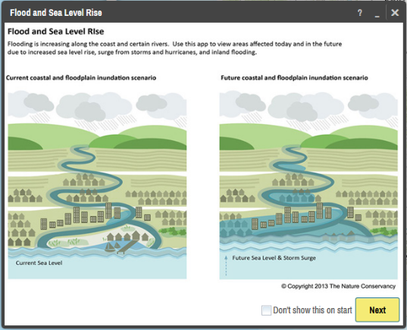
I. Visualizing Risk

- In your internet browser enter: maps.coastalresilience.org/northcarolina/
- Activate the Flood app by clicking on the icon on the left.

- Choose a Region
- Click on “Select a Region” box and select Chowan County from the drop-down menu.
- The map zooms to Chowan

- Zoom into Edenton
- Zoom by using the center scroll of your mouse or double-clicking over the area

-OR-
- In the top right corner of the map in the search bar, type in Edenton, NC
- As you type in the search box the drop-down list will auto-populate
- Select the address and the map will zoom to the address

- Choose a Hazard
- Click the “Select a Hazard” box and select Coastal Flooding (NC Emergency Mgmt)
- Slide the “Sea Level Rise” slider to 40 cm to see flooding impacts due to sea level rise alone
- Slide the “Flood Extent” slider to 100-yr to see areas in the future at risk to coastal flooding with sea level rise.
- Click on the icon next to “Flood Extent” for more information about the data you have selected

- Click on Opacity in the same box at the bottom right corner, below the sea level rise graph
- Click on the slider to adjust the opacity of the storm surge

- Minimize the Flood app window and leave the map on your zoomed in location.

II. Adding Community Specific Information to your Map
- Activate the Community Planning app by clicking on icon on the left.

- Select “Town of Edenton” and turn on the four data layers by clicking on the button next to each of them: Physical Vulnerability, Bridges, Historic District, and Social Vulnerability
- Notice the change on the map and legend – now both the hazard modeling information and the asset information can be seen
- Click the … to expand a pop-up menu that allows you to adjust the data layer’s transparency, adjust the transparency to half
- Click on the icon for more information about the data layer you have selected
- You can minimize or move the legend to see more of the map

This data can be used for land use planning, Community Rating System (CRS) planning, grant applications for resilience-building projects, emergency management, and communications pieces for residents, among other uses.

**Coastal Resilience Map Hints & Tips:
- Click on Tour for a brief introduction to the mapping site or visit coastalresilience.org/tools/training/ for an online Try Me Tutorials.
- This web-based tool can be used in most Internet browsers, including Chrome, Firefox, and Safari. NOT Internet Explorer.
- Refresh your browser window (push the F5 key) if the tool seems laggy (e.g. layers are stuck).
- Also try using a browser window which does not retain cookies or other browsing data. For example:
  - Chrome: incognito window
Firefox and Safari: private browsing window
Appendix 6: Timeline & Schedule of Activities
Below is the approximate timeline from the initial meeting with Edenton’s town staff to the completion of the project.
Month/Year | Purpose | Activities
January 2017 | Scoping meeting with Town Manager and planner | - Discuss project and time commitment  - Identify potential stakeholders to include  - Establish initial timeline
March 2017 | Map vulnerabilities with Town Manager, Planner, and other staff stakeholders | - Identify physical and social vulnerabilities from the town staff perspective
May 2017 | Survey town staff | - Identify coastal hazards and their impacts on the community  - Identify town needs to address impacts from hazards  - Identify specific areas that flood in town
April 2017 – December 2017 | Revise asset map, write narrative to justify included assets, and begin final report for town | - Update asset map according to town comments and suggested revisions. There may be several versions of the map until you add everything in the correct place.  - Write a narrative to complement the map so both the town staff and the public can easily understand what assets were included and why (see Appendix 1C)  - Begin final town report with information from background research, meetings with town staff, the town staff survey, and other relevant information
January 2018 – March 2018 | Prepare for public input workshops | - Create advertisements for public input workshops (see Appendix 3B)  - Work with town staff and volunteers to advertise through social media, newsletters, the local newspaper, and information boards around the community  - Purchase and prepare all supplies (see Appendix 3A)
March 2018 | Public input workshop | - Engage residents in the resiliency planning process  - Communicate the concept of resiliency to the community  - Retrieve input on coastal hazards and their impacts from the resident perspective  - Retrieve information on assets important to residents as well as localized flooding within town boundaries
March 2018 – May 2018 | Update asset maps and upload them to the coastal resilience mapping tool to pinpoint hotspots and prioritize projects. | - Added resident input to asset maps  - Worked with TNC to upload asset maps to the coastal resilience mapping tool  - Worked with town staff to identify hotspots where assets are currently, and will be, drastically affected by sea level rise or coastal flooding  - Worked with town staff and external partners such as The Nature Conservancy and Coastal Federation to identify specific projects that could mitigate or adapt hotspot areas to sea level rise or flooding  - Complete final report for the town

“‘Resilience’ means the ability to anticipate, prepare for, and adapt to changing conditions and withstand, respond to, and recover rapidly from disruptions.” (Former President Barack Obama, Executive Order 13653)
According to FEMA, “assets are defined broadly to include anything that is important to the character and function of a community and can be described very generally in the following four categories: People, Economy, Built environment, Natural environment.”
In the context of this project, a physical vulnerability is indicated by a geographic area exposed to a hazard, such as waterfront properties repeatedly flooded after hurricanes. A social vulnerability is indicated by a population that is exposed to a hazard, such as residents in a neighborhood in a low-lying area that repeatedly floods. Both physical and social vulnerabilities can be low or high risk, depending on their level of exposure, preparedness, and ability to recover after a disaster, among other indicators.
See Appendix 1B for the completed map and 1C for the narrative
In the context of this project, a physical vulnerability is indicated by a geographic area exposed to a hazard, such as waterfront properties repeatedly flooded after hurricanes. A social vulnerability is indicated by a population that is exposed to a hazard, such as residents in a neighborhood in a low-lying area that repeatedly floods. Both physical and social vulnerabilities can be low or high risk, depending on their level of exposure, preparedness, and ability to recover after a disaster, among other indicators.

