Town of Oriental

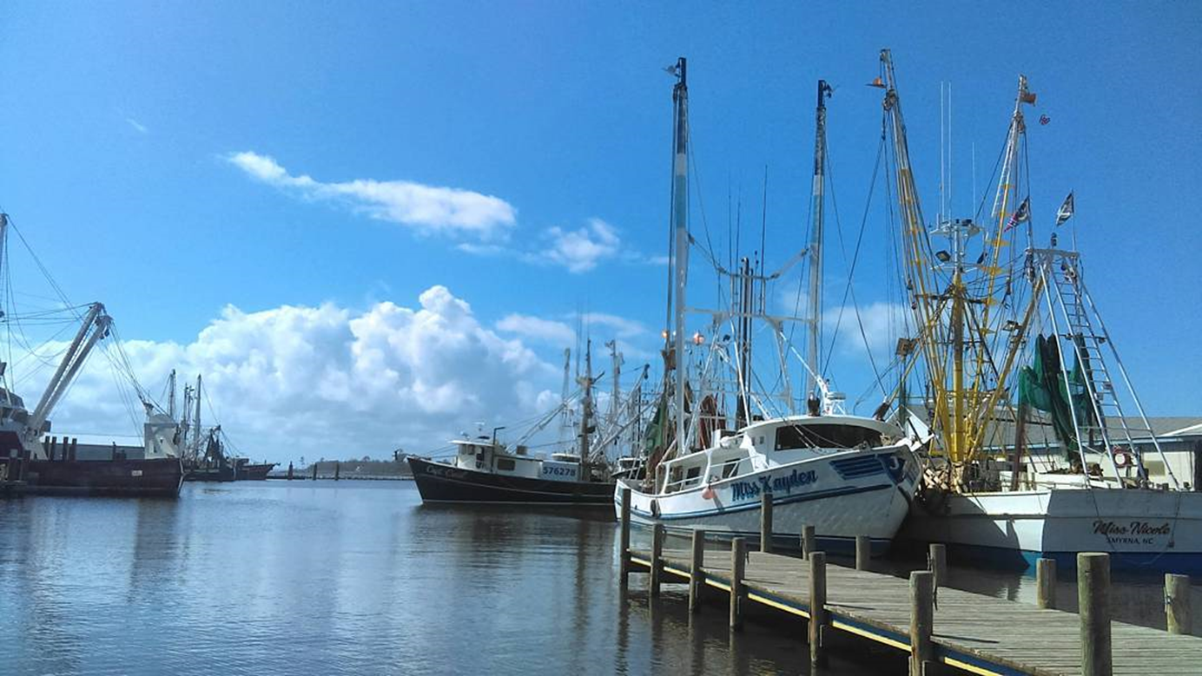
Photo credit: Monica Gregory, NOAA CMF Fellow. Oriental dock.

Resilience Evaluation and Needs Assessment
Final Report
May 2018
Table of Contents
Project Overview..……………………………………………………………………………………………………….....2
Purpose and Scope………………………………………………………………………………………………………....3
Section 1: Introduction…………………………………………………………………………………………………….4
Section 2: RENA Framework in Practice……………………………………………………………………………5
Resilience evaluation (RE) process
2.1.RE: Map town assets………………………………………………………………………………………6
2.2.RE: Identify current issues………………………………………………………………………………7
2.3.RE: Conduct public input workshops………………………………………………………………8
2.4.RE: Overlay current and future models………………………………………………………….11
Needs assessment (NA) process
2.5.NA: Identify hotspots……………………………………………………………………………………..11
2.6.NA: Prioritize assets……………………………………………………………………………………….12
2.7.NA: Document existing projects……………………………………………………………………..12
2.8.NA: Explore future projects…………………………………………………………………………….13
Data Resources………………………………………………………………………………………………………………..14
Funding Resources…………………………………………………………………………………………………………..16
Appendix ………………………………………………………………………………………………………………………...20

Project Overview
In 2016, the Division of Coastal Management (DCM) commenced a five-year project to create a resilience framework guide for coastal communities in North Carolina. DCM hired a two-year Fellow, Monica Gregory, as part of the Coastal Management Fellowship (CMF) through the National Oceanic and Atmospheric Administration (NOAA). The Fellow was hired to lay the groundwork for the guide by working with five communities to implement a vulnerability assessment and a needs assessment within their towns. The five communities will serve as case studies in the guide to illustrate the planning process, highlight best practices, and discuss resilience projects identified through the vulnerability assessment. Edenton, Pine Knoll Shores, Oriental, Duck, and Hatteras Village participated in the project.
The outcome of the five-year project will be a comprehensive guide to resilience-building in coastal communities in North Carolina. Oriental will serve as one of five case studies from which other communities can learn about resilience planning.
The final guide aims to serve local governments by:
1) illustrating a successful planning framework they can use to engage their communities in resilience and adaptation projects;
2) identifying common needs from local governments and compiling state and federal resources that can address those needs;
3) providing case studies across the North Carolina coast that can help guide other local governments in resilience planning;
and
4) discussing adaptation and mitigation strategies that can be applied in a variety of situations experienced by coastal communities in our state.

Purpose and Scope for Oriental
The purpose of this two-year project is to identify and map important social and physical assets in Oriental that may be vulnerable to current and future impacts from coastal hazards, including sea-level rise and storm surge. The planning process will help Oriental identify hotspots where the town can prioritize resilience-building projects. Through the process, participants will also identify local government and community-specific needs in building resilience.
Pamlico County has a robust regional hazard mitigation plan (HMP) which includes the Town of Oriental. This project meets several high priority needs highlighted in the HMP, including:
- Action # 1: Continue to address drainage issues as the need arises;
- Action #11: Research stormwater management and recommend strategies; and
- Action #13: Determine the number of repetitive loss properties within the town’s jurisdiction and develop strategies to mitigate future risk.
Oriental’s RENA results reinforce the ideas in the HMP and highlight additional concerns and priorities voiced by the community. This guide draws from the HMP for general information on Oriental such as hazards, demographics, capabilities, and risk. This guide adds to the information Oriental already possesses by mapping repetitive flooding in the town based on staff and resident knowledge as well as gathering more in-depth input about community priorities. It also identifies specific areas, such as streets, intersections, and buildings, that the town can target for resilience work.
The final map and guide for Oriental can be used for resilience planning purposes as well as for future grant applications related to resilience-building to fund projects in areas in need of adaptation or mitigation projects.

Section 1: Introduction
Regional survey
In February 2017, DCM released a survey to local-level staff and elected officials in coastal towns and counties to better understand their experiences with hazards and their needs for addressing them. DCM had an 11% response rate, which is about average for an online survey. Through questions about impacts from coastal hazards and existing planning efforts, DCM identified a critical need for a formal resilience planning framework to be used by regional, county, and town staff in adapting to and mitigating impacts from major and minor storms, sea level rise, hurricanes, and Nor’easters, among other hazards.
DCM staff formed an advisory committee to guide the research and selection process. Advisors included staff from The Nature Conservancy, North Carolina Sea Grant, the Coastal Federation, and DCM planners and field staff. DCM conducted a review of published resilience guides and community resilience planning methodologies.
DCM drew from various resources to create the methodology used in pilot communities. The Community Resilience Building Guide, the U.S. Climate Resilience Toolkit, the California Adaptation Planning Guide, and the Community Based Vulnerability Assessment Guide from MDC, Inc. and UNC Chapel Hill strongly influenced this project.

Selection process
To select pilot communities for case studies, DCM staff consulted state planners, state field staff, and nonprofit organizations for recommendations on towns with staff capacity and community buy-in to work through this process from beginning to end. After receiving a recommendation to reach out to Oriental, DCM staff held an initial scoping meeting with the Town Manager in January 2017. After discussing their history with coastal hazards, staff capacity, and community dynamics, the Town of Oriental accepted our invitation to participate in the pilot program as one of five communities.

Section 2: RENA Framework in Practice
DCM used the following eight-step process in each pilot community, divided into the resilience evaluation phase and the needs assessment phase:
Resilience evaluation (RE):
- Map community assets
- Identify current issues
- Conduct public input meetings
- Overlay current and future models
Needs assessment (NA):
- Identify hotspots
- Prioritize assets
- Document existing projects
- Explore future projects

Resilience Evaluation (RE)
2.1.RE. Map assets
In March 2017, DCM staff met with the Town Manager to map community assets in Oriental. Mapping assets helps the town identify important components to both the government and the community. Through the process, local government staff and officials explored their physical and social vulnerabilities under different hazardous scenarios. DCM downloaded a base map of the town from ArcGIS and printed the map at a large enough scale to identify roads and specific parcels. DCM brought the map to the meeting.
At the mapping meeting, the Town Manager worked with DCM to physically color in parcels that are considered important community assets to Oriental. DCM staff provided sharpies, highlighters, post-it notes, and colored tabs at the meeting. For each asset category, one color was used. For example, critical facilities like hospitals and the fire station were identified then colored with red sharpie. DCM staff recorded their color and location to later create a GIS attribute table and a key for the map.
The Town Manager identified critical facilities, cultural resources, fishing & boating facilities, flooding, local knowledge, recreational resources, and utilities as important components for asset mapping and vulnerability assessments in Oriental. DCM staff identified privately-owned vacant parcels and town-owned vacant parcels, which could be important as sites for resilience projects in the future.
Though not included in this project, additional social vulnerability indicator data exists, such as census data on reported income and data on property tax value. Such indicators can be used to identify areas where financial resources for recovery post-disaster may be limited. Other social vulnerability indicators that may be used in other communities – such as concentrated areas of 65+ residents, concentrated areas of non-English speakers, and concentrated areas where people have low trust in government – were not identified in Oriental.
After working with the Town Manager, DCM staff returned to their home office and transferred the data they collected to a digital map through ArcGIS. DCM created a narrative explaining the map as well as a key to use with the map. DCM sent questions, the draft map, and the draft narrative to the Town Manager for comments and additions. After multiple revisions, the Town Manager approved the asset map and narrative for Oriental.
2.2.RE. Identify current issues
Through online surveys, DCM collected the experiences and viewpoints of staff and elected officials in Oriental. The survey focused on staff knowledge and experience with coastal hazards and their impacts in the community.
Town Staff Survey Results
Thirteen staff members participated in the survey on coastal hazards and their impacts in Oriental, with 11 respondents having worked for the town for five years or less.
Hazards
The top three most common issues Oriental has faced in the past ten years are drainage issues (12 respondents); Nor’easters (12); and stormwater management issues (11). Ten respondents chose hurricanes and damaging winds as top issues, and nine respondents chose storm surge.
When asked to list the three most pressing issues facing Oriental, respondents listed flooded roads and drainage issues (10), wind-driven flooding from Nor’easters (4), and aging infrastructure (3). Respondents cited public welfare (8) related to pollution and disease and the local economy (7) as most affected by these issues, with a focus on transportation and access issues from flooded roads.

Flooding
Most respondents believe Oriental could withstand and recover from a minor storm with limited flooding: on a scale of one to ten, 11 of 13 respondents rated Oriental’s ability to recover as a five or above. Respondents say Oriental regularly experiences minor storms with limited flooding “on a yearly basis” and the town “manager and staff… know what has to be done in storm situations.”
Respondents differed in their thoughts on whether Oriental could withstand and recover from a major storm with extensive flooding, with seven of 13 respondents ranking Oriental’s ability as less than five. One respondent explained that “the last major storm that had major flooding caused havoc for two weeks.” Another respondent said “the last major storm wiped out town hall and many other businesses and residential properties.” Cascading effects from rains, wind, and tides are a major concern for Oriental.
Specific impacts from flooding
Of the seven respondents who have seen specific impacts from flooding around Oriental, the following areas were mentioned: Hodges Street (7), Main Street (5), Factory Street (4), South Street (2), Water Street (2), Midyette Street (2), Neuse Street (2), and Broad Street (1). Other areas such as the marinas, the Bean coffee shop, the seafood hut, the town dock, the art gallery, the harbor duck pond, White Farm, and the Inland Waterway Provision Company were mentioned.

Social impacts
Eleven of 13 respondents believe environmental issues disproportionately affect certain segments of the population in Oriental. Nine respondents recorded specific segments of Oriental’s population: elderly (7), low-income (6), and tourists (1).
Town Needs
Respondents cited a wide variety of needs to address environmental challenges in Oriental. Training (10), assistance with finding relevant funding for projects (9), additional staff (6), digital resources from state or federal entities (6), and resources to increase community buy-in (6) were the most common needs.

2.3.RE. Conduct public input workshops
In March 2018, Oriental and DCM conducted a public input workshop focused on two activities: 1) coastal hazard issues and prioritization and 2) asset mapping.
Activity 1: Issues and Prioritization
In the first activity, twenty residents worked to identify all issues they had experienced over the past 10 years in Oriental. The issues were taken from the staff survey (Appendix 2A, question 4) so the Town Manager could compare staff perceptions to resident perceptions of coastal hazards and their impacts.
Residents placed blue stickers next to each issue they had experienced. To prioritize issues, residents were given a red, yellow, and green flag sticker. They marked their top concern with the red sticker; their second concern with the yellow sticker; and their third concern with the green sticker.
Out of a list of 15 issues, over half of participants experienced the following hazards and impacts in Oriental over the past decade:
- Stormwater management issues (16)
- Hurricanes (15)
- Nor’easters (15)
- Drainage and ponding issues (14)
- Riverine flooding (14)
- Storm surge (14)
- Damaging winds (12)
- Shoreline erosion (12)
- Infrastructure failure and damage (11)
Residents cited the following concerns as top priorities for the town to prepare for, mitigate, or adapt to:
- Storm surge – Four residents listed storm surge as their top concern; three listed it as their second priority concern; and one listed it as their third priority concern
- Stormwater management – Three residents listed stormwater management as their top concern; one listed it as their second priority concern; and four listed it as their third priority concern
- Hurricanes – Three residents listed hurricanes as their top concern; four listed them as their second priority concern; and one listed them as their third priority concern
Other top concerns were Nor’easters (7); drainage and ponding (7); riverine flooding (3); damaging winds (2); infrastructure failure or damage (2); extreme temperatures (2); shoreline erosion (1); saltwater intrusion (1).

Activity 2: Asset mapping
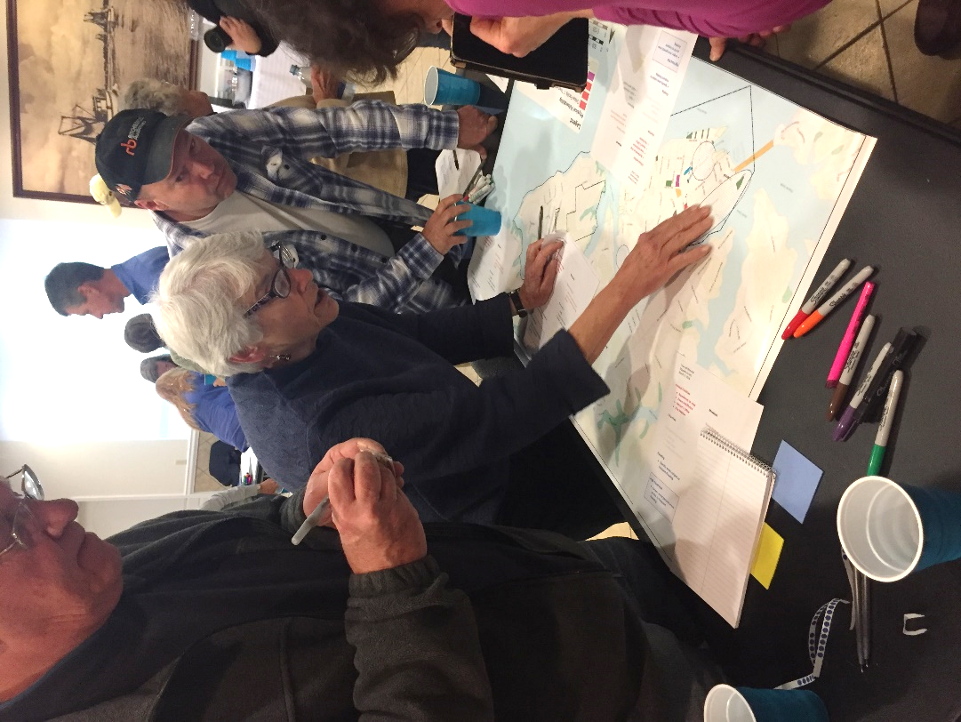
During the second activity, residents split into small groups to focus on asset mapping. Each group was led by a volunteer resident who used an instruction packet developed by the CMF (see Appendix 3C) to manage the activity.
Over the course of the activity, small groups discussed the assets to insure they were accurately portrayed on the map. Each group made additions, including adding the local theater to cultural resources; the Women’s Club to recreation; the bank, vet’s office, and food/fuel locations to commercial assets; and additional localized flooding and storm parking locations.
The maps below show the difference between the assets mapped by the town and assets added by residents:
Oriental residents work on asset mapping. March 1, 2018.

Map 1 – Asset Map with Town Staff Input
Map 2 – Asset Map with Resident Additions

2.4.RE. Overlay current and future models
In 2018, the CMF reached out to The Nature Conservancy (TNC) to request a collaboration between DCM’s asset mapping and TNC’s coastal resilience mapping tool. TNC agreed to host town asset maps so local government staff could easily apply sea level rise and coastal flooding models to their maps. TNC uses NOAA data for a variety of future scenarios; all data are readily available for download through the NOAA Digital Coast’s Coastal Flood Mapper. Potential datasets include:
- Coastal Flood Hazard Composite - Provides a quick visual assessment of areas most prone to flood hazard events.
- Shallow Coastal Flooding - Areas subject to shallow coastal flooding.
- FEMA Flood Zones - Areas at risk from flooding.
- Storm Surge - Areas at risk from storm surge.
- Sea Level Rise - Areas likely to be inundated by sea level rise.
In Oriental, current overlays are sea level rise data from NOAA and coastal flooding data for current mean high water, a 10-year flood event, a 100-year flood event, and past flooding from Hurricane Fran (1996) from North Carolina’s Division of Emergency Management.
Future scenarios through TNC’s coastal resilience mapper include risk in three separate years: 2045, 2060, and 2100. Town staff and leaders can choose to plan for low, medium, or high risk in any given year to see which assets will be most at risk from one or a combination of hazardous events.

Needs Assessment (NA) Process
2.5.NA. Identify hotspots
Through TNC’s mapping portal, town staff and residents can view their asset maps and overlay sea level rise scenarios, storm surge scenarios, and coastal flooding data. Staff can pinpoint areas to focus resilience-building efforts that are consistent with their ongoing resilience work or with their current town vision. The town staff can decide what planning scenario they wish to use: for example, a town can use the medium sea level rise scenario for the year 2045 to identify assets and areas they wish to adapt to or mitigate from increased flooding.
In the future, town staff can hold additional workshops to better understand community priorities in the face of sea level rise, increased frequency and severity of storm surge, and increased flooding.
2.6.NA. Prioritize assets
Oriental can prioritize assets and areas of vulnerability to focus their resilience-building efforts. Assets could be prioritized by residents in the community; by cost-benefit or return-on-investment analyses; or by other means selected by town staff. Staff could hold additional workshops to receive input from residents regarding asset prioritization.
2.7.NA. Document existing projects
The Town of Oriental has been working to integrate resilience planning into several aspects of their work:
1. The Raccoon Creek Flood Abatement Study – Through the RENA process, the Town of Oriental received a resilience-focused grant from DCM. The project was an engineering study to determine mitigation measures for reduction of frequency and level of flooding within the Raccoon Creek Drainage Basin within the Town of Oriental. The project evaluated the feasibility of raising the grade of Hodges Street to create a dyke and installing backwater valves to prevent tidal water from backing up through the culverts. The study also evaluated improvements needed to the existing ponds on Raccoon Creek to achieve nutrient reduction prior to discharge to the Neuse River.
2. Plan Adoptions – In 2017, Oriental signed on to the Pamlico Hazard Mitigation Plan. In addition, the town adopted a terraforming ordinance that prevents new construction from negatively impacting adjoining neighbors’ drainage. For example, the town required DCM and the Pamlico County Conservation staff to approve a bulkhead constructed in the duck ponds. The town also required a new builder to install a significant length of drainage from the rear of a new house to the front ditches.
3. Drainage Maintenance – Oriental has spent a portion of their budget in the last two years clearing catch basins so drainage areas to work as designed.
4. Impervious Surface Monitoring – Town staff monitor impervious surface in new construction and suggest the use of open pavers, ¾” and larger gravel, and permeable concrete.

2.8.NA. Explore future projects
In addition to recommendations from the community, town staff can explore potential policy changes and projects based on future sea level rise and flood scenarios. The following policies and projects are not prioritized. The list serves to inspire residents, officials, and staff to work collaboratively to make the Town of Oriental the most resilient town it can be:
Resident suggestions from public workshops:
- Maintain drainage ditches and work with private property owners to gain access to ditches on private property.
Additional suggestions from DCM:
- Adopt the final vulnerability map into land-use planning decisions to decrease unsustainable development in areas vulnerable to sea level rise or flooding.
- Align community plans through the lens of resilience, including economic plans, housing plans, and natural resource management plans.
- Work with the Community Rating System to increase Oriental’s rating and reduce the cost of flood insurance. Work with The Nature Conservancy and other entities like the Coastal Federation to achieve a higher score.
- Increase freeboard requirements within the town boundaries.
- Prepare for future impacts by using long-term planning scenarios such as “medium” or “high” scenarios in year 2100.
- Work to plan collaboratively for climate impacts at the watershed level. Bringing entities such as town officials, county officials, and neighboring town staff and officials will be critical. The Albemarle Pamlico National Estuary Partnership (APNEP) can help facilitate meetings or workshops related to climate planning.
- Create emergency plans for all public institutions. Plans for state buildings, churches, and other historic buildings (private and public) could be created. Oriental staff and business leaders could use the Red Cross Ready Rating Program to create emergency plans.
- Communicate the benefits of living shorelines to property owners around Oriental, specifically those living along Whittaker Creek where erosion is increasing. Work with the Coastal Federation to advocate for living shorelines where appropriate, particularly in light of the fast erosion rate of Whittaker Point.

Data Resources
The following resources are tools and useful guides to plan for resilience. Researchers, planners, and town managers may find them helpful in the context of hazard mitigation, resilience-building, and community engagement.
- Coastal Inundation Toolkit (NOAA Digital Coast):
A toolkit that communities can use to understand coastal inundation and to identify their risks and vulnerabilities. Users can visualize information to better explain risk concepts: https://coast.noaa.gov/digitalcoast/training/coastal-inundation-toolkit.html
- Coastal Resilience Index (Mississippi-Alabama Sea Grant Consortium):
A guide that can communities can use to examine different elements to increase their resilience: http://masgc.org/news/article/assessing-resilience-cri
- Community Based Vulnerability Assessment, 2009 (University of North Carolina and MDC, Inc):
A guidebook for communities to walk through the process of assessing their physical and social vulnerabilities, with an emphasis on social justice and inclusion:
http://www.mdcinc.org/sites/default/files/resources/Community%20Based%20Vulnerability%20Assessment.pdf
- Community Toolbox (University of Kansas):
A toolbox with extensive resources to better understand and engage with community members. The toolbox includes resources for developing assessment plans, understanding and describing communities, and conducting focus groups, among others: http://ctb.ku.edu/en/table-of-contents
- Naturally Resilient Communities, 2017 (APA, TNC, ASCE, and partners):
An online tool that helps decision-makers explore solutions to natural hazards based on the type of hazard, the type of community, the project scale, and the project cost. Additionally, the tool provides case studies from several regions in the U.S.:
http://nrcsolutions.org/strategies/?fwp_hazards=coastal
- The U.S. Climate Resilience Toolkit, 2016 (NOAA):
The Toolkit is designed to help people find and use tools, information, and subject matter expertise to build climate resilience. The Toolkit offers information from across the U.S. federal government in one easy-to-use location: https://toolkit.climate.gov/
- Vulnerability, Consequences, and Adaptation Planning Scenarios (VCAPS) tutorial, 2013 ( University of South Carolina, South Carolina Sea Grant Consortium, Carolinas Integrated Sciences and Assessments, and Social and Environmental Research Institute): A tutorial that walks through the process of using VCAPS, a tool for community decision-makers to better understand the challenges their communities face under climate change stressors: http://www.vcapsforplanning.org/docs/VCAPS%20UserGuide%2025March13.pdf
- Rising to the Challenge, Together, 2017 (The Kresge Foundation): An overview of the climate adaptation field with guidance on how to move forward cohesively: https://kresge.org/content/rising-challenge-together?utm_source=ASAP&utm_campaign=5851507e8a-EMAIL_CAMPAIGN_2017_12_29&utm_medium=email&utm_term=0_390b9a48ee-5851507e8a-420011193&mc_cid=5851507e8a&mc_eid=0e67b19bed
- ClimateAssessment.org, 2018 (National collaboration): ClimateAssessment.org facilitates rigorous and transparent evaluation of climate science and climate adaptation/mitigation practice, and aims to further develop and support a network of scientists and practitioners in producing, managing, and using credible and relevant climate-related information: https://www.climateassessment.org/
- Coastal Resilience, 2017 (The Nature Conservancy): A portal by The Nature Conservancy focused on case studies, mapping tools, and resources for communities to build their resilience to coastal hazards and their impacts: http://coastalresilience.org/
Funding Resources
The following short-list compiles information on local and national grant programs, information on nonprofits and agencies focused on funding resiliency-related projects, and existing lists of funding sources from other organizations. This list is not comprehensive.
Grants
- State Grant Program - North Carolina’s Department of Environmental Quality, Division of Coastal Management (DEQ-DCM) Planning and Management Grants
  - Funding frequency: Periodic; As funding allows
  - Description: DEQ-DCM’s Planning and Management grants help local governments in the 20 coastal counties fund local planning and management projects. Funding is prioritized by issue. During the 2017-2018 cycle, Natural Hazards and Storm Recovery projects were encouraged.
  - For more information: https://deq.nc.gov/about/divisions/coastal-management/coastal-management-land-use-planning/grants
- State Grant Program: Clean Water Management Trust Fund (CWMTF)
  - Funding frequency: Annually
  - Description: The CWMTF grants are available to non-profit and governmental organizations to protect land for natural, historical and cultural benefit, limit encroachment on military installations, restore degraded streams, and develop and improve stormwater treatment technology.
  - For more information: https://cwmtf.nc.gov/

- State Grant Program: Water Resources Development Grant Program
  - Funding frequency: Bi-annually
  - Description: The purpose of this program is to provide cost-share grants and technical assistance to local governments throughout the state. Applications for grants are accepted for seven purposes: General Navigation, Recreational Navigation, Water Management, Stream Restoration, Land Acquisition and Facility Development for Water-Based Recreation, NRCS Environmental Quality Incentives Program (EQIP) stream restoration projects and Feasibility/Engineering Studies.
  - For more information: http://deq.nc.gov/about/divisions/water-resources/water-resources-grants/financial-assistance
- Federal Grants: U.S. Climate Resilience Toolkit List
  - Funding frequency: Dependent on grant
  - Description: The U.S. Climate Resilience Toolkit is a website designed to help people find and use tools, information, and subject matter expertise to build climate resilience. The Toolkit offers information from all across the U.S. federal government in one easy-to-use location. In the United States, a range of government entities and private foundations offer financial and technical resources to advance local adaptation and mitigation efforts. For convenience, the Toolkit has compiled a list of some of those funding resources.
  - For more information: https://toolkit.climate.gov/content/funding-opportunities
- Federal Grants: Resilience AmeriCorps VISTAs Funding List
  - Funding frequency: Dependent on grant
  - Description: Resilience AmeriCorps VISTA builds capacity in vulnerable, low-income communities to develop plans and implement projects that increase the community’s resilience to shocks and stressors. The document was created for Resilience AmeriCorps VISTA members and lists a variety of grants for resilience-building.
  - For more information: http://www.regions.noaa.gov/secar/wp-content/uploads/2013/06/Federal-Funding-for-Resilience-Projects.pdf [PDF Download]
- Federal Grants: National Oceanic and Atmospheric Administration (NOAA), Office of Coastal Management (OCM)
  - Funding frequency: Dependent on grant
  - Description: NOAA is an agency that enriches life through science. Our reach goes from the surface of the sun to the depths of the ocean floor as we work to keep citizens informed of the changing environment around them. NOAA’s OCM manages a competitive grant program that funds projects that are helping coastal communities and ecosystems prepare for and recover from extreme weather events, climate hazards, and changing ocean conditions. All project proposals undergo a rigorous merit review and selection process by a panel of subject matter experts from across the United States that include representatives of government, academia, and private industry.
  - For more Information: https://coast.noaa.gov/resilience-grant/
- National Non-Profit Grants: The Kresge Foundation
  - Funding frequency: Dependent on grant
  - Description: The Kresge Foundation is a $3.6 billion private, national foundation that works to expand opportunities in America’s cities through grant-making and social investing in arts and culture, education, environment, health, human services and community development.
  - For more information: https://kresge.org/opportunities
- National Non-Profit Grants: Model Forest Policy Program (MFPP)
  - Funding frequency: Dependent on grant
  - Description: The Model Forest Policy Program is a national nonprofit that builds the capacity of communities to be climate resilient by sustaining water resources, productive forests, citizens’ wellbeing, and thriving economies. Our team compiled a Climate Resilience Funding Guide to help communities identify financial support for climate adaptation projects. MFPP’s will help communities learn about established funding programs that have evolved to provide funding for climate adaptation activities, and to match those funding sources with local adaptation goals.
  - For more information: http://www.mfpp.org/climate-resilience-funding-guide/ [Guide available to download for free]
Organizations
- Local Non-Profit Organization: Coastal Federation
  - Description: The North Carolina Coastal Federation is a member-supported 501(c)3 that focuses on protecting and restoring the North Carolina coast. Since 1982, the federation has been in the field restoring miles of coastline; training and educating students, adults and communities to take actions that result in cleaner coastal waters and advocating for an accessible, healthy, productive coast. The Coastal Federation has worked in communities across North Carolina to assist with grant-writing and to implement on-the-ground projects.
  - For more information: https://www.nccoast.org/about-us/
- Local Non-Profit Organization: North Carolina Land of Water (NC LOW)
  - Description: NC LOW is a 501(c)3 non-profit formed around 2016 that may be able to assist with identifying funding sources for local projects in North Carolina. CAMA counties covered in NC LOW’s region include: Bertie, Beaufort, Camden, Carteret, Chowan, Craven, Currituck, Dare, Gates, Hertford, Hyde, Pamlico, Pasquotank, Perquimans, Tyrrell, and Washington.
  - For more information: http://www.nclandofwater.org/
- National Non-Profit Organization (local chapter): The Nature Conservancy, North Carolina
  - Description: The mission of The Nature Conservancy is to conserve the lands and waters on which all life depends. For 41 years, TNC has been working in North Carolina. Staff in Kill Devil Hills, North Carolina, worked extensively with the CMF to host asset maps created by DCM and local governments. TNC has tools, resources, and staff expertise to assist communities to build resilience.
  - For more information: https://www.nature.org/ourinitiatives/regions/northamerica/unitedstates/northcarolina/index.htm

Appendix
Appendix 1: Asset Maps
-1A. Asset Map from Town Staff Input………………………………………………………………………….21
-1B. Final Asset Map with Resident Input……………………………………………………………………..22
-1C. Final Asset Map Narrative……………………………………………………………………………………..23
-1D. GIS Data Sources…………………………………………………………………………………………………..27
Appendix 2: Town Staff Survey
-2A. Survey…………………………………………………………………………………………………………………..28
-2B. Survey Report……………………………………………………………………………………………………….38
Appendix 3: Public Input Workshop Activities
-3A: Workshop Agenda & Preparation Needs……………………………………………………………….59
-3B: Workshop Advertisement Example……………………………………………………………………….62
-3C: Workshop Instructions for Volunteers…………………………………………………………………..63
-3D: Asset List for Workshop Participants…………………………………………………………………….71
Appendix 4: Modeling Examples………………………………………………………………………………………………72
Appendix 5: TNC Mapping Portal – Workflow Example……………………………………………………………74
Appendix 6: Timeline & Schedule of Activities…………………………………………………………………………76

Appendix 1: Asset Maps

1A. Asset Map from Town Staff Input
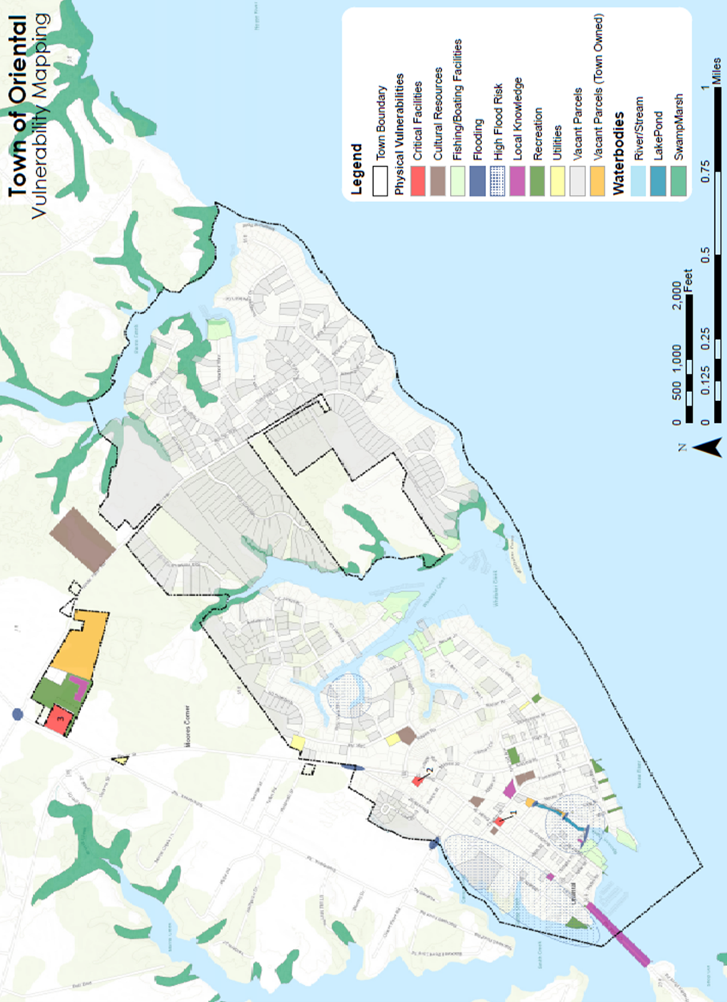
Number key: 1 = Town Hall. 2 = Doctor’s Office. 3 = Fire Station.

1B. Final Asset Map with Resident Input

1C. Final Asset Map Narrative
Introduction and Purpose
The Division of Coastal Management (DCM) and the Town of Oriental worked together to create a map of the community’s physical and social vulnerabilities to coastal hazards. Creating the vulnerability map is a multi-step process that aims to understand a community’s hazards and capabilities, as well as to prioritize assets to include on the map. After town staff work with DCM to create initial maps, residents will have an opportunity to add their knowledge to the maps through public meetings, follow-up interviews, and community surveys.
The mapping project is a three-part process: staff mapping, public input, and analysis. After the staff map is complete and reviewed by the Town Manager, DCM and town staff will conduct public meetings to add residents’ experiences with flooding. DCM will combine elements and ideas from staff and resident meetings into one map, add additional layers from coastal hazard models, and pinpoint ‘hotspots’ where towns can focus project-planning efforts and funding to increase their resilience.
DCM is undertaking this process as a pilot program to better understand community experiences with hazards and to identify areas where town staff can focus resources to mitigate future hazard-related damages. The maps can also serve as additional documentation when applying for grant funding for resilience projects. DCM will produce a guide outlining the process used in Oriental and other pilot communities.
At the end of the project period, DCM intends to create a step-by-step framework guide for coastal communities to repeat the process, with Oriental as one of five case studies in that guide.

Mapping Oriental: Introduction
The Town Manager and workshop participants identified commercial areas, critical facilities, cultural resources, boating facilities, localized flooding, storm parking, recreational resources, and utilities as important assets in Oriental. DCM has access to social vulnerability indicators, such as census data on reported income and property tax value, which can be used to identify areas where financial resources for recovery post-disaster may be limited. This map does not include those social vulnerability indicators. Additional social vulnerability indicators that may be used in other communities, such as locations of nursing homes, concentrated areas of 65+ residents, concentrated areas of non-English speakers, and concentrated areas where people have low trust in government, are not present in Oriental.
Asset Table
The following table is a full list of mapped assets, with the green header as the overarching category for each column:
Commercial | Critical Facilities | Cultural Resources | Boating Facilities | Localized Flooding | Storm Parking | Recreation | Utilities
Bank | Doctor's Office | Churches | Marinas |  |  | Public Water Access | Water Plant
Vet | Police Station/Town Hall | Museum | Boat Yards |  |  | Parks | Wellhead
Food/Fuel | Fire Station | Theater | Commercial Fisheries |  |  | Restrooms | Water Tower
 |  |  |  |  |  | Women’s Club | Lift Station
 |  |  |  |  |  | Town Docks | Sewage Treatment Plant/Lagoons

Commercial Areas
Residents identified the bank, the vet’s office, and businesses that provide food and fuel as important commercial assets for daily life in Oriental. Protecting commercial structures and insuring access to them is important to residents.
Critical Facilities
Critical facilities are buildings that are important in the aftermath of a disaster, whether because they provide public assistance (such as police stations or fire stations) or because the population residing within the facility needs immediate assistance (such nursing homes or hospitals). DCM and the Town Manager identified the police station and town hall, the fire station, and the doctor’s office as critical facilities. Staff from the police station, town hall, and fire station can serve as first-line responders following a natural disaster, as well as aid residents with mobility issues. There are no hospitals in Oriental, so the doctor’s office was included as the closest point for medical assistance within the town boundary.

Cultural Resources
Cultural resources are structures or areas that have a special meaning to a community, such as monuments, museums, and sacred spaces. Cultural resources can be damaged by a disaster and affect the culture and quality of life in a community. It is important to map cultural resources so both town staff and residents know their location for mitigation or recovery projects. Oriental identified the history museum, the theater, and churches as assets. There are no registered historical sites in Oriental, and known historical sites have already been mitigated against flooding.
Boating Facilities
Oriental has a history rooted in fishing and boating. The Town Manager and residents identified marinas, boat yards, and commercial fisheries as important resources to protect from coastal hazards for their commercial, recreational, and cultural value. In the event of a natural disaster, it would be important for Oriental to know the location of boating facilities for their economic and community importance. Fishing and boating assets are high-value targets for mitigation projects.

Localized Flooding
Localized flooding is included on the asset map so the town has a record of what staff and residents have experienced after natural disasters and flooding events. The flooding is mapped in specific locations, like roads that experience frequent ponding or intersections with drainage issues. Areas where locals experience flooding regularly can be targeted by the town for mitigation to better prepare the community.

Storm Parking
The Town Manager and residents identified storm parking as important additions to the map. Mapping areas where residents park their cars during storms and flood events provides a visualization of known high ground areas that should be mitigated against future flooding.

Recreation
Recreational resources are important for quality of life and the economy. Mapping recreational assets helps town staff pinpoint areas to mitigate to keep attracting tourists and maintain characteristics that make Oriental a unique, enjoyable place to live. Oriental identified public water access, public parks, town docks, and the public restroom as important recreational resources.

Utilities
Utilities are important infrastructure that should be identified pre- and post-disaster to keep a community safe and healthy. By mapping utilities, town staff can quickly locate areas post-disaster to repair damages. Utilities could be important for pre-disaster planning and mitigation projects to increase overall community resilience. Oriental identified their water plant, wellheads, water towers, and lift stations as important utilities in a resilience context. Residents identified the county-owned sewage treatment plant and its lagoons which could significantly affect environmental resources and quality of life in Oriental if damaged.
Geographic features
DCM staff included waterbodies on the map to better visualize locations prone to flooding based on natural geography, as well as to identify areas with the potential to mitigate flooding risk, such as wetlands that could be expanded.

1D. GIS Data Sources
The following table lists data sources used to compile asset maps in Oriental and other communities.
Layer Type | Source | Website
Building Footprint  Schools  Flood Hazard Areas  City Limits | NC Flood Mapping Program | https://sdd.nc.gov/sdd/DataDownload.aspx
Roads, Bridges, Rail | NC DOT | https://connect.ncdot.gov/resources/gis/pages/gis-data-layers.aspx
Waterbodies | USGS – National Hydrological Dataset | https://viewer.nationalmap.gov/basic/
Critical Infrastructure (Police, Fire…) | USGS – National Structures Dataset | https://viewer.nationalmap.gov/basic/
Historic Districts/Buildings | NC Historic Preservation Office | http://gis.ncdcr.gov/hpoweb/default.htm?config=AdvancedUser.xml
Duck & Hatteras Parcels | NC OneMap | http://data.nconemap.gov/geoportal/catalog/main/home.page
Edenton Parcels | Chowan County | http://maps.agdmaps.com/nc/chowan/
Pine Knoll Shores Parcels | Carteret County | http://gisdata-cc-gis.opendata.arcgis.com/
Oriental Parcels | Pamlico County | http://maps.agdmaps.com/nc/pamlico/

Appendix 2: Town Staff Survey

2A. Survey
*This survey was created using Qualtrics survey engine.
Town of Oriental: Coastal Hazards Survey

Thank you for taking the time to complete this survey, your input is very important to us! We are working with partners from the National Oceanic and Atmospheric Administration and the N.C. Division of Coastal Management to assess our vulnerabilities to coastal hazards such as storms and flooding. We are also exploring how we can become more “resilient” to coastal hazards. We would like to hear from you about the most common and pressing hazards and environmental issues you experience in Oriental, along with your needs for addressing them.
This survey contains three sections and should take less than 15 minutes to complete:
1. General Information
2. Environmental Issues in Our Community
3. Local Government Needs
All responses will remain confidential; no individual respondent will be identified in the survey report. If you would like to participate, please complete this survey by 5 p.m. on August 18, 2017. If you have questions or need assistance with the survey, please contact Monica Gregory at monica.gregory@ncdenr.gov or (252) 808-2808, ext. 230.
*Please note: this survey is intended for local government officials and staff only. Separate methods will be used to gather information from residents.
Thank you for taking the time to complete our survey!

1. Do you currently work for the Town of Oriental?
- Yes (1)
- No (2)
Condition: No Is Selected. Skip To: End of Survey. Condition: Yes Is Selected. Skip To: Which position from the following list....

2. Which position from the following list most closely matches your own?
- Accounting or Finance Officer
- Administrative Assistant
- Code Enforcement Officer
- Elected Official
- GIS Analyst
- Human Resources Officer
- Intern
- Planner
- Permitting Agent/Inspector
- Policy Analyst
- Public Safety Officer
- Public Works Officer
- Town Manager
- Other: ____________________

3. Approximately how long have you worked for the Town of Oriental?
- Less than 1 year (1)
- 1-5 years (2)
- 6-10 years (3)
- Over 10 years (4)

4. Please check all the issues you are aware that Oriental has faced in the last 10 years:
- Algal blooms (1)
- Beach erosion/estuarine shoreline erosion (2)
- Damaging winds (3)
- Drainage issues (16)
- Drought (4)
- Dune instability (5)
- Infrastructure failure/damage (6)
- Extreme temperatures (7)
- Flooding due to heavy precipitation/stormwater management issues (8)
- Hurricane (9)
- Nor'easter (10)
- Riverine flooding (11)
- Saltwater intrusion (12)
- Storm surge (13)
- Tidal flooding (14)
- Other (please list): (15) ____________________

5. In your experience, what are the three most pressing environmental issues facing Oriental at this time?

6. In what ways do those three environmental issues affect our community (e.g., damage to human health, damage to local economy, displacement of citizens, etc.)?

7. On a scale of what 1 to 10, where 1 is "completely unable" and 10 is "fully able," how would you rate Oriental’s ability to withstand and recover from a minor storm with limited flooding?
- 1 (1)
- 2 (2)
- 3 (3)
- 4 (4)
- 5 (5)
- 6 (6)
- 7 (7)
- 8 (8)
- 9 (9)
- 10 (10)

8. Why did you select this rating?

9. On a scale of what 1 to 10, where 1 is "completely unable" and 10 is "fully able," how would you rate Oriental’s ability to withstand and recover from a major storm with extensive flooding?
- 1 (1)
- 2 (2)
- 3 (3)
- 4 (4)
- 5 (5)
- 6 (6)
- 7 (7)
- 8 (8)
- 9 (9)
- 10 (10)

10. Why did you select this rating?

11. In your experience, do environmental issues disproportionately affect different sectors of our community (e.g., the elderly, the disabled, low-income, etc.)?
- Yes (1)
- No (2)
Condition: No Is Selected. Skip To: Click to write the question text.

11a. Which groups in Oriental are disproportionately affected? Please be as specific as possible.

12. In your experience, do environmental issues affect specific areas in Oriental more than others (certain streets, neighborhoods, buildings, etc.)?
- Yes (1)
- No (2)
Condition: No Is Selected. Skip To: End of Block.

12a. Which areas are more affected by environmental issues? Please be as specific as possible, including street names, neighborhood names, or building names, if you know them.

13. In your opinion, what is the most difficult part of dealing with environmental issues in Oriental (e.g., community buy-in, lack of financial resources, size of staff, etc.)?

14. In your experience, what does the Town need in terms of tools and resources to better address our environmental issues?
- Additional staff (1)
- Assistance with finding relevant funding (2)
- Assistance with grant writing (3)
- Digital resources from state or federal entities, such as visualization tools or case studies on similar issues your community faces (4)
- Resources to increase community buy-in (5)
- Training (7)
- Outreach materials (8)
- Other (please list): (6) ____________________

15. Do you have additional comments pertaining to your experiences with environmental issues in Oriental?

16. If you have anything else that you would like to share with us, please let us know!

- Thank you again for sharing your experiences and needs with us. If you have any questions or concerns, please contact Monica Gregory at monica.gregory@ncdenr.gov.Have a good day!

2B. Survey Report

Default Report
Town of Oriental: Coastal Hazards Survey
September 18th 2017, 7:42 am MDT
1. - Do you currently work for or serve as a commissioner for the Town of Oriental?
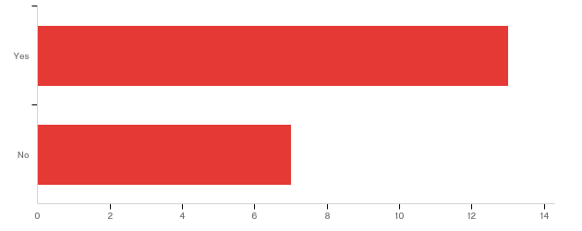

# | Answer | % | Count
1 | Yes | 65.00% | 13
2 | No | 35.00% | 7
 | Total | 100% | 20

4. - Please check all the issues you are aware Oriental has faced in the last 10 years:
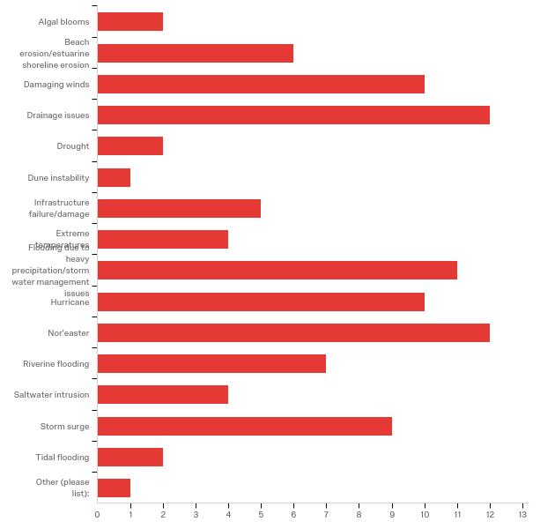

# | Answer | % | Count
1 | Algal blooms | 2.04% | 2
2 | Beach erosion/estuarine shoreline erosion | 6.12% | 6
3 | Damaging winds | 10.20% | 10
16 | Drainage issues | 12.24% | 12
4 | Drought | 2.04% | 2
5 | Dune instability | 1.02% | 1
6 | Infrastructure failure/damage | 5.10% | 5
7 | Extreme temperatures | 4.08% | 4
8 | Flooding due to heavy precipitation/stormwater management issues | 11.22% | 11
9 | Hurricane | 10.20% | 10
10 | Nor'easter | 12.24% | 12
11 | Riverine flooding | 7.14% | 7
12 | Saltwater intrusion | 4.08% | 4
13 | Storm surge | 9.18% | 9
14 | Tidal flooding | 2.04% | 2
15 | Other (please list): | 1.02% | 1
 | Total | 100% | 98

Other (please list):
Other (please list):
Harbor pollution due to shrimp boats sandblasted in water by one company

5. - In your experience, what are the three most pressing environmental issues facing Oriental now?

In your experience, what are the top three environmental issues most affect...
1)Roads flooding from wind driven water levels e.g.: Nor' Easter, 2) Aging storm drains, 3) Pavement crumbling from extended saturation
roads right of ways signs
storm water management and drainage issues and some roads being washed out
drainage saltwater intrusion mosquitoes
1 - Flooding due to Nor' Easter. 2 - Estuarine shoreline erosion 3 - Drainage
flooding, storm drainage,
Wind, rain, hurricane
Harbor Pollution, storm surge and storm water runoff
Flooding,Nor'easter,Drainage Issues
sea level rise, shoreline and barrier lands erosion, storm surge flooding
Drainage on Hodges St., drainage on Main St.
drainage, streets, flooding of streets

6. - In what ways do those three environmental issues affect our community (e.g.: damage to human health, damage to local economy, displacement of citizens, etc.)?

In what ways do the top three environmental issues affect your community (e...
Local business loose resident business and tourist business due to lack of access. Emergency evacuation is greatly hindered as is emergency response for EMS police and fire. Additionally, it adds to vehicle wear and tear expenses
public welfare
damage to local economy due to not being able to reach some businesses
all the above
1 - Damage to local economy, reroutes traffic and tractor trailers through neighborhoods, hotels use of town docks and waterway
vector infestations, and transportation issues
All the above
Pollution to our harbors, rivers and creeks.
Damage to Local economy and Displacement of Citizens
loss of habitable lands, exposure of residential and commercial property to increased storm damage, loss of residential and commercial lands and displacements of residents and businesses or services
Roads impassable, unable to get to homes and businesses
it brings insects and other problems like mold, etc.

7. - On a scale of what 1 to 10, where 1 is "completely unable" and 10 is "fully able," how would you rate Oriental's ability to withstand and recover from a minor storm with limited flooding?
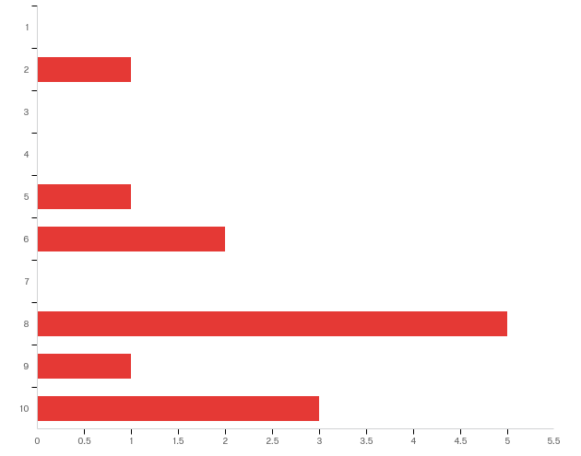

# | Answer | % | Count
1 | 1 | 0.00% | 0
2 | 2 | 7.69% | 1
3 | 3 | 0.00% | 0
4 | 4 | 0.00% | 0
5 | 5 | 7.69% | 1
6 | 6 | 15.38% | 2
7 | 7 | 0.00% | 0
8 | 8 | 38.46% | 5
9 | 9 | 7.69% | 1
10 | 10 | 23.08% | 3
 | Total | 100% | 13

8. - Why did you select this rating?

Why did you select this rating?
Of course, it does not come without hardship. It has happened and we have expended resources of the town to maintain safety, security and confidence for the residents.
my opinion
it doesn’t take much rain or flooding to block some streets and it last for days at times
flooding not to bad
We have been through minor storm with limited flooding before and worked through it.
minor storms are recovered from on a yearly basis it is the next level storm I think we can’t handle
We have withstood and recovered from all the flooding and hurricanes in the past
We have a great manager and staff that knows what must be done in storm situations
Because I believe it’s a fair assumption and depending on the wind with the storm
We unfortunately have had significant floods with Hurricane Isabelle and Irene which has culled homes not able to survive flooding and caused others to raise their homes and add additional storm and flood abatement measures. Storm flood water comes in fast, and except for some drainage ditches, generally runs out fast as soon as the wind shifts from the South. This is especially true if the flooding happened after a relatively dry period. The Town's Tree Board has planted more than 1,000 trees on town property and curated another couple of thousand which helps absorb standing water.
While the town is fully able to recover, the flooding is still an issue
survey said limited flooding

9. - On a scale of what 1 to 10, where 1 is "completely unable" and 10 is "fully able," how would you rate Oriental's ability to withstand and recover from a major storm with extensive flooding?
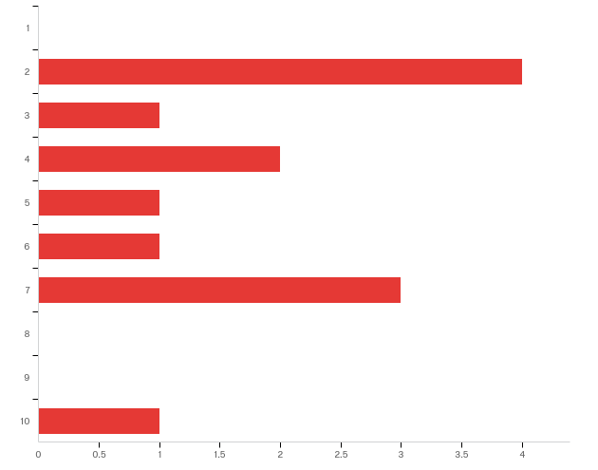

# | Answer | % | Count
1 | 1 | 0.00% | 0
2 | 2 | 30.77% | 4
3 | 3 | 7.69% | 1
4 | 4 | 15.38% | 2
5 | 5 | 7.69% | 1
6 | 6 | 7.69% | 1
7 | 7 | 23.08% | 3
8 | 8 | 0.00% | 0
9 | 9 | 0.00% | 0
10 | 10 | 7.69% | 1
 | Total | 100% | 13

10. - Why did you select this rating?

Why did you select this rating?
The last major storm that had major flooding cause havoc for weeks. used extreme amounts of town resources.
my opinion
the last major storm wiped out town hall and many other businesses and residential properties
poor drainage
Hurricane Irene.
a major storm would overcome any means we must disperse surge of storm waters
Same answer as my last
We have a reserve fund for severe storms but will need FEMA help. Depends on how quickly FEMA and the sate help local small communities like Oriental.
Based on what I've seen with Hurricane Matthew and Irene
We have done this all too many times. We lose businesses and homes, generally from flooding, but sometimes from wind damage. After each storm, we, the residents, businesses, and governments learn from what happened. Minimum building heights have continued to increase and the town encourages people to build well above the minimum. The water from a flood runs out very fast so we don't have to deal with standing water once the storm is over. There have been storms where it was impossible to determine where the Neuse River began and the town boundaries left off. To quote one local resident during Hurricane Isabelle: "Now there is nothing but the river". If global conditions do not contribute to extreme sea level rise, Oriental should do alright with flood drainage. It's the constant standing water that comes from a "Monsoon Season" like we are having this year that causes greater concern. Standing water encourages insect borne diseases, snakes and other generally unwanted water critters that wander the town and pose a threat to pets and residents. Our building codes have tightened in recent years, as have those of most communities on the water from the Gulf to Maine. We struggle with the residue, mostly vegetative, from major storms. It takes time to get the roads open, the power and water back on and basic services like phones back online. We have been grateful a number of times for the Salvation Army...when you need a hot meal, it's something that keeps you going. Because the county (Pamlico) is remote, the residents are used to doing what needs to be done. Most residents would leave Oriental for safety inland rather than ride out any hurricane predicted to be more than Level 1. But, Isabelle was a level 1 when she got here it was a huge flood (We can flood considerably during a Nor'easter). Irene was level 2 and was an even bigger flood (our second 100 year flood in 10 years). Storm water is not always the problem. With Hurricane Floyd, the soil was already soaked so the wind blew down trees, many trees, large trees. Power was out and so was the ability to move freely around town since many trees were intermingled with power cables with no way to know which were live. We rely on outsiders for infrastructure support. But, to answer the question, I've been a commissioner or a First Responder here through many storms and this small town has a great deal of resilience. Twenty years ago I would have answered this question with a 2...we're making progress.
As with the previous question, the Town will recover, but will take longer and at a larger cost
If a cat 3, 4 or 5 hit Oriental would be hurting. with flooded houses and businesses

11. - In your experience, do environmental issues disproportionately affect different sectors of our community (e.g.: the elderly, the disabled, low-income, etc.)?
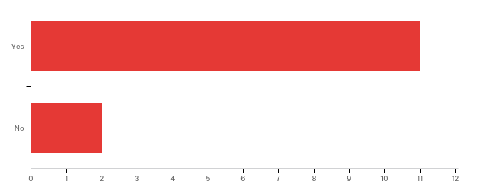

# | Answer | % | Count
1 | Yes | 84.62% | 11
2 | No | 15.38% | 2
 | Total | 100% | 13

11a. - Which groups in Oriental are disproportionately affected? Please be as specific as possible.

Please elaborate on your response so we can better understand how environme...
Low income- transportation challenged, they are unable to get to destinations they need to walk or ride bicycle to. Elderly are uneasy and unable to negotiate hazardous conditions well.
main street factory street and mostly Hodges street and broad street and sometimes midyette street
everyone
We are mostly an elderly community.
elderly and low income
Local population, tourist, low income, elderly,
When Irene hit Oriental in 2011 the town and many of its residents recovered quickly. They had means and insurance helping them. The low-income people needed help and did not have the means and in many case no insurance to help rebuild.
The elderly and the low-income areas.
Having been an "active retirement" destination for boaters since the 1980's, Oriental has many poor residents who are "aging in place". I'm sorry I don't have the average age handy, but we have many residents who now live alone as widows or widowers. Many still have the waterfront residence where they proudly docked a large sailboat or powerboat for years. These waterfront areas are often the first to be cutoff during a flooding event. The area of town known as "White Farm" is totally inaccessible if the main road is covered with water. It is a small peninsula of mostly wetlands. The town has explored building a trail that would provide an alternate route to the state road that flood so there might be an alternate route, not so much for residents, but for first responders who would be willing to answer a call out there. Unfortunately, the budget for such things is way beyond the town's capability. There are few, but some, very poor residents both in the town and the surrounding areas of Pamlico County. Right now, many do live on land that has not been flooded, but they do have to move around, many not having cars. When the roads are flooded, they have to walk through standing water to gets goods and services. Luckily the churches have assisted with transportation and also luckily, the flood waters do leave quickly. One problem has been distribution of food and goods after major storms. Sometime the less fortunate cannot get to the fire house for ice, food, etc. because they do not have a means of transportation to get there. There certainly were citizens who tried to help with that in past storms, but it is not a perfect system.
The elderly and low income as some are more likely to be un- or under insured
low income and high income we all are affected especially small businesses

12. - In your experience, do environmental issues affect specific areas in Oriental more than others (certain streets, neighborhoods, buildings, etc.)?

# | Answer | % | Count
1 | Yes | 84.62% | 11
2 | No | 15.38% | 2
 | Total | 100% | 13

12a. - Which areas are more affected by environmental issues? Please be as specific as possible, including street names, neighborhood names, or building names, if you know them.

Which areas are more affected by environmental issues? Please be as specifi...
Hodges, Factory, South, South Water, Main, Midyette,
drainage
main street factory street nuese street Hodges street midyette street broad street
all the above
Hodges, Main St., Factory St., Marina, Fish industry, coffee shop, seafood hut, town dock, Art gallery
Hodges st, main st factory st south water st and water st
Hodges's street floods with a mere whisper of a windstorm, not to mention a hurricane
All who live close or on the waters around Oriental
Hodges St, near the Harbor, Main St. and Neuse St. from both sides of duck ponds.
All the waterfronts are subject to erosion. I'm not sure if by "environment" you mean things that are a danger to the environment, but the commercial areas like the harbor where many fishing boats are serviced, can have fuel oil and other toxic substances washed into the water which can then be deposited into the marsh grasses, etc. This is also true of marinas as over the years some boats have sunk at their slips, been virtually inaccessible, and spilled a variety of substances into local waters. The "Duck Pond" adjacent to the harbor can easily become a "catchall" when storms with South winds push harbor waters up into the pond and the surrounding home sites.
The waterfront at Hodges Street from Inland Waterway Provision Company to just past the Bean and Main Street behind the Bean

13. - In your opinion, what is the most difficult part of dealing with environmental issues in Oriental (e.g.: community buy-in, lack of financial resources, size of staff, etc.)?

Thinking about your community, what is the most difficult part of dealing w...
Lack of equipment for the task(s), budget and man power
land or financing
size of staff and inability to solve specific issues
size of staff
Lack of financial resources and size of staff, and limited equipment.
small staff, and financial resources
Community buy-in. The neighborhoods do not prepare for hurricanes so when it hits the cleanup is massive
Lack of unlimited financial resources (we have a reserve fund) and size of staff (they are good but we are a small town)
Lack of Financial resources and Small Staff
Oriental has a history of hosting both waterfront commercial enterprise as well as residential and recreational waterfront opportunities. Most do try to at least follow the Federal and State environmental rules. Much to the chagrin of the commercial fish houses at the harbor, the residents ensconced at the Bean coffee shop sit in judgement of their activities. We have no on-the-water-authority as a town. All that rests with the state, and in some cases with the Federal Government. Being able to demonstrate that commercial operations are actually following clean water rules would go a long way to helping the commercial and recreational communities live better together. We do not have a staff that monitors environmental issues beyond those posed by the effluent produced by the town's water plant. Otherwise, we rely on state and federal resources which are rarely on site, and when called may arrive long after the issue in question is no longer apparent. The town has no staffing directly tasked with oversight of environmental issues.
lack of financial res

14. - In your experience, what does the Town of Oriental need in terms of tools and resources to better address our environmental issues?
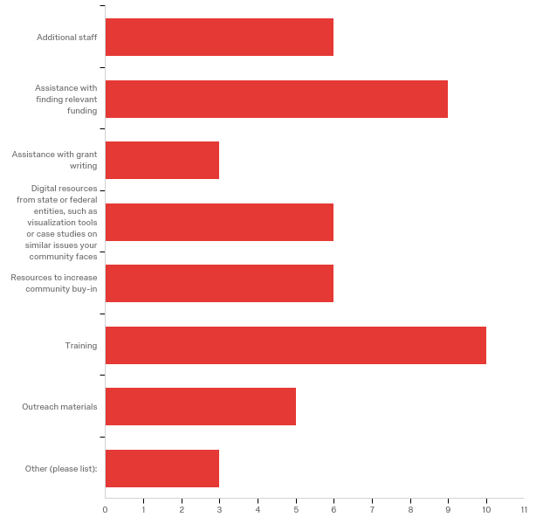

# | Answer | % | Count
1 | Additional staff | 12.50% | 6
2 | Assistance with finding relevant funding | 18.75% | 9
3 | Assistance with grant writing | 6.25% | 3
4 | Digital resources from state or federal entities, such as visualization tools or case studies on similar issues your community faces | 12.50% | 6
5 | Resources to increase community buy-in | 12.50% | 6
7 | Training | 20.83% | 10
8 | Outreach materials | 10.42% | 5
6 | Other (please list): | 6.25% | 3
 | Total | 100% | 48

Other (please list):
Other (please list):
Equipment and funding
new and shiny heavy equipment to implement and maintain storm drainage
more on site presence from state and federal staff responsible for overseeing environmental resources.

15. - Do you have additional comments pertaining to your experiences with environmental issues in Oriental?

Do you have additional comments pertaining to your experiences with environ...
We strive to keep the atmosphere and conditions in town as consistent as possible. Making safety the primary concern for town residents creates a dilemma when we have to choose which areas are able to be our focus and which ones are back-burner oriented.
no
need help with the drainage and also raising some streets would help
no
Small retirement community with limited resources. Due to the number of Nor' eaters flooding is a frequent.
No
We are a small retirement community with only 906 residents. We don't have the mechanical or physical labor need to repair the long-term areas that have eroded over the years of storms and nor'easters.
The town now operates a "Clean Marina" at the harbor. It supplies access to one of the few public, free, pump out stations in the region. It has been in operation about a year and is used extensively by boaters passing through and residents as well. We as a town are trying to lead by example. But, the environment is larger than one small town. We can manage here, but we are downstream from Raleigh. What they do there impacts us greatly. There is a lot of silt coming from upstream. The river is much shallower than years ago. What does the state do on a systemic level to integrate the state’s water resources to insure everyone who has access does the least damage?
Nothing additional
no

16. - If you have anything else that you would like to share with us, please let us know!

If you have anything additional pertaining to this survey or to your commun...
-----------------------------------------
yes
Thanks
hodges st is the absolute worse for flooding due to the road over the river isn't high enough, this causing flooding to water st and back to factory and main
Yes, I will.
One item -- we have a shrimp processor that sandblasts and paints his red boats in the harbor. One time the harbor was red with the sandblasting residue. Many residents called DEQ, Sate DEP, CAMA and other regulatory agencies only to be told the agencies could not take input over the phone and the agencies had to see it in person to verify the damage. Many sent in videos only to be told they would not be accepted...they had to see it in person. Well it is three hours from Raleigh and at least one hour from Morehead City to Oriental. How can you every catch anyone. Seems you have lots of regulations and or guidelines but no effective way of enforcing if you have to see it with your own eyes.... how do you catch anyone....?
Thank you for your interest in our community and I look forward to what we can learn together.
no

Appendix 3: Public Input Workshop Activities
3A. Workshop Agenda and Preparation Needs
The following agenda was used during the public workshop. The workshop took about 1.5 hours to complete.
Activity | Time
The Town Manager or Leader welcomes attendees and introduces the presenters. | 2 minutes
A Town Planner or Resident Expert talks about the town’s current issues and why this project is important for the town. | 10 minutes
The RENA Project Manager or Leader talks about the purpose of this project and the process attendees are undertaking.  During the presentation, volunteers pass out large blue dot stickers. | 15 minutes
Attendees take their blue dot stickers and mark all issues they experience within their community.  Attendees take their arrow stickers and mark their top three priorities: #1 red, #2 yellow, and #3 is green. | 40 minutes
The larger group reconvenes. The Project Manager splits the group into 3-5 people. | 10 minutes to count off and split into smaller groups
One volunteer will lead each group. The group will discuss the assets presented on the map and make additions as needed. The volunteer will take notes and insure that all information is captured. | 25 minutes
The small groups reconvene for questions. | 10 minutes

Total time: ~1.5-2 hours

Below is a list of supplies that must be gathered by the Project Manager or Leader before the workshop:
Supplies Needed | Purpose
Large hard-copy asset maps with a parcel base map – number depends on expected number of attendees | Asset maps will be ground-truthed by attendees. There should be 1 map for every 3-5 people. The maps should be large enough for attendees to identify each parcel in case attendees want to make additions to the map.
Large blue dot stickers | For attendees to mark all issues they have experienced in their communities
Arrow stickers – red, yellow, and green | For attendees to prioritize their #1, #2, and #3 issues
Sharpies – Black and Multicolored | Project Manager or Leader can use a black sharpie to take notes; Attendees can use various colored sharpies to take notes or mark on the asset maps
Large paper and tape/thumb tacks | A large sheet of paper should be taped or tacked to a wall or board. The issues should be listed on a large sheet of paper for attendees to mark with blue dots and with multicolored arrows.
Notebooks | Notebooks should be provided to volunteers to take notes as they lead small groups. Notebooks must be collected at the end of the workshop so the Project Manager or Leader can synthesize the ideas in the final report for the community.
Post-it Notes | Post-it notes should be on the tables with maps so attendees can take short notes and place them on the maps as needed.

Below is a list of pre-workshop activities that must be completed before the workshop:
Activity | Purpose
Reserve a space for the workshop | A space should be reserved at least a month before the workshop date to insure a date is set before advertising
Organize volunteers and provide training | Work with the local government or external organizations to obtain volunteers for the workshop. 1 volunteer for every 3-5 people will be best, if possible. Provide training at least two days before the workshop so the volunteers know about the project and the process that will be used during the workshop.
Advertise | Begin advertising 2-3 weeks before the workshop date. Advertise in multiple mediums such as through emails, flyers, and town newsletters.
Organize refreshments | If funds allow, order catering or provide refreshments such as coffee, tea, water, and light snacks for attendees on the date of the workshop
Write all 15 issues from the town staff survey (see Appendix 2A, question 4) on 2-3 pieces of large paper  - Leave one paper blank for “Other Issues” attendees wish to write-in for the exercise | Attendees will mark all issues they have experienced in their communities as well as prioritize those issues with stickers. This information should be matched with town staff responses to see which issues are most critical to both populations, and which issues town staff may need to better understand from the community perspective.
Pack supplies | The Project Manager or Leader should make sure they have the following supplies:  _____ - Sharpies  _____ - Blue dot stickers  _____ - Arrow stickers (red, green, yellow)  _____ - Post-it notes  _____ - Large sheets of paper  _____ - Tape or thumb tacks  _____ - Notebooks for volunteers  _____ - Pens or pencils  _____ - Printed maps for the session  _____ - Issues written on large sheets of paper
3B. Workshop Advertisement Example

Made by Monica Gregory, CMF, using Canva. 2018.

3C. Workshop Volunteer Instructions
Below is the volunteer instruction packet given to each volunteer before the workshop activities. Volunteers can help set up the workshop space, manage and lead groups, and tear down the workshop space.
Public Workshop Agenda
Activity | Time
The Town Manager or Leader welcomes attendees and introduces the presenters. | 2 minutes
A Town Planner or Resident Expert talks about the town’s current issues and why this project is important for the town. | 5-10 minutes
The RENA Project Manager or Leader talks about the purpose of this project and the process attendees are undertaking.  During the presentation, volunteers pass out large blue dot stickers. | 10 minutes
Attendees take their blue dot stickers and mark all issues they experience within their community.  Attendees take their arrow stickers and mark their top three priorities: #1 red, #2 yellow, and #3 is green. | 30 minutes
The larger group reconvenes. The Project Manager splits the group into 3-5 people. | 10 minutes to count off and split into smaller groups
One volunteer will lead each group. The group will discuss the assets presented on the map and make additions as needed. The volunteer will take notes and insure that all information is captured. | 40 minutes
The small groups will reconvene for questions. | 10 minutes

**Exit survey**

Total time : ~2 hours

Thank you again for volunteering to assist with our workshop!
Please arrive at Town Hall between
4.30 p.m. and 5 p.m. on Thursday, March 1.

Instructions:
Part I – Selecting and prioritizing issues
Activity overview:
- Participants will take blue dot stickers and place a sticker next to each of the issues they have experienced or seen in the past 10 years.
- Participants will take arrow stickers and prioritize their top three issues.
  - #1 concern should be in red;
  - #2 concern should be in yellow;
  - #3 concern should be in green.
- Participants can add issues on the last paper where I have created spaces for additional concerns.
- Participants can add comments directly below each issue -OR- participants can use the general comment notepad at the front of the room.
- Once finished, participants should sit back down so we know they are done with their selections.

Total time: About 30 minutes

Instructions:
Part 2 – Mapping assets:
Activity overview:
- Participants will work in small groups (ideally about 5 people per group) with one map per group.
- You will act as the small group facilitator.
  - Encourage open dialogue.
  - Insure that the small groups understand that they can mark directly on the map and use post-it notes for comments.
  - Insure that newly mapped assets are categorized clearly so I can add them to the map.
  - Take notes on any overarching ideas or consistent thoughts/concerns from your small group. A notebook will be provided to you.
  - When we have 5-10 minutes left, I will ask you to add newly mapped assets to the colorful asset list on the next page so I can clearly see new additions.
*I will be walking from group to group, but please feel free to grab me if you have any questions!

Total time: About 40 minutes

Color-Coded Asset List:
*At the end of your small group session, I will ask you to add newly mapped assets to this list under the appropriate category. If necessary, you can create new categories on the next page.
Critical Facilities
- Numbered on map
- New Asset:
- New Asset:
Comments:

Churches
- New Asset:
- New Asset:
Comments:

Fishing/Boating Facilities
- Marinas
- Boat Yards
- Commercial Fisheries
- New Asset:
- New Asset:
Comments:

Flooding
- Specific areas subject to frequent flooding
- New Area:
- New Area:
Comments:

High Flood Risk
- Larger, more general areas at-risk to frequent flooding
- New Area:
- New Area:
Comments:

Museum
- New Asset:
- New Asset:
Comments:

Recreation
- Parks
- Public Restrooms
- Public Water Access
- New Asset:
- New Asset:
Comments:

Utilities
- Water Plant
- Water Tower
- Wellheads
- Lift Station
- New Asset:
- New Asset:
Comments:
*Please use this space for new asset categories or additional comments*

3D. Asset List for Workshop Participants
Below is a color-coded list of assets given to each participant in the workshop. The overarching categories correspond to the asset map (Appendix 1A). This list helps participants quickly identify assets on the map by color and category. Participants should add to this list, and volunteers can record new assets and categories in their volunteer instruction packet (Appendix 3C).
Critical Facilities  - Numbered on map  - Town Hall/Police  - Doctor’s Office  - Fire Station  Churches  Fishing/Boating Facilities  - Marinas  - Boat yards  - Commercial fisheries  Flooding  - Specific areas subject to frequent flooding  High Flood Risk  - Larger, more general areas at-risk to frequent flooding | Museum  Storm Parking  - Informal parking areas used by residents during floods  Recreation  - Parks  - Public restrooms  - Public water access  Utilities  - Water plant  - Water tower  - Wellheads  - Lift station

Appendix 4: Modeling Examples
The Nature Conservancy (TNC) hosted our asset maps on their coastal resilience mapping tool starting in 2018. The tool allows town staff, planners, and the public to see which assets will be affected under a variety of conditions in current and future scenarios.
You can view the asset maps here.

Sea level rise projections for the current year confirm what locals already know. Certain areas along the waterfront are already subject to frequent, repetitive flooding. Three areas where locals pinpointed frequent flooding in Oriental match current-year sea level rise projects. They are circled in red below:

Under the medium sea level rise scenario (40 cm. or 15.7 in), some areas along the waterfront are more severely impacted. Streams begin to expand, and flood intensifies in neighborhoods already impacted by excess water. Three affected areas are circled in blue below:

Under the same medium sea level rise scenario, assets are more severely impacted under flood events. An example of projected flooding in downtown Oriental after a 100-year flood event under the medium sea level rise scenario is below. Oriental’s famed harbor is inundated by more than 36 inches (3 feet) of water (shown in yellow), as are many areas along the waterfront and streams:

Appendix 5: TNC Mapping Portal – Workflow Example
The following workflow was created by Lora Eddy from The Nature Conservancy to assist communities in visualizing risk. In Section II. Adding Community Specific Information to Your Map, towns can find a version of their asset map to help visualize their vulnerabilities to coastal hazards like flooding and sea level rise.

Flood and Sea Level Rise app - Example Workflow
Dare County
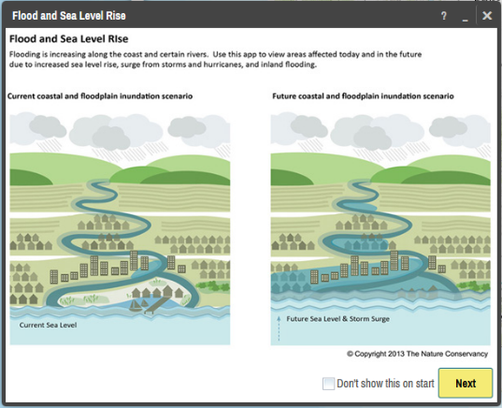
I. Visualizing Risk

- In your internet browser enter: maps.coastalresilience.org/northcarolina/
- Activate the Flood app by clicking on the icon on the left.

- Choose a Region
- Click on “Select a Region” box and select Pamlico County from the drop-down menu.
- The map zooms to Pamlico

- Zoom into Oriental
- Zoom by using the center scroll of your mouse or double-clicking over the area
-OR-

- In the top right corner of the map in the search bar, type in Oriental, NC
- As you type in the search box the drop-down list will auto-populate
- Select the address and the map will zoom to the address

- Choose a Hazard
- Click the “Select a Hazard” box and select Coastal Flooding (NC Emergency Mgmt)
- Slide the “Sea Level Rise” slider to 40 cm to see flooding impacts due to sea level rise alone
- Slide the “Flood Extent” slider to 100-yr to see areas in the future at risk to coastal flooding with sea level rise.
- Click on the icon next to “Flood Extent” for more information about the data you have selected

- Click on Opacity in the same box at the bottom right corner, below the sea level rise graph
- Click on the slider to adjust the opacity of the storm surge

- Minimize the Flood app window and leave the map on your zoomed in location.

II. Adding Community Specific Information to your Map
- Activate the Community Planning app by clicking on icon on the left.

- Select “Town of Oriental” and turn on this data layer by clicking on the button
- Notice the change on the map and legend – now both the hazard modeling information and the asset information can be seen
- Click the … to expand a pop-up menu that allows you to adjust the data layer’s transparency, adjust the transparency to half
- Click on the icon for more information about the data layer you have selected
- You can minimize or move the legend to see more of the map

This data can be used for land use planning, Community Rating System (CRS) planning, grant applications for resilience-building projects, emergency management, and communications pieces for residents, among other uses.

**Coastal Resilience Map Hints & Tips:
- Click on Tour for a brief introduction to the mapping site or visit coastalresilience.org/tools/training/ for an online Try Me Tutorials.
- This web-based tool can be used in most Internet browsers, including Chrome, Firefox, and Safari. NOT Internet Explorer.
- Refresh your browser window (push the F5 key) if the tool seems laggy (e.g. layers are stuck).
- Also try using a browser window which does not retain cookies or other browsing data. For example:
  - Chrome: incognito window
Firefox and Safari: private browsing window
Appendix 6: Timeline & Schedule of Activities
Below is the approximate timeline from the initial meeting with Oriental’s town staff to the completion of the project:
Month/Year | Purpose | Activities
January 2017 | Scoping meeting with Town Manager and planner | - Discuss project and time commitment  - Identify potential stakeholders to include  - Establish initial timeline
March 2017 | Map vulnerabilities with Town Manager | - Identify physical and social vulnerabilities from the town staff perspective
May 2017 | Survey town staff | - Identify coastal hazards and their impacts on the community  - Identify town needs to address impacts from hazards  - Identify specific areas that flood in town
April 2017 – December 2017 | Revise asset map, write narrative to justify included assets, and begin final report for town | - Update asset map according to town comments and suggested revisions. There may be several versions of the map until you add everything in the correct place.  - Write a narrative to complement the map so both the town staff and the public can easily understand what assets were included and why (see Appendix 1C)  - Begin final town report with information from background research, meetings with town staff, the town staff survey, and other relevant information
January 2018 – March 2018 | Prepare for public input workshops | - Create advertisements for public input workshops (see Appendix 3B)  - Work with town staff and volunteers to advertise through social media, newsletters, the local newspaper, and information boards around the community  - Purchase and prepare all supplies (see Appendix 3A)
March 2018 | Public input workshop | - Engage residents in the resiliency planning process  - Communicate the concept of resiliency to the community  - Retrieve input on coastal hazards and their impacts from the resident perspective  - Retrieve information on assets important to residents as well as localized flooding within town boundaries
March 2018 – May 2018 | Update asset maps and upload them to the coastal resilience mapping tool to pinpoint hotspots and prioritize projects. | - Added resident input to asset maps.  - Worked with TNC to upload asset maps to the coastal resilience mapping tool  - Worked with town staff to identify hotspots where assets are currently, and will be, drastically affected by sea level rise or coastal flooding  - Worked with town staff and external partners such as The Nature Conservancy and Coastal Federation to identify specific projects that could mitigate or adapt hotspot areas to sea level rise or flooding  - Complete final report for the town

“‘Resilience’ means the ability to anticipate, prepare for, and adapt to changing conditions and withstand, respond to, and recover rapidly from disruptions.” (Former President Barack Obama, Executive Order 13653)
According to FEMA, “assets are defined broadly to include anything that is important to the character and function of a community and can be described very generally in the following four categories: People, Economy, Built environment, Natural environment.”
Pamlico County Hazard Mitigation Plan. 2010. Pg. 263-265. http://www.pamlicocounty.org/Data/Sites/1/media/emergency%20management/pamlico%20county%20hmp%20final,%20revised%200710.pdf.
In the context of this project, a physical vulnerability is indicated by a geographic area exposed to a hazard, such as waterfront properties repeatedly flooded after hurricanes. A social vulnerability is indicated by a population that is exposed to a hazard, such as residents in a neighborhood in a low-lying area that repeatedly floods. Both physical and social vulnerabilities can be low or high risk, depending on their level of exposure, preparedness, and ability to recover after a disaster, among other indicators.
See Appendix 1B for the full asset map narrative
In the context of this project, a physical vulnerability is indicated by a geographic area exposed to a hazard, such as waterfront properties repeatedly flooded after hurricanes. A social vulnerability is indicated by a population that is exposed to a hazard, such as residents in a neighborhood in a low-lying area that repeatedly floods. Both physical and social vulnerabilities can be low or high risk, depending on their level of exposure, preparedness, and ability to recover after a disaster, among other indicators.

