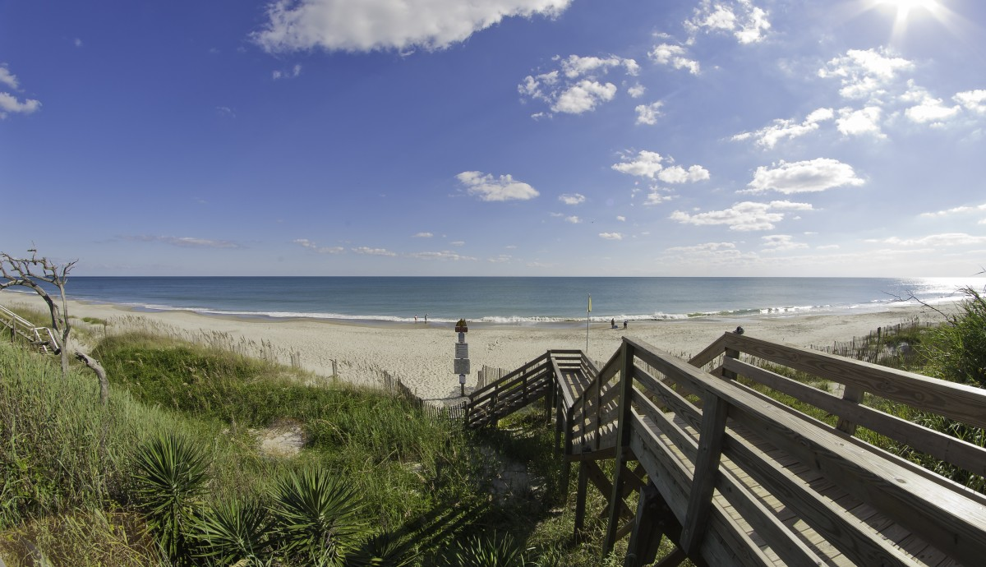
Town of Pine Knoll Shores
Beach access, Pine Knoll Shores. Photo credit: Crystal Coast NC

Resilience Evaluation and Needs Assessment
Final Report
May 2018

Table of Contents
Project Overview..………………………………………………………………………………………………………......2
Purpose and Scope……………………………………………………………………………………………………….....3
Section 1: Introduction……………………………………………………………………………………………………..4
Section 2: RENA Framework in Practice…………………………………………………………………………….5
Resilience evaluation (RE) process
2.1.RE: Map town assets……………………………………………………………………………………….6
2.2.RE: Identify current issues……………………………………………………………………………….8
2.3.RE: Conduct public input meetings…………………………………………………………………10
2.4.RE: Overlay current and future models…………………………………………………………..13
Needs assessment (NA) process
2.5.NA: Hotspot identification……………………………………………………………………………..14
2.6.NA: Asset prioritization………………………………………………………………………………….15
2.7.NA: Document existing projects…………………………………………………………………….16
2.8.NA: Explore future projects……………………………………………………………………………17
Data Resources……………………………………………………………………………………………………………….19
Funding Resources………………………………………………………………………………………………………….21
Appendix………………………………………………………………………………………………………………………..25
Project Overview
In 2016, The Division of Coastal Management (DCM) commenced a five-year project to create a resilience framework guide for coastal communities in North Carolina. DCM hired a two-year Fellow, Monica Gregory, as part of the Coastal Management Fellowship (CMF) through the National Oceanic and Atmospheric Administration (NOAA). The Fellow was hired to lay the groundwork for the resilience framework guide by working with five communities to implement a vulnerability assessment and a needs assessment within their towns. The five communities will serve as case studies in the resilience framework guide to illustrate the planning process, highlight best practices, and discuss resilience projects identified through the vulnerability assessment.
Edenton, Pine Knoll Shores, Oriental, Duck, and Hatteras Village participated in the project. The outcome of the five-year project will be a comprehensive guide to resilience-building in coastal communities in North Carolina.
The final guide aims to serve local governments by:
1) illustrating a successful planning framework they can use to engage their communities in resilience and adaptation projects;
2) identifying common needs from local governments and compiling state and federal resources that can address those needs;
3) providing case studies across the North Carolina coast that can help guide other local governments in resilience planning;
and
4) discussing adaptation and mitigation strategies that can be applied in a variety of situations experienced by coastal communities in our state.

Purpose and Scope for Pine Knoll Shores
The purpose of this two-year project is to identify and map social and physical vulnerabilities to coastal hazards in Pine Knoll Shores and to identify hotspots where the town can prioritize resilience-building projects. Through the process, participants will also identify local government and community-specific needs in building resilience, or the capacity to prepare for, respond to, and recover from a natural disaster.
Pine Knoll Shores has a robust strategic plan which highlights the need for resilience planning in the town. This project meets several objectives in four areas of Pine Knoll Shores Strategic Plan (see Appendix 7):
Area #1: Environment & Natural Resources
Objective 1. Limit adverse impacts
Area #2: Infrastructure
Objective 1. Safe streets
Area #3: Public Safety & Disaster Planning
Objective 3. Readiness for natural & manmade disasters
Area #4: Water Quality
Objective 1. Avoid flooding
This guide draws from the Pamlico Sound Regional Hazard Mitigation Plan for general information on Pine Knoll Shores such as hazards, demographics, capabilities, and risk. This guide adds to the information Pine Knoll Shores already possesses by mapping repetitive flooding in the town based on staff and resident knowledge as well as gathering more in-depth input about community priorities. It also identifies specific areas, such as streets, intersections, and buildings, that the town can target for resilience work. The final map and guide for Pine Knoll Shores can be used for resilience planning purposes as well as for future grant applications related to resilience-building to highlight identified areas in need of adaptation and mitigation projects.

Section 1: Introduction
Regional survey
In February 2017, DCM released a survey to coastal county and town staff to better understand their experiences with coastal hazards and their needs for addressing them. DCM had an 11% response rate, which is about average for an online survey. Through questions about impacts from coastal hazards and existing resilience-planning efforts, DCM identified a critical need for a formal planning framework to be used by regional, county, and town staff in adapting to and mitigating impacts from major and minor storms, sea level rise, hurricanes, and Nor’easters, among other hazards.
DCM staff formed an advisory committee to guide the research and selection process. Advisors included staff from The Nature Conservancy, North Carolina Sea Grant, the Coastal Federation, and DCM planners and field staff. DCM conducted a review of published resilience guides and community resilience planning methodologies.
DCM drew from various resources to create the methodology used in pilot communities. The Community Resilience Building guide, the U.S. Climate Resilience Toolkit, the California Adaptation Planning Guide, and the Community Based Vulnerability Assessment Guide from MDC, Inc. and UNC Chapel Hill are the strongest influences on this project.

Selection process
To select pilot communities for case studies, DCM staff consulted state planners, state field staff, and nonprofit organizations for recommendations on towns with staff capacity and community buy-in to work this process from beginning to end. After receiving direct interest from Pine Knoll Shores at a local conference, DCM staff held an initial scoping meeting with the town manager and planner in December 2016. After discussing their history with coastal hazards, staff capacity, and community dynamics, the Town of Pine Knoll Shores accepted our invitation to participate in the pilot program as one of five case study communities in the DCM resilience framework guide.

Section 2: RENA Framework in Practice
DCM used the following eight-step process in each pilot community, divided into the resilience evaluation phase and the needs assessment phase:
Resilience evaluation (RE): The first phase is intended to identify concerns and priorities of local government staff and town residents.
- Map assets
- Identify current issues
- Conduct public input meetings
- Overlay current and future models

Needs assessment (NA): The second phase is intended to assist the local government in identifying specific assets where they can focus resilience-building projects.
- Hotspot identification
- Asset prioritization
- Document existing projects
- Explore future projects

Resilience Evaluation (RE) Process
2.1.RE. Map assets
In April 2017, DCM staff met with the town manager and planner to map physical and social vulnerabilities in Pine Knoll Shores. DCM downloaded a base map of the town from ArcGIS and printed the map at a large enough scale to identify roads and specific parcels. DCM brought the map to the meeting.
At the mapping meeting, the town manager and planner worked with DCM to physically color in parcels that are considered important assets to Pine Knoll Shores. DCM staff provided sharpies, highlighters, post-it notes, and colored tabs at the meeting. For each asset category, one color was used. For example, critical facilities like hospitals and the fire station were identified then colored with red sharpie. DCM staff recorded their color and location to later create a GIS attribute table and a key for the map.
Under the GIS polygon layer, town staff identified boating access, critical facilities, cultural resources, private beach access, public beach access, areas that experience repetitive flooding, research sites, town-owned property, and utilities as physical vulnerabilities. Staff wanted emphasis on several assets which are denoted under the GIS point layer by points or special icons on the map. Those assets are emergency beach access, emergency helicopter landings, package treatment plants, private water access, a Coastal Federation sill site, water towers, and wells. Public trails are denoted under the GIS line layer. The Eastern Carolina Council mapped the stormwater management system in Pine Knoll Shores; the system is included as a data layer in the GIS database and can be turned on and off as needed. In addition, DCM and town staff identified recreational areas but for the purposes of this map, they have not been included. The recreation layer is still contained within the data and can be uploaded in GIS.
Pine Knoll Shores did not identify social vulnerability components to include on the map. Though not included in this project, additional social vulnerability indicator data exists, such as census data on reported income and data on property tax value. Such indicators can be used to identify areas where financial resources for recovery post-disaster may be limited. Social vulnerability indicators that be used in other communities – such as concentrated areas of 65+ residents, concentrated areas of non-English speakers, and concentrated areas where people have low trust in government – do not exist in Pine Knoll Shores.
After working with the town manager, DCM staff returned to their home office and used the physical map to transfer collected data to ArcGIS. DCM created a narrative explaining the map and outlining a key to use with the map. DCM sent questions, the draft map, and the draft narrative to the town manager for comments and additions.
After multiple revisions, the town manager approved the vulnerability map and narrative for Pine Knoll Shores. The map was presented to the Strategic Planning Committee then circulated to other town staff, board members and critical organizations in Pine Knoll Shores for commentary.
After additional comments and revisions to the map and narrative, DCM and town staff initiated the community input phase. DCM focused on including a diverse, comprehensive segment of the community to collect a variety of responses, experiences with flooding and other coastal hazards, and ideas that might increase the resilience of assets that are important to the community.

2.2.RE. Identify current issues
Through online surveys, DCM collected the experiences and viewpoints of staff and elected officials in Pine Knoll Shores. The survey focused on staff knowledge and experience with coastal hazards and their impacts in the community.
Town Staff Survey Results
Thirteen staff members participated in the survey on coastal hazards and their impacts in Pine Knoll Shores, with six respondents having worked for the town for six or more years.
Hazards
Out of a list 14 potential hazards, the most selected issues were beach erosion/estuarine shoreline erosion (11); drainage issues (11); hurricanes (10); damaging winds (10); flooding due to heavy precipitation/stormwater management issues (9); and Nor’easters (8).

When asked to list the most pressing environmental issues facing Pine Knoll Shores, respondents overwhelmingly cited shoreline erosion (9) and stormwater management issues (7) most often. Respondents cited damage to public or private property (7) as most affected by these issues, followed by damage to the local economy (5) and damage to human health or well-being (5).
Flooding
Most respondents believe Pine Knoll Shores could withstand and recover from a minor storm with limited flooding: on a scale of one to ten, 10 of 11 respondents rated Pine Knoll Shores’ ability to recover as an eight or above. Respondents say Pine Knoll Shores is a “StormReady city” and is “capable of fully completing [the task of recovery].” Respondents differed in their thoughts on whether Pine Knoll Shores could withstand and recover from a major storm with extensive flooding, with six respondents ranking the town’s ability as a seven or less. One respondent explained that “[the town] needs resources and equipment to clean up and repair infrastructure.” A few respondents were unsure of the town’s capabilities but signaled that major flooding was uncommon in Pine Knoll Shores.
Specific impacts from flooding
Of the 11 respondents who have seen specific impacts around Pine Knoll Shores, 10 respondents said the eastern end of town experiences regular flooding. Two respondents cited ocean front homes with little dune protection, and two respondents cited sound side homes. One respondent cited Live Oak as an area that regularly floods. One respondent cited the golf course area generally, with cul-de-sacs in that area flooding regularly.

Social impacts
Five of 11 respondents believe environmental issues disproportionately affect certain segments of the population in Pine Knoll Shores. Four respondents cited the elderly population as disproportionately affected.
Town Needs
Respondents cited a wide variety of needs to address environmental challenges in Pine Knoll Shores. Out of 11 respondents, the most common needs were digital resources from state or federal entities (6); assistance with finding relevant funding (4); Training (4); and resources to increase community buy-in (4).

2.3.RE. Conduct public input meetings
In March 2018, Pine Knoll Shores and DCM conducted a public input workshop focused on two activities: 1) coastal hazard issues and prioritization and 2) asset mapping.
Activity 1: Issues and Prioritization
In the first activity, 24 residents worked to identify all issues they had experienced over the past 10 years in Pine Knoll Shores. The issues were taken from the town staff survey (Appendix 2B, question 4) so the Town Manager could compare staff perceptions to resident perceptions of coastal hazards and their impacts.
Residents placed blue dot stickers next to each issue they had experienced. To prioritize issues, residents were given a red, yellow, and green flag sticker. They marked their top concern with the red sticker; their second concern with the yellow sticker; and their third concern with the green sticker.
Out of a list of 12 issues, with one additional issue added by residents, over half of participants experienced the following hazards and impacts in Pine Knoll shores over the past decade or more:
- Damaging Winds (22)
- Hurricanes (21)
- Beach & Estuarine Shoreline Erosion (20)
- Nor’easters (19)
- Tree loss (18)
- Storm surge (16)
- Infrastructure failure or damage (12)
- Dune instability (11)
- Drainage issues, Ponding, & Stormwater management (9)
Residents cited the following impacts from hazards as top priorities for the town to prepare for, mitigate, or adapt to:
- Drainage, ponding, & stormwater management issues – Eleven people selected drainage and related issues as a top concern in Pine Knoll Shores. Two residents listed it as their top concern, five listed it as their second-priority concern, and four listed it as their third-priority concern.
- Shoreline erosion, particularly on the estuarine side – Nine people selected beach and estuarine shoreline erosion as a top concern in Pine Knoll Shores, with most residents commenting that estuarine erosion was particularly worrisome. Six residents listed it as their top concern, three residents listed it as their second-priority concern, and one listed it as their third-priority concern.
- Tree loss – Tree loss was added by a resident before the issue selection and prioritization process began. Nine residents consider tree loss a top concern in Pine Knoll Shores. Three people cited it as their top concern, four people cited it as their second-priority concern, and two cited it as their third-priority concern.
Other hazardous impacts were top concerns, including damaging winds (4); dune instability (3); and infrastructure damage or failure (3).
Hurricanes were the most concerning coastal hazard, with three residents selecting them as their top-priority concern, one resident as their second-priority concern, and six residents as their third-priority concern.
Activity 2: Asset mapping
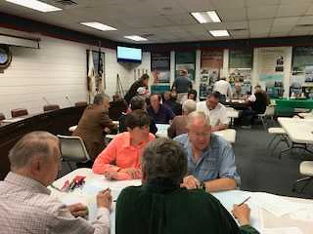
During the second activity, residents split into small groups to focus on asset mapping. Each group was led by a volunteer resident who used an instruction packet developed by the CMF (see Appendix 3C) to manage the activity.
Residents review asset maps in Pine Knoll Shores, April 2018.
Over the course of the activity, small groups discussed the assets to insure they were accurately portrayed on the map. Each group made additions, including adding more localized flooding locations. Residents also noted the importance of access to Pine Knoll Shores considering there is a single main road along the island. The road leads to two bridges located in neighboring towns that connect the island to the mainland. Bridges, roads, and access points are critical for both pre-disaster evacuation and post-disaster recovery.

The maps below show the difference between the assets mapped by the town and assets added by residents:
Map 1 – Assets Mapped with Town Staff
Map 2 – Assets Mapped with Resident Additions
2.4.RE. Overlay current and future models
In 2018, the CMF reached out to The Nature Conservancy (TNC) to request a collaboration between DCM’s asset mapping and TNC’s coastal resilience mapping tool. TNC agreed to host town asset maps so local government staff could easily apply sea level rise and coastal flooding models to their maps. TNC uses NOAA data for a variety of future scenarios; all data are readily available for download through the NOAA Digital Coast’s Coastal Flood Mapper. Potential datasets include:
- Coastal Flood Hazard Composite - Provides a quick visual assessment of areas most prone to flood hazard events.
- Shallow Coastal Flooding - Areas subject to shallow coastal flooding.
- FEMA Flood Zones - Areas at risk from flooding.
- Storm Surge - Areas at risk from storm surge.
- Sea Level Rise - Areas likely to be inundated by sea level rise.
In Pine Knoll Shores, current model overlays are sea level rise data from NOAA and coastal flooding data for current mean high water, a 10-year flood event, a 100-year flood event, and past flooding from Hurricane Fran (1996) from North Carolina’s Division of Emergency Management.
Future scenarios through TNC’s coastal resilience mapper include risk in three separate years: 2045, 2060, and 2100. Town staff and leaders can choose to plan for low, medium, or high risk in any given year to see which assets will be most at risk from one or a combination of hazardous events.

Needs Assessment (NA) Process
2.5.NA. Identify hotspots
Through TNC’s mapping portal, town staff and residents can view their asset maps and overlay sea level rise scenarios, storm surge scenarios, and coastal flooding data. Staff can pinpoint areas to focus resilience-building efforts that are consistent with their ongoing resilience work or with their current town vision. The town staff can decide what planning scenario they wish to use: for example, a town can use the medium sea level rise scenario for the year 2045 to identify assets and areas they wish to adapt or mitigate from increased flooding.
In the future, town staff can hold additional workshops to better understand community priorities in the face of sea level rise, increased frequency and severity of storm surge, and increased flooding.

2.6.NA. Prioritize assets
Pine Knoll Shores can prioritize assets and areas of vulnerability to focus their resilience-building efforts. Assets could be prioritized by residents in the community; by cost effectiveness; by cost-benefit or return-on-investment analyses; or by other means selected by town staff. Staff could hold additional workshops to receive input from residents regarding asset prioritization.

2.7.NA. Document existing projects
The Town of Pine Knoll Shores has been working to integrate resilience planning into several aspects of their work:
1. Stormwater studies – A resiliency-focused project is underway in Pine Knoll Shores. The study focuses on a flood and drainage engineering study; research into innovative right-of-way road drainage enhancements; and outreach to build community resiliency awareness through distribution of resources, community meetings, and activities. The engineering study examined the area surrounding the East End Storm Water Project, a project which diverts flood water on town streets through the golf course ponds to improve its quality before it reaches Bogue Sound. The intent of the engineering study was to improve the area's capacity to manage storm water runoff. Research into innovative options for road drainage focused on pervious drainage ditches and rain gardens. Outreach and education efforts enhanced residents' understanding of resiliency and impacts on flooding and water quality. In addition, the town provided resources to individual homeowners to increase resiliency.
2. StormReady Community – Pine Knoll Shores received the StormReady Community designation from the National Weather Service. StormReady uses a grassroots approach to help communities develop plans to handle all types of severe weather—from tornadoes to tsunamis. The program encourages communities to take a new, proactive approach to improving local hazardous weather operations by providing emergency managers with clear-cut guidelines on how to improve their hazardous weather operations. To be officially StormReady, a community must:
- Establish a 24-hour warning point and emergency operations center
- Have more than one way to receive severe weather warnings and forecasts and to alert the public
- Create a system that monitors weather conditions locally
- Promote the importance of public readiness through community seminars
- Develop a formal hazardous weather plan, which includes training severe weather spotters and holding emergency exercises.
3. Pine Knoll Shores developed a strategic plan that was revised in 2017. In the strategic plan, several goals and objectives align with building the community’s resilience to current and future weather and climate conditions, including remaining eligible for FEMA Storm Loss Mitigation, understanding potential impacts from sea level rise to the beaches, preparing for natural and manmade disasters, and preserving and protecting drinking water resources, among others.

2.8.NA. Explore future projects
Resident suggestions and concerns from public workshops:

Suggestions
- Continue participating in the StormReady Community program.
- Improve ease of entering the hurricane evacuation route from neighborhoods in Pine Knoll Shores.
- Establish a “Doc in a Box” office, or a medical office where residents can walk-in to consult a doctor.
- Explore alternative electric cable locations and weigh the costs of benefits of above-ground wind damage to cables vs. potential underground water damage to cables.
- Install a pipe under Salter Path Road to pump sand along the east end of Pine Knoll Shores.
- Create a siren warning system for water spouts.
- Maintain current regulations regarding tree conservation in Pine Knoll Shores and work with developers and contractors to keep tree clearing at a minimum.
  - Purchase the 9 acre site that has been up for debate to be part of the Blue Star Project.
- Continue using sand fences and beach nourishment techniques.
- Remove artificial barriers to water flow on public lands.
- Broaden access to the sound by non-HOA members.
- Create a permanent solution to the flooding in Lowell Court area; the recently installed pump is effective, but it is seen as a temporary fix.
Concerns
1. Elevated vacant lots are causing flooding on adjacent properties. A resident highlighted one specific lot on the corner of Yucca Court and Oakleaf Drive. The resident suggested the vacant lot be cleared to improve drainage in the area.
2. Wind damage from hurricanes are a concern for many residents. At least two residents advocated for the continued enforcement of tree ordinances to insure natural barriers to wind and water remain throughout the town.
3. The size of the decks on the Pine Knoll Shores Association (PKA) canal restricts boat traffic.
Additional suggestions from DCM:
- Adopt the final vulnerability map into land-use planning decisions to decrease unsustainable development in areas vulnerable to sea level rise or flooding.
- Align community plans through the lens of resilience, including economic plans, housing plans, and natural resource management plans.
- Continue working with the Community Rating System to increase rating and reduce the cost of flood insurance. Work with The Nature Conservancy and other entities like the Coastal Federation to achieve a higher score.
- Increase freeboard requirements within the town boundaries.
- Prepare for future impacts by using long-term planning scenarios such as “medium” or “high” scenarios in year 2100.
- Work to plan collaboratively for climate impacts at the watershed level. Bringing entities such as town officials, county officials, and neighboring town staff and officials will be critical. The Albemarle Pamlico National Estuary Partnership (APNEP) can help facilitate meetings or workshops related to climate planning.

Data Resources
The following resources tools and useful guides to plan for resilience. Researchers, planners, and town managers may find them useful in the context of hazard mitigation, resilience-building, and community engagement.
- Coastal Inundation Toolkit (Source - NOAA Digital Coast):
A toolkit that communities can use to understand coastal inundation and to identify their risks and vulnerabilities. Users can visualize information to better explain risk concepts: https://coast.noaa.gov/digitalcoast/training/coastal-inundation-toolkit.html
- Coastal Resilience Index (Source – Mississippi-Alabama Sea Grant Consortium):
A guide that can communities can use to examine different elements to increase their resilience: http://masgc.org/news/article/assessing-resilience-cri
- Community Based Vulnerability Assessment, 2009 (Source: University of North Carolina and MDC, Inc):
A guidebook for communities to walk through the process of assessing their physical and social vulnerabilities, with an emphasis on social justice and inclusion:
http://www.mdcinc.org/sites/default/files/resources/Community%20Based%20Vulnerability%20Assessment.pdf
- Community Toolbox (Source – University of Kansas):
A toolbox with extensive resources to better understand and engage with community members. The toolbox includes resources for developing assessment plans, understanding and describing communities, and conducting focus groups, among others: http://ctb.ku.edu/en/table-of-contents
- Naturally Resilient Communities, 2017 (Source – APA, TNC, ASCE, and partners):
An online tool that helps decision-makers explore solutions to natural hazards based on the type of hazard, the type of community, the project scale, and the project cost. Additionally, the tool provides case studies from several regions in the U.S.:
http://nrcsolutions.org/strategies/?fwp_hazards=coastal
- The U.S. Climate Resilience Toolkit, 2016 (Source – NOAA):
The Toolkit is designed to help people find and use tools, information, and subject matter expertise to build climate resilience. The Toolkit offers information from across the U.S. federal government in one easy-to-use location.
- Vulnerability, Consequences, and Adaptation Planning Scenarios (VCAPS) tutorial, 2013 – (Source: University of South Carolina, South Carolina Sea Grant Consortium, Carolinas Integrated Sciences and Assessments, and Social and Environmental Research Institute): A tutorial that walks through the process of using VCAPS, a tool for community decision-makers to better understand the challenges their communities face under climate change stressors: http://www.vcapsforplanning.org/docs/VCAPS%20UserGuide%2025March13.pdf
- Rising to the Challenge, Together, 2017 (The Kresge Foundation): An overview of the climate adaptation field with guidance on how to move forward cohesively: https://kresge.org/content/rising-challenge-together?utm_source=ASAP&utm_campaign=5851507e8a-EMAIL_CAMPAIGN_2017_12_29&utm_medium=email&utm_term=0_390b9a48ee-5851507e8a-420011193&mc_cid=5851507e8a&mc_eid=0e67b19bed
- ClimateAssessment.org, 2018 (National collaboration): ClimateAssessment.org facilitates rigorous and transparent evaluation of climate science and climate adaptation/mitigation practice, and aims to further develop and support a network of scientists and practitioners in producing, managing, and using credible and relevant climate-related information: https://www.climateassessment.org/
Coastal Resilience, 2017 (The Nature Conservancy): A portal by The Nature Conservancy focused on case studies, mapping tools, and resources for communities to build their resilience to coastal hazards and their impacts: http://coastalresilience.org/

Funding Resources
The following short-list compiles information on local and national grant programs, information on nonprofits and agencies focused on funding resiliency-related projects, and existing lists of funding sources from other organizations. This list is not comprehensive.
Grants
- State Grant Program - North Carolina’s Department of Environmental Quality, Division of Coastal Management (DEQ-DCM) Planning and Management Grants
  - Funding frequency: Periodic; As funding allows
  - Description: DEQ-DCM’s Planning and Management grants help local governments in the 20 coastal counties fund local planning and management projects. Funding is prioritized by issue. During the 2017-2018 cycle, Natural Hazards and Storm Recovery projects were encouraged.
  - For more information: https://deq.nc.gov/about/divisions/coastal-management/coastal-management-land-use-planning/grants
- State Grant Program: Clean Water Management Trust Fund (CWMTF)
  - Funding frequency: Annually
  - Description: The CWMTF grants are available to non-profit and governmental organizations to protect land for natural, historical and cultural benefit, limit encroachment on military installations, restore degraded streams, and develop and improve stormwater treatment technology.
  - For more information: https://cwmtf.nc.gov/

- State Grant Program: Water Resources Development Grant Program
  - Funding frequency: Bi-annually
  - Description: The purpose of this program is to provide cost-share grants and technical assistance to local governments throughout the state. Applications for grants are accepted for seven purposes: General Navigation, Recreational Navigation, Water Management, Stream Restoration, Land Acquisition and Facility Development for Water-Based Recreation, NRCS Environmental Quality Incentives Program (EQIP) stream restoration projects and Feasibility/Engineering Studies.
  - For more information: http://deq.nc.gov/about/divisions/water-resources/water-resources-grants/financial-assistance
- Federal Grants: U.S. Climate Resilience Toolkit List
  - Funding frequency: Dependent on grant
  - Description: The U.S. Climate Resilience Toolkit is a website designed to help people find and use tools, information, and subject matter expertise to build climate resilience. The Toolkit offers information from all across the U.S. federal government in one easy-to-use location. In the United States, a range of government entities and private foundations offer financial and technical resources to advance local adaptation and mitigation efforts. For convenience, the Toolkit has compiled a list of some of those funding resources.
  - For more information: https://toolkit.climate.gov/content/funding-opportunities
- Federal Grants: Resilience AmeriCorps VISTAs Funding List
  - Funding frequency: Dependent on grant
  - Description: Resilience AmeriCorps VISTA builds capacity in vulnerable, low-income communities to develop plans and implement projects that increase the community’s resilience to shocks and stressors. The document was created for Resilience AmeriCorps VISTA members and lists a variety of grants for resilience-building.
  - For more information: http://www.regions.noaa.gov/secar/wp-content/uploads/2013/06/Federal-Funding-for-Resilience-Projects.pdf [PDF Download]
- Federal Grants: National Oceanic and Atmospheric Administration (NOAA), Office of Coastal Management (OCM)
  - Funding frequency: Dependent on grant
  - Description: NOAA is an agency that enriches life through science. Our reach goes from the surface of the sun to the depths of the ocean floor as we work to keep citizens informed of the changing environment around them. NOAA’s OCM manages a competitive grant program that funds projects that are helping coastal communities and ecosystems prepare for and recover from extreme weather events, climate hazards, and changing ocean conditions. All project proposals undergo a rigorous merit review and selection process by a panel of subject matter experts from across the United States that include representatives of government, academia, and private industry.
  - For more Information: https://coast.noaa.gov/resilience-grant/
- National Non-Profit Grants: The Kresge Foundation
  - Funding frequency: Dependent on grant
  - Description: The Kresge Foundation is a $3.6 billion private, national foundation that works to expand opportunities in America’s cities through grant-making and social investing in arts and culture, education, environment, health, human services and community development.
  - For more information: https://kresge.org/opportunities
- National Non-Profit Grants: Model Forest Policy Program (MFPP)
  - Funding frequency: Dependent on grant
  - Description: The Model Forest Policy Program is a national nonprofit that builds the capacity of communities to be climate resilient by sustaining water resources, productive forests, citizens’ wellbeing, and thriving economies. Our team compiled a Climate Resilience Funding Guide to help communities identify financial support for climate adaptation projects. MFPP’s will help communities learn about established funding programs that have evolved to provide funding for climate adaptation activities, and to match those funding sources with local adaptation goals.
  - For more information: http://www.mfpp.org/climate-resilience-funding-guide/ [Guide available to download for free]
Organizations
- Local Non-Profit Organization: Coastal Federation
  - Description: The North Carolina Coastal Federation is a member-supported 501(c)3 that focuses on protecting and restoring the North Carolina coast. The Coastal Federation has worked in communities across North Carolina to assist with grant-writing and to implement on-the-ground projects.
  - For more information: https://www.nccoast.org/about-us/
- Local Non-Profit Organization: North Carolina Land of Water (NC LOW)
  - Description: NC LOW is a 501(c)3 non-profit formed that may be able to assist with identifying funding sources for local projects in North Carolina. CAMA counties covered in NC LOW’s region include: Bertie, Beaufort, Camden, Carteret, Chowan, Craven, Currituck, Dare, Gates, Hertford, Hyde, Pamlico, Pasquotank, Perquimans, Tyrrell, and Washington.
  - For more information: http://www.nclandofwater.org/
- National Non-Profit Organization (local chapter): The Nature Conservancy, North Carolina
  - Description: The mission of The Nature Conservancy is to conserve the lands and waters on which all life depends. For 41 years, TNC has been working in North Carolina. Staff in Kill Devil Hills, North Carolina, worked extensively with the CMF to host asset maps created by DCM and local governments. TNC has tools, resources, and staff expertise to assist communities to build resilience.
  - For more information: https://www.nature.org/ourinitiatives/regions/northamerica/unitedstates/northcarolina/index.htm

Appendix
Appendix 1: Asset Map
-1A. Asset Map with Town Staff Input…………………………………………………………………………26
-1B. Final Asset Map with Resident Input……………………………………………………………………27
-1C. Final Asset Map Narrative……………………………………………………………………………………28
-1D. GIS Data Sources…………………………………………………………………………………………………33
Appendix 2: Surveys
-2A. Town Staff Survey……………………………………………………………………………………………….34
-2B. Full Survey Report……………………………………………………………………………………………….44
Appendix 3: Public Input Workshop Activities
-3A: Workshop Agenda & Preparation Needs…………………………………………………………….66
-3B: Workshop Advertisement Example……………………………………………………………………..69
-3C: Workshop Instructions for Volunteers…………………………………………………………………70
-3D: Asset List for Workshop Participants…………………………………………………………….…….78
Appendix 4: Modeling Examples…………………………………………………………………………………………….79
Appendix 5: TNC Work Flow Example…………….……………………………………………………………………….81
Appendix 6: Timeline & Schedule of Activities………………………………………………………………………..83
Appendix 7: Pine Knoll Shores Strategic Plan………………………………………………………………………….84

APPENDIX 1: Asset Map
1A. Asset Map with Town Staff Input
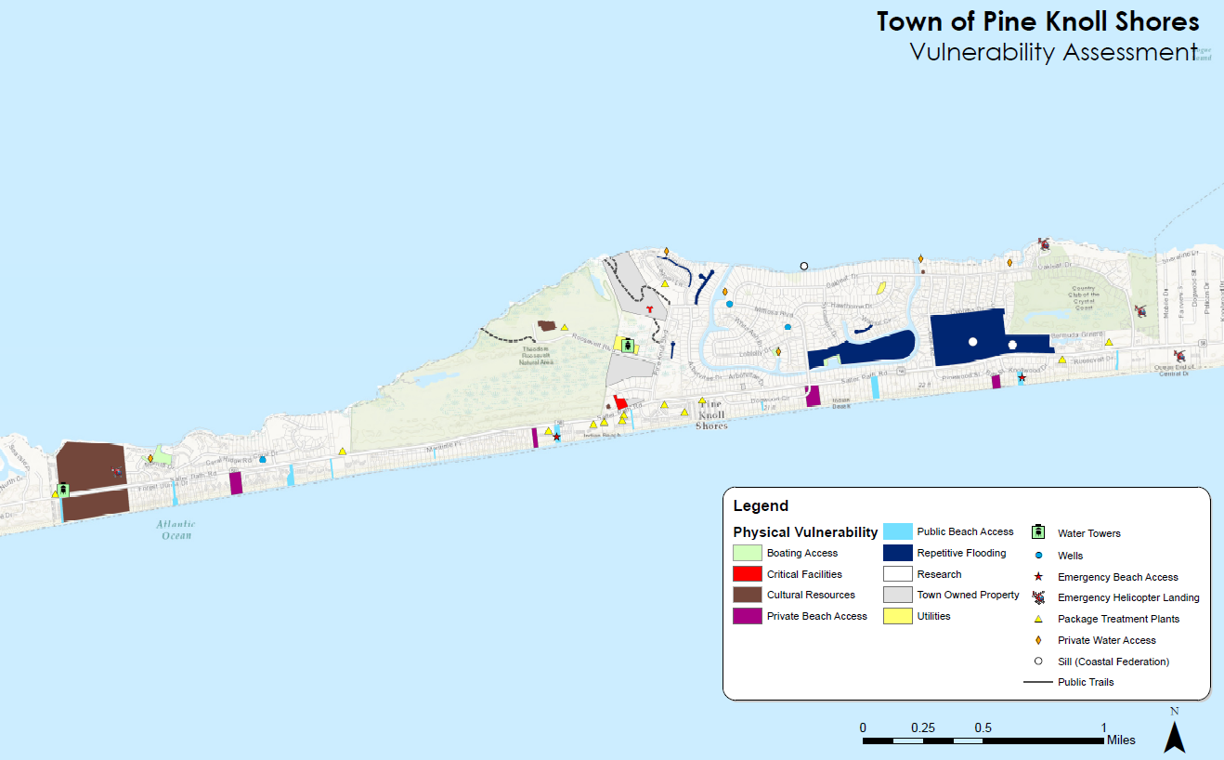
1B. Final Asset Map with Resident Input
1C. Final Asset Map Narrative

Introduction and Purpose
The Division of Coastal Management (DCM) and the Town of Pine Knoll Shores are created a map of the community’s physical and social vulnerabilities to coastal hazards. Creating the vulnerability map is a multi-step process that aims to understand a community’s hazards and capabilities, as well as to prioritize assets to include on the map. After the town staff worked with DCM to create initial asset maps, residents had an opportunity to add their knowledge to the maps through public meetings, follow-up interviews, and community surveys.
The mapping project is a three-part process: staff mapping, public input, and modeling. After the staff map was completed and reviewed by the staff point of contact, DCM and town staff conducted public meetings and surveys to add residents’ experiences with coastal hazards. DCM combined knowledge from staff and residents into one map, worked with The Nature Conservancy to upload maps onto their coastal resilience mapping tool, and pinpointed ‘hotspots’ where towns can focus project-planning efforts and funding to increase their resilience.
Mapping Pine Knoll Shores: Introduction
The dataset for Pine Knoll Shores’ assets is split into three layers: polygons, which denote parcel-level data; points, which denote specific sites within a parcel or area; and lines, which follow public trails in town.
Under the GIS polygon layer, town staff and residents identified critical facilities, cultural resources, HOA marinas, private beach access, public beach access, areas that experience repetitive flooding, research sites, town-owned property, and utilities as physical vulnerabilities.
Staff wanted emphasis on several assets which are denoted under the GIS point layer by points or special icons on the map. Those assets are emergency beach access, emergency helicopter landings, package treatment plants, private water access, Coastal Federation sill sites, water towers, and wells. Public trails are denoted under the GIS line layer.
The Eastern Carolina Council mapped the stormwater management system in Pine Knoll Shores; the system is included as a data layer in the GIS database and can be turned on and off as needed. In addition, DCM and town staff identified recreational areas but for the purposes of this map, they have not been included. The recreation layer is still contained within the dataset and can be uploaded in GIS.
Pine Knoll Shores staff and residents did not identify social vulnerability components to include on the map. However, surveyed staff did note that older populations, renters, and lower-income populations may need additional assistance pre- and post-disaster to help evacuate, maintain communications with the town, and rebuild.
Physical Vulnerabilities

The following table is a list of physical assets included on the GIS map as data layers. The first column denotes which GIS data layer each asset is assigned to. The white header is the overarching category for each column. Under the white header in each column, assets are further broken down:

Data Layer |  | HOA Marinas | Critical Facilities | Cultural Resources | Private Beach Access | Public Beach Access | Repetitive Flooding | Research | Town Owned Property | Utilities
Polygon |  |  | Town Hall (can serve as a temporary shelter) | Public Library |  |  |  | Groundwater Monitoring Stations |  | Aquarium Facilities
 |  |  | Police Station/Fire Station/EMS | Pine Knoll Shores Aquarium |  |  |  |  |  | Electric Co-op
 |  |  |  | Church
 |  |  |  | Heritage Tree (Oak)
Point |  | Private Water Access | Emergency Beach Access |  |  |  |  | Coastal Federation Sills |  | Well
 |  |  | Emergency Helicopter Landing |  |  |  |  |  |  | Water Tower
 |  |  |  |  |  |  |  |  |  | Package Treatment Plants
Line |  |  |  | Public Trail
Table 1: Physical assets in Pine Knoll Shores

Description:
HOA Marinas
Town staff and residents identified marinas owned by local HOAs as important resources to protect from coastal hazards for their recreational and cultural value. In the event of a natural disaster, it would be important for Pine Knoll Shores to know the location of marinas for their economic and community importance. Marinas are high-value targets for mitigation projects.
Critical Facilities
Critical facilities are buildings that are important in the aftermath of a disaster, whether because they provide public assistance (such as police stations or fire stations) or because the populations residing within the facility may need immediate assistance pre- or post-disaster (such as populations in nursing homes or hospitals). In Pine Knoll Shores, the building that houses the police department, fire department, and emergency services is critical, along with emergency beach access points and the town hall.
The police/fire/EMS staff can serve as first-line responders following a natural disaster, as well as aid residents with mobility issues when needed. The emergency beach access points allow responders to assist residents and visitors on the beaches. Those access points should be clear of obstruction at all times. The town hall can act as a temporary shelter during a major storm event, a distribution center for supplies and information, and a meeting point for residents and visitors for a variety of services post-disaster. The town hall is valuable piece of property that should be protected from flooding and other potential damages from coastal hazards.

Cultural Resources
Cultural resources are structures or areas that have a special meaning to a community, such as monuments, museums, and sacred spaces. Cultural resources can be damaged by a disaster and affect the culture, quality of life, and tourism revenue in a community. In Pine Knoll Shores, the public library, aquarium, the church, and heritage trees are major cultural resources that could qualify for mitigation or adaptation projects.

Private Beach Access
Private beach access points are HOA-owned and not accessible to the public. However, they are an important component for visitors renting beach houses and for part-time and full-time residents. Beach access points could be targeted for resilience-related projects, particularly those access points that may be in an area susceptible to flooding.

Repetitive Flooding
Areas that experience repetitive flooding can be targeted for resilience projects including but not limited to green infrastructure projects, pumping stations, or drainage infrastructure upgrades.
Research
There are two groundwater monitoring stations in Pine Knoll Shores. One station was set up and is monitored by the University of North Carolina for data collection purposes. Another station is controlled by the Town of Pine Knoll Shores and is used by staff to determine when to use a water pump during rain events. Research areas could be protected from damages by targeted mitigation projects if necessary.

Town Owned Property
Town-owned property was included so staff could easily identify where future projects or conservation efforts could occur without the need to acquire additional land.
Utilities
Utilities are important infrastructure that should be identified pre- and post-disaster to keep a community safe and healthy. Pine Knoll Shores’ utilities are the water treatment planta, pump stations, and communications buildings. By mapping utilities, town staff can quickly locate areas to repair or to focus mitigation planning efforts.
Public Trails
Public trails were included as assets to the town for tourism and quality of life purposes. They are important to mitigate from flooding and other damages to retain quality of life and accessibility in Pine Knoll Shores as public resources.
Geography
DCM staff included waterbodies (in light blue) and wetlands (in light green) on the map to better visualize locations prone to flooding based on natural geography, as well as to identify areas with the potential to mitigate flooding, such as wetlands that could be expanded.

Social Vulnerabilities
Pine Knoll Shores staff and residents did not identify social vulnerability components to include on the map. However, it is worth noting that the average age of residents in Pine Knoll Shores is around 60. An older average age may increase the need for resources to communicate and evacuate pre-disaster and to immediately assist residents post-disaster with emergency aid, access to their homes, or rebuilding.
According to town staff, about 30% of residents live in Pine Knoll Shores full-time and 70% live there part-time. In addition, Pine Knoll Shores experiences an increase in their tourist population during hurricane season. Resources and communications to the tourist population are essential to prepare people for impacts from extreme weather.
Additional social vulnerability indicators that could be used in other communities – such as concentrated areas of 65+ residents, concentrated areas of non-English speakers, and concentrated areas where people have low trust in government – were not identified in Pine Knoll Shores.

1D. GIS Data Sources
The following table lists data sources used to compile asset maps in Pine Knoll Shores and other communities.
Layer Type | Source | Website
Building Footprint  Schools  Flood Hazard Areas  City Limits | NC Flood Mapping Program | https://sdd.nc.gov/sdd/DataDownload.aspx
Roads, Bridges, Rail | NC DOT | https://connect.ncdot.gov/resources/gis/pages/gis-data-layers.aspx
Waterbodies | USGS – National Hydrological Dataset | https://viewer.nationalmap.gov/basic/
Critical Infrastructure (Police, Fire…) | USGS – National Structures Dataset | https://viewer.nationalmap.gov/basic/
Historic Districts/Buildings | NC Historic Preservation Office | http://gis.ncdcr.gov/hpoweb/default.htm?config=AdvancedUser.xml
Duck & Hatteras Parcels | NC OneMap | http://data.nconemap.gov/geoportal/catalog/main/home.page
Edenton Parcels | Chowan County | http://maps.agdmaps.com/nc/chowan/
Pine Knoll Shores Parcels | Carteret County | http://gisdata-cc-gis.opendata.arcgis.com/
Oriental Parcels | Pamlico County | http://maps.agdmaps.com/nc/pamlico/

Appendix 2: Surveys
2A. Town Staff Survey
*This survey was created using Qualtrics survey engine.
Town of Pine Knoll Shores: Coastal Hazards Survey

Thank you for taking the time to complete this survey. Your input is very important to us! We are working with partners from the National Oceanic and Atmospheric Administration and the N.C. Division of Coastal Management to assess our vulnerabilities to coastal hazards such as storms and flooding and how we can become a more resilient community. We would like to hear from you about the most common and pressing hazards and environmental issues you experience in Pine Knoll Shores, along with your needs for addressing them.
This survey contains three sections and should take less than 15 minutes to complete:
1. General Information
2. Environmental Issues in Our Community
3. Local Government Needs
All responses will remain confidential; no individual respondent will be identified in the survey report. If you would like to participate, please complete this survey by 5 p.m. on October 27, 2017. If you have questions or need assistance with the survey, please contact Monica Gregory at monica.gregory@ncdenr.gov or (252) 808-2808, ext. 230.
*Please note: this survey is intended for local government officials and staff only. Separate methods will be used to gather information from residents.
Thank you for taking the time to complete our survey!

1. Do you currently work for the Town of Pine Knoll Shores or serve as commissioner or board member for the town?
- Yes (1)
- No (2)
Condition: No Is Selected. Skip To: End of Survey. Condition: Yes Is Selected. Skip To: Which position from the following list....

2. Which position from the following list most closely matches your own?
- Accounting or Finance Officer (1)
- Administrative Assistant (2)
- Code Enforcement Officer (12)
- Elected Official (4)
- GIS Analyst (5)
- Human Resources Officer (6)
- Intern (7)
- Planner (8)
- Permitting Agent/Inspector (9)
- Policy Analyst (3)
- Public Works Official
- Town/County Manager or Town/County Manager Assistant (10)
- Other: (11) ____________________

3. Approximately how long have you worked for the Town of Pine Knoll Shores?
- Less than 1 year (1)
- 1-5 years (2)
- 6-10 years (3)
- Over 10 years (4)

4. Please check all the issues you are aware that Pine Knoll Shores has faced in the last 10 years:
- Algal blooms (1)
- Beach erosion/estuarine shoreline erosion (2)
- Damaging winds (3)
- Drainage issues (16)
- Drought (4)
- Dune instability (5)
- Infrastructure failure/damage (6)
- Extreme temperatures (7)
- Flooding due to heavy precipitation/stormwater management issues (8)
- Hurricane (9)
- Nor'easter (10)
- Riverine flooding (11)
- Saltwater intrusion (12)
- Storm surge (13)
- Tidal flooding (14)
- Other (please list): (15) ____________________

5. In your experience, what are the three most pressing environmental issues facing Pine Knoll Shores at this time?

6. In what ways do those three environmental issues affect our community (e.g., damage to human health, damage to local economy, displacement of citizens, etc.)?

7. On a scale of what 1 to 10, where 1 is "completely unable" and 10 is "fully able," how would you rate Pine Knoll Shores’ ability to withstand and recover from a minor storm with limited flooding?
- 1 (1)
- 2 (2)
- 3 (3)
- 4 (4)
- 5 (5)
- 6 (6)
- 7 (7)
- 8 (8)
- 9 (9)
- 10 (10)

8. Why did you select this rating?

9. On a scale of what 1 to 10, where 1 is "completely unable" and 10 is "fully able," how would you rate Pine Knoll Shores’ ability to withstand and recover from a major storm with extensive flooding?
- 1 (1)
- 2 (2)
- 3 (3)
- 4 (4)
- 5 (5)
- 6 (6)
- 7 (7)
- 8 (8)
- 9 (9)
- 10 (10)

10. Why did you select this rating?

11. In your experience, do environmental issues disproportionately affect different sectors of our community (e.g., the elderly, the disabled, low-income, etc.)?
- Yes (1)
- No (2)
Condition: No Is Selected. Skip To: Click to write the question text.

11a. Which groups in Pine Knoll Shores are disproportionately affected? Please be as specific as possible.

12. In your experience, do environmental issues affect specific areas in Pine Knoll Shores more than others (certain streets, neighborhoods, buildings, etc.)?
- Yes (1)
- No (2)
Condition: No Is Selected. Skip To: End of Block.

12a. Which areas are more affected by environmental issues? Please be as specific as possible, including street names, neighborhood names, or building names, if you know them.

13. In your opinion, what is the most difficult part of dealing with environmental issues in Pine Knoll Shores (e.g., community buy-in, lack of financial resources, size of staff, etc.)?

14. In your experience, what does the Town need in terms of tools and resources to better address our environmental issues?
- Additional staff (1)
- Assistance with finding relevant funding (2)
- Assistance with grant writing (3)
- Digital resources from state or federal entities, such as visualization tools or case studies on similar issues your community faces (4)
- Resources to increase community buy-in (5)
- Training (7)
- Outreach materials (8)
- Other (please list): (6) ____________________

15. Do you have additional comments pertaining to your experiences with environmental issues in Pine Knoll Shores?

16. If you have anything else that you would like to share with us, please let us know!

- Thank you again for sharing your experiences and needs with us. If you have any questions or concerns, please contact Monica Gregory at monica.gregory@ncdenr.gov.Have a good day!

2B. Full Report
Default Report
Town of Pine Knoll Shores: Coastal Hazards Survey
November 2nd 2017, 9:00 am MDT
1. - Do you currently work for the Town of Pine Knoll Shores or serve as commissioner or board member for the town?
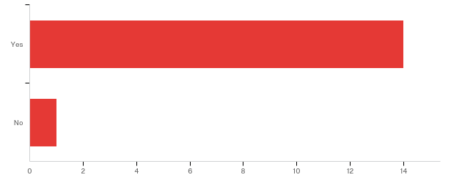

# | Answer | % | Count
1 | Yes | 93.33% | 14
2 | No | 6.67% | 1
 | Total | 100% | 15

2. - Which position from the following list most closely matches your own?

Position | Number | Percentage
Planning Board Member | 5 | 38.46%
Elected Official | 2 | 15.38%
Public Safety Official | 2 | 15.38%
Administrative Assistant | 1 | 7.69%
Planner | 1 | 7.69%
Strategic Planning Committee | 1 | 7.69%
Public Services Administrator | 1 | 7.69%
 | 13 | 100.00%

3. - Approximately how long have you worked with the Town of Pine Knoll Shores?
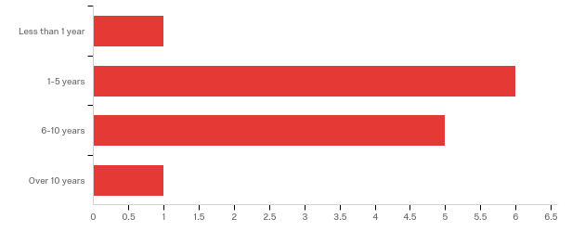

# | Answer | % | Count
1 | Less than 1 year | 7.69% | 1
2 | 1-5 years | 46.15% | 6
3 | 6-10 years | 38.46% | 5
4 | Over 10 years | 7.69% | 1
 | Total | 100% | 13

4. - Please check all the issues you are aware Pine Knoll Shores has faced in the last 10 years:
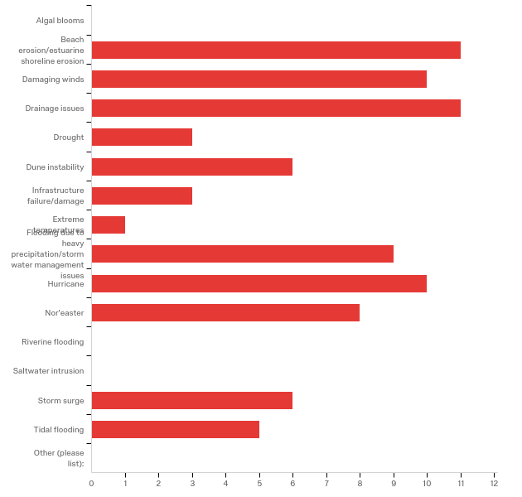

# | Answer | % | Count
1 | Algal blooms | 0.00% | 0
2 | Beach erosion/estuarine shoreline erosion | 13.25% | 11
3 | Damaging winds | 12.05% | 10
16 | Drainage issues | 13.25% | 11
4 | Drought | 3.61% | 3
5 | Dune instability | 7.23% | 6
6 | Infrastructure failure/damage | 3.61% | 3
7 | Extreme temperatures | 1.20% | 1
8 | Flooding due to heavy precipitation/stormwater management issues | 10.84% | 9
9 | Hurricane | 12.05% | 10
10 | Nor'easter | 9.64% | 8
11 | Riverine flooding | 0.00% | 0
12 | Saltwater intrusion | 0.00% | 0
13 | Storm surge | 7.23% | 6
14 | Tidal flooding | 6.02% | 5
15 | Other (please list): | 0.00% | 0
 | Total | 100% | 83

Other (please list):
Other (please list): - Text

5. - In your experience, what are the three most pressing environmental issues facing Pine Knoll Shores at this time?

In your experience, what are the three most pressing environmental issues facing Pine Knoll Shores at this time?
Salt water intrusion. Storm surge sound side from hurricane.
Shoreline stabilization, water quality, stormwater
beach erosion, loss of recreational beach, storm water runoff,
Infrastructure failure, Beach erosion, local flooding areas
beach erosion,
storm water flooding; beach erosion, canal pollution
Beach erosion, storm surge, and damaging winds.
shoreline erosion, storm water flooding, loss of protective vegetation
Hurricanes, wind events, drainage
Storm water management, Beach erosion, Hurricanes
stormwater flooding, beach erosion, water quality preservation

6. - In what ways do those three environmental issues affect our community (e.g.: damage to human health, damage to local economy, displacement of citizens, etc.)?

In what ways do those three environmental issues affect our community (e.g.: damage to human health, damage to local economy, displacement of citizens, etc.)?
House value, repair costs. possible bodily harm.
Potential impact to human health and well being
damage to local economy, water quality, land use projections
Possible home/ property damage, infrastructure replacement costs
damage to local economy,
you just named them
All the above
increased weather threats to infrastructure, reduced property values
Structural damage. Nothing major
Local economy, Human health, Property damage
damage to property, displaced residents

7. - On a scale of what 1 to 10, where 1 is "completely unable" and 10 is "fully able," how would you rate Pine Knoll Shores' ability to withstand and recover from a minor storm with limited flooding?
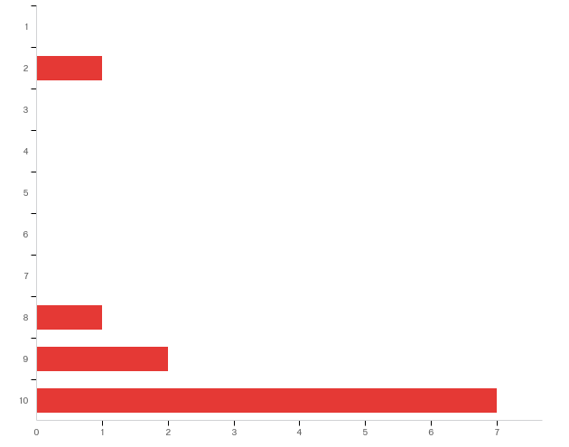

# | Answer | % | Count
1 | 1 | 0.00% | 0
2 | 2 | 9.09% | 1
3 | 3 | 0.00% | 0
4 | 4 | 0.00% | 0
5 | 5 | 0.00% | 0
6 | 6 | 0.00% | 0
7 | 7 | 0.00% | 0
8 | 8 | 9.09% | 1
9 | 9 | 18.18% | 2
10 | 10 | 63.64% | 7
 | Total | 100% | 11

8. - Why did you select this rating?

Why did you select this rating?
PKS is a StormReady city.
Town capable of fully completing this task
Town has made every effort to retain dense maritime vegetation which protects structures from wind. Also public safety has been proactive in putting in systems to deal with flooding in low areas. New construction requires capture of 2" of rainfall and engineered stormwater systems.
Town is well abreast of problems, needs to maintain adequate services
the key is minor - we have with stood a great deal in the past 20 years.
30 plus years living in PKS firsthand knowledge
We have proficient staff in public works, police, fire, town management, and community partnerships.
proper planning and equipment, knowledgeable and enthusiastic staff
Experience with storms.
Town's efforts to control stormwater.
History of Town being able to respond and recover

9. - On a scale of what 1 to 10, where 1 is "completely unable" and 10 is "fully able," how would you rate Pine Knoll Shores' ability to withstand and recover from a major storm with extensive flooding?
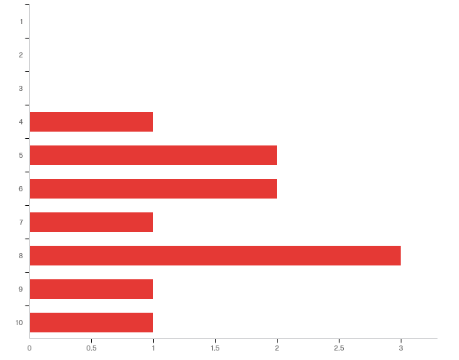

# | Answer | % | Count
1 | 1 | 0.00% | 0
2 | 2 | 0.00% | 0
3 | 3 | 0.00% | 0
4 | 4 | 9.09% | 1
5 | 5 | 18.18% | 2
6 | 6 | 18.18% | 2
7 | 7 | 9.09% | 1
8 | 8 | 27.27% | 3
9 | 9 | 9.09% | 1
10 | 10 | 9.09% | 1
 | Total | 100% | 11

10. - Why did you select this rating?

Why did you select this rating?
Need resources or rented equipment to clean up and repair infrastructure.
Not sure of the Town's full capacity in this situation
Only a guess since we haven't had a major storm since I've lived here (2002). Some parts of town would do better than others. Sound side homes would be flooded, a storm surge would wipe out dune structure which protects beach front properties. But Town management is highly qualified and proactive in bringing together resources to deal with all issues.
Capable staff and adequate cash to address problems
PKS being on an island is exposed to significant storm flooding and erosion which could, if major, eliminate a major portion of the town.
it’s just a guess. in 30 years i’ve never experienced “major flooding”
Depending on the storm size, intensity, and damage; we would be able to recover; however, it will press our resources.
same as the previous answer, however longer recovery period due to staff and equipment limitations and need for outside support (restoring of utilities, debris clearance and removal, and competition with other communities for resources)
Minor flooding
The Town is a storm ready community because of its planning.
Ability in the past to respond/recover

11. - In your experience, do environmental issues disproportionately affect different sectors of our community (e.g.: the elderly, the disabled, low-income, etc.)?
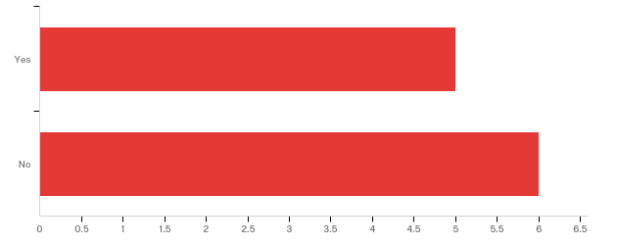

# | Answer | % | Count
1 | Yes | 45.45% | 5
2 | No | 54.55% | 6
 | Total | 100% | 11

11a. - Which groups in Pine Knoll Shores are disproportionately affected? Please be as specific as possible.

Which groups in Pine Knoll Shores are disproportionately affected? Please be as specific as possible.
Depends on locale of property.
The elderly, especially those with health issues, are not as capable of dealing with change. They don't have the technology to stay informed, not as easily evacuated or relocated when conditions require it.
elderly and low income who cannot respond quickly
we are a town with many elderly people. many widows, some widowers
primarily the elderly which are the majority of full time residents, second home owners which will not have ready access to survey and effect repairs

12. - In your experience, do environmental issues affect specific areas in Pine Knoll Shores more than others (certain streets, neighborhoods, buildings, etc.)?
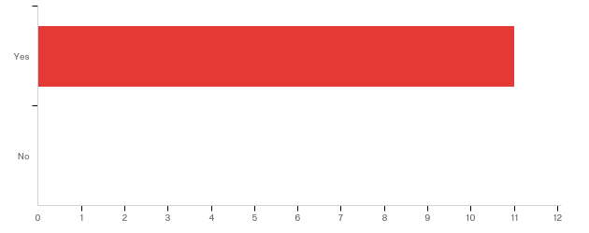

# | Answer | % | Count
1 | Yes | 100.00% | 11
2 | No | 0.00% | 0
 | Total | 100% | 11

12a. - Which areas are more affected by environmental issues? Please be as specific as possible, including street names, neighborhood names, or building names, if you know them.

Which areas are more affected by environmental issues? Please be as specific as possible, including street names, neighborhood names, or building names, if you know them.
East side and older homes. Some wooden ocean side condo's.
Flooding issues mostly in eastern part of Town
East end of town, sound side properties and beachfront. Live Oak floods during normal rainfall, as do a few neighborhoods around the golf course especially the cul-de-sacs.
Low lying streets- Yaupon, Juniper areas
those close to the sound and those with little dune protection on the ocean side.
the east end of town.. juniper, willow, cedar etc.
Cedar Rd, Holly Rd, Juniper Rd ; Flooding
areas subject to regular flooding (Yaupon, Juniper, Myrtle Ct, ocean and sound front structures
Flooding in eastern part of town and some cul-de-sacs.
Mimosa Blvd., Willow Rd.
Eastern portion of town experiences stormwater flooding and oceanfront is susceptible to beach erosion

13. - In your opinion, what is the most difficult part of dealing with environmental issues in Pine Knoll Shores (e.g. community buy-in, lack of financial resources, size of staff, etc.)?

In your opinion, what is the most difficult part of dealing with environmental issues in Pine Knoll Shores (e.g. community buy-in, lack of financial resources, size of staff, etc.)?
staff size and rainy day fund needs more reserves.
Community buy-in and understanding of the issue
Community buy-in, often costs money to do the right thing. And there are those who deny we have any environmental issues. Unfortunately, it tends to get political.
Funding
major catastrophic issues will overwhelm the town staff.
community buy in is a problem. The attitude is why should the majority of the town fix the cheap lots since people knew the flooding problems when they bought their house or lot
Significant recourses would be size of staff. Police and Fire Departments across the board need 2-3 more full-time personnel.
having or getting on site equipment and operators necessary to clear streets and restore utilities
Impatience of some citizens.
Community buy-in.
Size of staff

14. - In your experience, what does the Town of Pine Knoll Shores need in terms of tools and resources to better address our environmental issues?
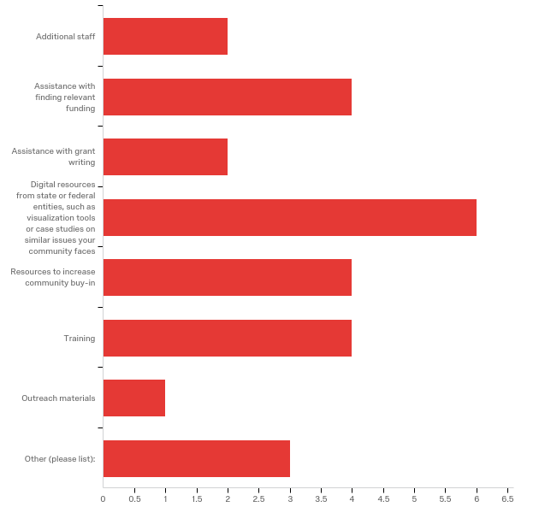

# | Answer | % | Count
1 | Additional staff | 7.69% | 2
2 | Assistance with finding relevant funding | 15.38% | 4
3 | Assistance with grant writing | 7.69% | 2
4 | Digital resources from state or federal entities, such as visualization tools or case studies on similar issues your community faces | 23.08% | 6
5 | Resources to increase community buy-in | 15.38% | 4
7 | Training | 15.38% | 4
8 | Outreach materials | 3.85% | 1
6 | Other (please list): | 11.54% | 3
 | Total | 100% | 26

Other (please list):
Other (please list): - Text
Nothing really. Others don’t need to pay for town problems via Grants, rtc
the staff of PKS is doing an excellent job on environmental issues. Just keep doing.
Additional fire and police personnel in a full-time capacity.

15. - Do you have additional comments pertaining to your experiences with environmental issues in Pine Knoll Shores?

Do you have additional comments pertaining to your experiences with environmental issues in Pine Knoll Shores?
No.
The Town appears to be very pro-active
not at this time
This survey is geared to start new programs labeled “. Environmental” for the sake of expediency which is not needed.
No
the town staff is very proactive in anticipating and planning for environmental issues and in keeping the town citizens and the second home owners informed throughout occasions of potential and actual emergencies. Both staff and HOAs are good at keeping lines of communication open
Pine Knoll Shores is working very diligently to prevent as much as possible environmental issues.
Not at this time

16. - If you have anything else that you would like to share with us, please let us know!

If you have anything else that you would like to share with us, please let us know!
None.
No
Thanks, will do. It's an amazing place to live and we want to keep it that way.
PKS is an excellent place to live and we enjoy it as is. Increased services means increased taxes which we do not need.
We love our police and fire department. They need additional full-time personnel.
nothing at this time
N/A

Appendix 3: Public Input Workshop Activities
3A. Workshop Agenda & Preparation Needs
The following agenda was used during the public workshop. The workshop took about 1.5 hours to complete.
Activity | Time
The Town Manager or Leader welcomes attendees and introduces the presenters. | 2 minutes
A Town Planner or Resident Expert talks about the town’s current issues and why this project is important for the town. | 10 minutes
The RENA Project Manager or Leader talks about the purpose of this project and the process attendees are undertaking.  During the presentation, volunteers pass out large blue dot stickers. | 15 minutes
Attendees take their blue dot stickers and mark all issues they experience within their community.  Attendees take their arrow stickers and mark their top three priorities: #1 red, #2 yellow, and #3 is green. | 40 minutes
The larger group reconvenes. The Project Manager splits the group into 3-5 people. | 10 minutes to count off and split into smaller groups
One volunteer will lead each group. The group will discuss the assets presented on the map and make additions as needed. The volunteer will take notes and insure that all information is captured. | 25 minutes
The small groups reconvene for questions. | 10 minutes
Total time: ~1.5-2 hours
Below is a list of supplies that must be gathered by the Project Manager or Leader before the workshop:
Supplies Needed | Purpose
Large hard-copy asset maps with a parcel base map – number depends on expected number of attendees | Asset maps will be ground-truthed by attendees. There should be 1 map for every 3-5 people. The maps should be large enough for attendees to identify each parcel in case attendees want to make additions to the map.
Large blue dot stickers | For attendees to mark all issues they have experienced in their communities
Arrow stickers – red, yellow, and green | For attendees to prioritize their #1, #2, and #3 issues
Sharpies – Black and Multicolored | Project Manager or Leader can use a black sharpie to take notes; Attendees can use various colored sharpies to take notes or mark on the asset maps
Large paper and tape/thumb tacks | A large sheet of paper should be taped or tacked to a wall or board. The issues should be listed on a large sheet of paper for attendees to mark with blue dots and with multicolored arrows.
Notebooks | Notebooks should be provided to volunteers to take notes as they lead small groups. Notebooks must be collected at the end of the workshop so the Project Manager or Leader can synthesize the ideas in the final report for the community.
Post-it Notes | Post-it notes should be on the tables with maps so attendees can take short notes and place them on the maps as needed.

Below is a list of pre-workshop activities that must be completed before the workshop:
Activity | Purpose
Reserve a space for the workshop | A space should be reserved at least a month before the workshop date to insure a date is set before advertising
Organize volunteers and provide training | Work with the local government or external organizations to obtain volunteers for the workshop. 1 volunteer for every 3-5 people will be best, if possible. Provide training at least two days before the workshop so the volunteers know about the project and the process that will be used during the workshop.
Advertise | Begin advertising 2-3 weeks before the workshop date. Advertise in multiple mediums such as through emails, flyers, and town newsletters.
Organize refreshments | If funds allow, order catering or provide refreshments such as coffee, tea, water, and light snacks for attendees on the date of the workshop
Write all 15 issues from the town staff survey (see Appendix 2B, question 4) on 1-2 pieces of large paper | Attendees will mark all issues they have experienced in their communities as well as prioritize those issues with stickers. This information should be matched with town staff responses to see which issues are most critical to both populations, and which issues town staff may need to better understand from the community perspective.
Pack supplies | The Project Manager or Leader should make sure they have the following supplies:  _____ - Sharpies  _____ - Blue dot stickers  _____ - Arrow stickers (red, green, yellow)  _____ - Post-it notes  _____ - Large sheets of paper  _____ - Tape or thumb tacks  _____ - Notebooks for volunteers  _____ - Pens or pencils  _____ - Printed maps for the session  _____ - Issues written on large sheets of paper
3B. Workshop Advertisement Example
Below is a sample flyer from the Town of Pine Knoll Shores. Pine Knoll Shores can replicate the flyer if they desire to do another input workshop or scale up the project to the county by using the free online tool, Canva.

3C. Workshop Volunteer Instructions
Below is the volunteer instruction packet given to each volunteer before the workshop activities. Volunteers can help set up the workshop space, manage and lead groups, and tear down the workshop space.
Activity | Time
Brian or Kevin welcomes attendees and introduces the project lead, Monica Gregory. | 2 minutes
The project lead talks about the purpose of this project and the process attendees are undertaking.  During the presentation, volunteers pass out large blue dot stickers. | 10 minutes
Attendees take their blue dot stickers and mark all issues they have experienced in town over the past ten years.  Attendees take their arrow stickers and mark their top three priorities: #1 red, #2 yellow, and #3 is green. | 30-40 minutes
The larger group reconvenes. The project lead splits the group into 3-5 people. | 10 minutes to count off and split into smaller groups
One volunteer will lead each group. The group will discuss the assets presented on the map and make additions as needed. The volunteer will take notes and insure that all information is captured. | 40-50 minutes
Small groups reconvene for questions.  **Exit survey** | 10 minutes

Total time: ~2 hours
Thank you again for volunteering to assist with our workshop!
Please arrive at Town Hall between
9 a.m. and 9.30 a.m. on Saturday, April 7.

Instructions:
Part I – Selecting and prioritizing issues
Activity overview:
- Participants will take blue dot stickers and place a sticker next to each of the issues they have experienced or seen in the past 10 years.
- Participants will take arrow stickers and prioritize their top three issues.
  - #1 concern should be in red;
  - #2 concern should be in yellow;
  - #3 concern should be in green.
- Participants can add issues on the last paper where I have created spaces for additional concerns.
- Participants can add comments directly below each issue -OR- participants can use the general comment notepad at the front of the room.
- Once finished, participants should sit back down so we know they are done with their selections.

Total time: About 30-40 minutes

Instructions:
Part 2 – Mapping assets:
Activity overview:
- Participants will work in small groups (ideally about 5 people per group) with one map per group.
- You will act as the small group facilitator.
  - Encourage open dialogue.
  - Insure that the small groups understand that they can mark directly on the map and use post-it notes for comments.
  - Insure that newly mapped assets are categorized clearly so I can add them to the map.
  - Take notes on any overarching ideas or consistent thoughts/concerns from your small group. A notebook will be provided to you.
  - When we have 5-10 minutes left, I will ask you to add newly mapped assets to the colorful asset list on the next page so I can clearly see new additions.
*I will be walking from group to group, but please feel free to grab me if you have any questions!

Total time: About 40-50 minutes

Color-Coded Asset List:
*At the end of your small group session, I will ask you to add newly mapped assets to this list under the appropriate category. If necessary, you can create new categories on the next page.
Boating Access
- Marinas
- New Asset:
- New Asset:
Comments:

Critical Facilities
- Numbered on map
- New Asset:
- New Asset:
Comments:
Cultural Resources
- Churches
- Public Library
- Heritage Trees
- Aquarium
- New Asset:
- New Asset:
Comments:

Private Beach Access
- New Asset:
- New Asset:
Comments:
Public Beach Access
- New Asset:
- New Asset:

Comments:
Repetitive Flooding
- New Area:
- New Area:
Comments:

Research
- Groundwater monitoring station
- Living Shoreline:
- New Asset:
Comments:

Town Owned Property
- New Asset:
- New Asset:
Comments:

Utilities
- New Asset:
- New Asset:
Comments:

*Please use this space for new asset categories or additional comments*

3D. Asset List for Workshop Participants
Below is a color-coded list of assets given to each participant in the workshop. The overarching categories correspond to the asset map (Appendix 1A). This list helps participants quickly identify assets on the map by color and category. Participants should add to this list, and volunteers can record new assets and categories in their volunteer instruction packet (Appendix 3C).
Appendix 4: Modeling Examples
The Nature Conservancy (TNC) hosted our asset maps on their coastal resilience mapping tool starting in 2018. The tool allows town staff, planners, and the public to see which assets will be affected under a variety of conditions in current and future scenarios.
You can view the asset maps here.
At the time of publication, Pine Knoll Shores’ asset map was not live on TNC’s coastal resilience mapping tool. The examples below are from another community, the Town of Oriental, that participated in the same process. Pine Knoll Shores asset map should be online by July 2018.
Sea level rise projections for the current year confirm what locals already know. Certain areas along the waterfront are already subject to frequent, repetitive flooding. Three areas where locals pinpointed frequent flooding in Oriental match current-year sea level rise projects. They are circled in red below:

Under the medium sea level rise scenario (40 cm. or 15.7 in), some areas along the waterfront are more severely impacted. Streams begin to expand, and flood intensifies in neighborhoods already impacted by excess water. Three affected areas are circled in blue below:

Under the same medium sea level rise scenario, assets are more severely impacted under flood events. An example of projected flooding in downtown Oriental after a 100-year flood event under the medium sea level rise scenario is below. Oriental’s famed harbor is inundated by more than 36 inches (3 feet) of water (shown in yellow), as are many areas along the waterfront and streams:
Appendix 5: TNC Mapping Portal – Workflow Example
The following workflow was created by Lora Eddy from The Nature Conservancy to assist communities in visualizing risk. In “Section II. Adding Community Specific Information to Your Map” in the following work flow, towns can find a version of their asset map to help visualize their vulnerabilities to coastal hazards like flooding and sea level rise.

Flood and Sea Level Rise app - Example Workflow
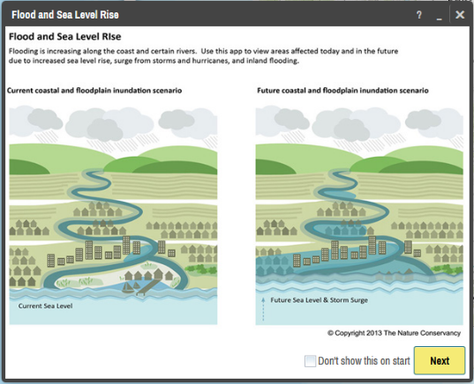
I. Visualizing Risk

- In your internet browser enter: maps.coastalresilience.org/northcarolina/
- Activate the Flood app by clicking on the icon on the left.

- Choose a Region
- Click on “Select a Region” box and select Carteret County from the drop-down menu.
- The map zooms to Pamlico

- Zoom into Pine Knoll Shores
- Zoom by using the center scroll of your mouse or double-clicking over the area
-OR-

- In the top right corner of the map in the search bar, type in Pine Knoll Shores, NC
- As you type in the search box the drop-down list will auto-populate
- Select the address and the map will zoom to the address

- Choose a Hazard
- Click the “Select a Hazard” box and select Coastal Flooding (NC Emergency Mgmt)
- Slide the “Sea Level Rise” slider to 40 cm to see flooding impacts due to sea level rise alone
- Slide the “Flood Extent” slider to 100-yr to see areas in the future at risk to coastal flooding with sea level rise.
- Click on the icon next to “Flood Extent” for more information about the data you have selected

- Click on Opacity in the same box at the bottom right corner, below the sea level rise graph
- Click on the slider to adjust the opacity of the storm surge

- Minimize the Flood app window and leave the map on your zoomed in location.

II. Adding Community Specific Information to your Map
- Activate the Community Planning app by clicking on icon on the left.

- Select “Town of Pine Knoll Shores” and turn on this data layer by clicking on the button
- Notice the change on the map and legend – now both the hazard modeling information and the asset information can be seen
- Click the … to expand a pop-up menu that allows you to adjust the data layer’s transparency, adjust the transparency to half
- Click on the icon for more information about the data layer you have selected
- You can minimize or move the legend to see more of the map

This data can be used for land use planning, Community Rating System (CRS) planning, grant applications for resilience-building projects, emergency management, and communications pieces for residents, among other uses.

**Coastal Resilience Map Hints & Tips:
- Click on Tour for a brief introduction to the mapping site or visit coastalresilience.org/tools/training/ for an online Try Me Tutorials.
- This web-based tool can be used in most Internet browsers, including Chrome, Firefox, and Safari. NOT Internet Explorer.
- Refresh your browser window (push the F5 key) if the tool seems laggy (e.g. layers are stuck).
- Also try using a browser window which does not retain cookies or other browsing data. For example:
  - Chrome: incognito window
Firefox and Safari: private browsing window
Appendix 6: Timeline & Schedule of Activities
Below is the approximate timeline from the initial meeting with Oriental’s town staff to the completion of the project:
Month/Year | Purpose | Activities
February 2017 | Scoping meeting with Town Manager and planner | - Discuss project and time commitment  - Identify potential stakeholders to include  - Establish initial timeline
April 2017 | Map vulnerabilities with Town Manager | - Identify physical and social vulnerabilities from the town staff perspective
June 2017 | Survey town staff | - Identify coastal hazards and their impacts on the community  - Identify town needs to address impacts from hazards  - Identify specific areas that flood in town
April 2017 – December 2017 | Revise asset map, write narrative to justify included assets, and begin final report for town | - Update asset map according to town comments and suggested revisions. There may be several versions of the map until you add everything in the correct place.  - Write a narrative to complement the map so both the town staff and the public can easily understand what assets were included and why (see Appendix 1C)  - Begin final town report with information from background research, meetings with town staff, the town staff survey, and other relevant information
January 2018 – March 2018 | Prepare for public input workshops | - Create advertisements for public input workshops (see Appendix 3B)  - Work with town staff and volunteers to advertise through social media, newsletters, the local newspaper, and information boards around the community  - Purchase and prepare all supplies (see Appendix 3A)
April 2018 | Public input workshop | - Engage residents in the resiliency planning process  - Communicate the concept of resiliency to the community  - Retrieve input on coastal hazards and their impacts from the resident perspective  - Retrieve information on assets important to residents as well as localized flooding within town boundaries

Appendix 7: Pine Knoll Shores Strategic Plan

“‘Resilience’ means the ability to anticipate, prepare for, and adapt to changing conditions and withstand, respond to, and recover rapidly from disruptions.” (Former President Barack Obama, Executive Order 13653)
Pamlico Sound Regional Hazard Mitigation Plan. Draft: 2015.
In the context of this project, a physical vulnerability is indicated by a geographic area exposed to a hazard, such as waterfront properties repeatedly flooded after hurricanes. A social vulnerability is indicated by a population that is exposed to a hazard, such as residents in a neighborhood in a low-lying area that repeatedly floods. Both physical and social vulnerabilities can be low or high risk, depending on their level of exposure, preparedness, and ability to recover after a disaster, among other indicators.
Appendix 1B.
In the context of this project, a physical vulnerability is indicated by a geographic area exposed to a hazard, such as waterfront properties repeatedly flooded after hurricanes. A social vulnerability is indicated by a population that is exposed to a hazard, such as residents in a neighborhood in a low-lying area that repeatedly floods. Both physical and social vulnerabilities can be low or high risk, depending on their level of exposure, preparedness, and ability to recover after a disaster, among other indicators.
See Appendix, Map 1 for the map with the stormwater management system and Map 2 for the map without the stormwater management system.

