Name of Facility

Standard Operating Procedure
for the Analysis of
Dissolved Oxygen with Luminescence Probe

Method: (Keep the one the lab is certified for and delete other)
ASTM D 888-12 C (LDO)
Hach 10360-2011, Rev. 1.2 (LDO)
Standard Methods 4500 O-H 2016(LDO)

Effective Date:

Supervisor Signature: ___________________ Date:__________
Supervisor Name (print):________________________________
Table of Contents
1.0 – Summary of Method Pg. x
2.0 – Definitions Pg. x
3.0 – Safety and Waste Handling Pg. x
4.0 – Apparatus and Equipment Pg. x
5.0 – Interferences Pg. x
6.0 – Sample Collection, Preservation and Holding Time Pg. x
7.0 – Calibration Pg. x
8.0 – Procedure Pg. x
9.0 – Documentation Pg. x
10.0 – Reporting Pg. x
11.0 – Preventative Maintenance Pg. x
12.0 – Quality Assurance and Quality Control Pg. x
13.0 – Troubleshooting and Corrective Action Pg. x
14.0 – Employee Training Pg. x
15.0 – References Pg. x
16.0 – Revision History Pg. x
Appendix A – DO Meter Calibration Verification Pg. x

Blue text is replaceable instructional language to be customized for your facility.
- Summary of Method

  - Luminescence-based sensor probes that measure luminescence lifetime are normally composed of a luminophore embedded sensing foil, an emitter (Light Emitting Diode - LED) and a photodetector. The pulsed or modulated emitter causes excitation of the luminophore, which is quenched in the presence of oxygen. The photodetector converts the luminescence emission into an electrical signal that can be sampled and processed to compute the luminescence phase shift or luminescence lifetime. This phase shift or lifetime is used to quantify dissolved oxygen
concentrations.

  - State what type of samples are analyzed, e.g., wastewater effluent, ground water monitoring well, etc.

- Definitions

  - Dissolved Oxygen (DO): The level of free, non-compound oxygen present in water or other liquids.

  - mg/L: Units for the measurement of DO.

  - NC WW/GW LCB: North Carolina Wastewater Groundwater Laboratory Certification Branch

  - (If needed) Post-Analysis Calibration Verification: A theoretical DO value is calculated based on the current air calibration conditions to verify the meter is reading accurately. Performed after analyzing samples at multiple locations.

  - Add any applicable acronyms or terms used by your facility

- Safety and Waste Handling

  - Items that would be included in this section are things such as:

- Precautionary measures (list here and at the critical steps in the procedure)
- Personal protective equipment (e.g., gloves, eye protection, lab coat, work in a hood, etc.)
- Hazardous chemicals/reagents
- Storage and disposal of samples and reagents
- Reference to Chemical Hygiene Plan, if applicable
- Location of Safety Data Sheets (SDS)

- Apparatus and Equipment
When sampling water of varying salinity, for example in brackish waters such as estuaries or coastal wetlands, it is recommended that you use a dissolved oxygen instrument that also measures conductivity for highest data accuracy. A dissolved oxygen instrument that also has a conductivity sensor will use the real-time salinity readings from the conductivity sensor for every mg/L calculation. This will make sampling easier since it will not be necessary to manually change the correction factor (perform a new calibration) at each new sampling site.

  - List your DO meter make and model

  - List probe make and model

  - If needed: Barometer

- Interferences

  - There are no known interferences at normal wastewater concentrations that interfere with DO detection and quantification with this method.

- Sample Collection, Preservation, and Holding Time

  - State what containers samples are collected in, if applicable. Samples must be collected in glass containers (e.g., glass BOD bottle and stopper)

  - State where the sample is analyzed e.g., in the stream, immediately at the sampling site, in the lab within holding time, etc.

  - There is no preservation requirement for DO.

  - The holding time for DO is 15 minutes.

- Calibration

  - Use 7.1 if the meter can be calibrated by the user and delete 7.2 through 7.9 (unless post-analysis verification is performed): The DO meter must be calibrated daily before compliance sample analysis.

    - State the calibration steps per the manufacturer’s instructions, for example; amount of time for the meter to warm up and where the probe is placed during calibration for instance, in a plastic bag, the probe storage cup, the storage well of the meter (each containing a wet sponge), or a BOD bottle partially filled with water.

    - State what variables are used by the meter to perform calibration, for example, temperature, pressure, elevation, salinity. Some of these might be programmed into the meter and don’t change (such as salinity for non-estuary waters), others will change each day depending on conditions. When samples with different salinities are analyzed, the meter must be calibrated for each salinity value.

  - Use 7.2 through 7.9 if your LDO meter cannot be calibrated by the user OR if a post-analysis verification is required. Specify if the following instructions are for the initial verification or a post-analysis verification, or both. The factory calibration of the DO meter must be verified each day before compliance sample analysis and/or after the last sample.

  - State the calibration steps per the manufacturer’s instructions

  - Use this section if the meter measures Conductivity to obtain a Salinity value for use in DO meter calibration-delete if not needed: In order to obtain accurate Salinity values for the DO meter calibration, the meter must first be calibrated for Conductivity. (recommend referring to your Conductivity SOP here for the proper calibration steps, or you can copy and paste the instructions)

  - State the probe conditions during verification: Place probe in a plastic bag, the probe storage cup, the storage well of the meter (each containing a wet sponge), or a BOD bottle partially filled with water.

  - Allow appropriate instrument warm-up time. (state minimum time here)

  - Read and record DO and temperature to the nearest 0.5 °C.

  - Apply the appropriate correction factor based on the atmospheric (barometric) pressure or altitude found in Table 2 to the DO value from Table 1 in Appendix A. Document the atmospheric pressure or altitude and salinity that is being used to determine the correction factor. (These tables have already been included at the end of the SOP and includes an example calculation.)

  - Compare the meter reading to the theoretical DO determined by Section 7.7 (update section reference if needed) to verify that the meter is within the acceptable range according to Section 11.1.

- Procedure

  - State the manufacturer’s instructions for meter operation.

  - Measure and record sample DO.

  - The rest of this procedure section is used if the meter is transported by vehicle. Use either #1 When the meter is transported by vehicle, a meter calibration is performed before analysis at each site. Follow steps in Section 7 for the calibration. or use #2: When the meter is transported by vehicle to another location after calibration, a post-analysis calibration verification must be performed after the last sample per Section 7.x. Delete whichever option (#1 or #2) you are not using.

- Documentation
The following must be documented in indelible ink whenever sample analysis is performed.
  - Date and time of sample collection

  - Date and time of sample analysis to verify the 15-minute holding time is met. Alternatively, one time may be documented for collection and analysis with the notation that samples are measured in situ or immediately at the sample site

  - Permitted facility name or permit number, and sample site (ID or location)

  - Collector’s/analyst’s name or initials

  - Conductivity calibration standard concentration, if applicable

  - Conductivity Check standard true value and observed value and evaluation, if applicable.

  - Calibration variables used by the meter (either elevation or barometric pressure [in mmHg], temperature and salinity. If you have entered constant values for elevation and/or salinity into the meter, those constant values are also required to be documented and could be included as a blanket statement on the benchsheet)

  - Meter calibration (and/or verification, if applicable) date and time(s)

  - Final calibration information (final DO reading in mg/L, the slope or % saturation- delete the ones not used)

  - If applicable- Temperature, pressure or altitude, salinity, theoretical DO value and meter reading obtained for the post analysis calibration verification

  - Units of measure

  - Instrument identification (serial number preferred)

  - Parameter analyzed

  - Final value to be reported

  - Method reference (refer to Certified Parameters Listing (CPL) for correct method description)

  - Data qualifier(s), where applicable

- Reporting

  - Describe rounding procedure

  - All data must be reported in mg/L.

- Quality Assurance and Quality Control

  - (Only keep this if the meter cannot be manually calibrated or the lab is performing a post-analysis verification) The theoretical DO value and the meter reading must agree within ± 0.5 mg/L. See Section 13.0 for corrective actions if the acceptance criterion is not met.

  - State who is transcribing the data to the DMR and whether anyone peer reviews (checks) it. Peer review is recommended, but if that is not possible, it is recommended that person recheck their own transcription for errors after a certain amount of time has passed

  - All documentation errors shall be corrected by drawing a single line through the error so that the original entry remains legible. Entries shall not be obliterated by erasures or markings. Wite-Out®, correction tape, or similar products designed to obliterate documentation are not to be used; instead the correction shall be written adjacent to the error. The correction shall be initialed by the responsible individual and the date of change documented. All manual data and log entries shall be written in indelible ink.

- Preventative Maintenance

  - State the probe storage conditions

  - State if a maintenance log or record is maintained

  - Sustained periods of sensor immersion in water containing high levels of chlorine dioxide may degrade sensor performance.

- Troubleshooting and Corrective Action

  - State what your corrective action will be if the verification checks are not within ± 0.5 mg/L. E.g., recalibrate meter and reanalyze previous samples, qualify samples on the DMR, verify the internal barometer and calibrate if necessary, etc.

- Employee Training

Employee training must be documented and kept on file.

  - Include required education, training, experience and/or demonstrated skills

  - Employee must have read and acknowledged understanding of this SOP – may also include reading the Approved Procedure for the Analysis of Dissolved Oxygen

  - Employee must demonstrate proficiency (e.g., side-by-side comparison with trained analyst, acceptable post calibration verification, etc.) before analyzing compliance samples for reporting. Specify how proficiency is demonstrated and how the results are evaluated.

- References

  - (Use appropriate one and delete the other) ASTM D 888-12 C (LDO)
Hach 10360-2011, Rev. 1.2 (LDO), Standard Methods 4500 O-H 2016 (LDO)

  - North Carolina Wastewater/Groundwater Laboratory Certification Approved Procedure for the Analysis of Dissolved Oxygen, Revision 11/29/2023 (consult NC WW/GW LCB website for latest revision).

  - 15A NCAC 02H .0800

  - Appendix A, Tables 1 and 2. The Dissolved Oxygen Handbook, YSI Incorporated, September 2009.

- Revision History

Type: Review or Revision | Date | Summary of Changes Made if Revision

Appendix A 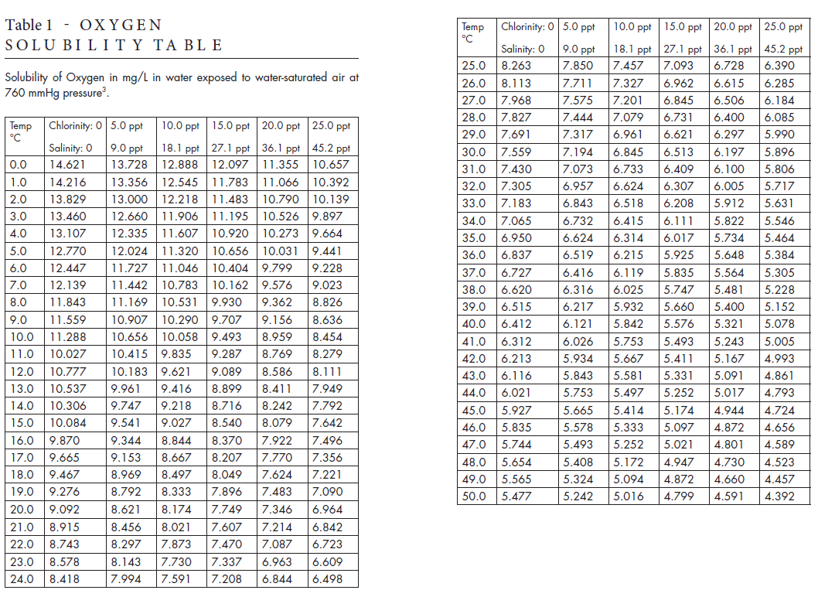

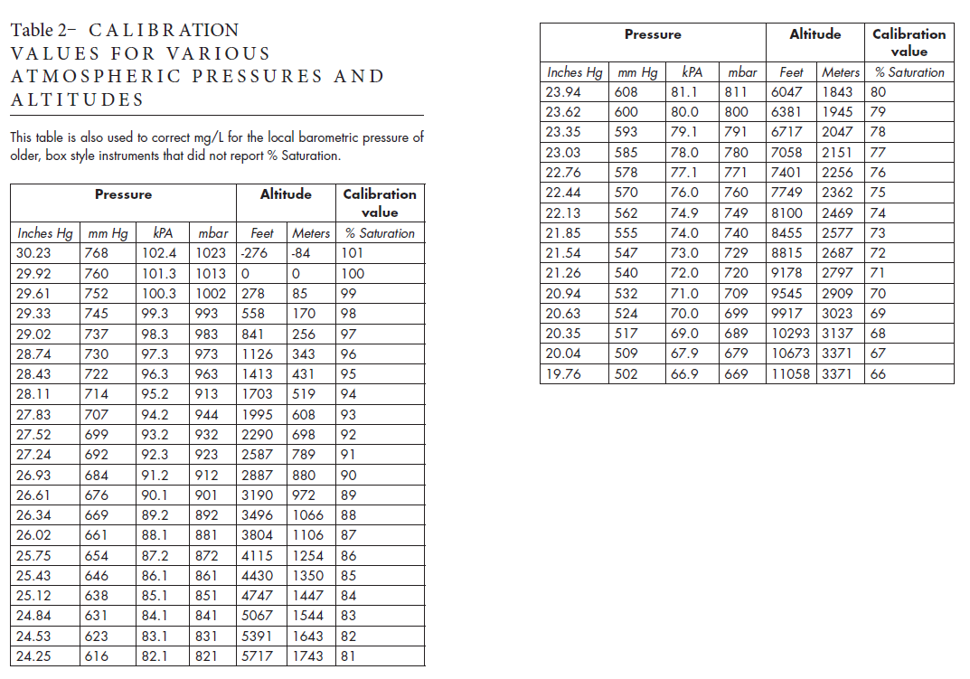

Example calculation for the theoretical DO value:
Assume the barometric pressure is 27.83 mmHg and the sample temperature is 22°C and has 0 ppt salinity.
From Table 2, the correction factor is determined by the % saturation at that pressure, i.e., 93% (0.93).
From Table 1, look in the cell where 22 °C and 0 ppt salinity overlap to get 8.743 mg/L.
Apply the correction factor to this value and compare to the reading on the meter.
Theoretical DO = 8.743 mg/L * 0.93 = 8.13 mg/L

