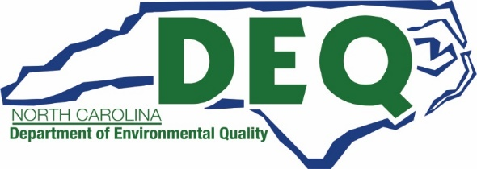

Project Final Report

INSTRUCTIONS:
Awardees are required to submit a final report at project completion. A final project report will include a narrative summary of the project or activity, project results (outputs and outcomes) including final emissions benefit calculations, and the successes and lessons learned for the entire project. Submission of this report is a requirement for the final payment of your project.
Part I: General Information
Project Title:
Organization Name:
Agreement/Contract Number:
Project Completion Date:

Part II: Final Report
Project Summary

Did any public relations events regarding your awarded project take place? If so, please describe the events.
Project Results (outputs and outcomes):
Please describe the successes and lessons learned for the project:
Any additional question or comments?

Part III: Certification
I hereby affirm, under penalty of law, that the information provided here is true and correct to the best of my knowledge.
Signature:
Print Name: |  | Date:

Part IV: Submission
Please email this completed form and any supporting documentation to your project manager listed here:

School Bus Program Sheila.Blanchard@ncdenr.gov

Onroad/Offroad/DERA Programs Jill.Vitas@ncdenr.gov

Transit Program Melanie.Henderson@ncdenr.gov

DC Fast Program Dave.Willis@ncdenr.gov

Level 2 Program Steven.Rice@ncdenr.gov

