Laserfiche: WebLink

Purpose
This document is to provide with some basic instructions to carry out the common functions in Laserfiche Document Management System. If at any time you have questions or difficulties, please contact Ethan (919-707-8249 or ethan.brown@ncdenr.gov).

General Info
Documents stored in the Laserfiche Document Management System are viewable through the public webpage. This is web-based software, so an internet connection is required.
WebLink URL: https://edocs.deq.nc.gov/WasteManagement/Browse.aspx
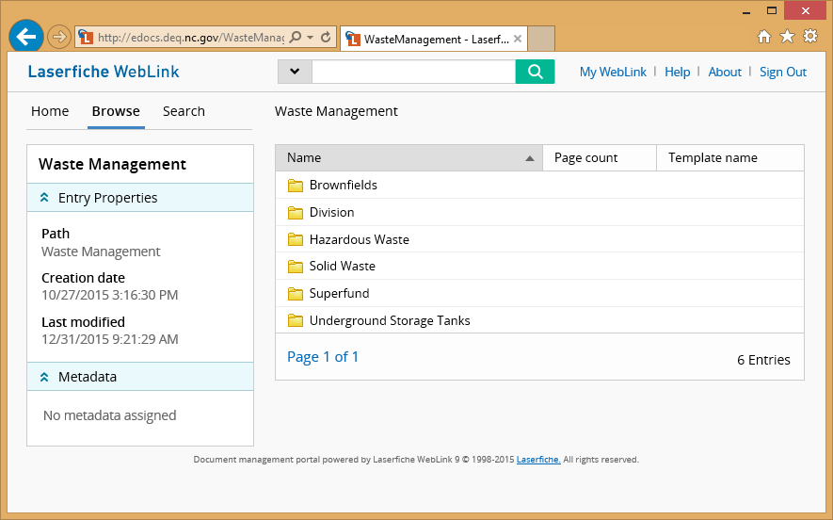

On the left panel at the top, you will see three tabs: “Home”, “Browse”, and “Search”. Each allow different views and methods for searching files. Across the top of the page, there is a general search box. Again, just a different way for searching files.

General Search Box
You can type any term you want in this box and it will conduct a search across all fields (indices)
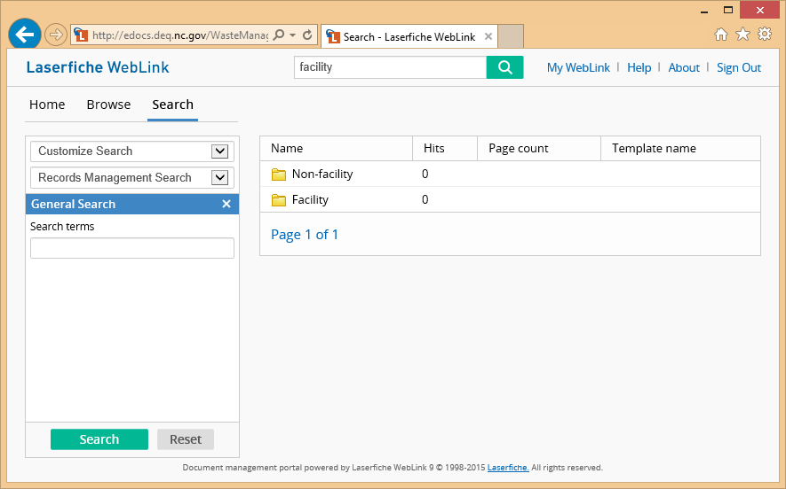

Search Tab
You can select the “Search” tab on the left. It will then give you choices for searching the files. The search most familiar to previous users is under “Customize Search” > “Template”. This will show all the fields associated with our template, “WM”.

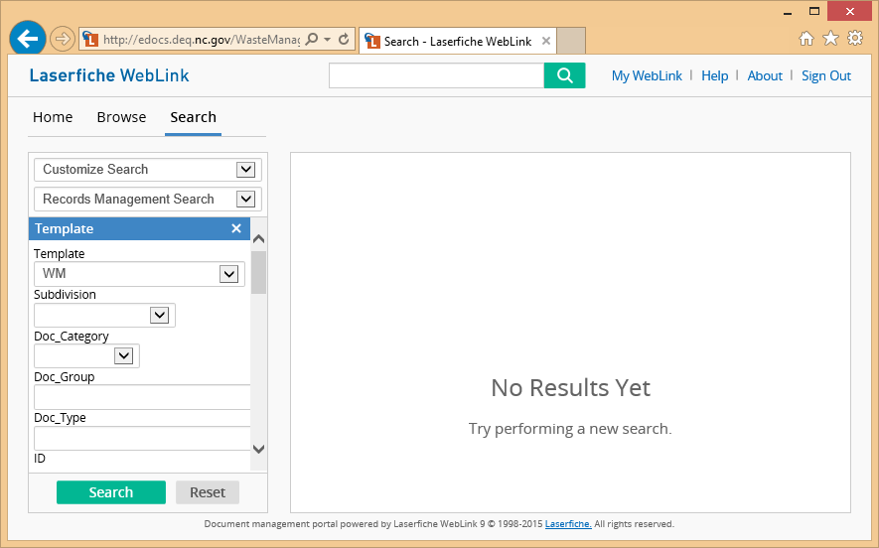

You can now use the drop-downs and text boxes to conduct searches. Things to remember, the search box at the top of the page conducts a fuzzy search. The search fields on the left don’t use fuzzy searches, but you can use “*” as a wildcard.

Browse Tab
The “Browse” tab allows a folder view, where users can click on the folders to open them.

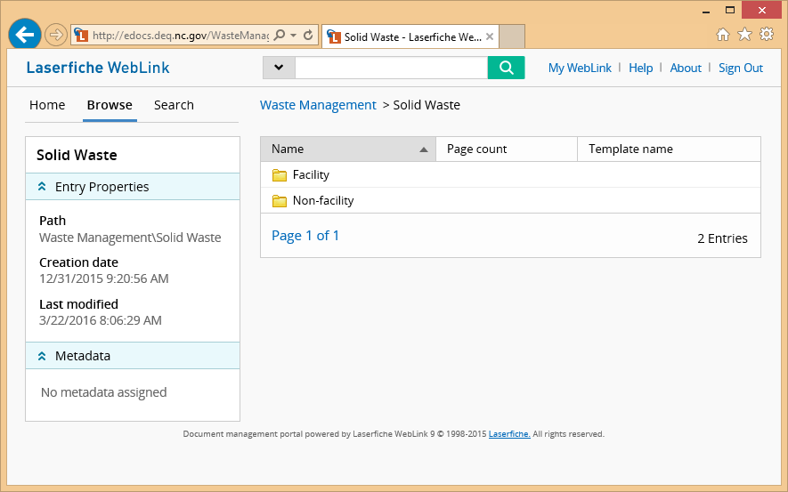

You will notice there are breadcrumbs across the top that allow you to go back or up a level.

Links

Laserfiche User Guide online
https://www.laserfiche.com/support/webhelp/laserfiche/9.2/en-us/userguide/laserfiche_client.htm

IMPORTANT NOTE:

Historical facility files, prior to 2010, have been added to the electronic file system. Some files that were imported have an EPA ID number beginning with AAA rather than the typical NCD or NCR. To allow for a full facility search enter only the last 9 numbers of the EPA ID number under the Property criteria, ID. If you do not know the facility’s EPA Id #, you can search for these files by using the current facility name which will prompt the former name to appear in the Description field under Properties.
Many of the historical documents contain multiple document types within a record. The document types may include but not limited to: General, Permitting, Groundwater, Enforcement, etc. To determine the information contained within a particular record, open the record to review the document types.
In addition the user should be aware, if searching by a date range, that some of the documents that were imported have dates of 1/1/1979 and 1/1/1900. These dates are not correct but you may not get the full set of documents anticipated if you do not account for this. When searching for documents that have multiple dates or undetermined date, use 1/1/00 as the catch-all date.

