**The Albemarle-Pamlico Estuarine System: Birds & Habitats**



**Overview:**

**Grade Level**

3rd-5th

**Objectives**

* To learn about and identify the birds that use the diverse habitats of the Albemarle-Pamlico Estuarine System.
* To learn and describe ways humans can affect the different estuarine habitats.
* To identify how animals survive in a habitat and ways they have to adapt if that habitat is lost.

**N.C. Standard Course of Study**

Grade 4

(LS.4.1.3, LS.4.1.2, ESS.4.3.2)

This activity will teach students about the different habitats found in the Albemarle-Pamlico estuarine system and the birds that live in them. Students will learn about different types of birds, their lifestyle, and how they use their habitat wisely. They will also learn how these habitats are being threatened by humans and climate change and how that has a major impact on the birds that live there.

**Materials:**

* Pencils
* Lined paper
* Scissors
* Glue or tape
* Paper (for habitat drawings)
* Markers or crayons

**Background:**

The **Albemarle-Pamlico estuarine system** is the second largest in the lower 48 states of the United States. With more than 3,000 square miles of open water, this important habitat supports a wide abundance of plants and animals. This estuarine system is composed of a number of sounds, major rivers, and barrier islands. **Sounds** are bodies of water similar to bays and inlets, but larger. This estuary is a very important habitat for many of North Carolina’s fish and shellfish. In fact, 95 percent of the state’s seafood species, such as shrimp, flounder, crabs, and oysters depend on estuarine waters for their survival.

There are a variety of different habitats that make up the **Albemarle-Pamlico estuarine system** and provide food and refuge for the birds that live there. Maritime forests, salt marshes, dunes and beaches, mudflats, and submerged aquatic vegetation areas are some of the different habitats that make up the estuary. Water birds live in all of these habitats and use different habitats for different needs—whether it’s nesting or looking for their next meal. Also, **barrier islands** are an important component of the Albemarle-Pamlico estuarine system and many birds use this land as a stopover location to rest and feed on their migrations south for the winter and north for the summer.

*Maritime forest*

**Maritime forests** grow on **barrier islands** on the eastern edge of the **Albemarle-Pamlico estuarine system**. They are usually protected from the wind and harsh salt spray of the ocean. These forests are dominated by a number of trees including live oaks, wax myrtle, red cedar, red maples, loblolly pines, sweet gums, and many others. Birds of prey, such as hawks or owls, can be found living amongst the canopy of these rare forests. Owls feed on small animals such as mice and snakes. Here you can find raccoons, foxes, otters, snakes, and different kinds of turtles and lizards. Many animals take shelter in the forest during storms. Ospreys and kingfishers may also be found in the forest

*Salt marsh*

**Salt marshes**, although a salty and harsh environment, are one of the earth’s most fertile ecosystems. They are usually found on the calmer, sound side of **barrier islands** and serve as critical nursery habitat for many animals, including a wide variety of fish and bird species. In the **Albemarle-Pamlico estuarine system** there are both brackish and fresh water marshes. **Brackish** means a mix of fresh and salt water. Many herons, egrets, ibises, and shorebirds can be found foraging and living around these marshes. The herons and egrets will actively hunt small fish in the shallow marsh waters and spear them with their sharp beaks. Ibises usually feed in packs and use their curved beaks to find burrowing crabs for food.

*Dunes and beaches*

**Beaches** and **dunes** are open sand spaces found along the east coasts of the **barrier islands** of the **Albemarle-Pamlico estuarine system**. They are shaped by and are constantly changing due to wind and ocean waves. The roots of American Beach Grass, sea oats, beach panic grass, and salt meadow cordgrass help to hold the dunes together. On the beaches however, there is little vegetation, but a lot of animals feed and live in both habitats. Ghost crabs and mammals such as foxes can be found hunting for food. Many shorebirds like gulls, terns, plovers, and sandpipers use the dunes and beach areas to nest and find food. As these areas are constantly changing, shorebirds have to change with their environment and try to find the most protected spots for their nests. Plovers feed at the water’s edge on small crustaceans, worms, snails, and insects. Gulls will eat almost anything including fish, shellfish, small mammals, or garbage, and nest in colonies in grasses. Terns usually dive into the water while they’re flying to catch the fish they eat.

*Mud flats*

Large **mud flats** are exposed in different parts of the **Albemarle-Pamlico estuarine system** when there is a strong northeast wind, which literally pushes the water out of the **sounds** into the ocean. This habitat is made of rich mud and sand and exposes many kinds of invertebrates such as shellfish and tube worms. A variety of shorebirds, such as gulls and terns, can be found on any exposed mud flat, feeding until they’re content. You can also usually find pelicans resting on the mud flats and flying off to dive for fish nearby.

*Submerged Aquatic Vegetation Areas*

Many beds of **submerged aquatic vegetation** (SAV) or underwater vegetation (different kinds of seagrass) are found in the low-salinity waters of the shallow Currituck Sound. This vegetation provides food and protection for a variety of small fish, crabs, aquatic insects, turtles, and other animals. The plants that you find growing underwater here are usually widgeon celery, sago pondweed, wild celery, and Eurasian water milfoil. The variety of grasses are essential feeding grounds for the many wintering waterfowl that live in this estuarine system for four months of the year. A variety of geese, swans, and loons can be found in these waters during the winter, but throughout the year you can find mergansers, buffleheads, grebes, and redhead ducks feeding among these grasses. Loons feed on a variety of small fish species. Redheads are diving ducks that eat the roots, stems, and leaves of the SAV.

*A changing, threatened environment*

The many important habitats of the **Albemarle-Pamlico estuarine system** are home to a lot of different birds; however estuaries all around North Carolina are being threatened daily by humans and climate change. North Carolina has 2.2 million acres of estuaries, but the largest system, the Albemarle-Pamlico, is especially threatened as the land is sinking lower (**subsidence**) and the ocean height is increasing (**sea-level rise**) over time. The shorelines of the Albemarle and Pamlico Sounds are one of the top three most threatened areas from sea-level rise in the United States. Birds are sensitive to environmental change and serve as good indicators of pollution and climate change.

**Subsidence**, **sea-level rise**, **pollution**, **excess nutrients** and **sediment**, **coastal development**, and **marine debris** are just some of the challenges organisms of the estuaries face. **Pollution**, **excess nutrients**, and **sediment** all enter the estuary from the rivers that supply the fresh water. Too many nutrients, which can be caused from fertilizer running off of farms and yards, can harm the waters of the estuary. **Coastal development** is a major issue on the Outer Banks of North Carolina that causes a lot of significant habitat loss for the many birds that use the estuary. As more shoreline is developed with docks, buildings, and roads, more habitats are lost and the birds have fewer places to feed and nest. Additionally, as humans live closer to the birds in the estuary, there is also an increase in trash that enters the water, known as **marine debris**. This is very hazardous to all animals as the trash can resemble food and the birds could eat it and get sick or die. It is very important to be aware of the effect humans have on the different habitats of the estuary, and we should try to have as little impact as possible. Since 1987, the Albemarle-Pamlico estuarine system has been designated as “an estuary of national significance” in the National Estuary Program by the Environmental Protection Agency. This reflects just how important these habitats are to the people and animals that rely on them.

**Activity:**

Before starting the activity, instructors may show a PowerPoint presentation to their students that relays the background information in a simple, useful way. Notes are provided for each slide, but the instructor may add their own information depending on their class and interests. Visit here for a PDF of the presentation: http://bit.ly/oTaODX. Instructors can email Lori Davis at lori.c.davis@ncdenr.gov for a copy of the actual PowerPoint presentation.

Divide the class into small groups (3-4 students) to conduct the two following activities.

***Many Birds!***

Instruct your students to cut out the birds and their food sources or just their food sources. After the students have cut everything out, they can match the birds to their estuarine food source. Groups can compare their different answers with each other. Additionally, have the students draw the five estuarine habitats (maritime forest, salt marsh, beaches and dunes, mud flat, submerged aquatic vegetation) the birds feed or live in, and then place the birds and food on top of the correct picture.

**Snowy & Great Egrets**

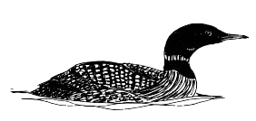

**Common Loon**

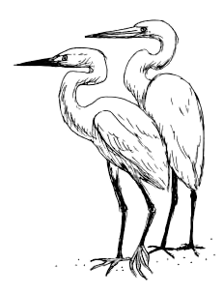

**Little Blue Heron**

**Laughing Gull**

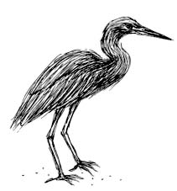

**Osprey**

**Brown Pelican**

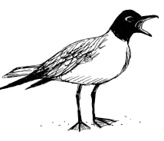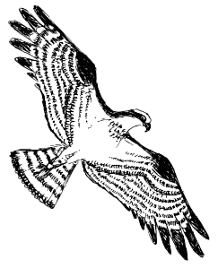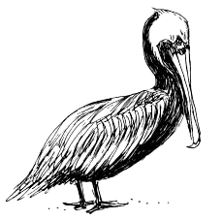

**Redhead**

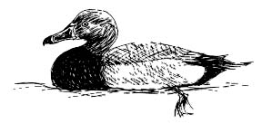

**Redhead**



***Answer Key***

**White Ibis**

**Least Tern**

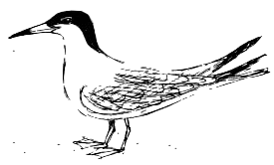

**Great Horned Owl**

**Piping Plover**

**Kingfisher**

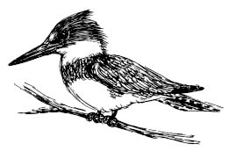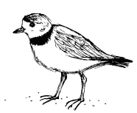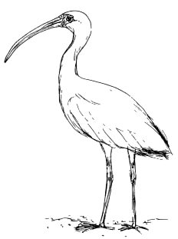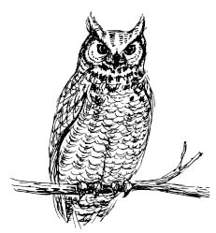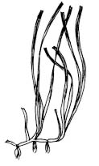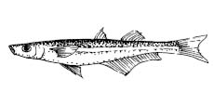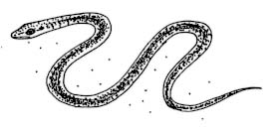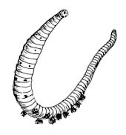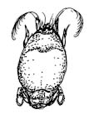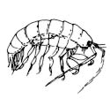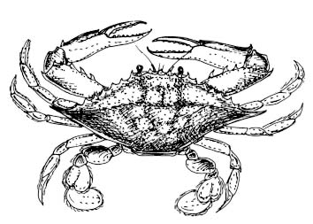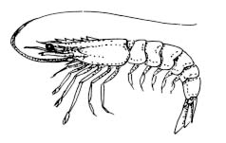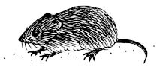

There are a variety of food sources for many of the birds that will work. Here is a list of the birds and the types of food they consume:



**Fish**: Snowy and Great Egrets, Laughing Gull, Little Blue Heron, Common Loon, Osprey, Brown Pelican, Least Tern, Kingfisher



**Shrimp**: Snowy and Great Egrets, Laughing Gull



**Crab**: Snowy and Great Egrets, Laughing Gull, White Ibis



**Snake**: Snowy and Great Egrets, Owl



**Aquatic Vegetation**: Redhead



**Mice**: Great Horned Owl

**Mice**: Great Horned Owl



**Beach Flea**: Piping Plover



**Mole Crab**: Piping Plover

**Lost Habitat**

Human impacts on estuarine habitats can have drastic effects. How do the birds adapt if they lose their home? In the same groups as above, have students consider each of the following scenarios and write down what they think would happen for each. After they have talked about each of the scenarios, have a larger discussion with all groups about how the birds will adapt to their changing environment and ways the students can help conserve these critical habitats.

*-The plovers cannot nest on the beaches because they have been destroyed by the development of large beach homes. Where do they go?*

*-Sea-level rise has caused the ocean water to flood the marsh, making it impossible for some of the ibises, piping plovers, and egrets to feed. Where do they go for food?*

*-There is trash (marine debris) in the sound that has blown in from restaurants and houses on the barrier island. How will this affect different birds that feed and live there?*

*-A large dock and boardwalk was built near a hotel—reducing some critical marsh habitat. What will the herons and egrets do?*

**Discussion Questions:**

1. How does a habitat help an animal survive?
2. How do animals adapt if they lose their home?
3. As humans, how do we affect habitats?
4. How can we help to conserve estuarine habitats?

**Extension:**

Have your students bring in something from home that could become marine debris.

**Vocabulary:**

* Albemarle-Pamlico Estuarine System
* sound
* salt marsh
* barrier island
* maritime forest
* brackish
* beach
* dune
* mud flat
* submerged aquatic vegetation
* subsidence
* sea level rise
* pollution
* excess nutrients & sediment
* coastal development
* marine debris

**References:**

Albemarle-Pamlico National Estuary Program. http://portal.ncdenr.org/web/apnep

The Albemarle-Pamlico Conservation and Communities Collaborative & The Albemarle-Pamlico National Estuary Program. 2009. Public Listening Sessions Report: Sea Level Rise and Population Growth in North Carolina. 68 pgs.

Seachange Consulting. 2010. Weighing Your Options, How To Protect Your Property from Shoreline Erosion: A handbook for estuarine property owners in N.C. 51 pgs.

Stokes, Donald and Lillian. 1996. Stokes Field Guide to Birds: Eastern Region. Little, Brown and Company. 471 pgs.

**National Science Standards:**

*Content Standards Science as Inquiry [1-4]*

*Life Science [1-4 & 5-8]*

*Science in personal and social perspectives [1-4 & 5-8]*

**Ocean Literacy Principles:**

*Essential Principle #5 The ocean supports a great diversity of life and ecosystems.*

*(Fundamental Concepts – d, i)*

*Essential Principle #6 The ocean and humans are inextricably interconnected.*

*(Fundamental Concepts – b, e, f,g)*