**Funky Food Chains**



**Overview:**

This activity will teach students about the energy cycle within an estuary and how it travels from producers to consumers and finally to decomposers via the food chain. Students will design their own estuarine creature and make up an estuarine food chain, as well as play an interactive game with their classmates.

**Grade Level**

3rd-5th

**Objectives**

* To learn about food chains and animals in estuaries.
* To discover the important roles of producers, consumers, and decomposers in estuaries.

**N.C. Standard Course of Study**

Grade 4

(ESS.4.3.1, 4.LS.4.1.2, ESS.4.3.2)

Grade 5

(LS.5.2.1, LS.5.2.3)

**Materials:**

* imagination!!
* construction paper
* large pieces of scrap paper (for food chains)

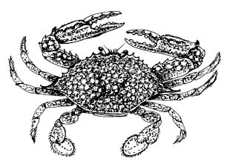

* scissors
* glue
* markers or crayons
* pipe cleaners
* googly eyes
* glitter
* feathers
* stapler
* tape

**Background:**

An **estuary** is a body of water mostly surrounded by land where salt water from the ocean mixes with the fresh water from rivers. North Carolina has 2.2 million acres of estuarine habitat, including the second largest estuarine system in the lower 48 states of the United States, the **Albemarle-Pamlico estuarine system**. Estuarine systems in North Carolina are composed of a number of important habitats including salt marshes, maritime forests, oyster reefs, beaches and dunes, and mud flats. The water found in an estuarine system is **brackish**, meaning a mix of salt and fresh water.

Estuaries are an extremely important place for plants and animals and act as a nursery for many young animals. Ninety-five percent of North Carolina’s seafood species, such as shrimp, oysters, crabs, and flounder, depend on the waters of our estuaries. They spend at least part of their life within estuarine habitats. Adult sea trout and red fish use estuaries as their feeding grounds as they swim along the edge of the salt marsh vegetation. Many kinds of birds, including migrating birds, live and feed among the different habitats of the estuary. There are complex connections between all of the animals and plants that inhabit estuarine systems. In fact, even the detritus, or fragments of dead organisms, play an important role, to feed the smaller animals such as shrimp.

In all estuaries around the world and throughout North Carolina, plants and animals rely on one another for food as they are all part of a complex food chain. A **food chain** is defined as a feeding hierarchy in which organisms in an ecosystem are grouped into trophic (nutritional) levels and are shown in a succession to represent the flow of food energy and the feeding relationships between them. Multiple food chains connect to one another via a **food web**.

Essentially, a food chain is a simple way to see how energy flows throughout the estuary. Every animal or plant is critical to the estuary due to the role they each play in the food chain, including producers, consumers, and decomposers. **Producers**, usually green plants, are at the base of the food chain and they make their own food. Green plants use photosynthesis to convert sunlight into food. **Consumers** eat producers or other smaller consumers lower on the food chain for energy. A **decomposer** is an organism that breaks down the remains of dead animals and plants, or consumers and producers. This provides food for the producers and consumers in the food chain and re-nourishes the environment.

Some of the **producers** of estuaries include salt meadow hay, cordgrass, and glasswort. All of these plants provide important habitat for juvenile fish, crabs, worms, and other animals. The plants’ intricate root system holds the mud and sand of the estuary together to stabilize the shoreline. Also, the plants help to filter the water and trap excess nutrients and harmful chemicals that could enter from the river water upstream.

The **decomposers** of the estuary are bacteria, flies, snails, tube worms, and fiddler and blue crabs. They all help to break down dead plant and animal matter.

The **consumers** of the estuary including shorebirds, fish, diamondback terrapins, snakes, rodents, foxes, raccoons, and dolphins, all eat smaller consumers or producers. When they die, they feed the decomposers as well. All the levels of the food chain depend on one another, so if there is a disturbance in one level it can negatively affect another level.

The following are some examples of estuarine food chains to share with your students:

* Copepods, striped mullet, spotted seatrout, Atlantic bottlenose dolphin

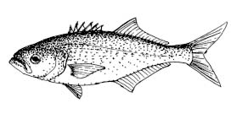

* Phytoplankton, bay scallop, cownose ray, scalloped hammerhead shark
* Amphipod, pinfish, osprey
* Phytoplankton, bay anchovy, Atlantic brief squid, bluefish

**Activity:**

***Create an estuarine creature***

Students should use their imagination to develop an estuarine creature that is a producer, decomposer, or consumer. Students can use any materials provided to make their estuarine creature, incorporating what they know about the different types of plants and animals that live in the many habitats of the estuaries. They must decide what the creature eats, where it lives, and how it uses its habitat to survive.

Questions to ask the students to think about before they get started:

-Is your creature a producer, consumer, or decomposer?

-Where does it live in the estuary?

-Does it have legs, fins, a tail, pinchers, or teeth?

-How many eyes does it have?

-What does it eat to survive in the estuary?

Hand out the following worksheets to your students, and they can work individually or in pairs. Tell your students to fill out the worksheets to help them plan before they build their estuarine creature. They can also draw their creature first before making it.

Once the students have created their new estuarine creature, they should develop a simple food chain that includes their made-up creature. This food chain should have at least three levels in it and they can draw it (with their new creature included) out on a large piece of scrap paper to share with their classmates. Students can work together to use all of their new estuarine creatures in one food chain. After creating their estuarine creature, the students should tell their classmates a couple of facts about the new estuarine creature.

**An example of an estuarine food chain:**

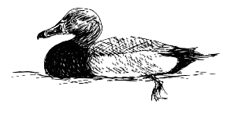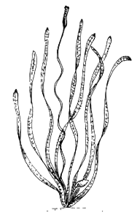

**Redhead Duck**

**(Consumer)**

**Aquatic Vegetation**

**(Producer)**

**Your estuarine creature is named**  .

**It is a (circle one):**

**Decomposer (**an organism that breaks down the remains of dead animals and plants, or consumers and producers)

**Producer (**usually green plants, are at the base of the food chain and they make their own food from sunlight)

**Consumer (**eat producers or other smaller consumers lower on the food chain for energy)



**Optional: Draw the creature you are going to build.**

**Where does your estuarine creature fit into the food chain?**

***The Food Chain Game***

Set-up: Students need to spread out over the designated area (classroom, outside field, etc.), seated in a crawling position.

How to play: Upon the teacher’s starting signal students approach one another via crawling as a piece of detritus, whereupon they conduct a game of rock-paper-scissors. The winner of the game stands up to jump as he or she becomes a grass shrimp. A grass shrimp may only challenge another grass shrimp. The winner gets into crab walking position and now becomes a blue crab. Blue crabs may only challenge other blue crabs. The winner stands, arms stretched out front to resemble jaws and becomes a red drum. Red drums may only challenge other red drums. The winner remains standing, arms stretched out in front, as they are fishing. Fishermen may only challenge other fishermen. The winner remains a fisherman while the loser falls back to the previous step in the food chain. The goal is to remain at the top of the food chain for as long as possible. Therefore, students move up and down the food chain depending on whether they win or lose.

**Discussion Questions:**

1. What is more important in the food chain—a decomposer, a producer, or a consumer?

*They are all equally important—without one of them the food chain would collapse!*

1. What benefits do the plants of the estuary provide all others that live there?

*Their root systems help to trap sediment from runoff and rivers enhancing water clarity. They also help filter out toxic chemicals and excess nutrients that could disrupt the estuarine system as a whole.*

**Extension:**

Have students create their own food chain to play in the food chain game.

**Vocabulary:**

* estuary
* Albemarle-Pamlico Estuarine System
* brackish
* food chain
* food web
* producer
* consumer
* decomposer

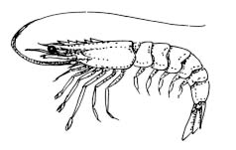

**References:**

http://www.biology-online.org/dictionary/Food_chain

National Estuarine Research Reserve System. 2008. http://www.estuaries.gov/

Seachange Consulting. 2010. Weighing Your Options, How To Protect Your Property from Shoreline Erosion: A handbook for estuarine property owners in N.C.. 51 pgs.

**National Science Standards:**

*Content Standards Science as Inquiry [1-4]*

*Life Science [1-4 & 5-8]*

**Ocean Literacy Principles:**

*Essential Principle #5 The ocean supports a great diversity of life and ecosystems.*

*(Fundamental Concepts – d, i)*