Nutrient Science Advisory Board Meeting, July 1, 2022
9:30 a.m. – 12:00 p.m., Virtual Teams Meeting

Attendees:

Members / Advisors
Mike Burchell
Charles Brown
Allison Weakley
Drew Blake
Andy McDaniel
Sandi Wilbur, JV Loperfido
Forrest Westall, Alix Matos
Haywood Pthisic
Sally Hoyt
Bill Hunt
Sarah Waickowski

TJCOG Staff
Maya Cough-Schulze

DEQ Staff
Trish D’Arconte, DWR NPS Planning
Jim Farkas, DEMLR Stormwater
Rich Gannon, DWR NPS Planning
John Huisman, DWR NPS Planning
Joey Hester, DWR NPS Planning

Guests
Ann Coan
Ashley Rodgers, Wake County
Barney Blackburn, Wake County
Jennifer Buzun, Durham
Allie Dinwiddie, DSWC
Ian Shannon, Alamance County
Michael Irwin, Durham
Jacob Dorman, Contech Engineering
Keith Larick, NC Farm Bureau
McKenzie Myers, Durham County
Nancy Daly, Wake County
Lauren Neaves, Durham County
Robert Patterson, Town of Apex
Jamie Smedsmo, UNC CH
Teresa Andrews, AWCK
Brajesh Tiwari, Durham
Megan Walsh, Durham
Kelly Williams, NC DMS

AGENDA: Standardizing Methods for SCM Nutrient and TSS Crediting – Trish D’Arconte
Presentation is available online at www.deq.nc.gov/nps

Meeting Summary

How DEQ currently handles proposals for new SCMs/data
- Apply to DEMLR NEST program for provisional installation of new SCM while monitoring performance, at two different sites
- Entities monitoring must put together a QAPP, work with a researcher and an outside lab, and submit completed studies with proposed Minimum Design Criteria
- SCMs must meet minimum performance for primary/secondary SCMs; approval = formal design requirements and performance rating
- No current process to formalize updating existing SCM nutrient performance/design requirements; this would be helpful but is not allowed within stormwater rules.

Issues with Current Approach
- NEST instructions only so detailed, gaps in nutrients approach, separate from SCM Credit Document
- NEST is for new practices, no documentation of approach used for existing practices
- Mixture of approaches used to assign nutrient values to existing practices
Proposed Changes to SCM Data Standards and Evaluation for SCMs
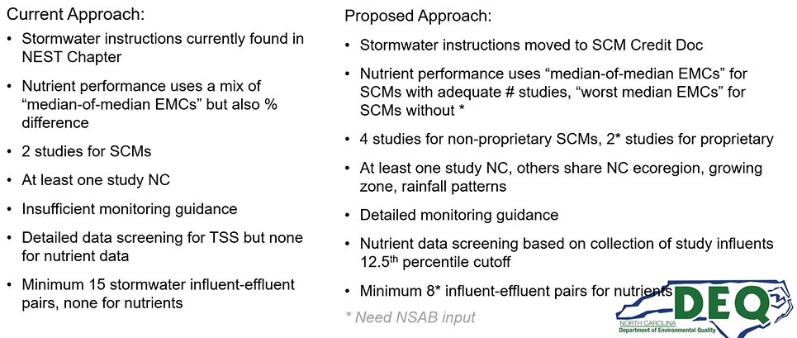
TSS: Use influent TSS data from NC and published studies from outside NC to establish acceptable minimum influent concentration

Discussion
Sally Hoyt has concerns about difference in number of studies for proprietary and non-proprietary studies
Trish D’Arconte would like to see four studies for all types. However, recent studies by Bill Hunt and others have uncovered that some published, approved SCM types only had two studies done and there is no way to update that in the rules right now. So they are hoping to give tentative approval with two studies and in future try to require four studies.
Andy McDaniel asked what DEMLR’s opinion was of moving the NEST chapter to the SCM Credit Document?
Trish clarified they have been worked closely with DEMLR on this and they are all in agreement.
Andy also asked how they define a study – collecting data at a discrete physical location?
Trish: Current approach: One study could look at four unique installations
Andy: How do you define studies being in NC Ecoregion?
Trish: Omernik Level 3 Ecoregion – Mountains, Piedmont, Inner and Outer Coastal Plain. If you are in one of these shared with NC, and have a similar growing zone and rainfall patterns, studies are eligible. Or at least similar growing zone and rainfall patterns as some part of NC – ie, coastal NJ.
Andy: Would be good to clarify growing zone means USDA hardiness zone and clarify what rainfall pattern means
Trish: Average annual rainfall comparable to NC
Jacob Dorman: Can appreciate wanting more studies but want to be careful of discouraging innovation. Proprietary SCMs are used in highly urban areas. Four studies could take 8-10 years. Could it be possible to address concerns about quality of data without requiring more studies?
Trish: We will want to maintain two sites minimum for provisional EMC and SCM design requirements. We wanted to be able to have the flexibility to require changes to the design requirements if future studies found issues. Data quality may not help us with this – it’s about site and design specifics.
Jacob: That’s a fair way to go – the other consideration is, will this be a full reset where we look at every practice? Studies in progress are using existing values. And TSS vs nutrients – 2 or 4?
Trish asks Jim Farkas – nothing conclusive yet
Jacob: Practices currently credited that need additional studies will need time to test/monitor – maybe should have some kind of grandfathering to give them time
Trish: Any practices installed maintains its credit. Anything in progress keeps its calculation process.
Sally Hoyt: Because of the lead time to do a research study – for those in the process of studies, what rules will apply?
Trish: Anyone in the NEST process should have talked to us on the front end (to get QAPP approved, etc)
Sally: Does not see the need for there to be one study in NC. If studies meet ecoregions and other similar qualities as NC, (ie, perhaps in VA), those should be able to be the studies. This would allow us to rely on the network of engineers working in similar conditions.
Trish: We will look into the possibility with DEMLR- this requirement originated with their original NEST program
Brajesh Tiwari: Could we require “one in NC or equivalent region” and define “equivalent region”?
Andy McDaniel: There are hundreds of stormwater research projects across the country – may be good to stipulate that the purpose is evaluating SCM performance across NC conditions, and about the experimental design, that the research studies evaluate annual load reductions
Trish: We will look into that and clarify if needed.

Unresolved issues
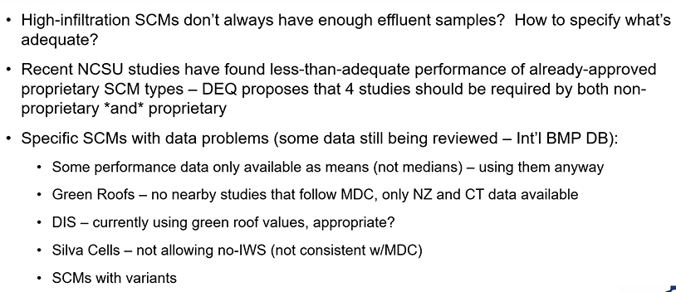
Trish and Sarah Waickowski have put all studies in a database and Trish is working to replicate NCSU calculations so that DEQ can keep SCM calculations “living” and update.
Some studies do not have raw data available; hence using means not medias above.
Considering making DIS EMCs same as managed pervious
How to evaluate SCMs with variants?
Proposed SCM EMCs and status of in-progress evaluations
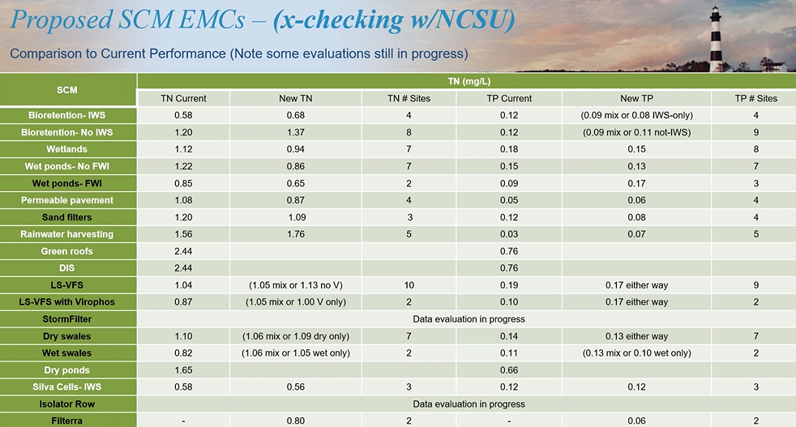
Ongoing questions about number of studies to require
Trish: Virophos has not seemed to improve performance of LS-FS
[Missed 5ish min here while Teams glitched repeatedly]
Jennifer Buzun: Are there standards for wet swales?
Trish: No design standards yet for wet swales
Rich: Performance doesn’t seem to differ from dry swales
Jennifer: We have had applications to install wet swales but are reluctant to approve without standards
Trish: Also, bioswale design standards in the works but won’t be ready for this iteration
Andy McDaniel: Do we have metadata or reports on how values in the table above were derived?
Trish: These will be included in SCM Credit Document
Sandi Wilbur: Did we have a criteria for changing EMCs?
Trish: Not currently.
Sandi: For SCMs with changed EMCs, should a statistical significance test be applied?
Trish: For SCMs with large volume reduction component, change in EMC may be less significant.
Sandi: Good to encourage and include studies on variants, even if they do not perform significantly different, because these variants may be useful later in different situations/locations/for different contaminants

Next Steps, Timeline
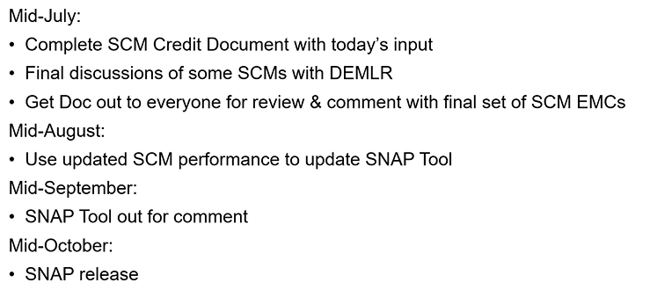

Updates
Bill Hunt: We hope to be starting to develop wet swale design guidance later this summer, finish this year. We submitted a NCLWF grant to finish DOT study on bioswales and the goal will be to develop EMCs for them; this won’t be ready for a couple years.
Trish: We are working on RSCs but that won’t come out with this. Sarah mentioned additional FWI studies upcoming, and we could hold publication of FWI EMCs from this document to wait for those studies, so that we could refine installation guidance and issue new EMCs. Do you think we should keep variants merged to ‘parent’ SCMs, if they don’t have statistically different results, until they have enough data to stand on their own?
Bill: It depends on how the studies are done. If done side by side, like LS-FS, the same water came in and was divided between two variants. I would suggest looking at the difference in performance between these two, then compare with the across the board LS-FS number, then apply the more conservative assessment.
Trish: I’ll need to work with Sarah to get which studies were side by side and get those values.
Bill: Sandi – we are looking at coming up with MDCs and EMCs for RSCs, hopefully by end of year.
Trish: Bioretention with and without IWS – previously calculated phosphorus across both, but seeing a difference between them in phosphorus performance, so think we need to separate them as different SCMs.
Bill: Ones with IWS may be lower in P because of when they were constructed – soil media has bee more refined as time went on. So my suggestion would be to keep them the same.
Jennifer Buzun: When will the new sand filter EMCs become official in the SNAP tool?
Trish: When we release the new SNAP tool.
Andy: Bill, when will you develop MDCs for RSCs?
Bill: Hope to be done by December.
Andy: DOT is actively working on design guidance as well – we should coordinate.
Bill will have his people coordinate!
Forrest: Things will change when we get new data – cost, long-term performance data – and consider lifetime of practices
Sally: With staffing changes at DEMLR, who is working on Manual updates and design guidance? (A; Jim Farkas)
Sally is interested in helping with RSC design criteria.

