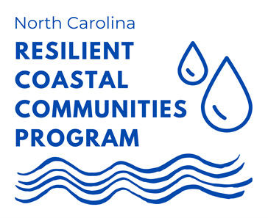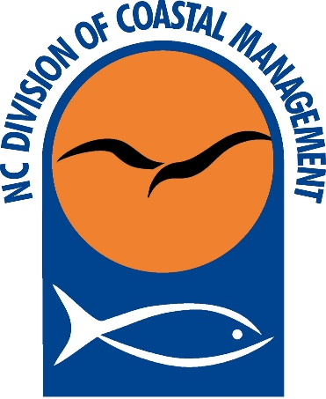
North Carolina Resilient Coastal Communities Program
Phases 1 & 2 Grant Application: Service Providers
2022-2023
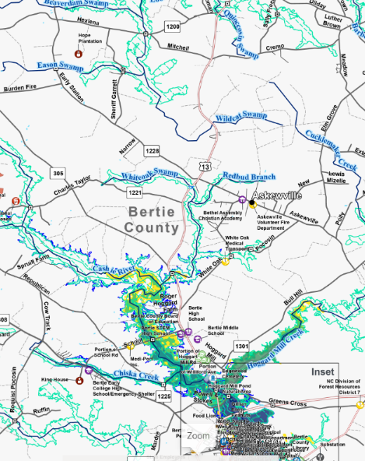
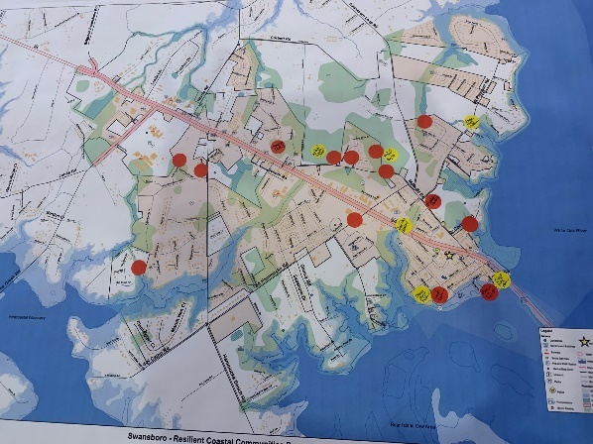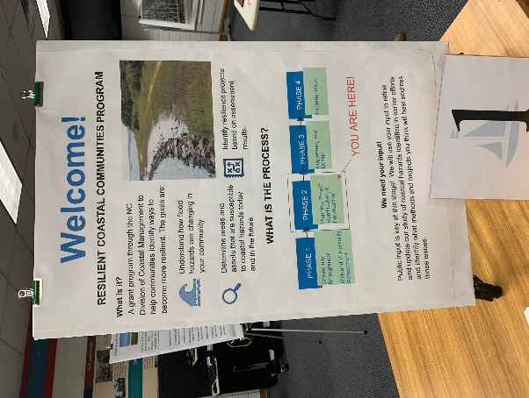

The Resilient Coastal Communities Program (RCCP) is a component of the North Carolina Resilient Communities Program, called for in the 2020 North Carolina Climate Risk Assessment and Resilience Plan. The North Carolina Division of Coastal Management (DCM) has received funding from the NC State Legislature and the National Fish and Wildlife Foundation (NFWF) to implement the RCCP in coordination with the NC Office of Recovery and Resiliency (NCORR), The Nature Conservancy (TNC), and NC Sea Grant (NCSG).

REQUEST FOR APPLICATIONS (RFA)
Phases 1 & 2 - Community Engagement, Risk and Vulnerability Assessment, Planning, Project Identification and Prioritization
Released: december 7, 2022
All applications due: feburary 3, 2023

The North Carolina Division of Coastal Management (DCM) is pleased to announce the availability of grants for Phases 1 and 2 of the RCCP. The objectives of these phases include performing data- and community-driven risk and vulnerability assessments, and developing portfolios of locally-identified and prioritized projects and actions to address risks.

The RCCP is a state-local partnership designed to help overcome barriers in coastal resilience and adaptation planning, boost local government capacity, and support a proactive, sustainable, and equitable approach to coastal resilience planning and project implementation.
The RCCP is a four-phase program that seeks to:
  - Address barriers to coastal resilience in North Carolina at the local level, such as limited capacity, economic constraints, and social inequities;
  - Assist communities with risk and vulnerability assessments and developing a portfolio of planned and prioritized projects;
  - Advance coastal resilience projects to “shovel-ready” status; and
  - Link communities to funding streams for project implementation.
The four phases are:
Phase 1: Community Engagement and Risk/Vulnerability Assessment
Phase 2: Planning, Project Identification, and Prioritization
*Phase 3: Engineering and Design
*Phase 4: Project Implementation
* To be eligible for Phases 3 & 4 funding a community must complete Phases 1 and 2 or an equivalent level of planning and community engagement.

NOTICE OF AVAILABLE FUNDS AND REQUIREMENTS (2022)

Overview: DCM is seeking applications from qualified providers to serve as subgrantees to provide direct technical assistance services to localities participating in Phases 1 and 2 of the RCCP. Selected subgrantees will lead the effort in completing Phases 1 and 2 of the RCCP following the Planning Handbook, which outlines the steps of the process, specific requirements, and products for Phases 1 and 2. Phases 1 and 2 walk communities through a series of steps to assess risks and vulnerabilities specific to their location, engage representative stakeholders, and complete a community-involved process to prioritize projects and action items to improve the resiliency of their community and critical assets. Subgrantee selections will be made based upon the criteria identified in this document.
Eligible Applicants: Eligible applicants include private planning and engineering firms, Councils of Government, Non-Governmental Organizations (NGOs), and academic institutions (private and public). Multiple organizations may partner on one application. Applicants may indicate a preference to work with specific communities and should submit letters of support from those communities as applicable. Applicants must indicate the maximum number of communities that they will consider working with concurrently.
Available Funding: DCM has approximately $1 million available for this round of Phases 1 and 2. DCM anticipates supporting up to 20 communities, and will allocate funding according to demand, need, and geographic scope. The anticipated range for grant awards is $50,000 - $70,000 per community.
Anticipated Contract Period: April 2023 – January 2024
Match Requirements: There is no cash or in-kind match requirement from community applicants or service providers.
Program Criteria and Prioritization: DCM will review applications and select applicants for consideration based on qualifications, prior experience, and capacity. In addition to evaluating applications in accordance with the above priorities, DCM shall consider the following factors:
- Experience with the following:
  - Resilience planning and working group facilitation at the local government level
  - Project identification, alternatives analysis, and prioritization
  - Conducting formal risk and vulnerability assessments
  - Outreach and community engagement, especially with socially vulnerable and underrepresented populations
  - Identifying and mapping critical assets using ArcGIS, including natural infrastructure and socially vulnerable populations
  - Experience with nature-based solutions to address coastal challenges
  - Analyzing coastal hazards and future conditions, such as sea-level rise
- Internal capacity, specifically level of staffing available to participate and organization’s ability to assist multiple communities, if requested
- Ability to ensure cost-effectiveness
Contracting: DCM will contract directly with successful applicants to provide technical assistance to one or more communities, as assigned by DCM in consultation with the applicant and communities.
Deliverables: The main deliverable will include a Resilience Strategy based on guidance provided in the RCCP Handbook. The two components of a Resilience Strategy include:
- Risk and Vulnerability Assessment Report- A key outcome of this process is a quantitative risk and vulnerability assessment, which will evaluate the vulnerability of the community’s population with special attention to socially vulnerable, and critical community assets to several coastal and climate risks, including tidal flooring, sea level rise, storm surge, and high-intensity rain events. Special attention will be given to socially vulnerable and underrepresented segments of the population, and natural infrastructure that provides both environmental and community resilience benefits.

- Project Portfolio- Participants will develop a project portfolio of options aimed at reducing exposure and sensitivity or increasing adaptive capacity to flooding and other hazards. A combination of policy, nonstructural, hybrid, and structural approaches should be considered.
Ownership and Credit Due: Products generated by this effort will be owned by the N.C. Division of Coastal Management and the respective community and made publicly available.
Application Checklist
Application cover sheet
Question responses
Supplemental documentation, if applicable, not to exceed 20 pages

Submission: Submit the application to rccp@ncdenr.gov by 5:00 pm, Friday, February 3, 2023.
Direct questions regarding the application to Mackenzie Todd, DCM Coastal Resilience Specialist: Mackenzie.todd@ncdenr.gov
To see final deliverables from the first round of Phases 1 and 2 click here.
DCM is hosting an informational webinar on the Phase 1 and 2 application process on January 12, 2023, from 2-4 p.m. You can register for it here.

North Carolina Resilient Coastal Communities Program
Phase 1 & 2 Service Provider Application 2022-2023
Provide answers to the following questions.

- Describe your organization’s experience in resilience planning and identify which of the following, if any, your team has developed: Local Resilience Plans, Regional Hazard Mitigation Plans, CAMA Land Use Plans, Watershed Restoration / Management Plans, Stormwater Plans, Resilience Plans, and Floodplain Management Plans. Web links to examples may be provided.

- Describe your organization’s experience with identifying and mapping critical assets (i.e., roads, hospitals, schools) natural infrastructure (i.e., rivers, wetlands, streams) and socially vulnerable populations (People who are considered socially vulnerable to climate impacts can include communities of color, children and seniors, low-income communities, people with disabilities, pregnant people, people with Limited English Proficiency (LEP), other historically disadvantaged people, people impacted by the social determinants of health, and populations identified by the American Public Health Association)

- Describe your organization's experience in community outreach and engagement. What engagement techniques have you used to reach socially vulnerable and underrepresented populations? Provide examples of the successful application of these engagement techniques.

- What is your experience in identifying and utilizing nature-based solutions to address coastal resilience challenges?

- What is your organization’s experience in assessing the future impacts of coastal hazards? For example, the impacts of sea level rise to a community.

- What techniques have you used to communicate climate hazard data to the general public, including socially vulnerable communities? Please provide examples.

- Describe your experience facilitating stakeholder groups at the local level, particularly for the purpose of helping communities to identify solutions to reduce their exposure to coastal hazards. Please provide examples.

- What methods do you use to analyze alternatives and prioritize solutions? Please provide examples.

- Applicants may be asked to assist more than one community. If selected, what is the maximum number of communities you could assist? Do you have any experience assisting multiple communities at once?

- How does your team prioritize and ensure cost-effectiveness? Please provide examples.

