North Carolina
Stormwater Control Measure
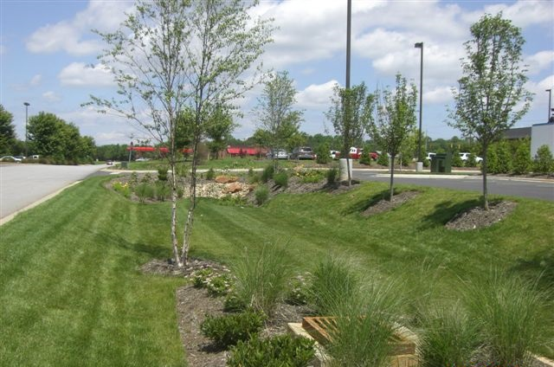
Credit Document
Table of Contents
Acknowledgements A-1
Part A: Introductory Information A-2
A.1. Purpose of this Document A-2
A.2. SCM Credit Table A-4
A.3. Other SCM Benefits A-7
A.4. Glossary A-9
Part B: Technical Foundation for Credits B-1
B.1. Performance Standards for Primary vs. Secondary SCMs B-2
B.2. Annual Runoff Treated Based on Percent Sizing B-5
B.3. Fates of Treated Runoff B-7
B.4. EMC Methodology B-9
Part C: Approval Process for New Stormwater Technologies (NEST) C-1
C.1. About the NEST Program C-1
C.2. NEST Program Requirements and Steps C-2
C.3. NEST Program Application C-3
C.4. NEST Monitoring Requirements C-8
C.5. NEST Final Report and Data Submittal C-9
C.6. NEST Review and Approval Process C-10
Part D: Credit for Each SCM D-13
D.1. Infiltration System D-13
D.2. Bioretention Cell D-15
D.3. Wet Pond and Floating Wetland Islands D-17
D.4. Stormwater Wetland D-20
D.5. Permeable Pavement D-22
D.6. Sand Filters D-26
D.7. Rainwater Harvesting D-28
D.8. Green Roof D-30
D.9. Disconnected Impervious Surface D-32
D.10. Level Spreader – Filter Strips D-35
D.11. Pollutant Removal Swale D-38
D.12. Dry Pond D-40
Part E: Credit for Each New Stormwater Technology E-1
E.1. StormFilter E-1
E.2. Silva Cell Suspended Pavement with Bioretention E-3
E.3. Filterra® E-5
E.4. BayFilter E-7
Part F: Overview of NCSU Modeling and Accounting Tools F-8
F.1. Bioretention Hydrologic Performance Tool (HyPerTool) F-8
F.2. Rainwater Harvester Model F-10
F.3. Permeable Pavement Hydrologic Performance Model (PermPave HyPerMod) F-10
F.4. SNAP Tool F-11
Part G: Technical Justifications and References G-1
G.1. Credits for Under and Oversizing SCMs G-1
G.2. Temperature and Bacteria G-2
G.3. Bioretention G-4
G.4. Permeable Pavement G-7
G.5. Wet Pond and Floating Wetland Islands G-9
G.6. Stormwater Wetlands G-11
G.7. Sand Filters G-14
G.8. Rainwater Harvesting G-15
G.9. Green Roofs G-17
G.10. Disconnected Impervious Surface G-19
G.11. Level Spreader-Filter Strips G-21
G.12. Pollutant Removal Swales G-24
G.13. Dry Ponds G-26
G.14. StormFilter G-28
G.15. Silva Cell Suspended Pavement with Bioretention G-29
G.16. Filterra G-31
G.17. BayFilter G-32

Acknowledgements
DEQ would like to thank the numerous people and organizations that directly contributed to this document, especially the following:
- Sarah Waickowski, NCSU Department of Biological and Agricultural Engineering, compiled and analyzed, and summarized the research data that forms the backbone of this document. She also adapted, ran, and summarized the results of the hydraulic models that were the basis for the under and oversizing credits.
- Dr. Bill Hunt, PE, NCSU Department of Biological and Agricultural Engineering, served as the lead advisor on data interpretation and decision-making.
- The Upper Neuse River Basin Association (UNRBA), with support from with their consultant, Cardno, assisted us in establishing nutrient credits for various sizes of SCMs, design variants for bioretention cells and design variants for level spreader-filter strips. In addition, the UNRBA was a valuable advisor in developing nutrient credits for all the other SCMS and a lead editor of this document.
- The SCM Crediting Team stakeholders patiently and wisely advised DEQ and NCSU throughout the process of developing SCM credits. This team included the following people: Ben Brown, Jennifer Buzun, Ryan Eaves, Sally Hoyt, Steve Jadlocki, Josh Johnson, Mark Hortsman, Lisa Kirby, Brian Lipscomb, Alix Matos, Peter Raab, Scott Whalen and Sandra Wilbur.

Introductory Information

Purpose of this Document
The purpose of the North Carolina Stormwater Control Measure (SCM) Credit Document is to present in one location all information related to how TSS removal, nutrient reduction and hydrologic performance is determined, credited and updated by NC DEQ in its various stormwater and nutrient management programs. It is intended to improve the clarity, consistency and reliability of the nutrient and total suspended solids (TSS) reduction values (aka “credits”) awarded for Stormwater Control Measures (SCMs) installed throughout North Carolina. Finally, it provides guidance for parties who wish to submit SCM performance data for evaluation of new proposed stormwater technologies or for refinement of existing, approved technologies. In the past, credits for SCMs have been listed in each individual chapter of the Stormwater Design Manual. The various SCM credits will now be listed together in this document for ease of reference, to facilitate updates as new research becomes available, and also to facilitate comparisons between different SCMs.
There are a variety of stormwater programs throughout the state, each with its own goals. The NPDES, Coastal Counties, Outstanding Resource Waters (ORW), High Quality Waters (HWQ) and Water Supply Watershed programs are based upon removing a certain level of Total Suspended Solids (TSS). TSS is the number one pollutant in the state and also acts as a surrogate for removal of other pollutants, such as phosphorus and heavy metals. In contrast, Nutrient Management Strategies (NMS) for the Neuse estuary, Tar-Pamlico estuary, Falls Lake, and Jordan Lake watersheds include stormwater programs designed to achieve targeted nutrient (total nitrogen and total phosphorus) loads from an entire site for new development and nutrient reductions from some existing development. All of the stormwater programs encourage runoff volume match from predevelopment to post-development conditions (sometimes called “Low Impact Development” or LID) as a voluntary alternative to the above goals.
To better delineate the technical foundations of the various stormwater programs, DEQ has assembled in this document a crediting matrix that answers each of the following questions for each SCM:
- Are basic TSS goals met? This dictates whether it receives a “primary” or “secondary” designation for state stormwater purposes.
- What are the relative proportions of the three annualized hydrologic “fates” of the stormwater after it enters the SCM (overflow, effluent, and evapotranspiration/infiltration)? This is necessary for estimating nutrient loading and runoff volume match.
- What is the average event mean concentration of all nitrogen compounds (TN) and all phosphorus compounds (TP) in the effluent from the SCM? This is also necessary for estimating nutrient loading.
It should be noted that, for the typical development subject to a state stormwater program (other than Nutrient Management Strategies), this document will not change how development is regulated. Most designers will choose to implement one “Primary SCM” (what was formerly referred to as an “85% TSS removal SCM”) for each drainage area that is fully sized for the design storm.
This document provides the technical foundations for designers who wish to do the following:
- Calculate hydrologic and nutrient reduction changes for SCMs that are oversized or undersized relative to the Water Quality Volume,
- Meet nutrient goals (equations and EMCs listed in this publication are used in the NC Stormwater Nitrogen and Phosphorus Tool v4 (SNAP v4) available at this URL: https://deq.nc.gov/about/divisions/water-resources/planning/nonpoint-source-management/nutrient-offset-information#stormwater ),
- Meet runoff volume match goals, and
- Understand the basis for DEQ’s SCM Credits.
In addition, as of the 2022 revision, this document also provides guidance to parties seeking to submit research data for use in either updating approved SCM credit specifications or seeking to gain approval for novel SCMs not yet approved for use by the Department, whether proprietary or public domain practices.

A note regarding the word “credit”: in this document, “credit” refers to the quantification of the hydrologic, nutrient reduction, or other pollutant management performance of an SCM. It is not to be construed as the same as a “Nutrient Offset Credit” as described in the Nutrient Offset Credit Trading Rule (15A NCAC 02B .0703 and related rules). However, the methods described in this document can be used in the determination of nutrient reduction for a given project as specified in those rules.
Methods of nutrient reduction for practices other than SCMs for meeting various nutrient management rules are available and are described in the companion document “Catalog of Nutrient Practices” (approved 4/15/2021).
Detailed design guidance for each type of SCM, as well as designing for runoff volume match and guidance for specific kinds of sites and development situations, can be found in NC DEMLR’s Stormwater Design Manual, found online here: https://deq.nc.gov/about/divisions/energy-mineral-and-land-resources/stormwater/stormwater-program/stormwater-design

SCM Credit Table
SCM | Role |  | % of Annual Runoff |  |  | EMC_{effluent} (mg/L)
 |  | HSG | Untreated Overflow | ET&I | Treated Effluent | TN | TP
Bioretention per MDC | Primary | A | 6 | 85 | 9 | 0.68 | 0.08
 |  | B | 6 | 67 | 27
 |  | C | 6 | 34 | 60
 |  | D | 6 | 13 | 81
Bioretention per MDC but without IWS (retrofits and special cases only) | Primary | A | 6 | 48 | 46 | 1.33 | 0.11
 |  | B | 6 | 19 | 75
 |  | C | 6 | 10 | 84
 |  | D | 6 | 8 | 86
Bioretention with design variants per Hyper Tool | Primary |  | Tool Output |  |  | 0.68 / 1.33 | 0.11
Infiltration per MDC | Primary | A | 16 | 84 | 0 | 0 * | 0 *
 |  | B | 16 | 84 | 0
 |  | C | 16 | 84 | 0
 |  | D | 16 | 84 | 0
Permeable pavement (infiltration) per MDC | Primary | A | 16 | 84 | 0 | 0 ** | 0 **
 |  | B | 16 | 84 | 0
 |  | C | 16 | 84 | 0
 |  | D | NA | NA | NA
Permeable pavement (detention, unlined) per MDC | Primary | A | 16 | 8 | 76 | 0.87 | 0.06
 |  | B | 16 | 4 | 80
 |  | C | 16 | 0 | 84
 |  | D | 16 | 0 | 84
Permeable pavement (detention, lined) per MDC | Primary | A | 16 | 0 | 84 | 0.87 | 0.06
 |  | B | 16 | 0 | 84
 |  | C | 16 | 0 | 84
 |  | D | 16 | 0 | 84
Permeable pavement with design variants per the Hyper Tool | Primary |  | Tool Output |  |  | 0.87 | 0.06
Wet Pond per MDC | Primary | A | 16 | 21 | 63 | 0.86 | 0.13
 |  | B | 16 | 16 | 68
 |  | C | 16 | 12 | 72
 |  | D | 16 | 8 | 76
 |  |  | 16 | 21 | 75
 |  |  | 16 | 16 | 68
 |  |  | 16 | 12 | 72
 |  |  | 16 | 8 | 76
Stormwater wetland per MDC | Primary | A | 16 | 34 | 51 | 0.94 | 0.15
 |  | B | 16 | 29 | 55
 |  | C | 16 | 25 | 59
 |  | D | 16 | 21 | 63

SCM | Role |  | % of Annual Runoff |  |  |  |  | EMC_{effluent} (mg/L)
 |  | HSG | Untreated Over-flow | ET&I |  | Treated Effluent |  | TN |  | TP
Sand Filter (open) per MDC | Primary | A | 10 | 9 |  | 81 |  | 1.09 |  | 0.08
 |  | B | 10 | 5 |  | 85
 |  | C | 10 | 0 |  | 90
 |  | D | 10 | 0 |  | 90
Sand Filter (closed) per MDC | Primary | A | 10 | 0 |  | 90 |  | 1.09 |  | 0.08
 |  | B | 10 | 0 |  | 90
 |  | C | 10 | 0 |  | 90
 |  | D | 10 | 0 |  | 90
Rainwater Harvesting per MDC | Primary | A | 15 max | Custom based on Tool output |  |  |  | 1.73 | 0.08
 |  | B | 15 max
 |  | C | 15 max
 |  | D | 15 max
Green Roof per MDC | Secondary | N/A | 0 | 60 |  | 40 |  | 2.44 |  | 0.76
DIS per MDC | Secondary | A | 10 | 58 |  | 32 |  | 2.44 |  | 0.76
 |  | B | 10 | 45 |  | 45
 |  | C | 10 | 36 |  | 54
 |  | D | 10 | 27 |  | 63
LS-FS per MDC | Secondary | A | 10 | 54 |  | 36 |  | 1.03 |  | 0.17
 |  | B | 10 | 36 |  | 54
 |  | C | 10 | 22 |  | 68
 |  | D | 10 | 13 |  | 77
LS-FS with Virophos sand added to the filter strip | Secondary | A | 10 | 54 |  | 36 |  | 1.03 |  | 0.17
 |  | B | 10 | 36 |  | 54
 |  | C | 10 | 22 |  | 68
 |  | D | 10 | 13 |  | 77
Treatment swale with dry conditions | Secondary | A | 10 | 22 |  | 68 |  | 1.07 |  | 0.13
 |  | B | 10 | 13 |  | 77
 |  | C | 10 | 4 |  | 86
 |  | D | 10 | 0 |  | 90
Treatment swale with wet conditions | Secondary | A | 10 | 36 |  | 54 |  | 1.05 |  | 0.11
 |  | B | 10 | 27 |  | 63
 |  | C | 10 | 18 |  | 72
 |  | D | 10 | 9 |  | 81
Dry Pond per MDC | Secondary | A | 16 | 8 |  | 76 |  | 1.33 |  | 0.22
 |  | B | 16 | 4 |  | 80
 |  | C | 16 | 0 |  | 84
 |  | D | 16 | 0 |  | 84
StormFilter per MDC with PhosphoSorb mediaTM | Primary | A | 10 | 0 |  | 90 |  | TBD (awaiting data) |  | TBD (awaiting data)
 |  | B | 10 | 0 |  | 90
 |  | C | 10 | 0 |  | 90
 |  | D | 10 | 0 |  | 90
Silva Cell per MDC | Primary | A | 6 | 85 | 9 |  | 1.23 |  |  | 0.23
 |  | B | 6 | 67 | 27
 |  | C | 6 | 34 | 60
 |  | D | 6 | 13 | 81
Filterra | Primary | A | 10 | 0 | 90 |  | 0.95 |  |  | 0.08
 |  | B | 10 | 0 | 90
 |  | C | 10 | 0 | 90
 |  | D | 10 | 0 | 90
BayFilter | Primary | A | 10 | 0 | 90 |  | TBD*** |  |  | TBD***
 |  | B | 10 | 0 | 90
 |  | C | 10 | 0 | 90
 |  | D | 10 | 0 | 90
* EMCs of 0.001mg/L TN and TP are used in the SNAP v4 tool for infiltration to avoid divide-by-zero errors.
** EMCs of 1.08mg/L TN and 0.05 mg/L TP are used in the SNAP v4 tool for infiltrating permeable pavement in cases where the user selects HSG D.

*** The current data is not sufficient to assess these SCMs for nutrient EMCs.

Other SCM Benefits
SCM Type | Protection of Streambanks | Protection of Stream Temp. | Removal of Pathogens | Maintenance Cost / Effort | Carbon Sequestration | Landuse Intensity | Multiple Uses
Bioretention | Excellent | Good | Excellent | Medium | Good | Very Low to Medium | Property buffer/screening, education, biodiversity, aesthetics, urban forestry, conversion from E&SC, heat island reduction, noise mitigation
Infiltration | Excellent | Excellent | Excellent | High‡ | Poor† | Medium to Very High | Aesthetics (“invisible SCM”), other aboveground landuses
Permeable Pavement (infiltration) | Excellent | Excellent | Excellent | Medium | Poor | Low to High | Aesthetics (“invisible SCM”), recreation⁑, parking, other aboveground landuses
Permeable Pavement (detention) | Fair | Good | Good | Medium | Poor | Low to High | Aesthetics (“invisible SCM”), recreation⁑, parking, other aboveground landuses
Wet Pond | Poor* | Poor | Fair | Low | Good | Very Low to Medium | Flood storage, education, biodiversity, aesthetics, conversion from E&SC, heat island reduction
Stormwater Wetland | Fair* | Fair | Good | Low | Excellent | Very Low to Medium | Flood storage, education, biodiversity, aesthetics, conversion from E&SC, heat island reduction
Sand Filter | Poor | Fair | Good | High‡ | Poor | Medium to Very High | Aesthetics (“invisible SCM”), other aboveground landuses
Rainwater Harvesting | Good | Good§ | Good | Medium | Poor | Very Low to High | Urban agriculture, education, water conservation
Green Roof | Good | Fair | Good | Medium | Poor | Low to High | Building protection, energy conservation, education, recreation, aesthetics, heat island reduction
DIS | Good | Good | Fair | Low | Good | Very Low to Medium | Aesthetics (“invisible SCM”)
LS-FS | Fair | Fair | Poor | Medium | Excellent | Very Low to Medium | Aesthetics (“invisible SCM”)
Pollutant removal Swale (wet) | Fair | Fair | Fair | Low | Excellent | Very Low to Medium | Aesthetics (“invisible SCM”), drainage, biodiversity
Pollutant removal Swale (dry) | Fair | Fair | Fair | Low | Excellent | Very Low to Medium | Aesthetics (“invisible SCM”), drainage
Dry Pond | Poor | Fair | Poor | Low | Good | Very Low to Medium | Flood storage, conversion from E&SC, other aboveground landuses, recreation
StormFilter | Poor | Good | Poor | High | Poor | Medium to Very High | Aesthetics (“invisible SCM”) , other aboveground landuses
Silva Cell | Good | Good | Good | Medium | Poor | Medium to Very High | Aesthetics (“invisible SCM”), urban forestry, property buffer/screening, heat island reduction, noise mitigation
Filterra | Fair | Fair | Poor | Medium | Poor | Medium to Very High Density | Aesthetics (“invisible SCM”), urban forestry, property buffer/screening, heat island reduction, noise mitigation
BayFilter | Fair | Fair§ | Poor | High | Poor | Medium to Very High | Aesthetics (“invisible SCM”) , other aboveground landuses
¹

Footnote text (need to sort out footnote formatting):

Streambank protection: practices that limit the number of hours streambanks are subject to bankfull flows or greater, infiltration/high ET/slow release also contribute to streambank protection. Are larger storms routed through, and what type of routing? Practices with interevent evapotranspiration, a little more peak flow/volume
Poor = streambank erosion likely to get worse, Fair = throughflow, don’t make things better or worse

* Infiltrating wet ponds and wetlands can be rated as Good with regard to streambank protection

Protection of stream temperature: based on the length of time water is below the surface, the potential for infiltration, and the amount of direct sunlight exposure to the water surface.
Poor = water heats up in SCM, Fair = no change to water received by SCM, Good & Excellent have some amount of infiltration

§ Rainwater Harvesting and Bayfilter – if storage tank is located underground temperature regulation is bumped up a notch (Good Excellent, Fair Good)

Pathogen removal: data-based assessment. Types of processes that improve pathogen removal include 1) filtration combined with subsequent drying or predation, 2) rapid flow through (Fair performance at best)

Manufactured treatment systems are generally poor with regard to pathogen removal, although removal mechanism counts a lot

Carbon sequestration:
Footprints with greater concrete have greater carbon impact (lower sequestration). The less a structure costs to build, the greater the amount of vegetation, the lower the carbon impact (greater sequestration). Excellent rating is based on a negative carbon footprint.

† Infiltration systems topped by vegetation have Good carbon sequestration.

Maintenance Cost/Effort:
‡ Sandfilters and Infiltration with vegetated surfaces are Low Maintenance cost/effort

Landuse Intensity rating: SCMs requiring more space (size relative to watershed) and aboveground tend to be more compatible with Very Low to Medium density settings (exurban to suburban). SCMs that can be placed underground can be used in very high density settings but usually requires some minimal density to be cost-effective. Some SCMs can double for other surfaces (rooftop, parking) but require more space than typical underground SCMs. Rainwater harvesting can be compatible with very low intensity uses where irrigation is a major use.

Approximate landuse density descriptions:
- Very low – rural residential, exurban, very-large-campus commercial (e.g. largest lots in RTP)
- Low – 0.5 to 2 ac residential, large-lot commercial / industrial (most of RTP), suburban
- Medium – small residential lots, townhouses, apartment complexes, commercial / institutional / mixed use with extensive open space, suburban
- High – higher intensity residential / mixed use, commercial / institutional with minimal open space, urban
- Very High – downtown blocks, very high intensity uses with minimal vegetation, ultra-urban

Other Benefits:
- Buffer/screening and noise mitigation based on the presence of shrubs and large trees,
- Heat island reduction based on shrubs, trees, or other significant evapotranspiration (e.g. open water).
- Flood control based on SCMs capable of managing peak flows.
- Biodiversity based on the typical design using vegetation other than turfgrass.
- Aesthetics based on either opportunity for creative landscaping / landscape architecture, or dual-use (especially turf or underground) and not obvious as a stormwater management technique (“invisible SCM”).
- Urban forestry based on SCM compatibility with urban trees and tree health.
- Recreation based on the ability to tolerate/accommodate heavy foot traffic.
- Other aboveground landuses refers to underground or dual-use SCMs, where the aboveground space can be used for other urban applications beyond stormwater treatment (e.g. parking, pedestrian / small vehicle transportation (“micromobility”), aboveground utilities, small structures).

⁑ DWR recommends that artificial turf, when designed with an underdrainage system similar to infiltrating or unlined detention permeable pavement, be credited similarly to permeable pavement for both Built-Upon Area (fully infiltrating), nutrient reduction, and benefits listed in this table.

Revision History
2022 Revision:
- Recalculated elements of SCM Credit Table to have all three Hydrologic Partitions (Overflow, ET&I, Effluent) add up to 100% andremoved “% Annual runoff treated for 100% sized” as users were having difficulty properly interpreting these values. The relative proportions of ET&I and Effluent that comprise the Treated Runoff have been retained for each SCM and presented as a separate table for each SCM. Explanations were expanded in the text for each SCM.
- “Fates” and “Hydrologic Fates” has been changed to “Hydrologic Partitioning” to clarify meaning.
- Major updates to Other Benefits table to include broader set of characteristics, updated existing characteristics.

- Moved New Stormwater Technologies (NEST) chapter from DEMLR’s Stormwater Design Manual to this document.
- NEST Program Requirements and Steps has been clarified to make a distinction between getting global approval for new SCM types/technologies vs. contributing data for revision of already-approved technologies.
- NEST Monitoring/Study requirements and data submission/Final Report details have been refined based on stakeholder input, comparison to methods used for International Stormwater BMP Database.
- Stormwater Technology Review and Approval Process has been refined and clarified based on stakeholder input and issues with some approved SCM types, collected other review & approval parts that were scattered elsewhere in document into this section. This includes determination of Primary/Secondary SCM, hydrologic performance, nutrient reduction performance.
- Documentation and clarification of how currently-approved SCM nutrient EMCs have been determined.
- Specific SCM EMCs and hydrologic fates updated where data are available.
- Removed raw data tables. List of studies/references are listed for each type of SCM. This information was duplicated across several chapters and has been condensed to provide one location for all materials for each SCM.
- Clarifications throughout.

Glossary

Design Variant | Modification to the design of an SCM (as required per the minimum design criteria) that results in a change in the performance of the SCM.
DIS | Disconnected Impervious Surface; the practice of directing stormwater runoff from built-upon areas to properly sized, sloped and vegetated pervious surfaces.
Effluent | Stormwater that is treated in an SCM and released as discharge to a drainage collection system or surface water.
EMC | Event Mean Concentration, the pollutant concentration of a composite of multiple samples collected during the course of a storm. The EMC accurately determines pollutant loads from a site and is most representative of average pollutant concentrations over an entire runoff event.
ET & I | Evapotranspiration and Infiltration; reduction of the volume of stormwater by either evaporation from the soil surface, transpiration from the leaves of the plants, or seepage into the soil, or a combination of these three.
FWI | Floating Wetland Island; may be added to a wet pond to improve its treatment performance. FWIs are typically large plastic mats with plants and soil media that float half above and half below water
HSG | Hydrologic Soil Group; based on estimates of runoff potential. Soils are assigned to one of four groups (A, B, C and D) according to the rate of water infiltration when the soils are not protected by vegetation, are thoroughly wet, and receive precipitation from long-duration storms.
IWS | Internal Water Storage; a zone in an SCM where stormwater is retained in the media or aggregate after a storm event to encourage denitrification and infiltration. An IWS is created by adding an elbow in the underdrain piping at a 90º angle vertically perpendicular to the horizontal underdrain.
LS-FS | Level Spreader-Filter Strip; a poured concrete linear lip constructed with a uniform slope of close to zero percent that spreads flow over a grassed area located immediately downslope. The length of the LS is based on the discharge rate of the stormwater that is directed to it. The vegetation and soils in the FS remove pollutants primarily via filtration and infiltration.
MDC | Minimum Design Criteria; the requirements set forth in state rules for siting, site preparation, design and construction, and post-construction monitoring and evaluation necessary for SCMs to comply with State water quality standards.
NMS | Nutrient Management Strategy; any stormwater rule focused on nutrient control as part of a larger state nutrient strategy designed to restore waters impaired by nutrient over-enrichment.
Percent sizing | The amount by which an SCM is under or oversized with respect to the required storm depth (1.5” in Coastal Counties, 1” elsewhere). In other words, a 100% sized SCM treats the volume of runoff resulting from the 1.5” storm in a Coastal County and the runoff from a 1.0” storm elsewhere. For example, an SCM outside of Coastal Counties that is sized to treat the runoff from the 0.8-inch storm is 80% sized. An SCM within a Coastal County that is sized to treat the 2.0-inch storm is 133% sized.
Primary SCM | An SCM that can stand alone to treat stormwater on a high-density project when it is designed per the MDC to treat the design storm. Primary SCMs include wet ponds, stormwater wetlands, infiltration systems, sand filters, bioretention cells, permeable pavement, green roofs, rainwater harvesting, and approved new stormwater technologies.
Secondary SCM | An SCM that does not achieve the annual reduction of Total Suspended Solids (TSS) of a “Primary SCM” but can be used in a treatment train with a Primary SCM or other Secondary SCMs to provide pre-treatment, hydraulic benefits or a portion of the required TSS removal.
SCM | Stormwater Control Measure; a permanent structural device that is designed, constructed, and maintained to remove pollutants from stormwater runoff by promoting settling or filtration or mimic the natural hydrologic cycle by promoting infiltration, evapo-transpiration, post-filtration discharge, reuse of stormwater, or a combination thereof.
Required storm depth | This is the depth of storm that is required to be treated per the 15A NCAC 02H .1000 Section, which can be summarized as 1.5” in Coastal Counties and 1.0” elsewhere.
TSS | Total Suspended Solids, which includes all particles suspended in water which will not pass through a filter. Nonpoint sources of total suspended solids include erosion from construction sites.
Virophos | A soil amendment that increases the ability of a soil to remove phosphorus.
VRA | Vegetated Receiving Area; the grassed area that receives flow in either a Disconnected Impervious Surface (DIS) or a Level Spreader-Filter Strip (LS-FS).

Technical Foundation for Credits

An applicant’s decision about which goal or goals to design SCMs for will depend on the stormwater requirements that apply to the project as well as the preferences of the project’s owner. Each column of the SCM Crediting Table in Section A above provides the information needed to support one or more of the goals that a designer may want to address. The following table associates the different design goals with portions of the SCM Credit Table.

Table B-1: How to Use Crediting Tables in Design
Design Goal | Relevant Columns of SCM Crediting Table | Where the Goal May be Applied
Runoff Treatment  (new development) | Blue | Any new development except for NMS areas.
Runoff Volume Match  (new development) | Green | Any new development project throughout the entire state.
Nutrient Export Compliance  (new development) | Green and Tan | NMS areas
Retrofits | Variable | NMS areas and elsewhere

Runoff treatment is met by treating the volume of stormwater runoff generated from all of the built-upon area of a project at build-out during a storm of the required storm depth in one or more primary SCMs or a combination of Primary and Secondary SCMs that provides equal or better treatment.
Runoff volume match is met by designing the project such that the annual runoff volume after development is not more than ten percent higher than the annual runoff volume of runoff before development, except in areas subject to SA waters, where runoff volume match means that the annual runoff volume after development is not more than five percent higher than the annual runoff volume before development.
Nutrient export compliance is met by designing the new development project such that the nutrient loading rates in pounds/acre/year do not exceed the rates allowed in the applicable NMS stormwater rule.
For regulatory purposes, retrofits can be used toward NMS rule compliance, primarily existing development stormwater rules, but also potentially for nutrient offset credit. Retrofits may also be installed for non-regulatory purposes to achieve one or more of the above benefits or the Other SCM Benefits listed in Table A-3.

Performance Standards for Primary vs. Secondary SCMs
In the past, 85% TSS removal has been used as a performance standard for SCMs to meet State stormwater rules. DEQ is no longer using that standard because it is not reflective of the actual field performance of SCMs. Most SCMs do not remove 85% of TSS across the range of typical TSS influent concentrations, especially at lower concentrations.
SCMs are now designated as either Primary or Secondary based on the demonstrated performance of test installations at TSS removal in research studies. With stakeholder input, DEQ developed the table and graph below to characterize the performance that is required of Primary SCMs for any required storm depth specified by a DEQ stormwater rule.

Table B-2 and Figure B-1 describe the standards against which studies of individual SCM installations are tested for adequacy in meeting stormwater treatment. For any given study of an SCM installation, the median influent and effluent for TSS is determined and compared against these diagrams. A study where this performance is met is considered to “pass”. Information on studies of TSS removal is provided for each SCM in Part D: Credit for Each SCM.

Table B-2: TSS Removal Standards for Studies of Primary SCMs

Median Influent EMC | Applicable Performance Standard^{1,2}
< 20 mg/L | Invalid test
20 – 35 mg/L | > 29% removal
35 – 100 mg/L | < 25 mg/L
100 mg/L | > 75% removal
¹ The median effluent EMC requirements may also be considered on a total load basis for SCMs that reduce runoff volume. Divide the performance standard by [100% – (% of runoff reduced)] to determine the corresponding load-based standards.
² Tests of SCMs designated as “Primary SCMs” meet the above standards as demonstrated through research studies. Proposed new stormwater technologies shall be held to this same standard.

Figure B-1: Required TSS Performance Standard for Studies of Primary SCMs
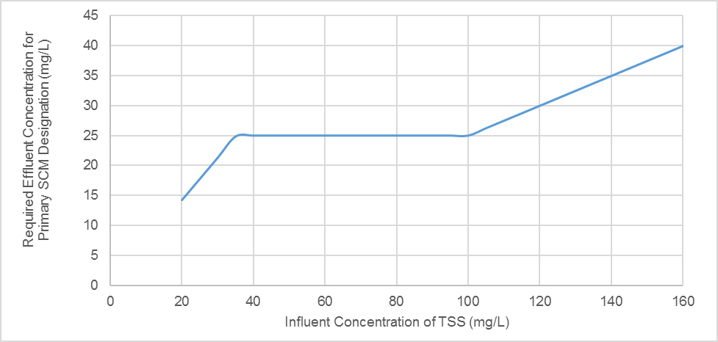
Invalid Test

Based on applying the above criteria to the available research results, the SCMs are designated as follows:
Table B-3: Types of Primary and Secondary SCMs and Their Uses
Types & Uses | Primary SCMs | Secondary SCMs
SCM Type | - Bioretention Cell  - Infiltration System  - Permeable Pavement  - Wet Pond¹  - Stormwater Wetland¹  - Sand Filter  - Rainwater Harvesting | - Green Roof  - Disconnected Impervious Surface  - Level Spreader-Filter Strip  - Pollutant removal Swale  - Dry Pond
SCM Uses | - As a stand-alone SCM to treat a new development site (when 100% sized).  - As a retrofit. | - In series with a primary SCM to reduce the volume of runoff and thus reduce the size of the primary SCM.  - In series with a primary SCM to provide pretreatment.  - In series with a primary SCM as a hydraulic device to slowly “feed” the stormwater runoff to the primary SCM, to reduce the size of the primary SCM.  - In series with another secondary SCM to treat the design storm in a manner that meets or exceeds performance standard.  - As a retrofit.
¹ The research data on wet ponds and stormwater wetlands indicate that only about 50% of installations studied meet the performance standard shown in the figure above. However, DEQ is retaining these as Primary SCMs due to their history as being considered stand-alone SCMs and their capacity to manage peak flows.
² The research data on level spreader-filter strips indicate that they do meet the performance standard shown in the figure above. However, DEQ is retaining LS-FS as a Secondary SCM for the present because the research sites were sized 50-300 times larger than the MDC for this SCM require.

Hydrologic Partitioning and Annual Runoff Treated
A SCM that is 100-percent sized treats the majority of the annual runoff from its contributing drainage area. However, a certain percentage of the runoff resulting from larger storm events is released as untreated stormwater. The percentage of annual runoff treated by a 100-percent sized SCM varies based on the treatment mechanisms of the device as well as the retention time. See the table below for DEQ’s estimations.
Minimum Design Criteria Rules require that SCMs designed to provide “runoff treatment” are designed for treating the volume of runoff from all built-upon area on a site (or other specified area) from a specific storm size. For most Rules, this is the 1” storm, but may be the 1.5” storm, the 1-year 24-hour storm, or other size. This amount of volume that the SCM is designed to treat is the volume from the design storm (1” or 1.5”) and SCMs designed to this standard are known as “full size” (or “100% sized”) in this document and the related Stormwater Nitrogen and Phosphorus Tool (SNAP). SCMs designed to “full size” are expected to treat some minimum proportion of the average annual runoff, which is presented as “% of annual runoff treated” or “treated runoff” at various points in this document.
For purposes of modeling SCM behavior, the total annual runoff volume is partitioned into three hydrologic “fates”: overflow (the proportion of runoff volume that is expected to bypass the system), ET&I (the proportion of runoff volume that is expected to leave through evapotranspiration & infiltration), and effluent (the proportion of runoff volume that is expected to receive treatment and be discharged above ground by the SCM). Note that “overflow” is equal to the remainder between the annual runoff flowing into the SCM and the “% annual runoff treated” or “treated runoff”. Of this “treated runoff” the relative proportion that leaves as ET&I vs Effluent has been estimated. In most cases this relative proportion changes depending on the Hydrologic Soil Group the SCM sits on. This relative proportion of treated runoff is presented for each SCM in its respective section.
For ease of reference in determining overall usefulness of an SCM for runoff volume reduction through ET&I, or when using the SNAP Tool, the proportions of annual runoff assigned to overflow, ET&I, and Effluent for a “full size” SCM have been provided in Table A.2. The relative division of treated runoff into ET&I and Effluent has been applied to allow the reader to see the proportion of the total annual runoff volume in these three “hydrologic fates”.
SCMs may be designed as “oversized” relative to this “full size”, or in some cases “undersized”. NCSU has provided models to assist the designer in determining how the size relative to “full size” changes the proportion of average annual runoff volume received that is bypassed by the system (e.g. “overflow”) and the proportion that is treated by the system. When using a differently sized system, if the proportions of annual runoff comprised by ET&I and Effluent are needed, the relative proportions for these fates, based on the onsite HSG, are applied to the proportion of the total annual runoff comprised by the treated volume.

Table B-4: Annual Runoff Treated by SCMs
SCMs (designed per the MDC unless otherwise specified) | % of annual runoff treated if 100% sized | How the percent of annual runoff treated was estimated
Bioretention  Bioretention without IWS | 94% | This is the output of NCSU’s HyPerTool for a bioretention cell that is 100% sized and designed per the MDC.
Infiltration  Permeable Pavement (infiltration or detention)  Wet Ponds  Wetlands  Dry Ponds | 84% | These SCMS are assumed to have a 60-hour average drawdown time. NCSU researchers ran a model with 20 years of rainfall data through 60-hour detention time devices to determine that, on the average, 84 percent of annual runoff if these SCMs are sized to treat the design storm.
Bioretention  (variations from MDC)  Permeable Pavement (variations from MDC) | Variable | Use the appropriate NCSU accounting tool to enter the sizing and its impact on runoff fates: Bioretention HyPerTool and the PermPave HyPerMod.
Sand Filter (open or closed) | 90% | Sand Filters are assumed to have a 12-hour average drawdown time. NCSU researchers ran a model with 20 years of rainfall data through 12-hour detention time devices to determine that, on the average, 90 percent of annual runoff will be treated for Sand Filters that are sized to treat 0.75 times the design storm (note that the MDC require only 75% sizing because of the short detention times of these two devices).
LS-FS  DIS | 90% | These SCMs are designed per the 0.75 in/hr drawdown time rather than a storm depth. NCSU has run a model based on 20 years of rainfall data showing that, on the average, 90 percent of annual runoff will be treated.
Green Roofs | 100% | The drainage area of a green roof is the green roof itself; all storms will rain directly on the green roof.
Rainwater Harvesting | 85% | Per the MDC, a 100-percent sized rainwater harvesting system is sized based on treating 85% of the annual runoff volume from the area that drains to it based on the results of the Rainwater Harvester.
Pollutant Removal Swale (wet or dry)  StormFilters, Filterra, BayFilter | 90% | May not be under or oversized for variable credit at this time.
Determining the performance for under and oversized SCMs is based on hydraulic modeling using 20 years of historic rainfall data. For infiltration, permeable pavement, wet ponds, stormwater wetlands and dry ponds, the estimated draw down time is 60 hours. More detailed information can be found in B.4. Credits for Under and Oversizing SCMs. Figure B-2 below shows how the percent of annual runoff treated changes with the percent sizing of these SCMs. Note that all of this information is programmed into the SNAPv4 Stormwater Nitrogen and Phosphorus Tool.
Figure B-2: Sizing versus Annual Runoff Treated for Infiltration, Wet Ponds, Stormwater Wetlands and Dry Ponds
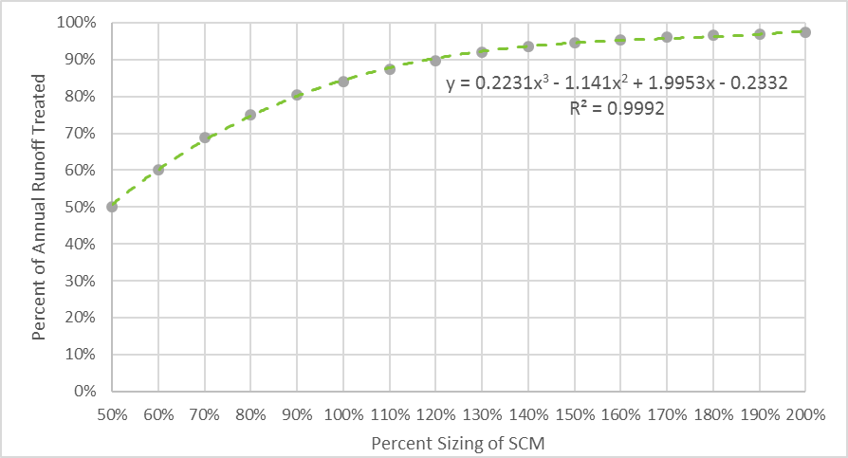

The performance of the other SCMs relative to sizing was determined as explained below.
Table B-5: Performance of SCMs Relative to Sizing
SCMs | How Sizing Affects Crediting
Sand Filters | Have own performance/sizing curve because, unlike the other SCMs, they are estimated to have 12-hour detention times and are only sized for 0.75 times the design storm. More detail can be found C-6 and Part F: Technical Justification and References.
Bioretention and Rainwater Harvesting | Credit should be determined with the appropriate NCSU Modeling Tool.
DIS and LS-FS | Not allowed to be undersized due to concerns about erosion. Oversized DIS and LS-FS are estimated to treat 90 percent of the annual runoff but are credited with a higher percentage of ET&I. See C-9 and C-10.
Permeable Pavement, Green Roofs, Pollutant Removal Swales, StormFilter, Filterra, and BayFilters | Green roofs, pollutant removal swales, Filterra, BayFilter and StormFilter may not be under or oversized for various reasons explained in the designated section of Part C. Permeable pavement may have alternative sizing with credit determined with the PermPave HyPerMod available from NCSU.

Hydrologic Partitioning of Treated Runoff
After determining the percent of total average annual runoff treated based on percent sizing, the second step is to partition the treated runoff into two more categories: ET&I and Effluent. For infiltration systems, wet ponds, stormwater wetlands, dry ponds and sand filters, DEQ and NCSU-BAE estimate that the percentage of ET&I remains constant relative to the treated portion regardless of how much the device is under or oversized.  The figure at the right shows how an infiltration system (as an example) is credited for under- and oversizing. Note that regardless of how large or small the device is, the treated runoff is 100% ET&I and 0% Effluent.  Infiltration systems, infiltrating permeable pavement, wet ponds, stormwater wetlands, dry ponds and sand filters, shall have their fates partitioned in the same way with respect to sizing.  Bioretention cells and rainwater harvesting shall have their fates partitioned with the appropriate NCSU modeling tool. Default (100% sized) values are included in the SNAPv4 Tool.  The treated runoff fates for pollutant removal swales and StormFilter shall be as stated in the crediting table because under and oversizing is not allowed. |  | Figure B-3: Sizing versus Runoff Fates for Infiltration Systems  a. 100% sized  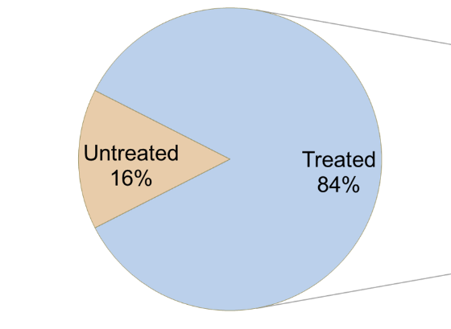  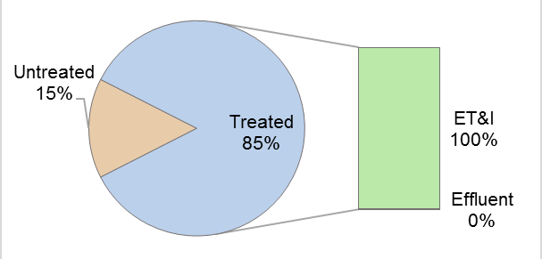  b. 70% sized  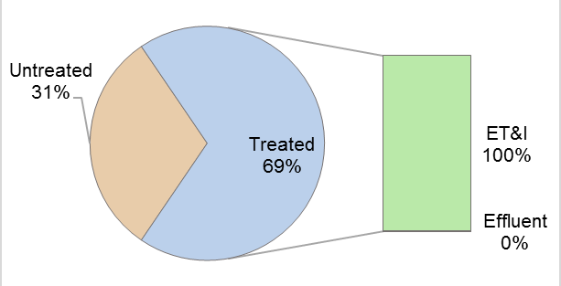  c. 130% sized  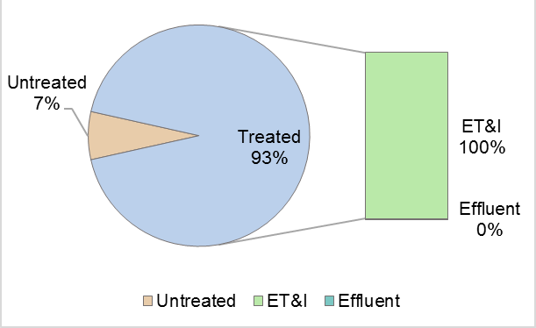
The fates of treated runoff for LS-FS and DIS are handled in an almost opposite manner than the infiltration system above. Regardless of how much these devices are oversized (note that undersizing an LS-FS or DIS is not allowed), LS-FS and DIS are estimated to treat 90 percent of the annual runoff. However, the percentage of ET&I increases as the vegetated receiving areas of these devices increases. Stormwater “lost” from SCMs as ET&I results in a commensurate level of nutrient load reduction.  See D.9. Disconnected Impervious Surface and D.10. Level Spreader-Filter Strip for more detailed information. | Figure B-4: Sizing versus Runoff Fates for  DIS installed in HSG C  a. 100% sized  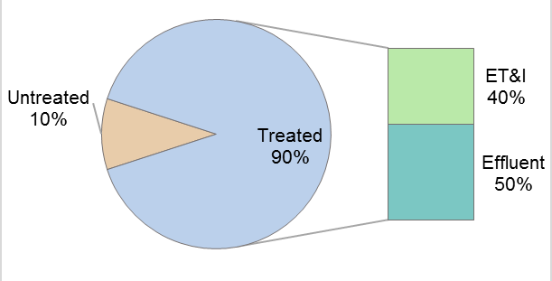  b. 200% sized  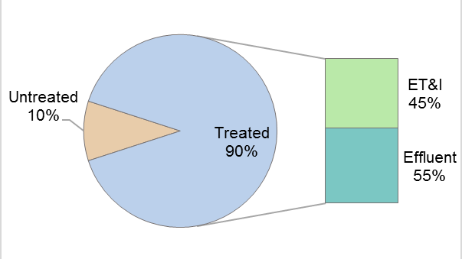  c. 400% sized  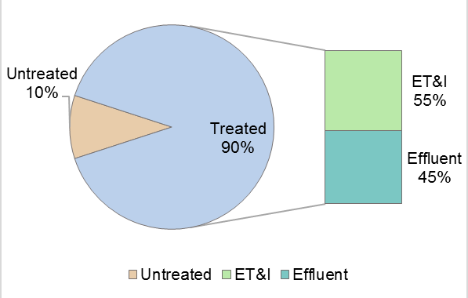

Crediting Basis for Under- and Oversizing SCMs
The percent of annual runoff volume treated by SCMs (indicated on the graphs that appear in B.2 and in each of the SCM explanations in Part C) was based on the prior work of Smolek et al. (2015). The detention-based SCMs received runoff from a hypothetical 15-acre watershed with a curve number of 98. Following the currents MDCs, the SCMs were designed with a 1-foot ponding depth and storm depths as a percentage (10 to 200%) of the water quality storm depth (1 or 1.5 inches). Drawdown orifice sizes were then determined for the SCMs such that that the drawdown depth at the end of 12, 60, or 72 hours was 0.50 inches (+/- 0.03 inches). This drawdown depth was used by Smolek et al. (2015) because outflow at this depth was negligible.
The drawdown orifice dimensions and SCM surface area were then evaluated with 20 years of rainfall data (07/01/96 to 07/01/16) from the State Climate Office of North Carolina for stations at the Asheville, Raleigh-Durham, and Wilmington airports to identify the percent of annual runoff volume treated by the SCMs sized as a percentage of the water quality storm event. These values were then evaluated with 20 years of rainfall data from the State Climate Office of North Carolina for stations at the Asheville, Raleigh-Durham, and Wilmington airports to identify the percent of annual runoff volume treated by SCMs sized from 10 to 200% of the sized with storm depths as a percentage of the water quality storm depth. The model also accounted for the hourly antecedent moisture conditions. The average of the annual percent overflow volumes for each SCM size, rainfall location, and drawdown period was calculated and plotted to create regression equations that will be used in regulatory tools.
Sand filters differed from the other SCMs in that they are estimated to have a 12-hour draw down time. However, the MDC for sand filters requires that they be sized for only 0.75 times the design storm. The 12-hr drawdown period results for over/under-sized SCMs were found as percentages of 1 or 1.5 inches rather than 0.75 inches and then this was corrected by normalizing the results by 0.75. Similar to the nutrient concentrations, a QA/QC of the models was performed. This included verifying the rainfall data, equations, and descriptive statistics were correct. Twenty years of QA/QC rainfall data were available for modeling.

NOAA (National Oceanic Atmospheric Administration). 2016. Precipitation data for the Raleigh-Durham International Airport (RDU), acquired from the NOAA online data portal. 15-minute precipitation data from 1980 to 2013 collected by NOAA at RDU were used to generate a precipitation time series for this period.
Smolek, A. P. (2016). Monitoring and modeling the performance of ultra-urban stormwater control measures in North Carolina and Ohio. (Unpublished Doctoral). North Carolina State University, Raleigh, NC. http://www.lib.ncsu.edu/resolver/1840.16/11020

Temperature and Bacteria
For temperature protection, it appears from literature that infiltration is the main process for reducing thermal loads. For bacterial reductions, it appears from literature infiltration, sun exposure, dry conditions (for wetlands and wet ponds: increased hydraulic retention time) are the main processes for reducing bacteria (Hathaway et al., 2009; Hathaway et al., 2011; Price et al., 2013; Mallin et al., 2002; Struck et al., 2008; Mallin et al., 2012).
Winston, R., Lauffer, M., Narayanaswamy, K., McDaniel, A., Lipscomb, B., Nice, A., & Hunt, W. (2015). Comparing bridge deck runoff and stormwater control measure quality in North Carolina. Journal of Environmental Engineering, 141(1), 04014045. doi:10.1061/(ASCE)EE.1943-7870.0000864

Buren, M., Watt, W., Marsalek, J., & Anderson, B. (2000). Thermal balance of on-stream storm-water management pond. Journal of Environmental Engineering, 126(6), 509-517. doi:6(509)

Hathaway, J. M., Hunt, W. F., Graves, A. K., Bass, K. L., & Caldwell, A. (2011). Exploring fecal indicator bacteria in a constructed stormwater wetland. Water Science and Technology: A Journal of the International Association on Water Pollution Research, 63(11), 2707. Retrieved from http://www.ncbi.nlm.nih.gov/pubmed/22049768

Hathaway, J., Hunt, W., & Jadlocki, S. (2009). Indicator bacteria removal in storm-water best management practices in Charlotte, North Carolina. Journal of Environmental Engineering, 135(12), 1275-1285. doi:10.1061/(ASCE)EE.1943-7870.0000107

Jones, M., & Hunt, W. (2009). Bioretention impact on runoff temperature in trout sensitive waters. Journal of Environmental Engineering, 135(8), 577-585. doi:10.1061/(ASCE)EE.1943-7870.0000022

Jones, M., & Hunt, W. (2010). Effect of storm-water wetlands and wet ponds on runoff temperature in trout sensitive waters. Journal of Irrigation and Drainage Engineering, 136(9), 656-661. doi:10.1061/(ASCE)IR.1943-4774.0000227

Lieb, D., & Carline, R. (2000). Effects of urban runoff from a detention pond on water quality, temperature and caged Gammarus minus (Say) (Amphipoda) in a headwater stream. Hydrobiologia, 441(1), 107-116. doi:1017550321076

Mallin, M. A., Ensign, S. H., Wheeler, T. L., & Mayes, D. B. (2002). Pollutant removal efficacy of three wet detention ponds. Journal of Environmental Quality, 31(2), 654-660. doi:10.2134/jeq2002.0654

Mallin, M. A., McAuliffe, J. A., McIver, M. R., Mayes, D., & Hanson, M. A. (2012). High pollutant removal efficacy of a large constructed wetland leads to receiving stream improvements. Journal of Environmental Quality, 41(6), 2046-2055. doi:10.2134/jeq2012.0025.

Price, W. D., Burchell II, M. R., Hunt, W. F., & Chescheir, G. M. (2013). Long-term study of dune infiltration systems to treat coastal stormwater runoff for fecal bacteria. Ecological Engineering, 52, 1-11. doi://dx.doi.org/10.1016/j.ecoleng.2012.12.008

Struck, S. D., Selvakumar, A., & Borst, M. (2008). Prediction of effluent quality from retention ponds and constructed wetlands for managing bacterial stressors in storm-water runoff. Journal of Irrigation and Drainage Engineering, 134(5), 567-578. doi:5(567)

Wardynski, B., Winston, R., & Hunt, W. (2013). Internal water storage enhances exfiltration and thermal load reduction from permeable pavement in the North Carolina mountains. Journal of Environmental Engineering, 139(2), 187-195. doi:10.1061/(ASCE)EE.1943-7870.0000626

Winston, R., Hunt, W., & Lord, W. (2011). Thermal mitigation of urban storm water by level spreader–vegetative filter strips. Journal of Environmental Engineering, 137(8), 707-716. doi:10.1061/(ASCE)EE.1943-7870.0000367

Nutrient EMC Methodology
Prior to the 2022 revision of this document, DEQ staff convened a committee of university experts, local government engineers, and practitioners to develop a set of standards for data quality to differentiate studies that can be used to determine effluent nutrient Event Mean Concentrations (EMCs) for SCMs. This subchapter documents the results of that committee’s work as they apply to both existing SCMs and future proposed SCMs or SCM revisions.

Influent Screening Values for Selection of Representative Data
Influent concentration thresholds have been established to screen out concentrations that are not representative of those typically found in developed sites. The chosen statistical minimum concentration threshold ensures that effluent data reliably reflect each SCM’s pollutant removal mechanisms rather than benefitting more from “clean” influent. This same approach was used to establish standards for TSS data. The Department shall use the 12.5th percentile as the statistical minimum screening threshold applied to the set of median influent values of both TN and TP for each study. The correlated nutrient concentration values based on the datasets used as described herein are 0.71mg/L TN and 0.05mg/L TP. These screening thresholds are subject to reevaluation every 5 to 10 years as additional findings dictate. DEQ anticipates that iterative reevaluations will result in progressively minor changes to the thresholds.

Methods to Establish Screening Thresholds
These two sections retrospectively document the process used to screen data and assign TN and TP EMC values for the current set of SCMs and describe the results practice by practice.
For all SCMs, only studies producing paired influent and effluent data from sites located in North Carolina, or from other sites meeting the study requirements described in Section C, are used. When possible, only published or submitted journal articles are used, and studies where the monitored SCM designs meet the MDCs. We also included influent data from several studies of practices that do not currently have nutrient approval and studies that only had influent data.
For each studied installation’s dataset the median influent TN and TP concentrations were calculated. We accounted for any outliers in the data by using median rather than mean values. For some published data, only mean values were available rather than the full set of influent and effluent data. Outlier data were included in the calculations of the median values.
The 12.5th percentile value of all influent medians, for TN and TP separately, were calculated and used to “screen” influent-effluent paired data points within each installation’sdataset. Wherever influent data were above the respective TN or TP screening value, the corresponding effluent data were included in the calculation of TN and TP median effluents for each dataset.

Development of Event Mean Concentrations (EMCs)
As noted above, effluent TN and TP medians were calculated for all SCM installations studied that met the qualifications listed in Section C, with some exceptions for SCMs with insufficient East Coast USA installations. Where possible, DEQ attempted to follow a set of preferences for assigning EMCs:
1. SCMs with “alternative designs” had a separate EMC calculated for that alternative where there were an adequate number of study installations for the “default design” and the “alternative design”. Where splitting the installations apart would result in fewer than 4 installations for either design, we looked to see if there were distinct differences in performance that would justify using fewer installations. With so few installations studied this decision was based on best professional judgement.
2. SCMs that had studies for 4 or more distinct installations had TN and TP EMCs assigned by using the median of installation effluent medians.
3. SCMs that had studies for only 2 or 3 distinct installations used the highest median TN and TP effluents from the installations to assign EMCs.
4. In cases where there were insufficient installations studied meeting the qualifications in Section C we used the same TN and TP EMCs as assigned in the 2018 version of this document.
The specific data availability, EMC calculation method, and the list of supporting references for each SCM are documented in Section D. All presently approved nutrient-reducing SCMs have had their influent data screened to produce the set of effluent values used to determine nutrient effluent EMCs for each SCM. Further details regarding the data and calculations for each SCM type are provided in the associated sections and in Part G:: Technical Justification and References. As of the 2022 revision of this document, the resulting values have been added to a revised SNAP Tool.
Prospectively, as new stormwater technologies are proposed to the Department, the Nonpoint Source Planning Branch will evaluate nutrient effluent data that has been screened with the above influent concentration values. Newly-approved nutrient-reducing SCMs will have a memo issued that describes how the new SCM and its characteristics are used with the SNAP Tool.
The Department intends to revisit the need to recalculate nutrient EMCs of all approved SCMs on a semi-regular schedule, no more frequently than 3 years between evaluations to provide a short-term measure of predictability for practitioners, and with a preferred frequency of 5 years between evaluations. Such reviews will take stock of any new data that has emerged during the intervening period. The public may submit supplemental SCM performance data at any time for consideration following the standards set out in Section C.5. NEST Final Report and Data Submittal.
The Department will reevaluate the influent statistical screening threshold on the same schedule as EMC reevaluation to accommodate new data. Where resulting changes in TN or TP influent screening values reduces the number of qualifying effluent values below 8 per installation for any already-approved SCM, that SCM will not be disapproved for nutrient purposes.
The Department will post the estimated schedule for each round of nutrient EMC reevaluation on its web site, including approximate due dates for submitting data, and an estimated release date for the revised nutrient calculator with new nutrient EMCs.

Approval Process for New Stormwater Technologies (NEST)

About the NEST Program
This chapter explains the process for requesting and potentially receiving a “blanket” approval for a new stormwater technology, as well as that for revising or reinforcing the performance value assignments of an existing SCM type.
Stormwater treatment is the subject of much academic research and technological improvement, and state stormwater programs around the country have various approaches to evaluating the suitability of stormwater technologies for their use. North Carolina’s stormwater rules allow the review and approval of new stormwater technologies for use on a “blanket” basis for sufficiently well-studied SCM types, as well as on a case-by-case basis (one development site at a time), . We will briefly describe the case-by-case option here, and the remainder of the chapter will focus on the blanket approval. …The following rule provision allows stormwater staff from the state, local government, or other permitted stormwater program to approve new stormwater technologies on a case-by case basis if the applicant meets the requirements of this rule item. Specifics of that approval process are determined by the applicable permitting authority.
15A NCAC 02H .1003(6) allows the permitting authority to approve projects that do not comply with all of the provisions of [the stormwater rules] on a case-by-case basis if the applicant demonstrate that the project provides equal or better stormwater control and equal or better protection of waters of the State than the requirements of this Section

The following rule provision gives the Department the authority to approve new stormwater technologies for subsequent use by applicants based on their presumptive performance. This “blanket” approval means the technology is pre-approved for use as a Primary or Secondary SCM and may also have an additional rating or evaluation for other water quality treatment objectives such as nutrient reduction.

15A NCAC 02H .1050(15) NEW STORMWATER TECHNOLOGIES. Applicants shall have the option to request Division approval of new stormwater technologies and associated MDC. The applicant shall submit to the Division the standards for siting, site preparation, design, construction, and maintenance of the stormwater technology as well as research studies demonstrating that the stormwater technology functions in perpetuity and is equally or more protective of water quality than the requirements of this Section. In accordance with G.S. 143-215.1 and 143-215.3, the Commission may delegate the review and approval of new stormwater technologies to Division staff and the Commission or its designee may request additional information deemed necessary to evaluate the stormwater technology. If the Commission or its designee deems that the applicant has demonstrated that the new stormwater technology shall be the same or more protective than the requirements of this Section, then the Division shall approve the use of the new stormwater technology to satisfy the requirements of this Section.

”Blanket” approval is required for any stormwater technology where the proposed design does not meet any existing SCM Minimum Design Criteria. An SCM designed to be more protective than that which is required in the Minimum Design Criteria is not required to go through this evaluation as long as no increased treatment is proposed relative to the SCM type its design is based upon. Proprietary products that are used as part of a traditional SCM (for example, proprietary underdrain pipes in a bioretention cell or chamber systems in an infiltration trench) do not need to go through the NEST program provided those products do not interfere with continued compliance with MDC for that SCM.

To be considered primary SCMs, new stormwater technologies must demonstrate they can achieve TSS reductions at different influent concentrations as described in Part B-2 of this document.

Invalid Test

Reevaluation of an existing, approved technology’s performance requires similar monitoring steps and data standards to those needed for new technologies and is also described in this chapter. Stormwater research may periodically provide such additional information with which to reevaluate the performance of an approved type of stormwater technology. Such supplemental research can be used to revise or reinforce the performance characteristics of any given type of SCM in future installations, such as TSS reduction, volume reduction, nutrient reduction, or other stormwater treatment parameters.
Where parties seek to provide new data for technologies which are already approved as Primary or Secondary SCMs, they do not need to formally enter the NEST Program but do need to submit a Final Report and raw study data as described in the “NEST Final Report and Data Submittal” section below. Submittal of new data for existing, approved SCMs will not otherwise be discussed for the remainder of this chapter.

NEST Program Requirements and Steps
Parties may propose new stormwater technologies through the New Stormwater Technology (NEST) Program, which provides a process by which the Department reviews and approves new practices as Primary or Secondary SCMs for use in satisfying State Stormwater requirements, and may also approve nutrient crediting specifications. The objective of this program is to characterize the performance of a proposed SCM type with set design standards in the kinds of physical and operational conditions that are likely to be encountered in North Carolina. The outputs of this program are a set of Minimum Design Criteria that, if followed, are likely to result in an SCM installation that performs similarly to those installations used to test SCM performance, a performance rating for TSS removal and optionally nutrient reduction, an estimate of hydrologic behavior in different settings, and potential limitations on the breadth of installation conditions based on the settings where SCMs were studied.

All proposals for evaluation of new or existing stormwater technologies shall follow the study and monitoring requirements set forth in Section C-4.
New or Existing Installations: Proponents of new technologies may propose to install them for an in-situ test of stormwater treatment performance, or they may propose to submit data collected from an already-installed SCM, or some combination of the two.
Similarity to Approved SCM Types: Proposals for a set of design requirements or use limitations different from those of an approved SCM type, proposals for different hydrologic or nutrient capabilities, or proposals for under a different proprietary name than those of approved SCM types must follow these procedures for independent provisional or global approval.

Stormwater Technology Revision or Reevaluation:
For all technologies that already have some level of approval, including those that have limitations on their use (“Provisional Minimum Design Criteria” or other limitations), proponents may submit data from additional studies of an SCM type for DEQ to use in consideration of widening the scope of use of an SCM type, altering the Minimum Design Criteria of an SCM type, improving the hydrologic performance rating of an SCM type, or improving the water quality performance rating (TSS, nutrients, or other) of an SCM type. Data submitted for this purpose must follow the NEST standards for study design and data submittal as described in Section C-4 and C-5. The Division will follow the process described in Section C-6 for adjusting Minimum Design Criteria, use limitations, hydrologic performance rating, or nutrient reduction rating.
SCM types with Minimum Design Criteria (which includes allowable conditions for use) set in Administrative Code (“Rules”) must go through the rulemaking process to adjust Minimum Design Criteria. Those with “Provisional Minimum Design Criteria” (those SCM types that are only represented in DEMLR’s Stormwater Design Manual) do not need to go through rulemaking to adjust either design requirements or widen the conditions where a technology may be applied. Adjustments of hydrologic performance, specifically the proportion of bypass in an average rainfall year or the relative proportions of infiltration/evapotranspiration and treatment flowthrough, do not require rulemaking. Adjustments to nutrient removal performance also do not require rulemaking but will only be conducted roughly every 3 to 5 years.
New Stormwater Technology (NEST) Review Process: For all technologies not already approved for use as Primary or Secondary SCMs, the following review process shall be used:

- The applicant shall submit a NEST Program Application to the Department that includes the items listed in Section C.3. .
- The Department shall accept the technology into the NEST Program for review if it finds that the application is complete and, by its judgment, that the new stormwater technology has the potential capability of meeting the performance standard in Section B.1. . The Department shall notify the applicant in writing that the device has been accepted into the NEST Program for evaluation.
- The new stormwater technology shall be installed on the proposed research site(s) and an entity other than the applicant or the designer or manufacturer of the SCM(s) shall conduct monitoring in accordance with Section C.4. . Research that has already been conducted may be used to demonstrate that the new stormwater technology achieves the performance standard in Section B-1 provided that the research meets all of the requirements in Section C.4. .
- The applicant shall submit a NEST Final Report pursuant to Section F-5 to the Department for review.
- The Department shall review the NEST Final Report and other materials and determine whether the applicant has demonstrated that the new stormwater technology will meet the performance standards stated in Section B.1. . The Department will follow the process laid out in section C-6 for the establishment of Minimum Design Criteria and assignment of hydrologic and nutrient reduction performance. This may include revisions to the proposed Minimum Design Criteria and limitations on the use of the technology.
- If the Department finds the new stormwater technology meets performance standards,, then the Department shall list the device on its web site as an approved NEST. The web site shall include the MDC and pollutant removal credit associated with the NEST.
- If a device is accepted into the NEST Program but the applicant does not complete monitoring within 36 months after the date on which the applicant was notified of acceptance, then the application shall be deemed to have been withdrawn.
- During the application, monitoring, reporting, and evaluation processes, the new stormwater technology may not be used as an SCM to meet State stormwater or nutrient management requirements on any sites other than the research sites.

NEST Program Application
The following information shall be provided to the Department when an applicant applies to the NEST Program
- a NEST Program Application Form. This form is available at the end of this section and includes the following information:
- the name, address and contact information of the applicant;
- the name, credentials, address and contact information of the designer or manufacturer of the new stormwater technology;
- the name, credentials, address and contact information of the entity conducting the research (describe separately for each study if necessary);
- stormwater project number(s), if applicable;
- the density of the entire project and of each drainage area;
- the name and certification information on the laboratory that will be used;
- information about applicability of other State and federal environmental permits to the project including CAMA Major Development Permits, NPDES, Sedimentation and Erosion Control Plan, and Section 404/401 permits; and
- a description of the new stormwater technology that will be used on the project;
(b) a description of physical, chemical, and/or biological treatment mechanisms employed;
(c) design drawings with dimensions for the test sites;
(d) a description of construction materials, including a description of any components of the treatment system that may contain nutrients or metals that might contribute to increased pollutant concentrations in the effluent;
(e) proposed Minimum Design Criteria for the new stormwater technology that includes all requirements for siting; site preparation, design, and construction; and maintenance activities and frequencies that are necessary to ensure that the device meets the stated pollutant removal rates in perpetuity, including the following:
- a description of any pretreatment requirements or recommendations;
- a description of all sizing methodology and technical design specifications based on a design maintenance frequency no more frequent than once per year;
- a description of bypass provisions incorporated in the equipment or installation; and
- maintenance procedures.
(f) expected treatment capabilities and performance characteristics for which approval is being sought, including the presentation of existing monitoring studies that have been performed on the NEST conforming to the requirements in Section C.5. ;
(g) a description of the research sites that will be used to demonstrate the NEST’s effectiveness as a stormwater treatment device, including the Hydrologic Soil Group on each sites;
(h) a Quality Assurance Project Plan conforming to the requirements in Section C.4. , describing the monitoring procedures and protocols that will be used for any new monitoring; and
(i) a timeframe for completion of the monitoring and for submittal of a Final Report and monitoring data conforming to the requirements in Section C.5. to the Department for review.

New Stormwater Technologies (NEST) Application Form

A. APPLICANT INFORMATION
I have read and understood Part C: New Stormwater Technologies of the SCM Crediting Document.
- Applicant name:
- Applicant contact information
Street Address:
City: State: Zip:
Phone: ( ) Fax: ( )
Email:
- Designer/Manufacturer name:
- Designer/Manufacturer contact information
Street Address:
City: State: Zip:
Phone: ( ) Fax: ( )
Email:

B. NEST INFORMATION
- Name of NEST:
- Description of the chemical, physical and biological process the NEST uses:

- Description of the construction materials, including a description of any components of the treatment system that may contain nutrients or metals that might contribute to increased pollutant concentrations in the effluent:

- Expected treatment capabilities of the NEST, including existing monitoring studies:

- Expected timeframe for completion of studies and submission of Final Report:

(Attach proposed Minimum Design Criteria and additional material about the new stormwater technology)

C. RESEARCH SITE #1 INFORMATION
- Name of research site #1:
- Address of research site #1 (street address):
City: State: Zip:
- Description of research site #1 (including percentage built-upon area):

- Stormwater permit number (if applicable):
- Other permits for research site #1 (if applicable):
- Name and credentials of researcher:
- Research contact information:
Street Address:
City: State: Zip:
Phone: ( ) Fax: ( )
Email:
(attach site plans and design drawings for this installation, and QAPP for this this research site)

D. RESEARCH SITE #2 INFORMATION
- Name of research site #2:
- Address of research site #2 (street address):
City: State: Zip:
- Description of research site #2 (including percentage built-upon area):

- Stormwater permit number (if applicable):
- Other permits for research site #2 (if applicable):
- Name and credentials of researcher:
- Research contact information:
Street Address:
City: State: Zip:
Phone: ( ) Fax: ( )
Email:
(attach site plans and design drawings for this installation, and QAPP for this this research site)

E. SUBMITTAL REQUIREMENTS
We require a hard copy and an electronic copy of the submittal package.
Submit the electronic copy to: stormwater@ncdenr.gov
Submit the hard copy to: NEST Program
NCDEQ | DEMLR | Stormwater Program
1612 Mail Service Center, Raleigh, NC 27699-1612

Initial each item below to indicate that the required information is provided in the application package:

Initials
1. One hard copy and one electronic copy of this application form, fully completed.

2. One hard copy and one electronic copy of the design drawings with dimensions for the test sites.

3. One hard copy and one electronic copy of proposed Minimum Design Criteria (MDC) for the NEST, including all requirements for site preparation, design, construction and maintenance. Please be sure to include a description of any pretreatment requirements or recommendation, a description of all sizing methodology and technical specifications based on a maintenance frequency of no less than one year, and a description of the bypass provisions.

4. One hard copy and one electronic copy of the Quality Assurance Project Plan conforming to the requirements of Section C-4.

5. One hard copy and one electronic copy of the timeframe for installation, monitoring and submittal of the final report.

Stormwater Technology Study and Monitoring Requirements
The following monitoring requirements shall be met for all studies, whether previously conducted or newly proposed:
- A minimum of one installation shall be located within the state of North Carolina. If not in North Carolina, other installations shall be located in areas with similar soils, climate, and weather patterns as found in North Carolina. This includes any study conducted in the following states: SC, GA, TN, VA, MD, DC, or DE. Sites in AL, FL, NJ, or PA may be considered. Applicants may submit other installations for consideration that share both an Omernik Ecoregion Level 3 and a USDA Plant Hardiness Zone in common with North Carolina and have an average annual rainfall comparable to any of the major population centers in North Carolina.
- The number and location of installations required also applies to expanding the use of a stormwater technology to nutrient reduction or other water quality treatment for which quantification or classification of performance is sought.

- At least two study installations shall be sized to 100% of the Water Quality Volume appropriate for the part of NC where installed (i.e. Coastal or elsewhere in NC), or sized for runoff a rainfall depth of 1”. No study installation shall be sized to less than 50% of the Water Quality Volume.
- For new stormwater technologies, initial development of Minimum Design Criteria may limit its use to the set of site conditions similar to those at the monitored installations. NCDEQ strongly recommends that proponents select study locations with significantly different characteristics to ensure the technology will operate consistently across a wide range of conditions and be granted wide applicability for use in meeting stormwater regulations.
- For each installation, the monitoring shall include sampling of the NEST’s performance for a minimum of 15 storm events over the course of a two-year period, with a minimum of three storm events in each season, and meeting TSS influent requirements below. Storm events monitored must be a minimum of 0.10 inches of rainfall and have a dry antecedent period (0” of rain) of 6 hours;
- Runoff volume into and out of the NEST, and volume bypassing the NEST, shall be monitored
- Precipitation may be locally monitored or estimated from a nearby weather station;
- Full storm hydrograph flow-weighted composite sampling of both the influent and effluent (but not bypass) shall be used for all water quality parameters except where this method is inappropriate (e.g. fecal coliform) Seventy percent or more of the hydrograph’s volume shall be represented by the sample collection for each storm event;
- Influent and effluent samples shall be collected and analyzed for Total Suspended Solids (TSS) for the evaluation of the device as a Primary or Secondary SCM. The median influent concentration of Total Suspended Solids (TSS) shall be between 50 and 150 mg/L for a valid sample;

If evaluating nutrient reduction performance, influent and effluent samples shall also be collected and analyzed for Total Kjeldahl Nitrogen (TKN), Nitrate + Nitrite (NO_{2,3}-N), and Total Phosphorus (TP). Other parameters may be monitored if the applicant is seeking approval for removal rates of those pollutants;
For evaluation of nutrient reduction performance, storm event influent concentrations must be a minimum of 0.71 mg/L for TN and 0.05 mg/L for TP. A minimum of 8 storm event influent-effluent pairs for each installation must meet this influent screening for their associated effluent concentrations to be included in evaluation of nutrient reduction performance;
Fewer than the required number of influent-effluent water quality pairs as listed above may be included in the data where infiltration is a significant mechanism of SCM action; and
Sampling, laboratory analysis, and data interpretation shall be conducted by an independent third party. The laboratory that is used shall be certified in accordance with Section .0800 of this Subchapter.
Studies meeting the requirements of the Charlotte-Mecklenburg Stormwater Services as part of their Pilot BMP Monitoring Program are considered to meet the requirements for this section.

NEST Final Report and Data Submittal
Whether SCM monitoring data are newly collected, or data from completed studies are submitted in support of SCM performance evaluation, DEQ requires specific data and in a format that allows easy evaluation of SCM performance, documents data quality and conditions, and enables storage of SCM performance datasets.
Monitoring data should be submitted minimally processed, including raw water quality data from the laboratory and stormwater sampler data, but with sufficient metadata and commentary to enable interpretation by Department staff. The Department suggests using the Excel data submittal template used by the International Stormwater BMP Database (ISBDB) project (https://bmpdatabase.org/submit-data - click on “Data Entry Spreadsheets” and use the “Data Entry Users’s Guide” for directions). All sheets in the ISBDB Excel template, except those for monitoring costs, should be completed to the maximum extent possible. Data provided should be sufficient for the Department to:
- Match together all storm event data together including rainfall depth, rate, duration, antecedent period, and peak 5 minute rainfall intensity;
- Match together all volume monitoring data to be able to determine bypass, influent, and effluent volumes;
- Match influent and effluent water quality data to storm event data;
- Identify water quality samples with lab qualifiers, and information on detection, quantitation, or other analysis limits;
- Clearly identify storm, volume, and water quality data points or samples where there was missing data, blank/spike/duplicate samples, or data quality concerns, with a description of the issue.
All SCM monitoring data shall be accompanied by a Final Report providing the following for each research study:

- site description including city and state, USDA hardiness zone, average annual rainfall, Omernik Level 3 ecoregion, soil type, series name, and hydrologic group;
- documentation of monitoring period including monitoring date range, climatic conditions (e.g. rainfall amount relative to local average annual conditions, and other conditions that may affect SCM performance), specific SCM maintenance and repair activities undertaken during the study period, SCM malfunctions or other SCM events, and events happening in the SCM drainage area (such as street sweeping, material spills, etc.);
- A description of the tested technology including design specs, treatment volume relative to water quality volume, proposed treatment capabilities and mechanisms;
- site plans, as-built plans, and details showing the technology, the area draining to the technology, including landcover types and square footage;
- Description of monitoring, sample collection, sample analysis methods, and laboratory name and certification information;
- (where applicable) a certification from the entity conducting the research that the Quality Assurance Project Plan approved by the Division was complied with during the conduct of the trial installations;

- a summary and interpretation of the monitoring results;
- statistical analysis of the monitoring data;
- proposed average annual runoff volume reduction as a proportion of water quality volume and proposed relative proportions of volume leaving the SCM via ET&I and volume treated and released by the SCM;
- proposed effluent EMCs for Total Nitrogen (TN) and Total Phosphorus (TP), determined as median value of all effluent samples;
- proposed effluent EMCs for any other pollutants that have been monitored as part of the NEST Program with an explanation of method used; and
- Proposed Minimum Design Criteria (MDC), design guidelines or recommendations, maintenance recommendations, and noting whether these have changed from initial enrollment in the NEST Program, or changes from current MDC Rules.

Stormwater Technology Review and Approval Process
Initial Review of NEST Final Reports and Submitted Monitoring Data:

After data have been collected for a new type of stormwater technology or submitted for an approved type of stormwater technology, the Department will evaluate the quality of the study(ies) provided. Evaluations will include:
- Whether all required data were collected and whether they meet minimum standards as described in Sections C-4 and C-5.
- Whether the test period conditions, including climate, runoff chemistry, operations and maintenance, were representative of likely installation conditions across the State, or whether the characteristics of the of study(ies) suggest limitations on use or design.
- Whether performance indicates that additional pre-treatment or other design modifications are necessary relative to the proposed Minimum Design Criteria.
Process for the Establishment of Design Criteria and Assignment of Performance Ratings:
If data are found to be generally adequate, the Department will follow the process described below for establishing Minimum Design Criteria in consultation with the applicant and assigning performance ratings (hydrologic/TSS or nutrients) based on submitted performance data.
When data for 2 or 3 studied installations are provided or available to DEQ, “Provisional MDC” will be developed that specify all design requirements and potentially limit SCM implementation to similar site characteristics as were found in the studies. Use limitations depend on the SCM’s physical configuration, its mechanisms of stormwater treatment, and other characteristics. Subsequent additional studies can invoke reevaluation and broadening of use limitations and modification of “Provisional MDC”. Limiting site characteristics may include:
- Hydrologic Soil Groups at site of SCMs studied where infiltration is part of the SCM’s mechanism of stormwater treatment (this can be inclusive, i.e. studying sites with HSG A and C means you can extend use to HSG B soils)
- Plant community type (e.g. shrubs/trees vs lawn vs other plant growth forms) where plant density and physical characteristics are an integral part of the SCM’s function
- Maximum watershed slope for SCMs studied (with no minimum slope limits) where slope may affect runoff collection or integrity of the SCM in high flow conditions
- The conditions under which runoff is supplied to the SCM (e.g. an upstream water storage to supply runoff to the SCM may be required)
- Specific maintenance practices & frequencies used at study sites
- Other characteristics that may affect performance
When data for 4 or more installations are provided or available to DEQ, a determination is made whether the SCM can have or is ready for unlimited (or broader) implementation, or whether some use limitations are still appropriate. “Final MDC” are developed and prepared for eventual rulemaking as part of the cycle of Stormwater Rule Revision.
When data for 2 or 3 installations are provided or available to DEQ, DEQ will assign hydrologic and (if available) nutrient performance with a conservative approach:
- The worst-performing (i.e. highest) nitrogen and phosphorus median effluent EMCs from all studied installations are used for assigning nutrient EMCs.
- % bypass for each studied installation is based on the total volume of runoff directed to an SCM during the course of study. The worst-performing % bypass from all studied installations is used for assigning the overflow part of hydrologic performance and must be equal to or less than 16% for that SCM type to be considered a Primary SCM. SCMs with this number of studies may only be used in “full-size” applications (no undersizing allowed, no oversizing can be credited).
- All studied installations’ median TSS influents and effluents must meet the screening thresholds in (NEST table) to be considered a Primary SCM.
- Subsequent additional studies will be included in the 3-to-5 year cycle of performance reevaluation conducted for all SCM types.
When 4 or more studies are provided or available to DEQ, depending on the breadth of study site conditions, DEQ will assign hydrologic and (if available) nutrient performance ratings in a way that recognizes the greater amount of data available:
- The median of all studied installations’ TN and TP median effluents (“median-of-medians”) is used for assigning nutrient EMCs.
- % bypass for each study is based on the total volume of runoff directed to an SCM during the course of study. The median %bypass of all studies is used for assigning the overflow part of hydrologic performance, unless the SCM follows a design that can be modeled with established methods such as 12hr-drawdown or 60hr-drawdown. Assigned % bypass must be no greater than 16% to be considered a Primary SCM. Under- and oversizing can be credited for SCMs that use a 12hr-drawdown or 60hr-drawdown design. Other SCMs must have additional studies to determine performance in conditions of under- or oversizing.
- At least 4 studied installations’ median TSS influents and effluents must meet the screening thresholds in (NEST table) to be considered a Primary SCM.
- Subsequent additional studies will be included in the 3-to-5 year cycle of performance reevaluation conducted for all SCM types.
For data from any number of studied installations and other data available to DEQ, volume reduction for each allowable Hydrologic Soil Group type is assigned (to the closest 5%) by the median volume reduction for the study with that particular HSG, or “median-of-medians” if more than one study is available for an HSG. Intermediate HSGs are interpolated. Subsequent additional studies may be included in the 3-to-5 year cycle of performance reevaluation conducted for all SCM types.
Final Steps in Approval of the New Stormwater Technology:
Upon completion of data review, proposed assignment of performance ratings, and proposed establishment of Minimum Design Criteria, the Department will take the following steps:
- If the data are for an approved stormwater technology, the Department will hold the conclusions of the review for the next round of periodic reevaluation of all approved SCM types and technologies.
- If the data are for a new stormwater technology, and the Department finds that the NEST Final Report demonstrates that the technology is effective as a Primary or Secondary SCM, then it shall:
- Direct the proponent to draft a chapter on the NEST design for Part D of the Stormwater Design Manual including Minimum Design Criteria;
- With direction from the Division reviewing nutrient EMCs*, draft a chapter on the NEST’s pollutant removal capabilities for Part D of the SCM Credit Document;
- Review and approve the chapters for the Stormwater Design Manual and the SCM Credit Document;
- Public notice for 30 days the draft chapters and the NEST Final Report, and respond to comments;
- Submit the final SCM Credit Document and Stormwater Design Manual chapters to the appropriate Division Directors for approval as a Primary or Secondary SCM and, if applicable, a nutrient reduction technology; and
- Directors shall authorize in writing the new stormwater technology to be used as a Primary or Secondary SCM and, if applicable, a nutrient reduction technology.
(b) If the Department finds that the NEST Final Report is inconclusive about whether the new stormwater technology meets the performance standard in Section B.1. , then the Division shall require additional research studies before the technology may be approved to be used as an SCM to meet the requirements set forth in this Section. The additional research studies shall comply with Section C.4. , and a subsequent NEST Final Report that complies Section C.5. shall be submitted to the Division for review and approval.
(c) If the NEST Final Report demonstrates that the new stormwater technology does not meet the performance standard in Section B.1. , then the Division shall take the following actions:
(i) The Division shall consider whether the technology may be approved as a Secondary SCM that could be used in conjunction with a Primary SCM on a site;
(ii) The Division shall not allow the technology to be used as a stand-alone SCM to meet the requirements set forth in this Section on future projects; and
(iii) The Division shall allow the continued use of the technology on the research sites provided that the NEST Final Report establishes that the technology discharges at a median effluent concentration for TSS of 35 mg/L or less or reduces the annual cumulative load of TSS by 65% or greater. If the technology does not meet this performance standard, then it shall be replaced at the research sites by an approved SCM that is designed, constructed, and maintained in accordance with 15A NCAC 02H .1050 through .1062.

Credit for Each SCM

Infiltration System

Hydrologic Partitioning and Nutrient Credit Table
SCM | Role |  | % of Annual Runoff |  |  | EMC_{effluent} (mg/L)
 |  | HSG | Untreated Overflow | ET&I | Treated Effluent | TN | TP
Infiltration per MDC | Primary | A | 16 | 84 | 0 | 0 * | 0 *
 |  | B | 16 | 84 | 0
 |  | C | 16 | 84 | 0
 |  | D | 16 | 84 | 0

Annual Runoff Treated Based on Percent Sizing
Based on modeling done by NCSU using 20 years of rainfall data, a device designed for the design storm (1 inch or 1.5 inches on the Coast) and a 60-hour drawdown time will treat 84 percent of the total annual runoff volume. Figure D-1 below shows how the percent of annual runoff treated changes depending on the percent sizing of the infiltration system.
Figure D-1: Sizing versus Annual Runoff Treated for Infiltration
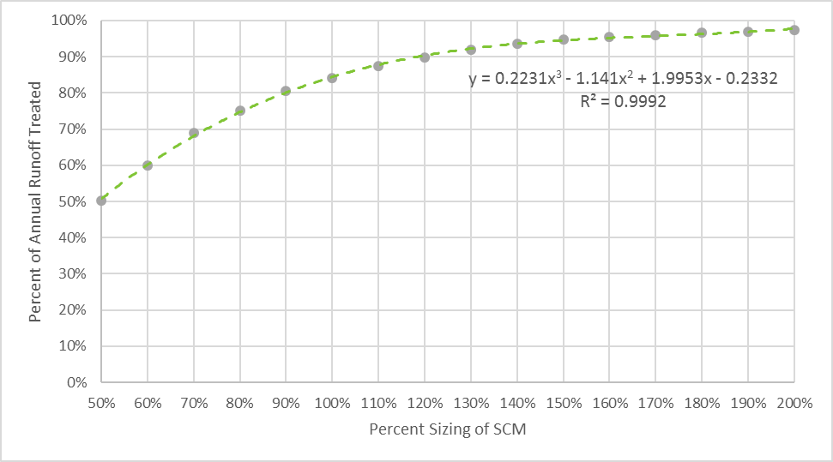

Hydrologic Partitioning of Treated Runoff

Because the MDC require that infiltration systems infiltrate the entire design storm, 100% of treated runoff is allocated to ET&I. The relative proportion of ET&I to Effluent in the Treated Runoff is estimated to remain constant regardless of whether the pond is under or oversized and regardless of Hydrologic Soil Group (HSG). The relative proportion of treated runoff between ET&I and Effluent as it varies based on HSG is shown in Table D-1. Figure D-2 below shows how the percent of annual runoff treated increases with the percent sizing of the infiltration system.

Table D-1: ET&I and Effluent as Percent of Treated Runoff in Infiltration Systems
SCM | HSG | ET&I | Effluent
Infiltration per MDC | A | 100 | 0
 | B | 100 | 0
 | C | 100 | 0
 | D | 100 | 0

Figure D-2: Runoff Fates for a 100% Sized Infiltration System
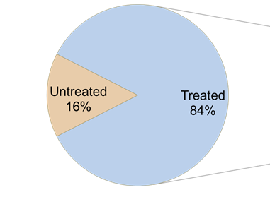
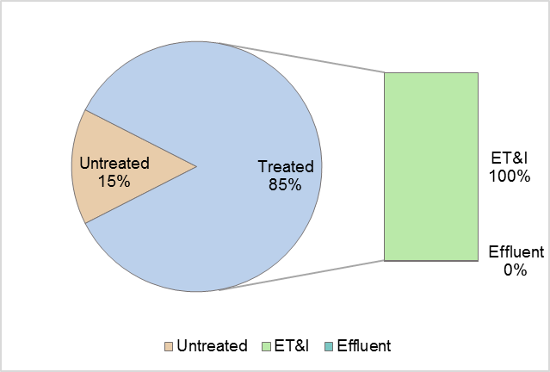

Minimum Design Criteria and Design Alternatives
Minimum Design Criteria for Infiltration Systems can be found in Rule 15A NCAC 02H .1051.
Design guidance for Infiltration Systems can be found in Chapter C-1 of the Stormwater Design Manual: https://deq.nc.gov/about/divisions/energy-mineral-and-land-resources/stormwater/stormwater-program/stormwater-design
There are no approved design alternatives for infiltration systems. However, rule language allows the applicant to propose design alternatives for any SCM and provide technical justification based on engineering calculations and the results of research studies showing that the proposed design is equally or more protective of water quality than the current MDC for the SCM and that it shall function in perpetuity.

Studies Used for TSS and Volume

Studies Used for Nutrient EMCs
EMCs are not relevant to infiltration systems because a correctly designed infiltration system will infiltrate the entire design storm. Runoff that exceeds the capacity of the infiltration system is considered “untreated.” EMCs for TN and TP equal to 0.001mg/L are used in the associated SNAPv4 tool to avoid divide-by-zero errors in intermediate calculation steps. These EMCs do not result in calculation of actual nutrient exports from these SCMs.

References

Bioretention Cell

Hydrologic Partitioning and Nutrient Credit Table
SCM | Role |  | % of Annual Runoff |  |  | EMC_{effluent} (mg/L)
 |  | HSG | Untreated Overflow | ET&I | Treated Effluent | TN | TP
Bioretention per MDC | Primary | A | 6 | 85 | 9 | 0.68 | 0.08
 |  | B | 6 | 67 | 27
 |  | C | 6 | 34 | 60
 |  | D | 6 | 13 | 81
Bioretention per MDC but without IWS (retrofits and special cases only) | Primary | A | 6 | 48 | 46 | 1.33 | 0.11
 |  | B | 6 | 19 | 75
 |  | C | 6 | 10 | 84
 |  | D | 6 | 8 | 86
Bioretention with design variants per Hyper Tool | Primary |  | Tool Output |  |  | 0.68 / 1.33 | 0.11

Annual Runoff Treated Based on Percent Sizing
The portioning of annual runoff between treated and untreated in the table was estimated using NCSU’s Bioretention HyPerTool, which provides options for selecting 50%, 75%, 100%, 150% and 200% sizing. To determine the annual runoff treated for bioretention cells that do not fall into these exact percentages, the user should interpolate between the two relevant sizes. HyPerTool is a Microsoft Excel spreadsheet model that references a database of hundreds of DRAINMOD simulations to allow for custom analysis and design of bioretention cells. More information on the Bioretention HyPerTool may be found in Part F: Overview of NCSU Modeling and Accounting Tools.
Under or oversizing a bioretention cell affects the percentage of annual runoff treated. However, it is not considered to change the TN or TP EMCs of the effluent.
To account for the uncertainty associated with this modeling-based approach, the user should select a factor of safety of 10 percent when applying the Bioretention HyPerTool.

Hydrologic Partitioning of Treated Runoff
The relative proportion of ET&I to Effluent in the Treated Runoff is estimated to change based on whether the bioretention cell is under or oversized. This ratio also varies for bioretention based on Hydrologic Soil Group (HSG). The relative proportion of treated runoff between ET&I and Effluent in full-sized bioretention as it varies based on HSG is shown in Table D-2.

Table D-2: ET&I and Effluent as Percent of Treated Runoff in Bioretention
SCM | HSG | ET&I | Effluent
Bioretention per MDC | A | 90 | 10
 | B | 71 | 29
 | C | 34 | 66
 | D | 13 | 87
Bioretention per MDC but without IWS (only retrofits and special cases) | A | 51 | 49
 | B | 20 | 80
 | C | 11 | 89
 | D | 9 | 91
Bioretention with design alternatives per HyPerTool | A | Tool Output | Tool Output
 | B
 | C
 | D

Where using an SCM designed to 100% of the Water Quality Volume, the SNAPv4 Tool will automatically include the above proportions of total annual runoff volume, treated volume, and ET&I volume. Where using an over- or undersized SCM, NCSU’s HyPerTool provides the proportions that the user enters into the SNAPv4 Tool. Note that NCSU’s HyPerTool labels Effluent as “Drainage” and also partitions the ET&I into “ET” and “Exfiltration”; these latter two divisions need to be added together for use in SNAP. The percentage of total annual runoff treated and the partitioning of treated runoff between ET&I and Effluent should be done through the use of NCSU’s HyPerTool as well.

Minimum Design Criteria and Design Alternatives
Minimum Design Criteria for Bioretention Cells can be found in Rule 15A NCAC 02H .1052.
Design guidance for Bioretention Cells can be found in Chapter C-2 of the Stormwater Design Manual: https://deq.nc.gov/about/divisions/energy-mineral-and-land-resources/stormwater/stormwater-program/stormwater-design
The three design alternatives listed below are options provided in the Bioretention HyPerTool. If a designer wishes to use one of the following design alternatives, the effect on Treated Runoff fates should be estimated using the Bioretention HyPerTool.

Design Alternative | Where it is allowed | Effects on Performance
Exclude the internal water storage (IWS) zone | On retrofits or new development where the IWS poses a threat to the SCM or the site | Reduces % annual runoff treated.  Reduces % of ET&I.  No effect on TN & TP EMCs.
Reduce the ponding depth from 12 to 9 inches (while retaining the same design volume) | Retrofit or new development | Increases % annual runoff treated.  Increases % ET&I.  No effect on TN & TP EMCs.
Increase the soil media depth from 3 to 4 feet in B, C and D soils. | Retrofit or new development | Increases % annual runoff treated Increases % ET&I.  No effect on TN & TP EMCs.

Studies Used for TSS and Volume
Bioretention (6 pass, 0 fail):
Location | Site Name | Mean Influent (mg/L) | Mean Effluent  (mg/L) | Removal Efficiency | Pass or Fail?
Charlotte | Hal Marshall | 49.50 | 20.00 | 60% | Pass
Knightdale | Mango Creek Small | 49.48 | 25.66 | 48% | Pass
Knightdale | Mango Creek Large | 47.96 | 20.38 | 58% | Pass
Nashville | Nashville Deep | 35.38 | 7.70 | 78% | Pass
Nashville | Nashville Shallow | 35.35 | 12.23 | 65% | Pass
Rocky Mount | Rocky Mount | 40.60 | 16.90 | 58% | Pass

Studies Used for Nutrient EMCs
EMCs for Bioretention with IWS were evaluated separately from Bioretention without IWS. Four studied installations met requirements for inclusion for Bioretention with IWS, and another eight studied installations met requirements for inclusion for Bioretention without IWS. For each SCM type, medians of installation medians for TN and TP were used to assign EMCs.

Site | Location | Resource
Willard BR w/IWS | Blacksburg, VA | Willard 2014
Hal Marshall w/o IWS | Charlotte, NC | Hunt et al. 2008
Graham South w/IWS | Graham, NC | Passeport et al. 2009
Louisburg 1 w/o IWS | Louisburg, NC | Sharkey 2005
Louisburg 2 w/o IWS | Louisburg, NC | Sharkey 2005
Mango Creek Large w/IWS | Knightdale, NC | Luell et al. 2011
Mango Creek Small w/IWS | Knightdale, NC | Luell et al. 2011
Nashville Deep w/o IWS | Nashville, NC | Brown and Hunt 2011a
Nashville Shallow w/o IWS | Nashville, NC | Brown and Hunt 2011a
I40 Catawba w/o IWS | Catawba Co., NC | Line and Hunt 2009
Cell CP w/o IWS | College Park, MD | Li and Davis 2009
Cell SS w/o IWS | Silver Springs, MD | Li and Davis 2009
Chapel Hill 2018 w/o IWS | Chapel Hill, NC | Johnson and Hunt 2019

Dr. Ryan Winston and Andrew Anderson provided raw data from former graduate students for the following sites: Mango Creek Small, Mango Creek Large, Nashville Shallow, and Nashville Deep. These data were summarized and published by Winston et al. (2015). Additionally, raw data from Sharkey (2006) were used for the Louisberg 1 and 2 sites. Data for sites: Graham North, Graham South, Rocky Mount (Sandy clay loam, SCL), and Hal Marshall were retrieved from published journal articles (Passport et al., 2009; Brown and Hunt, 2011; Hunt et al., 2008). The QA/QC consisted of verifying all of the data were transcribed and calculated correctly in the Excel file, and the descriptive statistics were consistent with published materials.

References
Brown, R.A., Hunt, W.F., 2011b. Underdrain Configuration to Enhance Bioretention Exfiltration to Reduce Pollutant Loads. Journal of Environmental Engineering, 137(11), 1082-1091. doi:10.1061/(ASCE)EE.1943-7870.0000437.
Two bioretention cells in Rocky Mount, North Carolina, were monitored for two year-long periods to measure the impact of varying IWS zone depths over sandier underlying soils. This research builds on previous findings of underdrain configuration at Piedmont sites in North Carolina. The increased hydraulic retention time in the sandy clay loam media resulted in lower outflow concentrations. For events monitored with drainage from the SCL cell, efficiency ratios of all the nitrogen species and TSS exceeded 0.5.

Brown, R.A., Hunt, W.F., 2011c. Impacts of Media Depth on Effluent Water Quality and Hydrologic Performance of Undersized Bioretention Cells. Journal of Irrigation and Drainage Engineering, 137(3), 132-143. doi:10.1061/(ASCE)IR.1943-4774.0000167.
Two sets of loamy-sand-filled bioretention cells of two media depths (0.6 m and 0.9 m), located in Nashville, North Carolina, were monitored from March 2008 to March 2009 to examine the impact of media depth on their performance with respect to hydrology and water quality. Estimated annual pollutant load reduction for total nitrogen, total phosphorus, and total suspended solids were 21, 10, and 71percent for the 0.6-m media cells and 19, 44, and 82 percent for the 0.9-m media cells, respectively. Design specifications and local nutrient sources attributed to the results of this study.

Hunt, W.F, A. R. Jarrett, J. T. Smith, and L. J. Sharkey. 2006. Evaluating Bioretention Hydrology and Nutrient Removal at Three Field Sites in North Carolina. Journal of Irrigation and Drainage Engineering, 132:600-608.
Three bioretention cells with varying media types and drainage configurations were evaluated for pollutant removal capabilities. Total nitrogen reductions averaged 40 percent by mass. Selection of media with a low phosphorus index improved phosphorus reductions relative to cells with a higher phosphorus index.

Hunt, W., Smith, J., Jadlocki, S., Hathaway, J., & Eubanks, P. (2008). Pollutant removal and peak flow mitigation by a bioretention cell in urban charlotte, N.C. Journal of Environmental Engineering, 134(5), 403-408. doi:10.1061/(ASCE)0733-9372(2008)134:5(403)

Hunt, W., Davis, A., & Traver, R. (2012). Meeting hydrologic and water quality goals through targeted bioretention design. Journal of Environmental Engineering, 138(6), 698-707. doi:10.1061/(ASCE)EE.1943-7870.0000504

Li, H. & Davis, A.P. (2009). Water quality improvement through reductions of pollutant loads using bioretention. Journal of Environmental Engineering, 135(8), 567-576.

Line, D.E. and W.F. Hunt. 2009. Performance of a Bioretention Area and a Level Spreader-Grass Filter Strip at Two Highway Sites in North Carolina. Journal of Irrigation and Drainage Engineering, 135(2): 217-224.
One LS-VFS and a bioretention area along the North Carolina highway system were evaluated for pollutant and volume reduction. The LS-VFS was found to have 49 percent total volume reduction over the 13 storm events monitored.

Liu, J., Sample, D.J., Bell, C., Guan, Y. (2014). Review and research needs of bioretention used for the treatment of urban stormwater. Water 2014, 6, 1069-1099.
This review paper summarizes data from 11 bioretention field studies for water quality performance. It includes discussion of Total Nitrogen (TN) and Total Phosphorus (TP) for systems with and without IWS. The studied BMPs varied in location, media composition and depth, surface area and ponding depth.

Luell, S. K. (2011). Evaluating the impact of bioretention cell size and swale design in treating highway bridge deck runoff. (Unpublished Master's). North Carolina State University, Raleigh, NC. http://www.lib.ncsu.edu/resolver/1840.16/6921

Luell, S. K., Hunt, W. F., & Winston, R. J. (2011). Evaluation of undersized bioretention stormwater control measures for treatment of highway bridge deck runoff. Water Science & Technology, 64(4) doi:10.2166/wst.2011.736

Passeport, E., Hunt, W., Line, D., Smith, R., & Brown, R. (2009). Field study of the ability of two pollutant removal bioretention cells to reduce storm-water runoff pollution. Journal of Irrigation and Drainage Engineering, 135(4), 505-510. doi:10.1061/(ASCE)IR.1943-4774.0000006

Sharkey, L. J. (2006). The performance of bioretention areas in North Carolina: A study of water quality, water quantity, and soil media. (Unpublished Master's). North Carolina State University, Raleigh, NC. http://www.lib.ncsu.edu/resolver/1840.16/2062

Willard, L.L. (2014). Does it pay to mature? Assessing the performance of a bioretention cell seven years post-construction [Master's thesis, Virginia Polytechnic Institute and State University]. https://vtechworks.lib.vt.edu/handle/10919/70758

Winston, R. J. 2016. Resilience of Green Infrastructure under Extreme Conditions. PhD dissertation, North Carolina State University. Department of Biological and Agricultural Engineering. Raleigh, NC. https://repository.lib.ncsu.edu/handle/1840.16/10890
This study validated the application of DRAINMOD as a tool to predict bioretention water balance to low-conductivity, clayey underlying soils.

Wet Pond

Hydrologic Partitioning and Nutrient Credit Table
SCM | Role |  | % of Annual Runoff |  |  | EMC_{effluent} (mg/L)
 |  | HSG | Untreated Overflow | ET&I | Treated Effluent | TN | TP
Wet Pond per MDC | Primary | A | 16 | 21 | 63 | 0.86 | 0.13
 |  | B | 16 | 16 | 68
 |  | C | 16 | 12 | 72
 |  | D | 16 | 8 | 76

Annual Runoff Treated Based on Percent Sizing
Based on modeling done by NCSU using 20 years of rainfall data, a device designed for the design storm (1 inch or 1.5 inches on the Coast) and a 60-hour drawdown time will treat 84 percent of the total annual runoff volume. Figure D-3 below shows how the percent of annual runoff treated increases with the percent sizing of the wet pond.
Figure D-3: Size versus Annual Runoff Treated for a Wet Pond
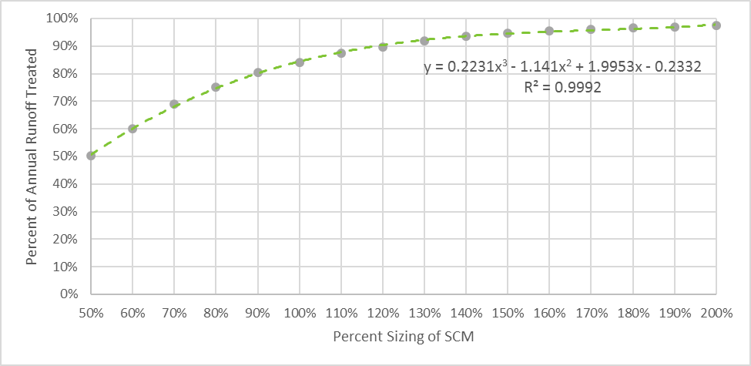

Hydrologic Partitioning of Treated Runoff
The relative proportion of ET&I to Effluent in the Treated Runoff is estimated to remain constant regardless of whether the pond is under or oversized but does vary based on Hydrologic Soil Group (HSG). The relative proportion of treated runoff between ET&I and Effluent as it varies based on HSG is shown in Table D-3. Figure D-4 below shows hydrologic partitioning of runoff for a 100% sized wet pond, and the relative proportions of Treated Runoff comprised by ET&I vs Effluent.

Table D-3: ET&I and Effluent as Percent of Treated Runoff in Wet Ponds
SCM | HSG | ET&I | Effluent
Wet Pond per MDC | A | 25 | 75
 | B | 20 | 80
 | C | 15 | 85
 | D | 10 | 90
Wet Pond per MDC with > 5% covered by FWI per Fig. 1 | A | 25 | 75
 | B | 20 | 80
 | C | 15 | 85
 | D | 10 | 90

Figure D-4: Runoff Fates for a 100% Sized Wet Pond
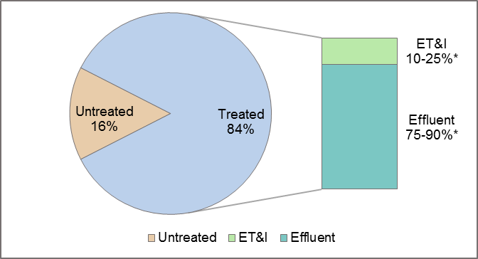
* NOTE: The percentages of ET&I and Effluent vary based on HSG.

Minimum Design Criteria and Design Alternatives
Minimum Design Criteria for Wet Ponds can be found in Rule 15A NCAC 02H .1053.
Design guidance for Wet Ponds can be found in Chapter C-3 of the Stormwater Design Manual: https://deq.nc.gov/about/divisions/energy-mineral-and-land-resources/stormwater/stormwater-program/stormwater-design
While Floating Wetland Islands are an approved alternative design, DEQ is in the process of revising the Minimum Design Criteria and nutrient EMCs. Otherwise there are no approved design alternatives for wet ponds. However, rule language allows the applicant to propose design alternatives for any SCM and provide technical justification based on engineering calculations and the results of research studies showing that the proposed design is equally or more protective of water quality than the current MDC for the SCM and that it shall function in perpetuity.

Studies Used for TSS and Volume
Wet Pond (4 pass, 4 fail):
Location | Site Name | Mean Influent (mg/L) | Mean Effluent  (mg/L) | Removal Efficiency | Pass or Fail?
Fayetteville | Bingham Wet Pond | 55.88 | 12.06 | 78% | Pass
High Point | Davis Pond | 97.00 | 39.00 | 60% | Fail
Durham | Hillandale | 354.00 | 30.00 | 92% | Pass
Durham | Museum | 225.67 | 24.47 | 89% | Pass
High Point | Piedmont Pond | 61.00 | 49.00 | 20% | Fail
Charlotte | Pierson | 127.00 | 56.07 | 56% | Fail
Fayetteville | Raeford | 51.93 | 21.93 | 58% | Pass
Charlotte | Shade Valley | 109.18 | 40.29 | 63% | Fail

Studies Used for Nutrient EMCs

Studies of seven wet pond installations meet requirements for inclusion, although one is as-yet unpublished NCSU data. Previously-used installation data were removed from consideration because watersheds included were largely agricultural. The median of installation medians was used to assign EMCs for both TN and TP.

Project Name | Location | Reference
Bingham WP | Fayetteville, NC | Baird 2014
Hillandale | Durham, NC | Winston et al. 2013
Museum WP | Durham, NC | Winston et al. 2013
Pierson WP | Charlotte, NC | Hathaway et al. 2007d
Raeford WP | Fayetteville, NC | Baird, J. B. 2014
Shade Valley WP | Charlotte, NC | Hathaway et al. 2007d
Armory WP | Durham, NC | (NCSU unpublished data)

Floating Wetland Islands are being reevaluated to refine their Minimum Design Criteria and TN and TP EMCs.

References
Baird, J. B. (2014). Evaluating the hydrologic and water quality performance of
infiltrating wet retention ponds. (Unpublished Master's). North Carolina State University, Raleigh, NC. http://www.lib.ncsu.edu/resolver/1840.16/9996

Borden, R., Dorn, J., Stillman, J., & Liehr, S. (1998). Effect of in-lake water quality on pollutant removal in two ponds. Journal of Environmental Engineering, 124(8), 737-743. doi:10.1061/(ASCE)0733-9372(1998)124:8(737)

Hathaway, J. M., Hunt, W. F., Smith, J. T., & Johnson, A. (2007b). Pierson pond final monitoring report. Raleigh, NC: North Carolina State University. https://stormwater.bae.ncsu.edu/resources/

Hathaway, J. M., Hunt, W. F., Smith, J. T., & Johnson, A. (2007d). Shade valley pond final monitoring report. Raleigh, NC: North Carolina State University. https://stormwater.bae.ncsu.edu/resources/

Winston, R. J., Hunt, W. F., Kennedy, S. G., Merriman, L. S., Chandler, J., & Brown, D. (2013). Evaluation of floating treatment wetlands as retrofits to existing stormwater retention ponds. Ecological Engineering, 54, 254-265. doi: http://dx.doi.org/10.1016/j.ecoleng.2013.01.023

Stormwater Wetland

Hydrologic Partitioning and Nutrient Credit Table
SCM | Role |  | % of Annual Runoff |  |  | EMC_{effluent} (mg/L)
 |  | HSG | Untreated Overflow | ET&I | Treated Effluent | TN | TP
Stormwater wetland per MDC | Primary | A | 16 | 34 | 51 | 0.94 | 0.15
 |  | B | 16 | 29 | 55
 |  | C | 16 | 25 | 59
 |  | D | 16 | 21 | 63

Annual Runoff Treated Based on Percent Sizing
Based on modeling done by NCSU using 20 years of rainfall data, a device designed for the design storm (1 inch or 1.5 inches on the Coast) and a 60-hour drawdown time will treat 84 percent of the total annual runoff volume. Figure D-5 below shows how the percent of annual runoff treated increases with the percent sizing of the stormwater wetland.
Figure D-5: Size versus Annual Runoff Treated for a Stormwater Wetland
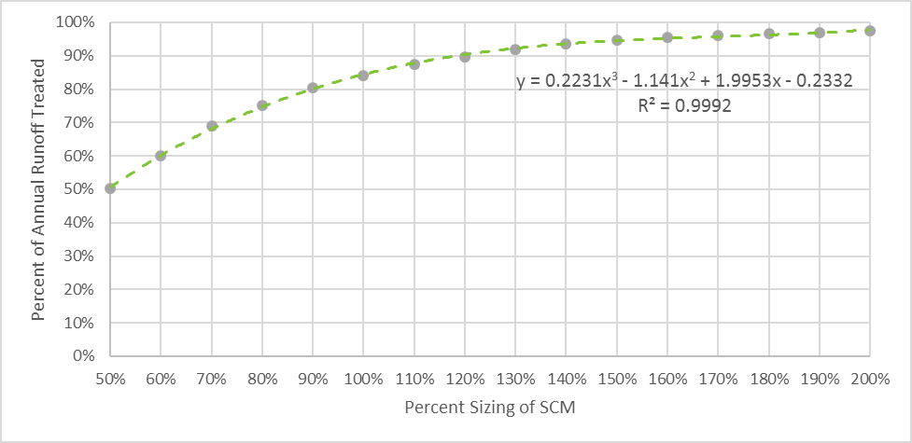

Hydrologic Partitioning of Treated Runoff
The relative proportion of ET&I to Effluent in the Treated Runoff is estimated to remain constant regardless of whether the wetland is under or oversized but does vary based on Hydrologic Soil Group (HSG). The relative proportion of treated runoff between ET&I and Effluent as it varies based on HSG is shown in Table D-4.Figure D-6 below shows runoff fates for a 100% sized stormwater wetland.
Table D-4: ET&I and Effluent as Percent of Treated Runoff in Stormwater Wetlands
SCM | HSG | ET&I | Effluent
Stormwater Wetland per MDC | A | 40 | 60
 | B | 35 | 65
 | C | 30 | 70
 | D | 25 | 75

Figure D-6: Runoff fates for a 100% Sized Stormwater Wetland
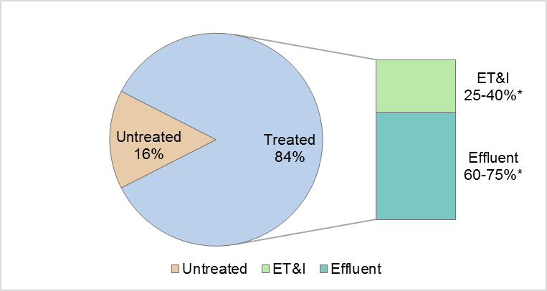
* NOTE: The percentages of ET&I and Effluent vary based on HSG.

Minimum Design Criteria and Design Alternatives
Minimum Design Criteria for Stormwater Wetlands can be found in Rule 15A NCAC 02H .1054.
Design guidance for Stormwater Wetlands can be found in Chapter C-4 of the Stormwater Design Manual: https://deq.nc.gov/about/divisions/energy-mineral-and-land-resources/stormwater/stormwater-program/stormwater-design
There are no approved design alternatives for stormwater wetlands. However, rule language allows the applicant to propose design alternatives for any SCM and provide technical justification based on engineering calculations and the results of research studies showing that the proposed design is equally or more protective of water quality than the current MDC for the SCM and that it shall function in perpetuity.

Studies Used for TSS and Volume
Stormwater Wetland (4 pass, 5 fail, 2 invalid):
Location | Site Name | Mean Influent (mg/L) | Mean Effluent  (mg/L) | Removal Efficiency | Pass or Fail?
Charlotte | Bruns Ave | 70.63 | 24.20 | 66% | Pass
Raleigh | Cent. Campus MS | 33.00 | 32.80 | 1% | Fail
Mooresville | Dye Branch | 76.80 | 12.30 | 84% | Pass
Charlotte | Edwards Branch | 29.38 | 25.06 | 15% | Fail
Edenton | Edenton Hospital | 34.14 | 26.71 | 22% | Fail
Wilmington | JEL Wetland | 12.50 | 4.10 | 67% | Invalid
Riverbend | Riverbend | 31.20 | 40.50 | -30% | Fail
Riverbend | Riverbend LSM | 9.89 | 8.37 | 15% | Invalid
New Bern | Simmons Base | 36.89 | 80.19 | -117% | Fail
New Bern | Simmons Event | 71.88 | 7.34 | 90% | Pass
Asheville | UNCA | 341.36 | 55.36 | 84% | Pass

Studies Used for Nutrient EMCs
Previous studies used to assign EMCs were excluded due to being pumped wetland systems, being in-line with streams, or being dominated by agricultural landuse. This left five studied installations meeting requirements for TN and six meeting requirements for TP. The median of installation effluent medians was used for assigning TN and TP EMCs.

Site | Location | Resource
Bruns Ave WL | Charlotte, NC | Johnson 2006
Dye Branch WL | Mooresville, NC | Hathaway and Hunt 2010
Edwards Branch WL | Charlotte, NC | Hathaway et al. 2007a
Riverbend WL | Riverbend, NC | Lenhart and Hunt 2011
Riverbend LSM | Riverbend, NC | Merriman and Hunt 2014; Merriman 2015
UNCA WL | Asheville, NC | Line et al. 2008

References
Bass, K. L. (2000). Evaluation of A small in-stream constructed wetland in North
Carolina’s coastal plain. (Unpublished Master's). North Carolina State University, Raleigh, NC. http://www.lib.ncsu.edu/resolver/1840.16/1737

Caldwell, P. V., Vepraskas, M. J., Skaggs, R. W., & Gregory, J. D. (2007). Simulating the water budgets of natural carolina bay wetlands. Wetlands, 27(4), 1112-1123. doi:10.1672/0277-5212(2007)27[1112:STWBON]2.0.CO;2

Hathaway, J. M., Hunt, W. F., & Johnson, A. (2007a). Edwards branch wetland final monitoring report. Raleigh, NC: North Carolina State University. http://charlottenc.gov/StormWater/SurfaceWaterQuality/Documents/EdwardsBranchWetlandFinalReport.pdf

Hathaway, J., & Hunt, W. (2010). Evaluation of storm-water wetlands in series in piedmont North Carolina. Journal of Environmental Engineering, 136(1), 140-146. doi:10.1061/(ASCE)EE.1943-7870.0000130

Johnson, J. L. (2006). Evaluation of stormwater wetland and wet pond forebay design and stormwater wetland pollutant removal efficiency. (Unpublished Master's). North Carolina State University, Raleigh, NC. http://www.lib.ncsu.edu/resolver/1840.16/1590

Lenhart, H., & Hunt, W. (2011). Evaluating four storm-water performance metrics with a North Carolina coastal plain storm-water wetland. Journal of Environmental Engineering, 137(2), 155-162. doi:10.1061/(ASCE)EE.1943-7870.0000307

Line, D. E., Jennings, G. D., Shaffer, M. B., Calabria, J., & Hunt, W. F. (2008). Evaluating the effectiveness of two stormwater wetlands in North Carolina. American Society of Agricultural and Biological Engineers, 51(2), 521-528.

Mallin, M. A., McAuliffe, J. A., McIver, M. R., Mayes, D., & Hanson, M. A. (2012). High pollutant removal efficacy of a large constructed wetland leads to receiving stream improvements. Journal of Environmental Quality, 41(6), 2046-2055. doi:10.2134/jeq2012.0025.

Merriman, L. S. (2015). Assessing the design and maintenance effects on ecosystem
services provided by regional-scale green stormwater infrastructure. (Unpublished Doctoral). North Carolina State University, Raleigh, NC. http://www.lib.ncsu.edu/resolver/1840.16/10687

Merriman, L., & Hunt, W. (2014). Maintenance versus maturation: Constructed storm-water Wetland’s fifth-year water quality and hydrologic assessment. Journal of Environmental Engineering, 140(10), 05014003. doi:10.1061/(ASCE)EE.1943-7870.0000861

Permeable Pavement

Hydrologic Partitioning and Nutrient Credit Table
SCM | Role |  | % of Annual Runoff |  |  | EMC_{effluent} (mg/L)
 |  | HSG | Untreated Overflow | ET&I | Treated Effluent | TN | TP
Permeable pavement (infiltration) per MDC | Primary | A | 16 | 84 | 0 | 0 ** | 0 **
 |  | B | 16 | 84 | 0
 |  | C | 16 | 84 | 0
 |  | D | NA | NA | NA
Permeable pavement (detention, unlined) per MDC | Primary | A | 16 | 8 | 76 | 0.87 | 0.06
 |  | B | 16 | 4 | 80
 |  | C | 16 | 0 | 84
 |  | D | 16 | 0 | 84
Permeable pavement (detention, lined) per MDC | Primary | A | 16 | 0 | 84 | 0.87 | 0.06
 |  | B | 16 | 0 | 84
 |  | C | 16 | 0 | 84
 |  | D | 16 | 0 | 84
Permeable pavement with design alternatives per the Hyper Tool | Primary |  | Tool Output |  |  | 0.87 | 0.06

Built-upon Area Credit for Infiltrating Pavement
Infiltrating permeable pavement that is designed per the MDC may be considered as 100% pervious for the following purposes:
a. On new projects: As a tool to keep a project below the BUA threshold for high density or to reduce the volume of the SCM that is treating the balance of the project.
b. On existing projects: As a tool to add a driveway, parking area, road, patio or other paved area while still adhering to a BUA restriction imposed by development covenants, SCM design or permit conditions.
The BUA credit for infiltrating permeable pavement cannot be used to create an exemption from the permit requirements in 15A NCAC 02H .1019(2)(c) [Coastal Stormwater Requirements], because the permeable pavement must be reviewed to determine whether it meets the MDC.

Annual Runoff Treated Based on Percent Sizing
Based on modeling done by NCSU using 20 years of rainfall data, a device designed for the design storm (1 inch or 1.5 inches on the Coast) and a 60-hour drawdown time will treat 84 percent of the total annual runoff volume. Figure D-7 below shows how the percent of annual runoff treated changes depending upon the percent sizing of the permeable pavement system.

Figure D-7: Sizing versus Annual Runoff Treated for Permeable Pavement
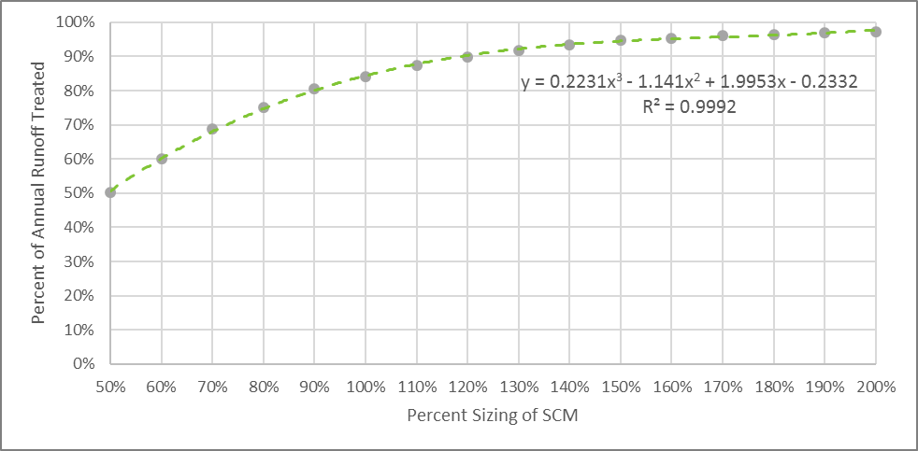

Hydrologic Partitioning of Treated Runoff
Because the MDC require that infiltration pavement systems infiltrate the entire design storm, 100% of treated runoff is allocated to ET&I. The relative proportion of ET&I to Effluent in the Treated Runoff is estimated to remain constant regardless of whether the system is under or oversized but does vary based on Hydrologic Soil Group (HSG). The relative proportion of treated runoff between ET&I and Effluent as it varies based on HSG is shown in Table D-5. Figure D-8 below shows how the percent of annual runoff treated increases with the percent sizing of an infiltrating permeable pavement system.

Table D-5: ET&I and Effluent as Percent of Treated Runoff in Permeable Pavement Systems
SCM | HSG | ET&I | Effluent
Permeable pavement (infiltration) per MDC | A | 100 | 0
 | B | 100 | 0
 | C | 100 | 0
 | D | NA | NA
Permeable pavement (detention, unlined) per MDC | A | 10 | 90
 | B | 5 | 95
 | C | 0 | 100
 | D | 0 | 100
Permeable pavement (detention, lined) per MDC | A | 0 | 100
 | B | 0 | 100
 | C | 0 | 100
 | D | 0 | 100
Permeable pavement with design alternatives per the HyPerMod | A | Tool Output | Tool Output
 | B
 | C
 | D

Figure D-8: Runoff Fates for a 100% Sized Permeable Pavement (Infiltration)
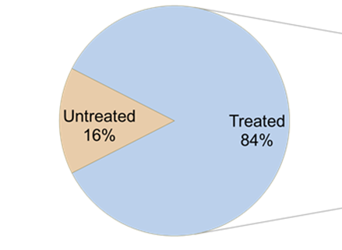
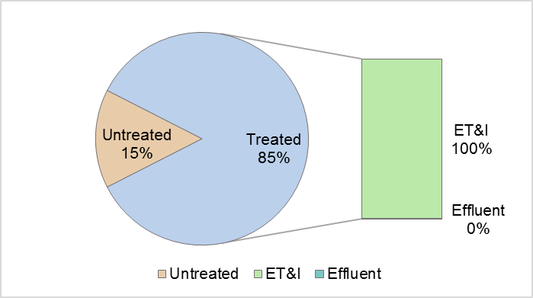

Permeable pavement systems that are designed for detention have all or nearly all of the treated runoff released as effluent. An unlined permeable pavement system installed in an A or B soil will infiltrate 10 or 5 percent of the design storm, respectively. This is illustrated in the figure below.
Figure D-9: Runoff Fates for a 100% Sized Permeable Pavement (Detention)
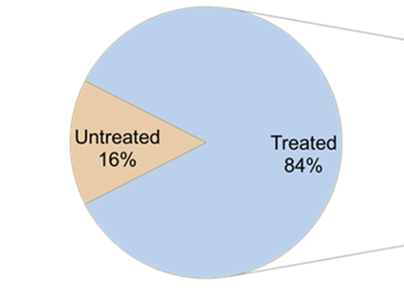
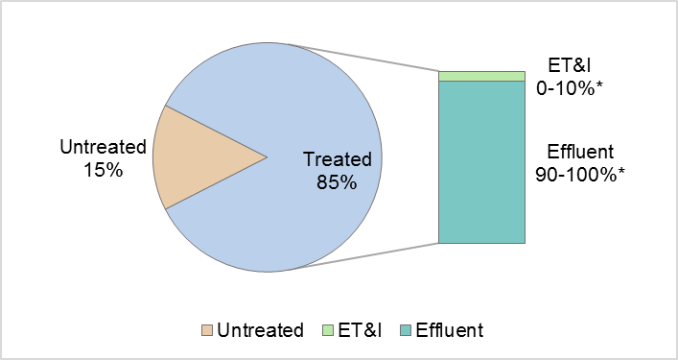
* Note: The partitioning between ET&I and Effluent depends on the soil type and whether a liner is used.

Minimum Design Criteria and Design Alternatives
Minimum Design Criteria for Permeable Pavement can be found in Rule 15A NCAC 02H .1055.
Design guidance for Permeable Pavement can be found in Chapter C-5 of the Stormwater Design Manual: https://deq.nc.gov/about/divisions/energy-mineral-and-land-resources/stormwater/stormwater-program/stormwater-design
Design alternatives to permeable pavement designs should be analyzed using the PermPave HyPerMod. The design alternatives that are available and their effects on the treatment outcomes are summarized in the table below. To account for the uncertainty associated with this modeling-based approach, the user should select a factor of safety of 10 percent when applying the PermPave HyPerMod. More information on the PermPave HyPerMod may be found in Part F: Overview of NCSU Modeling and Accounting Tools.

Design Alternative | Where it is allowed | Effect on Performance
Exclude the internal water storage (IWS) zone | Retrofit or new development | Reduces % annual runoff treated.  Reduces % of ET&I.  Increases TN & TP EMCs.
Vary the IWS depth | Retrofit or new development | A deeper IWS depth:  Increases % annual runoff treated.  Increases % of ET&I.  No effect on TN & TP EMCs.
Vary the profile depth (the combined depth of the pavement and aggregate) | Retrofit or new development | A deeper profile depth:  Increases % annual runoff treated.  Increases % ET&I.  Has no effect on TN & TP EMCs.
Vary the run-on ratio (the amount of additional runoff to the permeable pavement. | Retrofit or new development | A larger run-on ratio:  Reduces % annual runoff treated. Reduces % ET&I.  Has no effect on TN & TP EMCs.

Studies Used for TSS and Volume
Permeable Pavement (2 pass, 1 fail, 1 invalid):
Location | Site Name | Mean Influent (mg/L) | Mean Effluent  (mg/L) | Removal Efficiency | Pass or Fail?
Fayetteville | Fayetteville | 106.20 | 10.97 | 90% | Pass
Goldsboro | Goldsboro PICP | 12.00 | 8.00 | 33% | Invalid
Durham | Piney Wood | 703.17 | 14.74 | 98% | Pass
Willoughby Hills, OH | Ohio Lg Out | 26.00 | 159.00 | -512% | Fail

Studies Used for Nutrient EMCs
There are four studied installations that meet the requirements for evaluating TN and TP EMCs. The median of installation effluent medians was used for assigning TN and TP EMCs.

Site | Location | Resource
Fayetteville | Fayetteville, NC | Smolek 2016
Goldsboro | Goldsboro, NC | Bean et al. 2007
Piney Wood | Durham, NC | Smolek 2016
Cary | Cary, NC | Bean 2005

References
Bean, E.Z. 2005. A Field Study to Evaluate Permeable Pavement Surface Infiltration Rates, Runoff Quantity, Runoff Quality, and Exfiltrate Quality. (Unpublished Master's). North Carolina State University, Raleigh, NC.

Bean, E.Z., Hunt, W.F., & Bidelspach, A.D. (2007). Evaluation of four permeable pavement sites in eastern North Carolina for runoff reduction and water quality impacts. Journal of Irrigation and Drainage Engineering, 133(6), 583-592. doi:10.1061/(ASCE)0733-9437(2007)133:6(583)

Collins, K. A. (2007). A field evaluation of four types of permeable pavement with respect to water quality improvement and flood control. (Unpublished Master's). North Carolina State University, Raleigh, NC. http://www.lib.ncsu.edu/resolver/1840.16/2227

Collins, K., Hunt, W., & Hathaway, J. (2010). Side-by-side comparison of nitrogen species removal for four types of permeable pavement and standard asphalt in eastern North Carolina. Journal of Hydrologic Engineering, 15(6), 512-521. doi:10.1061/(ASCE)HE.1943-5584.0000139

Smolek, A. P. (2016). Monitoring and modeling the performance of ultra-urban stormwater control measures in North Carolina and Ohio. (Unpublished Doctoral). North Carolina State University, Raleigh, NC. http://www.lib.ncsu.edu/resolver/1840.16/11020

Winston, R. J., Davidson-Bennett, K. M., Buccier, K. M., & Hunt, W. F. (2016). Seasonal variability in stormwater quality treatment of permeable pavements situated over heavy clay and in a cold climate. Water Air Soil Pollution, 227(5) doi:10.1007/s11270-016-2839-6

Sand Filters

Hydrologic Partitioning and Nutrient Credit Table
SCM | Role |  | % of Annual Runoff |  |  | EMC_{effluent} (mg/L)
 |  | HSG | Untreated Over-flow | ET&I | Treated Effluent | TN | TP
Sand Filter (open) per MDC | Primary | A | 10 | 9 | 81 | 1.09 | 0.08
 |  | B | 10 | 5 | 85
 |  | C | 10 | 0 | 90
 |  | D | 10 | 0 | 90
Sand Filter (closed) per MDC | Primary | A | 10 | 0 | 90 | 1.09 | 0.08
 |  | B | 10 | 0 | 90
 |  | C | 10 | 0 | 90
 |  | D | 10 | 0 | 90

Annual Runoff Treated Based on Percent Sizing
Based on modeling done by NCSU using 20 years of rainfall data, a device designed for the design storm (1 inch or 1.5 inches on the Coast) and a 12-hour drawdown time will treat 90 percent of the total annual runoff volume. Per the MDC, sand filters are only required to be sized for 0.75 times the design storm because they have such rapid draw down times that allow stormwater to be treated throughout the duration of the storm, which increases their capacity. Figure D-10 below shows how the percent of annual runoff treated increases with the percent sizing of the sand filter.
Figure D-10: Size versus Annual Runoff Treated for a Sand Filter
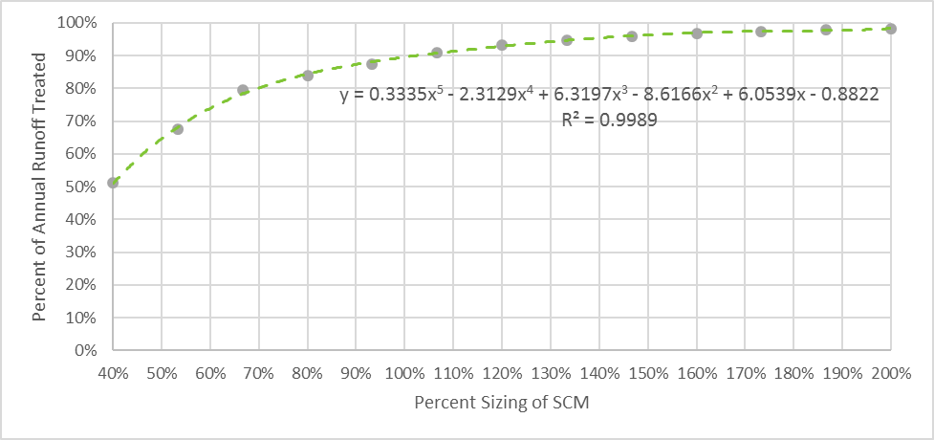

Hydrologic Partitioning of Treated Runoff
The relative proportion of ET&I to Effluent in the Treated Runoff is estimated to remain constant regardless of whether the sand filter is under- or oversized but does vary based on Hydrologic Soil Group (HSG). The relative proportion of treated runoff between ET&I and Effluent as it varies based on HSG is shown in Table D-6. . Figure D-11 below shows runoff fates for a 100% sized sand filter.

Table D-6: ET&I and Effluent as Percent of Treated Runoff in Sand Filters
SCM | HSG | ET&I | Effluent
Sand Filter (open) per MDC | A | 10 | 90
 | B | 5 | 95
 | C | 0 | 100
 | D | 0 | 100
Sand Filter (closed) per MDC | A | 0 | 100
 | B | 0 | 100
 | C | 0 | 100
 | D | 0 | 100

Figure D-11: Runoff Fates for a 100% Sized Sand Filter
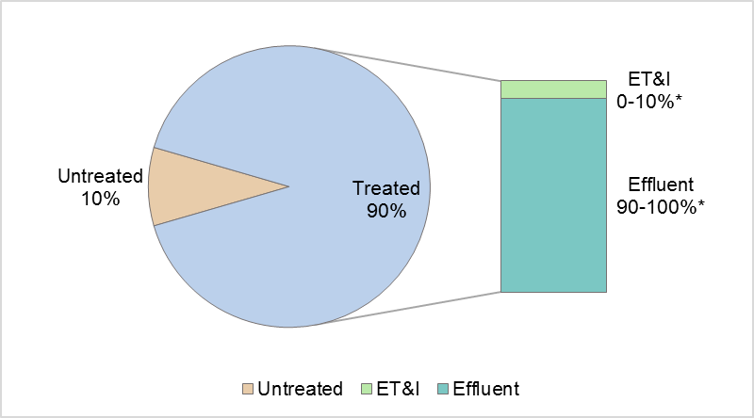
* NOTE: The percentages of ET&I and Effluent vary based on whether the sand filter is closed or open and the soil type for open sand filters.

Minimum Design Criteria and Design Alternatives
Minimum Design Criteria for Sand Filters can be found in Rule 15A NCAC 02H .1056.
Design guidance for Sand Filters can be found in Chapter C-6 of the Stormwater Design Manual: https://deq.nc.gov/about/divisions/energy-mineral-and-land-resources/stormwater/stormwater-program/stormwater-design
Other than the two options for “open” and “closed” sand filters, there are no approved design alternatives for sand filters. However, rule language allows the applicant to propose design alternatives for any SCM and provide technical justification based on engineering calculations and the results of research studies showing that the proposed design is equally or more protective of water quality than the current MDC for the SCM and that it shall function in perpetuity.

Studies Used for TSS and Volume
Sand Filters (3 pass, 1 fail, 1 invalid):
Location | Site Name | Mean Influent (mg/L) | Mean Effluent  (mg/L) | Removal Efficiency | Pass or Fail?
Alexandria, VA | Airpark | 47.00 | 14.00 | 70.21% | Pass
Tallahassee, FL | Appleyard | 182.59 | 50.00 | 72.62% | Fail
Tallahassee, FL | Megginnis | 105.18 | 4.87 | 95.37% | Pass
Durham, NH | Univ. of NH | 45.26 | 19.20 | 57.58% | Pass
North Potomac, MD | Willow Oaks 1 | 14.00 | 5.00 | 64.29% | Invalid

Studies Used for Nutrient EMCs
Sand Filters have three studied installations that meet requirements for evaluating TN and four studied installations for evaluating TP. All these studies were conducted by NCSU but have not yet been published. The median of installation effluent medians was used for assigning TP EMC, and the highest median EMC was used for assigning TN EMC. While wet swales are treated as an alternative design for hydrologic purposes, they are assigned the same EMC in order to maximize data available for assigning EMCs.

Site | Location | Resource
Cape SC | Fayetteville, NC | (unpublished NCSU data)
Park SC | Greensboro, NC | (unpublished NCSU data)
RNR SC | Fayetteville, NC | (unpublished NCSU data)
Sheetz SC | Greensboro, NC | (unpublished NCSU data)

References
Wright Water Engineers, Inc., Geosyntec Consultants for the Water Environment Research Foundation (WERF), American Society of Civil Engineers (ASCE)/Environmental and Water Resources Institute (EWRI), American Public Works Association (APWA), Federal Highway Administration (FHWA), & U.S. Environmental Protection Agency (EPA). (2016). International Stormwater BMP Database. Retrieved from http://www.bmpdatabase.org/retrieveBMPs.asp

Rainwater Harvesting

Hydrologic Partitioning and Nutrient Credit Table
SCM | Role |  | % of Annual Runoff |  |  | EMC_{effluent} (mg/L)
 |  | HSG | Untreated Over-flow | ET&I | Treated Effluent | TN |  | TP
Rainwater Harvesting per MDC | Primary | A | 15 max | Custom based on Tool output |  | 1.73 | 0.08
 |  | B | 15 max
 |  | C | 15 max
 |  | D | 15 max

Annual Runoff Treated Based on Percent Sizing
A rainwater harvesting system is considered to be a primary SCM when it is designed such that water demand, passive discharge or a combination of the two is provided for a minimum of 85% of the total annual runoff volume as demonstrated through water balance calculations. Rainwater harvesting may also be designed as a secondary SCM if it does not meet this goal but instead is used to slowly release a smaller fraction of the annual runoff volume.
Designers will use the NCSU Rainwater Harvester model to determine the annual runoff treated based on the system’s size, rainfall data for the location where it will be installed, its drainage area, and withdrawals from the cistern for use and/or drawdown.

Hydrologic Partitioning of Treated Runoff
To be considered a primary SCM, a rainwater harvesting system has to capture and treat a minimum of 85% of annual runoff. However, the relative proportion of ET&I to Effluent in treated runoff depends upon how the cistern water is used or discharged. For example, if cistern water is used as graywater or slowly infiltrated to a receiving vegetated area, then the entire volume of treated runoff will be considered as ET&I (removed from the system). On the other hand, if the water is discharged to a stormwater drain or another SCM, then the treated effluent from the rainwater harvesting system will take on the fates and EMCs of the location or device to which its effluent is discharged. The Rainwater Harvester Tool provides hydrologic partitioning of the average annual runoff (e.g. overflow, ET&I, and effluent) depending on the system setup as designed within the Tool.

Minimum Design Criteria and Design Alternatives
Minimum Design Criteria for Rainwater Harvesting can be found in Rule 15A NCAC 02H .1057.
Design guidance for Rainwater Harvesting can be found in Chapter C-7 of the Stormwater Design Manual: https://deq.nc.gov/about/divisions/energy-mineral-and-land-resources/stormwater/stormwater-program/stormwater-design
There are no approved design alternatives for rainwater harvesting systems. However, rule language allows the applicant to propose design alternatives for any SCM and provide technical justification based on engineering calculations and the results of research studies showing that the proposed design is equally or more protective of water quality than the current MDC for the SCM and that it shall function in perpetuity.

Studies Used for TSS and Volume
Rainwater Harvesting (5 invalid):
Location | Site Name | Mean Influent (mg/L) | Mean Effluent  (mg/L) | Removal Efficiency | Pass or Fail?
Raleigh | Fire Station 24 | 5.19 | 3.45 | 33.62% | Invalid
Raleigh | Fire Station 28 | 5.35 | 4.58 | 14.41% | Invalid
Raleigh | Fire Station 6 | 4.20 | 3.48 | 17.20% | Invalid
Raleigh | Fire Station 8 | 5.18 | 7.76 | -49.99% | Invalid
Raleigh | Whole Foods | 5.44 | 1.81 | 66.63% | Invalid

Studies Used for Nutrient EMCs

Five NCSU monitored rainwater harvesting tanks were used to determine the EMCs. All five sites were located in Raleigh, NC. Median pollutant effluent concentrations from each site were calculated, and the median of all installations’median concentrations was used to determine the EMCs.

Site | Location | Resource
Fire Station 24 RWH | Raleigh, NC | Debusk 2013; Debusk and Hunt 2014
Fire Station 28 RWH | Raleigh, NC | Debusk 2013; Debusk and Hunt 2014
Fire Station 6 RWH | Raleigh, NC | Debusk 2013; Debusk and Hunt 2014
Fire Station 8 RWH | Raleigh, NC | Debusk 2013; Debusk and Hunt 2014
Whole Foods RWH | Raleigh, NC | Wilson 2013; Wilson et al. 2014

References
DeBusk, K. M. (2013). Rainwater harvesting: Integrating water conservation and stormwater management. (Unpublished Doctoral). North Carolina State University, Raleigh, NC. http://www.lib.ncsu.edu/resolver/1840.16/8855

DeBusk, K. M., & Hunt, W. F. (2014). Impact of rainwater harvesting systems on nutrient and sediment concentrations in roof runoff. Water Science & Technology: Water Supply, 14(2), 220-229.

Jones, M. P., & Hunt, W. F. (2010). Performance of rainwater harvesting systems in the southeastern United States. Resources, Conservation and Recycling, 54(10), 623-629. doi: http://dx.doi.org/10.1016/j.resconrec.2009.11.002

Wilson, C. E. (2013). A comparison of runoff quality and quantity from an innovative underground low impact development and a conventional development. (Unpublished Master's). North Carolina State University, Raleigh, NC. http://www.lib.ncsu.edu/resolver/1840.16/8679

Wilson, C. E., Hunt, W. F., Winston, R. J., & Smith, P. (2014). Assessment of a rainwater harvesting system for pollutant mitigation at a commercial location in
Raleigh, NC, USA. Water Science & Technology: Water Supply, 14(2), 283-290.

Green Roof

Hydrologic Partitioning and Nutrient Credit Table
SCM | Role |  | % of Annual Runoff |  |  | EMC_{effluent} (mg/L)
 |  | HSG | Untreated Over-flow | ET&I | Treated Effluent | TN | TP
Green Roof per MDC | Secondary | N/A | 0 | 60 | 40 | 2.44 | 0.76

Annual Runoff Treated Based on Percent Sizing
Since a green roof receives all of the rain that falls upon it, it is considered to treat 100 percent of the annual runoff. Currently, there is not an approved method for under or oversizing a green roof.

Hydrologic Partitioning of Treated Runoff
Based on research conducted in North Carolina and in New Zealand (where the climate is very similar to North Carolina), a green roof designed in accordance with the MDC will divide the Treated Runoff into about 60 percent ET&I and 40 percent effluent, as shown in Table D-7. Figure D-12 below shows runoff fates for a 100% sized green roof.

Table D-7: ET&I and Effluent as Percent of Treated Runoff in Green Roofs
SCM | HSG | ET&I | Effluent
Green Roof per MDC | N/A | 60 | 40

Figure D-12: Runoff Fates for a Green Roof
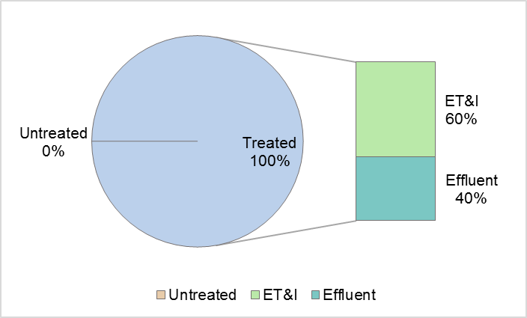

Minimum Design Criteria and Design Alternatives
Minimum Design Criteria for Green Roofs can be found in Rule 15A NCAC 02H .1058.
Design guidance for Green Roofs can be found in Chapter C-8 of the Stormwater Design Manual: https://deq.nc.gov/about/divisions/energy-mineral-and-land-resources/stormwater/stormwater-program/stormwater-design
There are no approved design alternatives for green roofs. However, rule language allows the applicant to propose design alternatives for any SCM and provide technical justification based on engineering calculations and the results of research studies showing that the proposed design is equally or more protective of water quality than the current MDC for the SCM and that it shall function in perpetuity.

Studies Used for TSS and Volume
Green Roof (3 invalid):
Location | Site Name | Mean Influent (mg/L) | Mean Effluent  (mg/L) | Removal Efficiency | Pass or Fail?
Auckland, NZ | Tamaki 100 mm | 4.00 | 5.40 | -35.00% | Invalid
Auckland, NZ | Tamaki 150 mm | 4.00 | 8.00 | -100.00% | Invalid
Auckland, NZ | WCC | 1.80 | 2.80 | -55.56% | Invalid

Studies Used for Nutrient EMCs

Data from two NCSU monitored green roofs, one published study, and three studies from the International Stormwater BMP Database were used to determine the EMCs for green roofs. These studies were conducted in Goldsboro, NC, Storrs, CT, and Auckland, NZ. Data from the Auckland sites were included because of the similar annual rainfall patterns between North Carolina and New Zealand (NIWA, 2016; State Climate Office of North Carolina, 2016). Median pollutant effluent concentrations from each site were calculated, and the mean of the median concentrations was used to determine the EMCs.

Site | Location | Resource
NCGR | Goldsboro, NC | Moran 2004; Hathaway et al. 2008
WCCGR | Goldsboro, NC | Moran 2004; Hathaway et al. 2008
Storrs GR | Storrs, CT | Gregoire and Clausen 2011
Tamaki 100 mm | Auckland, NZ | Wright Water Engineers, Inc. 2016; Fassman et al. 2013
Tamaki 150 mm | Auckland, NZ | Wright Water Engineers, Inc. 2016; Fassman et al. 2013
WCC | Auckland, NZ | Wright Water Engineers, Inc. 2016; Fassman et al. 2013

References
Fassman, E. A., Voyde, S. R., & Hong, Y. S. (2013). Extensive green (living) roofs for stormwater mitigation part 2: Performance monitoring. (No. TR2010/018). Auckland, NZ: Auckland UniServices.

Gregoire, B. G., & Clausen, J. C. (2011). Effect of a modular extensive green roof on stormwater runoff and water quality. Ecological Engineering, 37(6), 963-969. doi: http://dx.doi.org/10.1016/j.ecoleng.2011.02.004

Hathaway, A. M., Hunt, W. F., & Jennings, G. D. (2008). A field study of green roof hydrologic and water quality performance. American Society of Agricultural and Biological Engineers, 51(1), 37-44.
Moran, A. M. (2004). A North Carolina field study to evaluate greenroof runoff quantity, runoff quality, and plant growth. (Unpublished Master's). North Carolina State University, Raleigh, NC. http://www.lib.ncsu.edu/resolver/1840.16/803
NIWA. (2016). Climate summaries. Retrieved from https://www.niwa.co.nz/education-and-training/schools/resources/climate/summary
State Climate Office of North Carolina. (2016). 1971-2000 climate normals. Retrieved from http://climate.ncsu.edu/cronos/normals.php

Disconnected Impervious Surface

Hydrologic Partitioning and Nutrient Credit Table
SCM | Role |  | % of Annual Runoff |  |  | EMC_{effluent} (mg/L)
 |  | HSG | Untreated Over-flow | ET&I | Treated Effluent | TN | TP
DIS per MDC | Secondary | A | 10 | 58 | 32 | 2.44 | 0.76
 |  | B | 10 | 45 | 45
 |  | C | 10 | 36 | 54
 |  | D | 10 | 27 | 63

Annual Runoff Treated Based on Percent Sizing
Based on modeling done by NCSU using 20 years of rainfall data, a DIS designed for the 0.75 inch per hour storm intensity will treat 90 percent of the total annual runoff volume. A DIS may not be sized for less than the 0.75 inch per hour storm intensity due to the risk of erosion, which can cause the practice to become a source rather than a sink for TSS. Figure D-13 below shows the minimum sizing required for a DIS with respect to the area of rooftop from which is receives runoff. The maximum area that may drain to a single vegetated receiving area is 500 square feet of roof.
Figure D-13: Minimum Sizing for the Vegetated Receiving Area (VRA) of a DIS
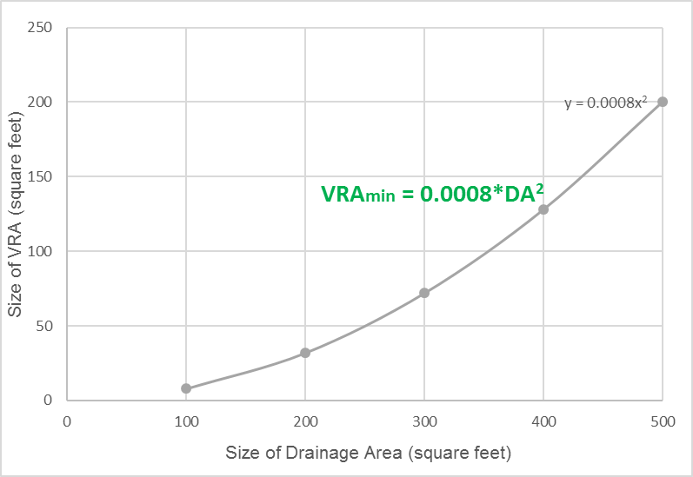

Hydrologic Partitioning of Treated Runoff
Oversizing an DIS that is designed to treat the entire 0.75 inch per hour storm from the drainage area will result in an increased fraction of the Treated Runoff being allocated to ET&I. Figure D-14 below shows the relative proportion of treated runoff comprised by ET&I for 100 percent sized and oversized DIS systems. The related Effluent percentage is 100 minus the ET&I. The percentage sizing would be determined based on the ratio between the area of the VRA required and the area of the VRA provided (see Figure D-13 above).
Figure D-14: Percent ET&I for DIS Based on VRA Size
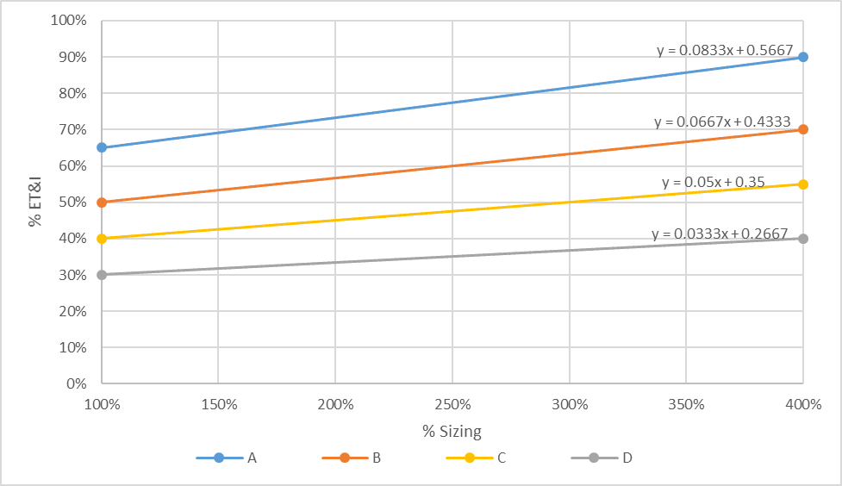

Minimum Design Criteria and Design Alternatives
Minimum Design Criteria for Disconnected Impervious Surface can be found in Rule 15A NCAC 02H .1060.
Design guidance for Disconnected Impervious Surface can be found in Chapter C-10 of the Stormwater Design Manual: https://deq.nc.gov/about/divisions/energy-mineral-and-land-resources/stormwater/stormwater-program/stormwater-design
There are no approved design alternatives for DIS. However, rule language allows the applicant to propose design alternatives for any SCM and provide technical justification based on engineering calculations and the results of research studies showing that the proposed design is equally or more protective of water quality than the current MDC for the SCM and that it shall function in perpetuity.

Studies Used for TSS and Volume

Studies Used for Nutrient EMCs
Four NC DIS studies were evaluated, all were found to have influent values too low to provide at least 8 influent-effluent pairs for assigning EMC values. TN and TP EMCs assigned in 2018 are used until more data are available.

References

Carmen, N.B., Hunt, W.F., and Anderson, A.R. 2013. Evaluating Residential Disconnected Downspouts as Stormwater Control Measures. 6th International Low Impact Development Conference. August 19-22, 2013. St. Paul, MN. (Extended Abstract)

Hunt, W.F., J.M. Hathaway, R.J. Winston, and S.J. Jadlocki. 2010. Runoff Volume Reduction by a Level Spreader - Vegetated Filter Strip System in Suburban Charlotte, NC. Journal of Hydrologic Engineering, 15(6): 399-503.
One LS-VFS system with a 19.4-meter level spreader and 900 m2 vegetated filter strip was monitored over a 14-month period with 23 monitored storm events. Receiving runoff from a 2.15 acre water shed only produced outflow from the LS-VFS system in three storm events that were all greater than 1.6 inches. Total volume reduction over the monitoring period was 85 percent.

Knight, E.M.P, W.F. Hunt, and R.J. Winston. Side-by-side evaluation of four level spreader–vegetated filter strips and a swale in eastern North Carolina. 2013. Journal of Soil and Water Conservation.
Two LS-VFS pairs and a swale in eastern North Carolina were evaluated for pollutant concentrations (N, P, and, TSS) and hydrologic performance. Two of the LS-VFSs were amended with sand and a phosphorus sorptive aggregate. Length of LS-VFS system was also evaluated. Runoff volumes were reduced by 36–59 percent. The systems consistently reduced the nitrogen and particulate pollution, while all systems increased total phosphorus.

Line, D.E. and W.F. Hunt. 2009. Performance of a Bioretention Area and a Level Spreader-Grass Filter Strip at Two Highway Sites in North Carolina. Journal of Irrigation and Drainage Engineering, 135(2): 217-224.
One LS-VFS and a bioretention area along the North Carolina highway system were evaluated for pollutant and volume reduction. The LS-VFS was found to have 49 percent total volume reduction over the 13 storm events monitored.

Taguchi, V., Hunt, W. F., & Carey, E. S. (2016). Windward Oaks downspout disconnection. Raleigh, NC: North Carolina State University.

Winston, R.J., W.F. Hunt, D.L. Osmond; W.G. Lord; and M.D. Woodward. 2011. Field Evaluation of Four Level Spreader–Vegetative Filter Strips to Improve Urban Storm-Water Quality. Journal of Irrigation and Drainage Engineering 137(3):170-182.
Two level spreader-vegetated filter strip pairs were tested in Louisburg and Apex, NC. The LS-VFS systems reliably removed particulate pollution from all locations. Runoff volumes were reduced by 40-50 percent. A minimum width of 25 feet appeared sufficient to achieve most observed benefits.

Level Spreader – Filter Strips

Hydrologic Partitioning and Nutrient Credit Table
SCM | Role |  | % of Annual Runoff |  |  | EMC_{effluent} (mg/L)
 |  | HSG | Untreated Over-flow | ET&I | Treated Effluent | TN | TP
LS-FS per MDC | Secondary | A | 10 | 54 | 36 | 1.03 | 0.17
 |  | B | 10 | 36 | 54
 |  | C | 10 | 22 | 68
 |  | D | 10 | 13 | 77
LS-FS with Virophos sand added to the filter strip | Secondary | A | 10 | 54 | 36 | 1.03 | 0.17
 |  | B | 10 | 36 | 54
 |  | C | 10 | 22 | 68
 |  | D | 10 | 13 | 77

Annual Runoff Treated Based on Percent Sizing
Based on modeling done by NCSU using 20 years of rainfall data, a device designed for the 0.75 inch per hour storm intensity will treat 90 percent of the total annual runoff volume. An LS-FS may not be sized for less than the 0.75 inch per hour storm intensity due to the risk of erosion, which can cause the practice to become a source rather than a sink for TSS. Figure D-15 below shows runoff fates for a 100% sized LS-FS.
Figure D-15: Minimum Sizing for the Vegetated Receiving Area (VRA) of an LS-FS
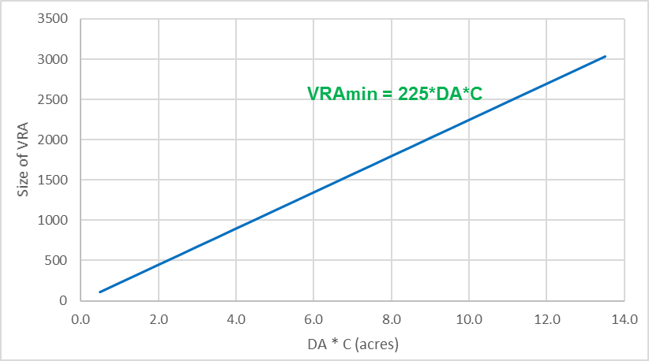
Dr. Ryan Winston and Andrew Anderson provided raw data from former graduate students for the following sites: Apex 25, Apex 50, Louisburg 25, and Louisburg 50. These raw data were summarized and published by Winston et al. (2015). Due to QA/QC issues, a combination of raw and published data from Knight et al. (2013) and Knight (2013) were used for the following sites: Wilson Small Amended, Wilson Large Amended, Wilson Small Unamended, and Wilson Large Unamended. The QA/QC consisted of verifying all of the data were transcribed and calculated correctly in the Excel file, and the descriptive statistics were consistent with published materials.
Study | DA (acres) | % Imp | Runoff Coeff (C) | Design Flow (cfs) | LS Length (ft) | VRA Width (ft) | Ratio of VRA to DA | Percent Volume Reduction
Line and Hunt, 2009 | 0.86 | 49% | 0.57 | 0.49 | 24 | 56 | 49 | 49%
Hunt et al., 2010 | 2.15 | 45% | 0.54 | 1.16 | 63.5 | 158 | 55 | 85%
Winston, 2011 | 0.49 | 73% | 0.75 | 0.37 | 13 | 25 | 35 | 48%
Winston, 2011 | 0.49 | 73% | 0.75 | 0.37 | 13 | 51 | 35 | 41%
Knight et al, 2013 | 0.27 | 56% | 0.62 | 0.17 | 26 | 20 | 155 | 36%
Knight et al, 2013 | 0.36 | 56% | 0.62 | 0.22 | 66 | 20 | 296 | 59%
Knight et al, 2013 | 0.38 | 56% | 0.62 | 0.24 | 26 | 20 | 110 | 42%
Knight et al, 2013 | 0.57 | 56% | 0.62 | 0.35 | 66 | 20 | 187 | 57%

In most cases, an LS-FS will be equipped with a flow splitting device (this is usually required per the MDC). If the LS-FS is installed as a retrofit, then the designer can design the flow splitting device to direct only a portion of the flow during the 0.75 inch per hour storm to the LS-FS. To design a LS-FS to capture only a portion of the flow from a large drainage area, a designer would work backward from the area that is available for the LS-FS installation. Using that information, the designer would calculate the flow rate that corresponds to the available VRA and design the flow splitting device to bypass larger storm events. The designer would determine the size of the drainage area that would be credited for nutrient removal by working backward from the equation:
VRA_{available}
DA_{credited} =
(225*C)

Hydrologic Partitioning of Treated Runoff
Oversizing an LS-FS is designed to treat the entire 0.75 inch per hour storm from the drainage area will result in an increased fraction of the Treated Runoff being allocated to ET&I. Figure D-16 below shows the relative proportion of treated runoff comprised by ET&I for 100% and oversized LS-FS systems. The related Effluent percentage is 100 minus the ET&I.
The percentage sizing would be determined based on the equation presented above.
Figure D-16: Percent ET&I for LS-FS Based on VRA Size
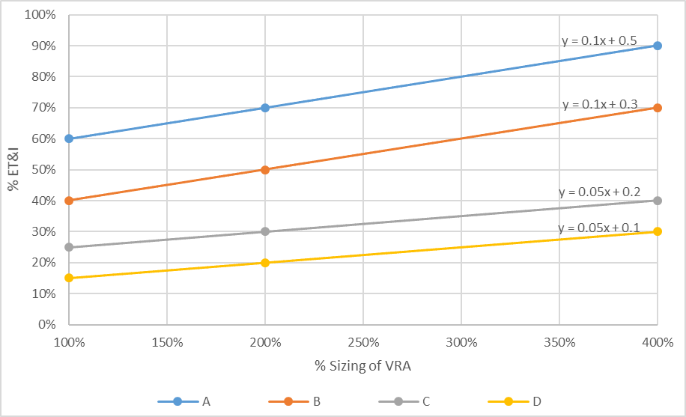

Minimum Design Criteria and Design Alternatives
Minimum Design Criteria for Level Spreader-Filter Strips can be found in Rule 15A NCAC 02H .1059.
Design guidance for Level Spreader-Filter Strips can be found in Chapter C-9 of the Stormwater Design Manual: https://deq.nc.gov/about/divisions/energy-mineral-and-land-resources/stormwater/stormwater-program/stormwater-design
Three design alternatives are currently available for LS-FS as summarized in the table below.
Design Alternative | Where it is Allowed | Effect on Results
Reducing the width of the filter strip (but it may not be reduced below 15 feet) | Retrofit only | Does not affect the credit in any way; but does provide flexibility in the geometry of the LS-FS that may be needed for retrofits.
Amending the filter strip with Virophos. | Retrofit or new development | Reduces the EMCs for TN and TP.
On retrofit projects, designers may have the option of reducing the 30-foot width of the VRA (required by LS-FS MDC 8) to 15 feet. However, the designer will need to extend the length of the level spreader such that the following equation still holds:
VRA_{min} = 225 * DA * C
A second design alternative to LS-FS that is allowed on either retrofits or new development is amending the soil in the VRA with ViroPhos sand. This design alternative does not alter the percentages of annual runoff treated or the percent ET&I.

Studies Used for TSS and Volume
Level Spreader-Filter Strips (7 pass, 1 fail):
Location | Site Name | Mean Influent (mg/L) | Mean Effluent  (mg/L) | Removal Efficiency | Pass or Fail?
Apex | Apex 25 | 64.00 | 37.00 | 42% | Fail
Apex | Apex 50 | 64.00 | 25.00 | 61% | Pass
Louisburg | Louisburg 25 | 41.50 | 17.00 | 59% | Pass
Louisburg | Louisburg 50 | 41.00 | 10.00 | 76% | Pass
Wilson | Wilson Small Amended | 33.00 | 5.00 | 85% | Pass
Wilson | Wilson Small Unamended | 33.00 | 8.00 | 76% | Pass
Wilson | Wilson Large Amended | 33.00 | 5.00 | 85% | Pass
Wilson | Wilson Large Unamended | 33.00 | 8.00 | 76% | Pass

Studies Used for Nutrient EMCs

Data from 8 installations were available for determining TN and TP EMCs for “plain” LS-FS and 2 installations for those amended with Virophos. Data for the two types were analyzed separately and found to not be different enough to use only 2 sites for rating Virophos performance. Median effluents from all 10 installations were used together, using the median of these 10 values, to establish EMCs for both “plain” LS-FS and LS-FS with Virophos.

Site | Location | Resource
Apex 25 LS-FS | Apex, NC | Winston et al. 2011
Apex 50 LS-FS | Apex, NC | Winston et al. 2011
Louisburg 25 LS-FS | Louisburg, NC | Winston et al. 2011
Louisburg 50 LS-FS | Louisburg, NC | Winston et al. 2011
Wilson Small Unamended LS-FS | Wilson, NC | Knight et al. 2013
Wilson Small Amended LS-FS | Wilson, NC | Knight et al. 2013
Wilson Large Unamended LS-FS | Wilson, NC | Knight et al. 2013
Wilson Large Amended LS-FS | Wilson, NC | Knight et al. 2013
Inlet East LS-FS | Chatham County, NC | Hunt et al. 2013
Inlet Swale LS-FS | Chatham County, NC | Hunt et al. 2013

References
Hunt, W.F., J.M. Hathaway, R.J. Winston, and S.J. Jadlocki. 2010. Runoff Volume Reduction by a Level Spreader - Vegetated Filter Strip System in Suburban Charlotte, NC. Journal of Hydrologic Engineering, 15(6): 399-503.
One LS-VFS system with a 19.4-meter level spreader and 900 m² vegetated filter strip was monitored over a 14-month period with 23 monitored storm events. Receiving runoff from a 2.15-acre water shed only produced outflow from the LS-VFS system in three storm events that were all greater than 1.6 inches. Total volume reduction over the monitoring period was 85 percent.

Hunt, W.F., Winston, R., Anderson, A. (2013). Final Report: Level Spreader-Vegetated Filter Strip Demonstration and Evaluation in Chatham Co., North Carolina. NCDEQ 319 Project, Contract Number 2861.

Knight, E.M.P, W.F. Hunt, and R.J. Winston. 2013. Side-by-side evaluation of four level spreader–vegetated filter strips and a swale in eastern North Carolina. Journal of Soil and Water Conservation, 68(1), 60-72. doi:10.2489/jswc.68.1.60.
Two LS-VFS pairs and a swale in eastern North Carolina were evaluated for pollutant concentrations (N, P, and, TSS) and hydrologic performance. Two of the LS-VFSs were amended with sand and a phosphorus sorptive aggregate. Length of LS-VFS system was also evaluated. Runoff volumes were reduced by 36–59 percent. The systems consistently reduced the nitrogen and particulate pollution, while all systems increased total phosphorus.

Line, D.E. and W.F. Hunt. 2009. Performance of a Bioretention Area and a Level Spreader-Grass Filter Strip at Two Highway Sites in North Carolina. Journal of Irrigation and Drainage Engineering, 135(2): 217-224.
One LS-VFS and a bioretention area along the North Carolina highway system were evaluated for pollutant and volume reduction. The LS-VFS was found to have 49 percent total volume reduction over the 13 storm events monitored.

Winston, R.J., W.F. Hunt, D.L. Osmond; W.G. Lord; and M.D. Woodward. 2011. Field Evaluation of Four Level Spreader–Vegetative Filter Strips to Improve Urban Storm-Water Quality. Journal of Irrigation and Drainage Engineering, 137(3), 170-182. doi:10.1061/(ASCE)IR.1943-4774.0000173.
Two level spreader-vegetated filter strip pairs were tested in Louisburg and Apex, NC. The LS-VFS systems reliably removed particulate pollution from all locations. Runoff volumes were reduced by 40-50 percent. A minimum width of 25 feet appeared sufficient to achieve most observed benefits.

Pollutant Removal Swale

Hydrologic Partitioning and Nutrient Credit Table
SCM | Role |  | % of Annual Runoff |  |  | EMC_{effluent} (mg/L)
 |  | HSG | Untreated Over-flow | ET&I | Treated Effluent | TN | TP
Treatment swale with dry conditions | Secondary | A | 10 | 22 | 68 | 1.07 | 0.13
 |  | B | 10 | 13 | 77
 |  | C | 10 | 4 | 86
 |  | D | 10 | 0 | 90
Treatment swale with wet conditions | Secondary | A | 10 | 36 | 54 | 1.05 | 0.11
 |  | B | 10 | 27 | 63
 |  | C | 10 | 18 | 72
 |  | D | 10 | 9 | 81

Annual Runoff Treated Based on Percent Sizing
Based on modeling done by NCSU using 20 years of rainfall data, a pollutant removal swale designed for the 0.75 inch per hour storm intensity will treat 90 percent of the total annual runoff volume. The partitioning of treated runoff between ET&I and Effluent is based on recent research conducted by NCSU-BAE at two North Carolina sites. A pollutant removal swale may not be sized for less than the 0.75 inch per hour storm intensity due to the risk of erosion, which can cause the practice to become a source rather than a sink for TSS. North Carolina has not yet developed oversizing standards for pollutant removal swales because they are not frequently selected SCMs.

Hydrologic Partitioning of Treated Runoff
The relative proportion of ET&I to Effluent in the Treated Runoff is estimated to vary based on Hydrologic Soil Group (HSG), as shown in Table D-8.
Table D-8: ET&I and Effluent as Percent of Treated Runoff in Pollutant Removal Swales
SCM | HSG | ET&I | Effluent
Pollutant removal swale with dry conditions | A | 25 | 75
 | B | 15 | 85
 | C | 5 | 95
 | D | 0 | 100
Pollutant removal swale with wet conditions | A | 40 | 60
 | B | 30 | 70
 | C | 20 | 80
 | D | 10 | 90

Minimum Design Criteria and Design Alternatives
Minimum Design Criteria for Pollutant Removal Swales can be found in Rule 15A NCAC 02H .1061.
Design guidance for Pollutant Removal Swales can be found in Chapter C-11 of the Stormwater Design Manual: https://deq.nc.gov/about/divisions/energy-mineral-and-land-resources/stormwater/stormwater-program/stormwater-design
There is one approved design alternative for swales in wet conditions. There are no other approved design alternatives for pollutant removal swales. However, rule language allows the applicant to propose design alternatives for any SCM and provide technical justification based on engineering calculations and the results of research studies showing that the proposed design is equally or more protective of water quality than the current MDC for the SCM and that it shall function in perpetuity.

Studies Used for TSS and Volume
Pollutant Removal Swale (4 pass, 0 fail, 3 invalid):
Location | Site Name | Mean Influent (mg/L) | Mean Effluent  (mg/L) | Removal Efficiency | Pass or Fail?
Johnston County | I40 A | 9.00 | 16.00 | -78% | Invalid
Johnston County | I40 B | 15.50 | 21.00 | -35% | Invalid
Duplin County | I40 D | 9.00 | 47.00 | -422% | Invalid
Knightdale | Mango Creek | 55.00 | 30.00 | 45% | Pass
Knightdale | Mango Creek Retrofitted Swale | 52.00 | 15.00 | 71% | Pass
Knightdale | Mango Creek Swale | 47.00 | 26.00 | 45% | Pass
Wilson | Wilson | 33.00 | 10.00 | 70% | Pass

Studies Used for Nutrient EMCs

EMCs were calculated separately for “dry swales” (5 installations for both TN and TP) and “wet swales” (2 installations for both TN and TP). EMCs for dry swales were calculated using the median of installation effluent medians for TN and for TP. EMCs for wet swales were calculated by using the highest median of installation effluent medians.

Site | Location | Resource
I40 A | Johnston County, NC | Winston et al. 2012
I40 B (wet swale) | Johnston County, NC | Winston et al. 2012
I40 C (wet swale) | Sampson County, NC | Winston et al. 2012
I40 D | Duplin County, NC | Winston et al. 2012
Mango Creek | Knightdale, NC | Luell 2001
Mango Creek 2 | Knightdale, NC | Powell 2015
Wilson | Wilson, NC | Powell 2015

References
Luell, S. K. (2011). Evaluating the impact of bioretention cell size and swale design in treating highway bridge deck runoff. (Unpublished Master's). North Carolina State University, Raleigh, NC. http://www.lib.ncsu.edu/resolver/1840.16/6921

Powell, J. T. (2015). Evaluating the hydrologic and water quality benefits associated with retrofitting vegetated swales with check dams. (Unpublished Master's). North Carolina State University, Raleigh, NC. http://www.lib.ncsu.edu/resolver/1840.16/10675

Winston, R., Hunt, W., Kennedy, S., Wright, J., & Lauffer, M. (2012). Field evaluation of storm-water control measures for highway runoff treatment. Journal of Environmental Engineering, 138(1), 101-111. doi:10.1061/(ASCE)EE.1943-7870.0000454

Dry Pond

Hydrologic Partitioning and Nutrient Credit Table
SCM | Role |  | % of Annual Runoff |  |  | EMC_{effluent} (mg/L)
 |  | HSG | Untreated Over-flow | ET&I | Treated Effluent | TN | TP
Dry Pond per MDC | Secondary | A | 16 | 8 | 76 | 1.33 | 0.22
 |  | B | 16 | 4 | 80
 |  | C | 16 | 0 | 84
 |  | D | 16 | 0 | 84

Annual Runoff Treated Based on Percent Sizing
Based on modeling done by NCSU using 20 years of rainfall data, a device designed for the design storm (1 inch or 1.5 inches on the Coast) and a 60-hour drawdown time will treat 84 percent of the total annual runoff volume. Figure D-17 below shows how the percent of annual runoff treated increases with the percent sizing of the dry pond.
Figure D-17: Size versus Annual Runoff Treated for a Dry Pond
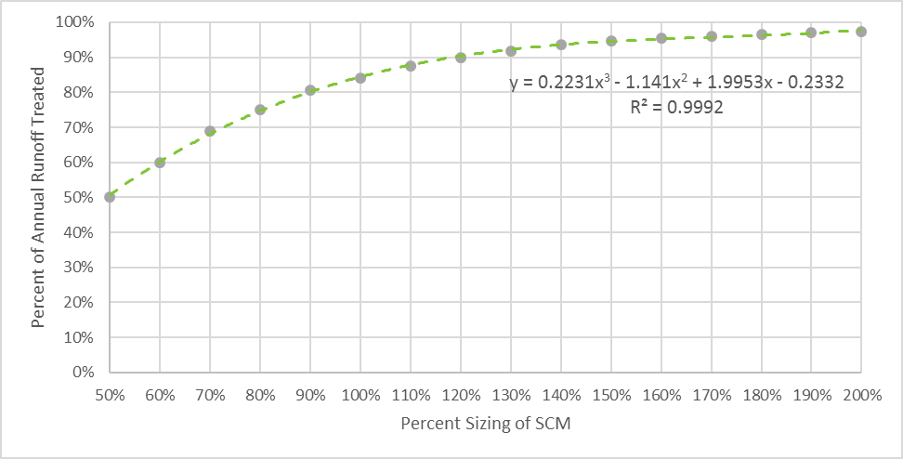

Hydrologic Partitioning of Treated Runoff
The relative proportion of ET&I to Effluent in the Treated Runoff is estimated to remain constant regardless of whether the pond is under or oversized but does vary based on Hydrologic Soil Group (HSG). The relative proportion of treated runoff between ET&I and Effluent as it varies based on HSG is shown in Table D-9. Figure D-18 below shows runoff fates for a 100% sized dry pond.

Table D-9: ET&I and Effluent as Percent of Treated Runoff in Dry Ponds
SCM | HSG | ET&I | Effluent
Dry Pond per MDC | A | 10 | 90
 | B | 5 | 95
 | C | 0 | 100
 | D | 0 | 100

Figure D-18: Runoff Fates for a 100% Sized Dry Pond
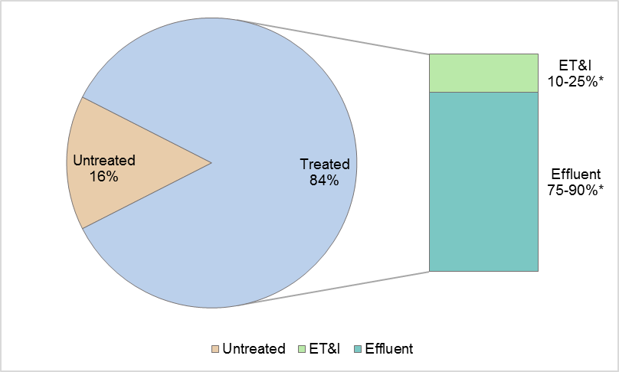
* NOTE: The percentages of ET&I and Effluent vary based on HSG.

Minimum Design Criteria and Design Alternatives
Minimum Design Criteria for Dry Ponds can be found in Rule 15A NCAC 02H .1062.
Design guidance for Dry Ponds can be found in Chapter C-12 of the Stormwater Design Manual: https://deq.nc.gov/about/divisions/energy-mineral-and-land-resources/stormwater/stormwater-program/stormwater-design
There are no approved design alternatives for dry ponds. However, rule language allows the applicant to propose design alternatives for any SCM and provide technical justification based on engineering calculations and the results of research studies showing that the proposed design is equally or more protective of water quality than the current MDC for the SCM and that it shall function in perpetuity.

Studies Used for TSS and Volume
Dry Pond (1 pass, 0 fail, 3 invalid):
Location | Site Name | Mean Influent (mg/L) | Mean Effluent  (mg/L) | Removal Efficiency | Pass or Fail?
Greenville, NC | Greenville | 98.50 | 28.00 | 71.57% | Pass
Charlottesville, VA | Hillsdale | 16.17 | 20.27 | 71.57% | Invalid
Charlotte | Morehead | 12.00 | 5.00 | -25.36% | Invalid
Charlotte | University | 12.00 | 7.00 | 58.33% | Invalid

Studies Used for Nutrient EMCs
Eight studied installations were available for assigning nutrient EMCs. However, only seven installations for TN qualified for use based on a minimum of 8 influent-effluent sample pairs. The medians of installation effluent medians for TN and for TP were used to assign EMCs.

Site | Location | Resource
MA 1 DP | Archdale, NC | Wissler et al 2020
MA 2 DP | Archdale, NC | Wissler et al 2020
MOV1 IN DP | Morrisville, NC | Mazer 2018
MOV2 IN DP | Morrisville, NC | Mazer 2018
Morehead Place DP | Charlotte, NC | Hathaway et al 2007c
Greenville DP | Greenville, NC | Wright Water Engineers et al 2016
University Park DP | Charlotte, NC | Hathaway et al 2007e
Mountain Park DP | Lilburn, GA | Wright Water Engineers et al 2016

References

Hathaway, J. M., Hunt, W. F., & Johnson, A. (2007c). Morehead place dry detention basin final monitoring report. Raleigh, NC: North Carolina State University. http://charlottenc.gov/StormWater/SurfaceWaterQuality/Documents/MoreheadPlaceDryDetentionFinalReport.pdf

Hathaway, J. M., Hunt, W. F., & Johnson, A. (2007e). University executive park dry detention basin final monitoring report. Raleigh, NC: North Carolina State University.

Mazer, K.E. 2018. Converting a Dry Pond to a Constructed Stormwater Wetland to Enhance Water Quality. (Unpublished Master's). North Carolina State University, Raleigh, NC.

Stanley, D.W. 1996. Pollutant Removal by a Stormwater Dry Detention Pond. Water Environment Research, Vol. 68, No. 6 (Sep. - Oct., 1996), pp. 1076-1083.

Wissler, A.D., Hunt, W.F., McLaughlin, R.A. 2020. Water Quality and Hydrologic Performance of Two Dry Detention Basins Receiving Highway Stormwater Runoff in the Piedmont Region of North Carolina. J. Sustainable Water Built Environ. 6(2): 05020002

Wright Water Engineers, Inc., Geosyntec Consultants for the Water Environment Research Foundation (WERF), American Society of Civil Engineers (ASCE)/Environmental and Water Resources Institute (EWRI), American Public Works Association (APWA), Federal Highway Administration (FHWA), & U.S. Environmental Protection Agency (EPA). (2016). International Stormwater BMP Database. Retrieved from http://www.bmpdatabase.org/retrieveBMPs.asp

Credit for Each New Stormwater Technology

StormFilter

Hydrologic Partitioning and Nutrient Credit Table
SCM | Role |  | % of Annual Runoff |  |  | EMC_{effluent} (mg/L)
 |  | HSG | Untreated Over-flow | ET&I | Treated Effluent | TN | TP
StormFilter per MDC with PhosphoSorb mediaTM | Primary | A | 10 | 0 | 90 | TBD (awaiting data) | TBD (awaiting data)
 |  | B | 10 | 0 | 90
 |  | C | 10 | 0 | 90
 |  | D | 10 | 0 | 90

Annual Runoff Treated Based on Percent Sizing
Based on modeling done by NCSU using 20 years of rainfall data, a device designed for the design storm (1 inch or 1.5 inches on the Coast) and a 12-hour drawdown time will treat 90 percent of the total annual runoff volume. Per the MDC, the required water quality volume retained upstream of the StormFilter shall be 0.75 times the design storm because it has such a rapid draw down time that allows stormwater to be treated throughout the duration of the storm. Per the requirements of the New Stormwater Technology (NEST) Program, the approval is for the configuration in which the device is tested. All StormFilter testing sited were equipped with 100 percent sized devices; therefore, the approval of this StormFilter requires 100-percent sizing be provided.

Hydrologic Partitioning of Treated Runoff
The relative proportion of ET&I to Effluent in the Treated Runoff is constant based on Hydrologic Soil Group (HSG), as shown in Table E-1.

Table E-1: ET&I and Effluent as Percent of Treated Runoff in StormFilter
SCM | HSG | ET&I | Effluent
StormFilter per MDC with PhosphoSorb mediaTM | A | 0 | 100
 | B | 0 | 100
 | C | 0 | 100
 | D | 0 | 100

Minimum Design Criteria and Design Alternatives

Minimum Design Criteria and design guidance for StormFilters can be found in Chapter D-1 of the Stormwater Design Manual: https://deq.nc.gov/about/divisions/energy-mineral-and-land-resources/stormwater/stormwater-program/stormwater-design
There are no approved design alternatives for StormFilter. However, rule language allows the applicant to propose design alternatives for any SCM and provide technical justification based on engineering calculations and the results of research studies showing that the proposed design is equally or more protective of water quality than the current MDC for the SCM and that it shall function in perpetuity.

Studies Used for TSS and Volume

Studies Used for Nutrient EMCs
(TBD pending data review)

Site | Location | Resource
Mitchell Community College | Mooresville, NC | Contech Engineered Solutions et al 2012
Lolo Pass Road | Zigzag, OR | Contech Engineered Solutions et al 2014

References
CONTECH Engineered Solutions Inc. 2014. The Stormwater Management StormFilter® with PhosphoSorb® Media Performance Evaluation Study: Lolo Pass Road, Zigzag, Oregon.
CONTECH Engineered Solutions Inc. 2012. North Carolina Department of Environment and Natural Resources Division of Water Quality Preliminary Evaluation Period Program Field Evaluation: The Stormwater Management StormFilter®: Treatment System.
CONTECH Construction Products Inc. 2010. Removal of Phosphorus from Urban Runoff Using the Stormwater Management StormFilter® with PhosphoSorb™ Media.
CONTECH Stormwater Solutions Inc. 2008. Design Guidelines: Design Methodologies for Projects in the State of North Carolina.
CONTECH Stormwater Solutions Inc. 2015. StormFilter® Inspection and Maintenance Procedures.

Silva Cell Suspended Pavement

Hydrologic Partitioning and Nutrient Credit Table
SCM | Role |  | % of Annual Runoff |  |  |  |  | EMC_{effluent} (mg/L)
 |  | HSG | Untreated Over-flow | ET&I |  | Treated Effluent |  | TN | TP
Silva Cell per MDC | Primary | A | 6 | 85 | 9 |  | 1.23 |  | 0.23
 |  | B | 6 | 67 | 27
 |  | C | 6 | 34 | 60
 |  | D | 6 | 13 | 81

Annual Runoff Treated Based on Percent Sizing

Hydrologic Partitioning of Treated Runoff
The partitioning of annual runoff into Treated Runoff and Bypass was estimated using NCSU’s HyPerTool, modeling Silva Cell like a bioretention cell at 100% size. NCSU’s HyPerTool partitions the Treated Runoff into ET&I versus Effluent. The HyPerTool was originally developed for traditional bioretention but has been used to successfully model Silva Cell systems as well.

Minimum Design Criteria and Design Alternatives

Minimum Design Criteria and design guidance for Silva Cells can be found in Chapter D-2 of the Stormwater Design Manual: https://deq.nc.gov/about/divisions/energy-mineral-and-land-resources/stormwater/stormwater-program/stormwater-design
There are no approved design alternatives for Silva Cells. However, rule language allows the applicant to propose design alternatives for any SCM and provide technical justification based on engineering calculations and the results of research studies showing that the proposed design is equally or more protective of water quality than the current MDC for the SCM and that it shall function in perpetuity.

Studies Used for TSS and Volume

Studies Used for Nutrient EMCs
Three studied installations were available for assigning nutrient EMCs. However, only two installations for TN qualified for use based on a minimum of 8 influent-effluent sample pairs. The highest installation effluent medians for TN and for TP were used to assign EMCs.
Site | Location | Resource
Ann SC | Wilmington, NC | Page et al. 2015
Orange SC | Wilmington, NC | Page et al. 2015
DSC North SC | Durham, NC | Waickowski et al 2021

References
Page, J.L., Winston, R.J., Hunt, W.F. 2015. Soils beneath suspended pavements: An opportunity for stormwater control and treatment. Ecological Engineering 82: 40-48.
Waickowski, S., Hunt,W. F., Kelly, A. 2021. Silva Cell Stormwater Retrofits. Final Report: North Carolina Land and Water Fund, Research Project 2014-2008.

Filterra®

Hydrologic Partitioning and Nutrient Credit Table
SCM | Role |  | % of Annual Runoff |  |  | EMC_{effluent} (mg/L)
 |  | HSG | Untreated Over-flow | ET&I | Treated Effluent | TN | TP
Filterra | Primary | A | 10 | 0 | 90 | 0.95 | 0.08
 |  | B | 10 | 0 | 90
 |  | C | 10 | 0 | 90
 |  | D | 10 | 0 | 90

Annual Runoff Treated Based on Percent Sizing
Based on the data from Withers and Ravenel study (2008), when properly sized Filterra shall treat 90% of the total annual rainfall.

Hydrologic Partitioning of Treated Runoff
The relative proportion of ET&I to Effluent in the Treated Runoff is constant based on Hydrologic Soil Group (HSG), as shown in Table E-2.

Table E-2: ET&I and Effluent as Percent of Treated Runoff in Filterra
SCM | HSG | ET&I | Effluent
Filterra® per MDC | A | 0 | 100
 | B | 0 | 100
 | C | 0 | 100
 | D | 0 | 100

Minimum Design Criteria and Design Alternatives
.
Minimum Design Criteria and design guidance for Filterra can be found in Chapter D-3 of the Stormwater Design Manual: https://deq.nc.gov/about/divisions/energy-mineral-and-land-resources/stormwater/stormwater-program/stormwater-design
In accordance with the MDC, the following Filterra configurations are approved:
  - Filterra Offline
  - Filterra Internal Bypass – Curb
  - Filterra Peak Diversion
  - Filterra Bioscape Vault
  - Filterra Bioscape

Any additional design alternatives would be required to be approved through the NEST program.

Studies Used for TSS and Volume

Studies Used for Nutrient EMCs
Three study sites were available for assigning nutrient EMCs; data are partly unpublished. Only two study sites for TN and two study sites for TP qualified for use based on a minimum of 8 influent-effluent sample pairs. The highest individual site effluent medians for TN and for TP were used to assign EMCs.
Site | Location | Resource
Fayetteville FT | Fayetteville, NC | Braswell et al 2018
Cal'z Pizza FT | Virginia Beach, VA | (unpublished data)
UVA FT | Charlottesville, VA | (unpublished data)

References
Braswell, A.S., Anderson, A.R., Hunt, W.F. 2018. Hydrologic and Water Quality Evaluation of a Permeable Pavement and Biofiltration Device in Series. Water, 10(33).

Geosyntec Consultants, 2015. Filterra Equivalency Analysis and Design Criteria.

Withers & Ravenel, 2008. Engineering Analysis for Filterra: Proprietary BMP Report.
Yu, Shaw L. and R.L. Stanford, 1996. Field Evaluation of Filterra® Stormwater Bioretention Filtration System. Department of Civil Engineering, University of Virginia, Charlottesville.

BayFilter

Hydrologic Partitioning and Nutrient Credit Table
SCM | Role |  | % of Annual Runoff |  |  | EMC_{effluent} (mg/L)
 |  | HSG | Untreated Over-flow | ET&I | Treated Effluent | TN | TP
BayFilter | Primary | A | 10 | 0 | 90 | TBD*** | TBD***
 |  | B | 10 | 0 | 90
 |  | C | 10 | 0 | 90
 |  | D | 10 | 0 | 90

Annual Runoff Treated Based on Percent Sizing
Based on modeling done by NCSU using 20 years of rainfall data, a device designed for the design storm (1 inch or 1.5 inches on the Coast) and a 12-hour drawdown time will treat 90 percent of the total annual runoff volume. Per the MDC, the required water quality volume retained upstream of the BayFilter shall be 0.75 times the design storm because it has such a rapid draw down time that allows stormwater to be treated throughout the duration of the storm. If a rate-based sizing is used, the device will be sized based on the flow rate of the 1 inch or 1.5 inches on the Coast rainfall event and no upstream storage will be required. Per the requirements of the New Stormwater Technology (NEST) Program, the approval is for the configuration in which the device is tested. All BayFilter testing sited were equipped with 100 percent sized devices; therefore, the approval of this BayFilter requires 100-percent sizing be provided.

Hydrologic Partitioning of Treated Runoff
The relative proportion of ET&I to Effluent in the Treated Runoff is constant based on Hydrologic Soil Group (HSG), as shown in Table E-3.

Table E-3: ET&I and Effluent as Percent of Treated Runoff in BayFilter
SCM | HSG | ET&I | Effluent
BayFilterTM per MDC | A | 0 | 100
 | B | 0 | 100
 | C | 0 | 100
 | D | 0 | 100

Minimum Design Criteria and Design Alternatives

Minimum Design Criteria and design guidance for BayFilters can be found in Chapter D-4 of the Stormwater Design Manual: https://deq.nc.gov/about/divisions/energy-mineral-and-land-resources/stormwater/stormwater-program/stormwater-design
There are no approved design alternatives for BayFilter. However, rule language allows the applicant to propose design alternatives for any SCM and provide technical justification based on engineering calculations and the results of research studies showing that the proposed design is equally or more protective of water quality than the current MDC for the SCM and that it shall function in perpetuity.

Studies Used for TSS and Volume

Studies Used for Nutrient EMCs
EMCs have not yet been determined for BayFilter. Data from two monitored sites in North Carolina and one monitored site in Washington may be available to determine the EMCs for BayFilter but are in the process of evaluation. These studies were conducted in Huntersville, NC, Jacksonville, NC, and Woodinville, WA.

Site | Location | Resource
Huntersville Town Center | Huntersville, NC | BaySaver Technologies, LLC et al. 2016
Jacksonville Marketplace | Jacksonville, NC | BaySaver Technologies, LLC et al. 2016
Woodinville Sammamish River Outfall | Woodinville, WA | BayFilter Technologies, LLC et al. 2016

References
BAYSAVER Technologies, LLC, 2016. City of Huntersville Stormwater Field Evaluation, BayFilter™
BAYSAVER Technologies, LLC, 2016. Jacksonville Marketplace, Stormwater Field Evaluation, BayFilter™
BAYSAVER Technologies, LLC, 2016, Technical Evaluation Report BayFilter™ EMC System, Woodinville Sammamish River Outfall, Woodinville, Washington
BaySaver Technologies, LLC, 2017. Design Manual
BaySaver Technologies, LLC. 2016. BayFilter™ Operations and Maintenance Manual.

Overview of NCSU Modeling and Accounting Tools

Bioretention Hydrologic Performance Tool (HyPerTool)
The Bioretention HyPerTool was developed by North Carolina State University and is available for download at https://stormwater.bae.ncsu.edu/resources/ (go to the section “NCSU Stormwater Downloads”). The model simulates the hydrologic performance of bioretention cells with various design configurations by using historical rainfall data, drainage area, underlying hydrologic soil group, media depth, and depth of the internal water storage zone. Outputs from the model include the runoff volume fates (infiltration/evaporation, effluent, and surface runoff or overflow) and annual pollutant loads removed by the SCM. Data from field studies in Boone and Durham, NC as well as Perkins Township and Willoughby Hills, OH were used to develop the model.
The Bioretention HyPerTool was developed using DRAINMOD, which is a long-term, continuous simulation agricultural drainage model that is readily adaptable to simulate water movement through bioretention practices. Many of the DRAINMOD inputs correspond directly to bioretention cell design specifications and its output can be applied to assess the hydrologic performance of bioretention cells (Brown et al 2011). DRAINMOD’s application for bioretention cells is fully described in Brown et al 2011a and Winston 2016.
The DRAINMOD application for bioretention was based on field-based monitoring of bioretention facilities in Rocky Mount and Nashville, North Carolina. Long-term simulations using DRAINMOD were conducted to calibrate model input parameters with a specific focus on bioretention design specifications currently presented in the NCDENR Stormwater BMP Manual (NCDENR 2009). Each of the 432 DRAINMOD simulations are based on sixty years of historical, hourly rainfall and daily temperature records from the Raleigh-Durham International and Wilmington airports. The factors that varied between the simulations were surface storage depth, surface storage volume relative to the design event, underlying soil type, media depth, and drainage configuration. The effects of over-sizing and under-sizing the bioretention surface storage volume was also evaluated based on five additional variations of surface storage volume relative to the design capacity.
NCSU collected detailed hydrologic data from two bioretention field sites over a 24-month monitoring and calibration period. The eight bioretention cells were located in Nashville, NC representing a Piedmont/Coastal site and Rocky Mount, NC (Upper Coastal Plain). The Nashville site was conventionally drained, while the Rocky Mount bioretention cells had IWS. Variable media depths, media types, drainage configurations, underlying soils, and surface storage volumes were also manipulated (see Brown 2011a et al, Brown et al. 2011b, Brown et al. 2011c, and Brown et al 2013 for details) but differed between the two sites. The results of the field studies were used to calibrate and validate DRAINMOD. For both the calibration and validation time periods, the modeled stormwater volume of exfiltration and evapotranspiration was within 1 and 5 percent of the predicted volume for the underlying soil type sand and sandy clay loam cells, respectively.
Existing bioretention specifications at Rocky Mount and Nashville were altered to analyze the overall impact of different design specifications on the model and the implications for design recommendations. Long-term simulations were also conducted based on 60 years of historical hourly rainfall and daily temperature records as described above. These studies provide data that extend the applicability of this practice across the NC Piedmont and Upper Coastal Plain. The application of the drainage results can also reasonably be extended to Coastal Plain systems which may lie above predominately sandy soils as the underlying soil types studied in the Upper Coastal Plain cells in the Rocky Mount study were sandy clay loam and sand. Three underdrain configurations associated with these cells were assessed, adding more robust calibration data to the DRAINMOD simulations. The two cells studied in Nashville, NC contained soil cores classified as sandy-loam, loamy-sand, sandy-clay-loam, and clay-loam. The presence of clay in these underlying soils suggested extrapolation of DRAINMOD and HyPerTool to the Piedmont and Mountain regions could be possible, where more clay is typically found than in the Coastal Plain.
The results of the field data were used to calibrate and validate DRAINMOD. Overall, the maximum error between the predicted and calculated runoff volume (using the SCS CN method) from each set of cells during the validation period was less than 10 percent of the total water budget. For this reason, the HyPerTool incorporates an option for the user to apply a Factor of Safety of 10 percent. Model statistics demonstrate the strong agreement between simulated and observed water depth, (i.e., the predictive capabilities of the model (see Figures 1 and 2, taken from Brown et al 2011)). Consistent with the data, nutrient credits that are calculated using the procedures established in this document require that the factor of safety of 10 percent be assumed when running the HyPerTool. Figure F-1 show the predicted versus observed runoff volume at the Nashville bioretention cell.
Figure F-1: Predicted Versus Observed Runoff Volume at the Nashville Bioretention Cell
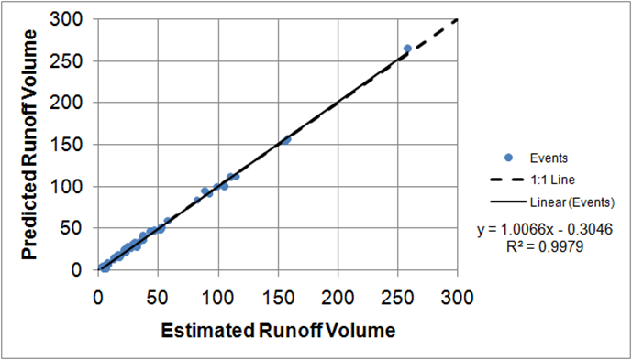

Brown, R. a., Skaggs, R.W., Hunt, W.F., 2013. Calibration and validation of DRAINMOD to model bioretention hydrology. J. Hydrol. 486, 430–442. Peer-review publication of Brown et al 2011. Description of DRAINMOD application for bioretention practices.

Rainwater Harvester Model
The Rainwater Harvester model was developed by North Carolina State University and is available for download at https://stormwater.bae.ncsu.edu/resources/ (go to the section “NCSU Stormwater Downloads”). The model simulates the hydrologic performance rainwater harvesting tanks or cisterns by using historical daily or hourly rainfall data, roof characteristics (drainage area, slope, and surface), cistern and overflow volumes, and detailed water usage information (Jones and Hunt, 2010; Debusk, 2013). Outputs from the model include: total runoff volume captured, average drawdown time, annual water usage, overflow frequency, annual pollutant loads removed by the system, and cost savings. Data from field studies in Craven County, Kinston, and Raleigh, NC were used to develop the model.
Location | Cistern Size (gal) | Contributing area (sf) | Normal annual rainfall | Water use
Craven County, NC | 2,998 | 1,798 | 54 | Irrigation
Raleigh, NC | 1,400 | 2,196 | 46 | Toilet flushing
Kinston, NC | 5,199 | 4,370 | 50 | Vehicle washing

DeBusk, K. M. (2013). Rainwater harvesting: Integrating water conservation and stormwater management. (Unpublished Doctoral). North Carolina State University, Raleigh, NC.
Jones, M. P., & Hunt, W. F. (2010). Performance of rainwater harvesting systems in the southeastern United States. Resources, Conservation and Recycling, 54(10), 623-629. doi: http://dx.doi.org/10.1016/j.resconrec.2009.11.002

Permeable Pavement Hydrologic Performance Model (PermPave HyPerMod)
The PermPave HyPerMod tool was developed by North Carolina State University and is available for download at https://stormwater.bae.ncsu.edu/resources/ (go to the section “NCSU Stormwater Downloads”). The model simulates the hydrologic performance of permeable pavement with various design configurations by using historical rainfall data, underlying hydrologic soil group, permeable pavement profile depth (pavement and aggregate), depth of the internal water storage zone, and run-on ratio (Smolek, 2016). Outputs from the model include the runoff volume fates (infiltration/evaporation, effluent, and surface runoff or overflow) and annual pollutant loads removed by the SCM. Data from field studies in Boone and Durham, NC as well as Perkins Township and Willoughby Hills, OH were used to develop the model.

Location | Pavement Type | DA (sf) | Percent Imperviousness | Pavement Infiltrative Surface Area (sf)
Boone, NC | PICP | NA | NA | 775
Durham, NC | PICP | 164 | 100% | 538
Perkins Township, OH | PC | 23,025 | 81% | 4,844
Willoughby Hillsª, OH | PICP | 9,580 | 100% | 2,207
Willoughby Hills^{b}, OH | PICP | 3,444 | 100% | 484
ª Site: Willoughby Hills Large
^{b} Site: Willoughby Hills Small
Smolek, A. P. (2016). Monitoring and modeling the performance of ultra-urban stormwater control measures in North Carolina and Ohio. (Unpublished Doctoral). North Carolina State University, Raleigh, NC. http://www.lib.ncsu.edu/resolver/1840.16/11020

SNAP Tool
North Carolina’s Stormwater Nitrogen and Phosphorus Tool (SNAP Tool) is a Microsoft Excel-based spreadsheet that uses the Simple Method to estimate annual runoff volume and nutrient loading generated by a user-defined development-scale watershed (<1 square mile). The Tool can estimate runoff volume and nutrient load reductions using different Stormwater Control Measures (SCMs). The type(s) and location(s) of the SCMs can be customized by users to optimize reduction of stormwater runoff and nutrients from a site.
The tool estimates annual runoff volume from a set of user-selected landcovers using the Simple Method and applies landcover-specific event mean concentrations (EMC) to determine the average annual total nitrogen and total phosphorus load contributed by each landcover type, and from the development site as a whole. SCMs are modeled by partitioning the influent runoff volume for the year across three hydrologic “fates”: bypassed or overflow which retains its original nutrient concentrations, treated effluent which leaves the SCM with an EMC specific to that SCM type, and water volume and nutrient load removed through evaporation, transpiration, and infiltration/exfiltration to shallow groundwater.
This SCM Credit Document has been developed as input to the SNAP tool and documentation of the methods used to determine hydrologic partitioning by SCMs and SCM-specific nitrogen and phosphorus effluent concentrations.

