Name of Facility
Standard Operating Procedure
for the Analysis of
Total Residual Chlorine, Low Level
Spectrophotometric, DPD
Method: SM 4500 Cl G-2011

Effective Date:

Supervisor Signature: ___________________ Date:__________
Supervisor Name (print):________________________________
Table of Contents
1.0 – Summary of Method Pg.
2.0 – Definitions Pg.
3.0 – Safety and Waste Handling Pg.
4.0 – Apparatus, Equipment and Reagents Pg.
5.0 – Interferences Pg.
6.0 – Sample Collection, Preservation and Holding Time Pg.
7.0 – Calibration Pg.
8.0 – Procedure Pg.
9.0 – Documentation Pg.
10.0 – Proficiency Testing Pg.
11.0 – Calculations and Reporting Pg.
12.0 – Quality Assurance and Quality Control Pg.
13.0 – Preventative Maintenance Pg.
14.0 – Troubleshooting and Corrective Action Pg.
15.0 – Employee Training Pg.
16.0 – References Pg.
17.0 – Revision History Pg.

Appendix 1 Pg.

Blue text is replaceable instructional language to be customized for your facility.
- Summary of Method

  - The pH buffer and DPD indicator are added to a sample and a colorimetric procedure is used to determine the concentration of total residual chlorine (TRC).

  - State what type of samples are analyzed, e.g., wastewater effluent, ground water monitoring well, etc. and the permit limits if applicable

  - State what your minimum reporting limit and working range is (based on the standards that are used for the factory-set calibration curve verification or construction of a laboratory-generated calibration curve)

  - This section is where any validated modifications to the method would be described

- Definitions

  - Calibration blank: Deionized or Distilled water, without chlorine and without DPD/buffer, that is used to zero the meter when a laboratory-prepared standard is used. A sealed standard (e.g., gel) blank may also be used for this purpose when sealed standards are used for the daily calibration verification.

  - Method blank: Deionized or Distilled water, from the same source used to make calibration and calibration verification standards, that is analyzed like a sample (i.e., with DPD/buffer added). The concentration of the method blank must not exceed 50% of the reporting limit (i.e., the lowest calibration or calibration verification standard concentration) or corrective action must be taken. Method blanks are required when using laboratory-prepared standards [including Proficiency Testing (PT) Samples] and anytime sample dilutions are performed.

  - Factory-set Calibration Curve: An internal calibration curve, generated and stored as meter programs by the instrument manufacturer.

  - Laboratory-generated Calibration Curve: A linear regression equation generated from the analysis of a series of laboratory-prepared liquid standards. Sample results are obtained by plugging sample absorbance values into the linear regression formula. This is usually performed automatically by direct read-out meters.

  - Second-source Standard: A standard prepared from a source independent (e.g., different vendor, different lot #) from that used to prepare the calibration standards. When using a factory-set calibration curve, all other standards are considered second source.

  - Daily Check Standard: A sealed standard (e.g., gel) or a laboratory-prepared standard of known concentration of the analyte of interest. A Daily Check Standard is used to evaluate laboratory performance and analyte recovery in a blank matrix.

  - Post-Analysis Calibration Verification Standard: A Daily Check Standard that is analyzed after all sample analyses.

  - µg/L: Units for the low-level measurement of TRC.

  - NC WW/GW LCB: North Carolina Wastewater Groundwater Laboratory Certification Branch

  - Add any other applicable acronyms used by your facility

- Safety and Waste Handling

  - Items that would be included in this section are things such as:
- Precautionary measures (list here and at the critical steps in the procedure)
- Personal protective equipment (e.g., gloves, eye protection, lab coat, work in a hood, etc.)
- Hazardous chemicals/reagents
- Storage and disposal of samples and reagents
- Reference to Chemical Hygiene Plan, if applicable
- Location of SDSs

- Apparatus, Equipment and Reagents
Note: Include storage conditions and expiration dates for standards and reagents. It is recommended catalog numbers also be included

  - List your meter with make and model

  - List the Pour-Thru cell and filtering apparatus, if applicable

  - Stock Calibration standard: what is the source of the stock calibration standard for the calibration verification or construction of a curve. (delete if contracting curve verification to another lab)

  - Check standard: state if it is purchased; or if prepared, how it is made. If using a laboratory-generated calibration curve, the check standard must be second source

  - Reagent water: state what type of water is used e.g., purchased deionized water, etc.

  - DPD reagent: state what is being used e.g., manufacturer, packet size or liquid reagent

  - Liquid buffer: (if using, e.g., manufacturer)

  - Include your sample cell size

  - Optional depending if PT samples are diluted by the facility and/or calibration/check standards are prepared by the facility: volumetric flask (state volumes used), volumetric pipet (state volumes used), mechanical pipet (if used)

  - Chemical containers are dated when received and when opened.

  - The date received, date opened (in use), vendor, lot number and expiration date of reagents is documented on a traceability log OR on the benchsheet.

  - The analyst’s initials, date of preparation, the volume or weight of standard(s) used, the solvent and final volume of the solution are documented when any solutions are prepared.

- Interferences

  - The DPD methods are subject to interference by oxidized forms of manganese. Sample color and turbidity may interfere in all colorimetric procedures. If interferences are present at your facility, document how to treat samples here.

- Sample Collection, Preservation and Holding Time

  - State what containers samples are collected in. Samples must be collected in glass or polyethylene containers.

  - There is no preservation requirement for Total Residual Chlorine.

  - The holding time is 15 minutes. Holding time is defined as the time from sample collection to the addition of DPD.

  - State where the sample is generally analyzed (e.g., immediately at the sampling site, in the lab within holding time, etc.)

- Calibration If a contract lab is used to perform calibration verifications, state that here instead of the directions that follow. If the lab is performing it, either the factory-set curve is verified (sections 7.1-7.7 follow Option 1 of the Approved Procedure for the Analysis of Total Residual Chlorine (DPD Colorimetric)) or a laboratory-generated calibration curve is programmed into the meter (sections 7.8-7.16 follow Option 3 of the Approved Procedure for the Analysis of Total Residual Chlorine (DPD Colorimetric)). Delete the section that is not applicable or update to describe Options 2 or 4 when using a daily curve.

  - The factory-set calibration curve on program (list program number) must be verified initially, every 12 months or any time the optics of the instrument are serviced.

  - The following standard concentrations are used: list your standard concentrations here (5 are required for annual calibration). One must be below your permit limit

    - See Appendix 2 for example standard preparation instructions or state here if this is contracted to another lab.

  - A method blank must be analyzed with the curve verification and have a value ≤ ½ the reporting limit (the reporting limit is the same concentration as your lowest standard in the curve)

  - Standards with concentrations < 50 µg/L must have a recovery of 75-125%.

  - Standards with concentrations ≥ 50 µg/L must have a recovery of 90-110%.

  - The Excel file shown in Appendix 1 is used to evaluate the acceptability of the curve verification. The Excel file may be downloaded from the NC WW/GW LC website here: https://deq.nc.gov/about/divisions/water-resources/water-resources-data/water-sciences-home-page/laboratory-certification-branch/technical-assistance-policies

  - If using a gel standard for daily calibration verification- Analyze the gel standard 3 times and document the individual values and the average. The average concentration will be the assigned value until the next curve verification.

  - Use sections 7.8 through 7.17 and delete 7.1-7.7 if constructing a laboratory-generated calibration curve (Option 3): A calibration curve must be constructed and programed into the meter initially, every 12 months and any time the optics of the instrument are serviced.

  - State which program on the instrument the constructed curve is saved in

  - The following standard concentrations are used: list your standard concentrations here (required to have 5 every 12 months and one must be below your permit limit)

    - See Appendix 2 for example standard preparation instructions or state here if this is contracted to another lab.

  - A method blank must be analyzed with the curve and have a value ≤ ½ the reporting limit (the reporting limit is the same concentration as your lowest standard in the curve)

  - For standards with concentrations < 50 µg/L, the back-calculated value and standard true value must agree within ± 25%.

  - For standards with concentrations ≥ 50 µg/L, the back-calculated value and standard true value must agree within ± 10%.

  - The correlation coefficient of the curve must be ≥0.995.

  - A second source standard must be analyzed and have a recovery of 70-125% for concentrations < 50 µg/L and have a recovery of 90-110% for concentrations ≥ 50 µg/L.

  - The excel file shown in Appendix 1 is used to evaluate the acceptability of the calibration curve. The Excel file may be downloaded from the NC WW/GW LC website here: https://deq.nc.gov/about/divisions/water-resources/water-resources-data/water-sciences-home-page/laboratory-certification-branch/technical-assistance-policies

  - If using a gel standard for daily calibration check- Analyze the gel standard 3 times and document the individual values and the average. The average concentration will be the assigned value until the next time a curve is constructed.

- Procedure

  - State the actual steps for analyzing the sample. Include steps such as how the meter is zeroed and what is used (e.g., reagent water or the gel blank). State the order in which reagents are added if using liquid reagents. If other steps such as manganese interference mitigation are followed, include that. State if sample blanking is used for color or turbidity and explain. State the order in which items are analyzed. Include the reaction time and how time is kept (e.g., with a timer) for the color development after reagents are added.

  - A daily check standard must be analyzed each day before sample analysis. See acceptance criteria in Section 12.

  - This section would be for analysts who are taking measurements at multiple sites and the meter is transported by vehicle. When the meter is transported by vehicle to another location after calibration, a post analysis calibration verification using the check standard must be analyzed after the last compliance sample. See acceptance criteria in Section 12.

- Documentation
The following must be documented in indelible ink whenever sample analysis is performed:
  - Date and time of sample collection

  - Date and time of sample analysis (i.e., time reagents are added) to verify the 15-minute holding time is met [Alternatively, one time may be documented for collection and analysis with the notation that samples are measured immediately at the sample site.]

  - Permitted facility name or permit number, and sample site (ID or location)

  - Collector’s/analyst’s name or initials

  - Preparation procedure and true values of laboratory-prepared standards, when applicable

  - Daily Check Standard analysis time

  - True value of the Daily Check Standard

  - Value obtained and percent recovery for the Daily Check Standard

  - Value obtained for the Method Blank, when prepared standards, PT Samples or diluted samples are analyzed (verification of ≤ ½ the concentration of the lowest calibration standard)

  - Time analyzed, true value, value obtained and percent recovery for the Post-analysis Calibration Verification Standard(s), where applicable

  - Quality control assessments (i.e., evaluation of acceptance criteria)

  - All data must be documented and reported in units of measure as specified in the permit (e.g., mg/L for regular level or µg/L for low level)

  - Traceability for chemicals, reagents, standards and consumables

  - Instrument identification (serial number preferred)

  - Date of most recent calibration curve generation or calibration curve verification

  - Statement that samples were filtered, when applicable

  - Final value to be reported

  - Parameter analyzed

  - Method reference (refer to Certified Parameters Listing (CPL) for correct method description)

  - Data qualifier(s), when applicable

  - Equipment maintenance (recommended)

- Proficiency Testing (PT) Procedure

  - Analysis of a blind PT Sample is required at least once during every 9-month PT calendar year (January 1- September 30).

    - A list of approved PT Sample Providers may be found on the NELAC website at http://nelac-institute.org/content/NEPTP/ptproviders.php. Check this list yearly to assure the chosen vendor is approved.

    - A PT Sample can be analyzed as early as January 1 and the graded result must be reported to NC WW/GW LC office from the PT Sample Provider no later than September 30.

  - PT Samples must be analyzed in accordance with the routine testing, calibration and reporting procedures, unless otherwise specified in the instructions supplied by the PT Sample Provider.

    - PT Samples are logged in and analyzed using the same staff, sample tracking systems, standard operating procedures including the same equipment, reagents, calibration techniques, analytical methods, and the same quality control acceptance criteria.

    - PT Samples shall not be analyzed with additional quality control. They are not to be replicated beyond what is routine for Compliance Sample analysis.

    - PT Sample analysis must be documented on the laboratory’s daily benchsheet.

  - The PT Sample Provider’s instructions for preparing the PT Sample must be followed and the practice documented by the analyst. The instruction sheet will be initialed and dated when the PT sample is prepared and retained for 5 years.

  - The following information must be included when reporting the PT Sample result.

    - EPA Lab Code: (enter here so it is easy to retrieve)

    - State Lab Certification number: (enter here so it is easy to retrieve)

    - Method description (refer to CPL for current method description): (enter here so it is easy to retrieve)

    - Mailing address for NC WW/GW LCB: 1623 Mail Service Center, Raleigh, NC 27699-1623

- Calculations and Reporting

  - Percent Recovery

% Recovery = Value Obtained x 100
True Value

  - Report in units of µg/L

  - Describe number of significant figures and rounding procedures

- Quality Assurance and Quality Control

  - Method blanks must have a concentration ≤ ½ the reporting limit, or corrective action must be taken (See Section 14.0).

  - Daily check standards and post-analysis check standards (if applicable) must read within ±10% of the known value for concentrations ≥50 µg/L and within ±25% for concentrations <50 µg/L, or corrective action must be taken (See Section 14.0).

  - Any sample greater than (state upper reporting limit) must be diluted to fall within the range of the calibration curve. Any sample less than (state lower reporting limit) will be reported as < (lower reporting limit)

  - If mechanical pipets are used for critical measurements (preparing standards) they must be calibrated every 12 months. State the frequency and steps for performing the calibration or state what lab is contracted to perform it.

  - State who is transcribing the data to the DMR and whether anyone peer reviews (checks) it. Peer review is recommended, but if that is not possible, it is recommended that the analyst rechecks their own transcription for errors after a certain amount of time has passed.

  - All documentation errors shall be corrected by drawing a single line through the error so that the original entry remains legible. Entries shall not be obliterated by erasures or markings. Wite-Out®, correction tape, or similar products designed to obliterate documentation are not to be used; instead the correction shall be written adjacent to the error. The correction shall be initialed by the responsible individual and the date of change documented. All manual data and log entries shall be written in indelible ink.

- Preventative Maintenance

  - State if a maintenance log or record is maintained

- Troubleshooting and Corrective Action

  - State what will be done if a meter does not pass the daily or post-analysis calibration checks or method blank criterion

- Employee Training

The following employee training must be documented and kept on file.

  - Include education, training, experience and/or demonstrated skills required for the position

  - Employee must have read and acknowledged understanding of this SOP – may also include reading the Approved Procedure for the Analysis of Total Residual Chlorine

  - Employee must obtain acceptable results on Proficiency Testing samples or other demonstrations of proficiency (e.g., Initial Demonstration of Capability (IDOC), side-by-side comparison with established analyst, etc.) before analyzing compliance samples for reporting. Specify how proficiency is demonstrated and how the results are evaluated.

- References

  - Standard Methods, 4500 Cl G-2011.

  - North Carolina Wastewater/Groundwater Laboratory Certification Approved Procedure for the Analysis of Total Residual Chlorine (DPD Colorimetric), Revision 11/29/2023 (consult NC WW/GW LCB for latest revision).

  - 15A NCAC 02H .0800

- Revision History

Type: Review or Revision | Date | Summary of Changes Made if Revision

Appendix 1(delete the excel spreadsheet that is not needed)
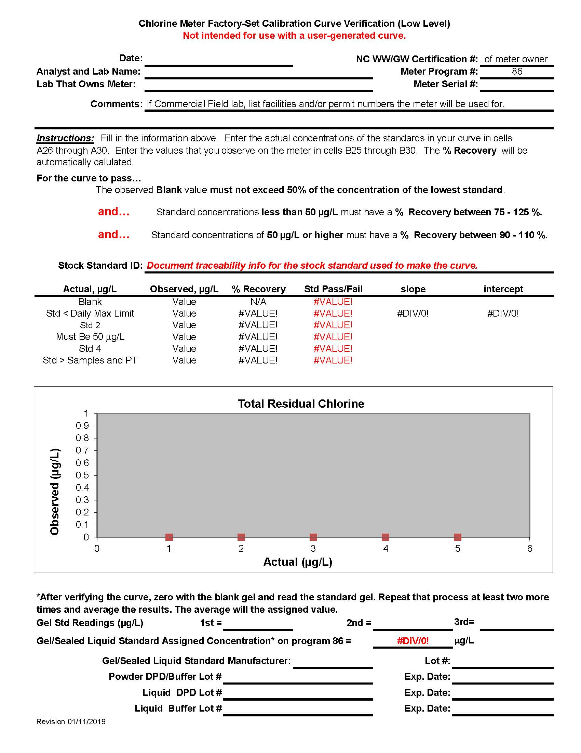

Appendix 2 (delete the standard preparation instructions that are not applicable)
TOTAL RESIDUAL CHLORINE CURVE PREPARATION
(For Facilities with a limit of 13 µg/L)

Note: The use of Class A Volumetric flasks and pipettes is critical to the accurate preparation of these low-level standards.

Needed Materials
Chlorine–Free Water
Potassium Permanganate
1-Liter Class A Volumetric Flask (Quantity = 1)
100-mL Class A Volumetric Flask (Quantity = 7)
50-mL Class A Volumetric Pipette (Quantity = 1)
25-mL Class A Volumetric Pipette (Quantity = 1)
10-mL Class A Volumetric Pipette (Quantity = 2)
5-mL Class A Volumetric Pipette (Quantity = 2)
2-mL Class A Volumetric Pipette (Quantity = 1)
1-mL Class A Volumetric Pipette (Quantity = 1)

800 mg/L Stock Standard – Prepare by dissolving 712.8 mg KMnO₄ (potassium permanganate) in 1 liter of chlorine-free water.

NOTE: If using a purchased 1000 mg/L Standard as your stock, the following Intermediate Standard should be prepared by diluting 8 mL of the 1000 mg/L standard to 100 mL with chlorine-free water.

80 mg/L Intermediate Standard – Prepare by diluting 10 mL of the 800 mg/L Stock Standard to 100 mL with chlorine-free water.

0.8 mg/L (800 µg/L) Working Standard - Prepare by diluting 1 mL of the 80 mg/L Intermediate Standard to 100 mL with chlorine-free water.

The Working Standard will be used to prepare your 5-Point Curve.

Add 50 mL of the Working Standard to a 100-mL volumetric flask and dilute to volume with chlorine-free water. This is your 400 µg/L Standard.

Add 25 mL of the Working Standard to a 100-mL volumetric flask and dilute to volume with chlorine-free water. This is your 200 µg/L Standard.

Add 10 mL of the Working Standard to a 100-mL volumetric flask and dilute to volume with chlorine-free water. This is your 80 µg/L Standard.

Add 5 mL of the Working Standard to a 100-mL volumetric flask and dilute to volume with chlorine-free water. This is your 40 µg/L Standard.

Add 5 mL of the 200 µg/L Standard to a 100-mL volumetric flask and dilute to volume with chlorine-free water. This is your 10 µg/L Standard.

Appendix 2 (delete the standard preparation instructions that are not applicable)
TOTAL RESIDUAL CHLORINE CURVE PREPARATION
(For Facilities with a limit of 17 µg/L)

Note: The use of Class A Volumetric flasks and pipettes is critical to the accurate preparation of these low level standards.

Needed Materials
Chlorine–Free Water
Potassium Permanganate
1-Liter Class A Volumetric Flask (Quantity = 1)
100-mL Class A Volumetric Flask (Quantity = 7)
50-mL Class A Volumetric Pipette (Quantity = 1)
25-mL Class A Volumetric Pipette (Quantity = 1)
10-mL Class A Volumetric Pipette (Quantity = 2)
5-mL Class A Volumetric Pipette (Quantity = 1)
2-mL Class A Volumetric Pipette (Quantity = 1)
1-mL Class A Volumetric Pipette (Quantity = 1)

800 mg/L Stock Standard – Prepare by dissolving 712.8 mg KMnO₄ (potassium permanganate) in 1 liter of chlorine-free water.

NOTE: If using a purchased 1000 mg/L Standard as your stock, the following Intermediate Standard should be prepared by diluting 8 mL of the 1000 mg/L standard to 100 mL with chlorine-free water.

80 mg/L Intermediate Standard – Prepare by diluting 10 mL of the 800 mg/L Stock Standard to 100 mL with chlorine-free water.

0.8 mg/L (800 µg/L) Working Standard - Prepare by diluting 1 mL of the 80 mg/L Intermediate Standard to 100 mL with chlorine-free water.

The Working Standard will be used to prepare your 5-Point Curve.

Add 50 mL of the Working Standard to a 100-mL volumetric flask and dilute to volume with chlorine-free water. This is your 400 µg/L Standard.

Add 25 mL of the Working Standard to a 100-mL volumetric flask and dilute to volume with chlorine-free water. This is your 200 µg/L Standard.

Add 10 mL of the Working Standard to a 100-mL volumetric flask and dilute to volume with chlorine-free water. This is your 80 µg/L Standard.

Add 5 mL of the Working Standard to a 100-mL volumetric flask and dilute to volume with chlorine-free water. This is your 40 µg/L Standard.

Add 2 mL of the Working Standard to a 100-mL volumetric flask and dilute to volume with chlorine-free water. This is your 16 µg/L Standard.

Appendix 2 (delete the standard preparation instructions that are not applicable)
TOTAL RESIDUAL CHLORINE CURVE PREPARATION
(For Facilities with a limit of 28 µg/L)

Note: The use of Class A Volumetric flasks and pipettes is critical to the accurate preparation of these low-level standards.

Needed Materials
Chlorine–Free Water
Potassium Permanganate

1-Liter Class A Volumetric Flask (Quantity = 1)
100-mL Class A Volumetric Flasks (Quantity = 7)
40-mL Class A Volumetric Pipette (Quantity = 1)
20-mL Class A Volumetric Pipette (Quantity = 1)
10-mL Class A Volumetric Pipette (Quantity = 2)
4-mL Class A Volumetric Pipette (Quantity = 1)
5-mL Class A Volumetric Pipette (Quantity = 1)
2-mL Class A Volumetric Pipette (Quantity = 1)
1-mL Class A Volumetric Pipette (Quantity = 1)

1000 mg/L Stock Standard – Prepare by dissolving 891 mg KMnO₄ (potassium permanganate) in 1 liter of chlorine-free water. (This standard can be purchased pre-made.)

100 mg/L Intermediate Standard – Prepare by diluting 10 mL of the Stock Standard to 100 mL with chlorine-free water.

1.0 mg/L (1000 µg/L) Working Standard - Prepare by diluting 1 mL of the Intermediate Standard to 100 mL with chlorine-free water.

The Working Standard will be used to prepare your 5-Point Curve.

Add 40 mL of the Working Standard to a 100-mL volumetric flask and dilute to volume with chlorine-free water. This is your 400 µg/L Standard.

Add 20 mL of the Working Standard to a 100-mL volumetric flask and dilute to volume with chlorine-free water. This is your 200 µg/L Standard.

Add 5 mL of the Working Standard to a 100-mL volumetric flask and dilute to volume with chlorine-free water. This is your 50 µg/L Standard.

Add 4 mL of the Working Standard to a 100-mL volumetric flask and dilute to volume with chlorine-free water. This is your 40 µg/L Standard.

Add 2 mL of the Working Standard to a 100-mL volumetric flask and dilute to volume with chlorine-free water. This is your 20 µg/L Standard.

