North Carolina Department of Environmental Quality
Division of Water Infrastructure
Fall 2023 Application for Funding
(Last updated: July 2023)

Low-interest loans, Principal Forgiveness (PF), and grants from the Drinking Water State Revolving Fund (DWSRF), the Clean Water State Revolving Fund (CWSRF), State Reserve Program (SRP), and Community Development Block Grant – Infrastructure (CDBG-I) program are available for drinking water and wastewater infrastructure construction projects. Principal forgiveness from the Bipartisan Infrastructure Law (BIL) DWSRF and CWSRF Emerging Contaminants funds are available for projects addressing PFAS contamination in drinking water and wastewater. Low-interest CWSRF loans are available for green projects such as stormwater quality infrastructure and stream restoration projects. Asset Inventory and Assessment (AIA) grants and Merger/Regionalization Feasibility (MRF) grants are available for drinking water and wastewater studies.
Pending state appropriations, grants from the Viable Utility Reserve (VUR) and Local Assistance for Stormwater Infrastructure Investments (LASII) may become available. VUR grants are for drinking water and wastewater infrastructure planning and construction projects for local governments designated as distressed. LASII grants are for stormwater planning, stormwater construction, and development and implementation of a new stormwater utility projects.
Complete this Application for Funding form and submit it along with required additional forms and documents to the Division of Water Infrastructure for consideration.
Note: there is a different application form for Lead Service Line Replacement funding.

Fall 2023 applications are due October 2, 2023 at 5:00pm.

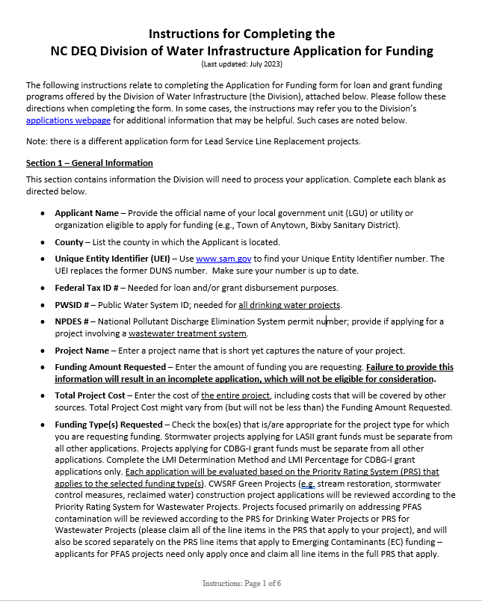 |  | 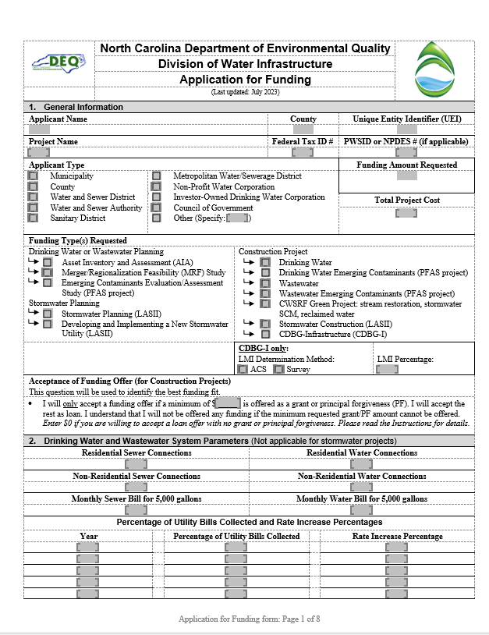
Instructions are enclosed. |  | Application form is attached after the Instructions.  Additional forms required for completing an application are available on the Division of Water Infrastructure’s application page.

(This page intentionally left blank)

Instructions for Completing the
NC DEQ Division of Water Infrastructure Application for Funding
(Last updated: July 2023)
The following instructions relate to completing the Application for Funding form for loan and grant funding programs offered by the Division of Water Infrastructure (the Division), attached below. Please follow these directions when completing the form. In some cases, the instructions may refer you to the Division’s applications webpage for additional information that may be helpful. Such cases are noted below.
Note: there is a different application form for Lead Service Line Replacement projects.
Section 1 – General Information
This section contains information the Division will need to process your application. Complete each blank as directed below.
- Applicant Name – Provide the official name of your local government unit (LGU) or utility or organization eligible to apply for funding (e.g., Town of Anytown, Bixby Sanitary District).
- County – List the county in which the Applicant is located.
- Unique Entity Identifier (UEI) – Use www.sam.gov to find your Unique Entity Identifier number. The UEI replaces the former DUNS number. Make sure your number is up to date.
- Federal Tax ID # – Needed for loan and/or grant disbursement purposes.
- PWSID # – Public Water System ID; needed for all drinking water projects.
- NPDES # – National Pollutant Discharge Elimination System permit number; provide if applying for a project involving a wastewater treatment system.
- Project Name – Enter a project name that is short yet captures the nature of your project.
- Funding Amount Requested – Enter the amount of funding you are requesting. Failure to provide this information will result in an incomplete application, which will not be eligible for consideration.
- Total Project Cost – Enter the cost of the entire project, including costs that will be covered by other sources. Total Project Cost might vary from (but will not be less than) the Funding Amount Requested.
- Funding Type(s) Requested – Check the box(es) that is/are appropriate for the project type for which you are requesting funding. Stormwater projects applying for LASII grant funds must be separate from all other applications. Projects applying for CDBG-I grant funds must be separate from all other applications. Complete the LMI Determination Method and LMI Percentage for CDBG-I grant applications only. Each application will be evaluated based on the Priority Rating System (PRS) that applies to the selected funding type(s). CWSRF Green Projects (e.g. stream restoration, stormwater control measures, reclaimed water) construction project applications will be reviewed according to the Priority Rating System for Wastewater Projects. Projects focused primarily on addressing PFAS contamination will be reviewed according to the PRS for Drinking Water Projects or PRS for Wastewater Projects (please claim all of the line items in the PRS that apply to your project), and will also be scored separately on the PRS line items that apply to Emerging Contaminants (EC) funding – applicants for PFAS projects need only apply once and claim all line items in the full PRS that apply.
- Acceptance of Funding Offer (for Construction Projects only) – Answer the question as described below if applying for construction projects. Your response to this question will determine for which funding program(s) the project is eligible.
The Division may offer a combination of grants or principal forgiveness (PF) and/or low-interest loans to applicants. Enter the minimum amount you require in grant or principal forgiveness funding to accept a funding offer from the Division for this application, thus indicating that you are willing to accept the rest of the funding offer as a loan. Enter $0 if you are willing to accept a loan-only offer. The Division will seek to maximize grant and PF being offered based on availability and eligibility, including above the stated minimum requested amount if applicable. Selecting a lower acceptable minimum amount than what you may be eligible for does not reduce your potential grant/principal forgiveness offer if funds are available. Selecting too high of an acceptable amount risks the possibility of not being offered any funding if there are insufficient grant/principal forgiveness funds available to meet your desired minimum or eligibility. If grant/principal forgiveness funding cannot be offered to meet your requested minimum, no funding offer (loan or grant) will be made.
Grants/PF are limited by the grant/PF eligibility of the applicant, by availability of grants and PF, and by program type (e.g. up to $3 million in CDBG-I grants; up to $500,000 in State Revolving Funds for most types of drinking water and wastewater construction projects unless additional PF funds are available which will be allocated in $500,000 increments; up to $3 million in Drinking Water Reserve or Wastewater Reserve grant funding; up to $5 million in stormwater construction projects funded from LASII; up to $5 million for drinking water construction projects addressing PFAS funded from BIL DWSRF Emerging Contaminants funds; up to $500,000 for drinking water evaluation/assessment studies to address PFAS contamination funded from BIL DWSRF Emerging Contaminants funds). Since drinking water and wastewater construction projects eligible for principal forgiveness from the State Revolving Funds may be limited to $500,000 in principal forgiveness, selecting a minimum grant/PF amount above $500,000 risks the possibility of not being offered any funding if there are insufficient grant/principal forgiveness funds.
Grant/principal forgiveness is limited by the eligibility of the applicant. For construction projects, provide a copy of the Affordability Calculator (available on the Division’s application page) or handwritten affordability calculations as part of the application package.
Section 2 – Drinking Water and Wastewater System Parameters (not applicable for stormwater projects)
This section contains information related to drinking water and wastewater system parameters, which is used across all programs except for the stormwater funding program (LASII). Please complete all blanks unless otherwise noted.
- Residential and Non-Residential Sewer and Water Connections – Follow the guidance found in Line Item 4.A of the Priority Rating System Guidance and Form for Division of Water Infrastructure Construction Funding Programs (Priority Rating System guidance, available on the Division’s application page). For wastewater applications, count only sewer connections. For drinking water applications, count only drinking water connections. Include only existing connections; do not include number of new connections resulting from the project.
- Monthly Sewer and Water Bills for 5,000 gallons – If your system offers both water and sewer service, provide the monthly bills for 5,000 gallons of use for each sewer and water. These rates are (1) used to calculate Line Item 3.B operating ratio eligibility via rates to median household income; (2) used to determine points in Line Item 4.B; and (3) used to determine grant or principal forgiveness eligibility for some funding programs. See Line Item 4.B in the Priority Rating System for Drinking Water/Wastewater guidance for more information about what is needed for this parameter.
Sections 3, 4, and 5 – Applicant, Application Preparer, and Engineer Contact Information
Complete this section with all pertinent information. The following bullet points contain specific information.
- Authorized Representative Name – This name must be either: (1) the top elected official (e.g., Mayor, Chair of the Board), (2) the top administrative official (e.g., Town Manager, Town Administrator, County Manager, CEO), or (3) must match the name listed on the Resolution by Governing Body of Applicant as the Authorized Representative. The Resolution by Governing Body authorizing filing of the application must be submitted as part of the application package. Note: For the CDBG-I program, the Authorized Representative must be named in the resolution, regardless of their title.
The Authorized Representative must sign the application at the end of the application form.
- Mailing Address of the Applicant – Provide the mailing address where the Applicant receives mail. For example, if the Applicant has a PO Box, provide this information rather than the physical address.
Note: Zip codes between PO Boxes and physical addresses may vary. If using a PO Box to receive mail, use the zip code that matches the PO Box.

- Application Preparer Contact Information – For the Application Preparer, provide the following: Preparer’s firm name, contact name, phone number, and email address.
- Engineer Contact Information – If your Application Preparer is the same as the Engineer Contact, check the “No” box. Section 5 may then be left blank. If the answer is “Yes”, provide the engineer’s firm name, contact name, phone number, and email address.
Section 6 – Project Description
In this section, provide a brief description of the proposed project in a broad level of detail. Include the project purpose and what the project entails. For example: rehabilitation of approximately 2,000 linear feet of sewer, construction of a new well, stream restoration, construction of a new stormwater control measure, connecting 104 residences in a disadvantaged area to the water system along Orchard St., planning for a new stormwater control measure, conducting an asset inventory and assessment of stormwater infrastructure, etc. Include information such as types of equipment to be included, capacity of equipment, estimates of line length, street names for sewer or waterline work, and/or neighborhoods or areas where work will occur or benefits will accrue. Descriptions of the work related to the major line items in the Project Budget (Sections 8a – 8c) must be included in the project description. For example, if approximately 2,000 linear feet of 4-inch, 3,000 linear feet of 6-inch, 4,000 linear feet of 8-inch pipe, or a stormwater control measure are listed in the project budget, they must be listed in the project description.
For projects rehabilitating and replacing infrastructure: it is recommended that if the applicant intends to utilize all funds requested to maximize the rehab and replacement work while still meeting the project purpose that the project description use approximate linear footage or other measurements and clearly identify the project areas in which the work will occur.
For drinking water and wastewater construction projects that address PFAS contamination, the project description must clearly indicate that the main purpose of the project (at least 75 percent of the project cost) is to address PFAS contamination.
For LASII stormwater construction and planning projects, only municipalities and counties are eligible to apply. If the applicant is a Council of Government or a nonprofit entity partnering with a municipality or county, the applicant must identify the municipalities and/or counties that are partners on the project. Describe the project, location of the project work, the beneficiaries of the project, and the nature of the partnership between the applicant and the municipalities/counties, including the roles and responsibilities of all partners and whether there is an agreement between the municipalities/counties and the applicant to conduct this project.
If the project is a regional project that involves two or more partners, such as two or more units of local government, identify all of the partners, describe the project and its location, the beneficiaries of the project, how the project is being co-funded (if applicable), and the nature of the partnership between all partners, including the roles and responsibilities of all partners. Identify whether the partners have interlocal agreement(s) or begun discussions on an agreement for the project.
If your drinking water construction or wastewater construction or emerging contaminants (PFAS) construction or CDBG-I construction project will add new connections to the water and/or wastewater system (or to a new system or to a decentralized system owned, operated, and maintained by the public utility), please estimate the number of new connections in this section. For drinking water projects that provide new public water service to disadvantaged areas or to projects that create new public water systems to address PFAS contamination, provide the number of affected customers that will be incorporated into the new or existing public water system.
If 50% or more of the project cost will directly benefit one or more disadvantaged areas (see the Guidance for drinking water/wastewater construction projects for line item 4.C.4), please check the box. Identify the disadvantaged areas and their direct benefits from the project in the project description. Indicate in the project budget and the narrative the costs associated with the direct benefit to the disadvantaged areas.
For drinking water, wastewater construction, Emerging Contaminants construction, CDBG-I, and CWSRF Green Projects only: check the appropriate box(es) if the project is a result of a study grant (Asset Inventory and Assessment grant and/or Merger/Regionalization Feasibility grant) previously awarded by the Division. If neither is the case, check None of the Above.
Section 7 – Additional Information for Consideration
In some situations, a construction project’s purpose might not be listed as eligible for points under Category 1 – Project Purpose of the relevant construction projects’ Priority Rating System. In these situations, you may use the Supplemental Guidance for the Ranking of Applications and Providing Additional Information for Consideration found on the Division’s application page. Please note the following related to this section:
- This section does not apply to the Drinking Water State Revolving Fund program.
- Information for this section must fit into the space provided.
Section 8 – Project Budget
Complete the project budget for your project as discussed in Sections 8a, 8b or 8c.
Complete Section 8a for all construction projects and for Emerging Contaminants evaluation/assessment studies.
Complete Section 8b for drinking water/wastewater Asset Inventory and Assessment grants and Merger/Regionalization Feasibility grants.
Complete Section 8c for stormwater planning grants or if you plan to develop and implement a new stormwater utility using LASII grant funds.
Section 8a – Project Budget for All Construction Projects and Emerging Contaminants (PFAS) Evaluation/Assessment Studies
Complete the project budget by addressing the categories provided in the table (insert rows as needed). Total the cost amount for each line and provide the total cost amount. Please note the following related to this section:
- Project budget is required.
- If applying for a construction project, include the pre-construction planning costs in the budget. Final design and permitting costs are eligible as pre-construction costs.
- Note the instructions at the top of Section 8a about separating costs and labeling them to show portions of the project costs that are attributable to certain factors, such as cost components for disadvantaged areas vs. non-disadvantaged areas, portions of the project that address PFAS contamination, and replacement/rehabilitation of older water/sewer lines vs. newer lines. This can be done by adding additional lines to the project budget (e.g.: (1) construction of 720 linear feet of waterline extensions in disadvantaged areas, and (2) 300 linear feet of waterline extensions in non-disadvantaged areas). You may also add additional columns for the sole purpose of separating and labeling costs as required at the top of Section 8.
- The project budget must be signed, dated and sealed by a properly licensed Professional Engineer (PE). If you do not provide a PE signature and seal on the budget, the application will be incomplete and not considered for funding. Note: If not using DocuSign to seal and sign the budget, put the seal/signature on the Word document or use a wet seal/signature with a scan of the wet seal/signature.
Section 8b – Project Budget for AIA and MRF Grants (Not applicable for any type of LASII stormwater projects)
Provide basic aspects of the AIA or MRF study costs. For example, if applying for an AIA grant, some budget items might include the following: (1) mapping of collection system, (2) condition assessment, and (3) grant administration. Note: AIA and MRF applications must be separate applications from each other and from construction projects.
Section 8c – Project Budget for Stormwater Planning Grants or Develop and Implement a New Stormwater Utility (LASII)
List each activity that will be undertaken in the stormwater planning study and/or in the development and implementation of a new stormwater utility (keeping them separate), and provide their associated costs.
Certification by Authorized Representative
The Authorized Representative must read and initial in the space beside each question, or use “N/A”.
Completeness Checklist
When assembling the application package, initial next to the checklist items to show that the information is in the package, if applicable. Failure to include or properly document an item marked with * will result in the application being incomplete and ineligible for consideration of funding. Forms are available separately on the Division’s application page.
Submittal Information
Applications must be submitted electronically no later than 5:00 pm on Monday, October 2, 2023.
- Submit the application electronically at: https://edocs.deq.nc.gov/Forms/Fall2023DWIFunding. Follow the directions as shown on the form on the website.
- Complete the required fields, almost all of which can be found directly from this Application for Funding form.
- For construction projects addressing emerging contaminants via the BIL SRF funds along with other types of funding (e.g., base SRF or SRP), check all appropriate funding types.
- Upload each required document (e.g. completed Application for Funding form, Resolution by Governing Body and the Form of Certification by the Recording Officer, Narrative to Claim Points, etc.) individually; do not upload a single file with the entire application package. Combine all documentation to support the narrative in claiming points into one file before uploading. Individual file sizes must be limited to 250 MB.
- Uploading files may take several minutes and may be slow during high volume periods. It is strongly encouraged to submit applications several days before the application due date to avoid technical difficulties.
- Once you have submitted your application online, the applicant submitter should receive a confirmation email.
- Online submittal of the application package is sufficient for all applications except for CDBG-Infrastructure applications. For CDBG-I applications only, please submit a hard copy of the application to the Division in addition to the application submitted online.
Application Signature
Signing of this application indicates the applicant’s willingness to accept federal and state conditions. The top elected official, the top administrative official, or the Authorized Representative who is named in the Resolution by Governing Body of Applicant must sign the application. Note: For the CDBG-I program, the Authorized Representative must be named in the Resolution, regardless of their title.
Note: Use a scanned wet signature, or DocuSign signature if signing electronically.
An application without this signature is incomplete and will not be eligible for consideration.

 | North Carolina Department of Environmental Quality
 | Division of Water Infrastructure
 | Application for Funding
 | (Last updated: July 2023)
- General Information
Applicant Name |  |  |  |  |  |  | County |  |  | Unique Entity Identifier (UEI)
Project Name |  |  |  |  |  |  | Federal Tax ID # |  |  | PWSID or NPDES # (if applicable)
Applicant Type |  |  |  |  |  |  |  |  |  | Funding Amount Requested
Municipality  County  Water and Sewer District  Water and Sewer Authority  Sanitary District |  | Metropolitan Water/Sewerage District  Non-Profit Water Corporation  Investor-Owned Drinking Water Corporation  Council of Government  Other (Specify: )
 |  |  |  |  |  |  |  |  |  | Total Project Cost
Funding Type(s) Requested
Drinking Water or Wastewater Planning  Asset Inventory and Assessment (AIA)  Merger/Regionalization Feasibility (MRF) Study  Emerging Contaminants Evaluation/Assessment Study (PFAS project)  Stormwater Planning  Stormwater Planning (LASII)  Developing and Implementing a New Stormwater Utility (LASII) |  |  |  |  | Construction Project  Drinking Water  Drinking Water Emerging Contaminants (PFAS project)  Wastewater  Wastewater Emerging Contaminants (PFAS project)  CWSRF Green Project: stream restoration, stormwater SCM, reclaimed water  Stormwater Construction (LASII)  CDBG-Infrastructure (CDBG-I)
 |  |  |  |  | CDBG-I only:  LMI Determination Method:  ACS Survey |  |  |  |  |  | LMI Percentage:
Acceptance of Funding Offer (for Construction Projects)
This question will be used to identify the best funding fit.
- I will only accept a funding offer if a minimum of $ is offered as a grant or principal forgiveness (PF). I will accept the rest as loan. I understand that I will not be offered any funding if the minimum requested grant/PF amount cannot be offered.
Enter $0 if you are willing to accept a loan offer with no grant or principal forgiveness. Please read the Instructions for details.

- Drinking Water and Wastewater System Parameters (Not applicable for stormwater projects)
Residential Sewer Connections |  |  |  |  |  | Residential Water Connections
Non-Residential Sewer Connections |  |  |  |  |  | Non-Residential Water Connections
Monthly Sewer Bill for 5,000 gallons |  |  |  |  |  | Monthly Water Bill for 5,000 gallons
Percentage of Utility Bills Collected and Rate Increase Percentages

Year |  |  |  | Percentage of Utility Bills Collected |  |  |  |  | Rate Increase Percentage

- Applicant Contact Information (See Instructions regarding the Authorized Representative)
Authorized Representative Name:
Authorized Representative Title:
Mailing Address Line 1:
Mailing Address Line 2:
City:
State:
Zip Code:
Physical Address Line 1:
Physical Address Line 2:
Physical Address City:
Physical Address State:
Physical Address Zip Code:
Phone Number:
Email Address:
- Application Preparer Contact Information
Firm Name:
Contact Name:
Phone Number:
Email Address:
- Engineer Contact Information
Is the engineering firm different from the application preparer? | Yes No
Engineering Firm Name:
Contact Name:
Phone Number:
Email Address:

- Project Description (see Instructions)
Estimated number of new connections served by Drinking Water or Wastewater construction, Emerging Contaminants (PFAS), or CDBG-I project:
50% or more of the project budget is to directly benefit a Disadvantaged Area. Both the Application Budget and Narrative must demonstrate that the project area includes a Disadvantaged Area and that 50% or more of the project budget directly benefits the Disadvantaged Area. See Application Guidance for Line Item 4.C.4 for details on the minimum documentation to be included in the Budget and Narrative.
For Drinking Water and Wastewater construction, Emerging Contaminants (PFAS), CWSRF Green Project, and CDBG-I:
The proposed project is a result of an Asset Inventory and Assessment grant previously awarded by the Division.
The proposed project is a result of a Merger / Regionalization Feasibility Study grant previously awarded by the Division.
None of the above.

- Additional Information for Consideration

8a. Project Budget for All Construction Projects and for Emerging Contaminants Evaluation/Assessment Studies Do not use for other planning studies.
- Drinking Water/Wastewater: Costs for portions of the project that will fulfill the requirements related to rehabilitating or replacing waterlines, old infrastructure, lead service lines, or emerging contaminants (DW/WW Priority Rating System Line Items 1.C.1, 1.D.1, 1.J.1, 1.J.2, 1.J.3, or 2.B.2) must be labeled and shown separately to successfully claim points.
- All: Costs for portions of the project that will directly benefit disadvantaged areas (DW/WW Priority Rating Systems Line Items 1.E or 4.C.4) must be labeled and shown separately to successfully claim points.
Indicate construction costs by line item (e.g., linear feet of different-sized lines, each type of stormwater control measure, each stream restoration reach). Include a more detailed construction cost budget if needed. | Division Funding Requested | Other Secured Funding Source(s) | Total Cost Amount
Construction Costs
Contingency (10% of construction costs):
Construction Subtotal:
Engineering Costs
Engineering Design
Permitting
Land Surveying Costs
Other:
Engineering Subtotal:
Administration Costs
Planning (pre-construction costs)
Easement/Land Acquisition Costs
Engineering Report Preparation
Environmental Documentation Preparation (if applicable)
Legal Costs
Project Funding Administration (if applicable)
Other:
Administration Subtotal:
TOTAL FUNDING REQUESTED AND PROJECT COST:
A Professional Engineer seal, signature, and date for the estimate must be provided in the space to the right for the application to be considered complete.
(Note: If not using DocuSign to seal and sign the budget, put the seal/signature on the Word document or use a wet seal/signature with a scan of the wet seal/signature.)

8b. Project Budget for AIA and MRF Grants Do not use for any type of LASII Stormwater project.
Add additional lines as needed. Only include items that are intended to be included in the Scope of Work for the project.
Division Funding Requested
TOTAL DIVISION FUNDING REQUESTED:

8c. Project Budget for Stormwater Planning Grant (LASII) and Grant to Develop and Implement a New Stormwater Utility (LASII). Do not use for any other project type, including stormwater construction (LASII).
- If the application includes a request for funds to both Develop and Implement a New Stormwater Utility and other Stormwater Planning work, the budget shown below must be labeled and shown separately.
- Add additional lines as needed.
Division Funding Requested
TOTAL DIVISION FUNDING REQUESTED FOR STORMWATER PLANNING GRANT (LASII):
TOTAL DIVISION FUNDING REQUESTED TO DEVELOP AND IMPLEMENT A NEW STORMWATER UTILITY (LASII):

Certification by Authorized Representative
The attached statements and exhibits are hereby made part of this application, and the undersigned representative of the Applicant certifies that the information in this application and the attached statements and exhibits are true, correct, and complete to the best of his/her knowledge and belief. By initialing each item and signature at the end of this application, he/she further certifies that:

_______ | - as Authorized Representative, I have been authorized to file this application by formal action of the governing body (e.g., by resolution) or as defined in this application as the Authorized Representative in Section 3 following the Instructions;
_______ | - the governing body agrees to provide for proper short-term and long-term maintenance and operation of the approved project after its completion;
_______ | - the Applicant has substantially complied with or will comply with all federal, state, and local laws, rules, regulations, ordinances, and funding conditions as applicable to this project;
_______ | - the Applicant will adopt and place into effect on or before the completion of the project a schedule of fees and charges which will provide for the adequate and proper operation, maintenance, and administration and repayment of all principal and interest on loans (if applicable) of the project [if not applicable, initial “N/A”];
_______ | - the Applicant has followed proper accounting and fiscal reporting procedures, as evidenced by the Applicant’s most recent audit report, and that the Applicant is in substantial compliance with provision of the general fiscal control laws of the State;
_______ | - the Project Budget for all construction projects provided in this application form (Section 8a, if applicable) includes all funding requested from all sources of funding proposed for this project;
_______ | - the (Town or County), North Carolina is organized and chartered under the laws of North Carolina, or the special purpose unit of local government is incorporated under the laws of North Carolina. All officials and employees are aware of, and in full compliance with NCGS 14-234, “Public officers or employees benefiting from public contracts; exceptions.” (For units of local government only. All others should initial “N/A”);
______ | - the Applicant acknowledges that all loans and Viable Utility Reserve grants are subject to approval by the Local Government Commission (not applicable for CDBG-I or stormwater planning projects);
______ | - the Applicant acknowledges that if the application is for a drinking water or wastewater project and any one of the local government units involved in the project is designated as distressed by the State Water Infrastructure Authority and the Local Government Commission, the local government unit(s) must complete the viable utility requirements in NCGS 159G-45(b) by conducting an asset assessment and rate study, participate in a training program, and develop a short-term and long-term action plan considering infrastructure repair, maintenance, and management, continuing education, and long-term financial management plan. Additional conditions may be imposed on the local government(s) designated as distressed by the State Water Infrastructure Authority and/or the Local Government Commission. (Initial “N/A” if does not apply to project type or all local governments involved in the project); and
_______ | - the Applicant acknowledges that, in accordance with G.S. 120-157.2, for local government debt to be issued greater than $1,000,000, the local government must report to Committee Chairs, Committee Assistant, and the Fiscal Research Division of the General Assembly at least 45 days prior to presentation before the Local Government Commission (For units of local government only. All others, and CDBG-I applicants should initial “N/A”).

Completeness Checklist
In addition to this application, the following items must be included in the application package to be eligible or to successfully claim priority points. Failure to include or properly document an item marked with * will result in an incomplete and ineligible application which will not be considered for funding. Please initial that each item is included in this submittal. If not applicable for the project, please initial “N/A”.

______ | Resolution by Governing Body of Applicant and the Form for Certification by the Recording Officer * †
______ | Comprehensive Narrative to Claim Points in the Priority Rating System *
______ | Documentation to Support the Comprehensive Narratives, including maps or images as needed
______ | Applicable Priority Rating System Form to Claim Points †
______ | Affordability Calculator † or handwritten affordability calculations (not applicable to CDBG-I or LASII stormwater planning)
______ | Fund Transfer Certification with appropriate box checked * † (not applicable to CDBG-I or LASII stormwater)
______ | Water & Sewer Financial Information Form † (not applicable to LASII stormwater projects)
______ | Stormwater Entity Eligibility Certification form * † (only for LASII stormwater applications)
______ | Commitment of Other Funds Form, Low to Moderate Income Documentation, and all Tab 8 Documents * † (only for CDBG-I applications). These documents must be complete per CDBG-I PRS Guidance.
______ | Current water and wastewater rate sheets in effect on application deadline (for both water and sewer if the utility provides both water and sewer, or for water or sewer depending on the utility service; not applicable to LASII stormwater)
______ | Professional Engineer seal with signature and date on Project Budget * (for Construction Projects and for Emerging Contaminants Evaluation/Assessment Studies only)
* Required in the application package. Failure to include or properly document will result in an incomplete and ineligible application which will not be considered for funding.
† Forms and templates are available separately on the Division’s application webpage.

Submittal Information
All application packages must be submitted electronically at https://edocs.deq.nc.gov/Forms/Fall2023DWIFunding

See Instructions on completing the form online.

Online submittal of the application package is sufficient for all applications, except for CDBG-Infrastructure applications.

For CDBG-Infrastructure applications only: in addition to submitting the application package electronically at the link above, you must send one (1) original hard copy* of the application package to:

Physical Address (FedEx, UPS)‡
Division of Water Infrastructure – 8th Floor, Archdale Building
512 North Salisbury Street
Raleigh, NC 27604
919.707.9160
* Provide a hard copy that is bound (3-ring binders). No paper clips, staples or binder clasps.
‡ For all courier services, please use the physical address, as having a courier deliver to the mailing address will delay package delivery.

Application Signature
Original signature is required for the application.
Application with no signature is incomplete and ineligible for consideration.
SIGNATURE OF TOP ELECTED OFFICAL, TOP ADMINISTRATIVE OFFICIAL, OR AUTHORIZED REPRESENTATIVE AS NAMED IN RESOLUTION*
 | , |  | ,
TYPED NAME |  | TYPED TITLE |  | DATE
*Note: For the CDBG-I program, signature must be of the Authorized Representative who must be named in the Resolution, regardless of their title.

