**SPEARS – Opportunity Portal - Business**

**QUICK**

**Guide**



The **HUD Section 3 Opportunity Portal** is intended to help HUD grantees and Section 3 businesses meet their Section 3 obligations for employment and contracting. The site is to be used by either Section 3 Workers or Employers. Section 3 Workers may use the site to Search for Jobs, post their profile/employment history for companies to search or post their business(es). Employers may use the site for posting opportunities or business(es) or search for Workers to fill positions. Authentication has been implemented using GSA’s Login.Gov service. Login.gov is an authentication service that offers the public secure and private online access to participating government programs, including the HUD Section 3 Opportunity Portal.

This document will guide the user through the creation of a Login.Gov account, logging into the Opportunity Portal application, and exercising the features that are available to both Section 3 Employers and Workers such as updating contact information, posting an employment profile, posting opportunities and searching for job/contract opportunities.

**Create a Login.gov UserID**

To access certain features in the Opportunity Portal such as creating a Worker profile so that businesses can search for you, posting Job and Contract opportunities, or search for Workers seeking employment, you must create a Login.gov account. If you only wish to search for open Job and Contract opportunities, you do not need a Login.gov account. To create an account:

1. Open a web browser such as Chrome, Edge, Firefox or Safari.
2. [Enter] <https://hudapps.hud.gov/OpportunityPortal> in the URL box.

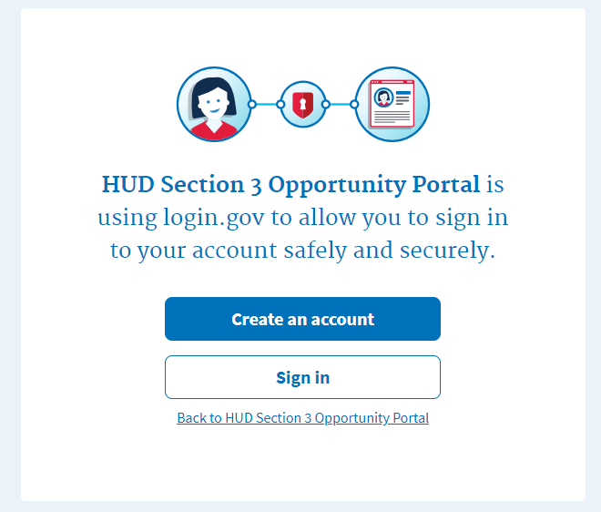

1. [Click] the **Create an account** button. *Note: if you already have an account, you can [Click] the* ***Sign in*** *button.*
2. Enter your email address in the **Email address** field (Note: this must be a valid email address that you can access at that time), then [Click] **Submit**.
3. You can now close the tab or window you are currently working in.
4. Go to your email account and look for a new email from no-reply@login.gov with the Subject: Confirm your email and open it.
5. In the email, [Click] the **Confirm your email address** button. (Note: this will open in your default browser; if you wish to use a different browser, simply copy this URL and paste it into the browser you wish to use.)
6. Create a new password. It must be at least 9 characters long and not be a commonly used password. Type the password into the Password field and [Click] **Continue**. (Note: you will not be able to move forward unless your password is “strong” enough).

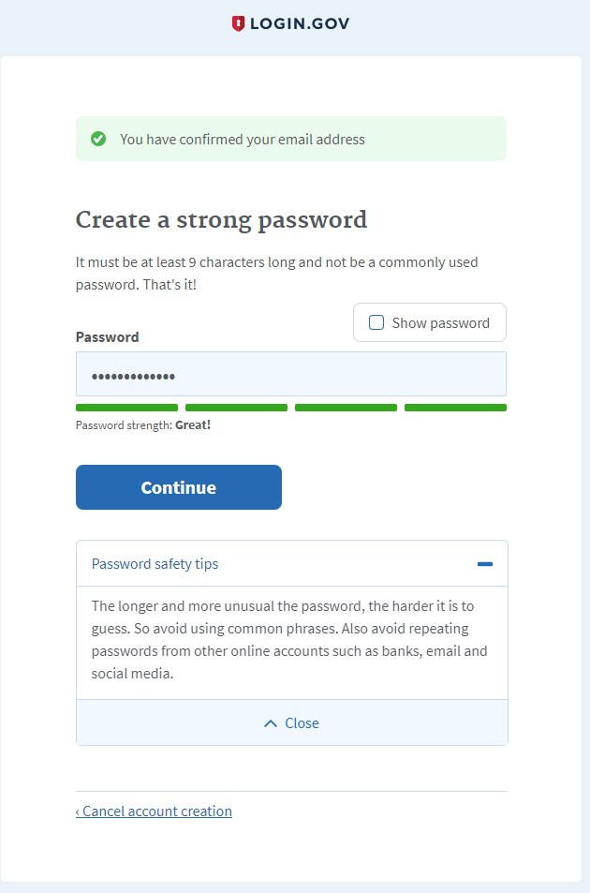

1. Login.gov requires “two factor authentication”, meaning you need to provide an additional way to prove you are the owner of your account when logging in (this adds an additional layer of security to your account). Choose one of the 3 options presented (the simplest is usually Text Message/SMS if you have a cell phone; otherwise, the next simplest is to get a phone call). Then [Click] the **Continue** button.
2. If you chose Text Message/SMS then enter your mobile phone number in the Mobile phone number field, then [Click] the **Send code button**.

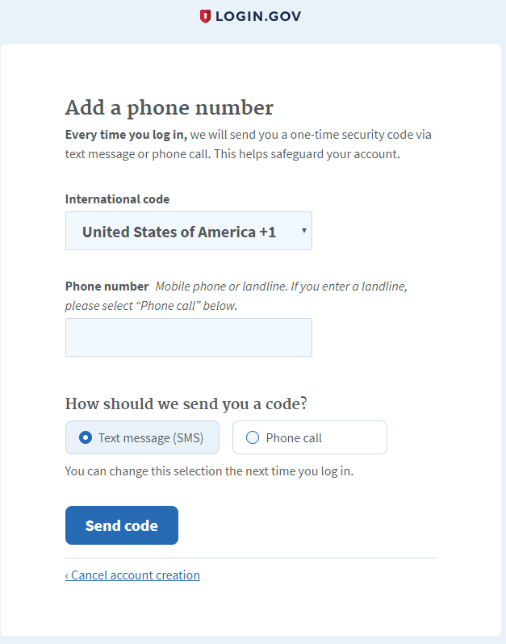

1. If you chose Text Message/SMS then enter your security code that you received via text message/SMS in the One-time security code field, then [click] **Submit**. (Note: you must do this within 10 minutes of receiving the code, or you will need to generate a new one).
2. Write down, print out, or take a screen shot of your personal key; you may need this to log in later to regain access to your account if you lose your phone, for example.
3. [Click] **Continue**.



1. Type the personal key that you just saved in the field that appears. You do not need to enter dashes, just the numbers and letters from your key.
2. [Click] **Agree and Continue**.

**Log in with Login.gov**

To log in to the Section 3 Opportunity Portal, do the following.

1. Once you have an account, you can go to <https://hudapps.hud.gov/OpportunityPortal> in your web browser, then [Click] the **Sign in** button.
2. [Enter] your **Email Address** and **Password** that you used when signing up for Login.gov and [Click] **Next.**
3. Follow the steps for multi-factor authentication.
4. You will then be logged into the application and the Section 3 Opportunity Portal home page will appear.

**Add Employer/Contractor Role, Add Contact Information**

Businesses must select one or more roles. One role gives the ability to add, edit, and delete Opportunities and Businesses. Another role gives the ability to search for Section 3 Workers seeking employment (this role must be approved by a HUD SPEARS system administrator before being granted). When you log in for the first time, you will need to select a role. You can also get to this page by [Selecting] **My Account** from the upper menu and then [Selecting] **View Profile**.

1. On the Role page, [Select] “**I want to participate as an employer/contractor that posts job, training and/or contracting opportunities**” AND/OR “**I want to participate as an employer/contractor that searches for Workers seeking employment. (This requires approval by HUD)**” and [Click] **Save**.

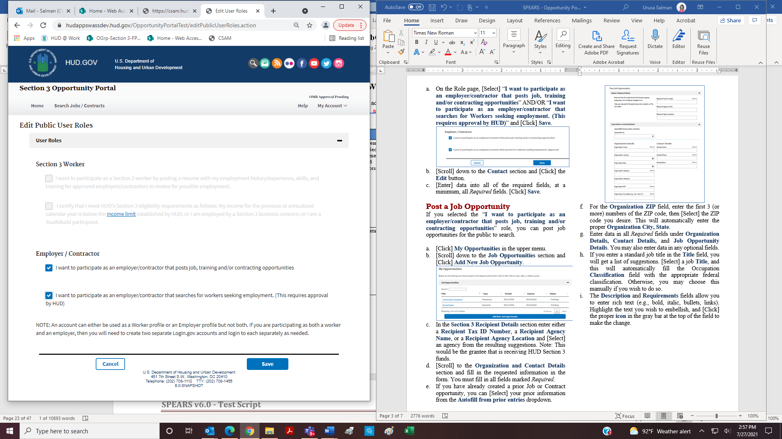

1. [Scroll] down to the **Contact** section and [Click] the **Edit** button.
2. [Enter] data into, at a minimum, all *Required* fields. [Click] **Save**.

**Post a Job Opportunity**

If you selected the “**I want to participate as an employer/contractor that posts job, training and/or contracting opportunities**” role, you can post job opportunities for the public to search.

1. [Click] **My Opportunities** in the upper menu.
2. [Scroll] down to the **Job Opportunities** section and [Click] **Add New Job Opportunity**.

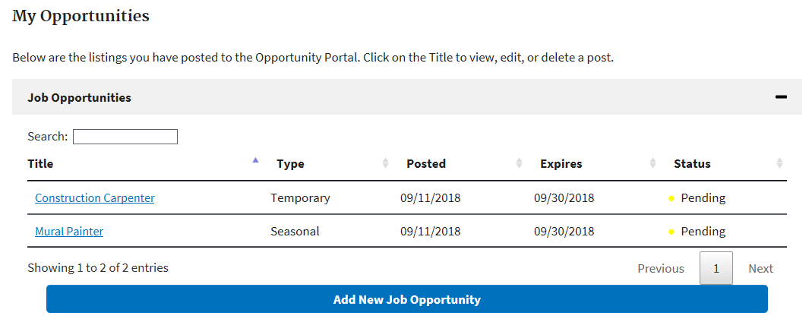

1. In the **Section 3 Recipient Details** section enter either a **Recipient Tax ID Number**, a **Recipient Agency Name**, or a **Recipient Agency Location** and [Select] an agency from the resulting suggestions. Note: This would be the grantee that is receiving HUD Section 3 funds.
2. [Scroll] to the **Organization and Contact Details** section and fill in the requested information in the form. You must fill in all fields marked *Required*.
3. If you have already created a prior Job or Contract opportunity, you can [Select] your prior information from the **Autofill from prior entries** dropdown.

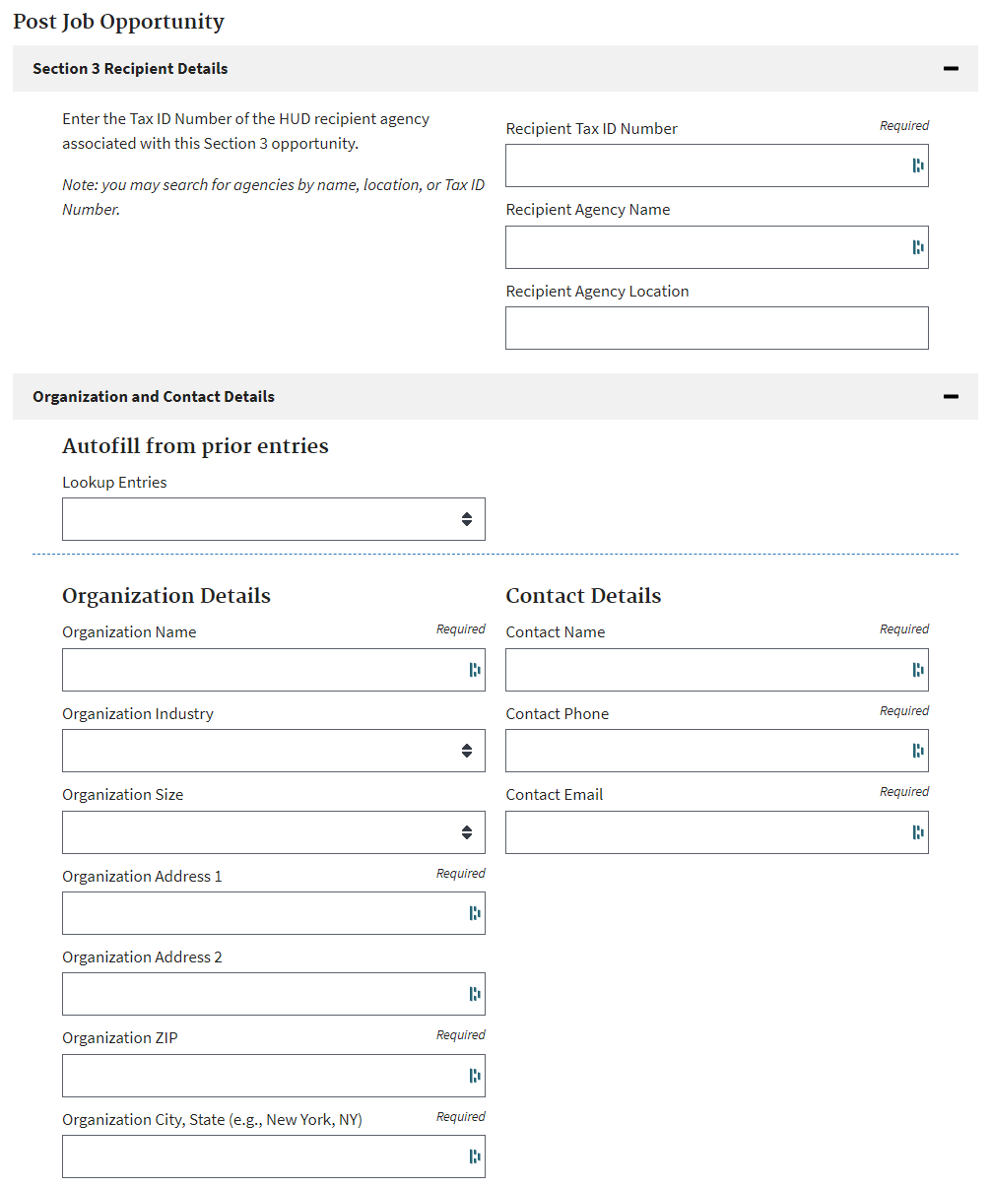

1. For the **Organization ZIP** field, enter the first 3 (or more) numbers of the ZIP code, then [Select] the ZIP code you desire. This will automatically enter the proper **Organization City, State**.
2. Enter data in all *Required* fields under **Organization Details, Contact Details,** and **Job Opportunity Details**. You may also enter data in any optional fields.
3. If you enter a standard job title in the **Title** field, you will get a list of suggestions. [Select] a job **Title**, and this will automatically fill the Occupation **Classification** field with the appropriate federal classification. Otherwise, you may choose this manually if you wish to do so.
4. The **Description** and **Requirements** fields allow you to enter rich text (e.g., bold, italic, bullets, links). Highlight the text you wish to embellish, and [Click] the proper **icon** in the gray bar at the top of the field to make the change.

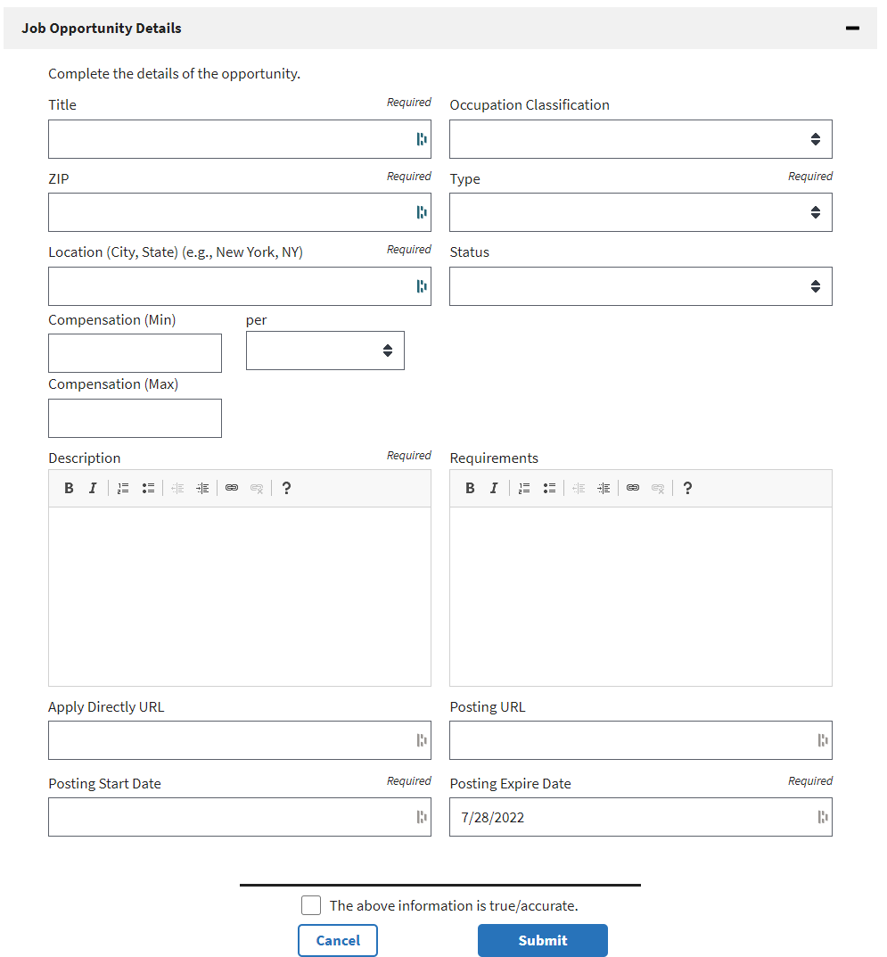

1. You can submit a URL where users can apply directly to your job if you have such a link on a different job site. To do this, enter the full URL (starting with http:// or https://) in the **Apply Directly URL** field. This will put a direct link to the application URL in your job posting.
2. If you have the same job listing posted to a different job site or your own web site, you can submit a link that goes directly to this job posting. To do this, enter the full URL (starting with http:// or https://) in the **Posting URL** field. This will put a direct link to the original job post in your new job posting.
3. Enter a **Posting Start Date** and **Posting Expire Date** by [Clicking] in the appropriate field and [Selecting] the date from the calendar popup. You can also enter the date directly in the following format: **mm/ddd/yyyy**. Note that job postings can be up to 1 year, and you can extend them as needed at a later date.
4. When all required fields and any optional fields are filled in and you are ready to save the information, [Click] “**The above information is true/accurate.”** Then [Click] **Submit**.
5. Your Job posting will be saved and viewable only by you. Each time you add or edit a Job posting, it will have a Pending status for 24 hours, after which it will be available for the public to search.

**View and Edit Job Opportunity Posting**

You may view the public view or edit your Job opportunity posting at any time.

1. [Click] **My Opportunities** in the upper menu.
2. On the **My Opportunities** page, find the Job opportunity you wish to view or edit by entering a keyword from your job title in the Search field (just under the Job Opportunities heading). You can also [Click] the **numbers** below the listing, or [Click] **Previous** or **Next** to page through your listing of Jobs.
3. If you wish to view the public view of the Job, [Click] on the **title**, then [Select] **View Public** **Post** from the context menu.
4. If you wish to edit your Job posting, [Click] on the **title**, then [Select] **Edit** from the context menu.
5. You can now edit any data as needed, then [Click] **Submit** to save the updates.
6. Your Job posting will be saved and viewable only by you until it is approved. Each time you add or edit a Job posting, it will have a Pending status for 24 hours, after which it will be available for the public to search.

**Delete a Job Opportunity Posting**

Following are the steps to delete a Job opportunity posting.

1. [Click] **My Opportunities** in the upper menu.
2. Find one of the Job Opportunities you wish to delete by entering a keyword from your job title in the Search field (just under the Job Opportunities heading), if it is not visible on the screen. You can also [Click] the **numbers** below the listing, or [Click] **Previous** or **Next** to page through your listing of Jobs.
3. Once you have found the desired posting, [Click] on the **title**, then [Select] **Delete** from the context menu.

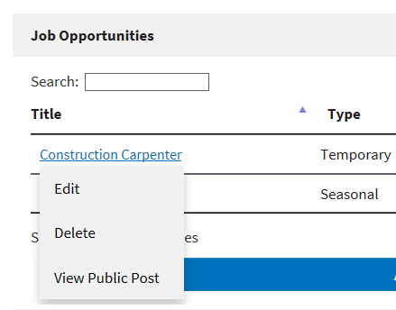

1. In the popup dialog, [click] “**OK**” to confirm deletion.

**Post Contract Opportunity**

If you selected the “**I want to participate as an employer/contractor that posts job, training and/or contracting opportunities**” role, you can post contract opportunities for the public to search.

1. [Click] **My Opportunities** in the upper menu.
2. [Scroll] down to the **Contract Opportunities** section and [Click] **Add New Contract Opportunity**.
3. In the **Section 3 Recipient Details** section enter either a **Recipient Tax ID Number**, a **Recipient Agency Name**, or a **Recipient Agency Location** and [Select] an agency from the resulting suggestions.

1. [Scroll] to the **Organization and Contact Details** section and fill in the requested information in the form. You must fill in all fields marked *Required*.
2. If you have already created a prior Job or Contract opportunity, you can [Select] your prior information from the **Autofill from prior entries** dropdown.
3. For the **Organization ZIP** field, enter the first 3 (or more) numbers of the ZIP code, then [Select] the ZIP code you desire. This will automatically enter the proper **Organization City, State**.
4. Enter data in all required fields under **Organization Details, Contact Details,** and **Contract Opportunity Details**. You may also enter data in any optional fields.
5. For the **NAICS Code,** [Enter] either a partial NAICS Code OR [Enter] a keyword for the code (such as “paint”, “plumbing”, etc.), then [select] one of the suggested codes.
6. The **Description** and **Requirements** fields allow you to enter rich text (e.g., bold, italic, bullets, links). Highlight the text you wish to embellish, and [Click] the proper **icon** in the gray bar at the top of the field to make the change.

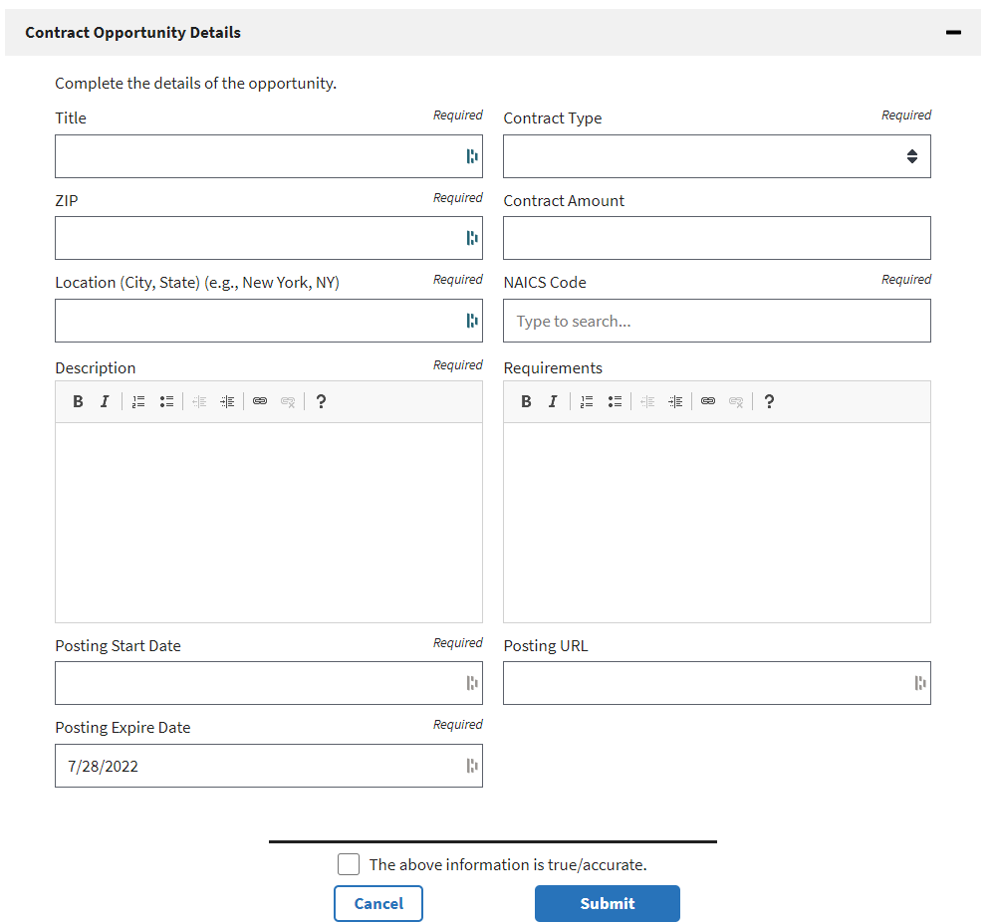

1. If you have the same contract listing posted to a different job site or your own web site, you can submit a link that goes directly to this contract posting. To do this, enter the full URL (starting with http:// or https://) in the **Posting URL** field. This will put a direct link to the original contract post in your new contract posting.
2. Enter a **Posting Start Date** and **Posting Expire Date** by [Clicking] in the appropriate field and [Selecting] the date from the calendar popup. You can also enter the date directly in the following format: **mm/dd/yyyy**. Note that contract postings can be up to 1 year, and you can extend them as needed at a later date.
3. When all required fields and any optional fields are filled in and you are ready to save the information, [Click] “**The above information is true/accurate.”** Then [Click] **Submit**.
4. Your Contract posting will be saved and viewable only by you. Each time you add or edit a Contract posting, it will have a Pending status for 24 hours, after which it will be available for the public to search unless it is flagged by HUD management.

**View and Edit Contract Opportunity Posting**

You may view the public view or edit your Contract opportunity posting at any time.

1. [Click] **My Opportunities** in the upper menu.
2. On the **My Opportunities** page, find the Contract opportunity you wish to view or edit by entering a keyword from your contract title in the Search field (just under the Contract Opportunities heading), if it is not visible on the screen. You can also [Click] the **numbers** below the listing, or [Click] **Previous** or **Next** to page through your listing of Contracts.
3. If you wish to view the public view of the Contract, [Click] on the **title**, then [Select] **View Public** **Post** from the context menu.
4. If you wish to edit your Contract posting, [Click] on the **title**, then [Select] **Edit** from the context menu.
5. You can now edit any data as needed, then [Click] **Submit** to save the updates.
6. Your Contract posting will be saved and viewable only by you. Each time you add or edit a Contract posting, it will have a Pending status for 24 hours, after which it will be available for the public to search unless it is flagged by HUD management.

**Delete Contract Opportunity Posting**

1. [Click] **My Opportunities** in the upper menu.
2. Find one of the Contract Opportunities you wish to delete by entering a keyword from your contract title in the Search field (just under the Contract Opportunities heading), if it is not visible on the screen. You can also [Click] the **numbers** below the listing, or [Click] **Previous** or **Next** to page through your listing of Contracts.
3. Once you have found the desired posting, [click] on the **title**, then [Select] **Delete** from the context menu.

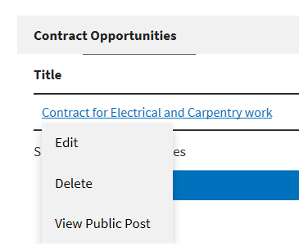

1. In the popup dialog, [click] “**OK**” to confirm deletion.

**My Businesses**

Any user may register their Section 3 self-certified business listing within the Section 3 Opportunity Portal. Any registered businesses are listed on the My Businesses page.

1. [Click] **My Section 3 Portal** in the upper menu, then

[Click] **My Businesses**.

Along with self-registered businesses, the application will Claim any businesses that match with the user’s email address. Upon caiming, a checkmark will appear beside the business for the next 3 days. After claiming, the user may edit and re-post the business similar to any other entries.

**Add Business**

You can add a Section 3 self-certified business listing within the Section 3 Opportunity Portal.

1. [Click] **My Section 3 Portal** in the upper menu, then

[Click] **My Businesses**.

1. [Click] **Add Business**.
2. **Business Information.**
3. [Enter] Business Name, Business Street Address, City, State
4. Enter the first 3 (or more) numbers of the ZIP code, then [Select] the ZIP code you desire. This will automatically update the **City** and **State** fields.
5. **Contact Information.**

[Enter] Business Telephone Number, Business Point of Contact and Business Email.

**Add a Business (cont.)**

1. **Business Details**

[Enter] Business Details in the following fields.

Optionally,

1. [Enter] County and/or City Area(s) that the business is **not** willing to serve. **Entries must be less than 200 characters**.
2. The Capabilities Narrative is a summary of a company's ability to perform. Narratives must be less than 4,000 characters.
3. **Small Business**

[Check] if you identify as a small business.

1. **Business Designations**

[Check] one or more checkboxes (optional) to select business designations.

1. **Provided Services**

The selection (one or more) of the following checkboxes is required.

1. **Business Currently Hiring**

[Select] the appropriate option for the business’ hiring status. (The default radio option is No).

1. **Section 3 Business Criteria**

The selection (one or more) of the following checkboxes is required.

[Check] The above information is true/accurate

[Click] Submit

**Edit a Business**

1. [Click] **My Section 3 Portal** in the upper menu, then

[Click] **My Businesses**.

1. [Click] the Title of a business, from the pop-up menu,

[Click] Edit

1. Revise the Business listing’s data as needed.
2. [Check] The above information is true/accurate
3. [Click] Submit

**View a Business**

1. [Click] **My Section 3 Portal** in the upper menu, then

[Click] **My Businesses**.

1. [Click] the Title of a business, from the pop-up menu,

[Click] View Public Post

**Delete a Business**

1. [Click] **My Section 3 Portal** in the upper menu, then

[Click] **My Businesses**.

1. [Click] the Title of a business, from the pop-up menu,

[Click] Delete

1. In the pop-up dialog, [click] OK

**Search for Section 3 Businesses**

[Click] **Search** in the upper menu, then

[Click] **Search Business**

1. **Select Metropolitan Area.**
2. In the Location text box, start entering the name of a state, metro area, county or zip code, then select the Location for the Business from the auto loaded drop down list. Selection of a Location is required.

1. **Select Filters.**
2. [Click] the “+” on the Filters section

1. [Check] on one or more Check Boxes   
   for Designations or Services to filter (optional)
2. [Click] Search to view Search Results.

1. **Export Results to Excel.**
2. To export the results of the business search to Microsoft Excel, [Click] the *Download search results* link, which is just before the table.
3. Depending on the browser, the file will either open in a viewer or can be downloaded and saved.
4. When opening the file in MS Excel, it may open in a Protected View.
5. If so, [Click] the **Enable Editing** option at the top of the screen.Graphical user interface, text, application

   Description automatically generated

**Search for Workers**

If you selected the role “**I want to participate as an employer/contractor that searches for Workers seeking employment. (This requires approval by HUD)**” and you are approved, you can search for Workers who have created a profile on the site.

1. [Click] **Search Workers** in the upper menu (Note: this menu option will only be available once you are approved by a system administrator).
2. [Enter] **Keywords** and a **Location** related to the job for which you are seeking employees (e.g., job title keyword, skills needed, etc.) and [Click] **Search**.

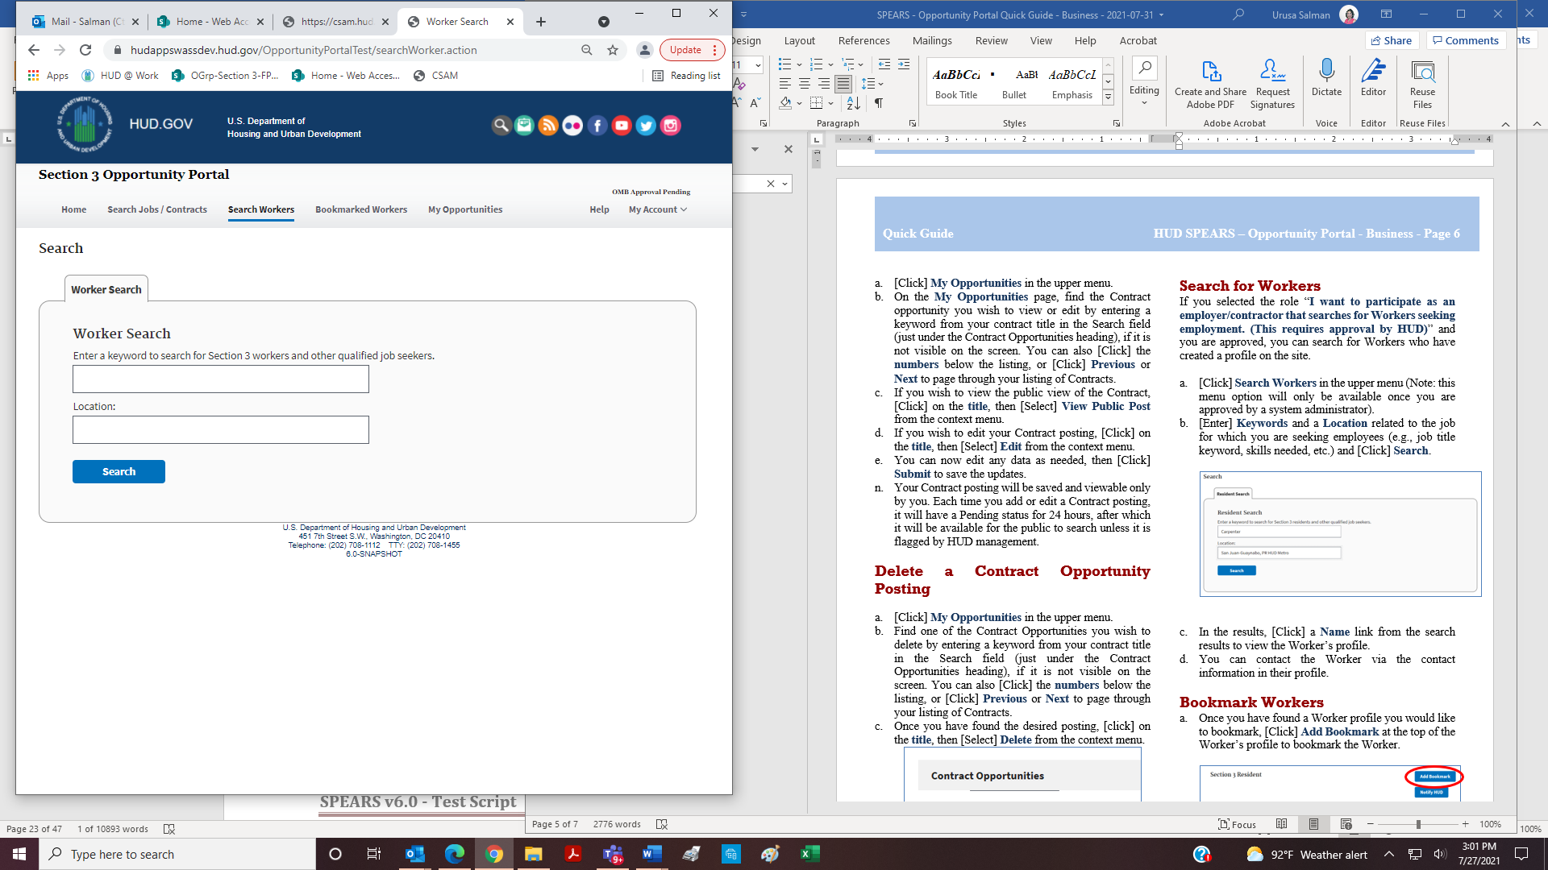

1. In the results, [Click] a **Name** link from the search results to view the Worker’s profile.
2. You can contact the Worker via the contact information in their profile.

**Bookmark Workers**

1. Once you have found a Worker profile you would like to bookmark, [Click] **Add Bookmark** at the top of the Worker’s profile to bookmark the Worker.

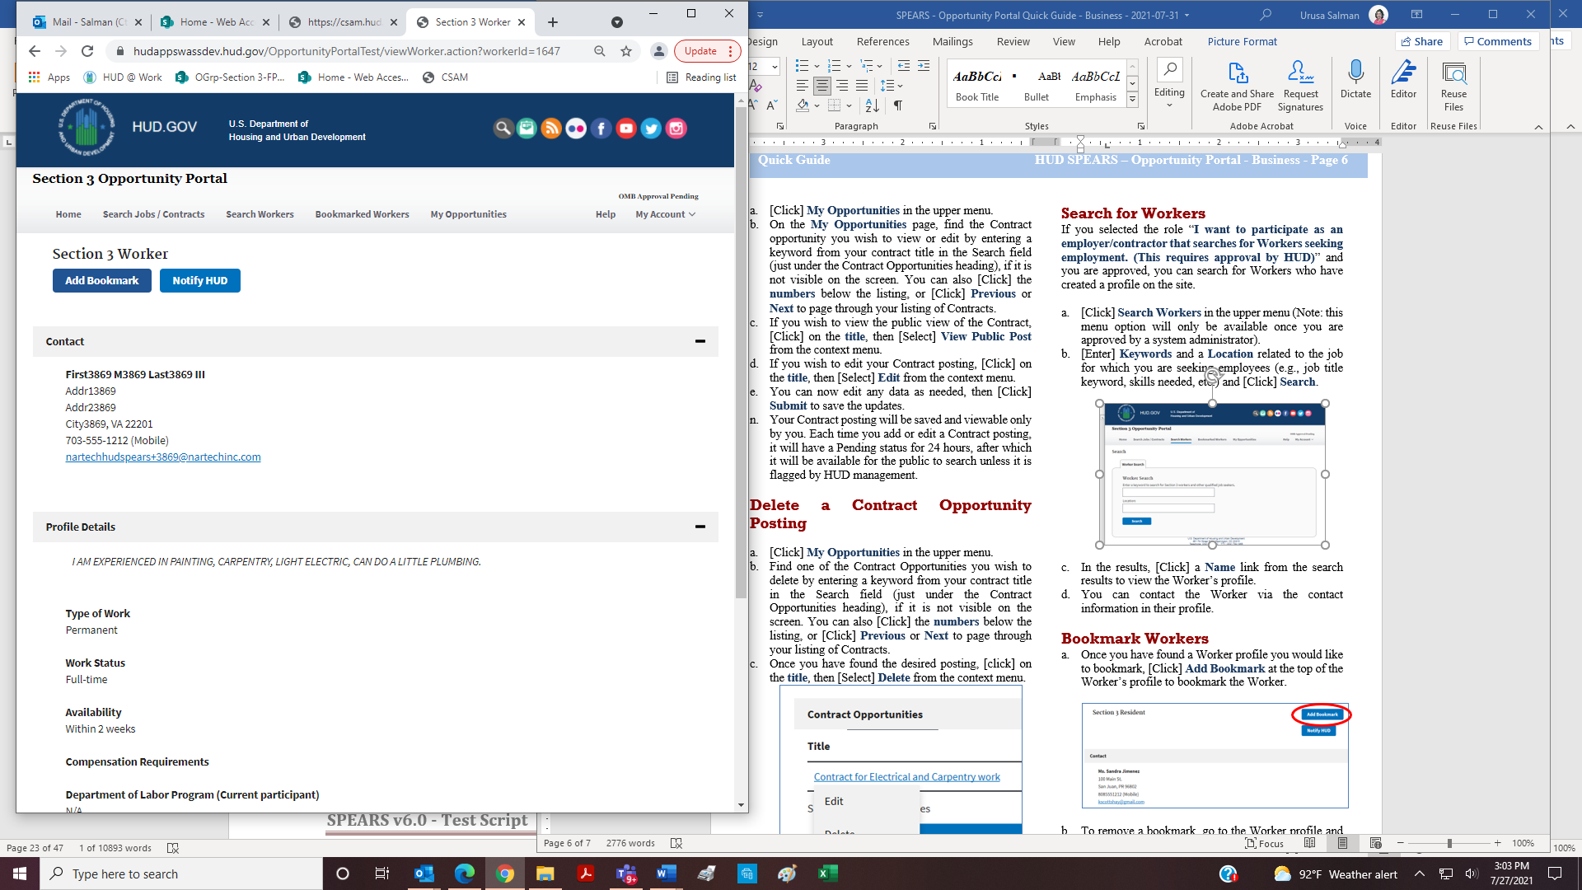

1. To remove a bookmark, go to the Worker profile and [Click] **Remove Bookmark** at the top of the page.
2. To see a list of all Workers you have bookmarked, [Click] **Bookmarked Workers** in the upper menu.
3. You can also remove bookmarks on this page by [Clicking] **Remove** next to the bookmark you wish to remove.

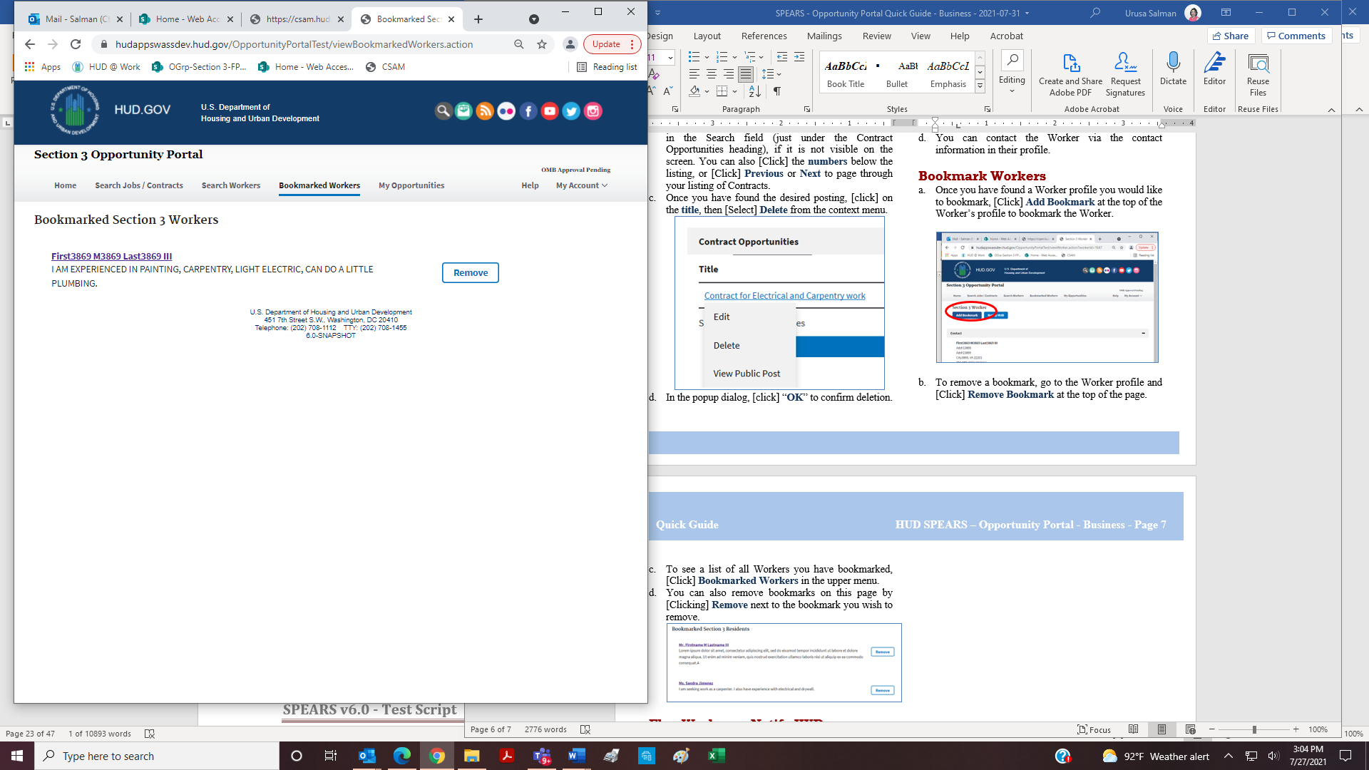

**Flag Workers—Notify HUD**

If you notice a profile that you believe violates HUD’s standards (such as a fake profile, spam, etc.) you can “flag” the profile for HUD review by doing the following steps.

1. Once you have found a Worker profile you would like to flag, [Click] **Notify HUD** at the top of the Worker’s profile to flag the Worker profile and notify HUD.

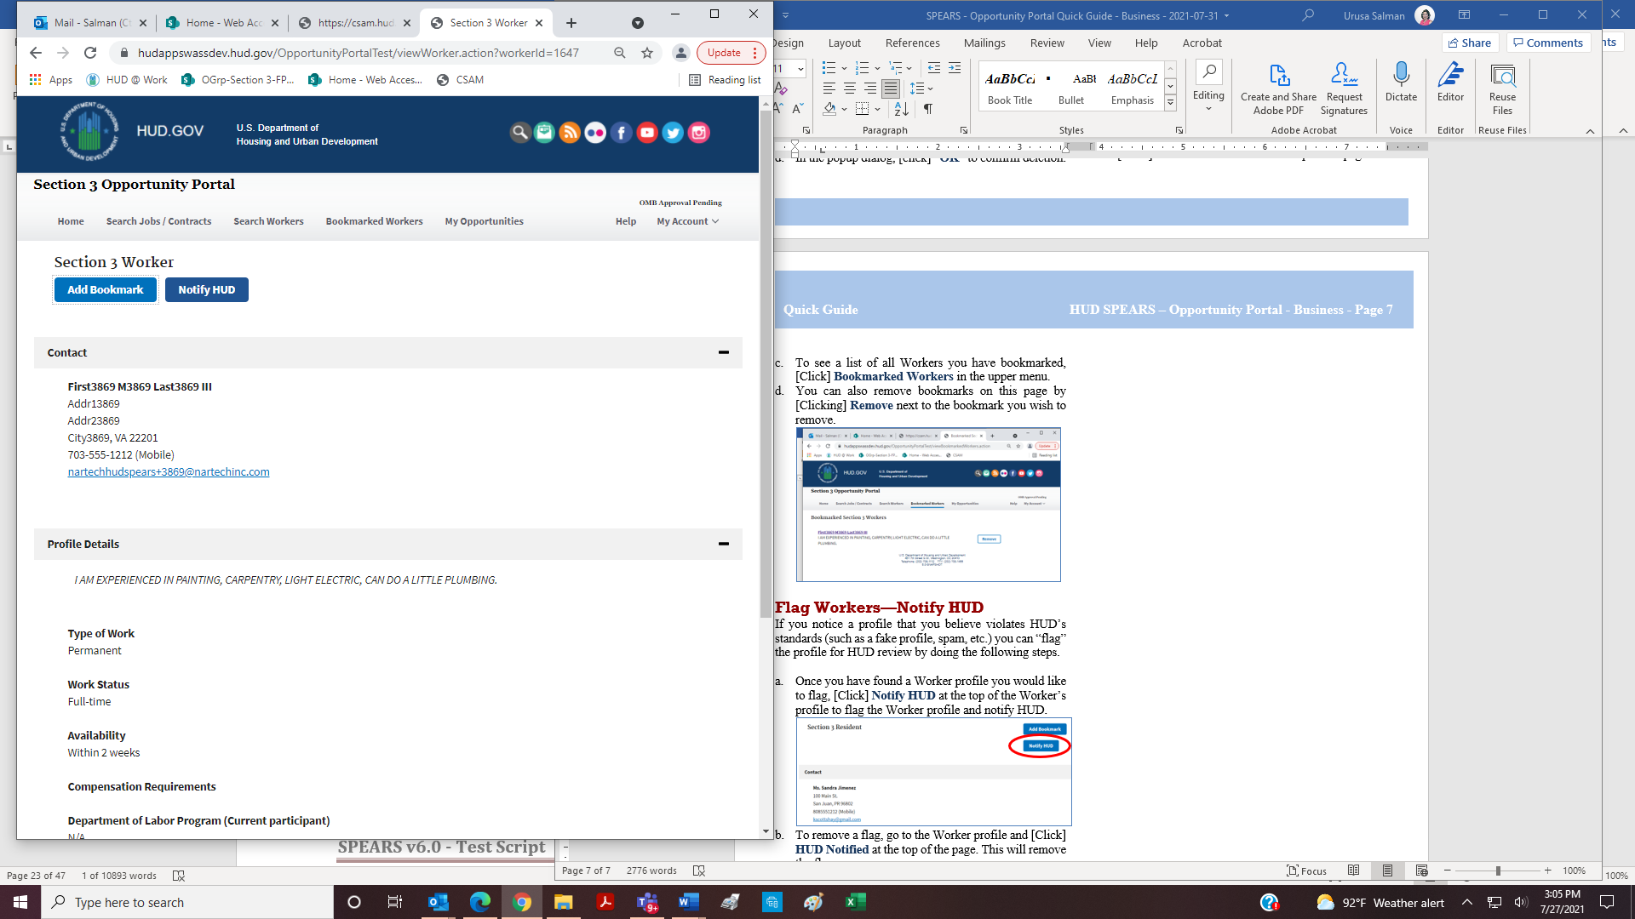

1. To remove a flag, go to the Worker profile and [Click] **HUD Notified** at the top of the page. This will remove the flag.