North Carolina Department of Environmental Quality
Division of Water Infrastructure
Spring 2022 Application for Funding
(Last updated: February 2022)

Grants and low-interest loans are available for drinking water and wastewater infrastructure construction and study projects. Complete and submit this application, along with required additional forms, to the Division of Water Infrastructure for consideration. Spring 2022 application due date is May 2, 2022.

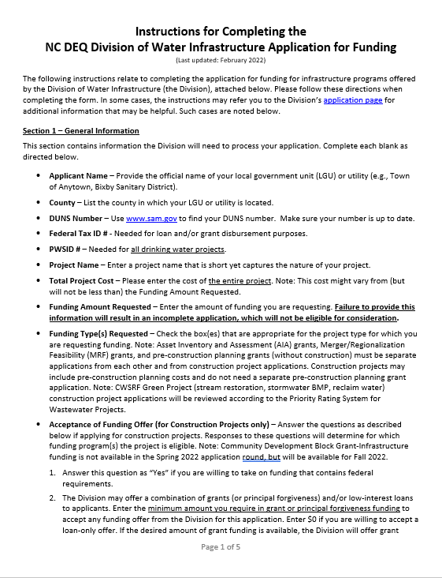 |  | 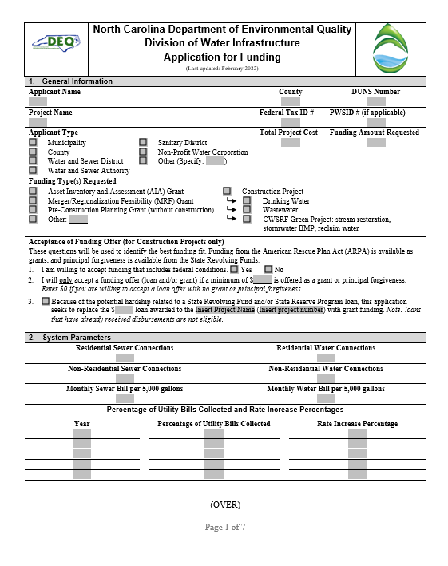
Instructions begin on the next page. |  | Application form is attached after the Instructions.  Additional forms required for completing an application are available on the Division of Water Infrastructure’s application page.

(This page intentionally left blank.)

Instructions for Completing the
NC DEQ Division of Water Infrastructure Application for Funding
(Last updated: February 2022)
The following instructions relate to completing the application for funding for infrastructure programs offered by the Division of Water Infrastructure (the Division), attached below. Please follow these directions when completing the form. In some cases, the instructions may refer you to the Division’s application page for additional information that may be helpful. Such cases are noted below.
Section 1 – General Information
This section contains information the Division will need to process your application. Complete each blank as directed below.
- Applicant Name – Provide the official name of your local government unit (LGU) or utility (e.g., Town of Anytown, Bixby Sanitary District).
- County – List the county in which your LGU or utility is located.
- DUNS Number – Use www.sam.gov to find your DUNS number. Make sure your number is up to date.
- Federal Tax ID # - Needed for loan and/or grant disbursement purposes.
- PWSID # – Needed for all drinking water projects.
- Project Name – Enter a project name that is short yet captures the nature of your project.
- Total Project Cost – Please enter the cost of the entire project. Note: This cost might vary from (but will not be less than) the Funding Amount Requested.
- Funding Amount Requested – Enter the amount of funding you are requesting. Failure to provide this information will result in an incomplete application, which will not be eligible for consideration.
- Funding Type(s) Requested – Check the box(es) that are appropriate for the project type for which you are requesting funding. Note: Asset Inventory and Assessment (AIA) grants, Merger/Regionalization Feasibility (MRF) grants, and pre-construction planning grants (without construction) must be separate applications from each other and from construction project applications. Construction projects may include pre-construction planning costs and do not need a separate pre-construction planning grant application. Note: CWSRF Green Project (stream restoration, stormwater BMP, reclaim water) construction project applications will be reviewed according to the Priority Rating System for Wastewater Projects.
- Acceptance of Funding Offer (for Construction Projects only) – Answer the questions as described below if applying for construction projects. Responses to these questions will determine for which funding program(s) the project is eligible. Note: Community Development Block Grant-Infrastructure funding is not available in the Spring 2022 application round, but will be available for Fall 2022.
- Answer this question as “Yes” if you are willing to take on funding that contains federal requirements.
- The Division may offer a combination of grants (or principal forgiveness) and/or low-interest loans to applicants. Enter the minimum amount you require in grant or principal forgiveness funding to accept any funding offer from the Division for this application. Enter $0 if you are willing to accept a loan-only offer. If the desired amount of grant funding is available, the Division will offer grant funding up to the full amount for which the applicant is eligible, including above the stated minimum request if applicable. Selecting a lower acceptable amount than what you may be eligible for does not reduce your potential grant offer if funds are available. Selecting too high of an acceptable amount risks the possibility of not being offered any funding if there are insufficient grant funds available to meet your desired minimum. If grant funding cannot be offered to meet your requested minimum, no funding offer (loan or grant) will be made.
Provide a copy of the Affordability Calculator (available on the Division’s application page) or handwritten affordability calculations as part of the application package.
- While American Rescue Plan Act (ARPA) State Fiscal Recovery Fund grants are available, applicants that have already been awarded a State Revolving Fund loan and/or State Reserve Program loan for a construction project may apply for a grant to replace the loan portion of the existing project. Projects that have already received disbursements are not eligible. If the application project is an existing project with an awarded loan but has not yet received disbursements, check this box, provide the amount of the awarded loan, the project name, and the project number, and complete the rest of the application for the construction project. The application will be reviewed among all other applications. The score sheet of the project’s previous application that received a loan award is available upon request to assist with completing this application.
Section 2 – System Parameters
This section contains information related to drinking water and wastewater system parameters, which is used across all programs. Please complete all blanks unless otherwise noted.
- Residential and Non-Residential Sewer and Water Connections – Follow the guidance found in Line Item 4.A of the Priority Rating System Guidance and Form for Division of Water Infrastructure Construction Funding Programs (Priority Rating System guidance, available on the Division’s application page). For wastewater applications, count only sewer connections. For drinking water applications, count only drinking water connections. Include only existing connections; do not include number of new connections resulting from the project.
- Monthly Water and Sewer Bills per 5,000 gallons – If your system offers it, provide the monthly bills for 5,000 gallons per month of use for both water and sewer. These rates are (1) used to calculate Line Item 3.B operating ratio eligibility via rates to median household income; (2) used to determine points in Line Item 4.B; and (3) used to determine grant / principal forgiveness eligibility for some funding programs. See Line Item 4.B in the Priority Rating System guidance (or Line Item 4.G in the CDBG-I Priority System Rating guidance) for more information about what is needed for this parameter.
Sections 3, 4, and 5 – Applicant, Application Preparer, and Engineer Contact Information
Complete this section with all pertinent information. The following bullet points contain specific information.
- Authorized Representative Name – This name must match the name listed on the Resolution by Governing Body of Applicant.
- Mailing Addresses – Provide the mailing address where the Applicant, Preparer, and Engineer receive mail. For example, if you have a PO Box, provide this information rather than your physical address.
Note: Zip codes between PO Boxes and physical addresses may vary. If using a PO Box to receive mail, use the zip code that matches the PO Box.

- Engineer Contact Information – If your Application Preparer is the same as the Engineer Contact, check the No box. Section 5 may then be left blank. If the answer is Yes, provide the appropriate information.
Section 6 – Project Description
In this section, provide a brief description of the proposed project in a broad level of detail. Include the project purpose and what the project entails (e.g., rehabilitation of 2,000 l.f. of sewer, construction of a new well). Include information such as types of equipment to be included, capacity of equipment, estimates of line length, street names for sewer or waterline work, and/or neighborhoods where work will occur. Descriptions of the work related to the major line items in the Project Budget (Sections 8a and 8b) must be included in the project description. For example, if 2,000 l.f. of 4-inch, 3,000 l.f. of 6-inch, and 4,000 l.f. of 8-inch pipe are listed in the project budget, they must be listed in the project description.
Expenses such as pre-construction expenses, rate studies, and training may be included in construction projects. Rate studies and training may also be included with AIA and MRF grant applications. If any of these items are part of the project, please include in the project description and specify how they are directly related to the construction or study project. For training, reimbursement will occur only for registration and mileage costs.
A construction project that is primarily (at least 75% of the Project Budget) to connect existing residences in disadvantaged, underserved areas that voluntarily choose to connect to the water and/or wastewater utility replacing on-site service to the residence, is eligible for a specific portion of the ARPA funds. Please specify in the project description if the application is for this type of construction project. Include a description of the project, specifying the streets in which connections will be made, and provide documentation to show that the area is disadvantaged and underserved. Documentation may include screenshots/printouts of NC DEQ’s Community Mapping System and the project area(s) identified overlapping “Potentially Underserved Block Groups 2019” or “Tribal Boundaries” that appear on the online map as purple and orange shaded areas, respectively. If the project area does not fall within a “Potentially Underserved Block Group” or “Tribal Boundary” layer on the Community Mapping System, but you believe the community is historically underserved or disadvantaged, please provide a paragraph explaining what factors would qualify this community as disadvantaged/underserved. Connection/tap-on fees and capacity/system development fees must be covered by the Funding Request Amount and included in the Project Budget (Section 8a), since they will not be charged to the residents.
If your project will add new connections to the water and/or wastewater system, please estimate the number of new connections in this section.
For construction projects and pre-construction planning grants only: check the appropriate box(es) if the project is a result of a study grant (Asset Inventory and Assessment grant and/or Merger/Regionalization Feasibility grant) previously awarded by the Division. If neither is the case, check None of the Above.
Section 7 – Additional Information for Consideration
In some situations, a project’s purpose may not be listed as eligible for points under Category 1 of the Priority Rating System. In these situations, you may use the Supplemental Guidance for the Ranking of Applications and Providing Additional Information for Consideration found on the Division’s application page. Please note the following related to this section:
- This section does not apply to the Drinking Water State Revolving Fund program.
- Information for this section must fit into the space provided.
Section 8 – Project Budget
Complete the project budget for your project as discussed in Section 8a and Section 8b.
Complete Section 8a for construction projects or pre-construction planning grants. If the project includes related training and/or rate study costs, include those in Section 8b.
Complete Section 8b for Asset Inventory and Assessment grants, Merger/Regionalization Feasibility grants, and training and/or rate study components to other projects.
Section 8a – Project Budget for Construction Projects and Pre-Construction Planning Grants only
Complete the project budget by addressing the categories provided in the table (insert rows as needed). Total the cost amount for each line and provide the total cost amount. Please note the following related to this section:
- Project budget is required for construction projects and pre-construction planning grants.
- If applying only for a pre-construction planning grant (without construction), complete the Engineering Costs and Administration Costs sections of the budget.
- If applying for a construction project, include the pre-construction planning costs in the budget. You do not need to apply for a separate pre-construction planning grant.
- If your project will connect residences in disadvantaged, underserved communities that voluntarily choose to connect to the water or wastewater systems, specify the line items (or the portions of the line items) that will be part of this portion of the project, and complete the Compensation for Connection Fees and System Development Fees line. Total should be at least 75% of the project budget in the Division Funding Requested column to potentially qualify for a specific portion of ARPA grant funds.
- The project budget must be signed and sealed by a properly licensed Professional Engineer (PE). If you do not provide a PE signature and seal on the budget, the application will be incomplete.
Section 8b – Project Budget for AIA and MRF grants, and training and/or rate study components to other projects
Provide basic aspects of the AIA or MRF study costs. For example, if applying for an AIA grant, some budget items might include the following: (1) mapping of collection system, (2) condition assessment, and (3) grant administration. Note: AIA and MRF applications must be separate applications from each other and from construction projects.
Training and/or rate studies may be components of a construction project, pre-construction planning grant, AIA, and/or MRF project. If so, specify the training and/or rate study costs in this section (and exclude from Section 8a, if applicable). Training and rate studies must be related to the project. Training is limited to $2,000 per applicant and covers registration and mileage costs for governing board officials and utility staff.

Certification by Authorized Representative
The Authorized Representative must read and initial in the space beside each question. If not applicable, use N/A.
Completeness Checklist
When putting together the application package, initial to show that the information is in the package. Incomplete applications will not be eligible for consideration.
Submittal Information
- Submit each application copy in a bound format (e.g., report cover with fasteners, plastic report combs, spiral or 3-ring binders).
- Number of copies to submit:
  - Send one (1) original and one (1) electronic copy of the application (on USB drive/CD/DVD).
- Delivery Method
  - All applications must be in the Division’s offices by 5 PM the day of application deadline. No exceptions.
  - If mailing, allow at least two weeks for delivery to the Mail Service Center address shown on the application. The Division recommends certified mail. Please call the Division’s offices to ensure that your package has been received.
  - If courier delivery or hand delivering, please use the physical address listed on the application. If courier delivery, verify that your package has arrived.
Application Signature
The Authorized Representation must sign the application. An application without this signature will be considered incomplete and will not be eligible for consideration.

(This page intentionally left blank.)

 | North Carolina Department of Environmental Quality
 | Division of Water Infrastructure
 | Application for Funding
 | (Last updated: February 2022)
- General Information
Applicant Name |  |  |  |  |  |  | County |  |  | DUNS Number
Project Name |  |  |  |  |  |  | Federal Tax ID # |  |  | PWSID # (if applicable)
Applicant Type |  |  |  |  |  |  | Total Project Cost |  |  | Funding Amount Requested
Municipality  County  Water and Sewer District  Water and Sewer Authority |  | Sanitary District  Non-Profit Water Corporation  Other (Specify: )
Funding Type(s) Requested
Asset Inventory and Assessment (AIA) Grant  Merger/Regionalization Feasibility (MRF) Grant  Pre-Construction Planning Grant (without construction)  Other: |  |  |  |  | Construction Project  Drinking Water  Wastewater  CWSRF Green Project: stream restoration, stormwater BMP, reclaim water
Acceptance of Funding Offer (for Construction Projects only)
These questions will be used to identify the best funding fit. Funding from the American Rescue Plan Act (ARPA) is available as grants, and principal forgiveness is available from the State Revolving Funds.
- I am willing to accept funding that includes federal conditions. Yes No
- I will only accept a funding offer (loan and/or grant) if a minimum of $ is offered as a grant or principal forgiveness. Enter $0 if you are willing to accept a loan offer with no grant or principal forgiveness.
- Because of the potential hardship related to a State Revolving Fund and/or State Reserve Program loan, this application seeks to replace the $ loan awarded to the Insert Project Name (Insert project number) with grant funding. Note: loans that have already received disbursements are not eligible.

- System Parameters
Residential Sewer Connections |  |  |  |  |  | Residential Water Connections
Non-Residential Sewer Connections |  |  |  |  |  | Non-Residential Water Connections
Monthly Sewer Bill per 5,000 gallons |  |  |  |  |  | Monthly Water Bill per 5,000 gallons
Percentage of Utility Bills Collected and Rate Increase Percentages

Year |  |  |  | Percentage of Utility Bills Collected |  |  |  |  | Rate Increase Percentage

(OVER)

- Applicant Contact Information
Authorized Representative Name:
Authorized Representative Title:
Mailing Address Line 1:
Mailing Address Line 2:
City:
State:
Zip Code:
Physical Address Line 1:
Physical Address Line 2:
Physical Address City:
Physical Address State:
Physical Address Zip Code:
Phone Number:
E-Mail Address:
- Application Preparer Contact Information
Firm Name:
Contact Name:
Mailing Address Line 1:
Mailing Address Line 2:
City:
State:
Zip Code:
Physical Address Line 1:
Physical Address Line 2:
Physical Address City:
Physical Address State:
Physical Address Zip Code:
Phone Number:
E-Mail Address:
- Engineer Contact Information
Is the engineering firm different from the application preparer? | Yes No
Engineering Firm Name:
Contact Name:
Mailing Address 1:
Mailing Address 2:
City:
State:
Zip Code:
Physical Address Line 1:
Physical Address Line 2:
Physical Address City:
Physical Address State:
Physical Address Zip Code:
Phone Number:
E-Mail Address:

- Project Description (see Instructions)
Estimated number of new connections served by project (if applicable):
For Construction Projects and Pre-Construction Planning Grants only:
The proposed project is a result of an Asset Inventory and Assessment Grant previously awarded by the Division?
The proposed project is a result of a Merger / Regionalization Feasibility Grant previously awarded by the Division?
None of the above.
- Additional Information for Consideration
(OVER)
8a. Project Budget (for Construction Projects and Pre-Construction Planning Grants only)
 | Division Funding Requested | Other Secured Funding Source(s) | Total Cost Amount
Indicate construction costs by line item (e.g., linear feet of different-sized lines)
Construction Costs
Contingency (10% of construction costs):
Construction Subtotal:
Engineering Costs
Engineering Design
Permitting
Land Surveying Costs
Engineering Subtotal:
Administration Costs
Planning (pre-construction costs)
Easement Preparation
Engineering Report Preparation
Environmental Documentation Preparation (if applicable)
Legal Costs
Compensation for Connection Fees and System Development Fees that will not be charged after connecting residences in disadvantaged, underserved areas (if applicable)
Project Funding Administration (if applicable)
Other:
Other:
Administration Subtotal:
TOTAL PROJECT COST:
A Professional Engineer signature and seal for the estimate must be provided in the space to the right for the application to be considered complete.

8b. Project Budget (for AIA and MRF grants, and training and/or rate study components to other projects)
Division Funding Requested
TOTAL DIVISION FUNDING REQUESTED:

(OVER)

Certification by Authorized Representative
The attached statements and exhibits are hereby made part of this application, and the undersigned representative of the Applicant certifies that the information in this application and the attached statements and exhibits are true, correct, and complete to the best of his/her knowledge and belief. By initialing each item and signature at the end of this application, he/she further certifies that:

_______ | - as Authorized Representative, he/she has been authorized to file this application by formal action of the governing body;
_______ | - the governing body agrees to provide for proper short-term and long-term maintenance and operation of the approved project after its completion;
_______ | - the Applicant has substantially complied with or will comply with all federal, state, and local laws, rules, and regulations and ordinances as applicable to this project;
_______ | - the Applicant will adopt and place into effect on or before the completion of the project a schedule of fees and charges which will provide for the adequate and proper operation, maintenance, and administration and repayment of all principal and interest on loans (if applicable) of the project;
_______ | - the Applicant has followed proper accounting and fiscal reporting procedures, as evidenced by the Applicant’s most recent audit report, and that the Applicant is in substantial compliance with provision of the general fiscal control laws of the State;
_______ | - the Project Budget for construction projects and pre-construction planning grants provided in this application form (if applicable) includes all funding requested from all sources of funding proposed for this project;
_______ | - the (Town or County), North Carolina is organized and chartered under the laws of North Carolina, or the special purpose unit of local government is incorporated under the laws of North Carolina. All officials and employees are aware of, and in full compliance with NCGS 14-234, “Public officers or employees benefiting from public contracts; exceptions.” (For units of local government only. All others should initial “N/A”);
______ | - the Applicant acknowledges that all loans, and Viable Utility Reserve grants, are subject to approval by the Local Government Commission;
_______ | - the Applicant acknowledges that, in accordance with G.S. 120-157.2, for local government debt to be issued greater than $1,000,000, the local government must report to Committee Chairs, Committee Assistant, and the Fiscal Research Division of the General Assembly at least 45 days prior to presentation before the Local Government Commission (For units of local government only. All others should initial “N/A”); and
_______ | - if the Applicant receives a grant with American Rescue Plan Act (ARPA) State Fiscal Recovery Funds, the Applicant acknowledges and accepts the following conditions:  - all ARPA project funds must be reimbursed by December 31, 2026;  - project funds will not be used to pay existing debt or as a match for other federal funds;  - if the project is also funded with other federal funds, the federal requirements of the other funds will apply to the ARPA funds; and  - for projects receiving ten million dollars or more in ARPA funding: recipients must certify or provide plans and reports meeting federal requirements on reporting on prevailing wage rates, project labor agreements, and related information as specified in the U.S. Treasury’s Compliance and Reporting Guidance for the State and Local Fiscal Recovery Funds (pages 21-22).

Completeness Checklist
In addition to this application, the following items must be included for a complete application package. Incomplete applications will not be considered. Please initial that each item is included in this submittal.

______ | Resolution by Governing Body of Applicant with Certification by Recording Officer*
______ | Water & Sewer Financial Information Form*
______ | Fund Transfer Certification*
______ | Applicable Priority Rating System Form* with supporting narratives and documentation
______ | Affordability Calculator* or handwritten affordability calculations
______ | Current rate sheets in effect on application deadline (for both water and sewer if the utility provides both water and sewer, or for water or sewer depending on the utility service)
______ | PE Seal on project budget (construction projects and pre-construction planning grants only. All others initial “N/A”)
______ | Supporting documentation/maps for construction projects that connect residences in disadvantaged, underserved areas to water/wastewater utility (if applicable. If not applicable, initial “N/A”)
* Forms and templates are available separately on the Division’s website.
** For each application, please provide copies that are bound (e.g., report cover with fasteners, plastic report combs, spiral or 3-ring binders). No paper clips, staples or binder clasps. **
Submittal Information
- Send one (1) original hard copy and one (1) electronic copy of the Application.

Send complete Application package to:
Mailing Address† (US Postal Service only) |  |  |  | Physical Address (FedEx, UPS)‡
Division of Water Infrastructure  1633 Mail Service Center  Raleigh, NC 27699-1633 |  |  |  | Division of Water Infrastructure – 8th Floor, Archdale Building  512 North Salisbury Street  Raleigh, NC 27604  919.707.9160
†Please allow two weeks for delivery if mailing via the US Postal Service.
‡For all courier services, please use the physical address, as having a courier deliver to the mailing address will delay package delivery.
Application Signature
Please note: original signatures are required for each application.
SIGNATURE OF AUTHORIZED REPRESENTATIVE
 |  | , |  |  | ,
TYPED NAME |  |  | TYPED TITLE |  |  | DATE

Eligibility for grants from the American Rescue Plan Act (ARPA) State Fiscal Recovery Funds will be determined according to the ARPA Administration Plan that is available on the Division’s webpage.
Potentially Underserved Block Groups are determined based on racial/ethnic composition and poverty rate, where (1) the share of nonwhites and Hispanic/Latino (of any race) within the community is over 50 percent or is at least 10 percent higher than the county’s or state’s share, and (2) the share of community population experiencing poverty is over 20 percent or is at least five percent higher than the county’s or state’s share.
Factors may include demographic, historical, cultural, linguistic, or low-wealth factors, existing contamination, or other relevant considerations.

