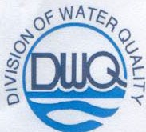
Michael F. Easley, Governor

William G. Ross Jr.. Secretary North Carolina Department of Environment and Natural Resources

Coleen H. Sullins, Director Division of Water Quality

MEMORANDUM

TO: THROUGH: FROM: SUBJECT:
Pat Donnelly Kent Wiggins Coleen Sullins
Removal of Standard Methods Method 10200 H by High Performance Liquid Chromotography (HPLC) as an approved method technique for chlorophyll a

I, Coleen Sullins, Director of the Division of Water Quality of the Department of Environmental and Natural Resources, do hereby approve the removal of the above cited parameter determinative method from the Laboratory Section Wastewater/Groundwater Certification Program. Standard Methods Method 10200 H by spectrophotometric and fluorometric determinative techniques remain approved.

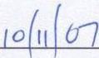

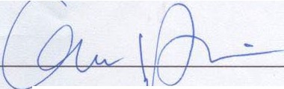
Coleen llins
Director, Division of Water Quality
Date

Laboratory Section
wwv..dwqlab org
Internet:

1623 Mail Service Center Raleigh, NC 27699-1623 Location: 4405 Reedy Creek Road Raleigh, NC 27607

Phone (919) 733-3908
Fax (919) 733-6241
N.?.rtbCarolina
/Vnturnll!f

Customer Service 1-877-623-6748

AnEqual Opportunity/AffirmativeAction Employer-50%Recycled/10% Post Consumer Paper

