State of North Carolina
Department of Environmental Quality
Division of Water Resources

15A NCAC 02H .0500 - Water Quality Certification, Lake Shoreline Stabilization
Form: SSGP 02-2022
_____________________________________________________________________________________________________

Instructions for Lake Shoreline Stabilization Application

When to use this form – This application form should be used to apply for a 401 Water Quality Certification to impact:

Description | U.S. Army Corps of  Engineers (USACE) Permit
Federal Energy Regulatory Commission (FERC) regulated lake shore or bottom | GP30
Tennessee Valley Authority (TVA) regulated lake shore or bottom | GP30
Local government regulated lake shore or bottom | GP30
USACE Reservoir owned/regulated lake shore or bottom | GP79
Private lake shore or bottom | GP80

When this form should not be used – This application form cannot be used for wetland or stream impacts. This information does not apply to landowners within the twenty coastal counties that are affected by Division of Coastal Management (CAMA) rules.

For more information – If you have been advised that you require a 401 Water Quality Certification, and would like more information about:
- The application process: https://deq.nc.gov/about/divisions/water-resources/water-quality-permitting/401-buffer-permitting-branch/401-isolated
- How to download an application form: https://deq.nc.gov/about/divisions/water-resources/water-quality-permitting/401-buffer-permitting-branch/application
- Application fees: https://deq.nc.gov/about/divisions/water-resources/water-quality-permitting/401-buffer-permitting-branch/401-isolated#FeesProcedures

If you are unable to download this information or application, please call (919) 707-9000 to request an application with instructions.

Please note – Not all impacts require written authorization from DWR. This may include the construction of docks or boathouses if there is no dredging or filling involved (other than the pilings). For more information on when an application is necessary, please visit our FAQ page: https://deq.nc.gov/about/divisions/water-resources/water-quality-permitting/401-buffer-permitting-branch/frequently#always_have_to_apply

How to apply – When submitting an online application to DWR, please use the following instructions as a checklist in order to ensure all required items are submitted. Adherence to these instructions will help facilitate a quicker review time and reduce the amount of requested additional information.

Provide complete answers and supporting information (maps, drawings, etc.) to the online application form as instructed. Please also provide the appropriate application fee (see below), to the Division of Water Resources, 401 & Buffer Permitting Unit, 1617 Mail Service Center, Raleigh, NC 27699-1617.

- Owner/ Applicant / Agent Information: Although the agencies will communicate with the individual(s) listed as applicant, the owner receives the original of all communications.
Owner Information: Please provide complete and accurate contact information.
Applicant/ Agent Information: Per 15A NCAC 02H .0502 , an agent may be given signatory authority for the owner/ applicant if a signed and dated copy of an Agent Authorization letter is included with the application. (A sample form may be found at http://www.saw.usace.army.mil/Portals/59/docs/regulatory/regdocs/Permits/SAMPLE_AGENT_AUTHORIZATION_FORM.pdf) If the applicant is not the owner, please provide complete and accurate applicant/ agent/ consultant contact information and upload the corresponding signed and dated agent authorization document granting the applicant owner approval.

- Project Information: These fields will help us identify your project and direct it to the correct project manager for timely review.
Project Name: If your project has a formal name please use this. If your project does not have a formal name, please identify your project by the owner’s name and proposed activity (Jones Property Access Road, Smith Guest House, etc.) List in parentheses any other names that have been used to identify the project in the past.
1. Provide a Vicinity/ Site Map: Upload some type of site map so that someone unfamiliar with the area can locate your project. A county map or USGS topographic map indicating the project location is usually sufficient. You may click the “look up address” option provided for assistance in finding location information for your project.
Provide Latitude/ Longitude Coordinates: The site coordinates are necessary so the agencies can accurately locate and analyze impacts from your proposed project. Site coordinates can be obtained from maps (online and paper), surveys, or from GPS devices. Coordinates should be written as latitude and longitude and expressed in decimal degrees (to the fourth decimal place). For assistance in obtaining latitude/longitude coordinates for your project, you may click the “look up address” option provided on the online form, or visit the GetLatLog website: https://getlatlong.net/. Please clearly label the location in which this coordinate was taken on attached site maps.
2. Site Plan: Upload a site plan showing the property boundaries, structures (buildings, docks, impervious surfaces, etc.), location of the shoreline, location of the impacts to the shoreline and/or lake bottom (excavation, dredging, rip rap, retaining walls, etc.), and the location of any vegetated areas that will be impacted (construction access corridors, etc.). In most cases the site plans do not have to be professionally prepared. However, if you intend to conduct hydraulic dredging, professionally prepared drawings will likely be required for the spoil structures. See the example diagram below and provided at the following link: https://edocs.deq.nc.gov/WaterResources/0/edoc/616616/Shoreline%20Layout.docx
3. Photograph of shoreline proposed to be stabilized: Include a scale of some sort (a yard stick, shovel handle, etc.) and upload photos.
4. Location of property where work is to be conducted: Include location information as specified as well as directions to the site.
- Nearest Town
- County
- Water body (lake, river, ocean) adjacent to property*
- Subdivision name or site address (including phase/ lot number
- Directions to site (including road names or SR numbers, landmark, etc.)
*Name of nearest water body can be found by navigating to the location using one of the following mapping sites:
- 1:24,000 USGS Topographic map, via the USGS Store at: http://store.usgs.gov
- NC One Map: http://data.nconemap.com/geoportal/dataexplorer/index.jsp
- NC Surface Water Classifications Map: http://ncdenr.maps.arcgis.com/apps/webappviewer/index.html?id=6e125ad7628f494694e259c80dd64265
If a stream or creek or other waterbody does not have a known name, please identify it as an “Unnamed tributary to ____” and list the nearest named stream into which it flows.
5. Describe the existing land use or condition of the site at the time of this application (Residential, developed, etc.)
6. Property size (in acres)
7. Description of proposed work: Include discussion as to how impacts have been avoided or minimized, hardening of shoreline has been avoided, or why it is necessary.
8. How work will be done: From land or water
9. Total amount of disturbance BELOW the normal pool lake level or normal water level:
- Temporary: Include all clearing for construction corridors, etc. expressed in square feet.
- Permanent: Include all clearing, back fill, excavation, rip rap, retaining walls, and the like expressed in square feet.
10. Total amount of disturbance ABOVE the normal pool lake level or normal water level:
- Temporary: Include all clearing for construction corridors, etc. expressed in square feet.
- Permanent: Include all clearing, back fill, excavation, rip rap, retaining walls, and the like expressed in square feet.
11. Describe the vegetation above the normal pool lake level/ normal water level and 50 feet landward to be impacted.
Upload a sketch depicting your proposal.

Application Fee
Once accepted by DWR, the application must be accompanied by the corresponding application fee and the appropriate DWR # assigned to it. (Checks made out to the NC Division of Water Resources need to include that DWR # in the memo.) The application fee is as follows (pursuant to G.S. 143-215.3D):
- $240.00 for impacts to lake (below normal water level) of less than 1 acre
- $570.00 for impacts to lake (below normal water level) of greater or equal to 1 acre
Signature
Per 15A NCAC 02H .0502 , the application shall be considered a “valid application” only if it bears the (digital) signature of a responsible officer of the company, municipal official, partner or owner. This signature certifies that the applicant has title to the property, has been authorized by the owner to apply for certification, or is a public entity and has the power of eminent domain. The signature also certifies that:
- The project proponent certifies that all information contained in the submitted packet is true, accurate, and complete to the best of their knowledge and belief
- The project proponent requests that the certifying authority review and take action on the CWA 401 certification request within the applicable reasonable period of time

Shoreline Layout Diagram
Please approximately sketch the below-listed information and provide dimensions for each item. (The next two pages include examples to follow and space to sketch your proposed plan):
  - All proposed vegetation clearing
  - Location of rip rap or fill to be placed above the Full Pond/ Normal Water Level elevation
  - Location of rip rap or fill to be placed below the Full Pond/ Normal Water Level elevation
  - Location of any proposed structures such as buildings, retaining walls, docks, etc.

Lake
(At Full Pond/ Normal Water Level)
Proposed
(Plan View)
Full Pond/ Normal Water Level
Shoreline

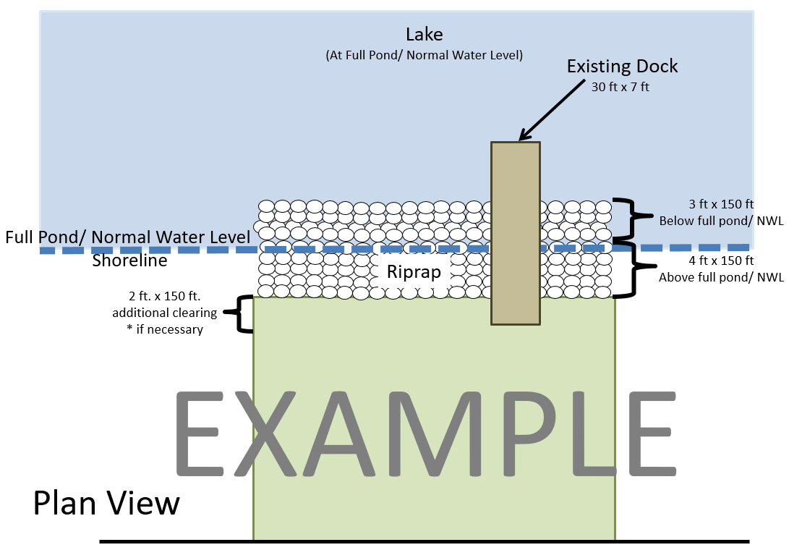
Proposed
(Side View)
Full Pond/ Normal Water Level
Shoreline
Lake
(At Full Pond/ Normal Water Level)
